Written Assignment #2: Logical and Physical Network Design

Logical and Physical Network Design (Module #2: Written Assignment)

Christine Herlihy  
2016FEB CMP-354-OL009

# Abstract

There are two types of diagrams (logical and physical) utilized in telecommunications to illustrate the layout of a network. This paper explains the elements of, and differences between, each type. Additionally, examples of a logical and physical network diagram are developed and presented.

# **Written Assignment #2: Logical and Physical Network Design**

Logical and physical network designs are both used to illustrate the layout of a telecommunications network. The primary difference between these two types of design is that while a physical topology describes, “the layout of the network media that interconnects the devices on a network,” a logical topology, “defines the way in which devices communicate and data is transmitted throughout the network” (Ciccarelli et. al 2013). The remainder of this paper explains the elements associated with each typology, explains the key differences between each type, and provides an example diagram of each.

1. **Physical Network Diagrams**

Physical network topologies describe the location of servers, nodes, and cables within a network, and how the nodes are physically connected to one another. To this end, physical network diagrams include physical elements of a network, such as cables, connectors, switches, routers, wireless access points, computers (servers and clients), and other input/output devices, such as printers. The way in which a physical network is visually represented will depend on its topology, and whether it is a wired, wireless, or hybrid network. There are many possibilities to choose from, including the physical bus, ring, star, mesh, and (various) hybrid topologies.

In a physical bus network, all the nodes in the network, including servers, computers, and other devices, are connected in a linear fashion by a single coaxial cable that runs through the network and has a terminator on each end. The terminator absorbs the electrical signal to prevent it from bouncing back through the network once it reaches the end of the line. It is possible to join multiple segments of cable using repeaters; thus, these might also be included in a physical network diagram of a physical bus network (Florida Center for Instructional Technology, 2013).

As its name suggests, a physical ring network is one in which all the nodes in the network are connected to one another in a circular form, eliminating the need for terminators. In a physical star network, each node in the network is connected via cable to a central hub; it is possible to construct an extended start topology by connecting one hub with spokes to another hub with spokes. In a wired physical mesh network, each device is connected to all other devices, which provides reliable connection in the event that a single connection between two nodes fails. A mesh topology can also be implemented wirelessly, by setting up many wireless access points (WAPs) that overlap in terms of range (Ciccarelli et. al 2013).

1. **Logical Network Diagrams**

In contrast to physical network diagrams, which focus on the tangible ways in which nodes in a network are connected, logical network diagrams describe how nodes in a network communicate with one another and transmit data, regardless of the way in which the network is physically connected. Thus, for example, while a network might use a physical star topology, data could be transmitted through the network in either a logical bus (i.e. linear from the source to all nodes), or logical ring (from one node to another and back to the start of the circle) fashion. A logical network diagram is more abstract than a physical network diagram, and “focuses on the fundamental functionality needed instead of specific technologies or products” (Ciccarelli et. al 2013). Logical network diagrams are typically produced by breaking the network into several conceptual layers. These layers include the access layer, which is closest to end users, the distribution layer, which connects the access layer to the wider network, and the core layer, which connects distribution layers within a network to one another.

Elements included within a logical network diagram will depend on the layer being represented. For example, a logical network diagram for a corporation with offices in five different cities might start with a core layer diagram showing how each corporate location is connected to the overarching wide area network (WAN) through a backbone network (BN), and multiple local area networks (LANs) per site, depending on the data transmission needs of each corporate site. To ensure that the organization’s current and future data transmission needs are taken into account, a logical diagram should also account for and reflect the ways in which access to enterprise resources (i.e. file and print servers, network support servers, database and application servers, etc.) are distributed across the network. Additionally, network traffic patterns must be predicted and mapped, so that different clusters of clients and servers (i.e. specific floors within an office building, specific clusters within a LAN, and/or specific sites among many disparate locations that will be connected through the WAN) can be identified as normal or high traffic groups (Ciccarelli et. al 2013).

1. **Key Differences**

The primary difference between physical network diagrams and logical network diagrams is the degree of abstraction—while the former is concrete, and focused mainly on the hardware components of a network, the latter is more abstract and focused on data transmission, and how the network will be perceived from the point of view of its end users. From the perspective of software engineering, it can be helpful to think of the logical network diagram as an interface that emphasizes functionality, which is then implemented by the physical network diagram, which puts more of an emphasis on form. The two types of diagrams are most useful when taken in tandem—i.e., when a well-designed logical network diagram provides a solid foundation and point of reference for the physical network design, which can then be used for trouble-shooting once the network is up and running.

1. **Example Diagrams**

I used a web-based application called Gliffy to design the examples of logical and physical network diagrams that appear below. These network diagrams are intended to represent a single building with multiple floors on a university campus. The logical diagram represents the floors and their needs in terms of access to network resources, but does not specify hardware components of the network. The physical diagram builds off of the framework provided by the logical diagram, and demonstrates how the required functionality will be implemented technologically.

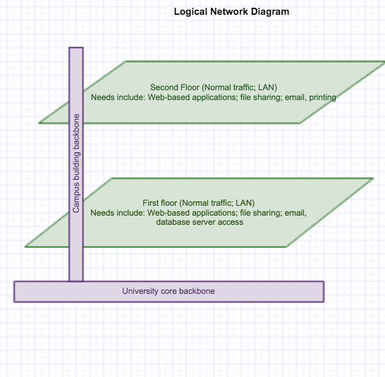

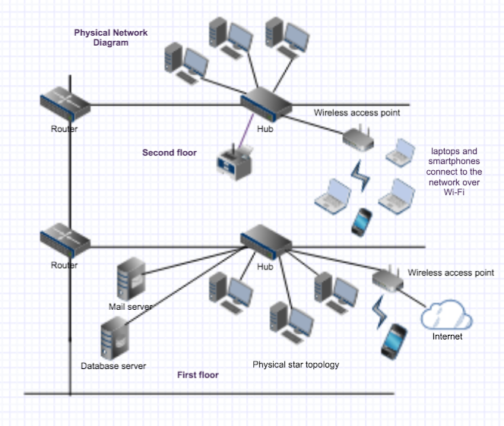

**Works Cited**

Ciccarelli, P., Faulkner, C., FitzGerald, J., Dennis, A., Groth, D., Skandier, T.,  and Miller, F. (2013). *Networking Basics,* (2nd ed.). New York: John Wiley & Sons.

Florida Center for Instructional Technology. (2013). Chapter 5: Topology. Retrieved March 3, 2016, from http://fcit.usf.edu/network/chap5/chap5.htm