Source Data Mapping Approach to CDMV5.3.1

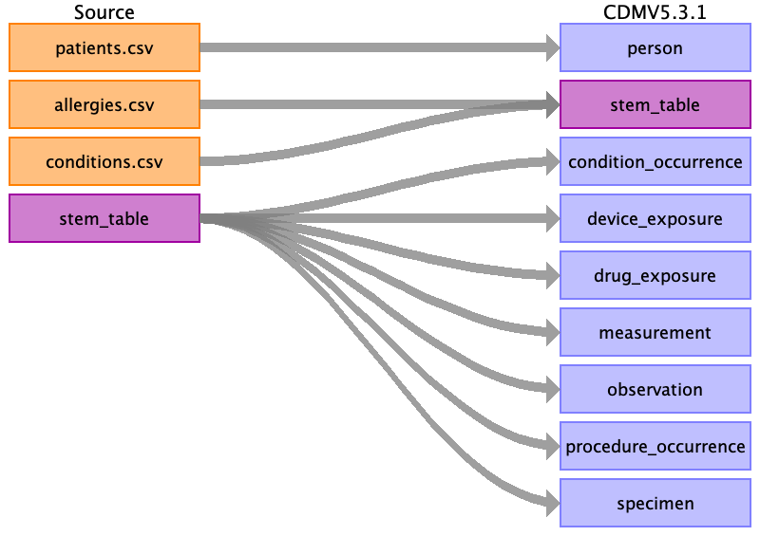

Table name: person

Reading from patients.csv

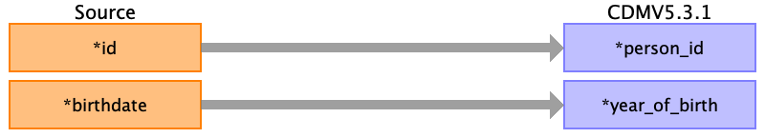

|  |  |  |  |
| --- | --- | --- | --- |
| Destination Field | Source Field | Logic | Comment |
| person_id | ﻿id |  |  |
| gender_concept_id |  |  |  |
| year_of_birth | birthdate |  |  |
| month_of_birth |  |  |  |
| day_of_birth |  |  |  |
| birth_datetime |  |  |  |
| race_concept_id |  |  |  |
| ethnicity_concept_id |  |  |  |
| location_id |  |  |  |
| provider_id |  |  |  |
| care_site_id |  |  |  |
| person_source_value |  |  |  |
| gender_source_value |  |  |  |
| gender_source_concept_id |  |  |  |
| race_source_value |  |  |  |
| race_source_concept_id |  |  |  |
| ethnicity_source_value |  |  |  |
| ethnicity_source_concept_id |  |  |  |

Table name: stem_table

Reading from allergies.csv

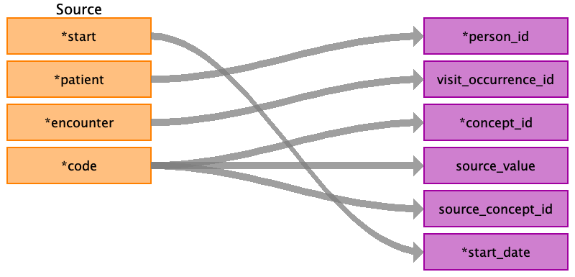

|  |  |  |  |
| --- | --- | --- | --- |
| Destination Field | Source Field | Logic | Comment |
| domain_id |  |  |  |
| person_id | patient |  |  |
| visit_occurrence_id | encounter |  |  |
| provider_id |  |  |  |
| id |  |  |  |
| concept_id | code |  |  |
| source_value | code |  |  |
| source_concept_id | code |  |  |
| type_concept_id |  |  |  |
| start_date | start |  |  |
| start_datetime |  |  |  |
| end_date |  |  |  |
| end_datetime |  |  |  |
| verbatim_end_date |  |  |  |
| days_supply |  |  |  |
| dose_unit_source_value |  |  |  |
| lot_number |  |  |  |
| modifier_concept_id |  |  |  |
| operator_concept_id |  |  |  |
| modifier_concept_id |  |  |  |
| modifier_source_value |  |  |  |
| quantity |  |  |  |
| range_high |  |  |  |
| range_low |  |  |  |
| refills |  |  |  |
| route_concept_id |  |  |  |
| route_source_value |  |  |  |
| sig |  |  |  |
| stop_reason |  |  |  |
| unique_device_id |  |  |  |
| unit_concept_id |  |  |  |
| unit_source_value |  |  |  |
| value_as_concept_id |  |  |  |
| value_as_number |  |  |  |
| value_as_string |  |  |  |
| value_source_value |  |  |  |
| anatomic_site_concept_id |  |  |  |
| disease_status_concept_id |  |  |  |
| specimen_source_id |  |  |  |
| anatomic_site_source_value |  |  |  |
| disease_status_source_value |  |  |  |
| condition_status_concept_id |  |  |  |
| condition_status_source_value |  |  |  |
| qualifier_concept_id |  |  |  |
| qualifier_source_value |  |  |  |

Reading from conditions.csv

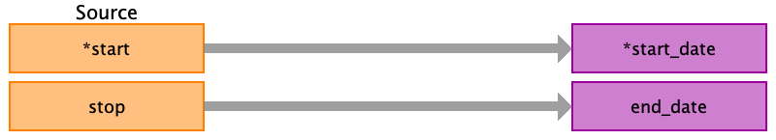

|  |  |  |  |
| --- | --- | --- | --- |
| Destination Field | Source Field | Logic | Comment |
| domain_id |  |  |  |
| person_id |  |  |  |
| visit_occurrence_id |  |  |  |
| provider_id |  |  |  |
| id |  |  |  |
| concept_id |  |  |  |
| source_value |  |  |  |
| source_concept_id |  |  |  |
| type_concept_id |  |  |  |
| start_date | start |  |  |
| start_datetime |  |  |  |
| end_date | stop |  |  |
| end_datetime |  |  |  |
| verbatim_end_date |  |  |  |
| days_supply |  |  |  |
| dose_unit_source_value |  |  |  |
| lot_number |  |  |  |
| modifier_concept_id |  |  |  |
| operator_concept_id |  |  |  |
| modifier_concept_id |  |  |  |
| modifier_source_value |  |  |  |
| quantity |  |  |  |
| range_high |  |  |  |
| range_low |  |  |  |
| refills |  |  |  |
| route_concept_id |  |  |  |
| route_source_value |  |  |  |
| sig |  |  |  |
| stop_reason |  |  |  |
| unique_device_id |  |  |  |
| unit_concept_id |  |  |  |
| unit_source_value |  |  |  |
| value_as_concept_id |  |  |  |
| value_as_number |  |  |  |
| value_as_string |  |  |  |
| value_source_value |  |  |  |
| anatomic_site_concept_id |  |  |  |
| disease_status_concept_id |  |  |  |
| specimen_source_id |  |  |  |
| anatomic_site_source_value |  |  |  |
| disease_status_source_value |  |  |  |
| condition_status_concept_id |  |  |  |
| condition_status_source_value |  |  |  |
| qualifier_concept_id |  |  |  |
| qualifier_source_value |  |  |  |

Table name: condition_occurrence

Reading from stem_table

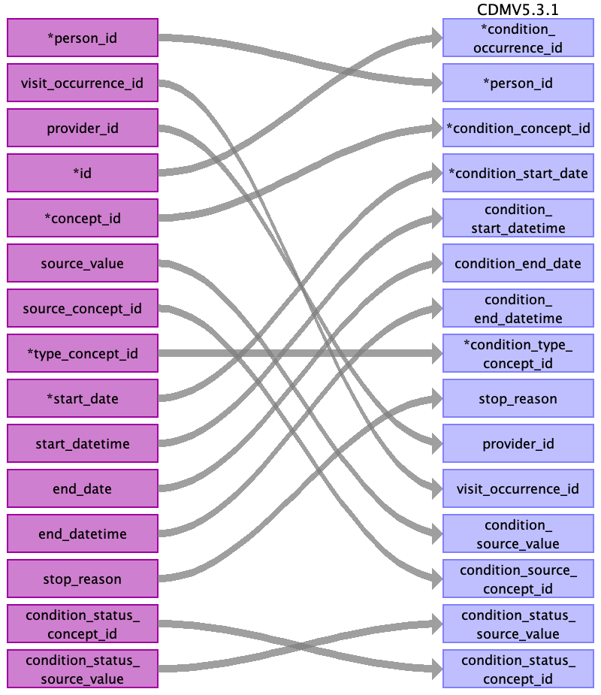

|  |  |  |  |
| --- | --- | --- | --- |
| Destination Field | Source Field | Logic | Comment |
| condition_occurrence_id | id |  |  |
| person_id | person_id |  |  |
| condition_concept_id | concept_id |  |  |
| condition_start_date | start_date |  |  |
| condition_start_datetime | start_datetime |  |  |
| condition_end_date | end_date |  |  |
| condition_end_datetime | end_datetime |  |  |
| condition_type_concept_id | type_concept_id |  |  |
| stop_reason | stop_reason |  |  |
| provider_id | provider_id |  |  |
| visit_occurrence_id | visit_occurrence_id |  |  |
| visit_detail_id |  |  |  |
| condition_source_value | source_value |  |  |
| condition_source_concept_id | source_concept_id |  |  |
| condition_status_source_value | condition_status_source_value |  |  |
| condition_status_concept_id | condition_status_concept_id |  |  |

Table name: death

Table name: device_exposure

Reading from stem_table

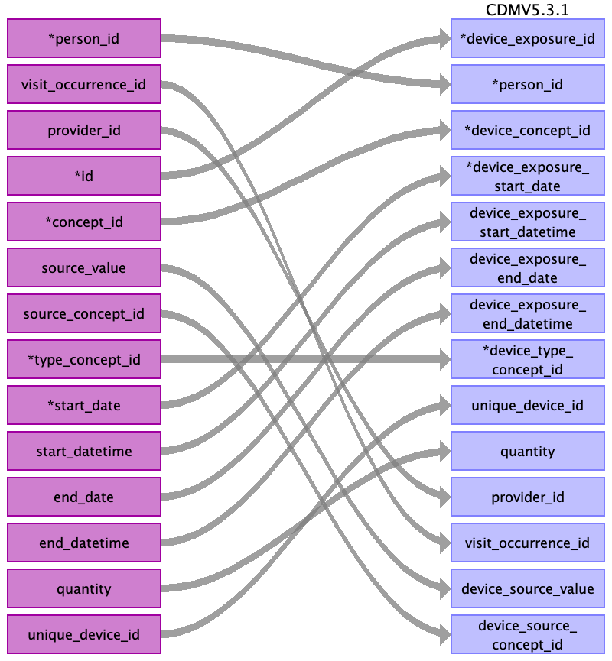

|  |  |  |  |
| --- | --- | --- | --- |
| Destination Field | Source Field | Logic | Comment |
| device_exposure_id | id |  |  |
| person_id | person_id |  |  |
| device_concept_id | concept_id |  |  |
| device_exposure_start_date | start_date |  |  |
| device_exposure_start_datetime | start_datetime |  |  |
| device_exposure_end_date | end_date |  |  |
| device_exposure_end_datetime | end_datetime |  |  |
| device_type_concept_id | type_concept_id |  |  |
| unique_device_id | unique_device_id |  |  |
| quantity | quantity |  |  |
| provider_id | provider_id |  |  |
| visit_occurrence_id | visit_occurrence_id |  |  |
| visit_detail_id |  |  |  |
| device_source_value | source_value |  |  |
| device_source_concept_id | source_concept_id |  |  |

Table name: drug_exposure

Reading from stem_table

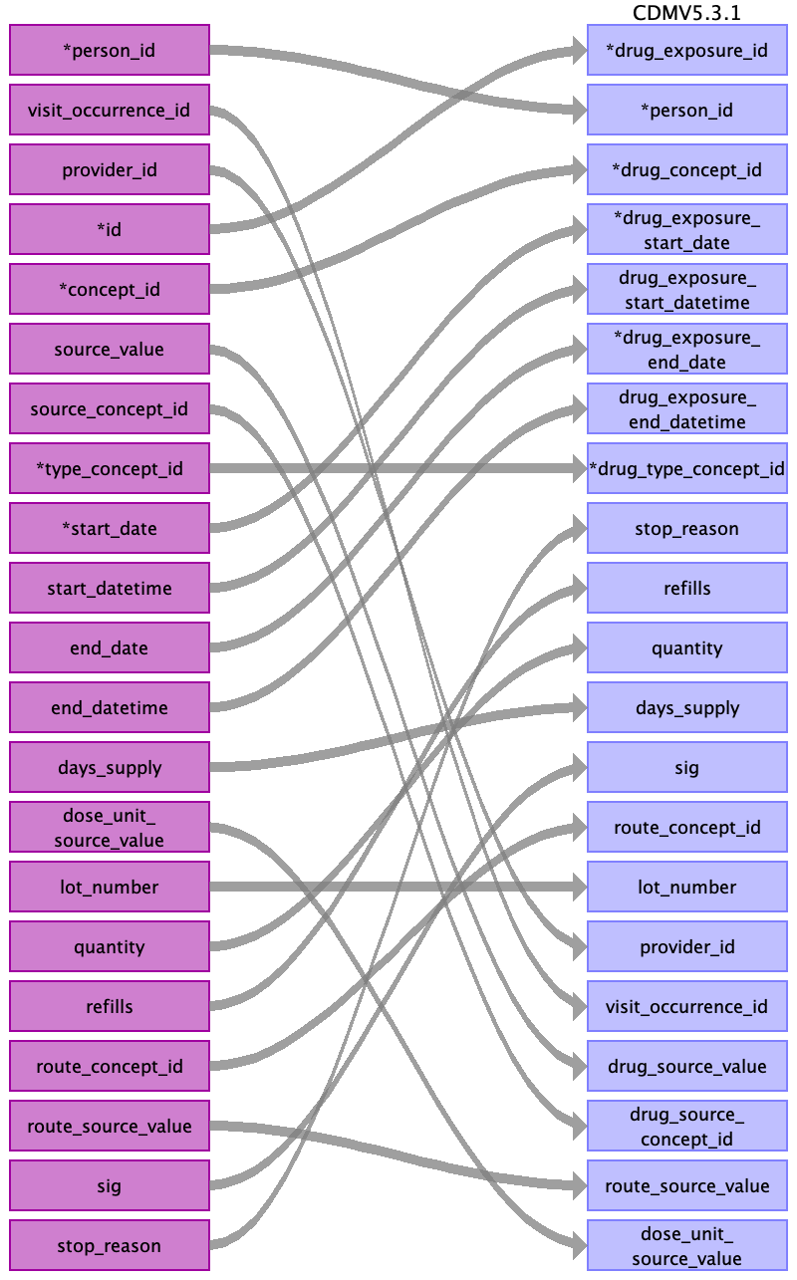

|  |  |  |  |
| --- | --- | --- | --- |
| Destination Field | Source Field | Logic | Comment |
| drug_exposure_id | id |  |  |
| person_id | person_id |  |  |
| drug_concept_id | concept_id |  |  |
| drug_exposure_start_date | start_date |  |  |
| drug_exposure_start_datetime | start_datetime |  |  |
| drug_exposure_end_date | end_date |  |  |
| drug_exposure_end_datetime | end_datetime |  |  |
| verbatim_end_date |  |  |  |
| drug_type_concept_id | type_concept_id |  |  |
| stop_reason | stop_reason |  |  |
| refills | refills |  |  |
| quantity | quantity |  |  |
| days_supply | days_supply |  |  |
| sig | sig |  |  |
| route_concept_id | route_concept_id |  |  |
| lot_number | lot_number |  |  |
| provider_id | provider_id |  |  |
| visit_occurrence_id | visit_occurrence_id |  |  |
| visit_detail_id |  |  |  |
| drug_source_value | source_value |  |  |
| drug_source_concept_id | source_concept_id |  |  |
| route_source_value | route_source_value |  |  |
| dose_unit_source_value | dose_unit_source_value |  |  |

Table name: fact_relationship

Table name: measurement

Reading from stem_table

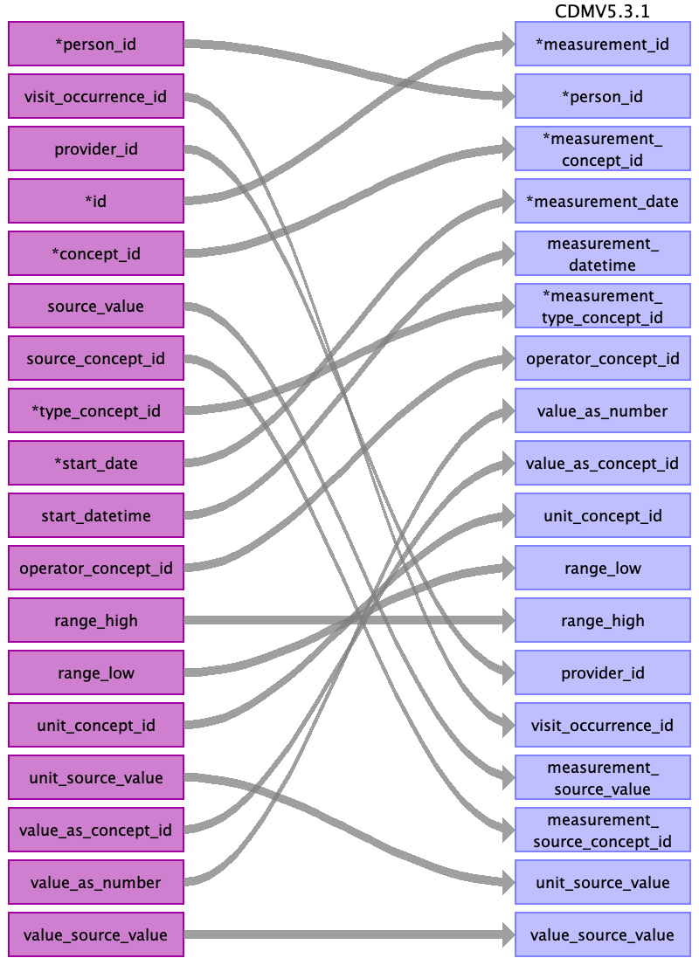

|  |  |  |  |
| --- | --- | --- | --- |
| Destination Field | Source Field | Logic | Comment |
| measurement_id | id |  |  |
| person_id | person_id |  |  |
| measurement_concept_id | concept_id |  |  |
| measurement_date | start_date |  |  |
| measurement_datetime | start_datetime |  |  |
| measurement_time |  |  |  |
| measurement_type_concept_id | type_concept_id |  |  |
| operator_concept_id | operator_concept_id |  |  |
| value_as_number | value_as_number |  |  |
| value_as_concept_id | value_as_concept_id |  |  |
| unit_concept_id | unit_concept_id |  |  |
| range_low | range_low |  |  |
| range_high | range_high |  |  |
| provider_id | provider_id |  |  |
| visit_occurrence_id | visit_occurrence_id |  |  |
| visit_detail_id |  |  |  |
| measurement_source_value | source_value |  |  |
| measurement_source_concept_id | source_concept_id |  |  |
| unit_source_value | unit_source_value |  |  |
| value_source_value | value_source_value |  |  |

Table name: note

Table name: note_nlp

Table name: observation

Reading from stem_table

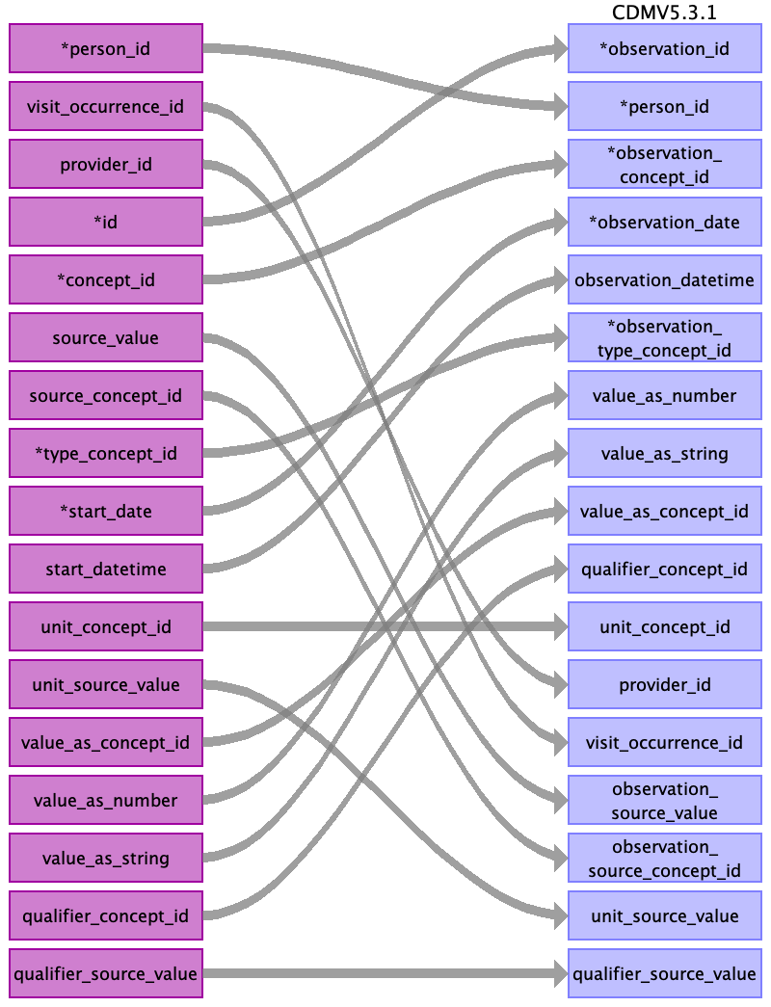

|  |  |  |  |
| --- | --- | --- | --- |
| Destination Field | Source Field | Logic | Comment |
| observation_id | id |  |  |
| person_id | person_id |  |  |
| observation_concept_id | concept_id |  |  |
| observation_date | start_date |  |  |
| observation_datetime | start_datetime |  |  |
| observation_type_concept_id | type_concept_id |  |  |
| value_as_number | value_as_number |  |  |
| value_as_string | value_as_string |  |  |
| value_as_concept_id | value_as_concept_id |  |  |
| qualifier_concept_id | qualifier_concept_id |  |  |
| unit_concept_id | unit_concept_id |  |  |
| provider_id | provider_id |  |  |
| visit_occurrence_id | visit_occurrence_id |  |  |
| visit_detail_id |  |  |  |
| observation_source_value | source_value |  |  |
| observation_source_concept_id | source_concept_id |  |  |
| unit_source_value | unit_source_value |  |  |
| qualifier_source_value | qualifier_source_value |  |  |

Table name: observation_period

Table name: procedure_occurrence

Reading from stem_table

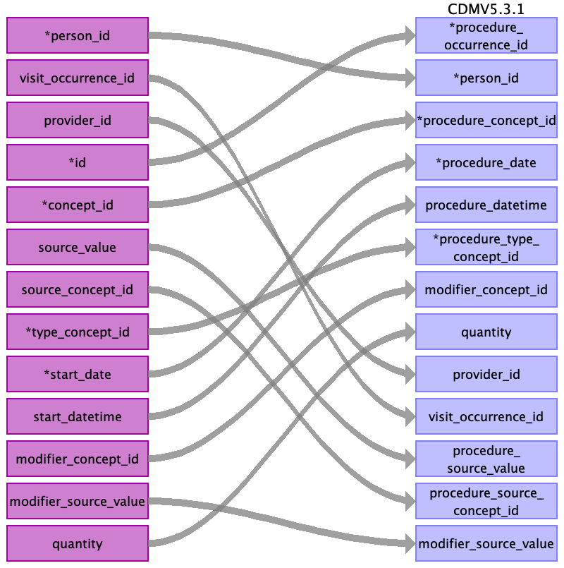

|  |  |  |  |
| --- | --- | --- | --- |
| Destination Field | Source Field | Logic | Comment |
| procedure_occurrence_id | id |  |  |
| person_id | person_id |  |  |
| procedure_concept_id | concept_id |  |  |
| procedure_date | start_date |  |  |
| procedure_datetime | start_datetime |  |  |
| procedure_type_concept_id | type_concept_id |  |  |
| modifier_concept_id | modifier_concept_id |  |  |
| quantity | quantity |  |  |
| provider_id | provider_id |  |  |
| visit_occurrence_id | visit_occurrence_id |  |  |
| visit_detail_id |  |  |  |
| procedure_source_value | source_value |  |  |
| procedure_source_concept_id | source_concept_id |  |  |
| modifier_source_value | modifier_source_value |  |  |

Table name: specimen

Reading from stem_table

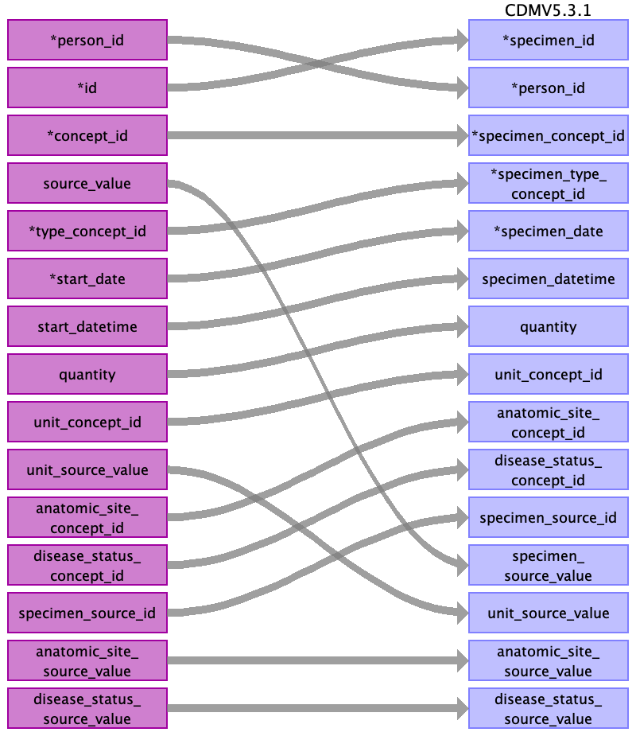

|  |  |  |  |
| --- | --- | --- | --- |
| Destination Field | Source Field | Logic | Comment |
| specimen_id | id |  |  |
| person_id | person_id |  |  |
| specimen_concept_id | concept_id |  |  |
| specimen_type_concept_id | type_concept_id |  |  |
| specimen_date | start_date |  |  |
| specimen_datetime | start_datetime |  |  |
| quantity | quantity |  |  |
| unit_concept_id | unit_concept_id |  |  |
| anatomic_site_concept_id | anatomic_site_concept_id |  |  |
| disease_status_concept_id | disease_status_concept_id |  |  |
| specimen_source_id | specimen_source_id |  |  |
| specimen_source_value | source_value |  |  |
| unit_source_value | unit_source_value |  |  |
| anatomic_site_source_value | anatomic_site_source_value |  |  |
| disease_status_source_value | disease_status_source_value |  |  |

Table name: visit_detail

Table name: visit_occurrence

Table name: cohort

Table name: cohort_attribute

Table name: condition_era

Table name: dose_era

Table name: drug_era

Table name: cost

Table name: payer_plan_period

Table name: care_site

Table name: location

Table name: provider

Table name: cdm_source

Table name: metadata

Table name: attribute_definition

Table name: cohort_definition

Appendix: source tables

Table: patients.csv

|  |  |  |  |
| --- | --- | --- | --- |
| Field | Type | Most freq. value | Comment |
| ﻿id | varchar | List truncated... |  |
| birthdate | date | 1908-08-17 |  |
| deathdate | date |  |  |
| ssn | varchar | List truncated... |  |
| drivers | varchar |  |  |
| passport | varchar |  |  |
| prefix | varchar | Mr. |  |
| first | varchar | List truncated... |  |
| last | varchar | Haag279 |  |
| suffix | varchar |  |  |
| maiden | varchar |  |  |
| marital | varchar | M |  |
| race | varchar | white |  |
| ethnicity | varchar | irish |  |
| gender | varchar | M |  |
| birthplace | varchar | Boston |  |
| address | varchar | List truncated... |  |
| city | varchar | Boston |  |
| state | varchar | Massachusetts |  |
| zip | int | 02108 |  |

Table: allergies.csv

|  |  |  |  |
| --- | --- | --- | --- |
| Field | Type | Most freq. value | Comment |
| start | date | 2011-01-09 |  |
| stop | date |  |  |
| patient | varchar | 85a25223-0837-40a4-9bf1-932bdd64016b |  |
| encounter | varchar | fa3fe7ba-bea9-4aa4-963c-391ff0fa34a4 |  |
| code | int | 419474003 |  |
| description | varchar | Allergy to mould |  |

Table: careplans.csv

|  |  |  |  |
| --- | --- | --- | --- |
| Field | Type | Most freq. value | Comment |
| id | varchar | List truncated... |  |
| start | date | List truncated... |  |
| stop | date |  |  |
| patient | varchar | 7f2d94ac-081b-43b7-8cb5-2d2fd9552899 |  |
| encounter | varchar | List truncated... |  |
| code | int | 53950000 |  |
| description | varchar | Respiratory therapy |  |
| reasoncode | int | 10509002 |  |
| reasondescription | varchar | Acute bronchitis (disorder) |  |

Table: conditions.csv

|  |  |  |  |
| --- | --- | --- | --- |
| Field | Type | Most freq. value | Comment |
| start | date | 2013-01-10 |  |
| stop | date |  |  |
| patient | varchar | c7751bda-c4bb-4334-a578-3314685f41b8 |  |
| encounter | varchar | 3b44ae5b-077c-4b83-a377-8c4cdc449569 |  |
| code | int | 444814009 |  |
| description | varchar | Viral sinusitis (disorder) |  |

Table: encounters.csv

|  |  |  |  |
| --- | --- | --- | --- |
| Field | Type | Most freq. value | Comment |
| id | varchar | List truncated... |  |
| start | varchar | List truncated... |  |
| stop | varchar | List truncated... |  |
| patient | varchar | 18d59307-54ab-42d7-b998-e76ac1ee923f |  |
| provider | varchar | 340f836c-8b1f-45e7-91f8-498de5fbb320 |  |
| encounterclass | varchar | ambulatory |  |
| code | int | 185349003 |  |
| description | varchar | Encounter for check up (procedure) |  |
| cost | real | 129.16 |  |
| reasoncode | int |  |  |
| reasondescription | varchar |  |  |

Table: imaging_studies.csv

|  |  |  |  |
| --- | --- | --- | --- |
| Field | Type | Most freq. value | Comment |
| id | varchar | List truncated... |  |
| date | date | List truncated... |  |
| patient | varchar | a9edebda-6b2d-43d0-bcce-2ecbb83cae9a |  |
| encounter | varchar | List truncated... |  |
| bodysite_code | int | 51185008 |  |
| bodysite_description | varchar | Thoracic structure (body structure) |  |
| modality_code | varchar | DX |  |
| modality_description | varchar | Digital Radiography |  |
| sop_code | varchar | 1.2.840.10008.5.1.4.1.1.1.1 |  |
| sop_description | varchar | Digital X-Ray Image Storage |  |

Table: immunizations.csv

|  |  |  |  |
| --- | --- | --- | --- |
| Field | Type | Most freq. value | Comment |
| date | date | 2014-01-18 |  |
| patient | varchar | 74b85400-824b-4fda-8a3b-d6e20de4599d |  |
| encounter | varchar | aaecdacd-361e-42bb-9a4c-c2999b6b38f4 |  |
| code | int | 140 |  |
| description | varchar | Influenza seasonal injectable preservative free |  |
| cost | real | 140.52 |  |

Table: medications.csv

|  |  |  |  |
| --- | --- | --- | --- |
| Field | Type | Most freq. value | Comment |
| start | date | 2014-04-04 |  |
| stop | date |  |  |
| patient | varchar | d3814387-d926-4d1b-acb1-55dce114b3d5 |  |
| encounter | varchar | dec7038a-8d28-4f45-9f2f-0dd71c5a7d86 |  |
| code | int | 316672 |  |
| description | varchar | Simvistatin 10 MG |  |
| cost | real | 263.49 |  |
| dispenses | int | 1 |  |
| totalcost | real | 3161.88 |  |
| reasoncode | int |  |  |
| reasondescription | varchar |  |  |

Table: observations.csv

|  |  |  |  |
| --- | --- | --- | --- |
| Field | Type | Most freq. value | Comment |
| date | date | 2011-07-12 |  |
| patient | varchar | a9edebda-6b2d-43d0-bcce-2ecbb83cae9a |  |
| encounter | varchar | 855e14bc-c81a-40e8-aa2d-327466ba6517 |  |
| code | varchar | 72514-3 |  |
| description | varchar | Pain severity - 0-10 verbal numeric rating [Score] - Reported |  |
| value | varchar | Never smoker |  |
| units | varchar | mg/dL |  |
| type | varchar | numeric |  |

Table: organizations.csv

|  |  |  |  |
| --- | --- | --- | --- |
| Field | Type | Most freq. value | Comment |
| id | varchar | List truncated... |  |
| name | varchar | List truncated... |  |
| address | varchar | List truncated... |  |
| city | varchar | List truncated... |  |
| state | varchar | MA |  |
| zip | int | List truncated... |  |
| phone | varchar | List truncated... |  |
| utilization | int | 1 |  |

Table: procedures.csv

|  |  |  |  |
| --- | --- | --- | --- |
| Field | Type | Most freq. value | Comment |
| date | date | 2012-12-17 |  |
| patient | varchar | 18d59307-54ab-42d7-b998-e76ac1ee923f |  |
| encounter | varchar | e044ca0e-ff73-4e34-b557-bb301ea930d1 |  |
| code | varchar | 428191000124101 |  |
| description | varchar | Documentation of current medications |  |
| cost | real | 516.65 |  |
| reasoncode | int | 72892002 |  |
| reasondescription | varchar | Normal pregnancy |  |

Table: providers.csv

|  |  |  |  |
| --- | --- | --- | --- |
| Field | Type | Most freq. value | Comment |
| id | empty |  |  |
| organization | empty |  |  |
| name | empty |  |  |
| gender | empty |  |  |
| speciality | empty |  |  |
| address | empty |  |  |
| city | empty |  |  |
| state | empty |  |  |
| zip | empty |  |  |
| utilization | empty |  |  |

Table: stem_table

|  |  |  |  |
| --- | --- | --- | --- |
| Field | Type | Most freq. value | Comment |
| domain_id | CHARACTER VARYING |  |  |
| person_id | INTEGER |  |  |
| visit_occurrence_id | INTEGER |  |  |
| provider_id | INTEGER |  |  |
| id | INTEGER |  |  |
| concept_id | INTEGER |  |  |
| source_value | CHARACTER VARYING |  |  |
| source_concept_id | INTEGER |  |  |
| type_concept_id | INTEGER |  |  |
| start_date | DATE |  |  |
| start_datetime | DATETIME |  |  |
| end_date | DATE |  |  |
| end_datetime | DATETIME |  |  |
| verbatim_end_date | DATE |  |  |
| days_supply | INTEGER |  |  |
| dose_unit_source_value | CHARACTER VARYING |  |  |
| lot_number | CHARACTER VARYING |  |  |
| modifier_concept_id | INTEGER |  |  |
| operator_concept_id | INTEGER |  |  |
| modifier_concept_id | INTEGER |  |  |
| modifier_source_value | CHARACTER VARYING |  |  |
| quantity | INTEGER |  |  |
| range_high | FLOAT |  |  |
| range_low | FLOAT |  |  |
| refills | INTEGER |  |  |
| route_concept_id | INTEGER |  |  |
| route_source_value | CHARACTER VARYING |  |  |
| sig | CHARACTER VARYING |  |  |
| stop_reason | CHARACTER VARYING |  |  |
| unique_device_id | CHARACTER VARYING |  |  |
| unit_concept_id | INTEGER |  |  |
| unit_source_value | CHARACTER VARYING |  |  |
| value_as_concept_id | INTEGER |  |  |
| value_as_number | DECIMAL |  |  |
| value_as_string | CHARACTER VARYING |  |  |
| value_source_value | CHARACTER VARYING |  |  |
| anatomic_site_concept_id | INTEGER |  |  |
| disease_status_concept_id | INTEGER |  |  |
| specimen_source_id | INTEGER |  |  |
| anatomic_site_source_value | CHARACTER VARYING |  |  |
| disease_status_source_value | CHARACTER VARYING |  |  |
| condition_status_concept_id | CHARACTER VARYING |  |  |
| condition_status_source_value | INTEGER |  |  |
| qualifier_concept_id | INTEGER |  |  |
| qualifier_source_value | CHARACTER VARYING |  |  |