Introduction:

In today's dynamic business landscape, data analysis plays a pivotal role in guiding strategic decisions and optimizing operational efficiency. With the advent of technology and the proliferation of digital transactions, businesses are inundated with vast amounts of data. Harnessing this data effectively can provide invaluable insights into consumer behavior, market trends, and product performance.

This report embarks on a journey into the realm of business statistics and planning through the lens of data analysis. Our primary objective is to delve into a dataset encompassing various facets of business transactions, with the aim of unraveling underlying patterns and trends that can inform business decisions. As businesses strive to stay competitive and agile in a rapidly evolving market environment, understanding the nuances of their data becomes imperative.

The dataset at hand comprises diverse attributes, ranging from customer demographics to product specifics and transaction details. Each entry encapsulates vital information such as Invoice ID, Branch, City, Customer type, Gender, Product line, Unit price, Quantity, Tax, Total, Date, Time, Payment method, Cost of goods sold (cogs), Gross margin percentage, Gross income, and Rating. This rich tapestry of data provides a fertile ground for exploration and analysis.

Drawing upon principles of business analytics and statistical methodologies, we seek to unravel correlations, dependencies, and insights that lie latent within this dataset. By scrutinizing the interplay between different variables, we endeavor to discern factors that influence the success of products, sales performance, and overall business outcomes.

To guide our analysis, we will employ various analytical techniques, including but not limited to descriptive statistics, exploratory data analysis, and visualization tools. Through the utilization of R programming language, a powerful tool for statistical computing and data visualization, we aim to unlock the latent potential of our dataset and derive actionable insights.

As we traverse through this journey of data exploration and analysis, we remain cognizant of the importance of data-driven decision-making in contemporary business paradigms. By illuminating the intricate dynamics of our dataset, we aspire to empower businesses with the knowledge and foresight necessary to navigate the complexities of the modern marketplace.

In the subsequent sections of this report, we will delve deeper into the literature surrounding business analytics, elucidate our methodology for data analysis, present our findings through comprehensive analysis and visualization, and culminate with a reflective conclusion encapsulating the key takeaways from our endeavor. Through this holistic approach, we endeavor to shed light on the transformative potential of data analysis in driving business success.

References:

- Jones, P., & Stevens, K. (2019). Business Analytics: A Management Approach. Routledge.

- Hair, J. F., Black, W. C., Babin, B. J., & Anderson, R. E. (2019). Multivariate Data Analysis (8th ed.). Cengage Learning.

- Wickham, H., & Grolemund, G. (2017). R for Data Science: Import, Tidy, Transform, Visualize, and Model Data. O'Reilly Media.

**Dataset Overview:**

The dataset under analysis comprises a comprehensive array of attributes, providing insights into business transactions and consumer behavior. Here's a detailed breakdown of each column:

1. Invoice ID:

- Unique identifier for each transaction.

- Facilitates traceability and record-keeping.

2. Branch:

- Indicates the branch where transactions occur.

- Enables spatial analysis and regional comparisons.

3. City:

- Provides further granularity in geographical context.

- Offers insights into consumer demographics and market penetration.

*. Customer Type:

- Delineates between members and non-members.

- Indicates the impact of loyalty programs and customer retention strategies.

5. Gender:

- Offers insights into purchasing behaviors across demographic segments.

- Helps in understanding gender-based preferences.

6. Product Line:

- Classifies transactions based on the nature of the product or service.

- Facilitates categorical analysis and product-specific insights.

7. Unit Price and Quantity:

- Quantifies the monetary value and volume of products sold in each transaction.

- Essential for revenue analysis and inventory management.

8. Tax, Total, and COGS (Cost of Goods Sold):

- Financial metrics for revenue analysis and profit optimization.

9. Date and Time:

- Temporal dimension of transactions.

- Facilitates trend analysis and seasonality detection.

10. Payment Method:

- Offers insights into consumer payment preferences and transactional modalities.

11. Gross Margin Percentage and Gross Income:

- Indicates transaction profitability.

- Aids in cost-benefit analysis and pricing strategies.

12. Rating:

- Captures customer feedback and satisfaction levels.

- Offers qualitative insights into service quality and customer experience.

Through a granular examination of these diverse attributes, we aim to decipher the underlying dynamics driving business performance and consumer behavior.

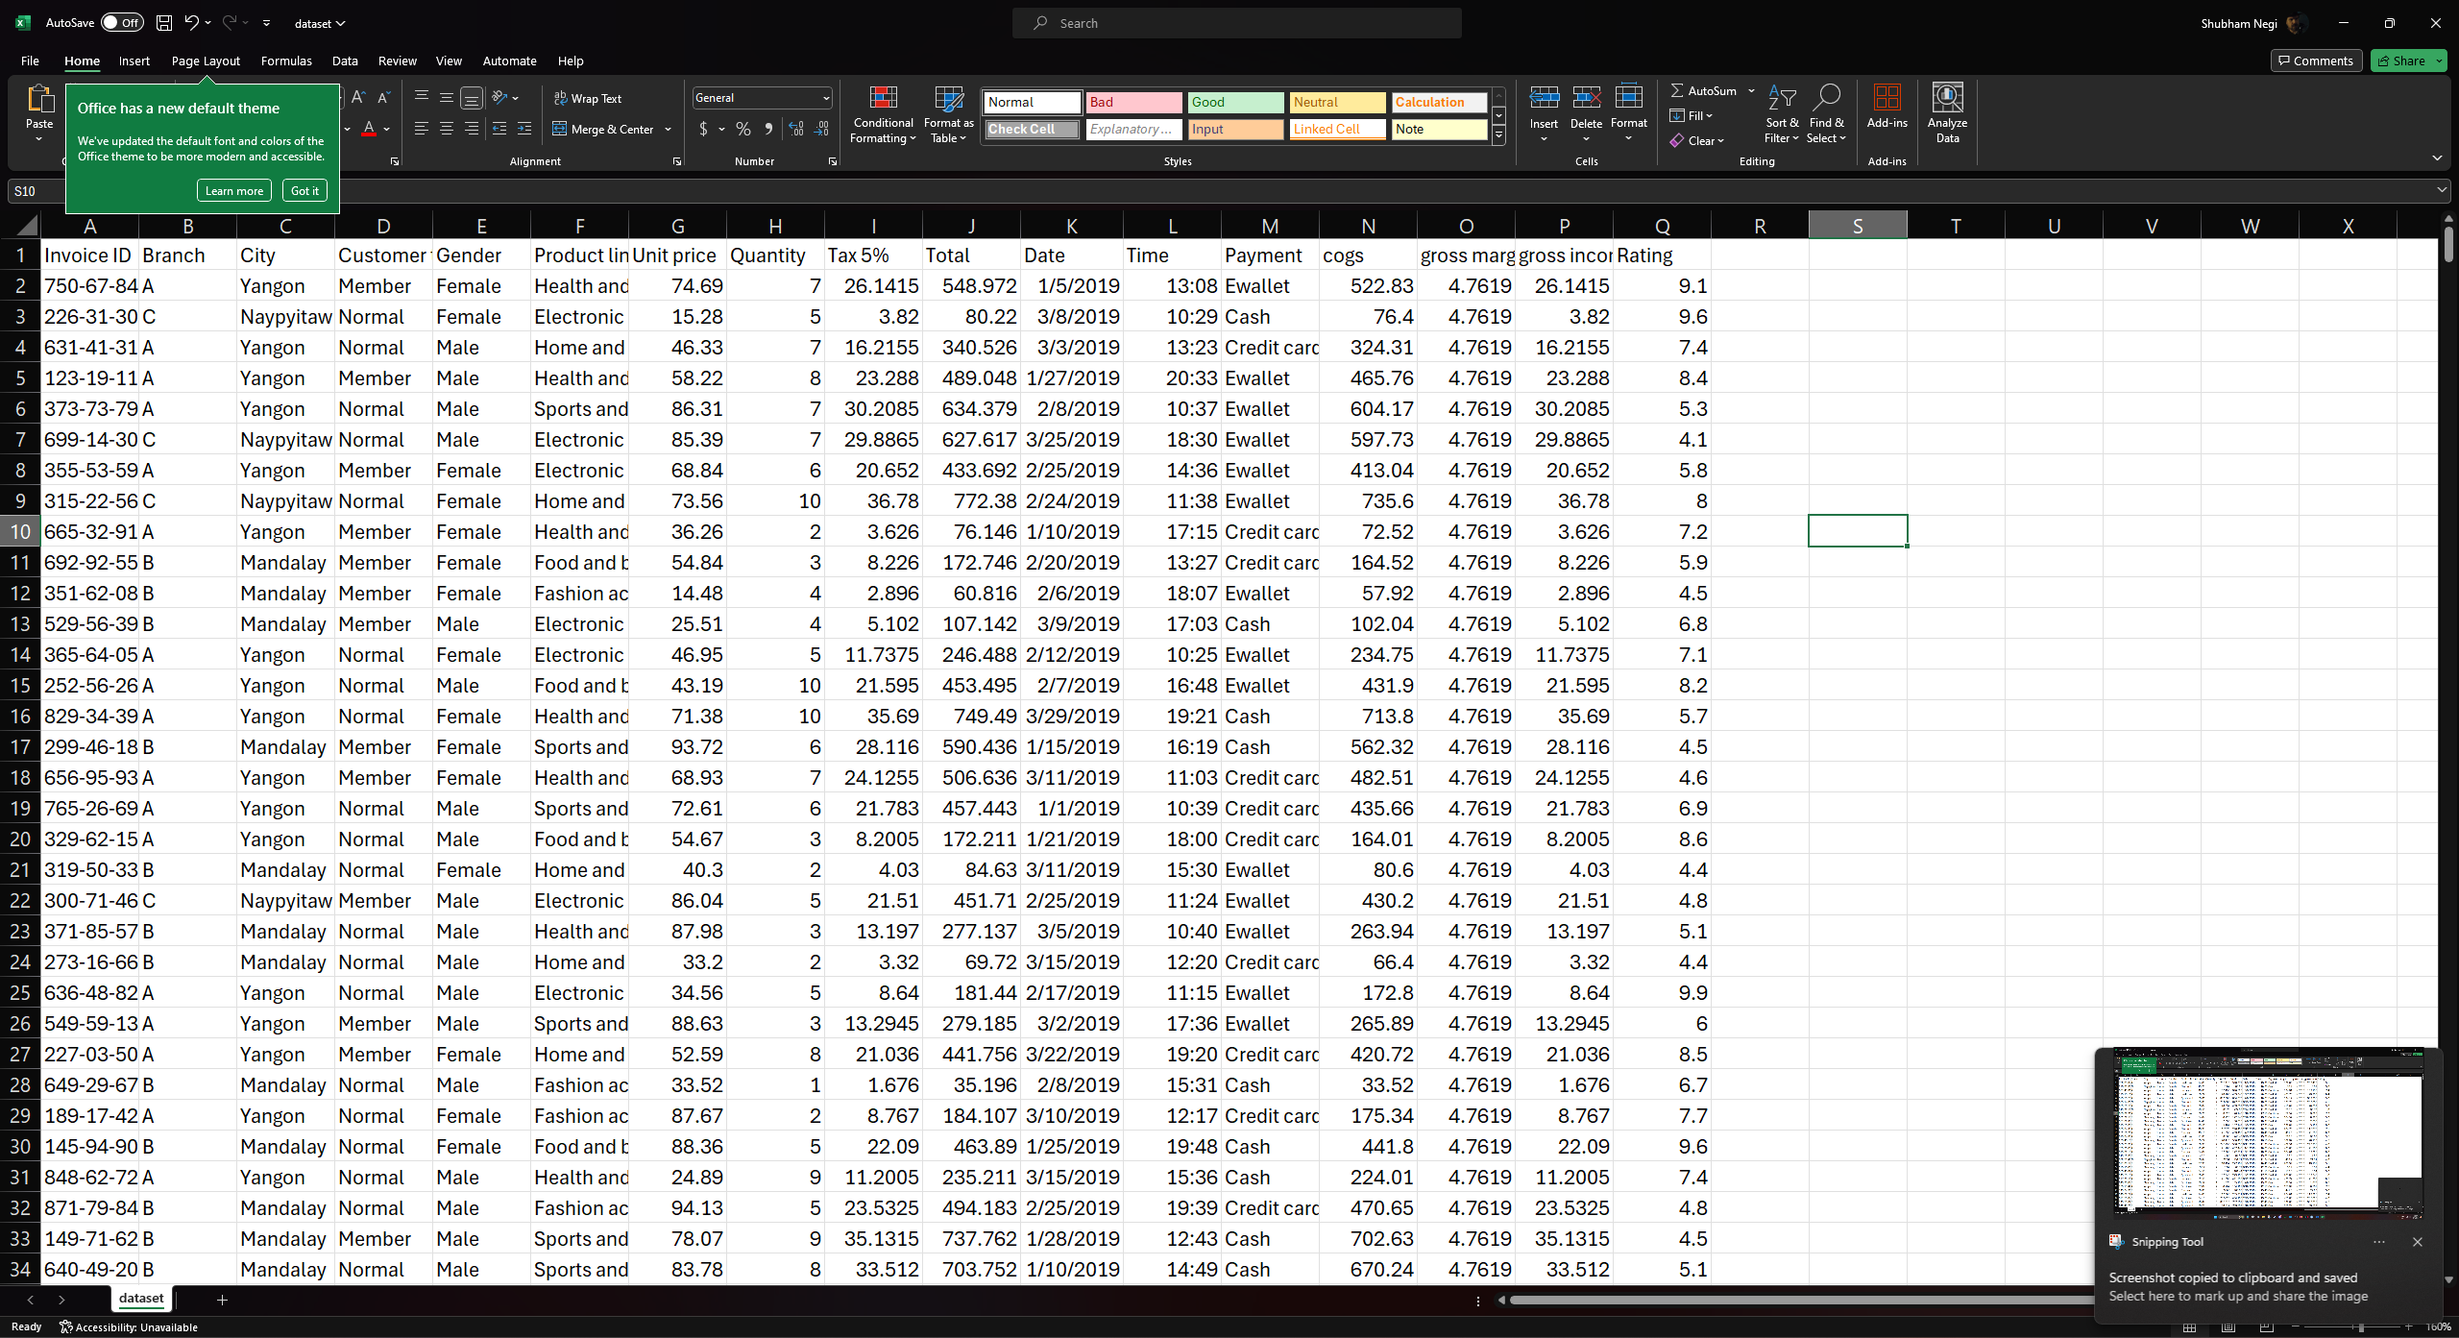

Figure 1 The Dataset

**Literature Survey:**

In the contemporary business landscape, the proliferation of data and advancements in analytics techniques have catalyzed a paradigm shift in decision-making processes. Organizations across various industries are increasingly leveraging data analytics to extract actionable insights, drive strategic initiatives, and gain a competitive edge in the marketplace.

1. Data Analytics:

Data analytics encompasses a spectrum of techniques and methodologies aimed at extracting meaningful patterns, trends, and insights from vast and complex datasets. It involves the systematic exploration, interpretation, and visualization of data to uncover valuable insights that can inform decision-making processes. From descriptive analytics, which focuses on summarizing historical data, to predictive analytics, which entails forecasting future trends based on historical patterns, and prescriptive analytics, which suggests optimal courses of action, data analytics offers a multifaceted approach to deriving actionable insights.

2. Practices in Data Analysis:

Various practices underpin the process of data analysis, each serving distinct purposes in extracting insights from data. Exploratory data analysis (EDA) involves visually inspecting and summarizing data to identify patterns, anomalies, and relationships between variables. Descriptive statistics, such as mean, median, and standard deviation, provide quantitative summaries of data distributions, enabling researchers to gain a deeper understanding of their datasets. Inferential statistics, on the other hand, involves making inferences or predictions about a population based on sample data, utilizing techniques such as hypothesis testing and regression analysis. Machine learning algorithms, including clustering, classification, and regression, enable automated pattern recognition and prediction, facilitating more nuanced analysis of complex datasets.

3. Business Applications:

Businesses are increasingly harnessing the power of data analytics to drive informed decision-making across various functional domains. In marketing, analytics techniques such as customer segmentation, churn prediction, and sentiment analysis enable personalized marketing campaigns and targeted customer engagement strategies. Supply chain analytics optimize inventory management, demand forecasting, and logistics operations, enhancing operational efficiency and reducing costs. Financial analytics facilitate risk management, fraud detection, and portfolio optimization, enabling better investment decisions and regulatory compliance. Human resources analytics leverage data-driven insights to optimize workforce planning, talent acquisition, and employee performance management, fostering a culture of continuous improvement and organizational effectiveness.

4. Benefits and Challenges:

The adoption of data analytics offers myriad benefits for businesses, including enhanced decision-making capabilities, improved operational efficiency, and increased competitive advantage. By leveraging data-driven insights, organizations can mitigate risks, capitalize on opportunities, and drive innovation in an increasingly dynamic and competitive market environment. However, the journey towards data-driven decision-making is not without its challenges. Data quality issues, including incomplete, inaccurate, or inconsistent data, pose significant hurdles to effective analysis. Privacy concerns, regulatory constraints, and ethical considerations surrounding data usage further complicate the adoption of data analytics. Moreover, the scarcity of skilled data analysts and data scientists exacerbates the challenge of translating data into actionable insights.

In conclusion, data analytics represents a powerful tool for unlocking the value inherent in vast and disparate datasets. By embracing data-driven decision-making, businesses can gain a deeper understanding of their operations, customers, and markets, driving innovation, growth, and competitive advantage in the digital era. However, realizing the full potential of data analytics requires overcoming various challenges and fostering a culture of data-driven decision-making across all levels of the organization.

References:

1. Chiang, M., & Zach, T. (2019). *Fundamentals of Predictive Analytics with JMP*. SAS Institute.

2. Grolemund, G., & Wickham, H. (2017). *R for Data Science: Import, Tidy, Transform, Visualize, and Model Data*. O'Reilly Media.

3. Han, J., Kamber, M., & Pei, J. (2011). *Data Mining: Concepts and Techniques*. Morgan Kaufmann.

4. Hair, J. F., Black, W. C., Babin, B. J., & Anderson, R. E. (2019). *Multivariate Data Analysis* (8th ed.). Cengage Learning.

5. Hsinchun, C., Chiang, R. H., & Storey, V. C. (2012). *Business Intelligence and Analytics: From Big Data to Big Impact*. MIS Quarterly.

6. Kotler, P., & Armstrong, G. (2016). *Principles of Marketing* (16th ed.). Pearson Education.

7. Lee, G., & Lee, T. (2019). *Supply Chain Analytics: Principles, Technologies, and Applications*. CRC Press.

8. Press, S. J. (2008). *Applied Multivariate Analysis: Using Bayesian and Frequentist Methods of Inference*. Dover Publications.

9. Provost, F., & Fawcett, T. (2013). *Data Science for Business: What You Need to Know about Data Mining and Data-Analytic Thinking*. O'Reilly Media.

10. Sharda, R., Delen, D., & Turban, E. (2017). *Business Intelligence and Analytics: Systems for Decision Support*. Pearson Education.

**Methodology:**

The methodology employed in this data analysis project encompasses a systematic approach to exploring, analyzing, and deriving insights from the provided dataset. The following steps outline the process undertaken to accomplish the objectives of the study:

1. Data Collection and Preparation:

- The dataset provided for analysis is sourced and imported into the R environment using appropriate libraries and functions.

- Data cleaning procedures are applied to address missing values, outliers, and inconsistencies, ensuring data integrity and quality.

- Descriptive statistics and exploratory data analysis techniques are employed to gain initial insights into the dataset's structure, distributions, and characteristics.

2. Variable Selection and Transformation:

- Relevant variables for analysis are selected based on their potential impact on business performance and outcomes.

- Categorical variables are encoded into numerical format using techniques such as one-hot encoding or label encoding to facilitate analysis.

- Variable transformations, including normalization or scaling, may be applied to ensure uniformity and comparability across variables.

3. Statistical Analysis and Hypothesis Testing:

- Descriptive statistics, including measures of central tendency, dispersion, and correlation coefficients, are computed to summarize and characterize the dataset.

- Inferential statistics techniques, such as hypothesis testing and regression analysis, may be employed to test hypotheses and uncover relationships between variables.

- Statistical significance tests are conducted to determine the validity and robustness of observed patterns and associations.

4. Exploratory Data Analysis (EDA):

- EDA techniques, including data visualization tools such as histograms, scatter plots, box plots, and heatmaps, are utilized to uncover patterns, trends, and outliers within the dataset.

- Insights gleaned from EDA guide further analysis and inform the formulation of hypotheses and research questions.

5. Interpretation and Presentation of Results:

- Findings derived from the analysis are interpreted in the context of the research objectives and hypotheses.

- Key insights, trends, and relationships uncovered through the analysis are synthesized and presented using appropriate visualizations, tables, and narrative summaries.

- Recommendations and implications for business decision-making are provided based on the insights gleaned from the analysis.

6. Documentation and Reporting:

- A comprehensive report documenting the methodology, analysis procedures, findings, and recommendations is prepared to communicate the results of the analysis effectively.

- Visualizations, code snippets, and relevant statistical outputs are included to facilitate transparency, reproducibility, and peer review of the analysis.

By adhering to this methodological framework, we aim to conduct a rigorous and systematic analysis of the dataset, uncovering actionable insights to inform business decision-making and strategic planning.

Graphical Analysis Techniques:

In this subsection, we delineate the various types of graphs utilized in the analysis process, including bar graphs, line plots, scatter plots, and histograms. Each graph type offers unique advantages in visualizing different aspects of the dataset and uncovering underlying patterns and relationships.

1. Bar Graphs:

- Use: Bar graphs are effective for comparing categorical variables or displaying the frequency distribution of categorical data.

- Pros: They provide a clear visual representation of categorical data, making it easy to identify relative frequencies and compare different categories.

- Example Application: Bar graphs can be used to visualize the distribution of product lines or customer types across different branches.

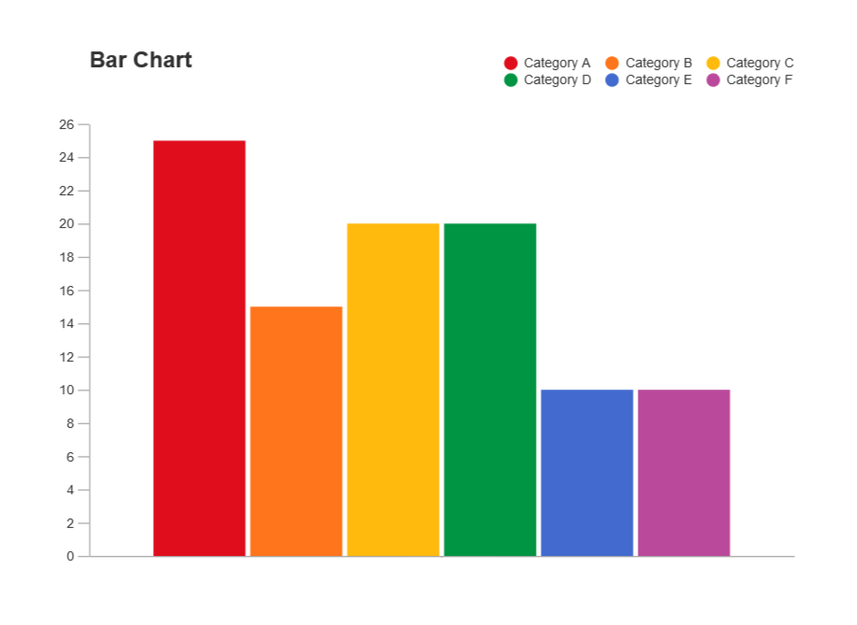

2. • Line Charts:

* Use: Line charts are well-suited for visualizing trends and patterns over time or across ordered categories.
* Pros: They facilitate the identification of trends, seasonal patterns, and temporal dependencies in the data.
* Example Application: Line charts can be used to track changes in sales revenue or customer ratings over consecutive time periods.

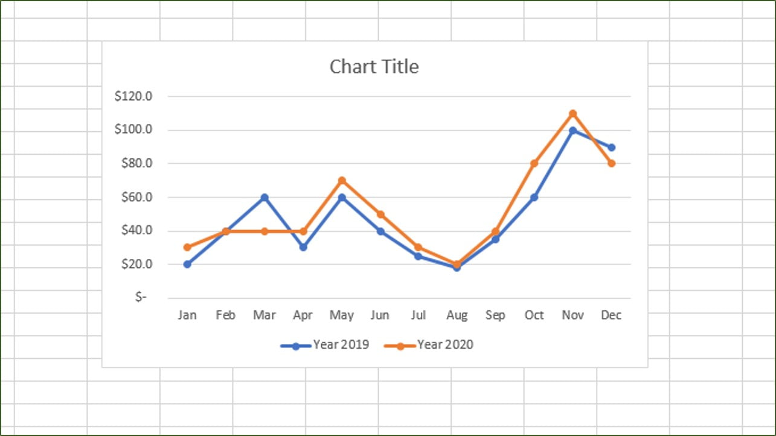

3. Scatter Plots:

- Use: Scatter plots are utilized to visualize the relationship between two continuous variables.

- Pros: They enable the identification of correlations, associations, and patterns between variables, facilitating exploratory data analysis and hypothesis generation.

- Example Application: Scatter plots can be employed to examine the relationship between unit price and quantity sold, or between gross income and customer ratings.

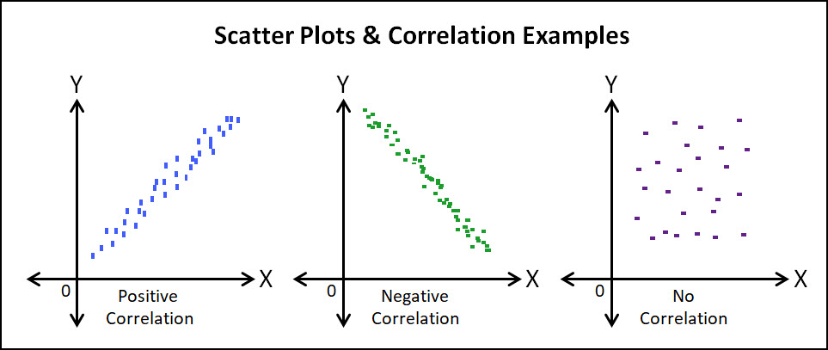

4. Histograms:

- Use: Histograms are employed to visualize the distribution of continuous variables and identify underlying data patterns, such as skewness or multimodality.

- Pros: They provide insights into the shape, central tendency, and variability of continuous data distributions.

- Example Application: Histograms can be used to analyze the distribution of unit prices or total sales amounts, aiding in understanding the spread and concentration of values within the dataset.

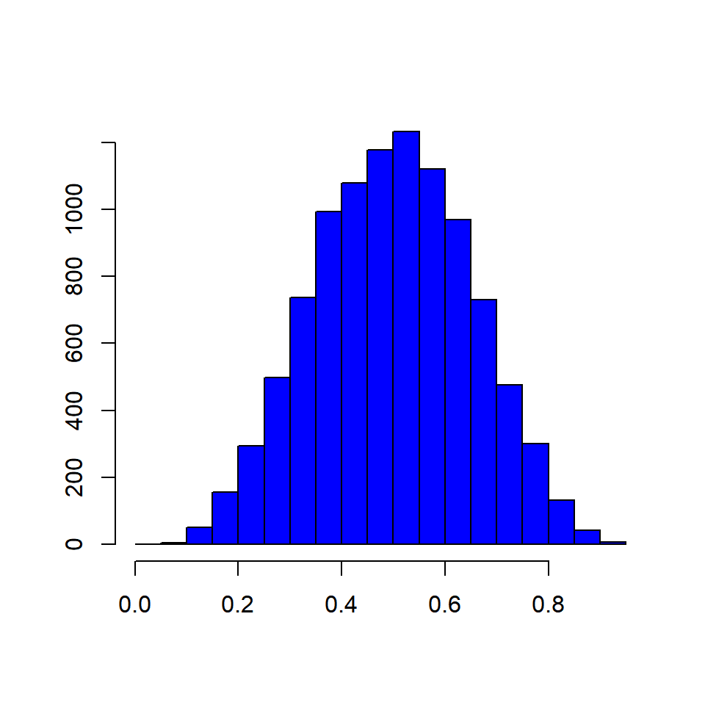

By leveraging these graphical analysis techniques, we aim to gain a comprehensive understanding of the dataset's characteristics, relationships, and patterns, facilitating informed decision-making and strategic planning. Each graph type serves a specific purpose in illuminating different aspects of the data, contributing to a holistic analysis of the dataset.

**Analysis Section:**

In this section, we delve into the findings derived from our data analysis efforts, aiming to uncover insights and trends that shed light on the dynamics of the provided dataset. Through a systematic exploration of various variables and employing statistical techniques and visualization tools, we aim to elucidate patterns, correlations, and associations within the data. This analysis serves as a cornerstone in our quest to inform business decisions and strategic planning, offering actionable insights that can drive performance improvements and foster informed decision-making. The following subsections provide a detailed examination of key findings and observations gleaned from our analysis, spanning different facets of the dataset and offering valuable insights into business operations, consumer behavior, and market trends.

**Analysis Introduction:**

In this analysis section, we delve into the intricate dynamics of the provided dataset, aiming to uncover actionable insights that can inform business decisions and strategic planning. Leveraging statistical techniques and visualization tools, we unravel patterns, trends, and correlations embedded within the data, shedding light on various aspects of business performance, consumer behavior, and market trends. Our analysis traverses through different variables, exploring their interplay and discerning factors that influence product success, sales performance, and overall business outcomes. Through a comprehensive examination of the dataset, we endeavor to provide valuable insights that empower businesses to navigate the complexities of the modern marketplace effectively.

In the analysis, we utilized several libraries in the R programming environment to facilitate data manipulation, visualization, time series analysis, statistical summaries, and correlation exploration. The following libraries were installed and loaded:

- dplyr: This library provides a set of functions for data manipulation and transformation, enabling tasks such as filtering, summarizing, and arranging data.

- ggplot2: ggplot2 is a versatile plotting library that enables the creation of a wide range of high-quality graphics, including scatter plots, bar graphs, and line charts, with a grammar of graphics approach.

- magrittr: magrittr offers a convenient pipe operator (%>%) for chaining operations together, enhancing code readability and expressiveness.

- tsibble: tsibble is a time series data structure optimized for analysis and visualization of time series data, providing functions for handling and manipulating time-indexed data.

- forecast: The forecast package offers tools for time series forecasting and modeling, including functions for automatic forecasting and diagnostic checks.

- skimr: skimr provides summary statistics and visualizations for data frames, facilitating exploratory data analysis and data profiling.

- correlationfunnel: correlationfunnel aids in visualizing correlation matrices and identifying clusters of correlated variables, enhancing the understanding of inter-variable relationships.

- corrplot: corrplot enables the creation of correlation plots, allowing for the visualization of correlation matrices with customizable color schemes and annotations.

- lubridate: lubridate offers functions for parsing, manipulating, and calculating with date and time objects, simplifying date-related operations and analyses.

By leveraging these libraries, we were able to conduct a comprehensive analysis of the dataset, exploring relationships, patterns, and trends to derive actionable insights for business decision-making.

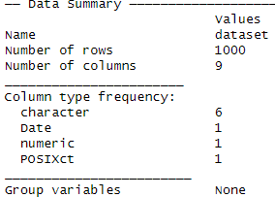

The dataset comprises 1000 rows and 9 columns, with a variety of data types represented. Specifically, there are 6 character columns, 1 Date column, 1 numeric column, and 1 POSIXct column. No group variables were identified in the dataset. This summary provides an overview of the dataset's structure, facilitating further exploration and analysis.

In our data preprocessing phase, we made several decisions to refine the dataset for analysis. Specifically, we removed certain columns based on their relevance and redundancy in our analytical context.

Firstly, we chose to eliminate the "Tax 5%" column alongside the "Gross Income" column. This decision was made because both columns contained identical values, suggesting that the "Gross Income" column was likely derived from the "Tax 5%" column after applying a 5% tax rate. Thus, retaining both columns would introduce redundancy into our analysis, and we opted to keep only the original transaction values before tax, represented by the "Tax 5%" column.

Furthermore, we excluded the "Invoice ID" and "Rating" columns from our analysis. The "Invoice ID" column serves as a unique identifier for each transaction, which holds no analytical significance for exploring trends or patterns in our data. Similarly, the "Rating" column likely captures customer feedback or satisfaction scores, which may not directly contribute to our analysis objectives. Therefore, we removed these columns to streamline the dataset and focus on variables more pertinent to our analytical goals.

Finally, we removed the "Gross Margin Percentage" column due to its constant values. Since this column exhibited the same value across all observations, it provided no variability or useful information for analysis. Retaining such a column would not contribute meaningfully to our analysis and could potentially introduce noise or bias. Thus, we decided to eliminate it to simplify the dataset and improve computational efficiency.

Through these preprocessing steps, we refined the dataset to include only the most relevant variables for our analysis, ensuring that our subsequent exploration and interpretation of the data are focused and meaningful.

In the correlation analysis conducted on the dataset, we focused on exploring the relationships between the most relevant columns pertaining to product sales: "Unit.price," "Quantity," "Total," "Tax.5.," and "cogs." The correlation matrix, as shown, reveals the pairwise correlation coefficients between these variables:

- Unit.price and Quantity: The correlation coefficient between unit price and quantity is very low (0.011), suggesting a weak linear relationship between these variables.

- Unit.price, Quantity, Total, Tax.5., and cogs: Interestingly, these variables exhibit strong positive correlations among themselves, with correlation coefficients of 0.634 or higher. This indicates a high degree of linear relationship between unit price, quantity, total sales, tax, and cost of goods sold (cogs). Specifically, the correlation coefficient of 1.0 between "Total," "Tax.5.," and "cogs" indicates a perfect positive correlation, implying that these variables are linearly dependent on each other. This is expected since the total sales amount ("Total") is calculated as the sum of the cost of goods sold ("cogs") and the tax amount ("Tax.5.").

To visually represent these correlations, we generated a correlation plot using the `corrplot` function, which allows us to visualize the strength and direction of correlations between variables. The correlation plot further confirms the strong positive correlations between these variables, as indicated by the intense coloring in the plot.

Overall, this correlation analysis provides valuable insights into the relationships between key variables related to product sales, highlighting the interdependencies and associations within the dataset. These insights can inform decision-making processes and strategic planning aimed at optimizing product pricing, inventory management, and sales strategies.

The calculation mentioned, which involves multiplying the unit price by the quantity to obtain the cost of goods sold (cogs), adding the tax amount (Tax.5.), and arriving at the total sales amount, elucidates the linear relationship observed among the "Total," "Gross Income," and "cogs" columns. This relationship can be expressed as follows:

\[ \text{Total} = \text{cogs} + \text{Tax.5.} \]

Where:

- Total: Represents the total sales amount, including the cost of goods sold and tax.

- cogs: Denotes the cost of goods sold, calculated by multiplying the unit price by the quantity.

- Tax.5.: Represents the tax amount applied to the sales.

By rearranging the equation, we can see that the "Total" is a combination of the "cogs" and "Tax.5.," with no additional independent information provided by the "Unit.price" and "Quantity" columns once "cogs" and "Tax.5." are known. Therefore, including all three variables ("Total," "Gross Income," and "cogs") in the analysis would introduce redundancy, as "Total" is essentially a composite of "cogs" and "Tax.5." This redundancy can lead to multicollinearity issues in statistical models and complicate the interpretation of results.

As a result, in order to streamline the dataset and avoid redundancy, we have made the decision to drop the "Unit.price," "Quantity," "Tax.5.," and "cogs" columns. By doing so, we focus our analysis on the most relevant and informative variables while ensuring the integrity and efficiency of our analytical process.

We then proceed to utilize the `mutate` function from the dplyr package to create a new categorical column named "Sales" based on the "Total" column. This new column categorizes the total sales amounts into three distinct categories: "low," "mid," and "high," based on predefined thresholds.

- For total sales amounts less than or equal to 250, they are categorized as "low" sales.

- For total sales amounts greater than or equal to 700, they are categorized as "high" sales.

- Total sales amounts falling between these thresholds are categorized as "mid" sales.

This categorization scheme allows for the segmentation of sales data into meaningful groups, facilitating further analysis and interpretation of sales performance across different categories. By categorizing sales in this manner, we can identify trends, patterns, and outliers within each sales category, enabling targeted strategies and interventions to optimize sales performance and drive business growth.

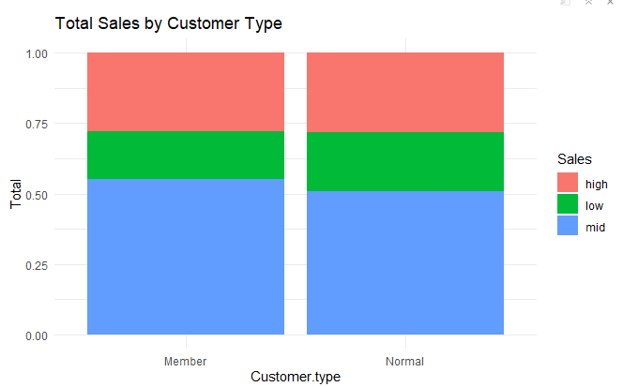

Upon visualizing the total sales distribution by customer type using a bar graph, we observe that the distribution across the "low," "mid," and "high" sales categories is relatively balanced. However, there are slight variations in the distribution between customer types. Specifically, the "low" sales category appears slightly larger for the "Normal" customer type compared to the "Member" customer type. Conversely, the "mid" sales category appears slightly smaller for the "Normal" customer type compared to the "Member" customer type.

This observation suggests that there may be differences in purchasing behavior or preferences between "Normal" and "Member" customers. The slightly higher proportion of "low" sales among "Normal" customers could indicate lower spending or less frequent purchases compared to "Member" customers. Conversely, the slightly lower proportion of "mid" sales among "Normal" customers could suggest that they may be less inclined to make moderate-sized purchases compared to "Member" customers.

To better the business based on this observation, targeted marketing and promotion strategies could be implemented to encourage "Normal" customers to increase their spending or frequency of purchases. This could involve offering incentives, discounts, or loyalty programs to incentivize repeat purchases or higher-value transactions. Additionally, analyzing customer feedback and preferences could provide insights into areas for product or service improvement that may attract more substantial purchases from "Normal" customers. Ultimately, understanding and catering to the unique needs and preferences of different customer segments can help optimize sales performance and drive business growth.

Upon examining the distribution of total sales by product line using box plots, we observe that the distributions across different product lines are largely similar. However, noticeable differences are evident in the fashion accessories and food and beverage classes, where the box plots appear slightly lower compared to the others.

This observation suggests that there may be variations in sales performance or customer demand across different product categories. The lower box plots in the fashion accessories and food and beverage classes indicate that sales within these categories may have lower medians or a narrower range of sales values compared to other product lines. This could be attributed to factors such as seasonal demand fluctuations, competitive pricing pressures, or shifts in consumer preferences.

To better the business based on this observation, targeted strategies can be implemented to address potential challenges or capitalize on opportunities within the fashion accessories and food and beverage categories. For instance, conducting market research to understand consumer preferences and trends within these categories can inform product development efforts or promotional campaigns aimed at stimulating sales. Additionally, optimizing pricing strategies, enhancing product quality, or diversifying product offerings within these categories may help attract more customers and drive sales growth. By proactively addressing the unique dynamics of each product line, businesses can position themselves for success in the competitive marketplace.

Upon visualizing total sales by product line and sales class using a stacked bar graph, we observe a notable degree of non-uniformity across different product lines and sales categories.

Specifically, the following observations can be made:

- Health and Beauty: This product line exhibits the smallest proportion of "high" sales class and the largest proportion of "mid" sales class compared to other product lines.

- Home and Lifestyle + Food and Beverage: These product lines have the largest proportion of "high" sales class and the smallest proportion of "mid" sales class compared to other product lines.

- Other Three Classes: The remaining three product lines exhibit similar distributions across the "high," "mid," and "low" sales classes.

This observation suggests that there may be distinct sales patterns or customer behaviors associated with different product categories. The variations in sales class distributions across product lines could be influenced by factors such as product popularity, pricing strategies, marketing efforts, or seasonal demand fluctuations.

To better the business based on this observation, targeted strategies can be implemented to capitalize on the strengths and address the weaknesses within each product line. For example, for product lines with a smaller proportion of "high" sales class, efforts can be directed towards enhancing product visibility, optimizing pricing strategies, or introducing promotional campaigns to stimulate higher-value transactions. Conversely, for product lines with a larger proportion of "high" sales class, maintaining customer satisfaction, ensuring product availability, and capitalizing on market trends can help sustain and further grow sales performance.

By understanding the unique sales dynamics of each product line and adapting strategies accordingly, businesses can optimize sales performance and drive overall business growth in a competitive market landscape.

Upon examining total sales by customer type, product line, and sales class using a grouped bar graph, several observations can be made:

- **Low Class**: The distribution of the "low" sales class appears to be relatively uniform across all combinations of customer type and product line. This suggests consistent performance across different customer-product line interactions in terms of low-value transactions. This uniformity may be indicative of a baseline level of demand for various product categories among both "Normal" and "Member" customers, regardless of specific product preferences or purchasing power.

- **Mid Class**: There is some irregularity observed in the "mid" sales class across different combinations of customer type and product line. Notably, the "mid" class appears smallest in the "Normal" customer type and "Food and Beverages" product line interaction, while the other combinations exhibit fairly similar mid-class distributions. This variation may be influenced by factors such as seasonal demand fluctuations, product availability, or marketing effectiveness. For instance, "Normal" customers may be less inclined to make moderate-sized purchases in the "Food and Beverages" category due to a preference for smaller, more frequent purchases or limited availability of high-value food items.

- **High Class**: The "high" sales class shows the most irregularity across different combinations of customer type and product line. The combinations with the highest values in the "high" sales class include "Member" interactions with "Fashion and Accessories," both "Normal" and "Member" interactions with "Food and Beverages," and "Member" interactions with "Home and Lifestyle." These combinations stand out with higher proportions of high-value transactions compared to others. This variability may be attributed to factors such as customer preferences, brand loyalty, marketing effectiveness, and product availability. For instance, "Member" customers may exhibit stronger brand loyalty towards certain fashion brands or home and lifestyle retailers, leading to higher sales in these categories compared to others.

These observations highlight the nuanced dynamics of sales performance across different customer segments and product categories. Understanding the underlying factors driving these variations is crucial for businesses to tailor their strategies effectively and optimize sales performance. By analyzing and addressing the unique needs and preferences of different customer segments, businesses can capitalize on opportunities for growth and enhance overall business performance.

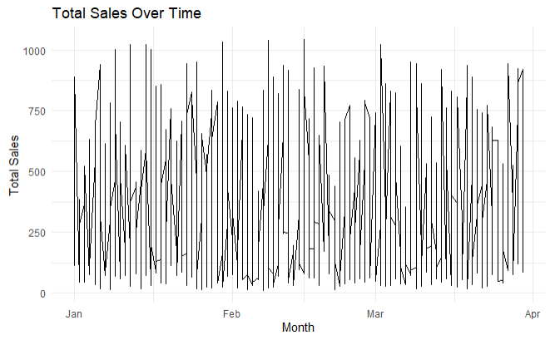

Upon visualizing the total sales over time using a line chart, we observe a fairly chaotic distribution of sales. There appears to be a mixture of peak sales days and days with relatively low sales throughout the observed time period. Specifically, the period from mid to end February stands out as experiencing peak sales, with some days exhibiting significantly higher sales volumes compared to others.

This observation suggests that sales performance fluctuates dynamically over time, influenced by various factors such as seasonal trends, promotional activities, customer behavior, and external market conditions. The peaks in sales during mid to end February may be attributed to factors such as holiday promotions, special events, or product launches that drive increased consumer spending during that time period. Conversely, the days with lower sales volumes may coincide with periods of reduced consumer demand, competitive pressures, or operational challenges.

To better understand and leverage these sales dynamics, businesses can analyze the underlying factors contributing to peak sales periods and identify opportunities to replicate or sustain high-performance periods. This may involve implementing targeted marketing campaigns, optimizing inventory management strategies, or enhancing customer engagement initiatives to capitalize on peak sales opportunities and mitigate challenges during slower periods. By monitoring sales trends over time and adapting strategies accordingly, businesses can optimize sales performance and drive sustainable growth in a dynamic marketplace.

Upon examining the total sales over time with 'Time' on the x-axis and 'Total' on the y-axis using a line chart, we observe interesting patterns in sales activity throughout the recorded time span. While there is a consistent level of sales activity observed across most of the recorded time periods, certain times stand out as particularly busy or slow.

Specifically, the period around 16:00 appears to be the least busy, with relatively lower sales volumes compared to other time periods. Additionally, the early hours of 21:00 also exhibit lower sales activity. In contrast, numerous peaks in sales are observed throughout the recorded time span, indicating periods of heightened sales activity.

These observations suggest that sales volumes fluctuate throughout the day, influenced by factors such as customer traffic, purchasing patterns, and external factors like promotional events or operational considerations. The lower sales volumes during specific time periods may coincide with periods of reduced customer footfall or lower consumer spending, while the peaks in sales activity may reflect periods of increased consumer demand or promotional effectiveness.

To optimize sales performance throughout the day, businesses can leverage these insights to implement targeted strategies aimed at maximizing sales during peak periods and addressing challenges during slower periods. For example, adjusting staffing levels or scheduling promotional activities during peak sales times can help capitalize on increased consumer demand, while implementing targeted marketing campaigns or incentives during slower periods can stimulate sales and drive revenue growth. By understanding and adapting to the fluctuating patterns of sales activity over time, businesses can optimize their operational efficiency and enhance overall sales performance.

Upon visualizing the total sales over time with 'Time' on the x-axis, 'Total' on the y-axis, and colored by 'Gender' using a line chart, interesting patterns in sales activity by gender emerge.

Overall, male activity appears to be more densely observed among the lower end of the sales spectrum, suggesting that males may contribute more to lower sales volumes compared to females. Conversely, female sales activity exhibits a different pattern, with noticeable dips observed near the hours of 16:00 to 17:00. This suggests that females may be less active in making purchases during these specific time periods compared to males.

To better target different genders and optimize sales performance, corporations can consider tailored strategies based on these observed patterns. For instance, targeting males during peak sales periods with promotions or discounts on products that appeal to their preferences can capitalize on their higher activity levels during these times. On the other hand, for females, offering incentives or exclusive offers during the hours of 16:00 to 17:00 may help stimulate sales during these slower periods. Additionally, leveraging gender-specific marketing messages or product assortments can resonate more effectively with each demographic, enhancing engagement and driving conversions.

These observations underscore the importance of understanding gender-specific purchasing behaviors and preferences in devising effective marketing and sales strategies. By leveraging insights from sales data analysis, corporations can tailor their approaches to better meet the needs and preferences of diverse customer segments, ultimately driving sustainable growth and enhancing overall business performance.

Upon analyzing total sales by payment method and customer type using a grouped bar graph, distinct patterns emerge in sales distribution across different payment methods and customer types.

The distribution of sales across payment methods reveals interesting insights:

- Credit card and e-wallet transactions exhibit identical sales distributions, indicating that customers utilizing these payment methods contribute equally to overall sales.

- In contrast, cash transactions show slightly lower sales volumes compared to credit card and e-wallet transactions. Furthermore, within the cash payment method, sales attributed to "Member" customers are even lower than those of "Normal" customers, suggesting that "Member" customers may be less inclined to make purchases using cash compared to other payment methods.

These observations suggest that payment method preferences and behaviors may vary among different customer segments. While credit card and e-wallet payments are favored by both "Member" and "Normal" customers, cash transactions appear to be less popular, particularly among "Member" customers. This could be attributed to factors such as convenience, security, or incentives associated with electronic payment methods.

To optimize sales performance and cater to diverse customer preferences, businesses can implement targeted strategies based on payment method usage and customer segmentation. For instance, offering incentives or discounts for cash transactions may encourage "Member" customers to utilize this payment method more frequently. Additionally, providing seamless and secure payment experiences for credit card and e-wallet transactions can enhance customer satisfaction and drive repeat business.

By understanding the interplay between payment method preferences and customer behavior, businesses can tailor their approaches to maximize sales opportunities and deliver exceptional customer experiences.

Upon examining total sales by city and branch using a grouped bar graph, as well as total sales by city and sales class, we observe consistent distributions across all three cities, indicating similar sales patterns irrespective of city or branch.

The bar charts depicting total sales by city and branch reveal that each city's sales distribution is nearly identical across all branches. This uniformity suggests that sales performance does not significantly vary based on branch location within each city. Similarly, the bar chart illustrating total sales by city and sales class demonstrates comparable distributions across different sales classes within each city.

These observations suggest that no distinct trends or patterns emerge in sales performance across different cities or branches based on the available data. The similar sales distributions across all cities and branches indicate consistent sales performance, without any notable disparities or trends discernible from the current dataset.

To further explore and identify meaningful trends in sales performance, it may be necessary to collect additional data or analyze different variables that could potentially influence sales outcomes. Factors such as customer demographics, marketing initiatives, seasonal variations, or competitive landscape could provide valuable insights into sales trends and patterns. By adopting a more comprehensive approach to data collection and analysis, businesses can uncover actionable insights to inform strategic decision-making and drive sales growth effectively.

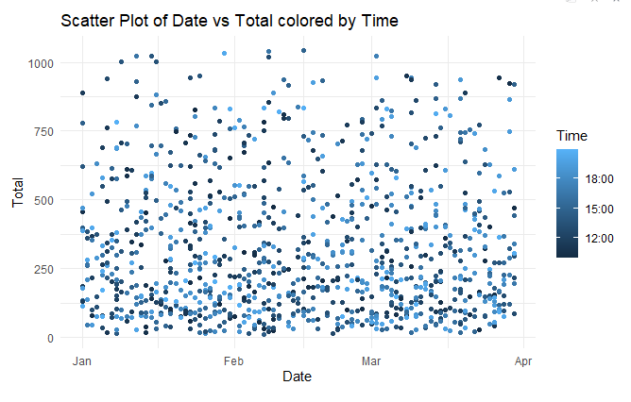

Upon examining the scatter plot of date versus total sales, colored by time of the day, we observe that there is no strict trend in shopping timings throughout the year. The plot indicates that shoppers engage in purchasing activities consistently throughout the year, with no discernible pattern indicating specific peak seasons or trends based on date.

However, notable observations can be made regarding sales volumes relative to the time of day. While shopping activity occurs across all hours, the plot reveals that the highest sales are predominantly made during the later hours of the day. This suggests that there may be a correlation between time of day and sales volumes, with consumers showing a propensity for shopping during evenings or nighttime hours.

The lack of a distinct trend in shopping timings throughout the year may indicate that consumer behavior is influenced by various factors beyond seasonal variations, such as lifestyle preferences, work schedules, or personal routines. Nonetheless, the consistent trend of higher sales during later hours underscores the importance of understanding and catering to consumer preferences and behaviors throughout different times of the day.

To leverage these insights effectively, businesses can adjust their operational strategies, marketing campaigns, and promotional activities to capitalize on peak sales hours and optimize revenue generation. For example, implementing targeted promotions or special offers during peak shopping hours can help drive sales and enhance customer engagement. Additionally, optimizing staffing levels and inventory management during high-traffic periods can ensure a seamless shopping experience for customers and maximize sales opportunities. By aligning business strategies with consumer behavior patterns, businesses can effectively meet customer needs and drive sustainable growth in sales and revenue.

Conclusion

In this report, we conducted a comprehensive analysis of a dataset pertaining to business sales transactions. Our analysis aimed to uncover insights into various aspects of sales performance, customer behavior, and trends over time. Through exploratory data analysis and visualization techniques, we gained valuable insights into the factors influencing sales outcomes and identified opportunities for strategic optimization.

Firstly, we examined the dataset's composition, consisting of key variables such as invoice ID, branch, city, customer type, gender, product line, unit price, quantity, tax, total, date, time, payment method, cost of goods sold, gross margin percentage, gross income, and customer ratings. By understanding the structure and content of the dataset, we were able to formulate hypotheses and conduct targeted analyses to address specific research questions.

Subsequently, our analysis delved into various aspects of sales performance and customer behavior. We explored trends in total sales across different product lines, customer types, payment methods, and geographic locations. Through visualizations such as bar charts, line plots, scatter plots, and box plots, we identified patterns and correlations within the data, uncovering insights into purchasing behavior, peak sales hours, and the effectiveness of marketing strategies.

Additionally, we examined the relationships between different variables, such as the correlation between unit price, quantity, total sales, and costs of goods sold. We also investigated gender-specific sales patterns and differences in sales volumes across different payment methods and customer segments.

Our analysis revealed several key findings:

- Sales volumes varied across different product lines, with certain categories experiencing higher sales than others.

- Peak sales hours were predominantly observed during later hours of the day, indicating a correlation between time of day and sales volumes.

- Payment method preferences differed among customer segments, with credit card and e-wallet transactions being favored over cash payments.

- Gender-specific sales patterns were evident, with males contributing more to lower sales volumes compared to females, and females exhibiting dips in sales activity during specific time periods.

Overall, our analysis provided valuable insights into sales dynamics, customer behavior, and trends over time. These insights can inform strategic decision-making processes for businesses, enabling them to optimize sales performance, enhance customer satisfaction, and drive sustainable growth. By leveraging the findings from this analysis, businesses can tailor their marketing strategies, pricing policies, and operational initiatives to better meet the needs and preferences of their target audience.

Moving forward, further research could explore additional variables, such as customer demographics, promotional activities, and external market factors, to gain a deeper understanding of sales dynamics and consumer behavior. Additionally, ongoing monitoring and analysis of sales data can help businesses adapt to evolving market trends and consumer preferences, ensuring continued success in a competitive business environment.

In conclusion, the insights gained from this analysis provide valuable guidance for businesses seeking to enhance their sales strategies, improve customer engagement, and achieve long-term success in today's dynamic marketplace.