PMI
CARD EDITOR
v1

HOW TO USE GUIDE
Professional Business Card Design Application

Complete step-by-step guide with screen references

Table of Contents

Overview & Process Flow 3
App Screen Layout 3
Step 1 — Start (Templates & Background) 4
Step 2 — Design (Colors & Typography) 6
Step 3 — Elements (Logo, Layout, Position) 8
Step 4 — Content (Text & People) 10
Step 5 — AI Studio 12
Step 6 — Save & Export 14
The Card Back & QR Code 16
Tips & Best Practices 17

Overview & Process Flow

The PMI Card Editor is a self-contained web application for creating professional double-sided business cards. It runs directly in any web browser — no installation required. The workflow is organized into 6 clearly numbered steps, and the card updates in real time as you make changes.

The 6-Step Workflow
- Step 1 — START: Choose a template or import a background image
- Step 2 — DESIGN: Set colors, typography, and ribbon/swoosh styles
- Step 3 — ELEMENTS: Upload a logo, choose a layout, position elements
- Step 4 — CONTENT: Enter person details, company name, and taglines
- Step 5 — AI STUDIO: Get AI-powered design feedback and suggestions
- Step 6 — SAVE & EXPORT: Save profiles and export PDF, PNG, JPG, or SVG

💡 TIP: You can jump between any step at any time using the tab bar — the workflow is non-linear. The Prev / Next buttons at the bottom of the left panel guide you through in order.

App Screen Layout

The application is divided into two main areas: the Left Panel (controls) and the Right Panel (live card preview).

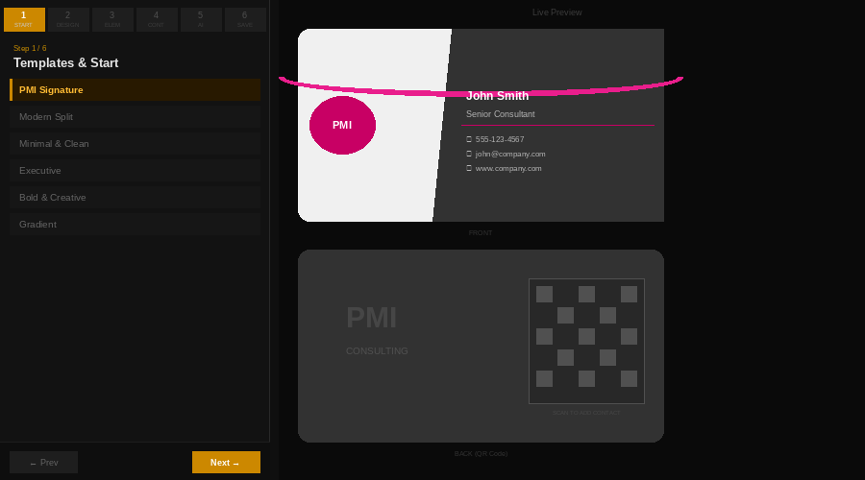
Figure 1 — Application layout overview showing the left control panel, step tabs, and live card preview

Key Screen Zones
Zone | Location | What It Does
Step Tabs (1–6) | Top of left panel | Jump between steps
Left Control Panel | Left side | All settings for the current step
Prev / Next Buttons | Bottom of left panel | Sequential step navigation
Export Bar | Bottom of left panel | PDF, PNG, JPG, SVG export buttons
Live Card Preview | Right panel | Real-time front and back card preview
Zoom Controls | Top of right panel | Adjust preview size (30%–100%)
Help Button (?) | Top-right corner | Context-sensitive help for each step

1 START — Templates & Background

This is where you choose the starting visual style for your card. Apply any built-in template to instantly set colors, ribbon style, split layout, and typography — all in one click.

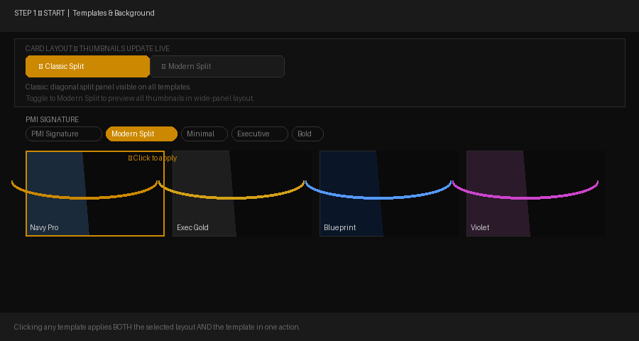
Figure 2 — Template Gallery showing PMI Signature, Modern Split, Dark & Moody, and other style categories

Template Categories
PMI Signature | PMI-branded cards — white or dark with the signature pink arc ribbon
Modern Split | Contemporary diagonal two-panel layouts
Minimal & Clean | Simple, understated designs ideal for professional services
Executive | Navy, gold, and dark premium styles for executive-level cards
Bold & Creative | High-contrast vibrant designs — stand out from the crowd
Gradient | Cards with gradient accent ribbons from one color to another
Dark & Moody | All-dark backgrounds with glowing accent colors
Custom Added | Your personally saved design variations (added over time)

Layout Toggle (New)
At the top of the templates panel, two buttons let you choose your card layout before picking a template. All thumbnails instantly update to show each design in the selected layout.
- Classic Split — Diagonal two-panel split always visible. Best for cards emphasizing the left logo area alongside right-panel contact info.
- Modern Split — Wider dark right panel with pronounced diagonal split. Best for bold, high-contrast designs.
★ TIP: Clicking a template applies both the template style AND the selected layout simultaneously. You can always fine-tune the split position and angle later in Step 3 → Layout tab.

How to Apply a Template
- Click a category tab (e.g., PMI Signature, Executive)
- Browse the thumbnail previews shown below the tab
- Click any thumbnail to instantly apply it to your card
- A gold banner at the bottom confirms the change with a Revert option

ℹ NOTE: Applying a template changes colors, ribbon style, and typography — it does NOT overwrite the content you've entered (name, phone, email, etc.).

Custom Templates (Your Saved Designs)
The "Custom Added" section at the bottom of the Templates panel stores your own saved designs. Use this to:
- Save a variation of your design for later reuse
- Organize designs by client, project, or style
- Apply a previously saved design with one click

To save a custom template: Click + Save Current Design, type a name and optional description, choose or create a category, and click Save.

Import Background / Template
This button jumps to the Background tab in Step 3 where you can upload a PNG, JPG, or SVG image as the card background. After uploading, use the sliders to control brightness, contrast, saturation, and opacity of the image.

💡 TIP: The app can use AI to analyze an uploaded card image and recreate its layout as an editable template. This requires a Claude or OpenAI API key (Step 5).

2 DESIGN — Colors & Typography

Step 2 controls every visual property of your card: the color palette, decorative ribbon/swoosh, and typography for every text element.

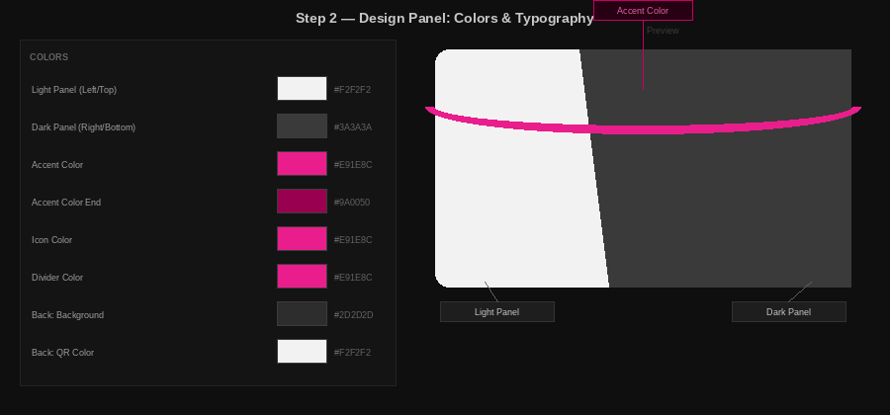
Figure 3 — Design panel showing color controls (left) and annotated card preview with Light Panel, Dark Panel, and Accent Color zones

Colors Tab
Every color on the card is independently controlled. Use the color picker swatches or type a hex value directly.

Field | What It Controls
Light Panel | Background color of the left/top portion of the card
Dark Panel | Background color of the right/bottom portion
Accent Color | Primary accent — drives ribbon, icons, and highlights
Accent Color End | Second color for gradient accents (end of ribbon gradient)
Icon Color | Color of the ☎ ✉ ⊕ icons on the card front
Divider Color | Color of the thin horizontal rule lines between sections
Back: Background | The back side's own background color
Back: QR Color | Color of the QR code pattern on the back
Back: Tagline Colors | Bold and light tagline text colors on the back

Typography Tab
Every text element on the card has independent typography settings. Click any element to expand its controls.

Person Name | Large name text on the front
Title / Position | Job title line below the name
Phone / Email / Website | Contact information rows
Tagline Bold | First (prominent) tagline line
Tagline Light | Second (lighter) tagline line
Company Name | Large company name on the back
Company Subtitle | Subtitle below company name (e.g., 'CONSULTING LLC')

For each element: adjust font size (px), Bold/Italic/Underline toggles, text color, font family (10 options), and letter spacing.

ℹ NOTE: The Reset Typography button at the top of the tab resets all typography settings to the active template's defaults.

Modern Split / Ribbon Tab
Controls the diagonal split and decorative ribbon that overlays it.

Split Position | How far across the card the split falls (0–100%). 100% = no split, single color.
Split Angle | Angle of the diagonal (60–120°). 90° = straight vertical. Lower angles lean left.
Ribbon Visible | Toggle the decorative ribbon/swoosh on or off
Ribbon Style | Shape: Arc, Arc Fade, PMI Ribbon, Double, Diagonal, Wave, Corner, Slash, Filled Arc
Ribbon Thickness | Stroke width of the ribbon (in pixels)
Ribbon Opacity | Transparency of the ribbon (0–100%)
Ribbon Fade | If enabled, the ribbon gradually fades from solid to transparent

3 ELEMENTS — Logo, Layout & Position

Step 3 manages what visual elements appear on the card, how they are arranged, and exactly where they are positioned.

Logo Tab
Control what appears in the left panel of the card front — typically your brand logo.

Logo Modes
PMI Logo | Use the bundled PMI logo (pre-loaded by default)
Upload Logo | Upload your own PNG or SVG file (transparent backgrounds supported)
Draw Logo | Use the built-in canvas tool to sketch a simple logo from scratch
Company Text | Display the company name and subtitle as large decorative text instead of a graphic

Logo Color Swap (uploaded logos only)
After uploading a logo, you can recolor specific parts to match your card's color scheme:
- Click the color swap icon on the Logo tab
- Hover over the logo preview — the color under your cursor is shown
- Click to sample a color as the 'swap from' source
- Set the 'swap to' replacement color
- Front and back logo colors are controlled independently

💡 TIP: Color Swap is ideal for recoloring a company logo to match your card's accent color or to create a white version for the dark back panel.

Layout Tab
Classic Layout | Standard business card: logo left, contact info stacked on the right. Most flexible for individual element positioning.
Modern Split Layout | Two-panel design with large company branding in the top-left quadrant and name/contacts across the right panel. Automatically arranges elements.

Position Tab
Fine-tune the exact X and Y coordinates of every card element using sliders or by typing values directly. Each control has a Reset (↺) button to return to template defaults.

Logo X / Logo Y | Position of the logo on the card
Logo Width | Size of the logo (height scales automatically)
Name X / Name Y | Position of the person's name
Title X / Title Y | Position of the job title
Phone / Email / Website | Individual positions for each contact row
Tagline positions | Position of bold and light tagline text
QR X / QR Y / QR Size | Position and size of the QR code on the back

Background Tab
Upload a background image for the card front or back. The image layer appears above the color panels but below all text and elements.
Opacity | How transparent the background image is (0 = invisible, 100 = fully opaque)
Brightness | Lighten or darken the background image
Contrast | Increase or reduce the contrast range
Saturation | Increase or reduce the color intensity of the image

4 CONTENT — Text, People & Company

Step 4 is where you enter all the text that appears on the card — the cardholder's personal details, company information, and taglines.

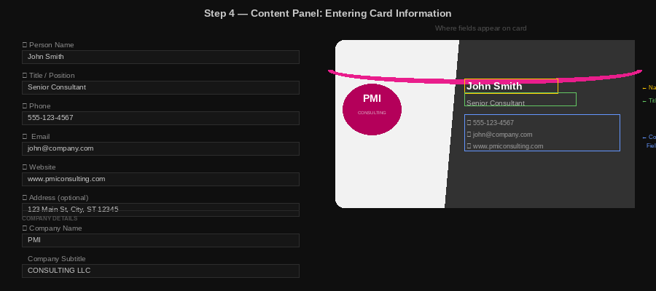
Figure 4 — Content panel with form fields (left) and annotated card preview showing where each field appears (right)

Person Details
Field | Front Card Location | Back Card
Name | Large name text on the right panel | Used in QR vCard
Title / Position | Line below the name | Used in QR vCard
Phone | Contact row with ☎ icon | Used in QR vCard
Email | Contact row with ✉ icon | Used in QR vCard
Website | Contact row with ⊕ icon | Used in QR vCard
Address (optional) | Contact row with 📍 icon | —

Company Details
Company Name | Large text on the card back. Also used in the logo area if 'Company Text' logo mode is selected.
Company Subtitle | Displayed below the company name (e.g., 'CONSULTING LLC' or 'EST. 2010').

Taglines
Two tagline lines appear on the back of the card, below the QR code area:
Bold Tagline | Primary tagline — displayed with an emphasized, accent-colored style
Light Tagline | Secondary tagline or descriptor — lighter styling for supporting text

ℹ NOTE: Both tagline fields support inline rich text formatting. Select any word and use the Bold, Italic, and Color buttons in the tagline editor to style individual words differently.

Divider Lines
Toggle the thin horizontal rule lines on the card front:
- Divider Line 1 — Separates the title from the contact information rows
- Divider Line 2 — Appears below the contact info rows, above the taglines

People Manager
The People Manager lets you save named contact profiles to quickly switch between different cardholders without changing the card design. This is ideal for producing the same card design for multiple people on a team.

Saving a Profile
- Fill in all content fields for the person
- Type a name in the "Profile Name" field (e.g., "Jane Doe")
- Click Save Person Profile
- The profile appears in the saved list below

Using a Saved Profile
- Find the profile in the list
- Click Load next to their name
- All content fields update to that person's information — the design stays the same

💡 TIP: Saved profiles persist between browser sessions. Build a library of team members once and reload them anytime.

5 AI STUDIO — Design Intelligence

The AI Studio connects to leading AI services to analyze your card design, provide structured feedback, generate logo concepts, and suggest design improvements with before/after previews.

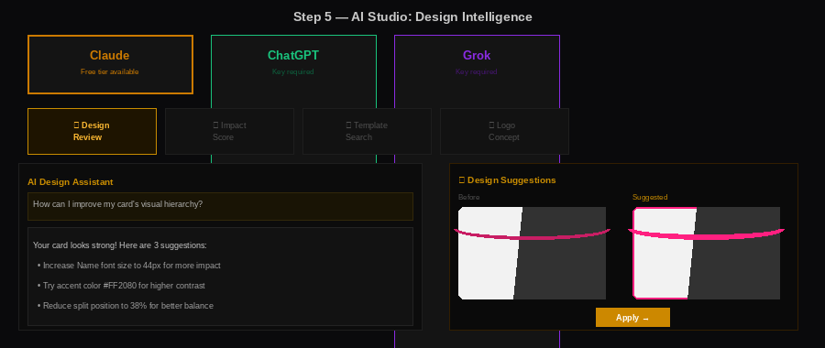
Figure 5 — AI Studio showing the provider selector (top), mode tabs, chat conversation, and Suggestion Panel with before/after card previews

Choosing an AI Provider
Provider | Free Tier | API Key | Best For
Claude (Anthropic) | Yes — Claude Haiku | Optional | Design review, suggestions. Best default choice.
ChatGPT (OpenAI) | No — key required | Always required | Logo image generation with DALL-E 3
Grok (xAI) | No — key required | Always required | Alternative AI perspective on design

Claude Free (no API key needed) is recommended for first-time users. It works immediately for design review, impact scoring, and template search.

AI Modes

🎨 Design Review
The AI analyzes your current card and provides structured feedback on color harmony, typography, visual hierarchy, whitespace, and overall readability. Specific color suggestions are shown as clickable hex swatches.

⚡ Impact Score
Rates your card across 5 dimensions on a 0–10 scale, displayed as progress bars: Visual Impact, Professionalism, Memorability, Color Harmony, and Typography. An overall score and improvement tips are included.

🔍 Template Search
Describe the design style you're looking for (e.g., 'dark luxury tech startup card'). The AI provides matching template suggestions with direct links to Dribbble, Behance, Canva, Moo, and similar sites.

🎯 Logo Concept
Describes logo design ideas based on your company name and industry. With a paid OpenAI key, this mode generates actual logo images using DALL-E 3. A Use as Card Logo button applies the generated image directly.

Design Suggestions Panel
When the AI recommends specific changes (colors, ribbon styles, layout adjustments), a Suggestion Panel appears automatically below the AI response:
- Each suggestion shows Current vs. Suggested as a side-by-side mini card preview
- Click Apply… to preview the change on your full card
- Click Apply All to apply every suggestion at once
- Click Save as New Template to save the applied version as a reusable custom template
- A Revert banner at the bottom of the screen lets you undo any applied change

ℹ NOTE: Design Suggestions require an active internet connection and a valid AI provider setup. Claude Free works without an API key for text-based suggestions.

Getting an API Key

Claude (Anthropic) — Free Tier Available
- Go to console.anthropic.com
- Sign up for a free account
- Navigate to API Keys and create a new key
- Paste it into the Claude API Key field in the AI Studio

OpenAI — Required for ChatGPT and DALL-E
- Go to platform.openai.com
- Create an account and add billing information
- Go to API Keys and create a new key
- Paste it into the OpenAI API Key field in the AI Studio

6 SAVE & EXPORT — Configurations & File Export

Step 6 provides access to saved configurations, the People Manager, custom templates, and all export options. The export buttons are always visible at the bottom of the left panel from any step.

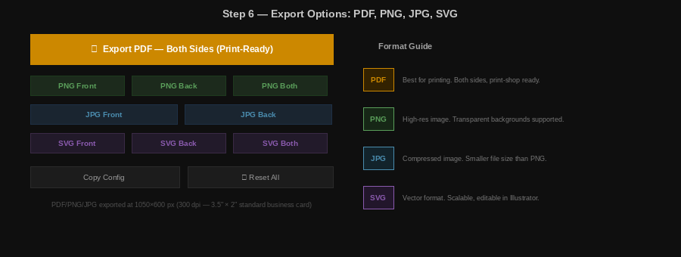
Figure 6 — Export panel showing PDF, PNG, JPG, and SVG export options with the format guide

Saved Configurations
Save complete design snapshots — everything including colors, typography, ribbon settings, layout, and logo position — under a named entry.

How to Save a Configuration
- Type a configuration name (e.g., 'Dark Navy Final')
- Optionally enter a company/group name to organize by client or project
- Click Save Configuration
- To restore: expand the company group, click Load next to any saved config

💡 TIP: Save a configuration before making major design experiments. This gives you a reliable restore point.

Export Options
Format | Button | Best For | Resolution
PDF | Export PDF — Both Sides | Professional printing, print shops | 1050×600 px per side, 300 DPI
PNG | PNG Front / Back / Both | Digital sharing, websites, presentations | 1050×600 px, transparent support
JPG | JPG Front / Back | Smaller file size for email | 1050×600 px, compressed
SVG | SVG Front / Back / Both | Vector — scalable, editable in Illustrator | Fully scalable vector

ℹ NOTE: PDF export is recommended for all printing purposes. It generates a properly sized (3.5" × 2") print-ready file with both card sides.

Copy Config & Reset
Copy Config | Copies the full card design as JSON text to the clipboard. Useful for sharing an exact design state with another user.
Reset All | Resets every setting to factory defaults. WARNING: This cannot be undone unless you have a saved configuration.

The Card Back & QR Code

The back of every card is automatically generated. It includes the company branding, taglines, and a QR code that encodes the cardholder's contact information as a vCard.

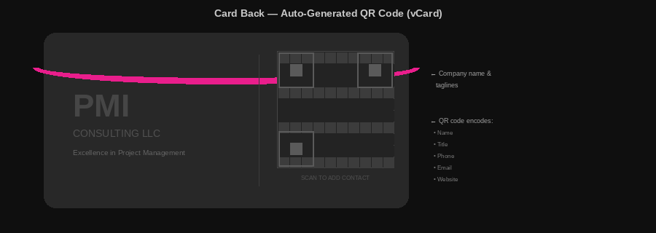
Figure 7 — Card back showing company name, taglines, and the auto-generated vCard QR code with contact data annotation

What the QR Code Contains
The QR code is a vCard — a standard digital contact format supported by all smartphone contacts apps. When scanned, the phone offers to save the person directly to the contacts list.

The QR code automatically includes:
- Full name
- Job title
- Phone number
- Email address
- Website URL
- Company name and subtitle

ℹ NOTE: The QR code updates automatically as you type in the Content fields — no manual action required.

Back Card Customization
- The back background color is set independently in the Colors tab (Step 2)
- QR code color is adjustable — use a light color for dark backgrounds
- Taglines appear below the QR code — customize them in Step 4
- Company name size and style are set in the Typography tab

Tips & Best Practices

General Workflow Tips
- Start with a template that is close to your desired style — it's faster than building from scratch
- Fill in real content early so the card looks realistic as you adjust the design
- Save a Configuration (Step 6) before making major design experiments
- Use the People Manager to create a library of team members you can apply to any design
- Run an AI Impact Score (Step 5) before exporting to catch common design issues

For Multiple People, Same Design
- Design and finalize your card in Steps 1–3
- Save the configuration in Step 6
- Enter the first person's details in Step 4 and export
- Use People Manager to load the next person — the design stays the same
- Export again for each person

Color & Design Tips
- Set the Accent Color first — it drives the ribbon, icons, and dividers simultaneously
- For split cards, the Name text color should contrast well with the Dark Panel background
- The Ribbon Fade option creates a modern fading arc effect — a signature PMI look
- Try Split Position between 38–45% and Split Angle between 82–86° for the classic PMI feel

Export & Printing Tips
- Always use PDF export for professional printing — it is pre-sized to 3.5" × 2" at 300 DPI
- PNG is best for digital use — it supports transparent backgrounds
- SVG format is ideal if you want to make further edits in Adobe Illustrator or Inkscape
- Most professional print shops accept PDF; online services like MOO, Vistaprint, and GotPrint all support it

AI Studio Tips
- Claude Free (no key required) is a good starting point — try Design Review before exporting
- Ask the AI 'What are the top 3 things I should change?' for a focused, actionable response
- When AI suggests specific color changes, the Suggestion Panel shows before/after previews — always compare before applying
- Logo image generation (DALL-E 3) requires a paid OpenAI API key — text-based logo concepts work with any provider

PMI Card Editor v1 — Professional Business Card Design Application
Self-contained portable application · Runs in any modern web browser

