UNIVERSITY OF RWANDA
College of Science and Technology

──────────────────────────────────────────────────

MODULE: Mobile Application and Handheld Devices

RNP E-CYAMUNARA ONLINE AUCTION PLATFORM
A Mobile Application for Rwanda National Police Online Vehicle Auctions

PROJECT REPORT

GROUP 6

# | Full Name | REGISTRATION NUMBER
1. | NIYOMUGABO Eduard | 223005447
2. | NDAYISHIMIYE Issa | 223010434
3. | IRUMVA Jean Marie | 223021336
4. | MANZI Stiven | 223020636

Academic Year: 2025 – 2026
Submission Date: 11 May 2026

ABSTRACT
E-CYAMUNARA is a mobile application developed using Flutter and Dart, backed by a Supabase cloud backend, that brings Rwanda National Police (RNP) vehicle auctions fully online. Before this application, vehicle auctions were conducted physically at police regions headquarters, which made them inaccessible to most citizens, slow, and easy to manipulate. This project replaces the entire physical process with a secure, real-time digital system that allows citizens (clients) to browse auctions, place bids, and track their results from their phones. Region Admins manage auctions within their assigned province, while a Super Admin oversees the entire national system.
The application was built over one month by a four-member team as a project for the Mobile Application and Handheld Devices module. The system supports three roles namely Client, Region Admin, and Super Admin across five regions (Eastern, Western, Northern, Southern, Central) and three auction categories (Cars, Motorcycles, Bicycles). Key technologies used include Flutter, Dart, Riverpod, GoRouter, Supabase, PostgreSQL, and Deno Edge Functions. The report documents the full development journey from idea generation through design, implementation, testing, and deployment.

TABLE OF CONTENTS
Abstract ii
Table of Contents iii
List of Figures iv
Chapter One: Introduction 1
1.1 Background of the Study 1
1.2 Problem Statement 2
1.3 Motivation 2
1.4 Objectives 3
1.5 Scope of the System 3
1.6 Significance of the Project 4
Chapter Two: Literature Review 5
2.1 Traditional Auction Systems 5
2.2 Online Auction Systems 5
2.3 Mobile Auction Applications 6
2.4 Comparison and Justification 7
Chapter Three: System Analysis and Design 8
3.1 Requirements Analysis 8
3.2 System Architecture 9
3.3 Database Design 10
Chapter Four: System Implementation 14
4.1 Project Setup and Structure 14
4.2 Authentication Module 15
4.3 Client Module 17
4.4 Region Admin Module 20
4.5 Super Admin Module 24
4.6 Notifications and Feedback 26
4.7 Security Implementation 27
4.8 Performance and Responsiveness 28
Chapter Five: Testing and Results 29
5.1 Testing Strategy 29
5.2 Functional Testing 29
5.3 Device Testing 31
Chapter Six: Challenges Faced 32
Chapter Seven: Future Improvements 36
Chapter Eight: Conclusion 37
References 38

LIST OF FIGURES
Figure 1: Splash Screen
Figure 2: Region Selection Screen
Figure 3: Unified Login Screen
Figure 4: Client Registration Screen
Figure 5: Forgot Password Screen
Figure 6: Client Home Screen
Figure 7: Auction Detail Screen
Figure 8: Bid Confirmation Screen
Figure 9: My Bids Screen
Figure 10: Notifications Screen (Client)
Figure 11: Feedback Screen
Figure 12: Client Profile Screen
Figure 13: Region Admin Dashboard
Figure 14: Post Auction Screen
Figure 15: Manage Auctions Screen
Figure 16: View Bids Screen
Figure 17: Close Auction Screen
Figure 18: Client Management Screen
Figure 19: Region Reports Screen
Figure 20: Client Feedbacks Screen (Admin)
Figure 21: Admin Profile Screen
Figure 22: Super Admin Dashboard
Figure 23: Manage Region Admins Screen
Figure 24: National Reports Screen
Figure 25: System Architecture Diagram
Figure 26: Database Schema Diagram
CHAPTER ONE: INTRODUCTION
1.1 Background of the Study
Rwanda National Police (RNP) regularly auctions vehicles that have been impounded, confiscated, or decommissioned from service. These auctions are an important source of government revenue and provide citizens with an opportunity to purchase vehicles at competitive prices. For many years, these auctions were conducted the traditional way where people had to travel physically to a Police Region Headquarters on a specific day, register on paper, and bid by raising their hand or shouting out prices in a crowded room or write their bids on provided papers.
This approach worked for a long time, but as Rwanda has grown and as more people now own smartphones, there is a strong expectation that government services should also go digital. Rwanda Vision 2050 and the Smart Rwanda Master Plan both emphasise the use of technology to improve how government services are delivered. It was within this context that the idea for E-CYAMUNARA was born.
The name 'E-CYAMUNARA' combines the English letter 'E' (standing for Electronic) with the Kinyarwanda word 'Icyamunara' which means auction. Together, the name simply means 'Electronic Auction,' and it captures exactly what the application does and it takes the traditional police auction and moves it onto a mobile app where anyone in Rwanda can participate from their phone.
1.2 Problem Statement
The existing physical auction system for Rwanda National Police vehicles had several serious problems that made it inefficient, unfair, and inaccessible to most citizens:
- Physical attendance required: Citizens had to travel to the auction venue, which was costly and time-consuming, especially for people living far from Police Region Headquarters.
- Limited reach: Only people who lived nearby or heard about the auction in advance could participate.
- No transparency: It was difficult for bidders to verify who else was bidding or what the current highest bid was. This opened the door for corruption and bid manipulation.
- Paper-based records: All records were maintained on paper, making it hard to track auction history, winners, or disputes.
- No real-time updates: If you left the auction hall, you had no way of knowing what was happening. There was no way to bid remotely.
- Administrative burden: Region Admins had to manage everything manually by writing bid records, calculating totals, and producing reports by hand.
These challenges meant that many qualified Rwandan citizens were excluded from participating in police vehicle auctions, and the process lacked the transparency and accountability that is expected in modern public governance.
1.3 Motivation
As a group of IT students, we saw this as a perfect opportunity to use the technical skills we had been learning throughout our studies, particularly in mobile application development to solve a real problem that affects Rwandan citizens. We were motivated by several things:
- We wanted to build something real and useful, not just a demo application.
- Mobile phones are now very common in Rwanda. Building a mobile app means the solution is accessible to millions of people.
- We had learned Flutter and Supabase in our coursework and wanted to put them to practical use.
- The project gave us the chance to practise clean software architecture, security practices, and teamwork, all essential skills for professional developers.
We also believed that if this application were ever deployed in a real setting, it could genuinely improve how police vehicle auctions are conducted, saving time for citizens and reducing corruption.
1.4 Objectives
General Objective
To design and develop a mobile application that enables Rwanda National Police to conduct vehicle auctions online, allowing citizens to participate remotely through their smartphones.
Specific Objectives
- To allow citizens to register, browse active auctions, and place bids in real time.
- To allow Region Admins to post auctions, manage bids, close auctions, and generate reports for their assigned region.
- To allow a Super Admin to manage all Region Admins, view national reports, and configure system-wide settings.
- To implement a secure Role-Based Access Control (RBAC) system so that each user type only sees what they are supposed to see.
- To encrypt sensitive personal information such as National ID numbers to protect user privacy.
- To send real-time push notifications to bidders when they are outbid or when they win an auction.
- To provide a clean, easy-to-use mobile interface that works well on a wide range of Android devices.
1.5 Scope of the System
The application was designed to serve Rwanda National Police specifically, and covers the following scope:
- Platform: Android mobile application (Flutter)
- Regions: Eastern, Western, Northern, Southern, Central
- Auction categories: Cars, Motorcycles, Bicycles
- User roles: Client (citizen bidder), Region Admin (police officer managing auctions from assigned region), Super Admin (A Commissioner who is in charge of RNP Auctions )
- Backend: Supabase cloud platform (PostgreSQL database, authentication, file storage, real-time updates, Edge Functions)
The application was not designed to handle payment processing. Winning bidders are notified through the app, and actual payment and vehicle handover remain handled in person by police staff.
1.6 Significance of the Project
This project is significant for several reasons:
- It digitalises a government process, reducing paperwork and increasing efficiency.
- It improves transparency by giving all registered citizens equal access to auction information.
- It demonstrates how students can use modern mobile development tools to build production-quality applications.
- It provides a working prototype that could, with further development, be deployed as an official government application.
- It contributes to Rwanda's digital transformation goals by moving a previously manual government service to a mobile platform.

CHAPTER TWO: LITERATURE REVIEW
2.1 Traditional Auction Systems
Auctions have existed for centuries as a method of selling goods to the highest bidder. In the traditional model, buyers gather in a physical location at a set time. An auctioneer announces the item, sets a starting price, and accepts oral bids from the crowd until no one bids higher. The highest bidder wins and pays on the spot or shortly after. This model is simple and direct but comes with well-known limitations.
According to Milgrom (1989), traditional auctions suffer from problems of limited reach, because only those who can physically attend can participate. This naturally restricts competition, often resulting in lower final prices than would be achieved if more bidders could participate. For government auctions specifically, limited participation also raises fairness concerns, the process favours people who happen to live close to the venue or who have strong social networks that alert them to auction dates.
In Rwanda, police vehicle auctions are conducted at the regional level. Citizens in one province may not know about auctions happening in another province, and even within the same province, announcements are sometimes made only days in advance through RNP websites or social media, making it difficult for ordinary citizens to prepare.
2.2 Online Auction Systems
The emergence of internet-based auction platforms most famously eBay, launched in 1995 changed how auctions work fundamentally. Online auctions remove the need for physical presence and allow anyone with an internet connection to bid from anywhere in the world. Sellers can reach a much larger pool of buyers, which typically results in better final prices. Buyers benefit from a wider selection and the ability to participate from the comfort of their homes.
Research by Lucking-Reiley (2000) found that online auction mechanisms closely mirror theoretical auction models in terms of bidder behaviour and price discovery. The transparency of online systems where all bids are recorded and visible, also helps prevent collusion and fraud that can occur in traditional physical auctions.
Government bodies worldwide have adopted online auction systems for public asset disposal. The United States General Services Administration (GSA) and various European government agencies use dedicated online platforms to auction surplus equipment, vehicles, and property. These systems have demonstrated significant efficiency gains and improved public trust in the disposal of public assets.
2.3 Digital Transformation in Government Services
Rwanda has been recognised internationally as a leader in digital government transformation in Africa. The Rwanda Information Society Authority (RISA) and the Ministry of ICT have driven numerous initiatives to digitise public services. Platforms such as Irembo (the national e-government portal) have already moved many citizen-facing services online.
The Smart Rwanda Master Plan 2020-2024 specifically highlighted the need to digitise government asset management processes. Vehicle auctions by institutions like Rwanda National Police represent exactly the kind of process that benefits from digitalization, it is a repetitive, high-volume transaction that currently requires significant manual labour and physical presence. Moving it online saves time for both citizens and police staff.
2.5 Comparison and Justification
Feature | Traditional Auction | E-CYAMUNARA
Participation | Physical attendance only | Anywhere via smartphone
Information access | Word-of-mouth / radio/social-medias | Push notifications + app listing
Bid transparency | Limited, auctioneer-controlled | All bids recorded in real time
Record keeping | Paper-based | Digital database with full history
Administrative reports | Manual, time-consuming | Automated, generated on demand
Accessibility | Only near the venue | Nationwide, 5 regions covered
Security | Prone to manipulation | Encrypted, role-controlled, server-side bid validation
Reach | Local only | National, all regions supported

As shown in the comparison above, E-CYAMUNARA addresses every major weakness of the traditional system while adding new capabilities that were not previously possible. The application is therefore not just an incremental improvement, it is a fundamental transformation of how police vehicle auctions work in Rwanda.

CHAPTER THREE: SYSTEM ANALYSIS AND DESIGN
3.1 Requirements Analysis
Functional Requirements
The following are things the system must be able to DO:
ID | Requirement | Role
FR-01 | Users can register with full name, phone, national ID, and district | Client
FR-02 | Users can log in and the system identifies their role | All
FR-03 | Users can reset their password via phone number | Client
FR-04 | Clients can view all active auctions in their region | Client
FR-05 | Clients can view auction details including photos and current highest bid | Client
FR-06 | Clients can place a bid higher than the current highest bid | Client
FR-07 | Clients can view all their previous bids and their status | Client
FR-08 | Clients receive push notifications when outbid or when they win | Client
FR-09 | Clients can submit feedback and ratings for auctions | Client
FR-10 | Clients can update their profile and profile photo | Client
FR-11 | Region Admins can post new auctions with photos | Region Admin
FR-12 | Region Admins can view all bids on their auctions | Region Admin
FR-13 | Region Admins can close auctions and select a winner | Region Admin
FR-14 | Region Admins can suspend and activate client accounts | Region Admin
FR-15 | Region Admins can generate reports for their region | Region Admin
FR-16 | Super Admin can add and manage Region Admins | Super Admin
FR-17 | Super Admin can view national reports across all regions | Super Admin
FR-18 | Super Admin can configure system-wide settings | Super Admin

Non-Functional Requirements
ID | Requirement | Details
NFR-01 | Security | Passwords hashed by Supabase Auth; National IDs encrypted with AES-256
NFR-02 | Performance | Screens must load in under 3 seconds on a 4G connection
NFR-03 | Usability | Interface must be usable by non-technical citizens
NFR-04 | Reliability | System must handle concurrent bids without data corruption
NFR-05 | Maintainability | Clean Architecture ensures code is easy to update
NFR-06 | Scalability | Supabase cloud backend scales automatically with load
NFR-07 | Compatibility | Must work on Android 7.0 (API 24) and above
NFR-08 | Privacy | No sensitive personal data stored in plain text

3.2 System Architecture
E-CYAMUNARA follows the Clean Architecture pattern, a widely-used approach in mobile development that separates the application into three distinct layers: Presentation, Domain, and Data. This separation makes the code easier to understand, test, and maintain.
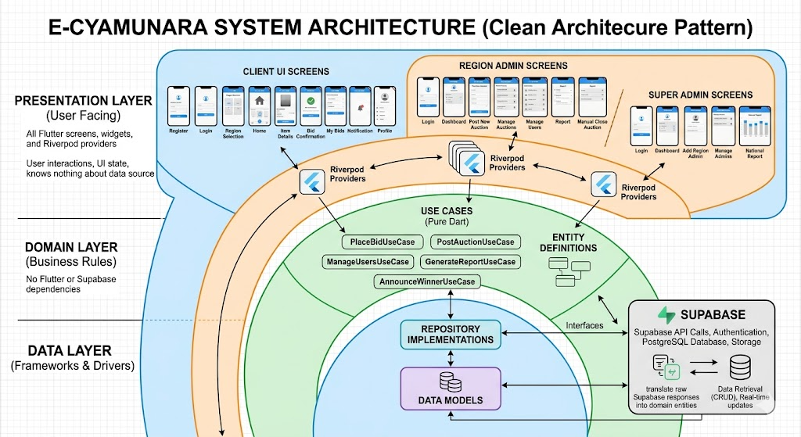
Figure: System Architecture Diagram
The three architectural layers are:
- Presentation Layer: Presentation Layer: Contains all Flutter screens, widgets, and Riverpod providers. This is what the user sees and interacts with. It knows nothing about where data comes from. it just asks the Domain layer for it.
- Domain Layer: Domain Layer: Contains the business rules (use cases) and entity definitions. For example, the PlaceBidUseCase checks business rules before calling the data layer. This layer is pure Dart with no Flutter or Supabase dependencies.
- Data Layer: Data Layer: Contains the repository implementations and data models. This is where actual Supabase API calls happen. Repositories translate raw Supabase responses into domain entities.
On the backend, Supabase provides a complete Backend-as-a-Service (BaaS) solution: PostgreSQL for the database, GoTrue for authentication, Storage for images, Realtime for live data updates, and Deno-based Edge Functions for server-side business logic.
The overall technology stack is summarised below:
Component | Technology | Purpose
Mobile App | Flutter + Dart | Cross-platform mobile UI
State Management | Riverpod | Reactive, testable state across all screens
Navigation | GoRouter | Type-safe routing with role-based guards
Database | PostgreSQL (Supabase) | Stores all auction, user, and bid data
Authentication | Supabase Auth | JWT-based login, session management
File Storage | Supabase Storage | Auction photos, profile photos, national IDs
Real-time | Supabase Realtime | Live bid updates and auction changes
Server Logic | Deno Edge Functions | Bid validation, auction closing, notifications
Push Notifications | OneSignal | Real-time alerts to mobile devices
Encryption | AES-256 (encrypt pkg) | National ID protection
Crash Reporting | Sentry | Error tracking in production

3.3 Database Design
The database was designed on PostgreSQL, hosted by Supabase. The design follows third normal form (3NF) to avoid data redundancy. Below is a description of each main table and its purpose.
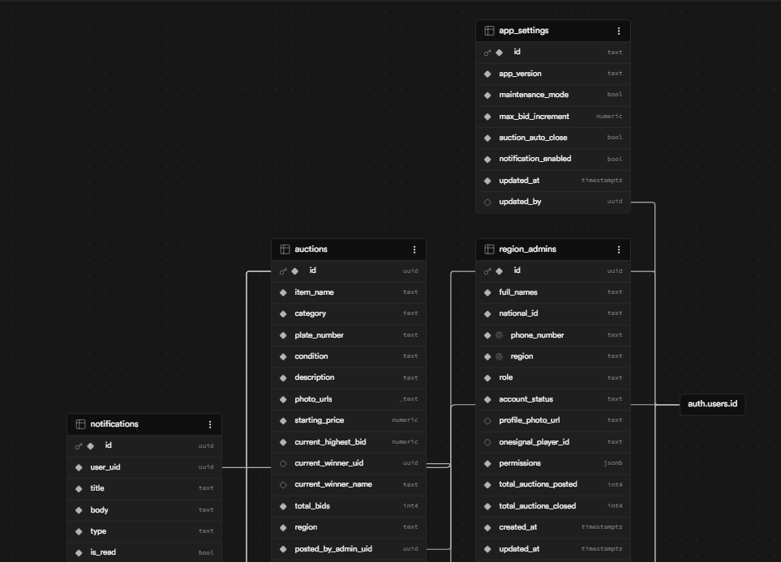
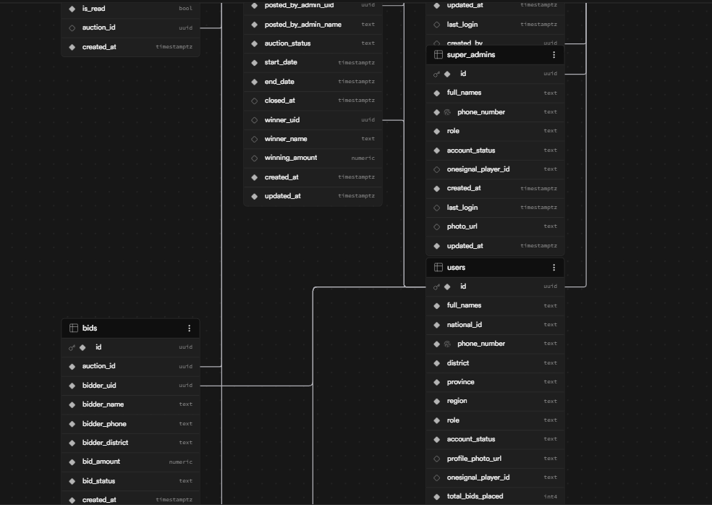
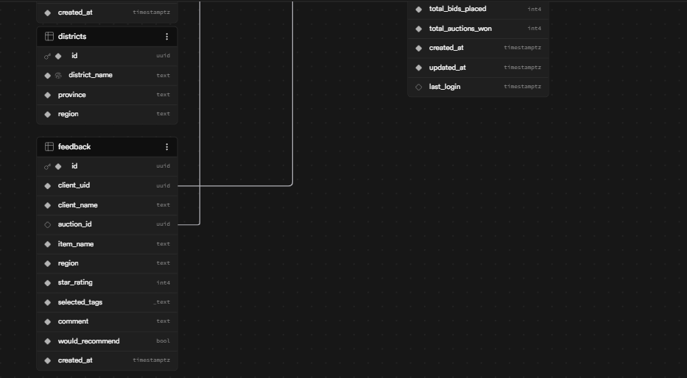

Figure: Database Entity Relationship Diagram (ERD)
Main Tables
- users: users: Stores client accounts. Each client has a unique phone number, an encrypted national ID, their assigned district and region, and a status field (active or suspended). The role column is always fixed to 'client'.
- region_admins: region_admins: Stores region administrator accounts. Each admin is locked to one region (enforced by a database trigger). Admins cannot be created directly, they must be created through the create-admin Edge Function.
- super_admins: super_admins: Stores the national system administrator account. The system requires at least one super admin at all times (enforced by a trigger).
- auctions: auctions: The central table. Stores all auction listings with fields for item details, photos, pricing, region, status (draft/active/closed/cancelled), and winner information.
- bids: bids: Records every bid placed. Each bid is linked to an auction and a bidder. A bid_status field tracks whether a bid is currently 'winning' or 'outbid'.
- feedback: feedback: Stores client feedback after auctions. auction_id is optional (nullable) to allow general feedback as well as auction-specific feedback.
- notifications: notifications: Stores all push notification records so users can view their notification history in the app.
- app_settings: app_settings: A single-row configuration table that the Super Admin can update to control system-wide settings like maintenance mode and auto-close rules.
Row-Level Security (RLS) policies are applied to every table to ensure that users can only read and write data that belongs to them. For example, a client from the Eastern region cannot read bids placed by clients in the Western region.
CHAPTER FOUR: SYSTEM IMPLEMENTATION
4.1 Project Setup and Structure
The project was initialised using the Flutter CLI with the command flutter create ecyamunara. All required packages were then added to pubspec.yaml. The most important packages used in the project were:
Package | Version | Purpose
supabase_flutter | ^2.5.6 | Full Supabase integration (DB, Auth, Storage, Realtime)
flutter_riverpod | ^2.5.1 | State management
go_router | ^14.2.7 | Navigation and role-based routing
cached_network_image | ^3.4.1 | Efficient image loading from Supabase Storage
image_picker | ^1.1.2 | Photo selection from gallery or camera
flutter_secure_storage | ^9.2.2 | Secure key storage for encryption
encrypt | ^5.0.3 | AES-256 encryption for National IDs
onesignal_flutter | ^5.2.6 | Push notifications
fl_chart | ^0.69.0 | Charts for reports and dashboards
pdf | ^3.11.1 | PDF report generation
intl | ^0.19.0 | Date/number formatting
sentry_flutter | ^8.3.0 | Crash reporting

The folder structure inside lib/ follows the Clean Architecture pattern, divided into core/, data/, domain/, and presentation/ directories. All screens are organised by role under presentation/screens/, making it easy to find the code for any particular screen.
4.2 Authentication Module
Authentication was one of the most complex parts of the project because we had to handle three different types of users (clients, region admins, and super admins) without using three separate login screens. Instead, we built a single unified login screen that adapts based on the phone number entered.
4.2.1 Unified Login Screen
The login screen accepts a phone number and password. When the user taps 'Login', the system converts the phone number into an internal email address (for example, +250782345678 becomes rw0782345678@ecyamunara.rw). This is necessary because Supabase Auth works with email addresses, not phone numbers directly. After login, the system checks which role table the user's ID appears in and routes them to the correct dashboard.

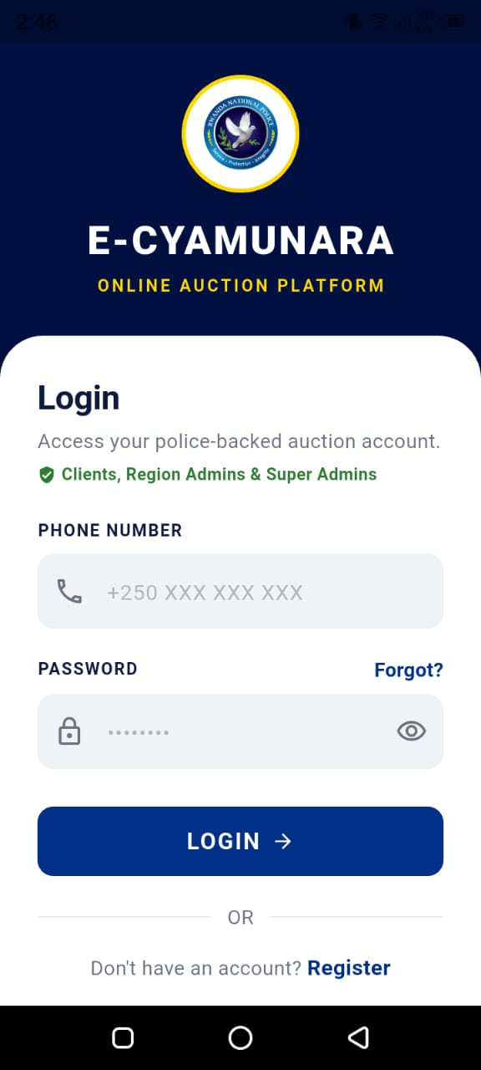

Figure: Unified Login Screen
4.2.2 Client Registration
New clients register through the RegisterScreen, providing their full name, phone number, national ID, district, and a password. The national ID is encrypted before being stored in the database using AES-256 encryption. After registration, the client is directed to the RegionSelectScreen to choose their region, which is then saved to their profile.

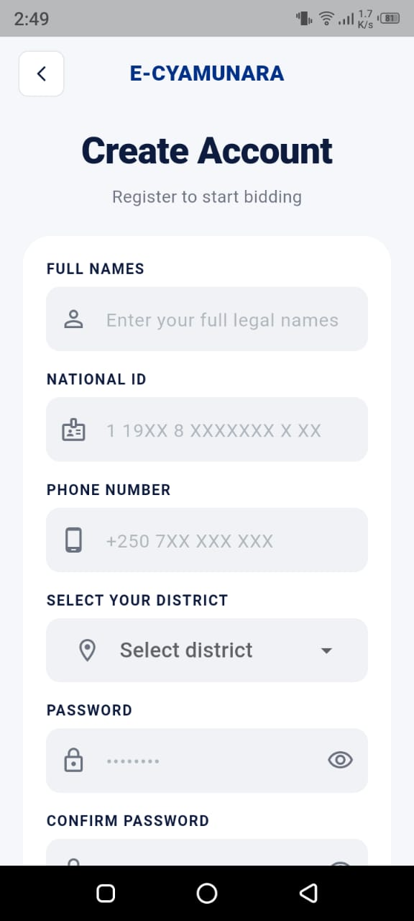

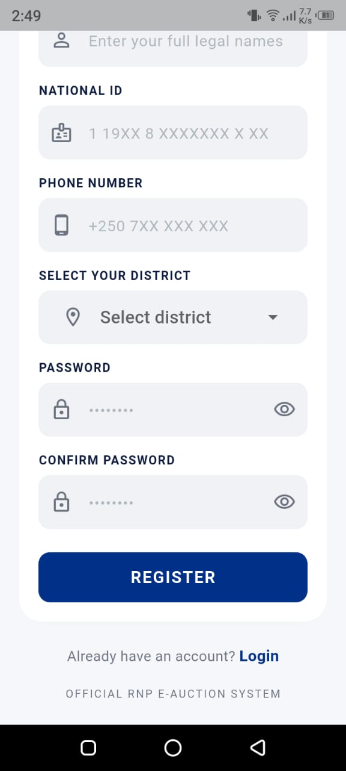

Figure: Client Registration Screen

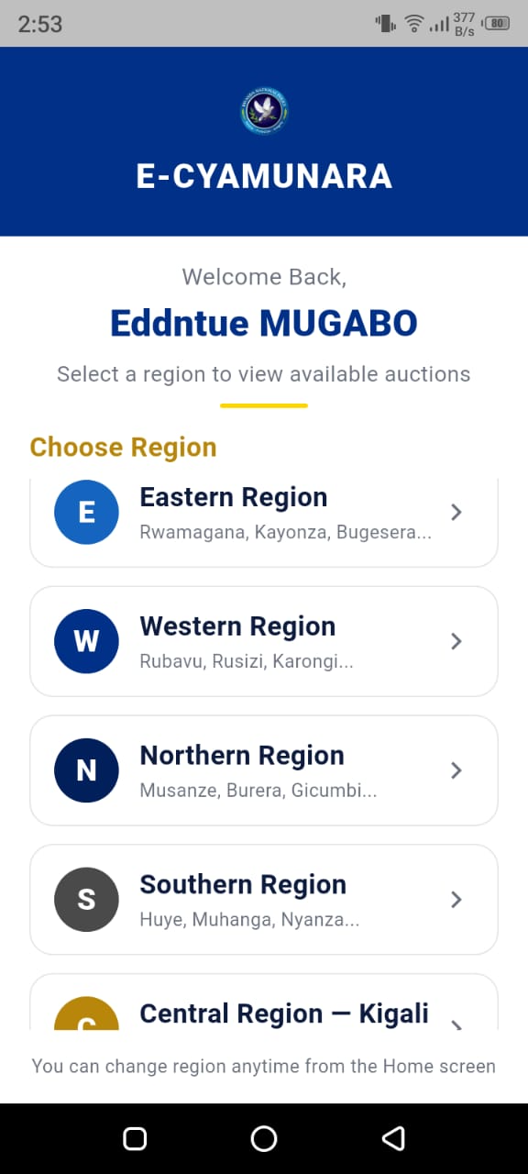
Figure: Region Selection Screen
4.2.3 Password Reset
The password reset flow is handled by a modal bottom sheet that appears when the user taps 'Forgot Password'. The user enters their phone number, and the app calls the reset-client-password Edge Function on Supabase. This function generates a reset token and handles the password update server-side. A key challenge here was that error messages were initially hidden behind the bottom sheet because we were using SnackBars. we resolved this by replacing the SnackBar with an inline error text widget inside the sheet itself.

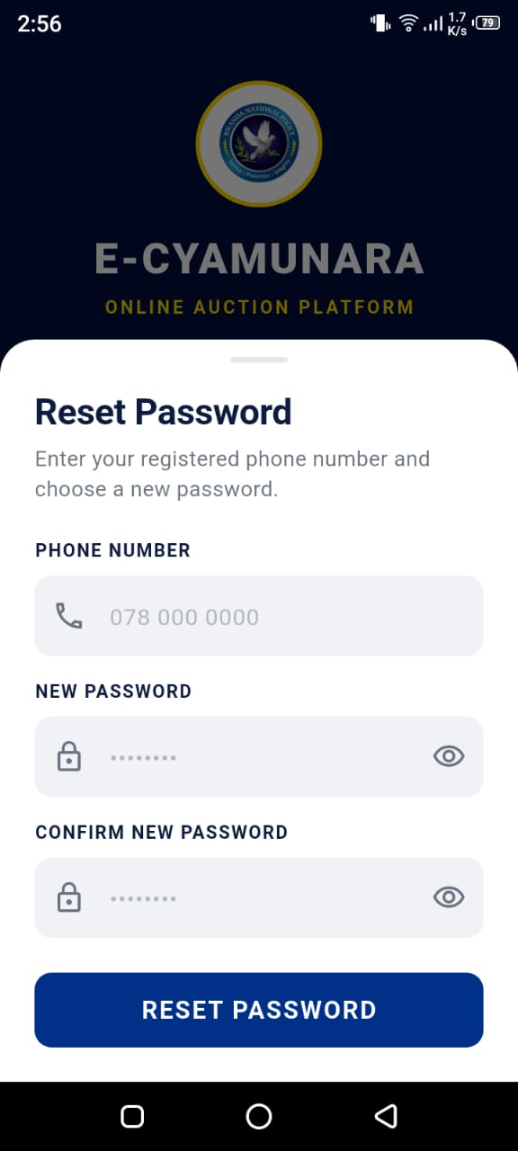
Figure: Forgot Password Screen
4.2.4 Splash Screen and Role Routing
When the app starts, a branded splash screen is shown for 1.5 seconds while the app checks whether the user is already logged in. If they are, the app determines their role and routes them directly to the correct dashboard. If they are not logged in, they are taken to the login screen. This makes the app feel fast and professional, users are never stuck on a blank screen.
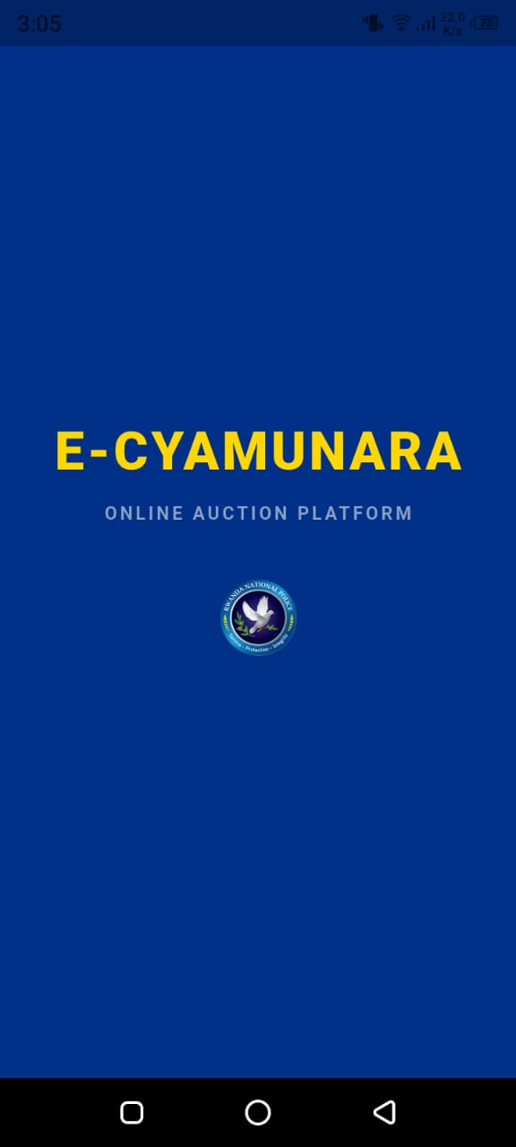
Figure: Splash Screen
4.3 Client Module
The client module is the heart of the application from the citizen's perspective. It contains eight screens, each serving a specific purpose in the auction participation journey.
4.3.1 Home Screen
The Home Screen is the first thing a client sees after selecting the region. It displays a list of active auctions in the client's region. Each auction card shows the item photo, name, category, current highest bid, and the time remaining before the auction closes. Clients can filter auctions by category (Cars, Motorcycles, Bicycles) and search by item name. The auction list is loaded from Supabase using a StreamProvider, which means the list automatically updates in real time if an admin posts a new auction or if the highest bid changes.
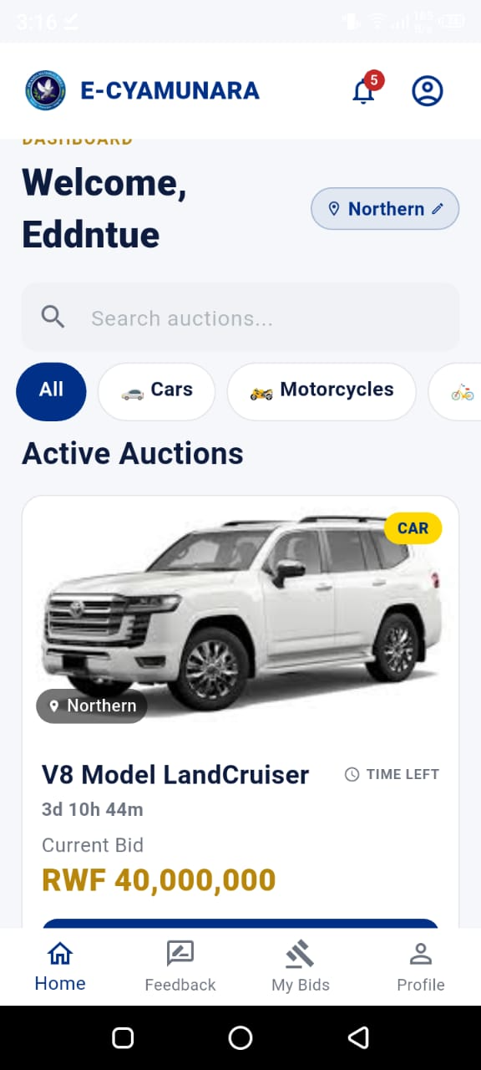
Figure: Client Home Screen
4.3.2 Auction Detail Screen
When a client taps on an auction card, they are taken to the Auction Detail Screen. This screen shows full details about the item, multiple photos (displayed in a horizontal scroll), the vehicle's plate number, condition, starting price, and a description. A prominent card at the top shows the current highest bid and the name of the current leading bidder. Below this, a bid input field allows the client to enter their bid amount. The system automatically enforces that the bid must be higher than the current highest bid.
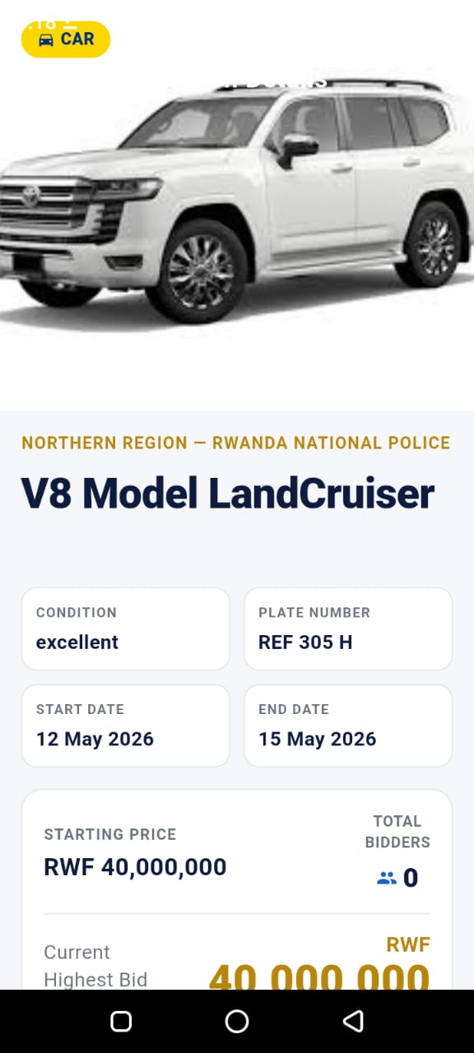
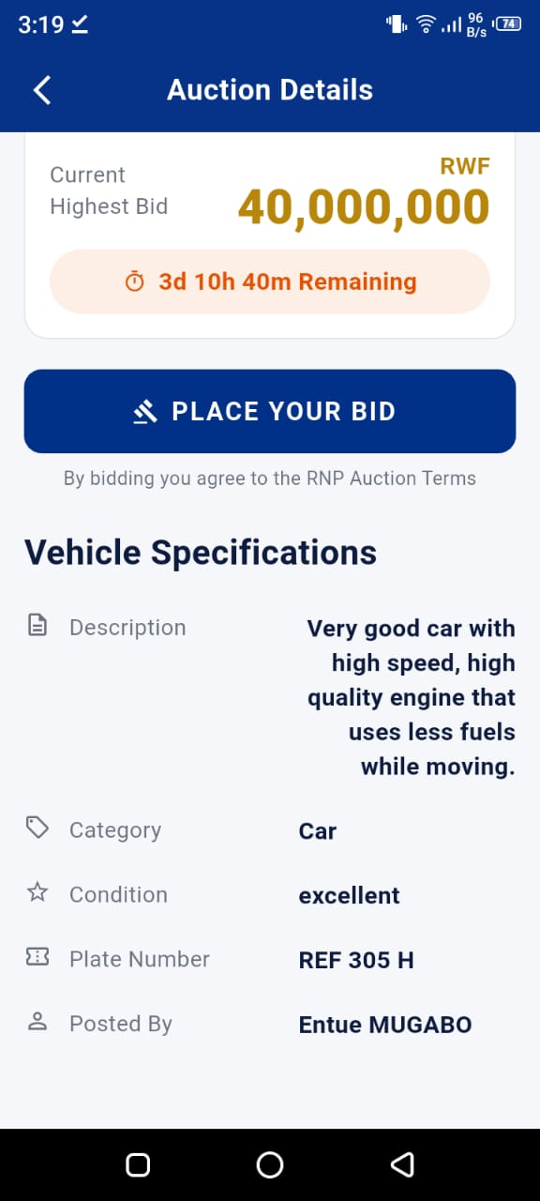
Figure: Auction Detail Screen
4.3.3 Bid Confirmation Screen
Before a bid is submitted, the client is shown a confirmation screen that summarises the bid amount, the auction item, and a reminder that bids cannot be undone. This prevents accidental bids. When the client confirms, the app calls the place-bid Edge Function on Supabase. This function runs on the server and atomically validates the bid amount, updates the auction's current highest bid, and marks all previous bids as 'outbid'. Running this logic on the server is important for security; it means a client cannot manipulate the app to place an invalid bid.
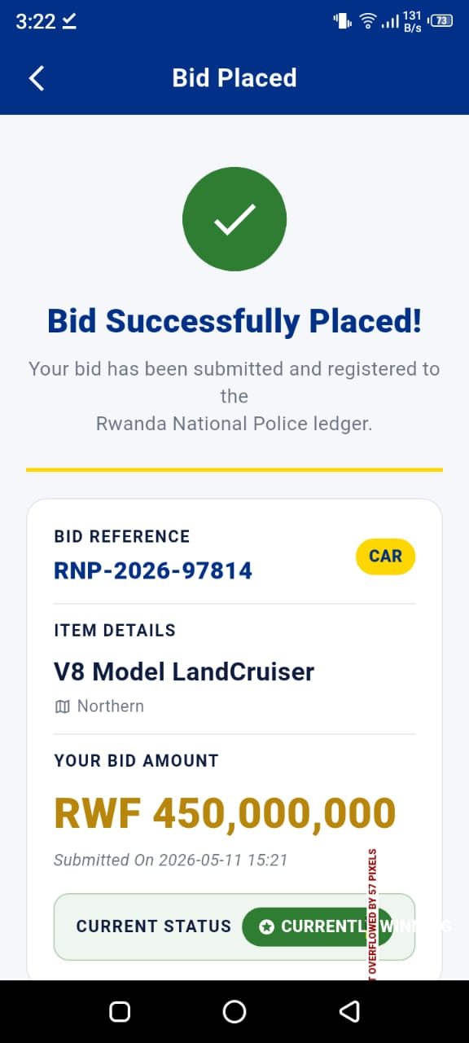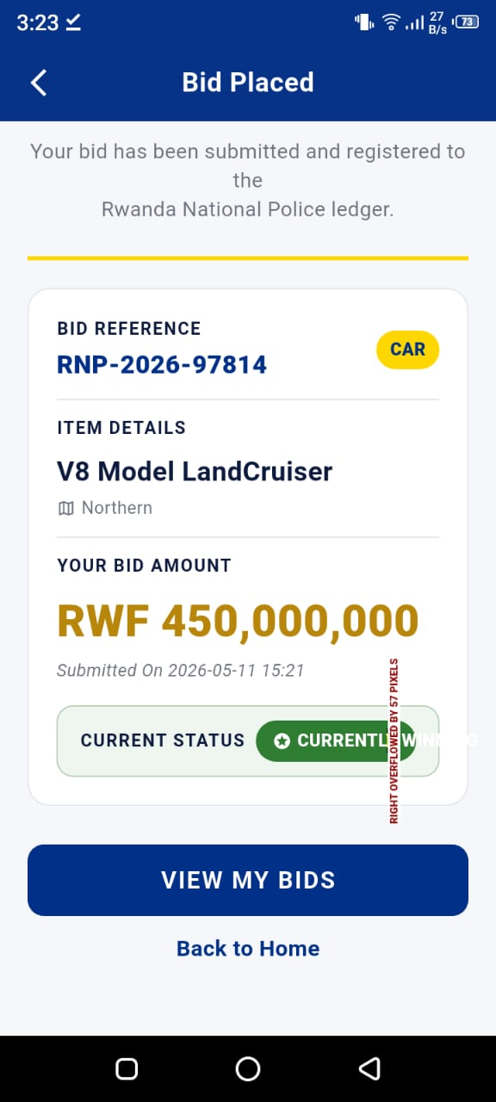
Figure: Bid Confirmation Screen
4.3.4 My Bids Screen
The My Bids Screen shows a history of all bids the client has placed. Each entry shows the auction name, the amount bid, the bid status (winning or outbid), and the date. Summary statistics at the top show the total number of bids placed and how many auctions the client has won. This screen helps clients keep track of their activity and know which auctions they are currently leading.
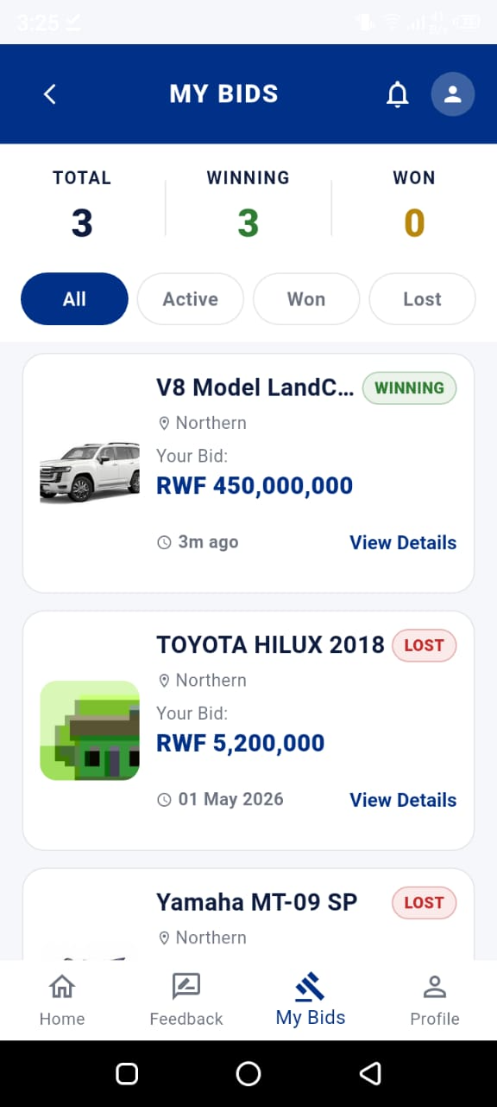
Figure: My Bids Screen
4.3.5 Notifications Screen
Every time a client is outbid or wins an auction, they receive a push notification via OneSignal. The Notifications Screen in the app shows a history of all notifications received. Notifications are stored in the notifications database table and marked as read when the client opens them. Unread notifications are highlighted with a blue dot.
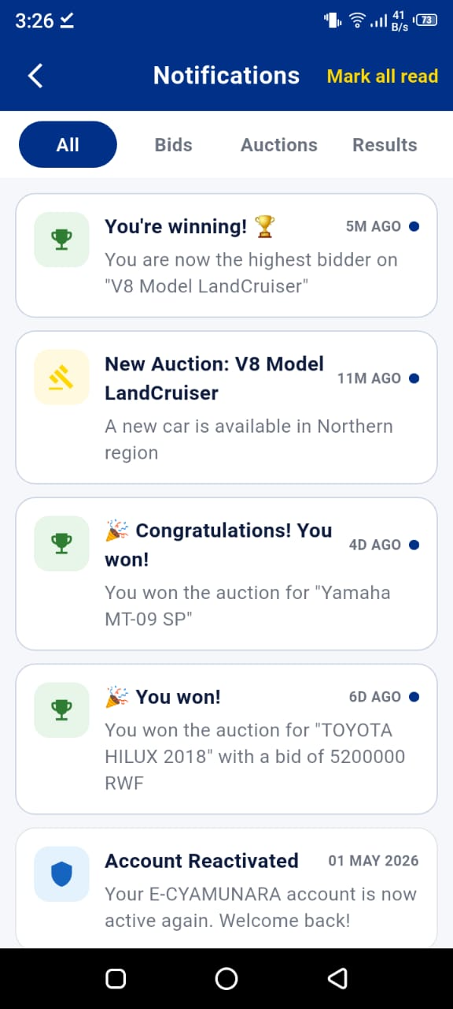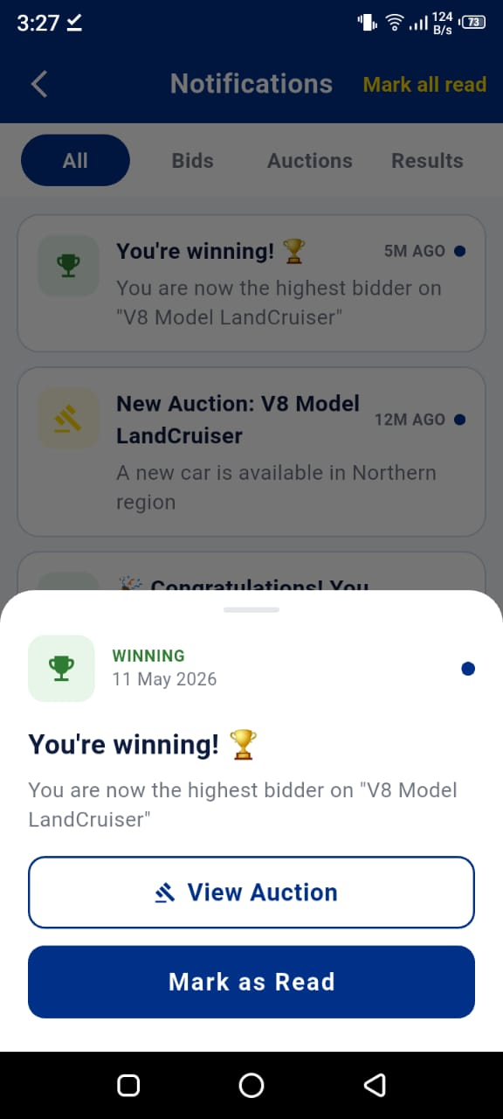
Figure: Notifications Screen (Client)
4.3.6 Feedback Screen
After an auction ends, clients can leave feedback about their experience. The feedback screen includes a 5-star rating, pre-defined feedback tags (such as 'Fair Process', 'Good Communication', 'Would Participate Again'), a free-text comment field limited to 250 characters, and a 'Would you recommend this?' toggle. Feedback can also be submitted independently of any specific auction through a general feedback option. The auction_id field in the database is nullable to support this use case.
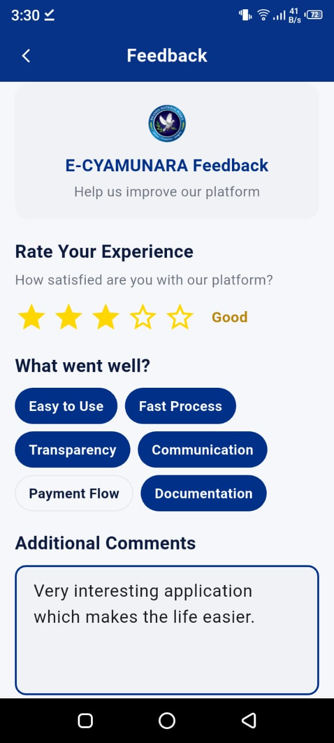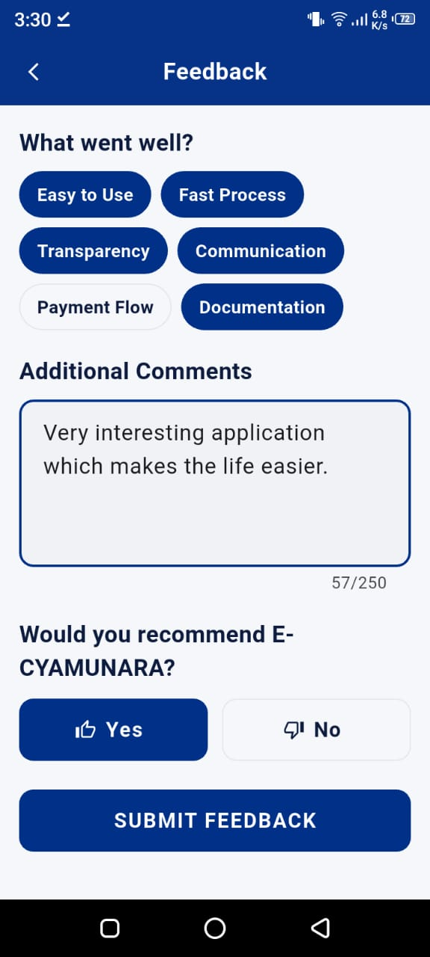
Figure: Feedback Screen
4.3.7 Profile Screen
The Profile Screen allows clients to view and update their personal information. Clients can change their profile photo by selecting an image from their phone's gallery. The image is uploaded to Supabase Storage in the profile-photos bucket. The screen also shows the client's region, district, and account status.
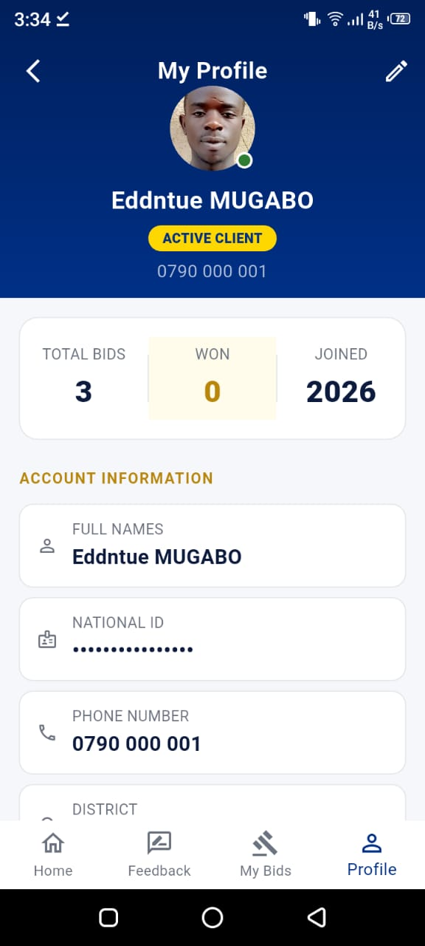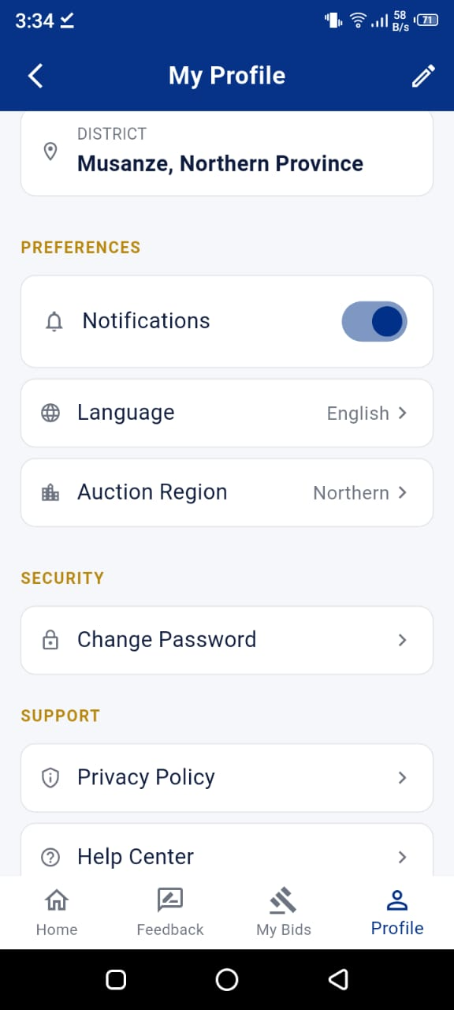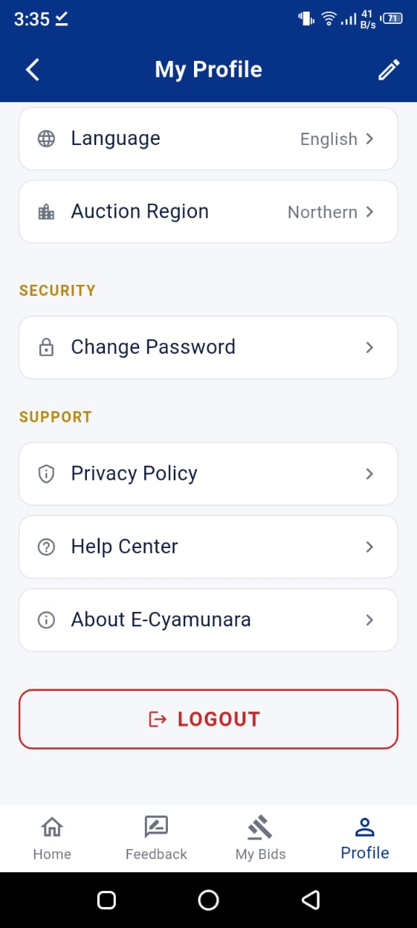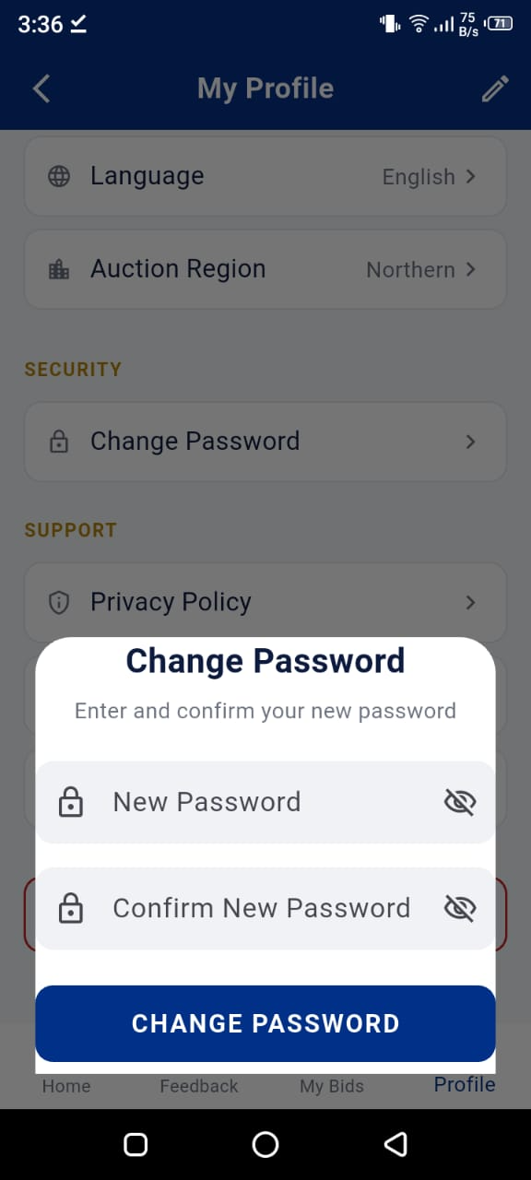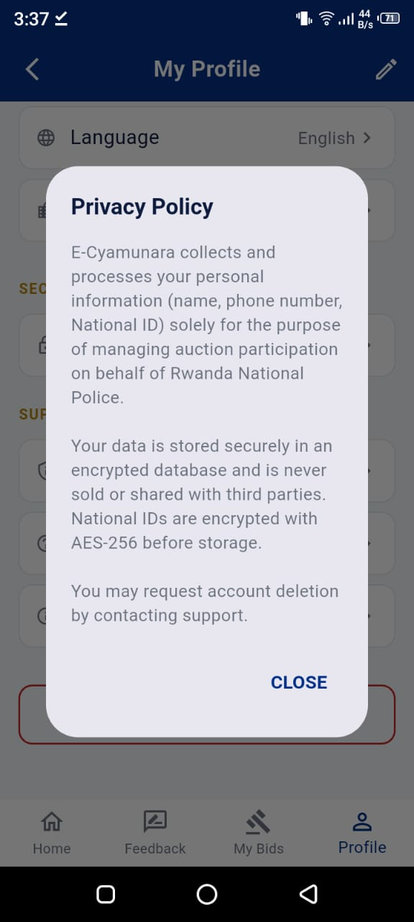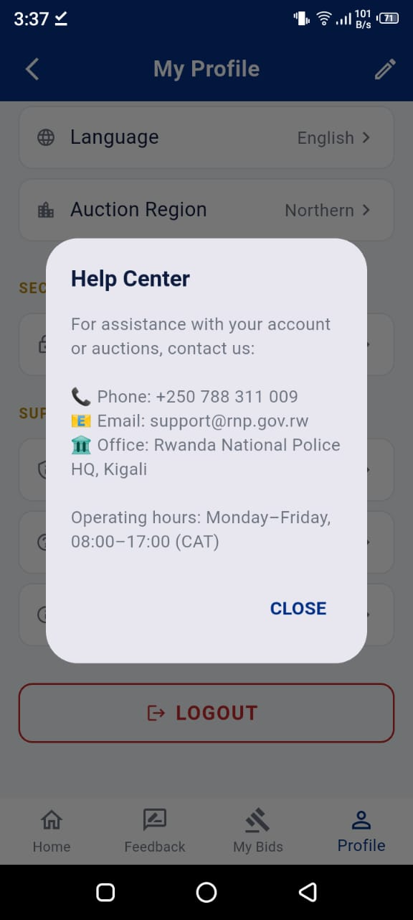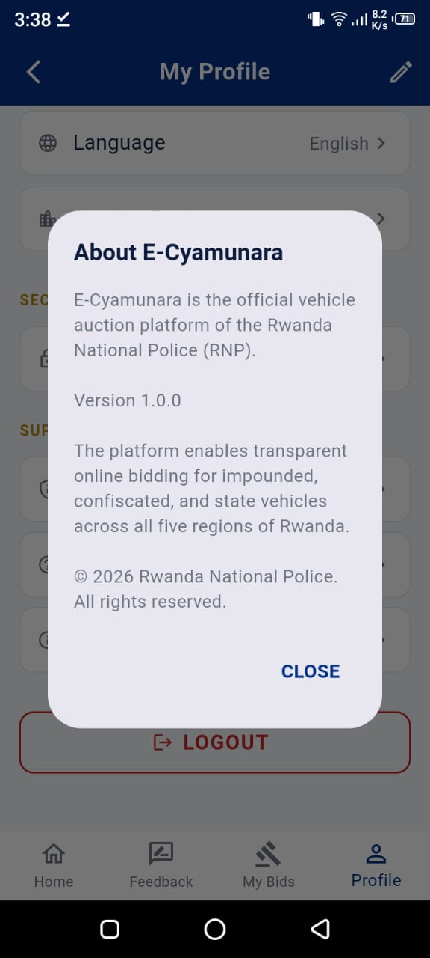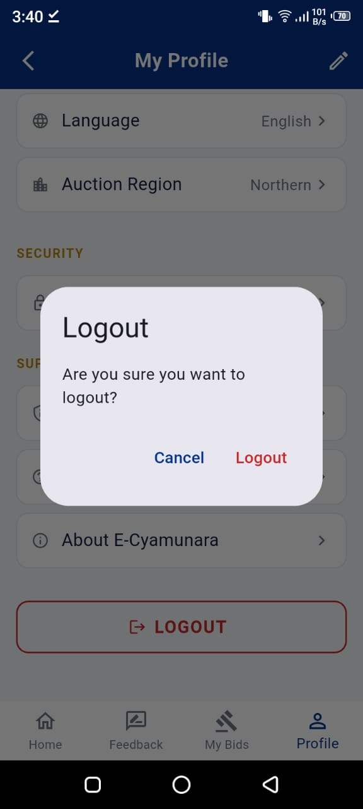
Figure: Client Profile Screen
4.4 Region Admin Module
The Region Admin module gives police officers who manage auctions in a specific region the tools they need to create and manage auctions, handle client accounts, and produce reports. Region Admins are locked to their assigned region by a database trigger — they can only see and manage content within their region.
4.4.1 Admin Dashboard
The Admin Dashboard is the Region Admin's home screen. It shows key statistics for the admin's region: total auctions posted, number of active auctions, total bids placed, and number of registered clients. These figures are loaded dynamically from the database on each visit. Below the statistics, there are quick-action buttons for the most common tasks: Post Auction, Manage Auctions, Client Management, and Reports.
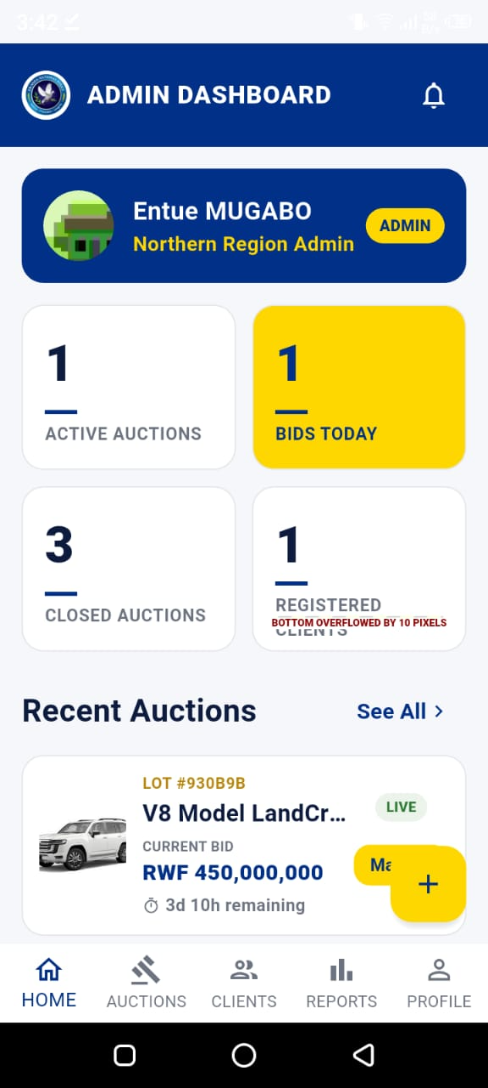
Figure: Region Admin Dashboard
4.4.2 Post Auction Screen
The Post Auction Screen allows a Region Admin to create a new auction. The form includes fields for the item name, category, plate number, condition (Good/Fair/Poor), description, starting price, auction start date, and end date. The admin can also upload up to five photos of the vehicle from their phone's gallery. Photos are uploaded to Supabase Storage in the auction-photos bucket. The auction is saved with a status of 'active' once published.
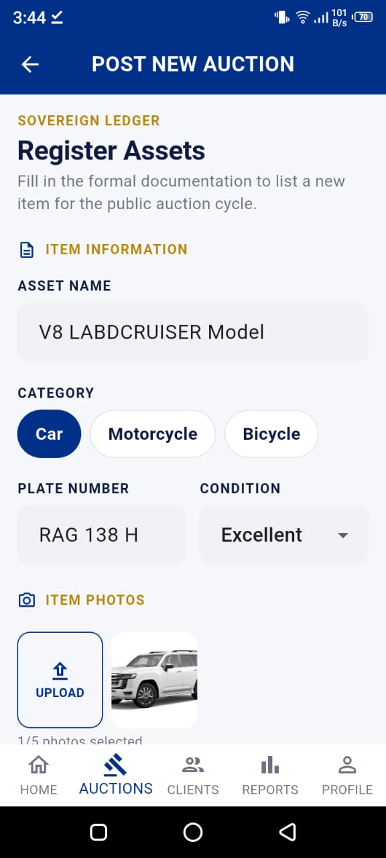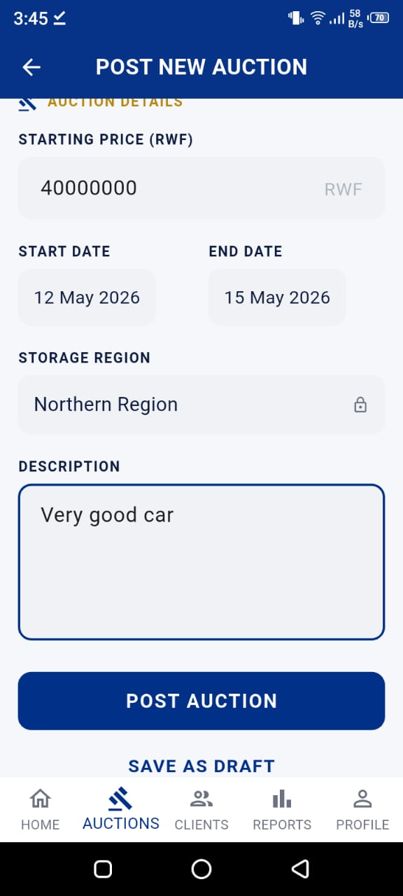
Figure: Post Auction Screen
4.4.3 Manage Auctions Screen
The Manage Auctions Screen shows all auctions posted by the Region Admin. Auctions are displayed in a list with their current status. The admin can tap on any auction to view its full details, or swipe to access options like editing, closing, or cancelling the auction.
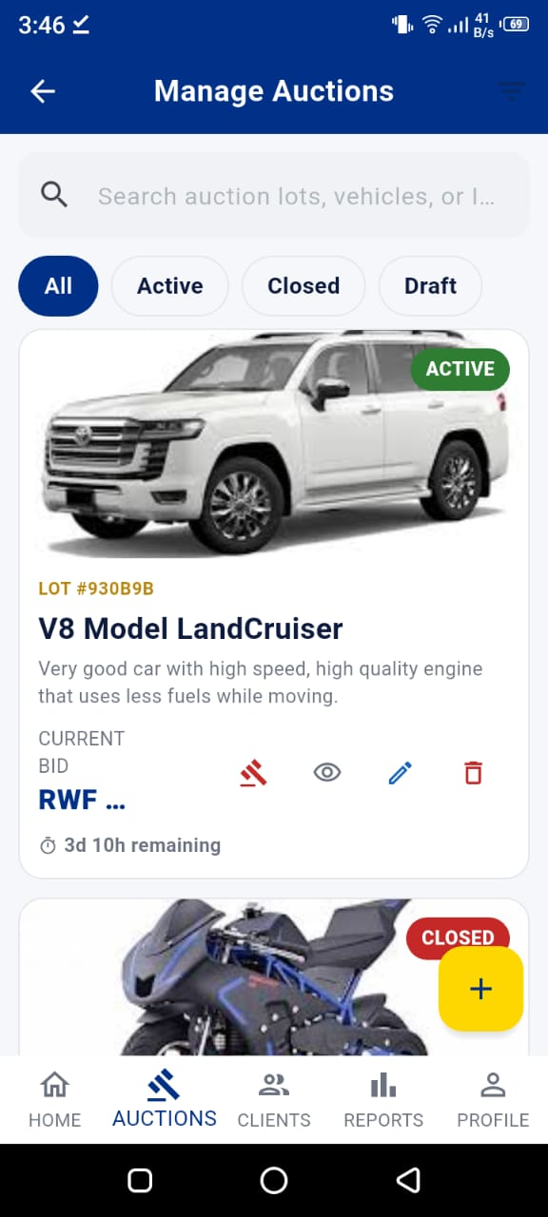

Figure: Manage Auctions Screen
4.4.4 View Bids Screen
From the Manage Auctions screen, the admin can tap any active auction to view all bids placed on it. Bids are shown in descending order with the highest bid at the top. The leading bidder is highlighted. The admin can see each bidder's name, phone number, district, and bid amount, along with the time the bid was placed.
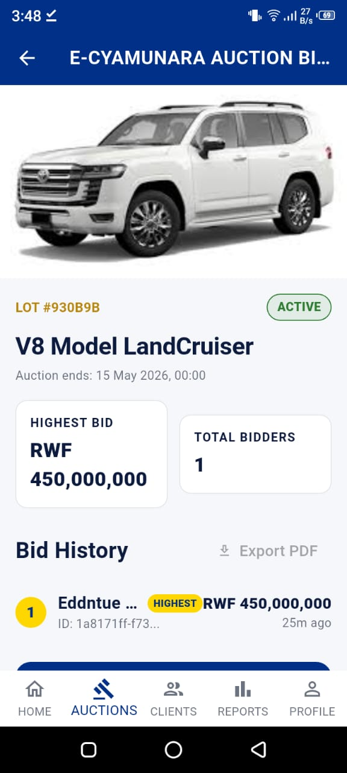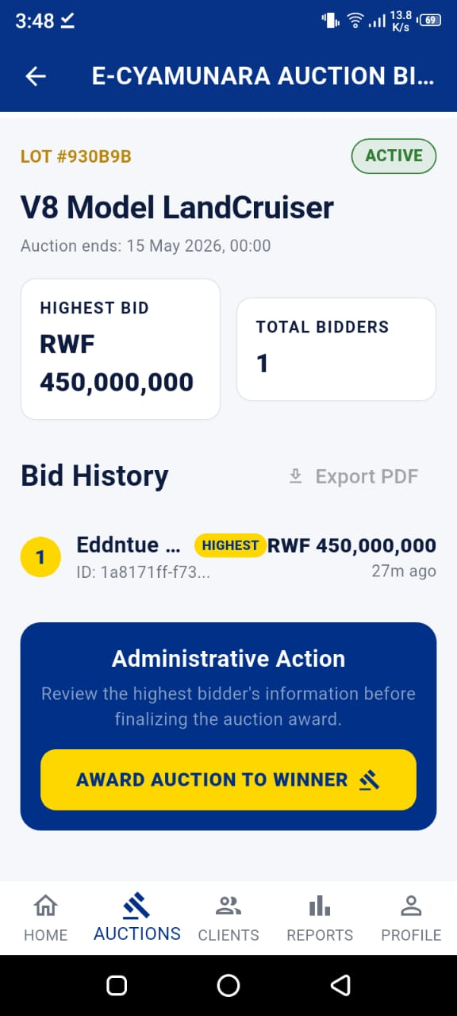
Figure: View Bids Screen
4.4.5 Close Auction Screen
When an auction ends, the Region Admin uses the Close Auction Screen to officially close it. The screen shows the winning bid and the winner's details. The admin can accept the winning bid or, if there is a valid reason, reject all bids and cancel the auction. Closing the auction triggers the close-auction-manually Edge Function, which updates the auction status to 'closed', records the winner information, and sends push notifications to the winner and all outbid participants.
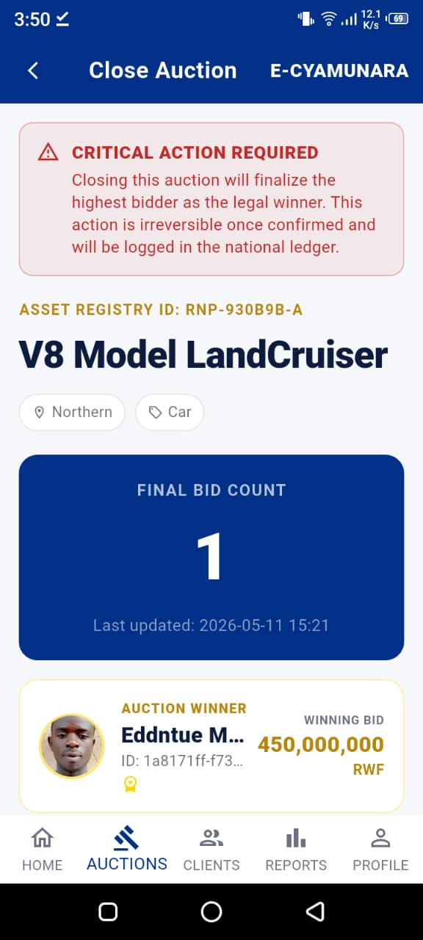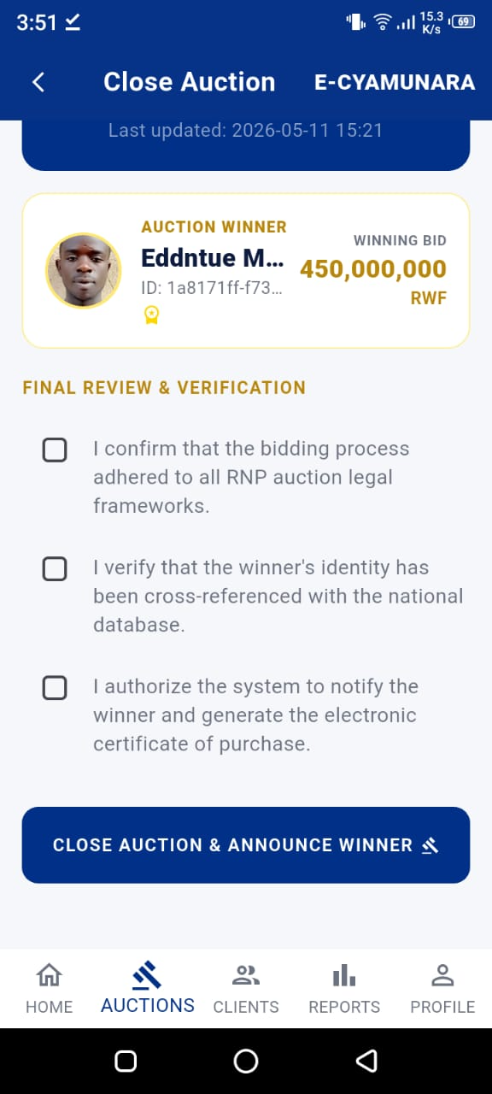

Figure: Close Auction Screen
4.4.6 Client Management Screen
The Client Management Screen shows all registered clients in the admin's region. For each client, the admin can see their name, phone number, district, and account status. Admins can suspend a client account (for example, if a client submitted a fraudulent bid) or reactivate a previously suspended account. Account suspension is handled server-side through the suspend-user and activate-user Edge Functions.
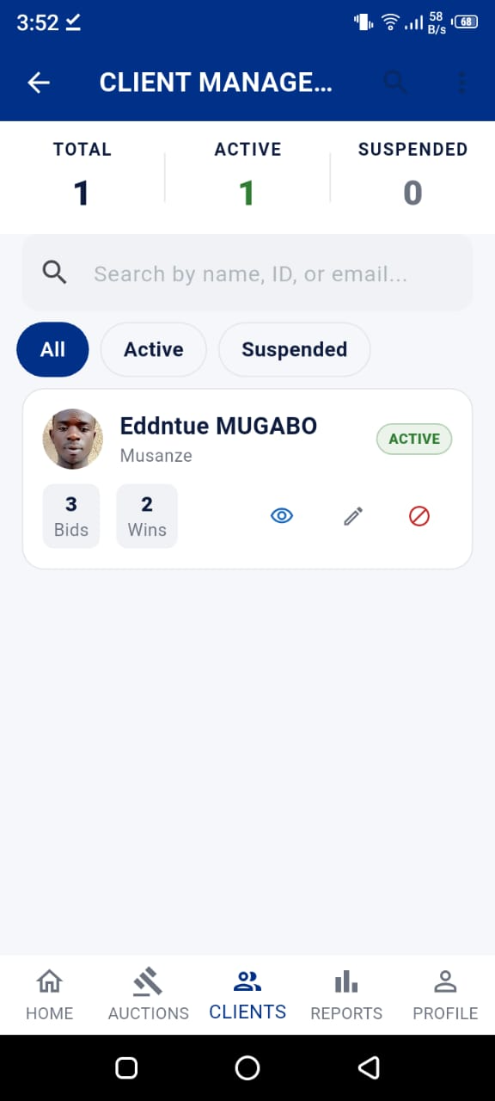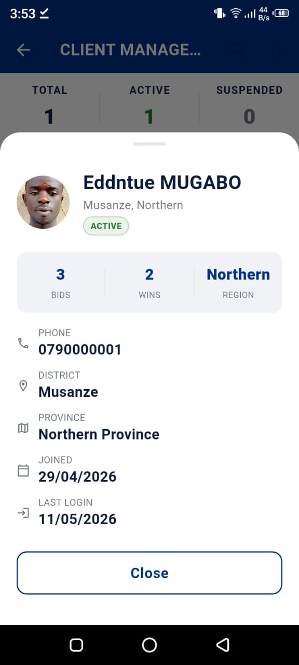
Figure: Client Management Screen
4.4.7 Region Reports Screen
The Region Reports Screen provides the Region Admin with a summary of auction activity in their region. It shows charts for auction statistics (using the fl_chart package), bid activity over time, and category breakdowns. The admin can also generate and download a PDF report for a selected time period. PDF generation uses the pdf and printing packages to create a formatted document that can be saved or shared.
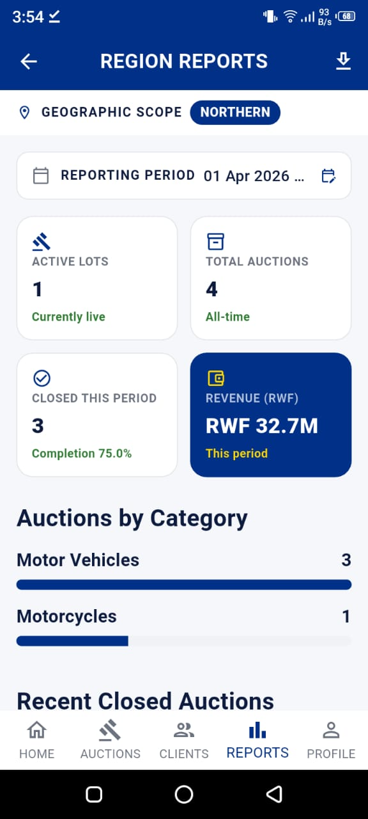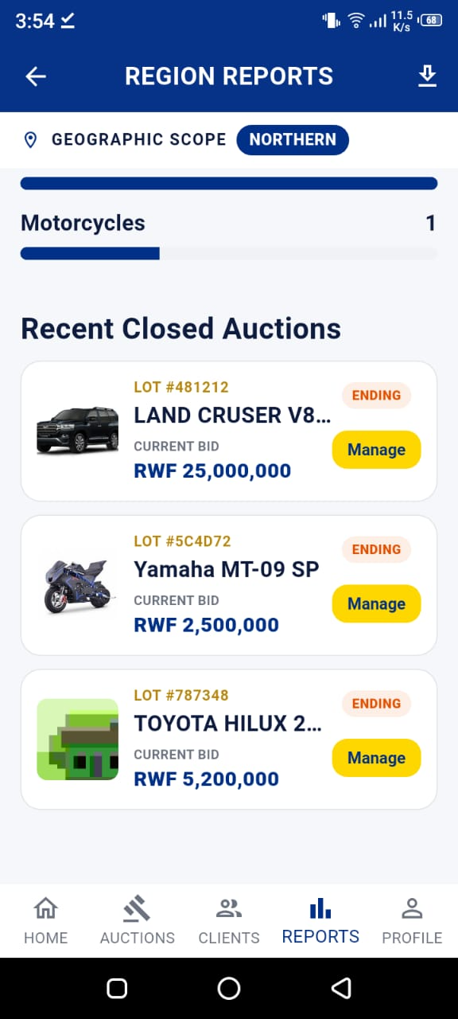
Figure: Region Reports Screen
4.4.8 Client Feedbacks Screen
This screen allows Region Admins to read all feedback submitted by clients in their region. Feedback entries show the rating, tags selected, and comment. This screen was added in the later stages of development when it was realised that admins needed visibility into client satisfaction, not just auction performance numbers.
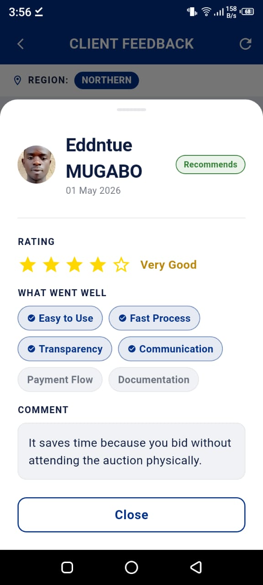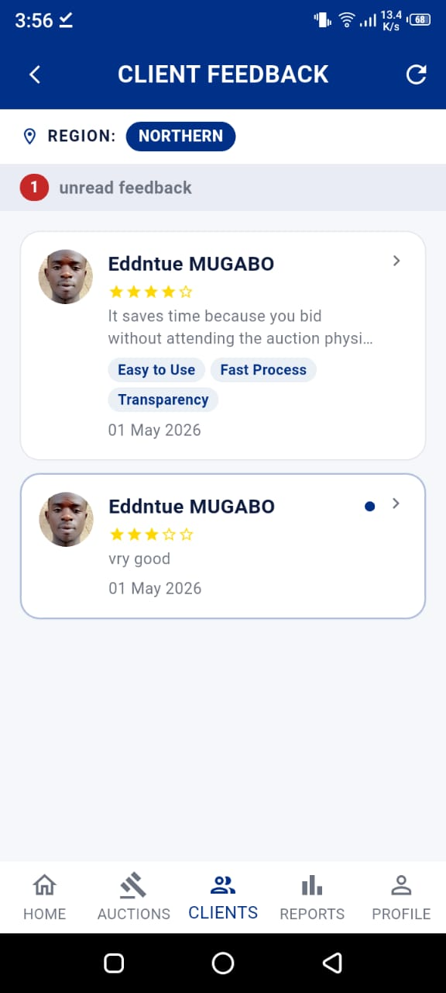

Figure: Client Feedbacks Screen (Admin View)
4.4.9 Admin Profile and Notifications
Like the client module, the admin module includes a Profile Screen for viewing and updating personal information, and a Notifications Screen for viewing system notifications such as new bids placed on their auctions or system alerts from the Super Admin.
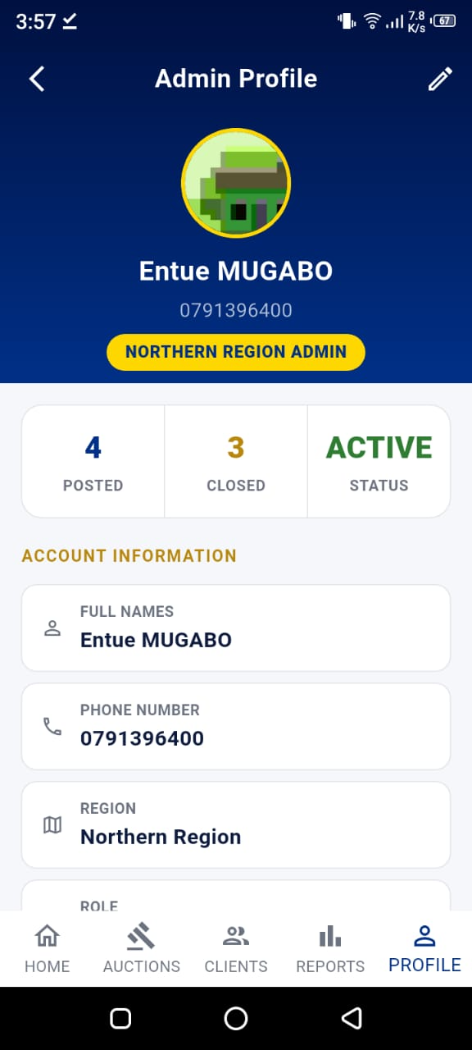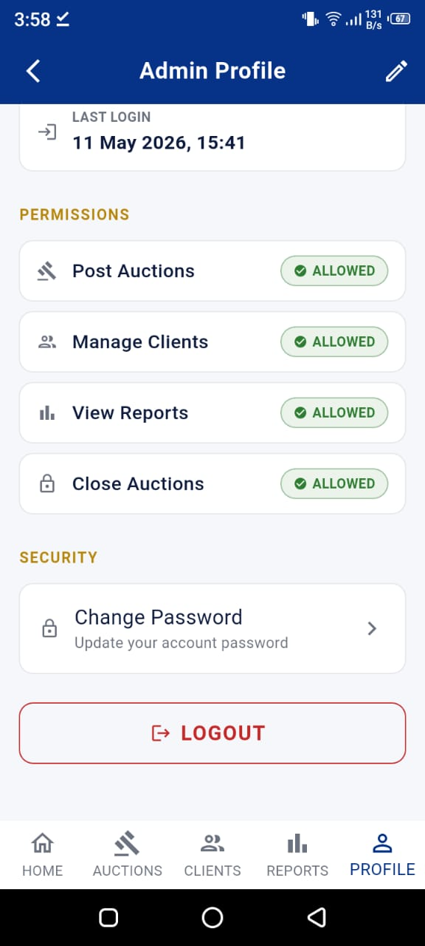
Figure: Admin Profile Screen
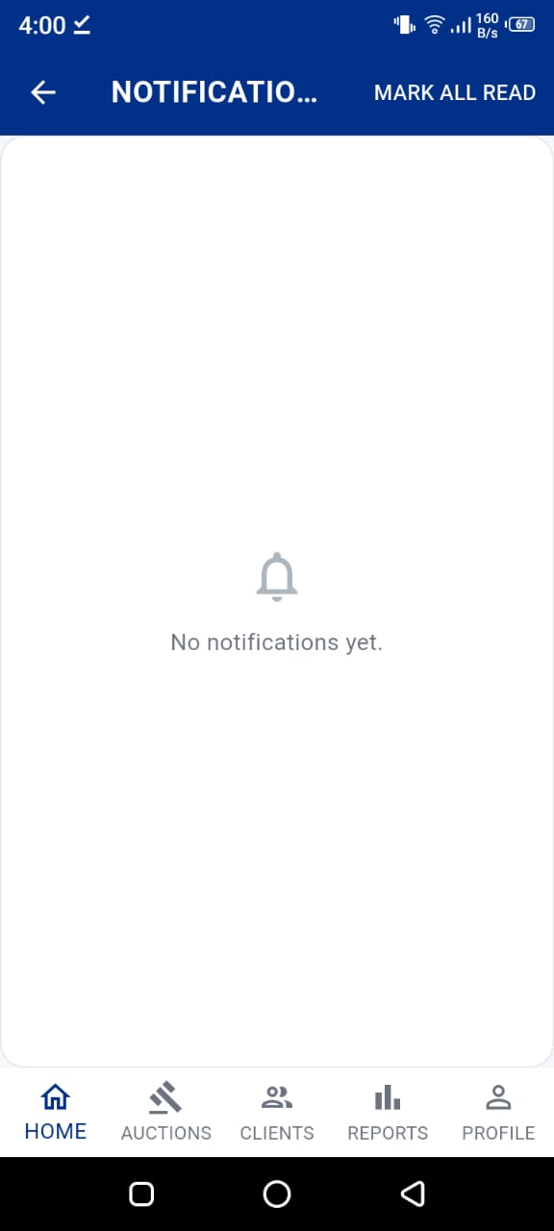

Figure: Admin Notifications Screen
4.5 Super Admin Module
The Super Admin has the highest level of access in the system. This role is for the RNP officer responsible for overseeing the entire national auction system. The super admin module was designed to be minimal and focused — the super admin does not manage individual auctions but instead manages the administrators who do.
4.5.1 Super Admin Dashboard
The Super Admin Dashboard shows national-level statistics: total auctions across all regions, total bids placed nationally, total registered clients, and a breakdown by region. Quick-action cards allow navigation to the key super admin functions.
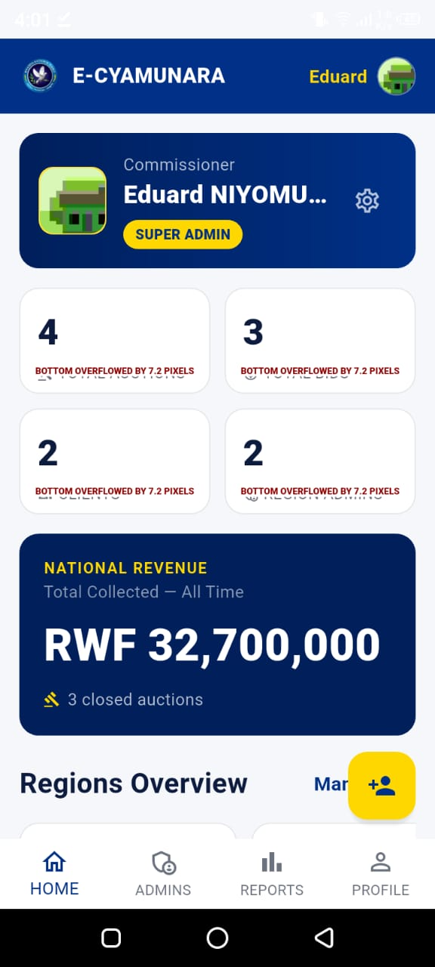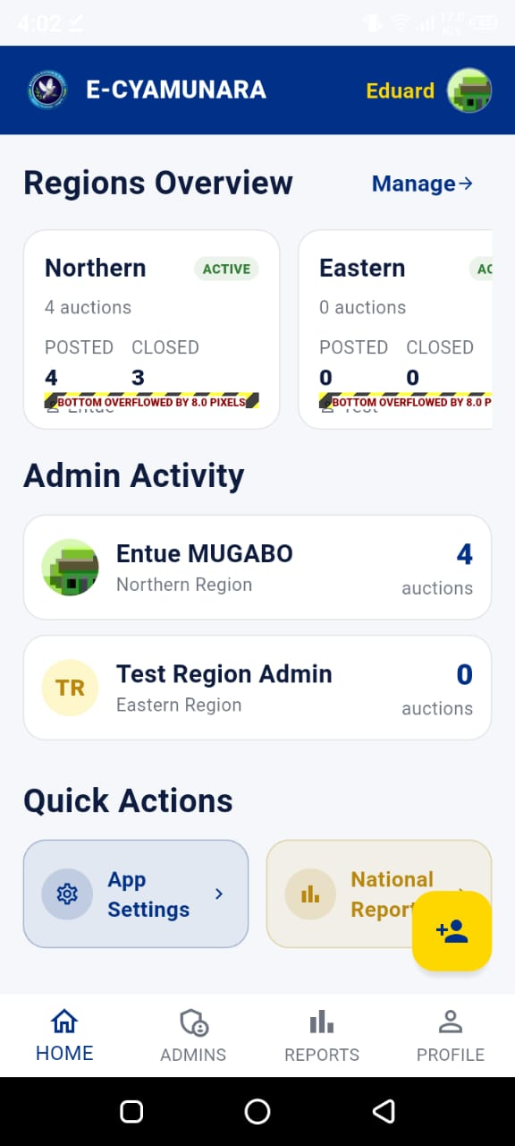
Figure: Super Admin Dashboard
4.5.2 Manage Region Admins Screen
This screen shows all Region Admins currently registered in the system. Each card shows the admin's name, region, account status, and contact details. The super admin can add new region admins (one per region), suspend or reactivate admins, and view their activity statistics.
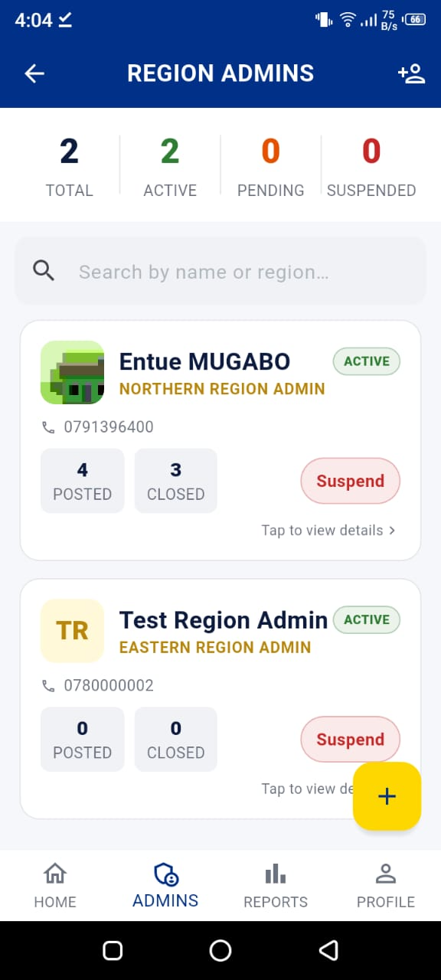
Figure: Manage Region Admins Screen
4.5.3 Add / Edit Admin Screen
The Add Admin Screen is a form for creating a new Region Admin. The super admin enters the new admin's full name, phone number, national ID, and selects their region. The system automatically generates an email and temporary password. Account creation is handled by the create-admin Edge Function using Supabase's service role key, this bypasses Row Level Security and allows the admin account to be created without the admin needing to register themselves.
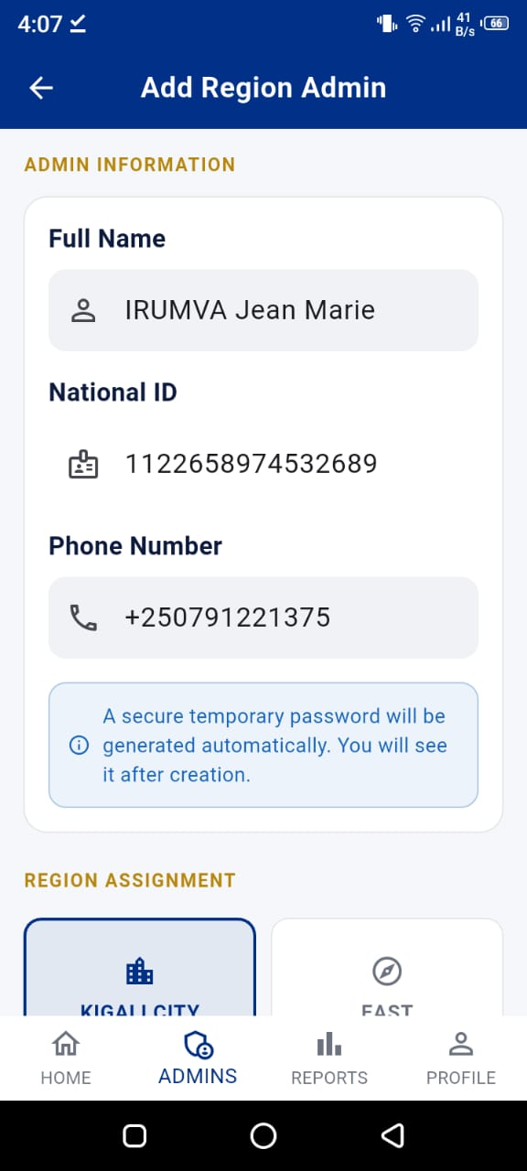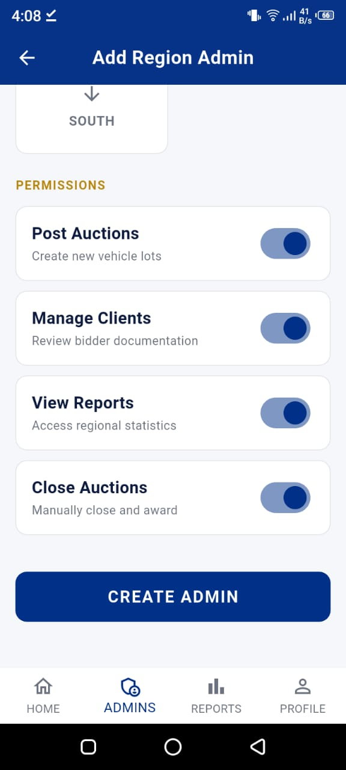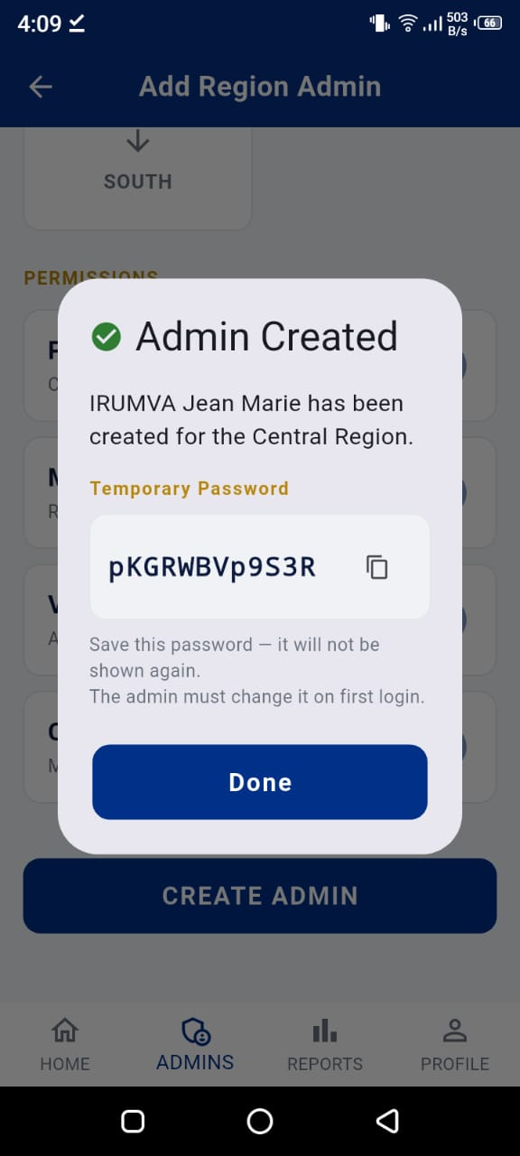
Figure: Add / Edit Admin Screen
4.5.4 National Reports Screen
The National Reports Screen shows charts and statistics aggregated from all five regions. The super admin can compare performance across regions, see which categories are most popular, and identify regions with the highest auction activity. PDF reports can be generated at the national level.
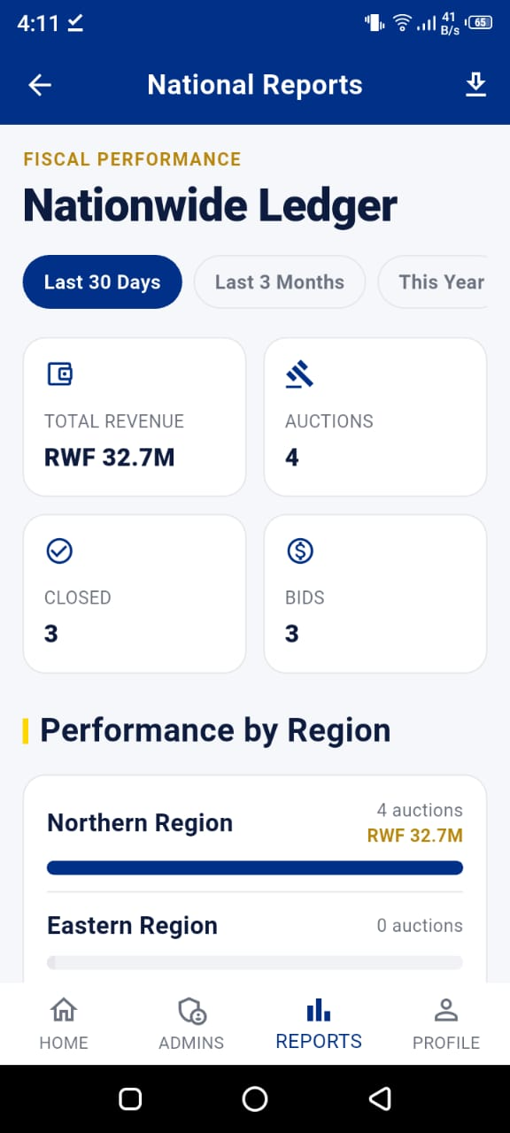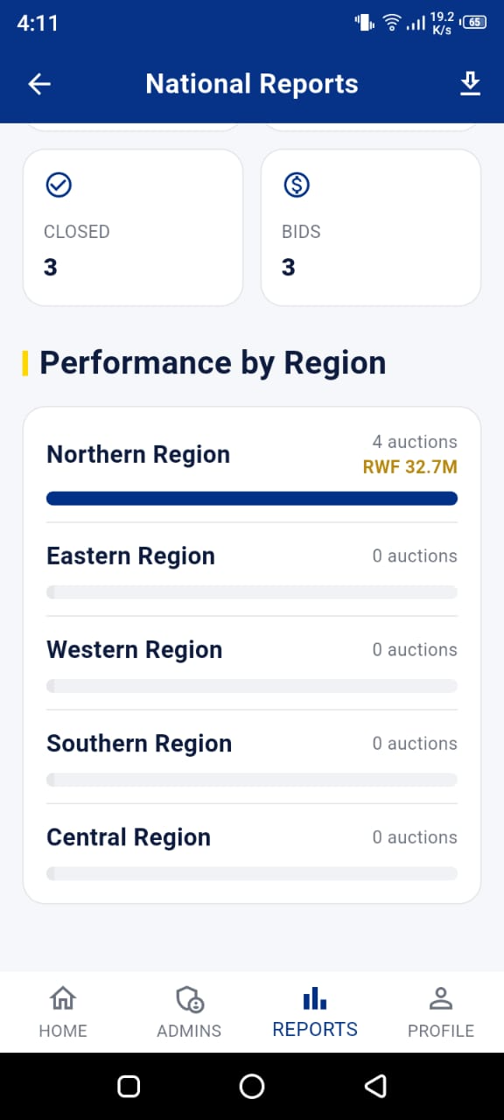
Figure: National Reports Screen
4.5.5 App Settings Screen
This screen allows the super admin to toggle system-wide settings such as maintenance mode (which disables the app for all users except admins), automatic auction closing, and notification settings. These settings are stored in the app_settings table and are read by Edge Functions on the server side.
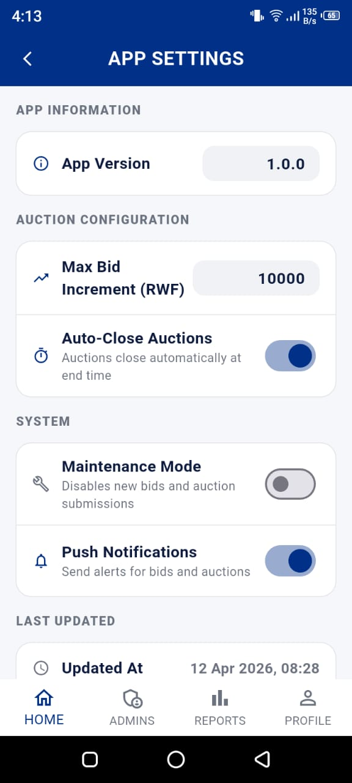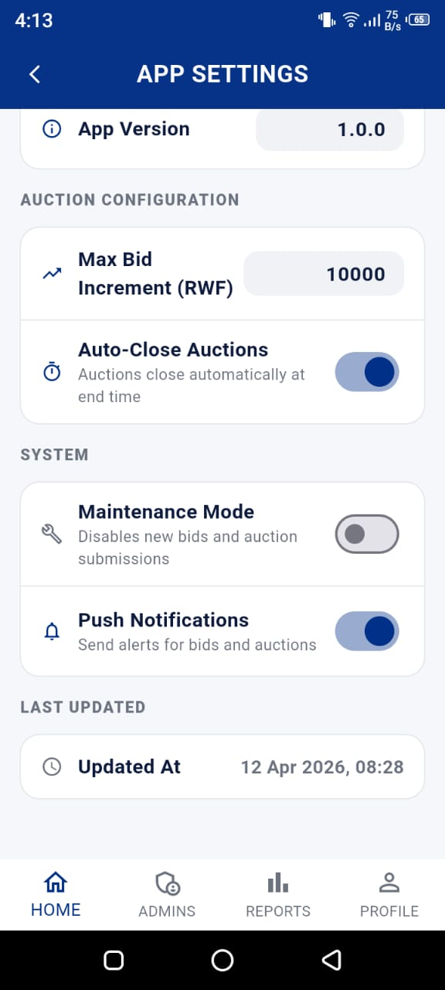

4.6 Notifications and Feedback
Push notifications are sent using OneSignal, a free push notification service. When a client registers, their OneSignal player ID is saved to their user record in the database. When a notification needs to be sent (for example, when a client is outbid), the send-auction-notification Edge Function reads the target client's player ID from the database and uses the OneSignal API to send the notification.
Notification types supported by the system include:
- new_auction: Sent to all clients in a region when a new auction is posted.
- outbid: Sent to a client when another bidder places a higher bid.
- winning: Sent to a client when they become the current highest bidder.
- won: Sent to the winner when an auction is officially closed.
- system: Administrative announcements from the Super Admin.
4.7 Security Implementation
Security was a priority throughout the development of E-CYAMUNARA. The following measures were implemented:
- Database Security: Row-Level Security (RLS): Every database table has RLS policies that restrict what each user can read and write. A client cannot read another client's data.
- Data Encryption: National ID encryption: National ID numbers are encrypted using AES-256 before being stored. The encryption key is stored in the device's secure keystore (flutter_secure_storage), not in the database.
- Bid Security: Server-side bid validation: Bids are not placed directly by the client app. Instead, the app calls the place-bid Edge Function, which validates the bid on the server. This prevents a client from modifying the app to place invalid bids.
- Account Control: Account suspension: Suspended accounts are checked on every navigation event. A suspended user is automatically signed out the next time they try to use the app.
- Role Integrity: Role locking: Database triggers prevent a Region Admin's region from being changed after creation, and prevent the last Super Admin from being deleted.
- Admin Creation: Admin creation via Edge Function: Region Admin accounts cannot be created through the normal registration flow. They must be created by the Super Admin through the create-admin Edge Function, which uses a service role key with elevated privileges.
4.8 Performance and Responsiveness
To ensure the application works well on a range of Android devices, including older phones running Android 7 (the minimum supported version), we applied the following strategies:
- Image caching: The cached_network_image package caches auction photos locally after the first load, so they do not need to be downloaded again.
- Role caching: The user's role is cached for 5 seconds in memory to reduce the number of Supabase queries made during navigation.
- Responsive layouts: All screens use Flutter's flexible layout widgets (Expanded, Flexible, SingleChildScrollView) to adapt to different screen sizes and keyboard states.
- Loading and empty states: Every screen that fetches data from Supabase shows a loading spinner while waiting and a friendly empty state message if there is no data to display.
- 15-second timeout: All Supabase calls have a timeout to prevent the app from freezing if the network is slow.

CHAPTER FIVE: TESTING AND RESULTS
5.1 Testing Strategy
Testing was conducted throughout the development process rather than as a single phase at the end. We used a combination of functional testing, UI testing, and device testing on real Android hardware. Because this was a university project without a formal QA team, all testing was performed by the development team members.
5.2 Functional Testing
Functional testing verified that each feature works as specified in the requirements. The following table shows the key test cases, expected results, and actual results:
Test ID | Feature Tested | Expected Result | Actual Result | Status
TC-01 | Client registration | Account created, redirect to region select | Account created, redirect to region select | PASS
TC-02 | Client login | Redirect to Client Home Screen | Redirect to Client Home Screen | PASS
TC-03 | Admin login | Redirect to Admin Dashboard | Redirect to Admin Dashboard | PASS
TC-04 | Super Admin login | Redirect to Super Admin Dashboard | Redirect to Super Admin Dashboard | PASS
TC-05 | Place valid bid | Bid saved, auction updated, outbid notification sent | All behaviours confirmed | PASS
TC-06 | Place bid lower than current | Error shown, bid rejected | Inline error displayed | PASS
TC-07 | Post auction with photos | Auction created and visible to clients | Auction appears on client home | PASS
TC-08 | Close auction | Winner recorded, notifications sent | Winner saved, notifications sent via OneSignal | PASS
TC-09 | Suspend client account | Client cannot log in | Client is signed out on next navigation | PASS
TC-10 | Password reset | Password updated, can log in with new password | Reset successful | PASS
TC-11 | Submit feedback | Feedback saved in database | Feedback visible in admin feedbacks screen | PASS
TC-12 | Generate region report | PDF generated and available for download | PDF generated successfully | PASS
TC-13 | Forgot password error (SnackBar hidden) | Error visible to user | Error now shown inline (fixed) | PASS
TC-14 | Non-auction feedback (no auction_id) | Feedback saved without auction reference | Saved after DB migration to make auction_id nullable | PASS

5.3 Device Testing
In addition to testing in the Android emulator within Android Studio, we conducted testing on real Android devices using wireless ADB debugging. Wireless ADB allows a phone to be connected to the development computer over Wi-Fi, so the Flutter app can be installed and debugged without a USB cable. This was particularly useful for testing in real-world conditions.
Devices used for testing:
Device | Android Version | Screen Size | Result
Samsung Galaxy A32 | Android 11 | 6.4 inch | All screens functional
Tecno Camon 19 Pro | Android 12 | 6.8 inch | All screens functional
Samsung Galaxy J7 Pro | Android 8.1 | 5.5 inch | All screens functional, some overflow fixed
Android Emulator | Android 14 | 5.5 inch (virtual) | Used for initial development testing

Testing on older devices (Android 7 and 8) revealed some layout overflow issues that were not visible on newer devices with larger screens. These issues are documented in detail in Chapter Six (Challenges Faced).

CHAPTER SIX: CHALLENGES FACED
Software development rarely goes exactly as planned. This chapter documents the real challenges we encountered during the development of E-CYAMUNARA and explains how we resolved each one. These challenges were not failures; they were learning opportunities that made the final product more robust.
Challenge 1: RenderFlex Overflow Errors
Problem:
Several screens showed 'RenderFlex overflowed by X pixels' errors on smaller devices and when the keyboard was open. This happened most often on the login screen, the password reset bottom sheet, and the My Bids screen.
Root Cause:
The overflow occurred because we were using fixed-height containers inside Column widgets without wrapping them in Expanded or SingleChildScrollView. When the keyboard appeared, it reduced the available screen height, causing the remaining content to overflow.
Solution:
We replaced fixed-height containers with flexible widgets. For screens that need to scroll, we wrapped the Column content in a SingleChildScrollView. For the password reset bottom sheet specifically, we added padding based on MediaQuery.of(context).viewInsets.bottom at the root of the widget not inside the scroll view which was the key fix.

Challenge 2: SnackBar Hidden Behind Bottom Sheet
Problem:
Error messages on the password reset bottom sheet were not visible to users because we were using ScaffoldMessenger.showSnackBar() inside the modal bottom sheet. Users saw no error even when one occurred.
Root Cause:
Snackbars rendered behind the modal bottom sheet because the sheet sits on top of the Scaffold in the widget hierarchy, and the Snackbar was being displayed at the bottom of the Scaffold behind the sheet.
Solution:
We replaced all Snackbar error messages inside bottom sheets with inline error Text widgets that appear directly within the sheet's content. This change made errors immediately visible to the user without requiring any navigation or dismissal.

Challenge 3: feedback.auction_id NOT NULL Constraint
Problem:
Clients were unable to submit general feedback (feedback not related to any specific auction). The feedback form allowed the auction_id to be empty, but the database rejected the insert because auction_id was defined as NOT NULL.
Root Cause:
The original database schema was designed assuming all feedback would be tied to an auction. The use case of general feedback was added later during development, but the database schema was not updated to match.
Solution:
We ran a database migration (ALTER TABLE feedback ALTER COLUMN auction_id DROP NOT NULL) to make the column nullable. We also updated the Dart model's toMap() method to omit the auction_id key from the insert map when it is empty, rather than sending a null value.

Challenge 4: Black Screen on App Startup (Android 7)
Problem:
On some Android 7 devices, the app showed a black screen for 5-10 seconds on startup before loading the login screen. This made the app appear broken to users.
Root Cause:
The app router was making three separate Supabase database queries on every navigation event to determine the user's role. On slower devices and networks, these queries took several seconds, and during this time the router returned null (no route), causing a black screen.
Solution:
We implemented a 5-second in-memory role cache in the app router. Once the role is determined, it is cached and reused for subsequent navigation events within 5 seconds. We also added a 15-second timeout on all Supabase calls and improved the splash screen animation so the app appears responsive even while the role is being determined.

Challenge 5: GoTrue MX Email Validation Rejecting Fake Email Domains
Problem:
Supabase Auth's GoTrue server (v2.188.1+) added automatic MX record validation for email addresses. Our system converts phone numbers to fake internal emails (e.g., rw0782345678@ecyamunara.rw), but these emails do not have real MX records, so GoTrue rejected them.
Root Cause:
The ecyamunara.rw domain does not exist as a real email domain, so the MX lookup fails and GoTrue rejects the registration.
Solution:
We worked around this by routing all user registration and creation through Supabase Edge Functions using the service role (admin) client. The admin.createUser() method bypasses MX validation, allowing fake internal email addresses to be used for authentication purposes.

Challenge 6: Real-time Bid Updates and State Synchronisation
Problem:
When a new bid was placed, the auction detail screen did not always show the updated highest bid immediately. Other clients on the same auction saw stale data.
Root Cause:
We were using FutureProvider for auction data, which only fetches once and does not update when the database changes. Multiple providers were also holding separate copies of auction data without being linked.
Solution:
We converted auction list providers to StreamProvider backed by Supabase Realtime subscriptions. When the bids table is updated, the stream emits a new event, which triggers a widget rebuild. We also invalidated related providers after bid placement to ensure all parts of the app saw the updated data.

Challenge 7: Region Admin Region Locking
Problem:
During early development, it was possible for a Region Admin to change their assigned region, which would give them access to auctions and clients in a different region than the one they were authorised for.
Root Cause:
The region field in the region_admins table was editable just like any other field. There was no database-level enforcement preventing changes.
Solution:
We added a PostgreSQL trigger (lock_admin_region) that fires on any UPDATE to the region_admins table and raises an exception if an attempt is made to change the region column. This is enforced at the database level and cannot be bypassed by the Flutter app.

Challenge 8: Wireless ADB Setup for Physical Device Testing
Problem:
Setting up wireless debugging between the development laptop and Android phones was initially confusing, especially for Android 7 devices which use a different wireless ADB connection method than Android 11+.
Root Cause:
Android 7 does not support the built-in wireless debugging feature introduced in Android 11. It requires a different setup: first connect via USB, enable ADB over TCP/IP, then disconnect the USB and reconnect wirelessly.
Solution:
We followed the older method: connected via USB, ran 'adb tcpip 5555', disconnected USB, found the phone's IP address in Wi-Fi settings, and ran 'adb connect [IP]:5555'. Once connected wirelessly, flutter run detected the device normally. We documented this process for the team so all members could test on physical devices.

CHAPTER SEVEN: FUTURE IMPROVEMENTS
The current version of E-CYAMUNARA provides a working and tested system for online vehicle auctions. However, as with any software product, there is always room for improvement. The following enhancements are planned for future versions:
Feature | Description | Priority
Mobile Money Integration | Allow winning bidders to pay directly through the app using MTN Mobile Money or Airtel Money. This would complete the end-to-end process within the app. | High
Kinyarwanda Localisation | Add a full Kinyarwanda translation of the app interface so that citizens who are more comfortable reading in Kinyarwanda can use the app easily. | High
SMS Alerts | Send SMS notifications to users who do not have the app installed, alerting them about new auctions and bid updates. | Medium
AI Bid Prediction | Analyse historical bid data to suggest a competitive starting bid amount or predict the likely final price of an auction. | Medium
Offline Support | Cache auction listings locally so clients can browse available auctions even when they have no internet connection. | Medium
Live Auction Streaming | Allow Region Admins to stream live video of an auction item so remote bidders can see the vehicle in real time before bidding. | Low
AI Fraud Detection | Use machine learning to identify unusual bidding patterns that may indicate bid manipulation or shill bidding. | Low
Email Notifications | Send email summaries of bid activity and auction results to users who prefer email over push notifications. | Medium
PDF Invoice Generation | Automatically generate a PDF invoice for winning bidders as proof of their winning bid for administrative purposes. | High
Expanded Categories | Add more auction categories beyond Cars, Motorcycles, and Bicycles — such as boats, heavy machinery, or electronic equipment. | Low
Analytics Dashboard | Provide super admins with a richer analytics dashboard with trends, forecasts, and comparative analysis across years. | Medium

CHAPTER EIGHT: CONCLUSION
E-CYAMUNARA set out to solve a real problem: Rwanda National Police vehicle auctions were slow, inaccessible, and paper-based. By building a mobile application that puts the entire auction process on a smartphone, we have created a system that is more transparent, more accessible, and more efficient than anything that existed before.
The application we built is not a simple demo, it is a production-ready system with real security measures, a proper database design with Row-Level Security, server-side business logic running as cloud functions, real-time data updates, push notifications, PDF report generation, and an encrypted storage mechanism for sensitive personal data. It handles three different types of users with completely separate experiences and permissions, all enforced at both the application and database levels.
Throughout the development journey, we encountered and resolved eight significant technical challenges from layout overflow issues to authentication system changes that broke our email format, to database constraints that required schema migrations. Each challenge taught us something new about Flutter, Supabase, PostgreSQL, or software architecture in general.
As a team, we grew significantly as developers during this project. We learned how to:
- Design and implement a Clean Architecture mobile application from scratch.
- Work with a cloud backend (Supabase) including authentication, storage, real-time subscriptions, and server-side functions.
- Implement production-quality security measures including AES-256 encryption, Row-Level Security, and Role-Based Access Control.
- Debug complex issues that span the full stack from Flutter widget layout to PostgreSQL trigger logic.
- Test applications on real Android devices using wireless debugging.
- Collaborate as a four-person team, dividing responsibilities and integrating work across multiple modules.
We believe E-CYAMUNARA demonstrates that university students in Rwanda can build software of genuine national value. With further development, particularly the addition of mobile money payments and Kinyarwanda language support; this application could be deployed as a real service used by Rwandan citizens and the Rwanda National Police.
We are proud of what we built, grateful for the learning experience, and excited to apply these skills in our professional careers as software engineers.

REFERENCES
- Balachandran, S., & Prasad, N. (2017). Challenges and benefits of deploying cloud computing in health care: A review. In 2017 International Conference on Research and Innovation in Information Systems (ICRIIS). IEEE. https://doi.org/10.1109/ICRIIS.2017.8002519
- Flutter Team. (2024). Flutter documentation. Google. https://docs.flutter.dev
- Google. (2024). Dart programming language. Google. https://dart.dev
- Lucking-Reiley, D. (2000). Auctions on the Internet: What's being auctioned, and how? The Journal of Industrial Economics, 48(3), 227–252. https://doi.org/10.1111/1467-6451.00122
- Milgrom, P. R. (1989). Auctions and bidding: A primer. Journal of Economic Perspectives, 3(3), 3–22. https://doi.org/10.1257/jep.3.3.3
- Riverpod Contributors. (2024). Riverpod: A reactive caching and data-binding framework for Flutter & Dart. https://riverpod.dev
- Rwanda Information Society Authority (RISA). (2020). Smart Rwanda master plan 2020-2024. Ministry of ICT and Innovation, Republic of Rwanda.
- Supabase Inc. (2024). Supabase documentation. Supabase. https://supabase.com/docs
- Supabase Inc. (2024). Row level security in PostgreSQL. Supabase. https://supabase.com/docs/guides/database/row-level-security
- Vandiver, B., & Hacker, R. (2021). PostgreSQL: Up and running (3rd ed.). O'Reilly Media.
- VanderZanden, B. (2018). GoRouter: A declarative routing package for Flutter. https://pub.dev/packages/go_router
- World Bank. (2021). Digital Rwanda: Transforming public services through technology. World Bank Publications.
- Yaroslav Shmarov. (2023). Flutter Riverpod 2.0: The ultimate guide. Code with Andrea. https://codewithandrea.com/articles/flutter-riverpod-2-ultimate-guide/
- International Telecommunication Union. (2023). Measuring digital development: Facts and figures 2023. ITU Publications. https://www.itu.int/itu-d/reports/statistics/facts-figures-2023/
- OneSignal Inc. (2024). OneSignal push notification documentation. https://documentation.onesignal.com
- Sentry Inc. (2024). Sentry Flutter SDK documentation. https://docs.sentry.io/platforms/flutter/

