МИНОБРНАУКИ РОССИИ
Санкт-Петербургский государственный
электротехнический университет
«ЛЭТИ» им. В.И. Ульянова (Ленина)
Кафедра Вычислительной техники
отчет
по лабораторной работе № 7
по дисциплине «Построение отчетов
в PDF- и HTML- форматах»
Тема: Создание отчетов на языке Java
Студент гр. 4312 | Устинов В. А.
Преподаватель | Лазарев Э. А.

Санкт-Петербург
2025

Цель работы
Знакомство со способами формирования отчетов с использованием конструктора Jaspersoft iReport Designert.
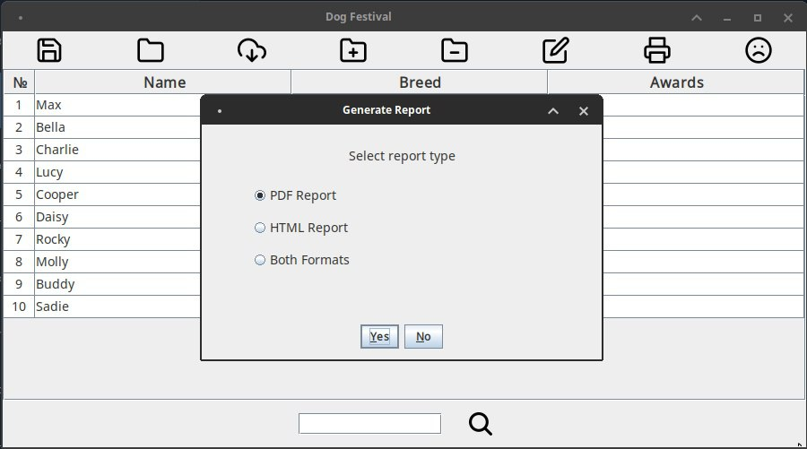
Создание отчета через экранную форму
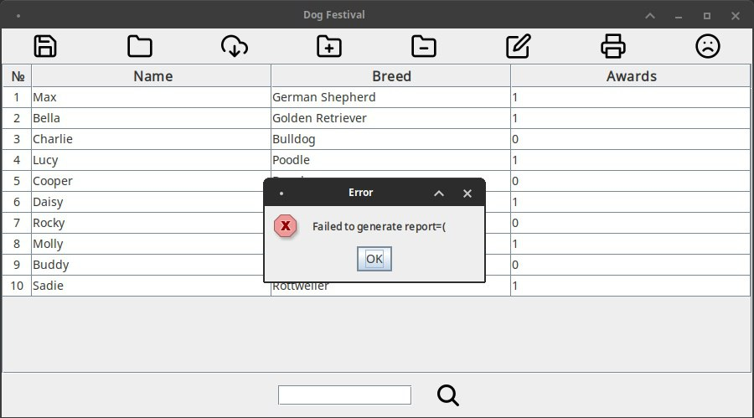
Рисунок 1 — Окно выбора формата отчета
Рисунок 2 — Ошибка создания отчета

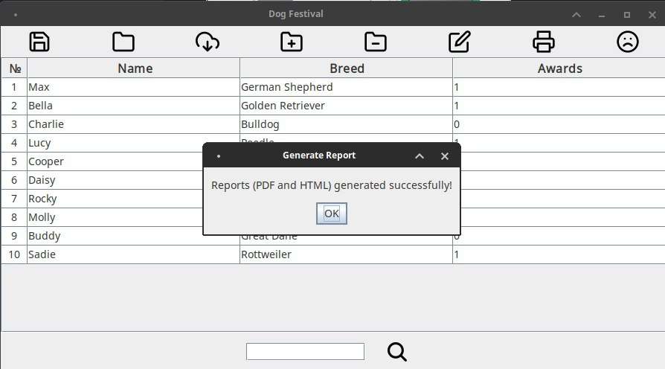
Рисунок 3 — Успешное создание отчета

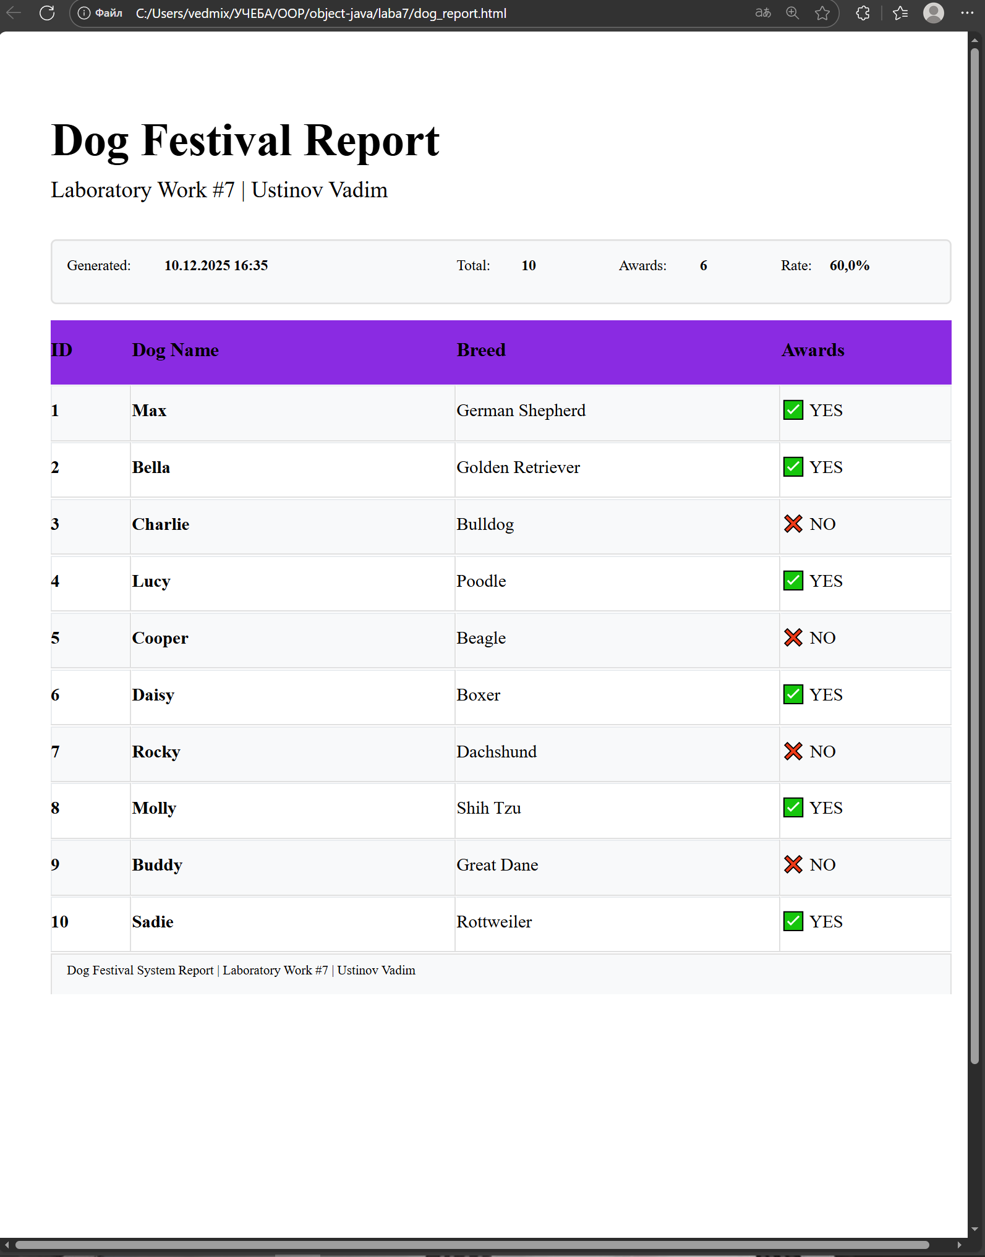
Содержимое отчетов
Рисунок 4 — Отчет в формате HTML

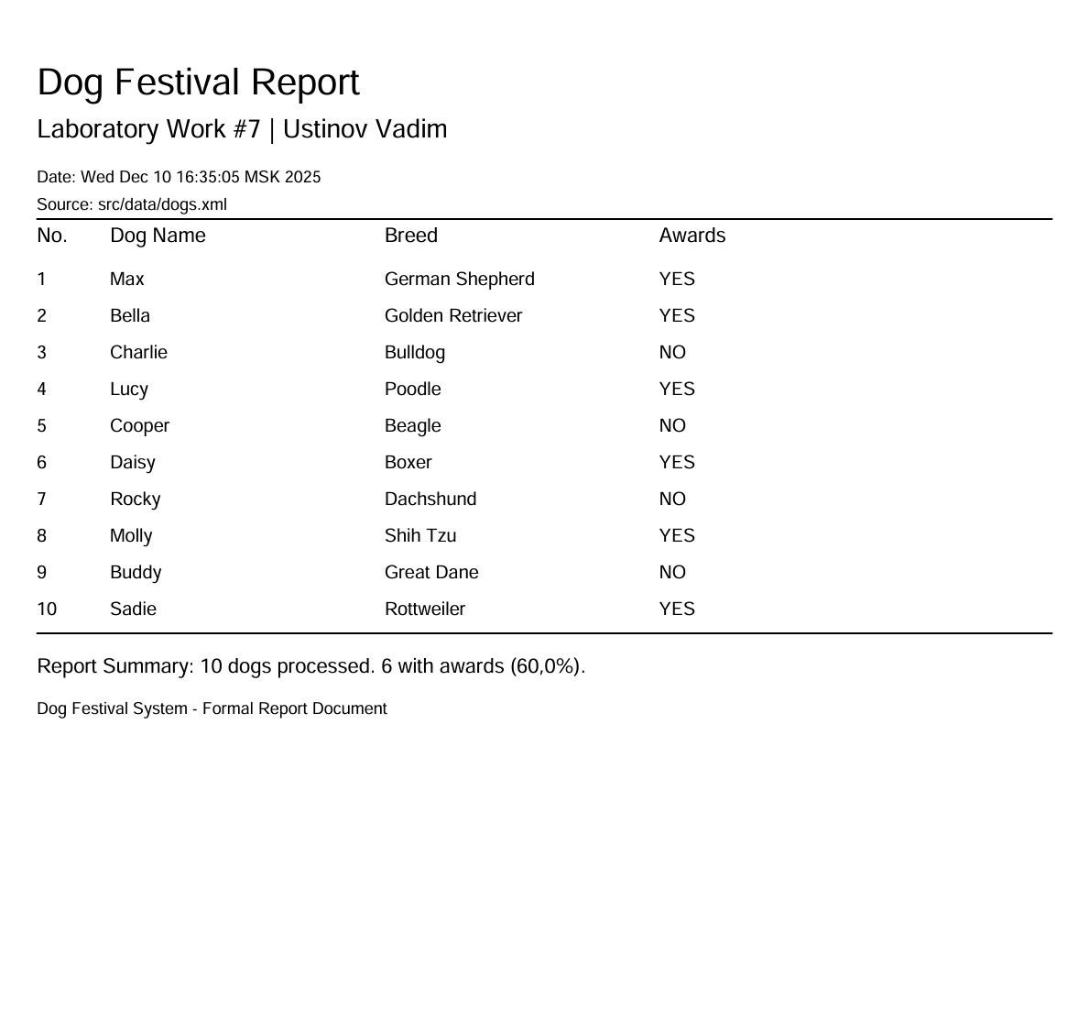
Рисунок 5 — Отчет в формате PDF

Документация Javadoc
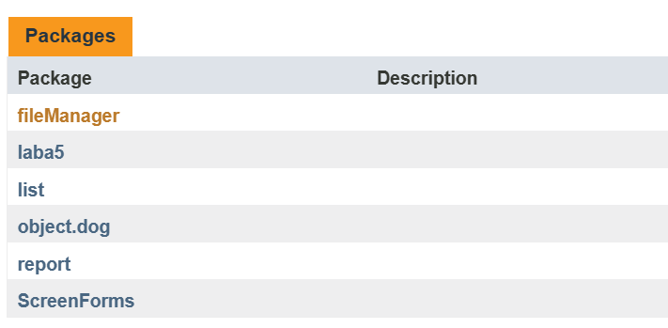

Рисунок 6 — Основные пакеты программы
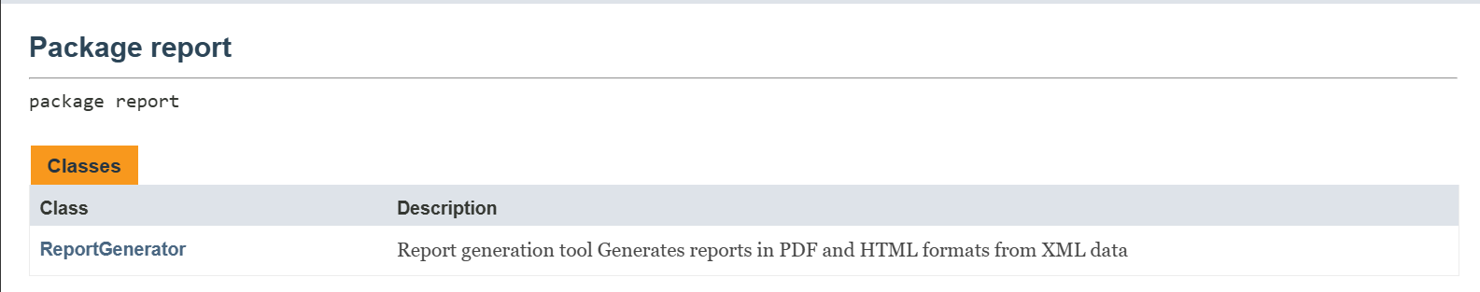
Рисунок 7 — Новый пакет, сделанный для генерации отчетов
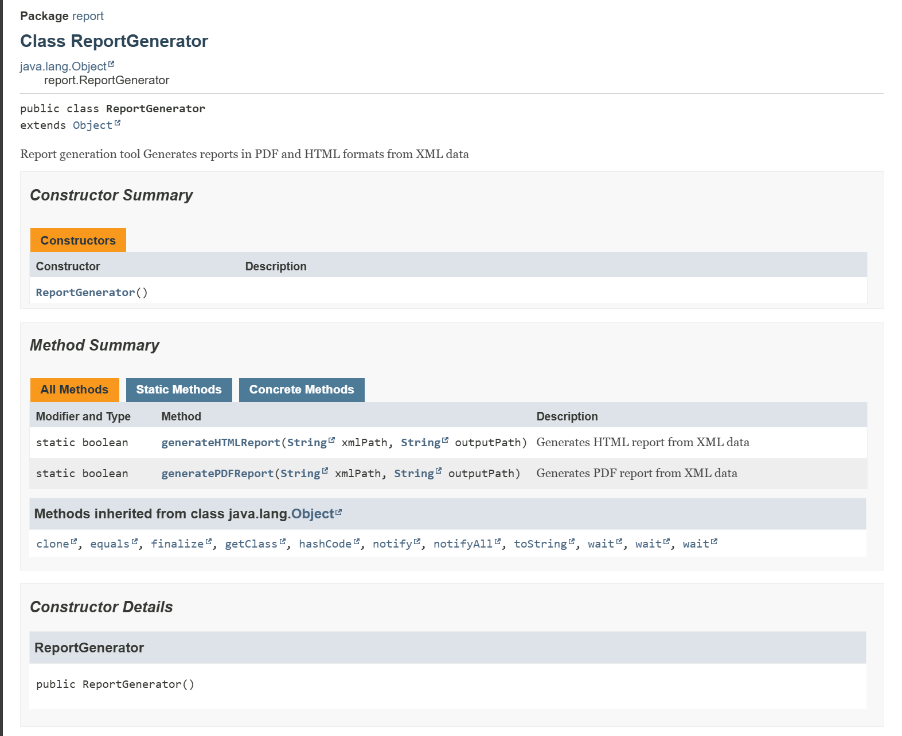
Рисунок 8 — Новый класс, генерирующий PDF/HTML отчеты

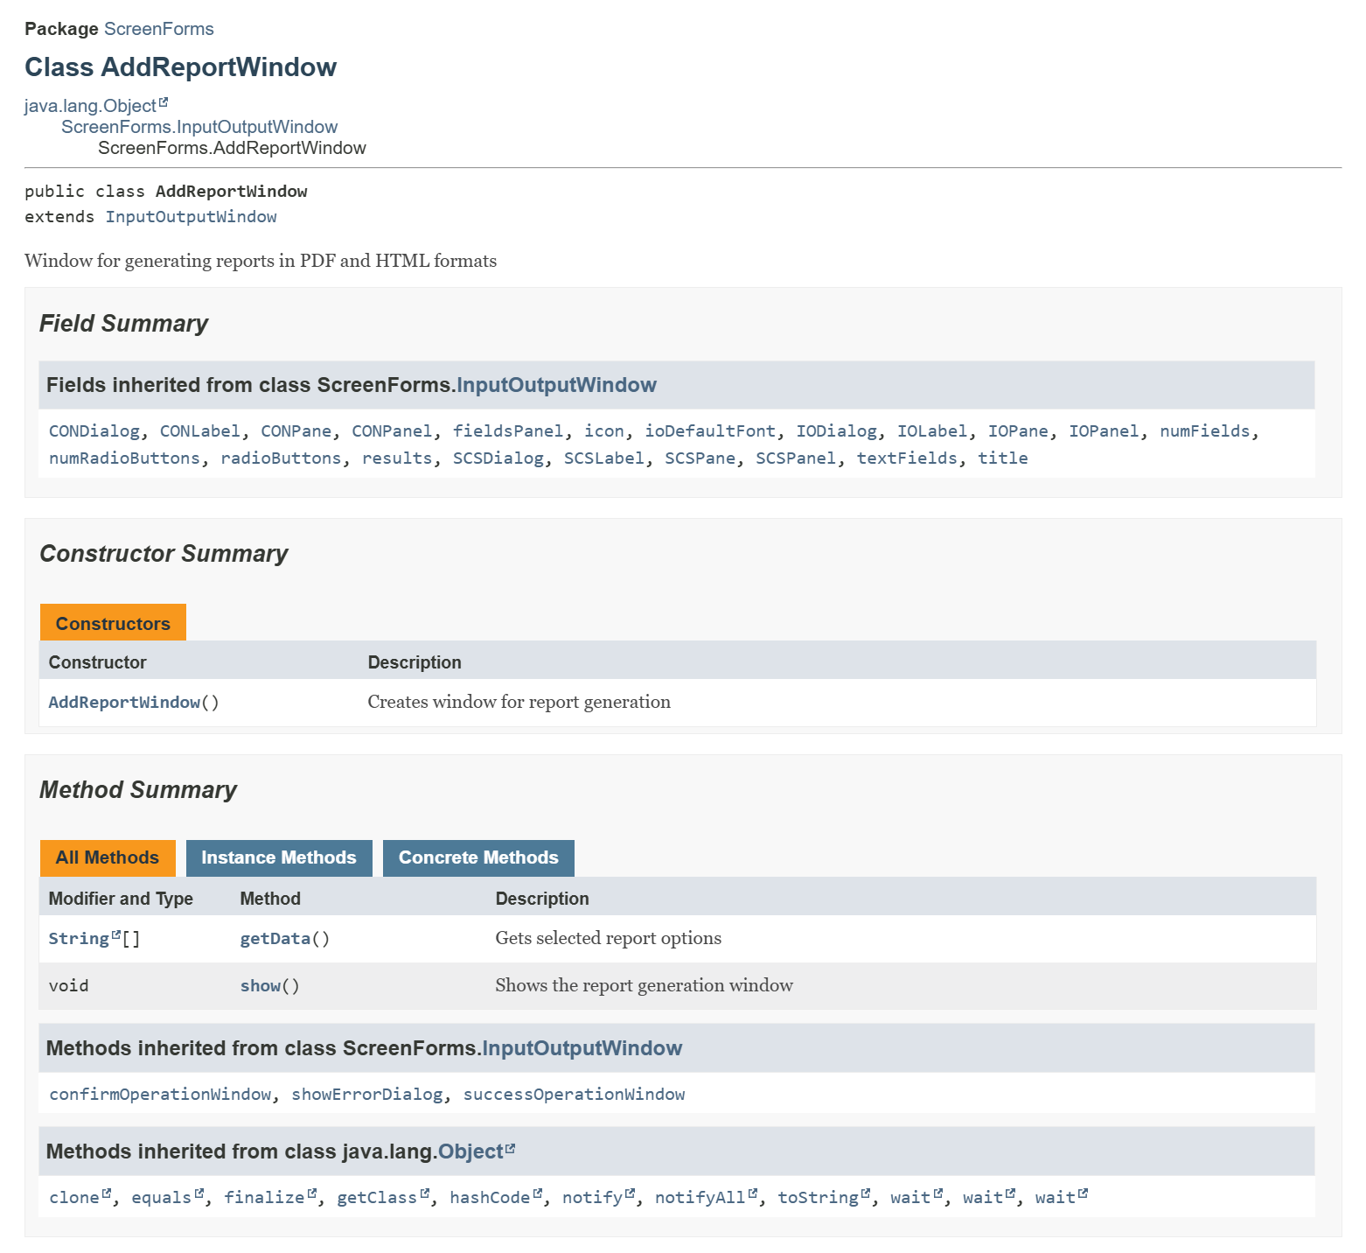
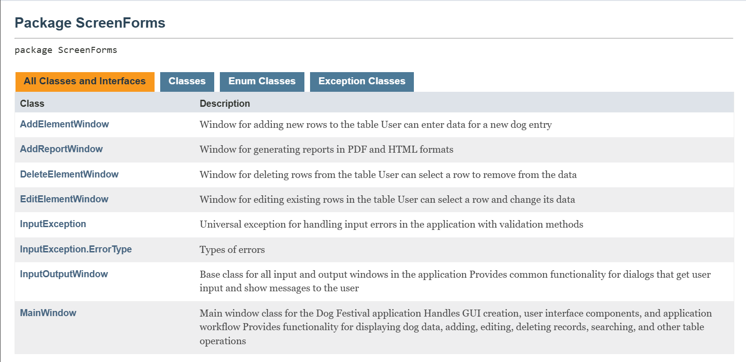
Рисунок 9 — Пакет экранной формы
Рисунок 10 — Новый класс для генерации отчетов

Текст программы

1)ReportGenerator.java
package report;

import net.sf.jasperreports.engine.*;
import net.sf.jasperreports.engine.data.JRMapCollectionDataSource;
import fileManager.FileManager;
import list.List;
import object.dog.Dog;
import java.util.*;

/**
* Report generation tool
* Generates reports in PDF and HTML formats from XML data
*/
public class ReportGenerator {

// Paths to JRXML templates
private static final String PDF_TEMPLATE = "src/report/pdf_report.jrxml";
private static final String HTML_TEMPLATE = "src/report/html_report.jrxml";

/**
* Generates PDF report from XML data
* @param xmlPath Path to source XML file with dog data
* @param outputPath Path where PDF file will be saved
* @return true if generation successful, false otherwise
*/
public static boolean generatePDFReport(String xmlPath, String outputPath) {
try {
//Load data from XML file
FileManager = new FileManager();
List<Dog> dogs = fileManager.inputFromXML(xmlPath);

if (dogs.getSize() == 0) {
return false;
}

//Convert data to Map format for JasperReports
java.util.List<java.util.Map<String, Object>> dataList = convertToMapList(dogs);

//Calculate statistics for report
int awardsCount = countAwards(dogs);
double percentage = calculatePercentage(awardsCount, dogs.getSize());

//Create report parameters (metadata and statistics)
java.util.Map<String, Object> params = createParams(xmlPath, dogs.getSize(),
awardsCount, percentage);

//Check if template file exists
java.io.File templateFile = new java.io.File(PDF_TEMPLATE);
if (!templateFile.exists()) {
return false;
}

///Generate PDF report using JasperReports
//Compile JRXML template
JasperReport report = JasperCompileManager.compileReport(PDF_TEMPLATE);

//Create data source from converted data
JRMapCollectionDataSource dataSource = new JRMapCollectionDataSource((java.util.Collection) dataList);

//Fill report with data and parameters
JasperPrint print = JasperFillManager.fillReport(report, params, dataSource);

//Export filled report to PDF file
JasperExportManager.exportReportToPdfFile(print, outputPath);

return true;

} catch (Exception e) {
return false;
}
}

/**
* Generates HTML report from XML data
* @param xmlPath Path to source XML file with dog data
* @param outputPath Path where HTML file will be saved
* @return true if generation successful, false otherwise
*/
public static boolean generateHTMLReport(String xmlPath, String outputPath) {
try {
//Load data from XML file
FileManager = new FileManager();
List<Dog> dogs = fileManager.inputFromXML(xmlPath);

if (dogs.getSize() == 0) {
return false;
}

//Convert data to Map format for JasperReports
java.util.List<java.util.Map<String, Object>> dataList = convertToMapList(dogs);

//Calculate statistics for report
int awardsCount = countAwards(dogs);
double percentage = calculatePercentage(awardsCount, dogs.getSize());

//Create report parameters (metadata and statistics)
java.util.Map<String, Object> params = createParams(xmlPath, dogs.getSize(),
awardsCount, percentage);

//Check if template file exists
java.io.File templateFile = new java.io.File(HTML_TEMPLATE);
if (!templateFile.exists()) {
return false;
}

///Generate HTML report using JasperReports
//Compile JRXML template
JasperReport report = JasperCompileManager.compileReport(HTML_TEMPLATE);

//Create data source from converted data
JRMapCollectionDataSource dataSource = new JRMapCollectionDataSource((java.util.Collection) dataList);

//Fill report with data and parameters
JasperPrint print = JasperFillManager.fillReport(report, params, dataSource);

//Export filled report to HTML file
JasperExportManager.exportReportToHtmlFile(print, outputPath);

return true;

} catch (Exception e) {
return false;
}
}

/**
* Counts how many dogs have awards
* @param dogs List of Dog objects to analyze
* @return Number of dogs with awards
*/
private static int countAwards(List<Dog> dogs) {
int count = 0;
for (int i = 0; i < dogs.getSize(); i++) {
if (dogs.at(i).hasAward()) count++;
}
return count;
}

/**
* Calculates percentage of dogs with awards
* @param awardsCount Number of dogs with awards
* @param total number of dogs
* @return Percentage value (0.0 to 100.0)
*/
private static double calculatePercentage(int awardsCount, int total) {
return total > 0 ? (awardsCount * 100.0 / total) : 0;
}

/**
* Converts List<Dog> to List<Map> format for JasperReports
* Each Map represents one row in the report with field names matching JRXML template
* @param dogs List of Dog objects to convert
* @return List of Maps with report data
*/
private static java.util.List<java.util.Map<String, Object>> convertToMapList(List<Dog> dogs) {
java.util.List<java.util.Map<String, Object>> dataList = new java.util.ArrayList<>();

for (int i = 0; i < dogs.getSize(); i++) {
Dog = dogs.at(i);
java.util.Map<String, Object> row = new java.util.HashMap<>();

// Map keys must match field names in JRXML templates
row.put("id", i + 1);
row.put("name", dog.getName());
row.put("breed", dog.getBreed());
row.put("awardsText", dog.hasAward() ? "YES" : "NO");
row.put("awards", dog.hasAward());

dataList.add(row);
}

return dataList;
}

/**
* Creates parameters for JasperReports templates
* These parameters are used in report headers, footers, and summary sections
* @param xmlPath Source XML file path
* @param totalDogs Total number of dogs
* @param awardsCount Number of dogs with awards
* @param percentage of dogs with awards
* @return Map of report parameters
*/
private static java.util.Map<String, Object> createParams(String xmlPath, int totalDogs,
int awardsCount, double percentage) {
java.util.Map<String, Object> params = new java.util.HashMap<>();

// Report metadata
params.put("REPORT_TITLE", "Dog Festival Report");
params.put("LAB_NUMBER", "Laboratory Work #7");
params.put("GENERATION_DATE", new Date());
params.put("SOURCE_FILE", xmlPath);

// Report statistics
params.put("TOTAL_DOGS", totalDogs);
params.put("AWARDS_COUNT", awardsCount);
params.put("AWARDS_PERCENTAGE", percentage);

return params;
}
}

2)AddReportWindow.java
package ScreenForms;

import javax.swing.*;
import java.awt.*;

/**
* Window for generating reports in PDF and HTML formats
*/
public class AddReportWindow extends InputOutputWindow
{
private JPanel mainPanel;
private ButtonGroup RadioButtonsGroup;
private JPanel radioButtonsPanel;
private JRadioButton pdfRadio;
private JRadioButton htmlRadio;
private JRadioButton bothRadio;
private static final String XML_FILE_PATH = "src/data/dogs.xml";

/**
* Creates window for report generation
*/
public AddReportWindow()
{
super("Select report type", "Generate Report", 0, 0);

//Create panel for options with padding
mainPanel = new JPanel();
mainPanel.setLayout(new BoxLayout(mainPanel, BoxLayout.Y_AXIS));
mainPanel.setBorder(BorderFactory.createEmptyBorder(20, 30, 20, 30));

//Radio buttons for report type selection
radioButtonsPanel = new JPanel(new GridLayout(3, 1, 10, 10));
radioButtonsPanel.setMaximumSize(new Dimension(400, 100));

RadioButtonsGroup= new ButtonGroup();
pdfRadio = new JRadioButton("PDF Report");
htmlRadio = new JRadioButton("HTML Report");
bothRadio = new JRadioButton("Both Formats");

pdfRadio.setSelected(true);
RadioButtonsGroup.add(pdfRadio);
RadioButtonsGroup.add(htmlRadio);
RadioButtonsGroup.add(bothRadio);

pdfRadio.setFont(new Font("Arial", Font.PLAIN, 14));
htmlRadio.setFont(new Font("Arial", Font.PLAIN, 14));
bothRadio.setFont(new Font("Arial", Font.PLAIN, 14));

radioButtonsPanel.add(pdfRadio);
radioButtonsPanel.add(htmlRadio);
radioButtonsPanel.add(bothRadio);

//Add components to main panel
mainPanel.add(radioButtonsPanel);
mainPanel.add(Box.createVerticalStrut(10));

super.IOPanel.add(mainPanel, BorderLayout.CENTER);
//Set minimum window size
super.IODialog.setMinimumSize(new Dimension(450, 150));
//Center the window
super.IODialog.setLocationRelativeTo(null);
//Repack window for proper display
super.IODialog.pack();
}

/**
* Shows the report generation window
* @throws InputException if there's an error
*/
@Override
public void show() throws InputException
{
super.IODialog.setLocationRelativeTo(null);
super.IODialog.setVisible(true);

String[] reportOptions = getData();

if (reportOptions != null && reportOptions[0] != null)
{
boolean success = generateReport(reportOptions[0]);

if (success) {
String successMessage = "Report";
if (reportOptions[0].equals("both")) {
successMessage = "Reports (PDF and HTML)";
}
successMessage += " generated";

super.successOperationWindow(successMessage);
super.SCSDialog.setVisible(true);
} else {
JOptionPane.showMessageDialog(
super.IODialog,
"Failed to generate report=(",
"Error",
JOptionPane.ERROR_MESSAGE
);
}
}
}

/**
* Generates report of selected type
* @param reportType report type ("pdf", "html" or "both")
* @return true if generation successful, false otherwise
*/
private boolean generateReport(String reportType)
{
boolean success = false;

try {
switch(reportType) {
case "pdf":
success = report.ReportGenerator.generatePDFReport(XML_FILE_PATH, "dog_report.pdf");
break;

case "html":
success = report.ReportGenerator.generateHTMLReport(XML_FILE_PATH, "dog_report.html");
break;

case "both":
boolean pdfSuccess = report.ReportGenerator.generatePDFReport(XML_FILE_PATH, "dog_report.pdf");
boolean htmlSuccess = report.ReportGenerator.generateHTMLReport(XML_FILE_PATH, "dog_report.html");
success = pdfSuccess && htmlSuccess;
break;

default:
success = false;
}
} catch (Exception e) {
success = false;
}

return success;
}

/**
* Gets selected report options
* @return array with selected options (only report type)
*/
@Override
public String[] getData()
{
if (super.IOPane.getValue() == null) {
return null;
}

if (super.IOPane.getValue() instanceof Integer) {
int option = ((Integer) super.IOPane.getValue()).intValue();

if (option == JOptionPane.YES_OPTION || option == JOptionPane.OK_OPTION)
{
String[] results = new String[1];

//Determine selected report type
if (pdfRadio.isSelected()) {
results[0] = "pdf";
} else if (htmlRadio.isSelected()) {
results[0] = "html";
} else if (bothRadio.isSelected()) {
results[0] = "both";
} else {
results[0] = null;
}

return results;
}
}

return null;
}
}

