МИНОБРНАУКИ РОССИИ
Санкт-Петербургский государственный
электротехнический университет
«ЛЭТИ» им. В.И. Ульянова (Ленина)
Кафедра Вычислительной техники
отчет
по лабораторной работе № 9
по дисциплине «Модульное тестирование приложения»
Тема: Тестирование Java проекта
Студент гр. 4312 | Устинов В. А.
Преподаватель | Лазарев Э. А.

Санкт-Петербург
2025

Цель работы
Знакомство с технологией модульного тестирования Java приложений с использованием системы JUnit.

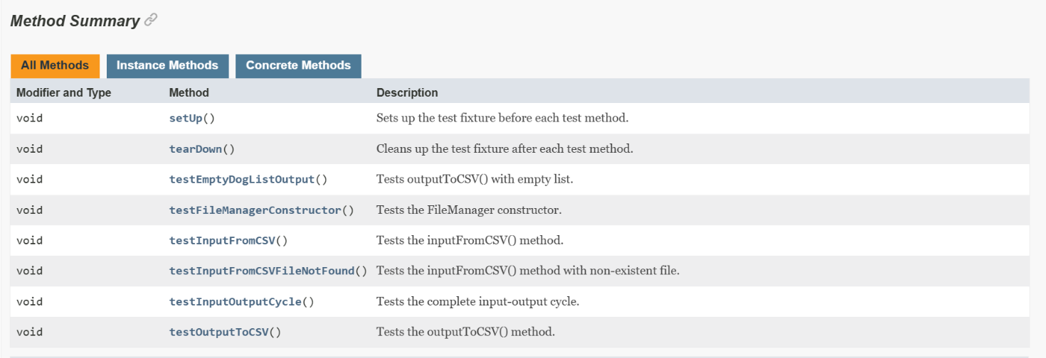
Перечень методов, которые тестируются в приложении
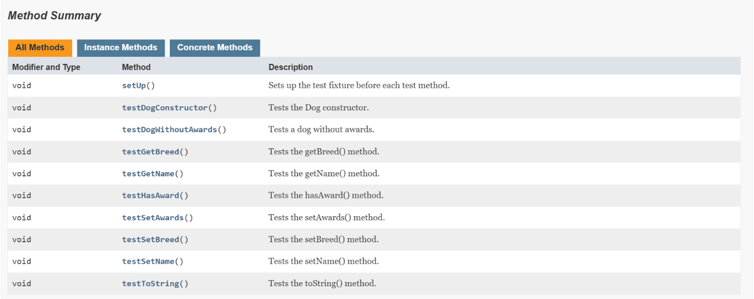
Рисунок 1 — Перечень тестируемых методов класса fileManager
Рисунок 2 — Перечень тестируемых методов класса Dog

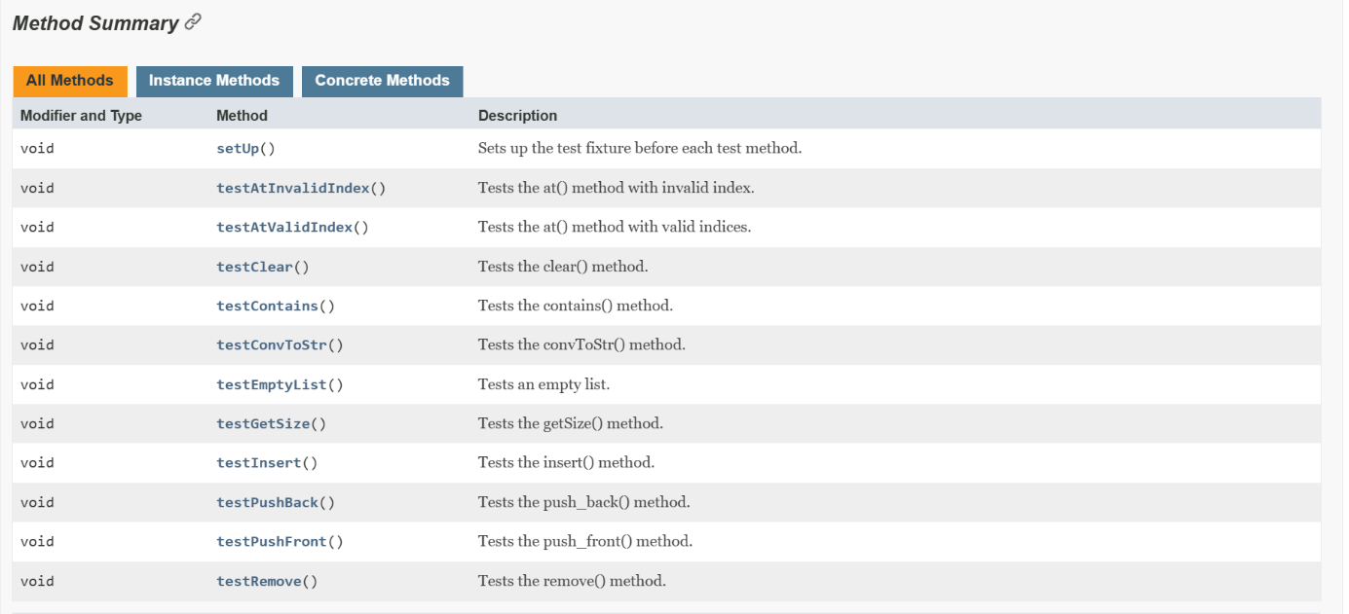

Рисунок 3 — Перечень тестируемых методов класса List

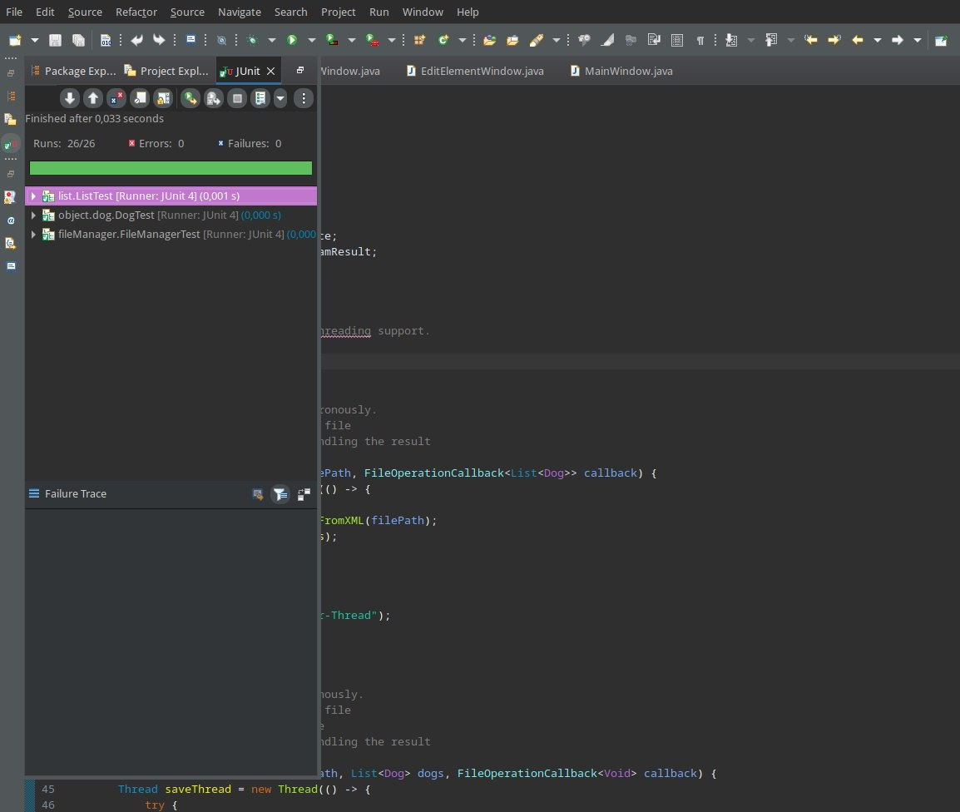
Скриншоты, иллюстрирующие выполнение тестов
Рисунок 4 — Все тесты успешно пройдены

Исходные тексты классов тестов
1)fileManagerTest.java
package fileManager;

import org.junit.Test;
import org.junit.Before;
import org.junit.After;
import static org.junit.Assert.*;
import java.io.*;
import java.nio.file.*;

// Import custom classes
import list.List;
import object.dog.Dog;

/**
* JUnit test class for the FileManager class.
* Tests file input/output operations with CSV files.
* This test class handles integration testing with the file system.
*
* @author Your Name
* @version 1.0
* @see FileManager
*/
public class FileManagerTest {

private FileManager;
private static final String TEST_INPUT_FILE = "test_dogs.csv";
private static final String TEST_OUTPUT_FILE = "test_output.csv";

/**
* Sets up the test fixture before each test method.
* Creates a FileManager instance and test CSV file.
* @throws IOException if file creation fails
*/
@Before
public void setUp() throws IOException {
fileManager = new FileManager();

// Create test CSV file
String testData = "Rex;German Shepherd;1\n" +
"Bella;Golden Retriever;0\n" +
"Max;Labrador;1";
Files.write(Paths.get(TEST_INPUT_FILE), testData.getBytes());
}

/**
* Cleans up the test fixture after each test method.
* Deletes test files created during testing.
*/
@After
public void tearDown() {
// Clean up test files
try {
Files.deleteIfExists(Paths.get(TEST_INPUT_FILE));
Files.deleteIfExists(Paths.get(TEST_OUTPUT_FILE));
} catch (IOException e) {
// Ignore cleanup errors
}
}

/**
* Tests the FileManager constructor.
* Verifies that a FileManager object can be created.
*/
@Test
public void testFileManagerConstructor() {
assertNotNull("FileManager instance should be created", fileManager);
}

/**
* Tests the inputFromCSV() method.
* Verifies that data can be read from a CSV file.
* @throws IOException if file reading fails
*/
@Test
public void testInputFromCSV() throws IOException {
List<Dog> dogs = fileManager.inputFromCSV(TEST_INPUT_FILE);

assertNotNull("Dog list should not be null", dogs);
assertEquals("Should read 3 dogs from file", 3, dogs.getSize());

// Verify first dog
assertEquals("First dog name should be 'Rex'", "Rex", dogs.at(0).getName());
assertEquals("First dog breed should be 'German Shepherd'",
"German Shepherd", dogs.at(0).getBreed());
assertTrue("First dog should have awards", dogs.at(0).hasAward());
}

/**
* Tests the inputFromCSV() method with non-existent file.
* Verifies that IOException is thrown when file doesn't exist.
* @throws IOException expected to be thrown
*/
@Test(expected = IOException.class)
public void testInputFromCSVFileNotFound() throws IOException {
fileManager.inputFromCSV("non_existent_file.csv");
}

/**
* Tests the outputToCSV() method.
* Verifies that data can be written to a CSV file.
* @throws IOException if file writing fails
*/
@Test
public void testOutputToCSV() throws IOException {
List<Dog> dogs = new List<>();
dogs.push_back(new Dog("Charlie", "Beagle", true));
dogs.push_back(new Dog("Lucy", "Poodle", false));
dogs.push_back(new Dog("Rocky", "Boxer", true));

fileManager.outputToCSV(TEST_OUTPUT_FILE, dogs);

assertTrue("Output file should be created",
Files.exists(Paths.get(TEST_OUTPUT_FILE)));

// Verify file content
java.util.List<String> lines = Files.readAllLines(Paths.get(TEST_OUTPUT_FILE));
assertEquals("File should contain 3 lines", 3, lines.size());
assertEquals("First line should match", "Charlie;Beagle;1", lines.get(0));
}

/**
* Tests the complete input-output cycle.
* Verifies that data can be read, written, and read again without corruption.
* @throws IOException if any file operation fails
*/
@Test
public void testInputOutputCycle() throws IOException {
// Read original data
List<Dog> originalDogs = fileManager.inputFromCSV(TEST_INPUT_FILE);

// Write to new file
fileManager.outputToCSV(TEST_OUTPUT_FILE, originalDogs);

// Read back from new file
List<Dog> readDogs = fileManager.inputFromCSV(TEST_OUTPUT_FILE);

// Verify data integrity
assertEquals("Number of dogs should match",
originalDogs.getSize(), readDogs.getSize());

for (int i = 0; i < originalDogs.getSize(); i++) {
assertEquals("Dog names should match",
originalDogs.at(i).getName(), readDogs.at(i).getName());
}
}

/**
* Tests outputToCSV() with empty list.
* Verifies that empty lists can be handled correctly.
* @throws IOException if file writing fails
*/
@Test
public void testEmptyDogListOutput() throws IOException {
List<Dog> emptyList = new List<>();
fileManager.outputToCSV(TEST_OUTPUT_FILE, emptyList);

assertTrue("File should be created even for empty list",
Files.exists(Paths.get(TEST_OUTPUT_FILE)));
}
}

2)listTest.java
package list;

import org.junit.Test;
import org.junit.Before;
import static org.junit.Assert.*;
import org.junit.Rule;
import org.junit.rules.ExpectedException;

/**
* JUnit test class for the List class.
* Tests all public methods of the generic List implementation.
* This test class verifies the data structure functionality.
*
* @author Your Name
* @version 1.0
* @see List
*/
public class ListTest {

private List<String> stringList;
private List<Integer> integerList;

/**
* Rule for testing expected exceptions.
*/
@Rule
public ExpectedException exceptionRule = ExpectedException.none();

/**
* Sets up the test fixture before each test method.
* Creates new List instances for testing.
*/
@Before
public void setUp() {
stringList = new List<>();
integerList = new List<>();
}

/**
* Tests an empty list.
* Verifies that a newly created list is empty.
*/
@Test
public void testEmptyList() {
assertTrue("New list should be empty", stringList.isEmpty());
assertEquals("Empty list size should be 0", 0, stringList.getSize());
}

/**
* Tests the push_back() method.
* Verifies that elements can be added to the end of the list.
*/
@Test
public void testPushBack() {
stringList.push_back("First");
assertFalse("List should not be empty after push_back", stringList.isEmpty());
assertEquals("List size should be 1", 1, stringList.getSize());
assertEquals("First element should be 'First'", "First", stringList.at(0));
}

/**
* Tests the push_front() method.
* Verifies that elements can be added to the beginning of the list.
*/
@Test
public void testPushFront() {
stringList.push_front("First");
assertEquals("First element should be 'First'", "First", stringList.at(0));

stringList.push_front("Second");
assertEquals("New first element should be 'Second'", "Second", stringList.at(0));
}

/**
* Tests the insert() method.
* Verifies that elements can be inserted at specific positions.
*/
@Test
public void testInsert() {
stringList.push_back("A");
stringList.push_back("C");
stringList.insert("B", 1);

assertEquals("List size should be 3", 3, stringList.getSize());
assertEquals("A", stringList.at(0));
assertEquals("B", stringList.at(1));
assertEquals("C", stringList.at(2));
}

/**
* Tests the getSize() method.
* Verifies that list size is correctly reported.
*/
@Test
public void testGetSize() {
assertEquals("Initial size should be 0", 0, stringList.getSize());
stringList.push_back("A");
assertEquals("Size after adding one element should be 1", 1, stringList.getSize());
}

/**
* Tests the at() method with valid indices.
* Verifies that elements can be retrieved by index.
*/
@Test
public void testAtValidIndex() {
stringList.push_back("A");
stringList.push_back("B");
stringList.push_back("C");

assertEquals("Element at index 0 should be 'A'", "A", stringList.at(0));
assertEquals("Element at index 1 should be 'B'", "B", stringList.at(1));
assertEquals("Element at index 2 should be 'C'", "C", stringList.at(2));
}

/**
* Tests the at() method with invalid index.
* Verifies that IndexOutOfBoundsException is thrown for invalid index.
*/
@Test(expected = IndexOutOfBoundsException.class)
public void testAtInvalidIndex() {
stringList.push_back("A");
stringList.at(1); // Should throw IndexOutOfBoundsException
}

/**
* Tests the remove() method.
* Verifies that elements can be removed from the list.
*/
@Test
public void testRemove() {
stringList.push_back("A");
stringList.push_back("B");
stringList.push_back("C");

stringList.remove(1); // Remove "B"

assertEquals("Size after removal should be 2", 2, stringList.getSize());
assertEquals("First element should remain 'A'", "A", stringList.at(0));
assertEquals("Second element should now be 'C'", "C", stringList.at(1));
}

/**
* Tests the contains() method.
* Verifies that the list correctly reports if it contains elements.
*/
@Test
public void testContains() {
stringList.push_back("A");
stringList.push_back("B");

assertTrue("List should contain 'A'", stringList.contains("A"));
assertTrue("List should contain 'B'", stringList.contains("B"));
assertFalse("List should not contain 'C'", stringList.contains("C"));
}

/**
* Tests the clear() method.
* Verifies that the list can be completely cleared.
*/
@Test
public void testClear() {
stringList.push_back("A");
stringList.push_back("B");
stringList.push_back("C");

assertEquals("Initial size should be 3", 3, stringList.getSize());

stringList.clear();

assertTrue("List should be empty after clear", stringList.isEmpty());
assertEquals("Size should be 0 after clear", 0, stringList.getSize());
}

/**
* Tests the convToStr() method.
* Verifies that the list can be converted to string array.
*/
@Test
public void testConvToStr() {
stringList.push_back("First");
stringList.push_back("Second");

String[] result = stringList.convToStr();

assertNotNull("Result should not be null", result);
assertEquals("Array length should be 2", 2, result.length);
assertEquals("First element should be 'First'", "First", result[0]);
assertEquals("Second element should be 'Second'", "Second", result[1]);
}
}

3)DogTest.java
package object.dog;

/**
* A class representing a dog
* It contains information about the nickname, breed, and awards.
* @author Vadim Ustinov
* @version 1.0
*/
public class Dog
{
private String name;
private String poroda;
private boolean hasAward;

/**
* Constructor for creating a Dog object
* @param inpName is the dog's nickname
* @param inpBreed dog breed
* @param inpHasAward availability of awards
*/
public Dog(String inpName, String inpBreed, boolean inpHasAward)
{
name = inpName;
poroda = inpBreed;
hasAward = inpHasAward;
}

/**
* Function returns the dog's name
* @return dog's name
*/
public String getName(){return name;}

/**
* Function returns the dog's breed
* @return dog's breed
*/
public String getBreed(){return poroda;}

/**
* Function checks for the dog's awards
* @return true if there are rewards, otherwise false
*/
public boolean hasAward(){return hasAward;}

/**
* Function sets a new dog name
* @param newName new nickname
*/
public void setName(String newName){name = newName;}

/**
* Function sets a new breed of dog
* @param newPoroda new breed
*/
public void setBreed(String newPoroda){poroda = newPoroda;}

/**
* Function sets the dog's awards
* @param newHasAward availability of awards
*/
public void setAwards(boolean newHasAward){hasAward = newHasAward;}

@Override
public String toString()
{
int hasAwardInt;
if(hasAward)
{
hasAwardInt = 1;
}
else
{
hasAwardInt = 0;
}
return name + ";" + poroda + ";" + hasAwardInt;
}
}

