Stuff for Sailors  Custom Project Order Form  Boat · Van · RV  425-677-4829 · sailoratlarge@stuffforsailors.com  www.stuffforsailors.com | 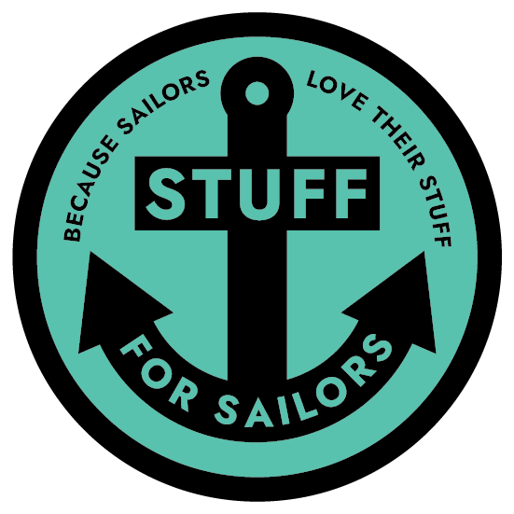  Custom-Fit Storage,  Mounts & Brackets  Marine-Grade,  UV-Stable Materials  Binocular, VHF  & Electronics Mounts  Personalized Soaps,  Keychains & Gifts  Design, 3D Print  & Install

One-off custom design & fabrication
Have something in mind that isn't one of our standard products? This is the form for it. Give us as much detail as you can and we'll take it from there.

Client Information

Name | Email
Phone | Best way to reach you
Mailing address

Vessel Information

Vessel name | Make & model
Length | Home port / marina

Your Custom Project

Tell us what you'd like made. The more detail and measurements you can give, the faster we can quote it. Photos and sketches help enormously — attach or email them with this form.
What do you want us to make? Describe the item and what it needs to do.

What will it hold, secure, or mount? (make/model of any gear it's built around)

Key dimensions (list all you can — L × W × H, diameters, thicknesses)

Where and how will it be mounted? Note any nearby trim, curves, or obstructions.

Do you have reference photos / sketches / a sample to send? ☐ Yes (attaching / emailing) ☐ No ☐ Need help measuring

Mounting Environment & Material

Where will this be mounted? ☐ Interior (inside the boat) ☐ Exterior (cockpit / on deck / exposed)
Mounting location determines the material. Exterior parts must be UV-stable to survive sun and weather; interior parts have far more color and finish options.
EXTERIOR colors (UV-stable):
☐ Black ☐ White ☐ Grey
EXTERIOR, carbon-fiber reinforced (UV-stable, extra strength):
☐ Black ☐ Grey
INTERIOR colors:
Interior mounting opens up a much wider range of colors and finishes — tell us what you have in mind and we'll work with you.
Interior color / finish requested

Pricing & Process

Pricing: quoted per project — every custom job is different.
• Site visit / consultation (if needed to measure or assess the space)
• Design time (CAD modeling to your dimensions and mounting spot)
• Materials (standard ASA/PETG, or carbon-fiber/nylon upcharge — see below)
• Print time (larger or more complex parts take longer on the printer)

Pricing above assumes standard ASA (exterior) or PETG (interior); see material & color options above.

How it works:
Once we've talked through your project and I have a sense of the design and materials involved, I'll put together a firm quote covering the items above. From there: I print a prototype first in PLA — a low-cost, low-durability material just to check fit. It's yours to keep either way, but it's not built for real use and would fail under normal load. If the prototype fits right, I move to the final build in your chosen material. A 50% deposit gets the order started.

For Office Use — Stuff for Sailors

Quote # | Date received | Target material
Est. print time | Quoted price | Deposit (50%)
Notes

Thank you — every piece is designed and made to order. Once we have your details we'll follow up with any questions and a firm quote.

