Stuff for Sailors  Binocular Cradle  Boat · Van · RV  425-677-4829 · sailoratlarge@stuffforsailors.com  www.stuffforsailors.com | 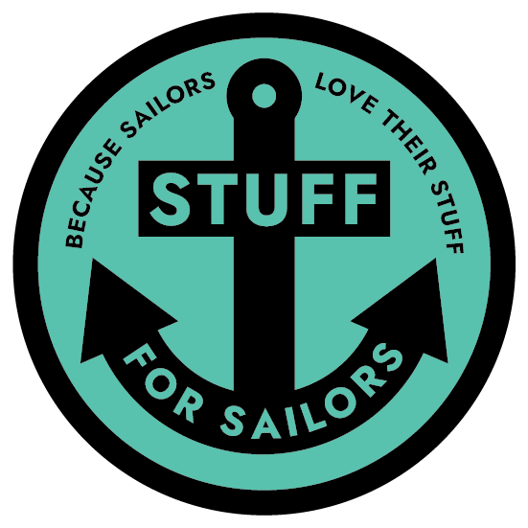  Custom-Fit Storage,  Mounts & Brackets  Marine-Grade,  UV-Stable Materials  Binocular, VHF  & Electronics Mounts  Personalized Soaps,  Keychains & Gifts  Design, 3D Print  & Install

Custom-fit to your binoculars
A secure, grab-and-go cradle designed around your exact pair, mounted where you want it.

Client Information

Name | Email
Phone | Best way to reach you
Mailing address

Vessel Information

Vessel name | Make & model
Length | Home port / marina

Binocular Cradle — Specifications

A secure, quick-access cradle designed around YOUR binoculars, with an articulating rail-clamp mount so it sits right where you want it. Because it's built to your exact pair, the make and model are essential.

Binocular make & model | Magnification (e.g. 7×50)
If you can give us the make and model, we can usually find the exact dimensions. If they're older or unbranded, fill in the measurements below.
Barrel diameter (each objective end) | Distance between barrel centers
Overall height (top to objective) | Approx. weight
Are your binoculars: ☐ Standard porro-prism (classic wide shape) ☐ Straight-barrel / roof-prism ☐ Not sure — will send photos

Mount

How would you like it mounted? ☐ Rail clamp (specify rail dia. below) ☐ Flat surface / bulkhead screw mount ☐ Not sure — advise me
If rail-mounted: rail outside diameter | Rail orientation (horizontal / vertical)
Where on the boat will it live? (helm, companionway, nav station, etc.)

Mounting Environment & Material

Where will this be mounted? ☐ Interior (inside the boat) ☐ Exterior (cockpit / on deck / exposed)
Mounting location determines the material. Exterior parts must be UV-stable to survive sun and weather; interior parts have far more color and finish options.
EXTERIOR colors (UV-stable):
☐ Black ☐ White ☐ Grey
EXTERIOR, carbon-fiber reinforced (UV-stable, extra strength):
☐ Black ☐ Grey
INTERIOR colors:
Interior mounting opens up a much wider range of colors and finishes — tell us what you have in mind and we'll work with you.
Interior color / finish requested

Pricing & Process

Base price: $40 — includes designing the cradle to fit your specific make & model.
• Carbon-fiber reinforced: +25%
• Nylon (highest durability): priced separately, by request — honestly usually more than this application needs

Pricing above assumes standard ASA (exterior) or PETG (interior); see material & color options above.

How it works:
Once we agree on design details, I print a prototype first in PLA — a low-cost, low-durability material just to check fit. It's yours to keep either way, but it's not built for real use and would fail under normal load. If the prototype fits right, I move to the final build in your chosen material. A 50% deposit gets the order started.

For Office Use — Stuff for Sailors

Quote # | Date received | Target material
Est. print time | Quoted price | Deposit (50%)
Notes

Thank you — every piece is designed and made to order. Once we have your details we'll follow up with any questions and a firm quote.

