Stuff for Sailors  Mini Toolbox Wall Hanger  Boat · Van · RV  425-677-4829 · sailoratlarge@stuffforsailors.com  www.stuffforsailors.com | 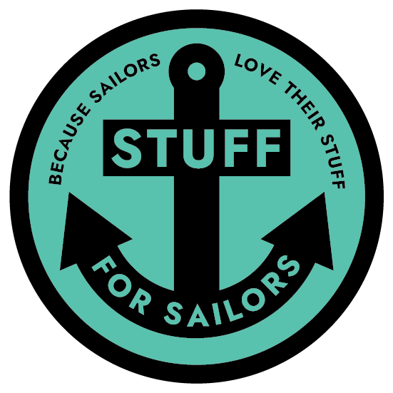  Custom-Fit Storage,  Mounts & Brackets  Marine-Grade,  UV-Stable Materials  Binocular, VHF  & Electronics Mounts  Personalized Soaps,  Keychains & Gifts  Design, 3D Print  & Install

French cleat mount for your mini toolbox
A secure wall mount for U.S. General or Kobalt mini toolboxes, built on a French cleat so the box lifts on and off in seconds.

Client Information

Name | Email
Phone | Best way to reach you
Mailing address

Vessel Information

Vessel name | Make & model
Length | Home port / marina

Mini Toolbox Wall Hanger — Specifications

A French-cleat wall mount sized to a U.S. General (Harbor Freight) or Kobalt mini toolbox — the box lifts on and off the cleat in seconds. Alternative custom mounting hardware is available if you'd rather not use the standard cleat.

Toolbox brand: ☐ U.S. General (Harbor Freight) ☐ Kobalt ☐ Other / not sure

Model / size (specific mini toolbox size or item number, if known)

Mounting hardware: ☐ Standard French cleat (included) ☐ Alternative custom mounting hardware

Where will it be mounted? (bulkhead, van wall, garage, etc.)

Mounting Environment & Material

Where will this be mounted? ☐ Interior (inside the boat) ☐ Exterior (cockpit / on deck / exposed)
Mounting location determines the material. Exterior parts must be UV-stable to survive sun and weather; interior parts have far more color and finish options.
EXTERIOR colors (UV-stable):
☐ Black ☐ White ☐ Grey
EXTERIOR, carbon-fiber reinforced (UV-stable, extra strength):
☐ Black ☐ Grey
INTERIOR colors:
Interior mounting opens up a much wider range of colors and finishes — tell us what you have in mind and we'll work with you.
Interior color / finish requested

Pricing & Process

Price: $35 — French cleat wall mount sized to a U.S. General or Kobalt mini toolbox.
• Alternative custom mounting hardware available on request instead of the standard cleat
• Carbon-fiber reinforced: +25%

Pricing above assumes standard ASA (exterior) or PETG (interior); see material & color options above.

How it works:
Once we agree on design details, I print a prototype first in PLA — a low-cost, low-durability material just to check fit. It's yours to keep either way, but it's not built for real use and would fail under normal load. If the prototype fits right, I move to the final build in your chosen material. A 50% deposit gets the order started.

For Office Use — Stuff for Sailors

Quote # | Date received | Target material
Est. print time | Quoted price | Deposit (50%)
Notes

Thank you — every piece is designed and made to order. Once we have your details we'll follow up with any questions and a firm quote.

