Stuff for Sailors  Handheld VHF Holster  Boat · Van · RV  425-677-4829 · sailoratlarge@stuffforsailors.com  www.stuffforsailors.com | 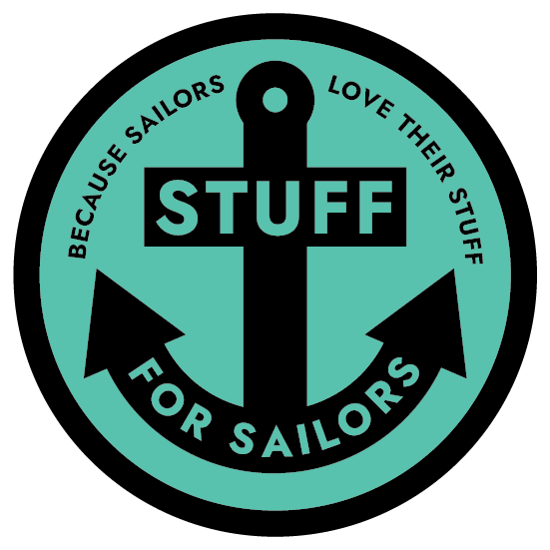  Custom-Fit Storage,  Mounts & Brackets  Marine-Grade,  UV-Stable Materials  Binocular, VHF  & Electronics Mounts  Personalized Soaps,  Keychains & Gifts  Design, 3D Print  & Install

Custom-fit to your radio
Keeps your handheld VHF secure and within reach underway — designed around your exact model.

Client Information

Name | Email
Phone | Best way to reach you
Mailing address

Vessel Information

Vessel name | Make & model
Length | Home port / marina

Handheld VHF Holster — Specifications

A secure holster for your handheld VHF, designed around your exact radio so it clicks in and stays put underway, with an articulating rail-clamp mount. Make and model let us match it precisely.

VHF make & model | With or without the belt clip / antenna?
Give us the make and model if you can — we can usually source exact dimensions. Otherwise fill in the measurements below. Note if you want the holster to fit WITH a belt clip attached.
Radio height (not counting antenna) | Width | Depth / thickness
Antenna base diameter | Any protruding buttons / PTT side?
Retention preference: ☐ Snug friction fit ☐ Positive clip / latch ☐ Strap over the top ☐ Advise me

Mount

How would you like it mounted? ☐ Rail clamp (specify rail dia. below) ☐ Flat surface / bulkhead screw mount ☐ Not sure — advise me
If rail-mounted: rail outside diameter | Rail orientation (horizontal / vertical)
Where on the boat will it live? (helm, companionway, nav station, etc.)

Mounting Environment & Material

Where will this be mounted? ☐ Interior (inside the boat) ☐ Exterior (cockpit / on deck / exposed)
Mounting location determines the material. Exterior parts must be UV-stable to survive sun and weather; interior parts have far more color and finish options.
EXTERIOR colors (UV-stable):
☐ Black ☐ White ☐ Grey
EXTERIOR, carbon-fiber reinforced (UV-stable, extra strength):
☐ Black ☐ Grey
INTERIOR colors:
Interior mounting opens up a much wider range of colors and finishes — tell us what you have in mind and we'll work with you.
Interior color / finish requested

Pricing & Process

Base price: $40 — includes designing the holster to fit your specific make & model.
• Carbon-fiber reinforced: +25%
• Nylon (highest durability): priced separately, by request — honestly usually more than this application needs

Pricing above assumes standard ASA (exterior) or PETG (interior); see material & color options above.

How it works:
Once we agree on design details, I print a prototype first in PLA — a low-cost, low-durability material just to check fit. It's yours to keep either way, but it's not built for real use and would fail under normal load. If the prototype fits right, I move to the final build in your chosen material. A 50% deposit gets the order started.

For Office Use — Stuff for Sailors

Quote # | Date received | Target material
Est. print time | Quoted price | Deposit (50%)
Notes

Thank you — every piece is designed and made to order. Once we have your details we'll follow up with any questions and a firm quote.

