Stuff for Sailors  Companionway Washboard Storage Rack  Boat · Van · RV  425-677-4829 · sailoratlarge@stuffforsailors.com  www.stuffforsailors.com | 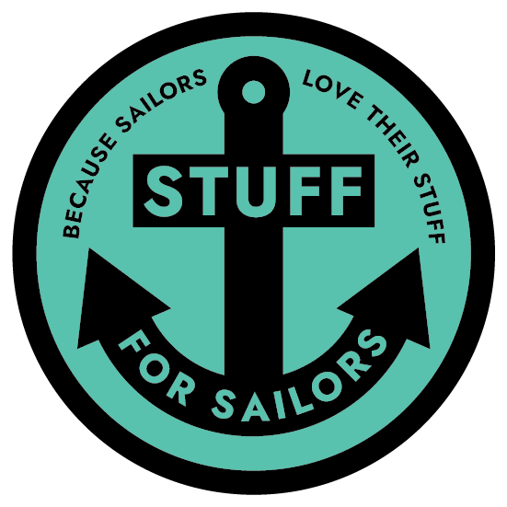  Custom-Fit Storage,  Mounts & Brackets  Marine-Grade,  UV-Stable Materials  Binocular, VHF  & Electronics Mounts  Personalized Soaps,  Keychains & Gifts  Design, 3D Print  & Install

Custom-built to your boat's drop boards
Keep your washboards stowed, protected, and within reach. Built to your exact boards and mounting spot.

Client Information

Name | Email
Phone | Best way to reach you
Mailing address

Vessel Information

Vessel name | Make & model
Length | Home port / marina

Companionway Washboard Storage Rack — Specifications

This rack stows your companionway washboards (drop boards) securely when they're not in the hatch — out of the way, protected, and easy to grab. It's built to your exact boards, so accurate measurements matter. If you can, measure twice.

How many washboards should the rack hold? | Are the boards all the same size? (Y / N)
If your boards are different sizes (many boats taper), give the measurements for EACH board below — add a note for board 1 (top), board 2 (middle), etc.
Board dimensions — for each board: WIDTH × HEIGHT, and full THICKNESS. Note which is top / middle / bottom.

Thickness of the thin edge / lip where the board slides into the companionway track

This thin sliding edge is often a different (thinner) thickness than the body of the board — it's the part that rides in the hatch channel. We need it to size the slots correctly.

Mounting Details

Describe the mounting location (bulkhead, locker door, cockpit, etc.):

Will the innermost (back) board sit flush against the bulkhead / mounting surface? ☐ Yes, flush ☐ No — there's a gap or standoff
Is there any trim, molding, handrail, or hardware near the mount that would change the needed depth or shape? Describe it:

Impeding trim is the #1 reason a rack needs a custom depth — a raised trim piece or a handrail can mean the rack has to stand off the surface. Tell us about anything close by.

Mounting Environment & Material

Where will this be mounted? ☐ Interior (inside the boat) ☐ Exterior (cockpit / on deck / exposed)
Mounting location determines the material. Exterior parts must be UV-stable to survive sun and weather; interior parts have far more color and finish options.
EXTERIOR colors (UV-stable):
☐ Black ☐ White ☐ Grey
EXTERIOR, carbon-fiber reinforced (UV-stable, extra strength):
☐ Black ☐ Grey
INTERIOR colors:
Interior mounting opens up a much wider range of colors and finishes — tell us what you have in mind and we'll work with you.
Interior color / finish requested

Pricing & Process

Pricing: quoted per rack once we know board count, sizes, and mounting details — see “For Office Use” below.
• Carbon-fiber reinforced: +25% over standard material price
• Nylon (highest durability): priced separately, by request

Pricing above assumes standard ASA (exterior) or PETG (interior); see material & color options above.

How it works:
Once we agree on design details, I print a prototype first in PLA — a low-cost, low-durability material just to check fit. It's yours to keep either way, but it's not built for real use and would fail under normal load. If the prototype fits right, I move to the final build in your chosen material. A 50% deposit gets the order started.

For Office Use — Stuff for Sailors

Quote # | Date received | Target material
Est. print time | Quoted price | Deposit (50%)
Notes

Thank you — every piece is designed and made to order. Once we have your details we'll follow up with any questions and a firm quote.

