Asmita Gautam
3/18/2020
Assignment 07
Graphical analysis with python
Program name: Program_07.py
Program Creator: Asmita Gautam

Description:
This program completes the graphical analysis of the data and generate a variety of figures.

Source and format of input data:
Provenance: Earthquake data set was obtained from USGS earthquake hazards web site. Select all earthquake for the past 30 days in the “Spreadsheet Format” through the link:
http://earthquake.usgs.gov/earthquakes/feed/v1.0/csv.php
This dataset format is csv file and its contents are describe in the above link
This dataset was obtained in March 11th 2020.

Why genfromtxt() will not work with this data file?

genfromtxt is from numpy module. NumPy arrays have one dtype for the entire array, while pandas DataFrames have one type per column. The given dataset doesnot have same dtype between the columns but has same dtype within each column. So, pd.read_csv() will be able to read give csv file, but genfromtxt() will not work with the given data file.

Types of analysis:
1. Histograms: Histogram plots are generated to study the happening probability of earthquakes. Alteration of bin width and range are studied while histrogram generation.
2. KDE plots : KDE plots of the same data set would be studied for determining kernel density estimation.
3. Latitude versus longitude plots: Latitude versus longitude plot is generated to understand the occurrence pattern of earthquake along longitude and latitude in last 30 days
4. Normalized CDF of earthquake depths : Cumulative distribution of earthquake is generated from Normalized CDF with its depths.
5. Scatter-plot of earthquake magnitudes with depth :The relationship of earthquake magnitude with depth is determined with the scatter-plot of earthquake magnitude with depth.
6. Q-Q plot :

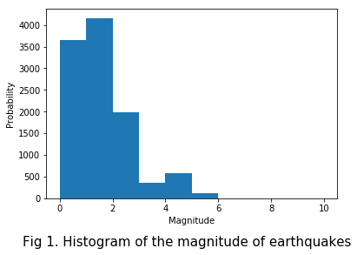
The given fig 1. is the histogram with the bin width of 1 and range of 0 to 10. This histogram indicates that probability of higher magnitude earthquake is less. Whereas the earthquakes with less than 2 magnitude are more probable to occur.
Bin width and range alteration will change the smoothness of the histogram. Larger bin number increases the smoothness and is more suitable for the data-set with which has larger ranges , like with larger range of the magnitude. Whereas, range alteration could also alter the histogram, the range of the histogram should be in accordance to the range of magnitude of the data-set.
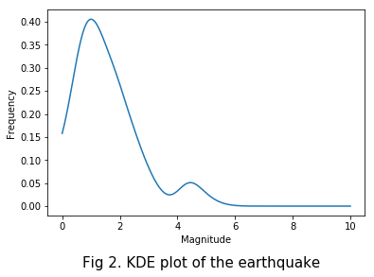
The given fig 2. is the KDE plot of the earthquake, the kernel type is Gaussian and bin width is 0.1. The kernel distribution estimation is similar to histogram but KDE is smoother relative to histogram.
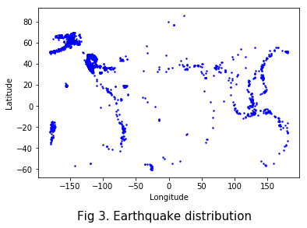
The above Fig 3. is the earthquake distribution. The earthquake distribution plot shows that the more occurrence of earthquake is in the region where continental plate coincide.
The longitude and latitude are plotted x and y axis because it is represented similar on the world map.
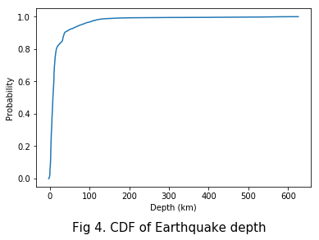
The given Fig 4. is the cumulative distribution function (CDF) of the earthquake depth. The CDF plot indicates that the most earthquake depths are from 0 to 50 km, since the slope of the line from 0 to 50 km is high. The lower slope of the line after 200 indicates that there might be only few earthquakes with more than 200 km depths.

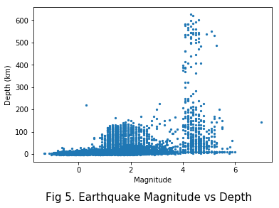

The given fig 5. is the scatter-plot of the earthquake magnitude vs depth. The plot show that the occurrence of the lower magnitude at lower depth are higher. It also indicates that the earthquake at higher depth are probable at higher magnitude.

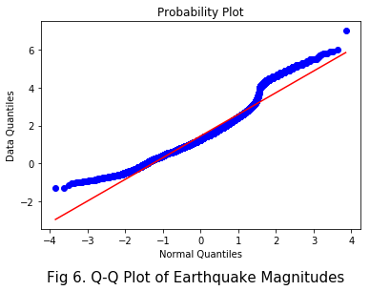

The above fig 6. is the Q-Q plot of earthquake magnitudes. The Q-Q plot indicates that the distribution is more likely to normal distribution.

