Tyler Field

5/1/2020

ABE 65100

Lab 7 Metadata

**Source and Format of Input Data**

The data used was downloaded on March 3, 2020 from the USGS Earthquake Hazards website (https://earthquake.usgs.gov/earthquakes/feed/v1.0/csv.php) by selecting all earthquakes in the past 30 days. The values are comma separated and the first line of the file contains the variable names. It had data for 11214 earthquakes, with their magnitudes, latitudes, longitudes, and depths, among other variables. The data is read in using the *pd.read_table()* function instead of *np.genfromtxt()* because some lines have a different number of values than others (due to missing values).

**Types of Analysis Conducted**

The six plots generated from the data are a histogram of earthquake magnitudes, a KDE plot of earthquake magnitudes, a scatter plot of latitudes vs longitudes, a cumulative distribution function of earthquake depths, a scatter plot of earthquake magnitude vs depth, and a Q-Q plot of earthquake magnitudes.

**Graphical Analysis Figures**

Figure 1 shows the histogram generated from the earthquake magnitudes using a bin width of one and a range from zero to ten. The range affects what values are included within the histogram and the bin width affects how many bins there are. Since the total range is ten with a width of one, this results in ten bins with boundaries on the integer values from zero to ten. Too wide of a bin width will prevent observation of data trends, while too narrow of a bin width will show the trend with a lot of noise. For this case, all values between two integers are grouped into a single bin. For example, all earthquakes in the range of zero to one are grouped into the first bin. The histogram has a peak in the second bin and is skewed to the right. This makes sense since low magnitude earthquakes occur much more frequently than higher magnitude earthquakes.

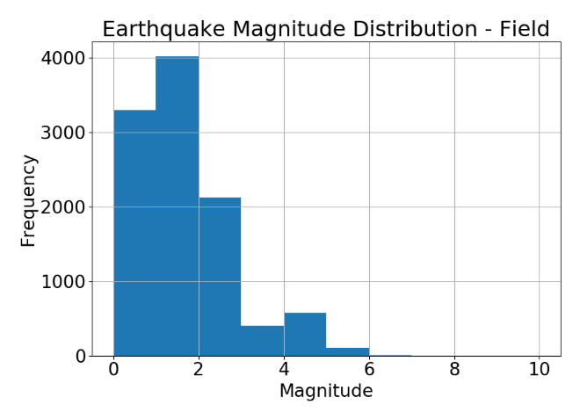

**Figure 1:** Earthquake Magnitude Histogram Distribution

Figure 2 shows a KDE generated from the earthquake magnitudes using a Gaussian kernel and a bandwidth of 0.25. It appears similar to the histogram generated previously, but with a smooth curve instead of boxed bins. This also caused it to extend into the negative magnitude range, which is unrealistic. Overall, the general shape of the KDE plot in Figure 2 matches the histogram shown in Figure 1.

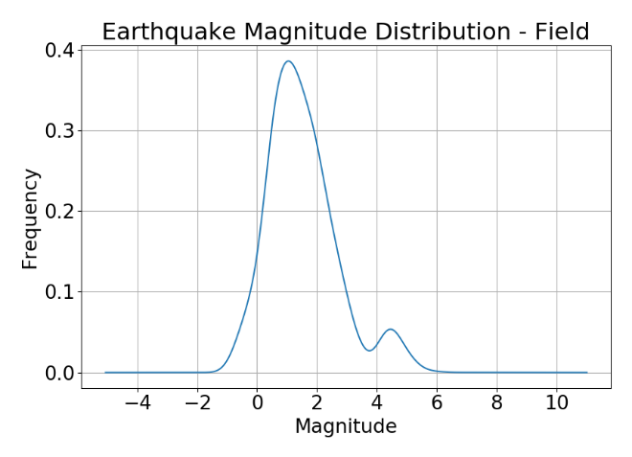

**Figure 2:** Earthquake Magnitude KDE Distribution

Figure 3 shows a scatterplot of earthquake locations by using latitude and longitude as the axes. The plot roughly resembles a map of the world, particularly the boundaries of tectonic plates. This makes sense as these are the primary locations where earthquakes occur.

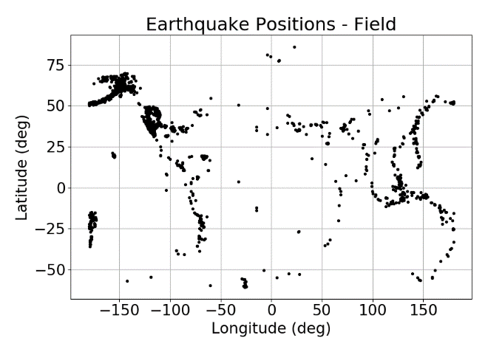

**Figure 3:** Earthquake Latitude & Longitude Scatterplot

Figure 4 shows a cumulative density distribution for earthquake depths. As it quickly reaches a value of 1.0, this implies that most earthquakes occur at shallow depths of less than 100-150 kilometers.

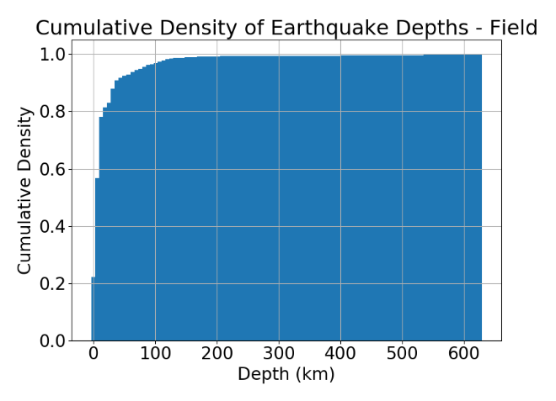

**Figure 4:** Earthquake Depth Cumulative Density

Figure 5 shows scatterplot of earthquake magnitude vs depth. The depths are all very shallow for lower magnitudes but spread out more for higher magnitude earthquakes. This implies that if the depth is greater than about 200 kilometers, then the earthquake is likely of higher magnitude. Additionally, if the earthquake magnitude is low, then the depth is likely shallow. It should be noted though, that just because the depth is shallow, that does not imply a certain magnitude of earthquake.

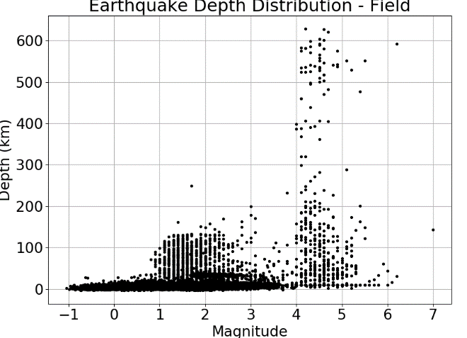

**Figure 5:** Earthquake Magnitude vs Depth Scatterplot

Figure 6 shows a Q-Q plot of earthquake magnitude. The Q-Q plot assumes that the magnitude distribution is normal. Referring to Figure 2 since it uses a Gaussian kernel for the magnitude data, the magnitudes show a non-insignificant peak around a magnitude of 4.7. Besides this feature, the data looks fairly normal. This agrees with Figure 6 showing a fairly linear set of points, except for around Theoretical quantile 1.5 where it increases quickly. This likely corresponds to the small peak in Figure 2. Overall, the data somewhat agrees with the normal distribution.

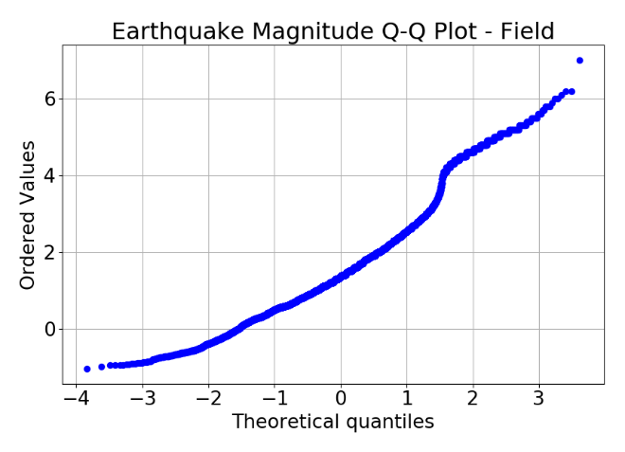

**Figure 6:** Earthquake Magnitude Q-Q Plot