METADATA

Author: Mingda Lu
Time Created: April 3, 2020
Script: program_09.py
Description: The script was created to improve the data quality. Improvements of data quality can be observed graphically (as plots of the data) and numerically (as table of number of inappropriate data modified).

1. Input Data
Data was provided by the instructor, which contains 5 columns as Date, Precip, Max Temp, Min Temp, and Wind Speed, respectively named as DataQualityChecking.txt. Time period is 2 years from Jan 1st, 1915 to Dec 31st, 1916.

2. Script Notes
The created script, program_09.py, contains main 6 parts as below:
2.1. Read data from a given .txt file.
2.2. Remove all No Data Values.
Data with unknown value was set and recorded as -999, this part of code replaces that -999 data to NaN for future use.
2.3. Check for Gross Error where values are not reasonable.
This part of code replaces unreasonable records to NaN. Precip < 0 and >25, Temp <25 and >35, Wind Speed < 0 and >10 are considered as unreasonable data.
2.4. Swap Min Temp and Max Temp if recording mistake occurs where Min is larger than Max.
This part of code swaps the Min Temp value with Max Temp value if Min Temp is occurred as larger than Max Temp, which is not possible and considered as mis-recorded data.
2.5. Remove data with unreasonable range between Min and Max.
Max Temp should not be 25 degree Ceausescu larger than Min Temp (Max Temp – Min Temp < 25). If not, one of the recorded data for the day is wrong. This part of code replaces the data for that day by NaN.
2.6. Plot results.
This part of the code creates plots for Original provided data compare to Checked data.

3. Table of Summary

 | Precip | Max Temp | Min Temp | Wind Speed
1. No Data | 2 | 2 | 2 | 0
2. Gross Error | 15 | 14 | 2 | 2
3. Swapped | 0 | 4 | 4 | 0
4. Range Fail | 0 | 5 | 5 | 0

4. Plot Results

4.1 Precip Check
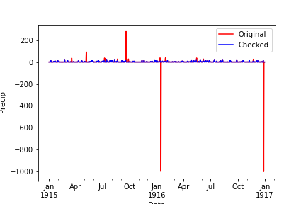
Two obvious mistakes and some other unreasonable values (>200) can be identified directly from the graph (-999 values). Blue line shows the checked data with all unreasonable and mistake values replaced by NaN is more reasonable. From this plot, most of the Checked values lie on the Original line. With given constrains, daily precipitation should be in the range of 0 to 25. The checked data removes all ‘outliers’ and could be used for analysis in order to aim a more precise goal.

4.2 Temp Check
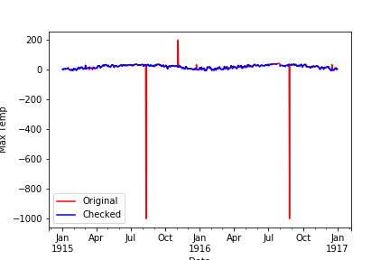

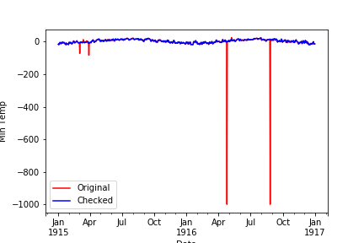
Above plots illustrated the check for Temp Data (upper: Max Temp Data, lower: Min Temp Data). The given constrain indicates that the temperature is in the range of -25 to 25 degree Ceausescu for the specific location. Unreasonable value was replaced by NaN. Some errors, especially where Min Temp is larger than Max Temp, are fixed to be more reasonable by swapping Min and Max values. Therefore, no negative value will occur while calculating Temp difference. This checked data ensures that software could work on this data successful without any ambiguities.

4.3 Wind Speed
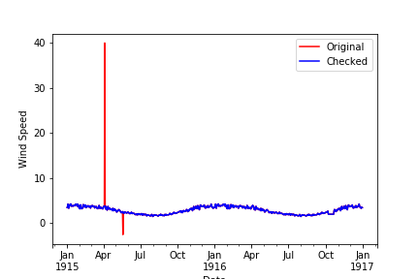

Only 2 unreasonable peaks can be observed from above Wind Speed data plot. Most of the Checked data fit perfectly with Original data. The original data is overall good for analysis purpose. However, in order to use that in software, those unreasonable value could cause problems. The checked data is clean for modeling purposes, such as feasibility study of build a wind farm at this location, that that extreme value could not cause overestimate in total/average amount of power generation.

