ABE651 – Environmental Informatics

Tippecanoe River and Wildcat Creek Comparison
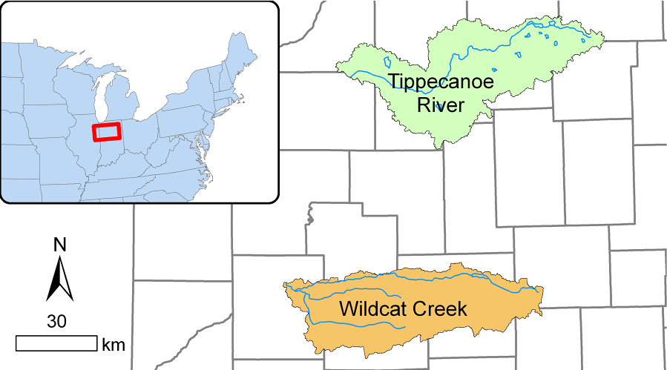

Eric Kong
4/23/2020
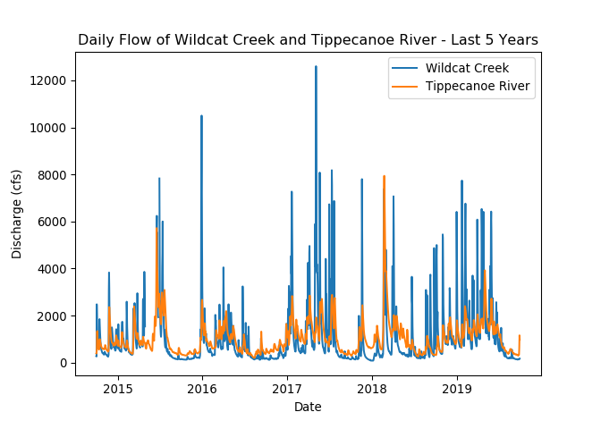

Comparison of the last 50 years

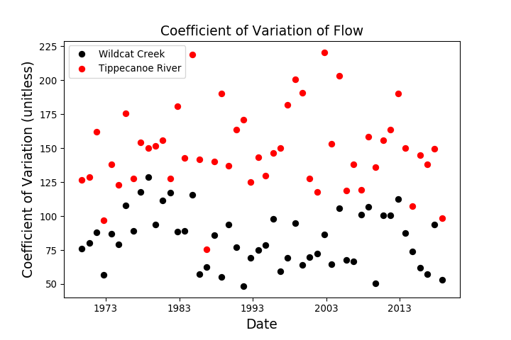

Comparison of the last 50 years

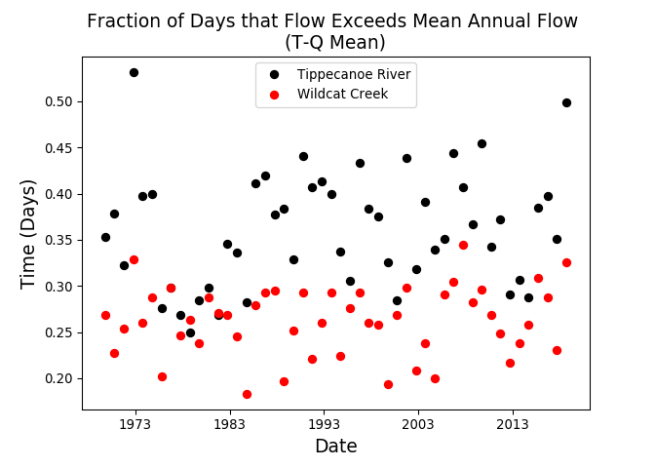

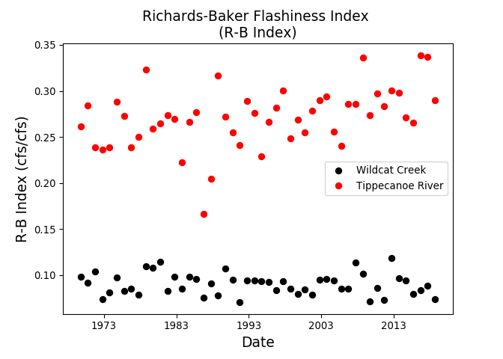
Comparison of the last 50 years

Comparison of the last 50 years

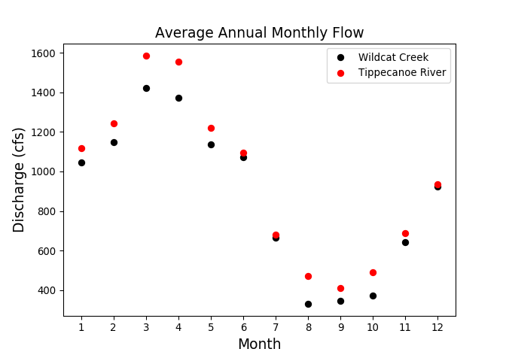

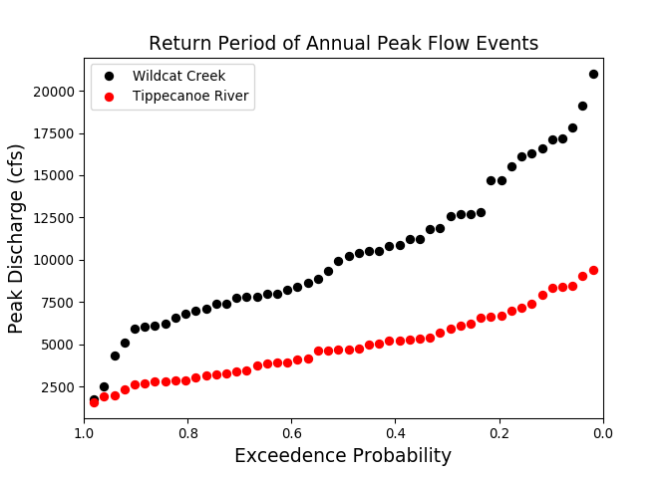
Comparison of the last 50 years

