SCREENING REPORT | AUGUST 2026
Illinois Data Centers and the Hidden Diesel Backup Fleet
A rapid assessment of air permits, generator inventories, operating limits, and compliance records
Prepared for environmental nonprofit research and investigation planning | Data through May 21, 2026
CENTRAL FINDING The listed data centers collectively resemble a large, geographically concentrated diesel-generation fleet. The selected regulatory inventories describe about 504 generators and at least 1.24 GW of standby nameplate capacity, even though the units are regulated facility by facility as emergency equipment.

504  selected generators | 1.24 GW  known nameplate capacity | 20  unique regulatory records | 55%  capacity in five largest records

Executive summary
- Scale: The selected inventories document a fleet whose nameplate capacity is numerically comparable to a large power station, although it is not a continuously operating power source.
- Concentration: Eight listed facilities with Elk Grove-area addresses account for 188 units and 518.5 MW - roughly 42% of documented capacity.
- Modern build-out: 22 of 73 air-permit documents are dated 2024 or later, indicating that the regulatory picture is changing quickly.
- Accountability: Compliance agreements include alleged emissions-limit exceedances, late emissions reports, missed deviation reporting, and construction of generators before obtaining a permit.

1 | A large and concentrated standby fleet
The strongest signal is cumulative scale. Across 20 unique Document Explorer records with a selected generator inventory, the workbook identifies 504 units and 1,238 MW of known electrical nameplate capacity. The shared ORD-01/ORD-02 record is counted once in these totals. Five records contain about 55% of the capacity.
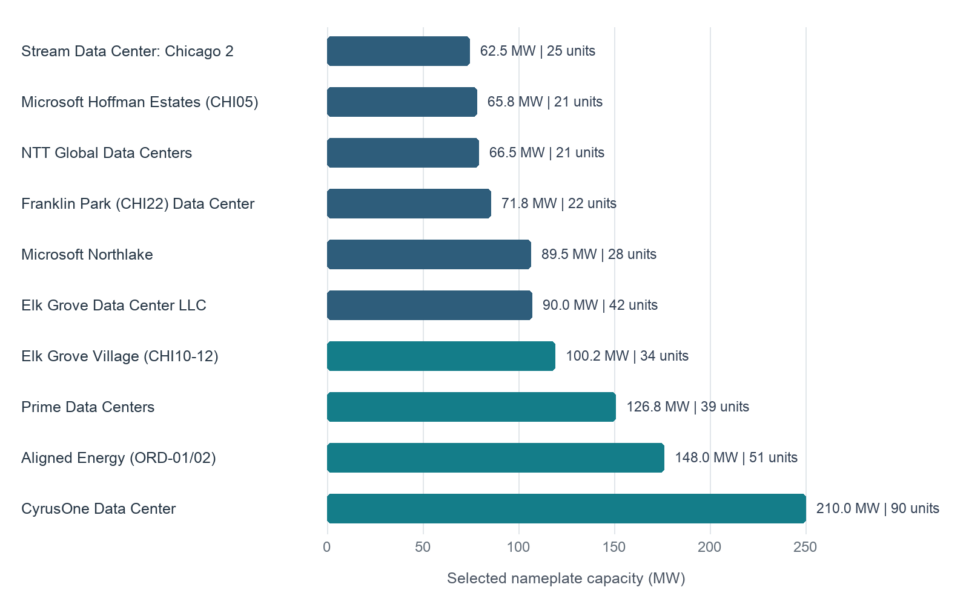
Figure 1. Ten largest selected regulatory inventories by standby-generator capacity.
Source: Illinois Data Center Regulatory Inventory, Facilities and Generators sheets. Shared ORD-01/ORD-02 record de-duplicated.
Generator count alone can mislead. Edged's selected inventory contains 66 relatively small units totaling about 45 MW, while CyrusOne's 90-unit inventory totals 210 MW. Among the 499 units with a recovered kW rating, roughly 63% are rated at 2,500 kW or more. Capacity, engine technology, operating hours, and location are therefore more useful screening variables than unit count by itself.

Geographic concentration
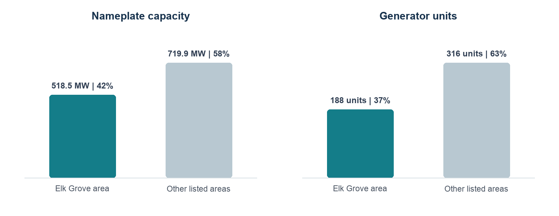
Figure 2. Elk Grove-area facilities contain about 42% of selected capacity and 37% of selected units.
Source: Facility manifest addresses and selected generator records. 'Elk Grove area' includes addresses containing Elk Grove or Elk Grove Village.
This clustering reframes the issue as a neighborhood-scale cumulative-impact question. Routine testing, outages, or grid emergencies could cause many engines in the same industrial corridor to operate within a short period. The workbook cannot estimate exposure by itself, but it identifies where demographic, school, health, ambient-air, and wind analyses would be most valuable.

2 | A rapidly changing regulatory landscape
The document set spans 2007 through May 2026, but recent activity is substantial: 22 of 73 final air-permit documents are dated 2024 or later. Eleven of the 20 selected regulatory inventories rely on permit evidence from 2024 or later. Any public-facing inventory should therefore be maintained as a time series rather than treated as a one-time census.
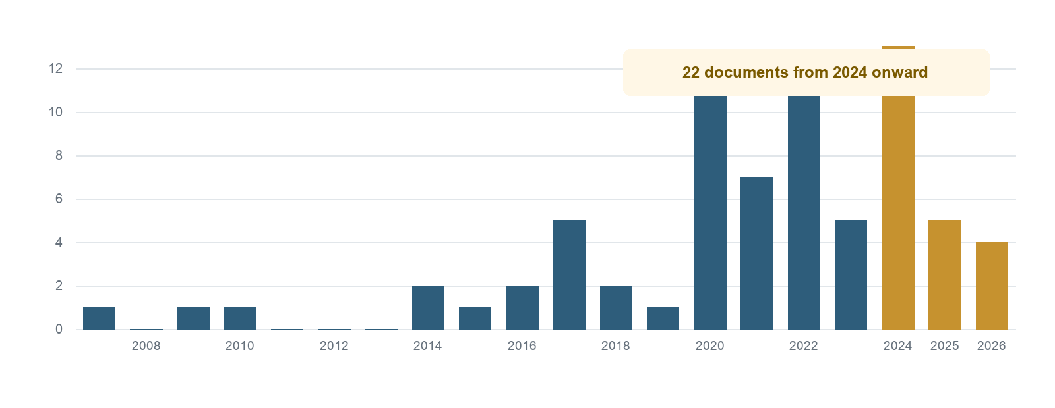
Figure 3. Final air-permit documents by year in the downloaded corpus.
Source: Documents sheet. Counts reflect documents in this 25-facility screening sample, not all Illinois data centers.

Operating limits change the pollution picture
Nameplate capacity is not annual generation or annual emissions. Extracted permits include individual-generator runtime limits from approximately 180 to 1,200 hours per year, aggregate fleet-hour limits, and monthly or annual diesel-consumption limits. Actual emissions depend on permitted and actual operating hours, load, engine age, emission factors, testing schedules, emergency use, fuel, and control equipment.

Compliance records show multiple failure modes
Allegation theme | Records | What the agreements describe
Late Annual Emissions Reports | 3 | Equinix, CyrusOne Aurora, and Ensono reporting allegations.
Emission-limit exceedances | 2 | CO and VOM allegations involving Equinix generators G7-G10.
Deviation reporting | 1 | Alleged failure to notify the Compliance Section within 30 days.
Construction before permitting | 1 | Stream allegedly constructed four generators before obtaining an air construction permit.
Source: Compliance sheet. These are allegations summarized from executed compliance commitment agreements, not independent findings by this report.
WHY IMAGERY MATTERS The Stream agreement is a concrete example of the monitoring opportunity: satellite imagery or aerial photography could help identify new generator yards or construction activity and compare observed timing with permit issuance.

3 | Implications for nonprofit research
The most compelling public-interest framing is that cloud reliability has a physical, local, and diesel-intensive footprint. The regulatory system evaluates engines permit by permit, while residents experience the cumulative mix of nearby sources. This dataset provides a starting point for testing whether those two scales diverge.
- Verify the largest fleets. Manually review the latest permits for CyrusOne, Aligned Energy, Prime, CHI10-12, and Elk Grove Data Center LLC before publishing exact totals.
- Build a construction timeline. Use historical imagery to date generator-pad expansion and compare observed changes with construction-permit and operating-permit dates.
- Measure cumulative exposure. Combine facility footprints with schools, homes, environmental-justice indicators, existing pollution sources, ambient monitors, and prevailing winds.
- Move from capacity to emissions. Extract generator-specific emission factors, permitted hours, fuel limits, testing conditions, and control requirements; then obtain actual runtime or fuel-use records where possible.

Interpretation limits
- This is a 25-facility screening sample, not a statewide census of all Illinois data centers.
- Only 2 of 38 selected generator-group records are marked Reviewed; the others remain OCR-derived and require confirmation.
- Selected inventory means the latest extractable operating-permit inventory plus later construction additions, or the most recent extractable permit when no operating inventory was available.
- Five selected units lack a recovered kW rating and therefore contribute zero to the reported capacity total; 1.24 GW should be treated as a minimum known value.
- A permit's presence does not establish that every authorized unit was constructed, remains installed, or operates during a given event.
- ORD-01 and ORD-02 share one regulatory record; this report counts that record once, but the allocation of its equipment between the two addresses remains unresolved.

Method and sources
The analysis is based on the Illinois Data Center Regulatory Inventory workbook assembled from Illinois EPA Document Explorer records. The corpus contains 112 downloaded PDFs: 73 final air permits, five compliance documents, seven NPDES permits, and 27 site-remediation documents. OCR was performed on the 78 air-permit and compliance PDFs, totaling 1,181 pages. The report uses the workbook's selected generator records and de-duplicates the shared ORD-01/ORD-02 agency record for aggregate calculations.
Primary source portal: https://webapps.illinois.gov/EPA/DocumentExplorer/
Underlying source URLs, document IDs, hashes, OCR paths, page references, and evidence excerpts are retained in the regulatory workbook.

