LAND-USE CHANGE
AT AURORA DATA CENTERS
Construction dates, prior land use, disturbed area, current roof footprint, and development timelines
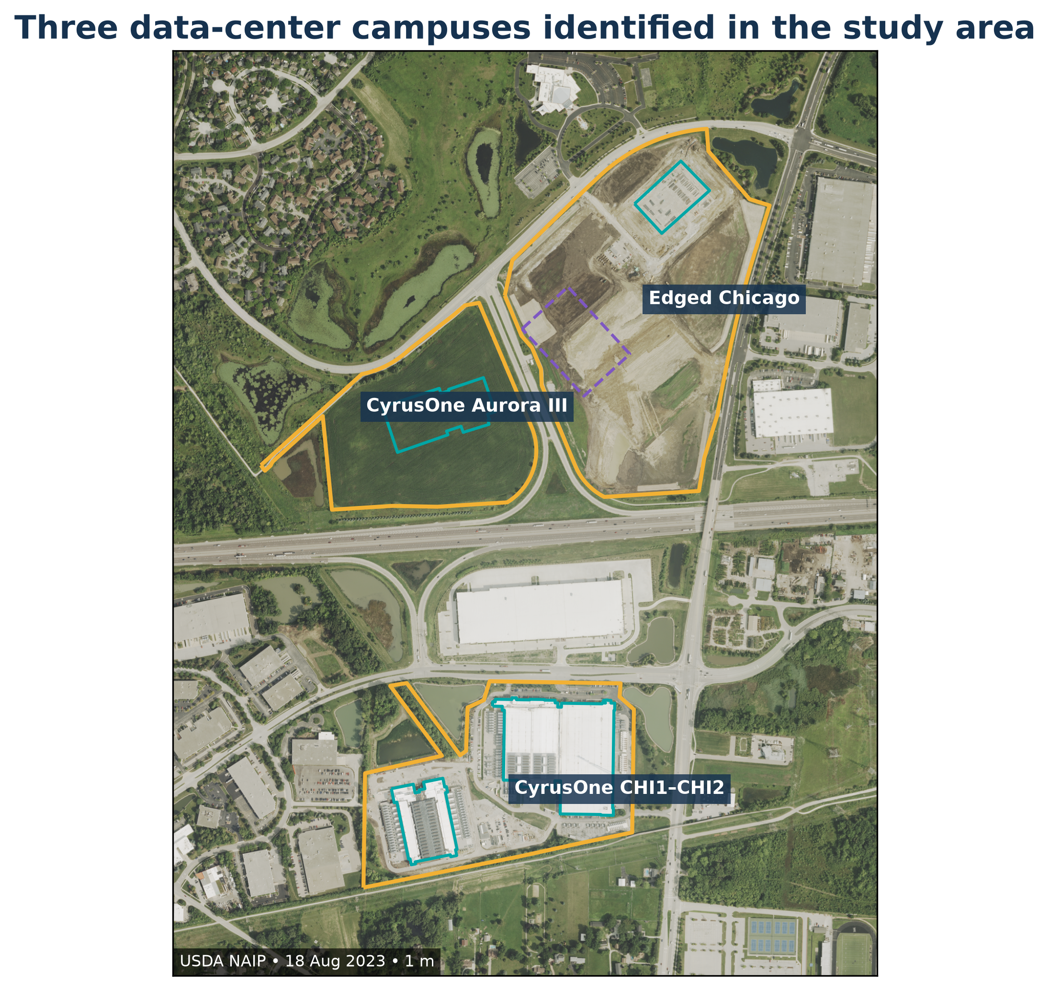
Study area: northeast Aurora, Illinois • 41.7795–41.8178° N, 88.2698–88.2092° W
Prepared 8 September 2026

Executive summary
Three distinct data-center campuses were identified inside the supplied GeoJSON: the Edged Chicago campus, the older CyrusOne CHI1-CHI2 campus, and the newer CyrusOne Aurora III/CHI3 campus. Four current roofs have Overture/OSM polygons. The active Edged ORD01-2 roof is represented separately by approved plan dimensions with approximate positioning. The campuses contain approximately 122.7 acres of remotely sensed construction disturbance.
Campus | Construction began | Prior land use | Disturbed area estimate | Current roof footprint
Edged Chicago | 2023-05-22 | agricultural | 52.7 ac  (52.7–65.1) | 10,789 m² mapped  + 23,724 m² plan
CyrusOne CHI1–CHI2 | 2006/2007 | mixed agricultural / previously developed / forested | 40.8 ac  (32.0–41.5) | 60,573 m² mapped
CyrusOne Aurora III | 2024-09-13 | agricultural | 29.2 ac  (29.2–32.2) | 19,766 m² mapped

The main finding. The two recent campuses occupied undeveloped planned-development parcels that were under active row-crop cultivation immediately before construction. Multiple independent datasets identify approximately 83% to 92% of each parcel as cultivated crops or cropland. The older CHI1-CHI2 campus had a mixed baseline and should not be described as an unqualified agricultural greenfield.

Interpretation of area metrics
Roof footprint, gross floor area, campus area, and disturbed area are not interchangeable. Roof footprint is the plan-view building envelope. Gross floor area counts floors. Campus area follows the parcel boundary. Disturbed area includes roofs, pavement, construction pads, utility work, drainage, and exposed ground. Mapped Overture/OSM roofs, approved-plan geometry, and satellite-interpreted built surfaces are therefore maintained as separate provenance classes.
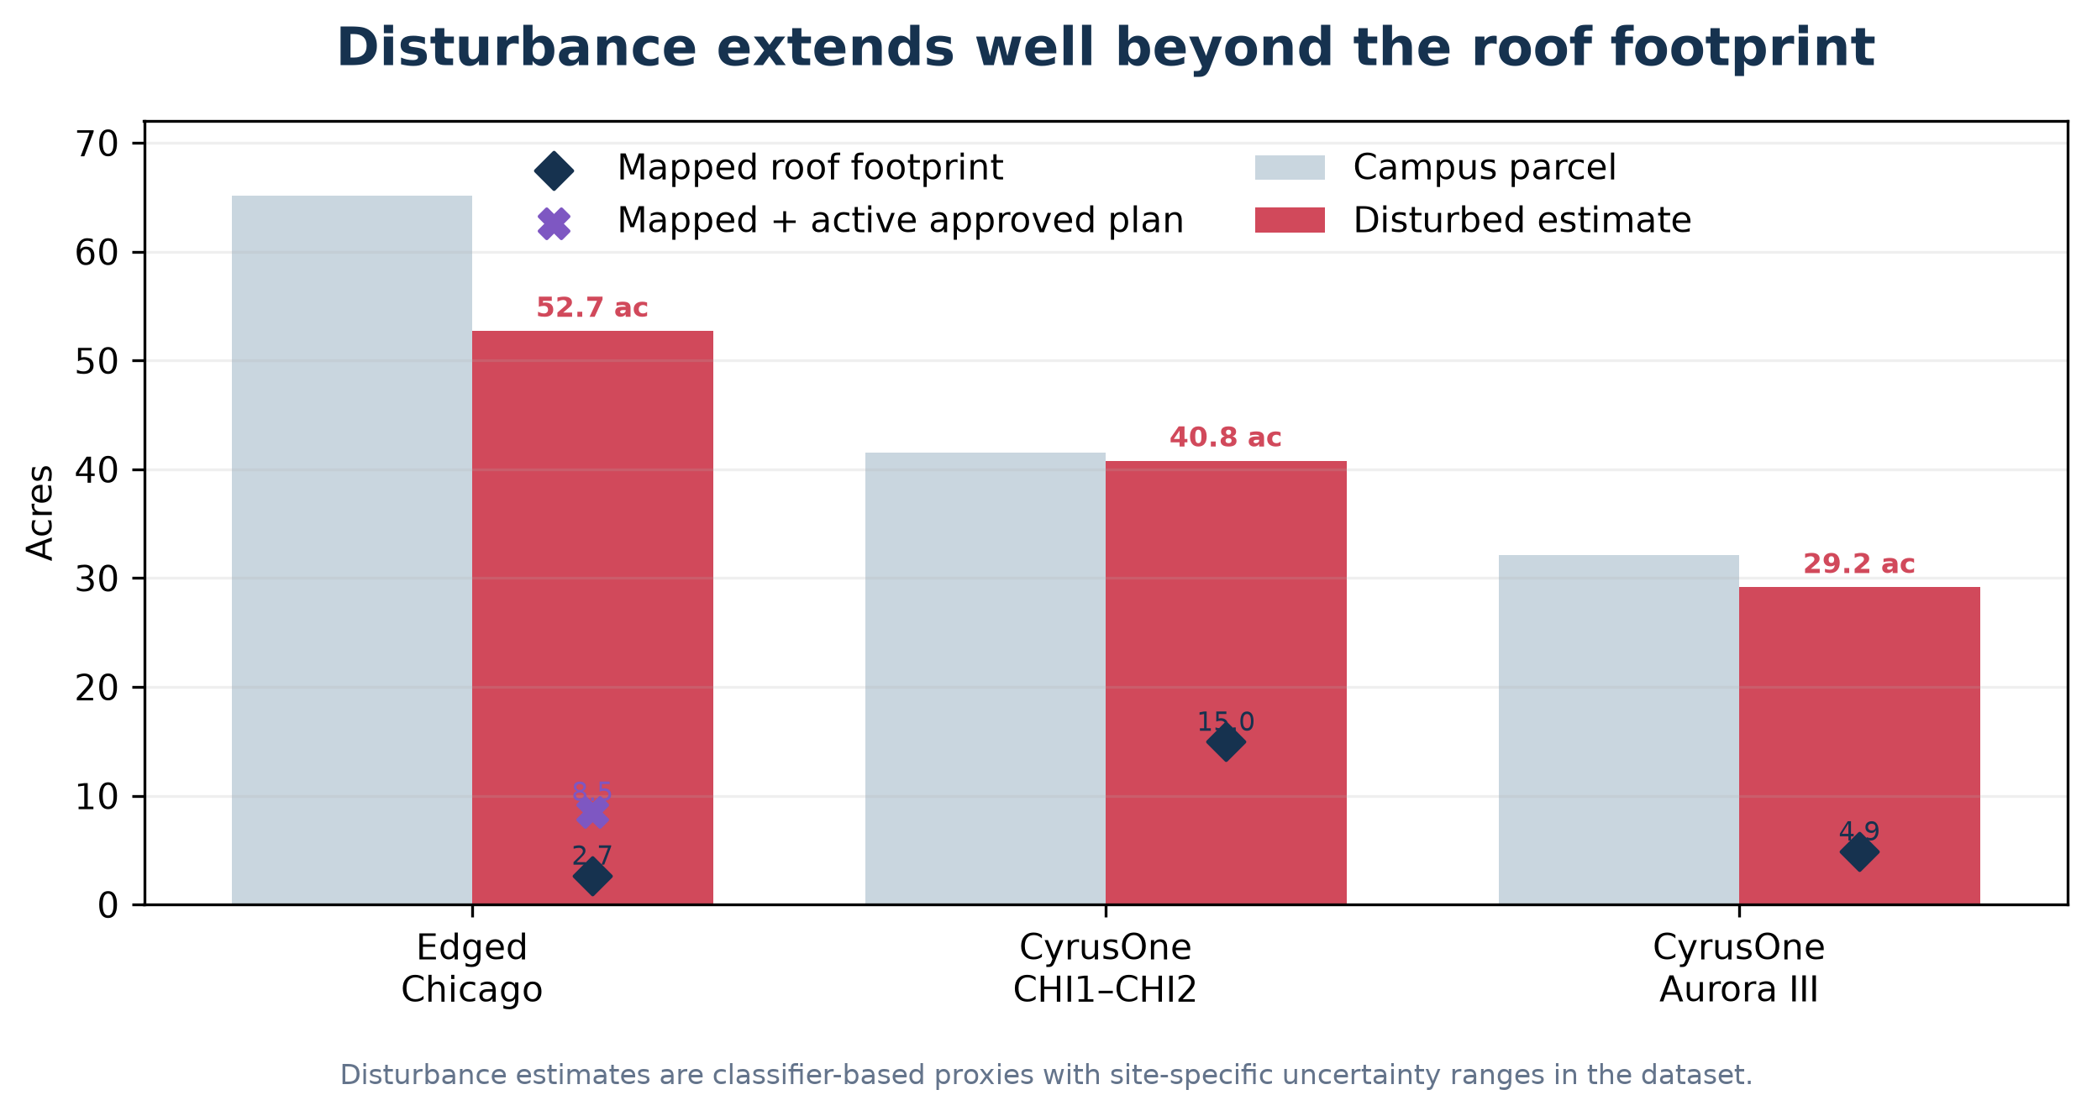
Figure 1. Parcel, disturbance, and roof areas. Exact values and uncertainty fields are included in the structured dataset.

Study design and evidence
The analysis began with the repository’s harmonized Illinois data-center references and regulatory inventory. Candidate points and polygons were reconciled to city parcel ownership, addresses, current Overture building footprints, municipal development plans, operator announcements, and dated open imagery. This process separated three campuses and resolved the unnamed PNNL polygon as CyrusOne CHI2.

Imagery and classification workflow
Component | Method
Dated imagery | USDA NAIP (1 m; 2011–2023), Landsat Collection 2 (30 m; 2005–2015), and Copernicus Sentinel-2 L2A (10 m; 2016–2026) were inspected as before/during/after evidence.
Land-cover time series | Google Earth Engine Dynamic World V1 was summarized annually from 2016 through 2026 using a median probability composite and 10 m argmax class areas.
Older baseline | USDA Cropland Data Layer and Landsat were used for CHI1 because Dynamic World begins after that building was constructed.
Footprints | Current mapped roofs come from Overture Buildings release 2026-08-19.0, with underlying OSM geometry edits dated October 2025 to February 2026. Edged ORD01-2 is stored separately using approved plan dimensions and approximate positioning.
Area measurement | All areas were calculated in NAD83 / UTM zone 16N (EPSG:26916). Spatial interchange files are delivered in EPSG:4326.

Confidence rules
High confidence requires agreement between dated imagery and a primary documentary source or precise mapped geometry. Medium confidence indicates a clear remote-sensing signal with approximation in timing or geometry. Low-medium confidence is used where a 10–30 m land-cover model is acting as a proxy for a complex, older industrial parcel.
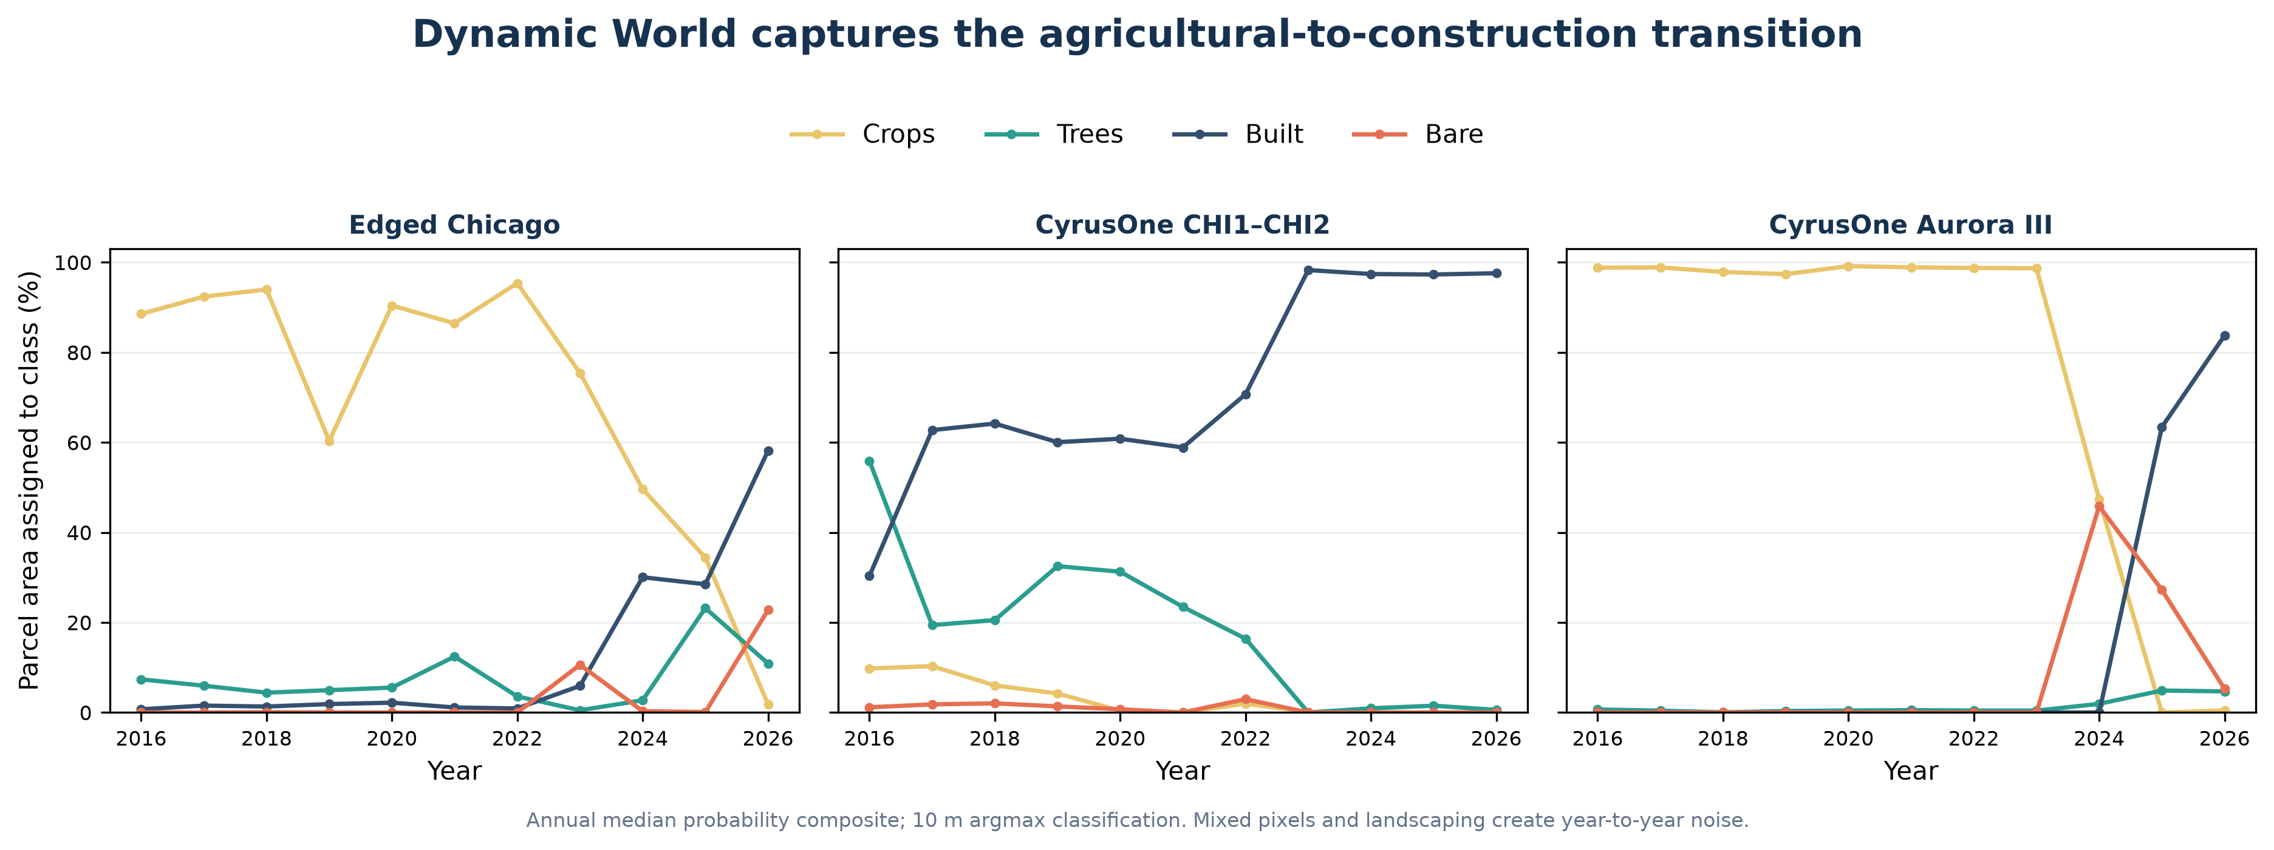
Figure 2. Annual Dynamic World class shares show abrupt crop-to-bare-to-built transitions at the recent campuses.

Independent checks on prior land use
Dynamic World was checked against four alternative land-cover or land-use sources and direct aerial interpretation. The comparisons use each campus parcel, not a point sample. Agreement is strongest for Edged Chicago and Aurora III, where crop-specific USDA results, regional land-use mapping, and visible field patterns all support recent cultivation.
Evidence | Edged Chicago | CyrusOne Aurora III
Dynamic World | 95.4% crops in 2022 | 98.7% crops in 2023
USDA CDL | 2022: 42.7% corn, 40.9% soybeans; 84.9% cultivated | 2023: 79.1% corn, 3.6% soybeans; 82.8% cultivated
USGS NLCD | 2021: 85.1% cultivated crops | 2021: 84.6% cultivated crops
ESA WorldCover | 2021: 83.7% cropland | 2021: 91.9% cropland
CMAP inventory | 2020 land use: Agriculture | 2020 land use: Agriculture
USDA NAIP | September 2021: crop rows visible | August 2023: cultivated field visible
Aurora planning record | January 2023: vacant PDD parcel | July 2024: vacant PDD parcel

Conclusion for the recent campuses. Confidence is high that both parcels supported active row crops before construction. The defensible range is approximately 84% to 95% agricultural cover at Edged and 83% to 99% at Aurora III. The City records describe the parcels as vacant because that is their development status; it does not rule out interim cultivation. The precise description is therefore undeveloped planned-development land under active row-crop cultivation, rather than agriculturally zoned land.

Older CHI1-CHI2 baseline
The older campus requires different wording. CMAP's aerial-photo-derived 2005 inventory assigns the future CHI1 location to vacant residential land use, while the 2006 USDA CDL and Landsat analysis indicates that much of the surface was pasture or cropland. This supports a mixed undeveloped baseline, but not proof of a formal agricultural use. Before CHI2 construction, the September 2015 NAIP image shows wooded cover, open ground, and developed edges. Confidence is medium for the agricultural or pasture share and high for the broader mixed-baseline conclusion.
The datasets are not fully independent. USDA CDL uses NLCD information for non-agricultural training, and Dynamic World and WorldCover both use Sentinel imagery. The highest-weight evidence is the agreement between direct NAIP interpretation, CMAP's parcel-scale inventory, and USDA's crop-specific corn and soybean classes.

Provisional Dynamic World built-surface envelopes
To address map currency, two satellite-interpreted screening layers were extracted directly from the January-August 2026 Dynamic World image collection. Both require built to be the dominant class in a median probability composite. The core layer also requires median built probability of at least 0.50; the inclusive layer uses 0.30. Connected patches smaller than 500 m2 were removed.
Campus | Core built surface | Inclusive built surface | Large unmatched candidates
Edged Chicago | 6.1 ac / 2 patch(es) | 22.9 ac / 2 patch(es) | 2
CyrusOne CHI1-CHI2 | 36.5 ac / 1 patch(es) | 39.5 ac / 1 patch(es) | 0
CyrusOne Aurora III | 12.4 ac / 1 patch(es) | 20.4 ac / 1 patch(es) | 1

Interpretation. These are provisional built-surface envelopes, not building footprints. At 10 m resolution, Dynamic World commonly merges roofs with pavement, construction pads, and equipment yards. The inclusive layer is useful for flagging potentially missing or recently changed mapped geometry; it should not replace Overture/OSM or an as-built survey.
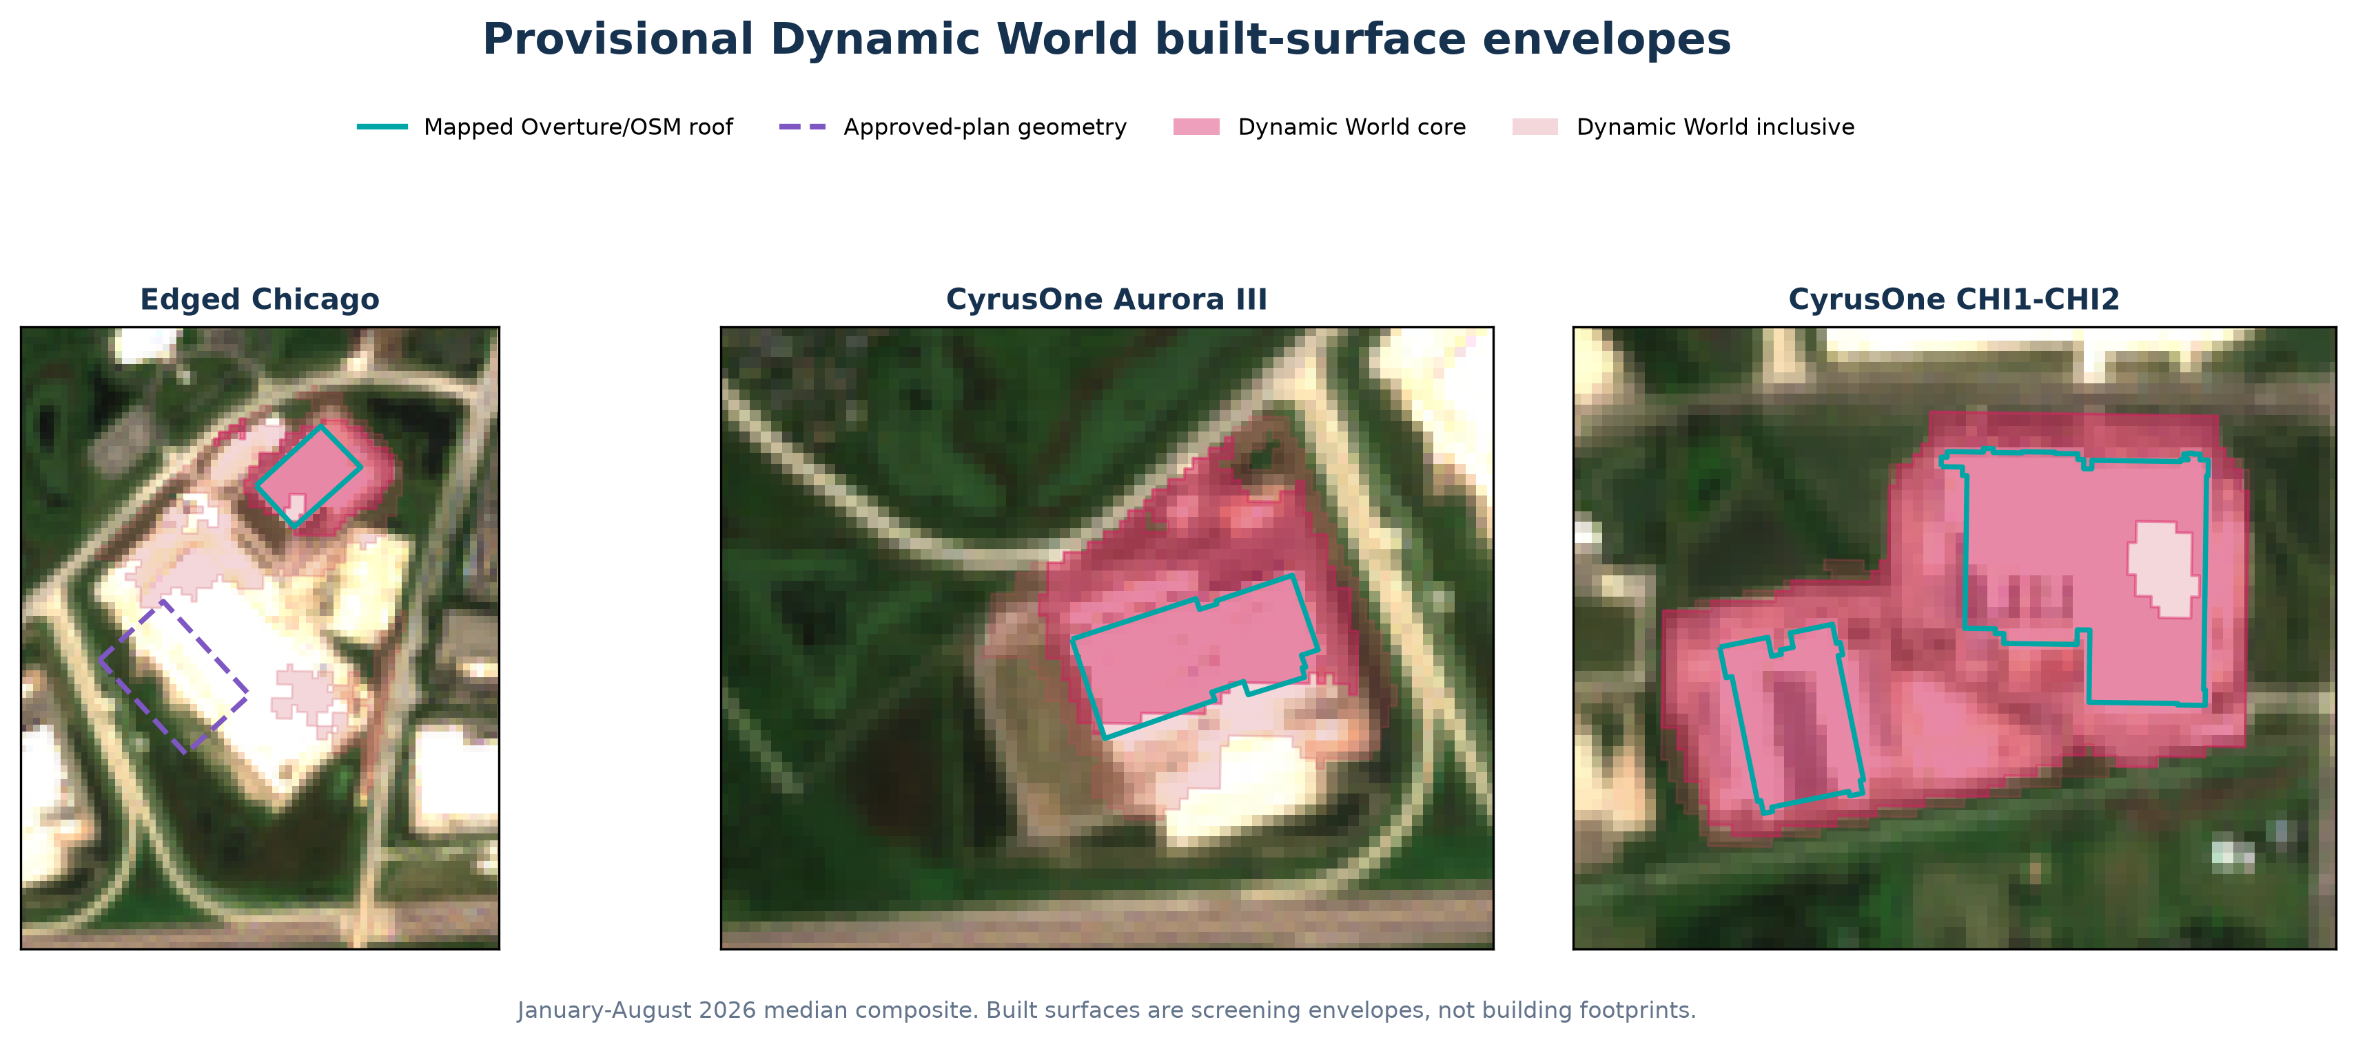
Figure 3. Core and inclusive 2026 Dynamic World built-surface envelopes compared with mapped roofs and approved-plan geometry.

Edged Chicago campus
The 65.1-acre Edged campus occupies six Edged Chicago LLC parcels along Bilter and Eola Roads. The approved preliminary plan contains three buildings. ORD01-1 is operating; ORD01-2 was topped out in June 2026 and remains under construction; the third building is planned.
Land conversion. Previously undeveloped planned-development land under active row-crop cultivation. Dynamic World assigned 95.4% of the parcel to crops in 2022; USDA CDL identified 83.6% as corn or soybeans and 84.9% as cultivated. CMAP classified the location as Agriculture in 2020, while Aurora's approval record called the parcel vacant. The May 2023 groundbreaking, August 2023 NAIP construction scene, and official February 2025 opening bracket the first phase tightly.
Building | Geometry provenance | Roof footprint | Reported gross floor area | Confidence
Edged ORD01-1 | current mapped footprint | 10,789 m² | 207,967 ft² | high
Edged ORD01-2 | approved plan footprint approximate position | 23,724 m² | 415,934 ft² | low-medium

Mapped roof area is 10,789 m². Adding the active ORD01-2 approved-plan footprint gives a provisional total of 34,514 m². Estimated disturbed area is 52.7 acres; the plausible upper bound is the full 65.1-acre parcel assembly.
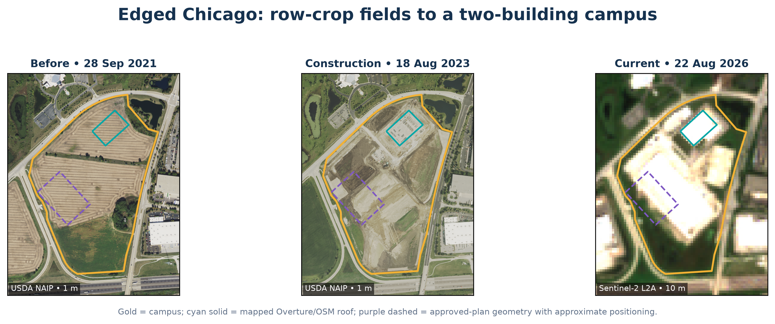
Figure 4. Cyan shows the mapped ORD01-1 roof. Purple dashed ORD01-2 geometry uses approved dimensions but approximate positioning.

Development timeline
Date | Event | Evidence
14 Jun 2022 | Last clear preconstruction satellite baseline | Sentinel-2; crop-dominant parcel
22 May 2023 | Campus / ORD01-1 groundbreaking | Edged official release
18 Aug 2023 | Building and broad grading visible | USDA NAIP
27 Feb 2025 | ORD01-1 opened | Edged official release
13 Nov 2025 | ORD01-2 groundbreaking | Edged official release
4 Jun 2026 | ORD01-2 topped out | Edged official release
Q2 2027 | ORD01-2 target operation | Operator schedule; future

CyrusOne CHI1–CHI2 campus
The original CyrusOne campus occupies the 41.5-acre 2905 Diehl Road parcel. CHI1 is the former CME Group data center; CHI2 is the smaller western building that appeared after the reported December 2016 construction start. The repository’s previously unnamed PNNL building is therefore reconciled to CHI2.
Land conversion. Mixed baseline, not a simple greenfield label. Around the future CHI1 footprint, the 2006 Cropland Data Layer was approximately 74% pasture/cropland, 18% previously developed, 3% forest, and 4% other. The future CHI2 footprint was a wooded/open/developed mix before construction.
Building | Construction chronology | Roof footprint | Reported gross floor area
CHI1 / CME | Change begins 2006–2007; reported year built 2009 | 44,858 m² | 428,000 ft²
CHI2 | Started Dec 2016; roof visible Jul 2017 | 15,716 m² | 316,000 ft²

Estimated disturbed area: 40.8 acres. Because Dynamic World sees nearly the entire mature industrial parcel as built in 2023, the estimate is best treated as a parcel-scale proxy; the structured dataset carries a 32.0–41.5-acre range.

Development timeline
Date | Event | Evidence
2006 | Future CHI1 footprint still mostly agricultural/pasture | Landsat and USDA CDL
2006–2007 | Initial CHI1 land-cover transition | Annual CDL/Landsat interval
2009 | CHI1 reported year built | Facility directory; medium confidence
15 Mar 2016 | CME announced sale of 428,000 ft² facility to CyrusOne | CME Group release
Dec 2016 | CHI2 construction reported to begin | Facility reporting; corroborated by imagery
2 Jul 2017 | CHI2 roof visible | USDA NAIP
2018 | CHI2 development documented as 316,000 ft² | Aurora planning record

CHI1–CHI2 visual evidence
The image sequence separates the campus’s two main construction waves. CHI1 is absent from the coarse 2006 baseline but fully present by the first available NAIP scene. In 2015 the western CHI2 pad remains a mix of open and wooded cover; by July 2017 its roof is clearly visible.
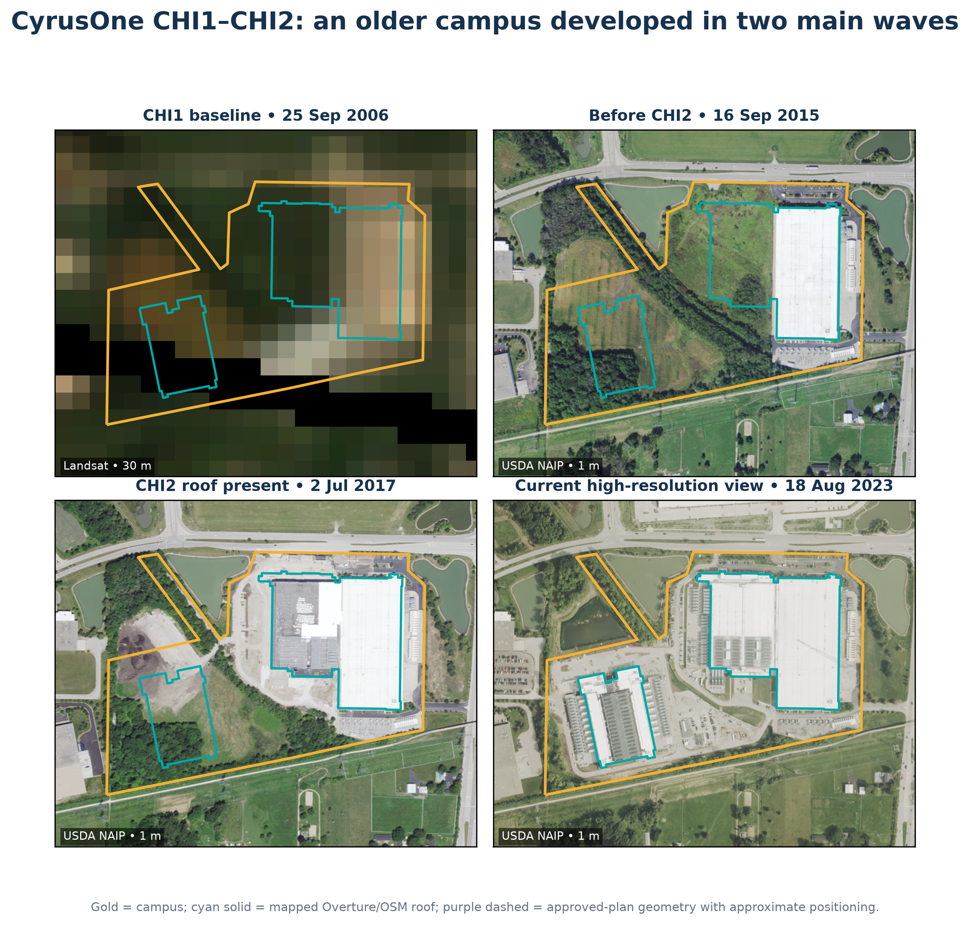
Figure 5. CHI1–CHI2 sequence. The 30 m 2006 baseline supports interval dating but not precise site delineation.
Why the older date remains an interval. The available 30 m annual imagery detects the 2006–2007 land-cover change, while documentary evidence reports a 2009 build year. Without the original grading permit or certificate of occupancy, a single exact construction date would imply false precision.

CyrusOne Aurora III / CHI3 campus
CyrusOne’s second Aurora campus occupies a separate 32.2-acre parcel at 2725 Bilter Road. The announced program contains two buildings totaling 446,000 square feet. One current roof is mapped; no second roof was present by the latest 22 August 2026 Sentinel-2 observation.
Land conversion. Previously undeveloped planned-development land under active row-crop cultivation. Dynamic World assigned 98.7% to crops in 2023; USDA CDL identified 82.7% as corn or soybeans and 82.8% as cultivated. CMAP classified the location as Agriculture in 2020, while Aurora's 2024 planning record called the parcel vacant. The August 2023 NAIP image visibly confirms cultivation. Construction began in September 2024.
Current roof | Status | Roof footprint | Planned campus program
CyrusOne CHI3 building 1 | Substantially complete | 19,766 m² (212,755 ft²) | Two buildings / 446,000 ft² gross

Estimated disturbed area: 29.2 acres in 2025, when Dynamic World assigned 63.4% to built and 27.2% to bare ground. The parcel boundary provides a 32.2-acre upper bound.
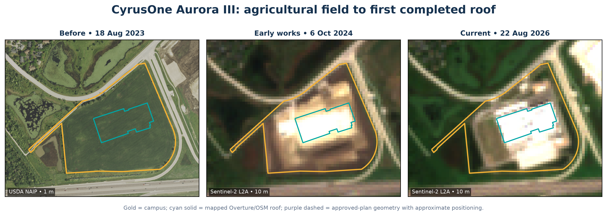
Figure 6. Aurora III imagery sequence shows the crop-to-bare-to-built progression after the September 2024 groundbreaking.

Development timeline
Date | Event | Evidence
18 Aug 2023 | Cultivated field; no construction | USDA NAIP
13 Sep 2024 | Groundbreaking announced | CyrusOne official release
6 Oct 2024 | Grading and early building works visible | Sentinel-2
26 Oct 2025 | First roof appears substantially enclosed | Sentinel-2
25 Jun 2026 | Substantial completion reported | CyrusOne campus update; naming caveat
22 Aug 2026 | One current roof; second building not visible | Sentinel-2 and Overture

Limitations and appropriate use
Issue | Implication
Disturbed area | Dynamic World is a 10 m semantic land-cover product, not an engineering grading survey. Built and bare pixels omit revegetated or water-management areas and may overclassify bright industrial surfaces. Use the estimate together with its lower/upper bounds.
Older construction | CHI1 predates Dynamic World and the available NAIP sequence. Its start is interval-dated from 30 m Landsat/CDL change and a reported 2009 build year; exact permit and commissioning dates remain unresolved.
Edged ORD01-2 geometry | The roof polygon is an analytical approximation based on the approved 417.2 x 612.1 ft plan dimensions. Its area is reliable to plan precision, but its georeferenced position is approximate and is stored separately from mapped roofs.
Status | Current means evidence available through 8 September 2026. Construction and operating status can change faster than public map releases.
Land-use percentages | Percentages from CDL and Dynamic World are classifier outputs and should be treated as approximate composition, especially at mixed edges and for the 30 m older baseline.
Land cover versus designation | Observed cultivation does not establish agricultural zoning, enrollment in a farmland program, or a permanent agricultural use. Aurora described both recent parcels as vacant planned-development land.

Recommended next validation steps
- Obtain Aurora grading permits and certificates of occupancy for exact CHI1 and CHI2 construction/operation dates.
- Digitize final as-built civil plans or acquire sub-meter 2026 orthophotography for a survey-quality ORD01-2 roof and disturbance boundary.
- Repeat the Dynamic World and Sentinel-2 analysis after the next cloud-free season to track Edged ORD01-2 landscaping and any second Aurora III building.
- Use the supplied evidence catalog and per-phase confidence fields when integrating the results into a broader data-center inventory.

Delivered structured data
File | Contents
aurora_data_center_land_use_change.gpkg | Canonical sites and provenance-separated geometry layers
mapped_building_footprints | Overture/OSM roof polygons with source edit dates
approved_plan_footprints | Approved dimensions with approximate georeferenced position
development_phases (.csv, .parquet) | Event intervals, status, and confidence
predevelopment_land_use (.csv, .parquet) | Phase-level prior-cover estimates
dynamic_world_annual (.csv, .parquet) | Annual 2016–2026 class probabilities and areas
dynamic_world_built_core_2026 | Conservative 10 m satellite built-surface screening polygons
dynamic_world_built_inclusive_2026 | More sensitive 10 m screening polygons for map-currency review
evidence_catalog / source_crosswalk | Provenance and repository reconciliation

Sources
Primary and open-data sources are listed below. The machine-readable evidence catalog includes the same records and their analytical use.
[1] Local harmonized reference sites. processed-data/harmonized-data-center-reference-sites-illinois.geojson — Candidate IDs site_00603, site_01911 and site_02530
[2] Local Illinois regulatory inventory. processed-data/illinois-data-center-regulatory-facilities.geojson — Edged and CyrusOne facility/generator records
[3] City of Aurora Parcels MapServer. https://gis.aurora.il.us/arcgis/rest/services/Parcels/Parcels/MapServer/0 — Ownership, parcel boundaries and acreage
[4] Aurora File 23-0044. https://aurora-il.legistar.com/LegislationDetail.aspx?GUID=6D64A5E2-09B6-4786-B142-69F7F0AC4938&ID=6013833 — Approved three-building plan and dimensions
[5] Aurora File 17-01180. https://aurora-il.legistar.com/LegislationDetail.aspx?GUID=8558F28D-3318-4388-A645-32A726B9409D&ID=6657046 — CHI2 plan and 316,000 square feet
[6] Edged groundbreaking release. https://edged.us/news/edged-breaks-ground-on-new-ultra-efficient-waterless-data-center-campus-in-aurora — May 22, 2023 groundbreaking; 65 acres; three phases
[7] Edged opening release. https://edged.us/news/edged-opens-new-data-center-to-power-chicagos-ai-boom — February 27, 2025 opening
[8] Edged expansion release. https://edged.us/news/edged-us-expands-chicagoland-campus — November 13, 2025 ORD01-2 groundbreaking; Q2 2027 target
[9] Edged top-out release. https://edged.us/news/edged-us-tops-out-second-sustainable-data-center-on-edged-chicago-campus — June 4, 2026 top-out
[10] CyrusOne Aurora campus groundbreaking release. https://www.cyrusone.com/media-coverage-press-releases/cyrusone-breaks-ground-on-new-data-center-in-aurora — September 2024 groundbreaking; two buildings, 446,000 square feet
[11] CyrusOne Aurora campus construction update. https://www.cyrusone.com/data-centers/north-america/aurora-il-back-up-generator-schedule — June 2026 substantial-completion statement; public naming is potentially ambiguous
[12] CME Group sale announcement. https://investor.cmegroup.com/news-releases/news-release-details/cme-group-announces-agreement-sell-aurora-ill-data-center — 2016 sale; existing 428,000-square-foot data center
[13] Overture Maps Buildings. https://docs.overturemaps.org/guides/buildings/ — Current roof polygons; release 2026-08-19.0
[14] Google Dynamic World V1. https://developers.google.com/earth-engine/datasets/catalog/GOOGLE_DYNAMICWORLD_V1 — 2016–2026 annual land-cover probabilities and class areas
[15] USDA NAIP. https://planetarycomputer.microsoft.com/dataset/naip — 1 m dated aerial imagery, 2011–2023
[16] Copernicus Sentinel-2 L2A. https://planetarycomputer.microsoft.com/dataset/sentinel-2-l2a — 10 m dated optical imagery, 2016–2026
[17] USGS Landsat Collection 2 Level-2. https://planetarycomputer.microsoft.com/dataset/landsat-c2-l2 — 30 m imagery, 2005–2015
[18] USDA Cropland Data Layer. https://developers.google.com/earth-engine/datasets/catalog/USDA_NASS_CDL — 30 m land-cover evidence for pre-Dynamic World years
[19] CMAP Land Use Inventory 2020. https://services5.arcgis.com/LcMXE3TFhi1BSaCY/ArcGIS/rest/services/LUI20_geodatabase_v1_CMAP/FeatureServer/0 — Independent parcel-scale land-use classification
[20] CMAP Land Use Inventory 2005. https://www.arcgis.com/home/item.html?id=2be439b2e0e84f58ab219b7baf3feff2 — Aerial-photo-derived historical land use at CHI1
[21] USGS National Land Cover Database 2021. https://www.usgs.gov/centers/eros/science/annual-national-land-cover-database — Independent cultivated-crops cross-check
[22] ESA WorldCover 2021. https://esa-worldcover.org/en — Independent 10 m cropland cross-check
[23] Aurora File 24-0479. https://aurora-il.legistar.com/LegislationDetail.aspx?GUID=1417FF27-336E-467B-B82E-04ACD7974169&ID=6780393 — Aurora III planning status and final plan

Reproducibility
Analysis scripts are in analysis/aurora_land_use_change. Raw imagery chips and manifests are in data/aurora_land_use_change/raw/imagery. Script 08 reproduces the parcel-level USDA CDL, USGS NLCD, and ESA WorldCover cross-checks. The Earth Engine scripts record their datasets, aggregation methods, scale, and project metadata. The final README documents coordinate systems and field semantics.
Bottom line. Edged Chicago and CyrusOne Aurora III replaced planned-development parcels that were actively cultivated before construction. CHI1-CHI2 developed in two waves from a mixed vacant, agricultural or pasture, wooded, and partly developed baseline. Disturbed area is approximately 122.7 acres. Mapped roofs total 22.5 acres; including the active Edged plan yields 28.4 acres provisionally.

