**BASIC RESEARCH PROPOSAL COVER PAGE**

|  |  |  |  |  |  |  |
| --- | --- | --- | --- | --- | --- | --- |
| **1.** SUBMIT TO:  Director  U.S. Army Engineer Research and Development Center | **2.** For consideration by  Geospatial Interactions and Processes from Heterogeneous  and/or Complex Geospatial Data  Geospatial Analysis and Intelligence  Environmental Interfaces of Engineering Systems  Multi-Scale Characterization and Modeling of Materials  Engineered Materials by Design  Future Transformative Technologies for Military Engineering  Innovative Material Science for Infrastructure  Computational Science and Complex Military Systems  Resilient Installation Science  Informed Threat Environment  Biotechnology for Warfighting Functions  Unique Biological, Chemical, and Physical Processes | | | | | **3.** PI ERDC experience  < 5 years  5 - 15 years  > 15 years |
| **4.** Title of Proposed Project | | | | | | |
| **5.** Table of Contents:  **Table of Contents**  **TECHNICAL PROPOSAL** 2  **CURRICULUM VITAE** 5  **COST ESTIMATE** 7  **MARKETING CHART** 8  **QUESTION CHART** 9  **NARRATIVE CHART** 10  **OPTIONAL CHART** 11  **OPTIONAL CHART** 12 | | | | | | |
| **6.** Total Proposed  Amount: $K | | | **7.** Proposed Duration (number of months) | | | **8.** Proposed Start Date |
| **9.** Principal Investigator (PI), Laboratory, Telephone numbers and email address: | | | | | | |
| **TYPED NAMES** | | **CONTACT TELEPHONE NUMBER** | | **LABORATORY** | **E-MAIL ADDRESS** | |
| co-PI | |  | |  |  | |
| co-PI | |  | |  |  | |
| co-PI | |  | |  |  | |
| **Director of Submitting Laboratory** – In signing this block, I am certifying I have reviewed this proposal and find it is representative of Basic (6.1) level research. | | | | | | |

# **TECHNICAL PROPOSAL**

1. **Title:**
2. **Research Objective:** State the basic research problem being pursued or the question to be answered by the research objective. **Provide a testable hypothesis in bold text**.
3. **Potential Impact and Significance:** Describe the significance or potential impact to the scientific field or discipline and the relevance to the ERDC and the Army if the research goals are achieved. Explain why the Army should pursue and fund this research.
4. **Innovation:** Provide details on why this research should be considered innovative. Will the project utilize novel ideas and methods to produce significant new insights and knowledge?
5. **Strategic Research Area Relevance:** The Strategic Research Areas (SRAs) identify the priority research topics for the ERDC. Identify the SRA to which your proposal most directly applies and provide details indicating the relevance of the proposed research to the chosen SRA.
6. **Background:** Provide a clear statement of the present state of knowledge in the field including internal ERDC research and research outside of ERDC. Describe how the proposed effort will build upon the current state of the science/knowledge gaps. Does the research plan reflect a broad understanding of the underlying science and of comparable work being done within the scientific community (i.e., state of knowledge in industry, academia, other federal laboratories, internationally)? Does this effort build upon work being conducted elsewhere? Explain how this is basic research.
7. **Effort Description:** The general plan of work including the broad design of activities to be undertaken. Provide a clear description of experimental methods and procedures and plans.Describe the research plan to test the hypothesis that will explain the phenomena to be investigated. Describe the intended research effort (i.e., research objectives and exit criteria) for each 12-month period up to 36 months total. If the proposed research effort cannot be accomplished within a 36-month period, explain why and describe the intended research objectives and exit criteria for the additional time period requested to complete the work. Describe the major technical tasks and technical milestones. For each research task, describe the research methods and techniques that will be employed to test the hypothesis. Is the use of modeling, simulation, and/or experimentation appropriate and well-suited to making advancements in new knowledge? Will the proposed methods create new capabilities or enhance existing capabilities? Are the experimental capabilities, in terms of parameters that can be measured, comparable to that of theory to predict these parameters at the same level of accuracy? Are there any opportunities to bring theory and experiment into better balance?
8. **Effort Timeline:** Specify timelines and deliverables for each activity. List risks associated with each activity and methods for reanalyzing and modifying the project plan if necessary. A milestone is NOT a product (i.e. journal article, conference proceeding, etc.). A milestone is an achievement and/or discovery of the research and could be associated with a Go/No-Go decision. Go/No-Go decisions should also be noted on the timeline (bold outline).

|  |  |  |  |  |  |  |  |  |  |  |  |  |
| --- | --- | --- | --- | --- | --- | --- | --- | --- | --- | --- | --- | --- |
| Task/Milestone | Year 1 | | | | Year 2 | | | | Year 3 | | | |
| Task 1 <*Title*> |  |  |  |  |  |  |  |  |  |  |  |  |
| 1.1 <*Title*> |  |  |  |  |  |  |  |  |  |  |  |  |
| 1.2 <*Title*> |  |  |  |  |  |  |  |  |  |  |  |  |
| Milestone |  |  |  |  |  |  |  |  |  |  |  |  |
| Product |  |  |  |  |  |  |  |  |  |  |  |  |
| Task 2 <*Title*> |  |  |  |  |  |  |  |  |  |  |  |  |
| 2.1 <*Title*> |  |  |  |  |  |  |  |  |  |  |  |  |
| 2.2 <*Title*> |  |  |  |  |  |  |  |  |  |  |  |  |
| Milestone |  |  |  |  |  |  |  |  |  |  |  |  |
| Product |  |  |  |  |  |  |  |  |  |  |  |  |
| Task n <*Title*> |  |  |  |  |  |  |  |  |  |  |  |  |
| n.1 <*Title*> |  |  |  |  |  |  |  |  |  |  |  |  |
| n.2 <*Title*> |  |  |  |  |  |  |  |  |  |  |  |  |
| Milestone |  |  |  |  |  |  |  |  |  |  |  |  |
| Product |  |  |  |  |  |  |  |  |  |  |  |  |

1. **Evaluation Plan/Exit Criteria:** A good evaluation plan appropriate to the scale of the project will provide information as the project is developing and will determine how effectively the project has achieved its goals. How you intend to evaluate the final project and how you will determine whether this project met your scientific expectations. Explain how you will know if you have answered the scientific question addressed and also how any go/no go decisions, if included, will be evaluated.
2. **Dissemination Plan:** Include plans for making project results available to other researchers. Explain in detail how you will disseminate information on the success and content of your project to others. List the peer reviewed publications that will be prepared as a result of the research conducted from this project. A final closeout report submitted via the ERDC Programs Office will be MANDATORY at the end of the last FY of the effort.
3. **Management Plan:** Sufficient detail should be provided to allow for reviewers to evaluate whether the plan includes appropriate expertise and infrastructure to perform the research objectives detailed in the description of the project. Describe the organization of the project staff and methods of assessing performance. For each member of the team, include a description of responsibilities, percent effort, and explain why a given position is necessary for the completion of the proposed research. Include who will take over the project (Co-PI) should the submitting PI change over the course of the effort. All researchers are not Co-PIs.
4. **Bibliography:** Include a bibliographic listing of the key literature citations that serves as the basis for this research project. (Does not count toward the page limit.)
5. **Resubmission:** If this proposal is not a resubmission of a prior proposal, omit this section. If all or portions of this proposal have been submitted in the past, provide explanation for the resubmission and documentation of any changes or revisions. The format should be similar to a ‘Response to Reviewers’ for referred journal articles and should not exceed one (1) page in length. This explanation does not count against the three (3) page limit for Pre-Proposal submissions or ten (10) page limit for Full Proposal submissions. Failure to complete this section, if applicable, will disqualify the proposal for re-evaluation.

# **CURRICULUM VITAE**

(Limit to 2 pages for each ERDC participant)

1. **Title:**
2. **Name:**
3. **Current Position, Department and Division:**
4. **Education:** (Bullet format example)

* 2000 Ph.D. (Degree), Name of School, City, State, Country
* 1995 M.S. (Degree), Name of School, City, State, Country
* 1985 B.S. (Degree), Name of School, City, State, Country

1. **Relevant Professional Experience or Employment:** (Bullet format example)

* 2015
* 2010

1. **Relevant Publications:** (Bullet format bibliographic citation example)

* Doctor, B.P., and Maxwell, D.M., New Approaches to Medical Protection Against Chemical Warfare Nerve Agents, New York: CRC Press, 2001, pp. 191-214
* List up to 5 significant related publications.

1. **Invention Disclosures and Patent Applications:** (Bullet format example)

* 2015
* 2010

1. **Research Achievement and Recognition Awards:** (Bullet format example)

* 2015
* 2010

1. **Previous Research Results:** Report results from prior ERDC basic research (6.1) projects. If any PI or co-PI identified on the project has received ERDC 6.1 funding in the past five years, information on the award(s) is required.
2. **Alphabetized List of Non-ERDC/External Collaborators:** (Past 48-months)

* Co-editor names and their current organizational affiliations
* Graduate advisor/post-doc sponsor names and their organizational affiliations
* Names of individuals for whom the PI has been a thesis advisor

# **COST ESTIMATE**



Note: The labor rate is the fully-loaded labor burdened rate, which includes the current effective rate, and is found in CEFMS. The fully-loaded labor burdened rate includes benefits, the laboratory departmental rate, and G&A rate. For the non-labor costs, the most current military G&A rate should be utilized. Researchers should prepare their cost estimates with coordination from their administrative assistants/budget analysts and with support and approval of their branch chiefs. For planning purposes, the FY21 military G&A rate is 10.0%; and the FY21 departmental rates are CERL = 30.0%, CHL = 37.0%, CRREL = 36.0%, EL = 32.0%, GSL = 30.0%, ITL = 33.0%, and GRL = 28.0%. These FY21 rates can be used for initial planning purposes, but the rates at the time of submission should be used for the cost estimate, and these rates can be obtained from your administrative assistants/budget analysts and branch chiefs who are being actively engaged with to complete this cost estimate. **Adjustments for salary increases are already incorporated to the direct labor formulas.**

**.**

# **MARKETING CHART**

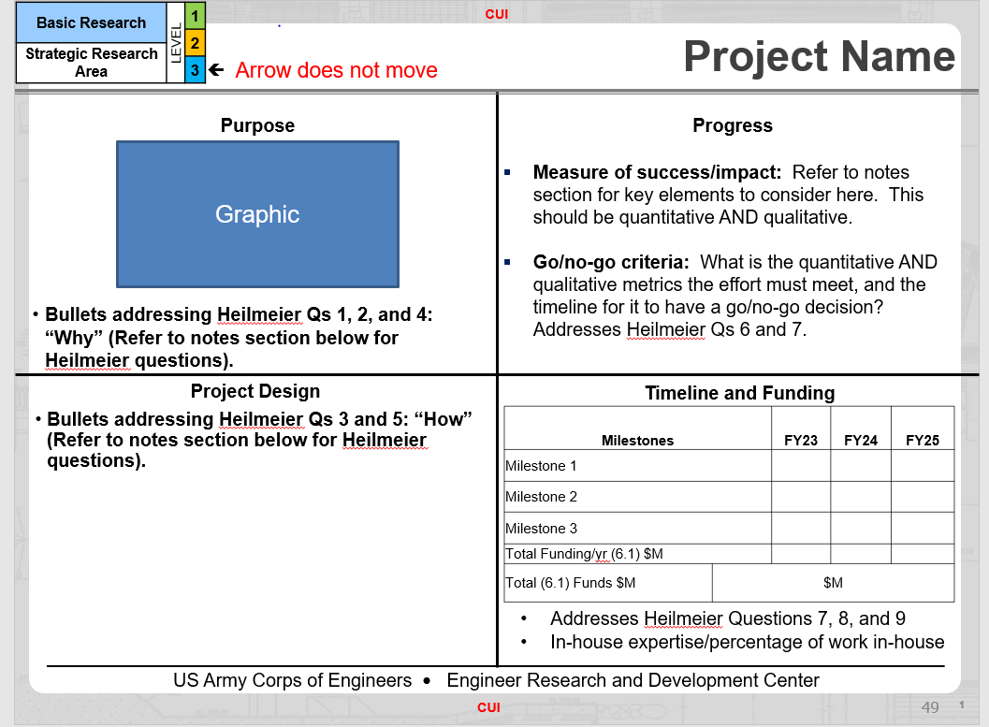

# **QUESTION CHART**

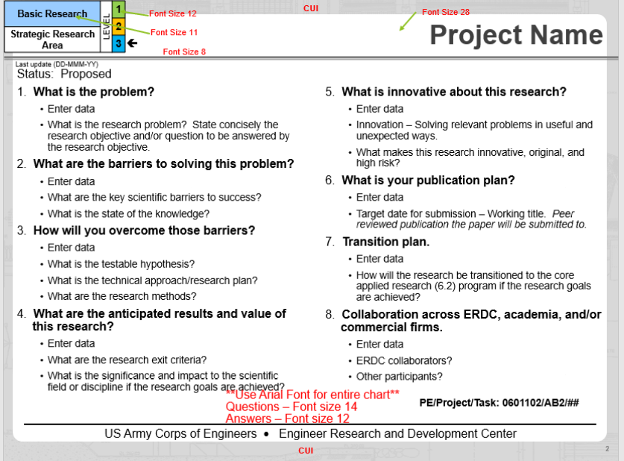

# **NARRATIVE CHART**

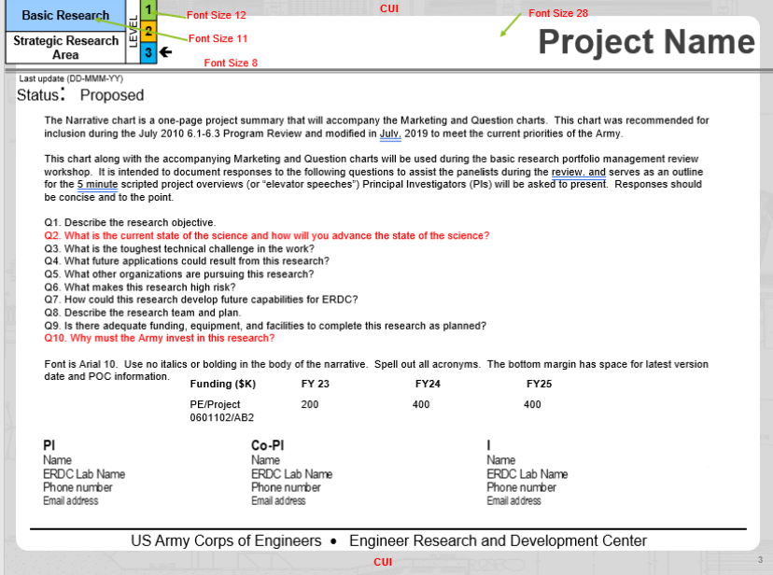

# **OPTIONAL CHART**

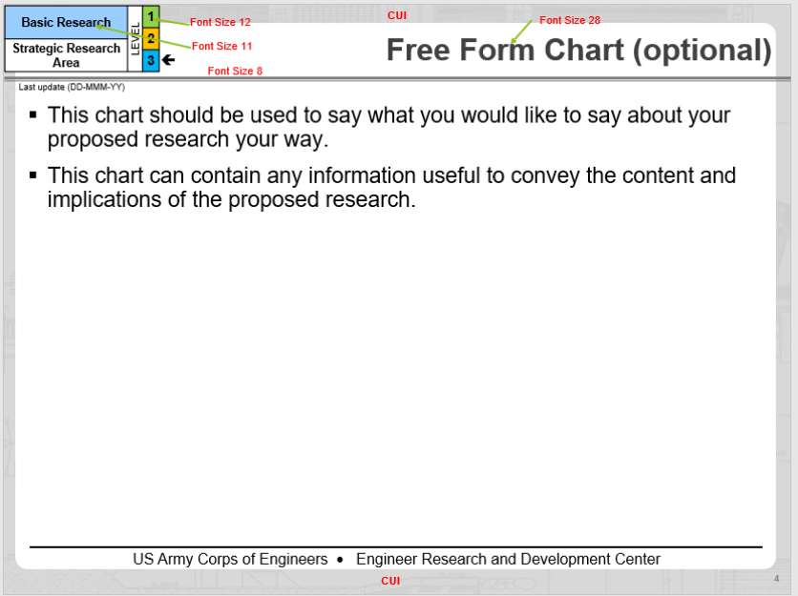

# **OPTIONAL CHART**

