1. What is your module all about? Make a short introduction about the module that was assigned to you.

The module that was assigned to us is Registration module. Registration module is a framework for entering data of a user such as a Barangay officials and residents in a certain barangay. Registration module provides forms for personal information about the users. This will need them to fill up the forms in order to create an account and login to the system. All of the information provided by the user will be transfer to the system database.

1. What are the problems in our Barangay? How can it be answered by the module that you will be created?

The Manual filings of personal information takes too long. Filing cabinets makes it hard to find a certain person information. And anybody can access your information without your consent. The registration module was created to provide safety for users about their personal information. The module insures that the only user can access the information is the admin and the user who provided it.

3.   What are the objectives of your module? Enumerate it all.

 to develop registration and login form for barangay officials and residents.

to develop a secure registration module

1. What will be your plan on gathering information to be used on your module? Online Articles? Provide the list of resources you have used as reference to your studies.

By using technology to gather information needed in creating our system. In a way of searching through internet and asking reliable persons who has the idea on how the process work and to be able to incorporate the said process to our system.

-google scholar

-udemy

-wikipedia

1. Provide a screenshot of the progress you have done on your assigned module.

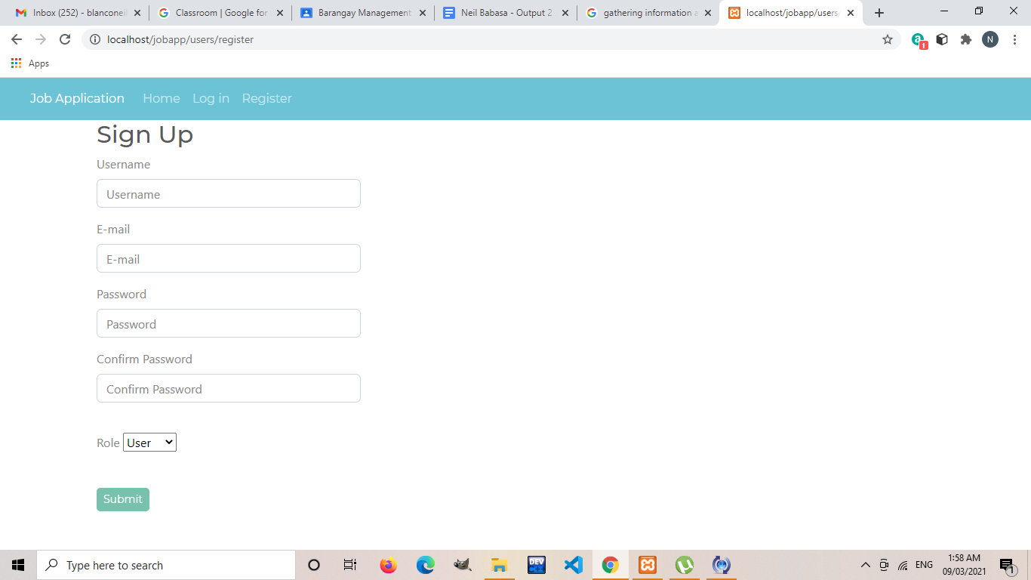

6.   Provided that you’ll be creating a project by partner, how would it help you as an IT Professional? Discuss one professional activity being observed by working in a team.

It will be much easier to work with a partner or a team because it makes the process much easier just by breaking the process equally and working with it fairly and separately with each member. Thus, making a big task easier to accomplish with each member participating and finishing their own assigned part of the process.