**Setup manual for the OpenAnalogToRS485 board**

To flash the board via the Arduino IDE the following steps need to be done:

**Arduino IDE setup:**

A smal tutorial can be found at the following link (chapter: Preparing the Arduino IDE for STM32 (Blue Pill)):

<https://circuitdigest.com/microcontroller-projects/getting-started-with-stm32-blue-pill-development-board-stm32f103c8-using-arduino-ide>

**Board Flashing:**

To flash the Board, like shown in the following picture:

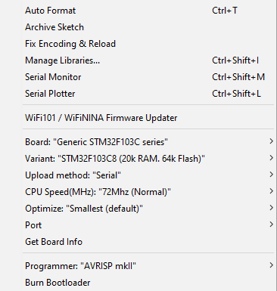

After this the connectors oft he UART Programmer will get connected in the following order, with no other wires connected:

5V-TX-RX-GND

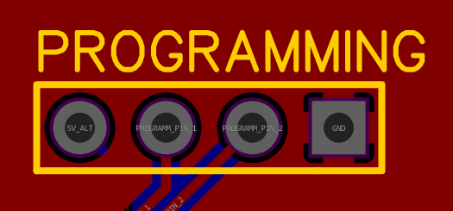

After this the Programm can be transmitted as usual via the upload button inside of the Arduino IDE