LAP 1 REPORT  
OBJECT-ORIENTED PROGRAMMING

# The Very First Java Programs

## *2.2.1* Write, compile the first Java application:

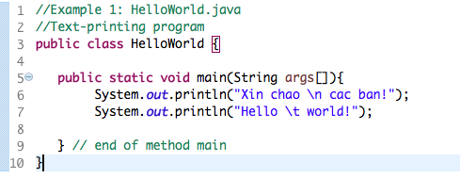

*Results*

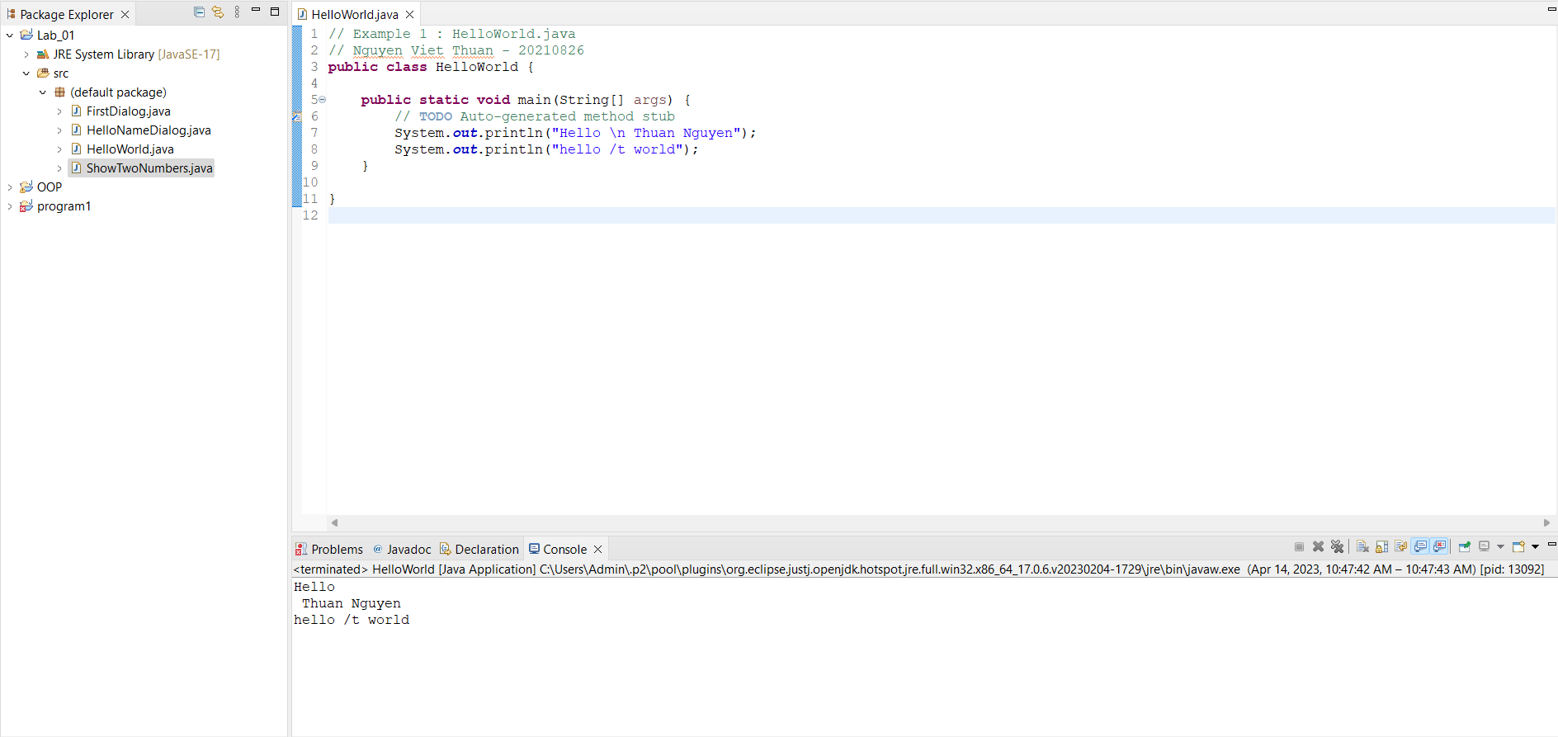

## 2.2.2 Write, compile the first dialog Java program

### Screen Shot 2019-02-12 at 12

## 2.2.3 Write, compile the first input dialog Java application

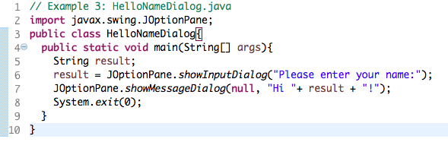

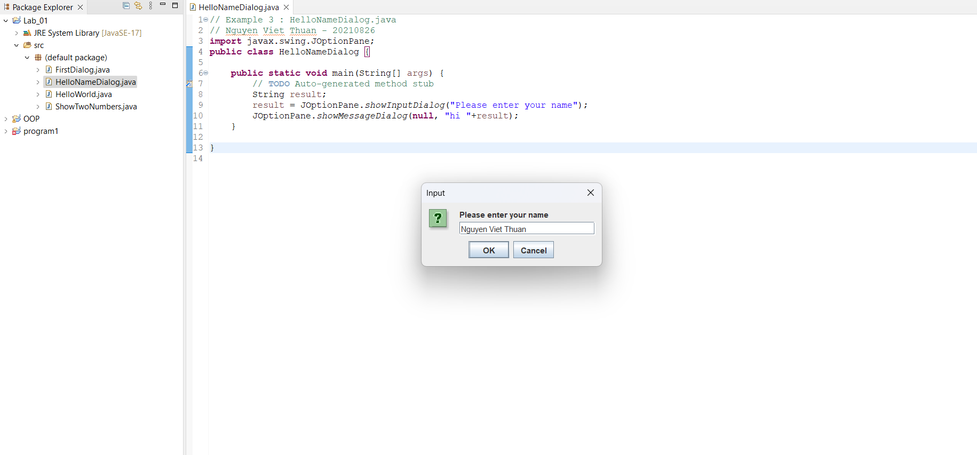

## 2.2.4 Write, compile, and run the following example:

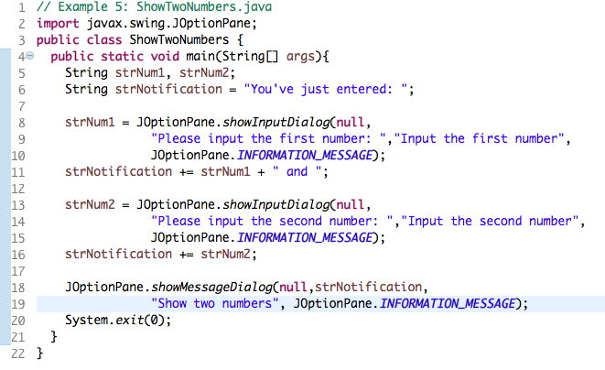

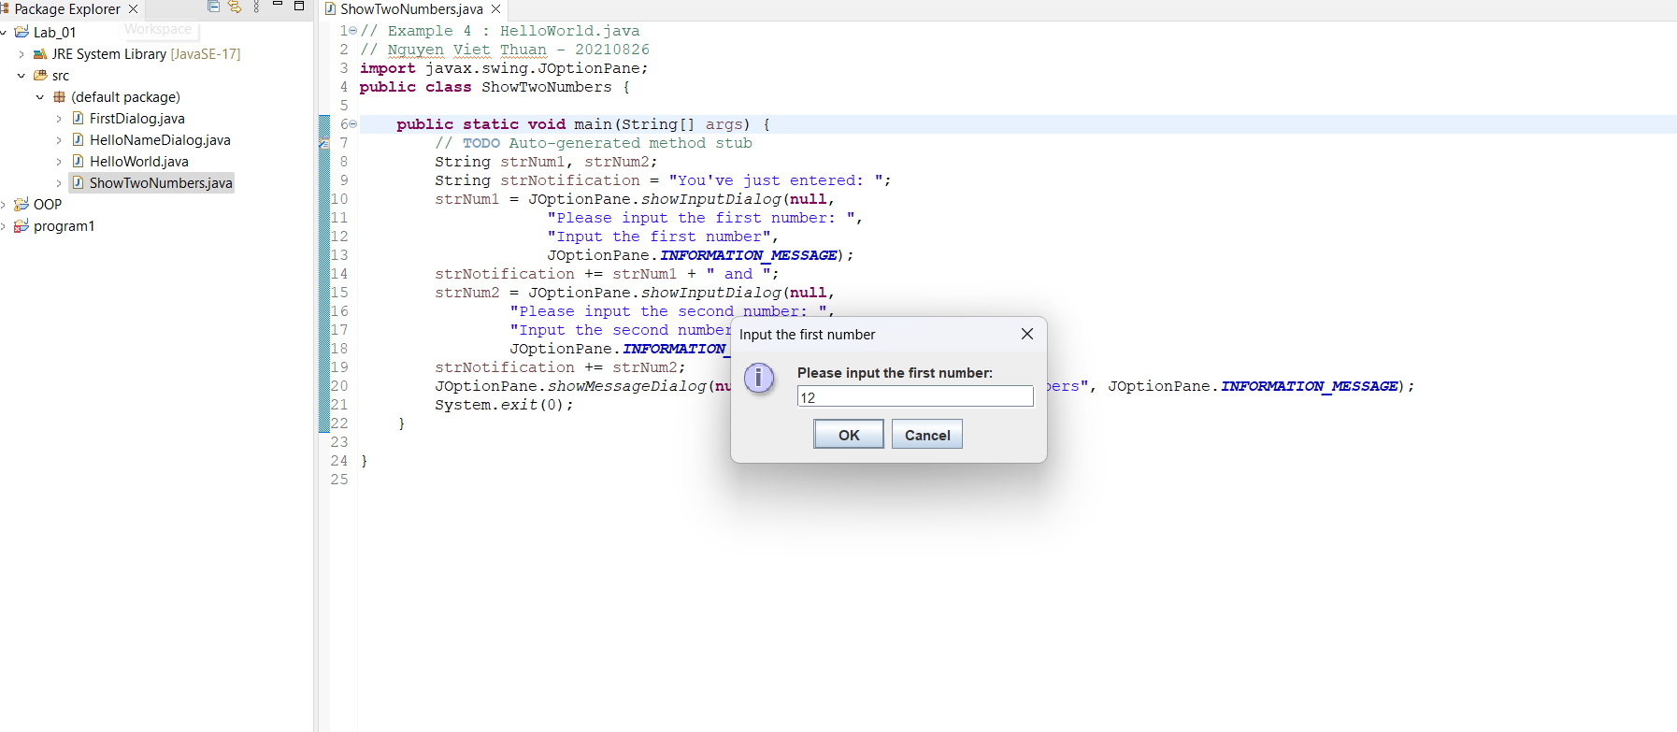

## 2.2.5 Write a program to calculate sum, difference, product, and quotient of 2 double numbers which are entered by users.

  
