LAP 1 REPORT  
OBJECT-ORIENTED PROGRAMMING

# The Very First Java Programs

## 2.2.1 Write, compile the first Java application:

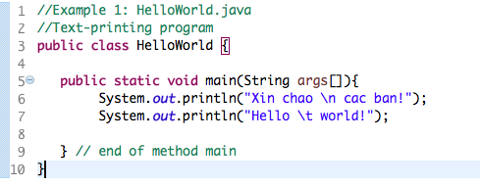

Results

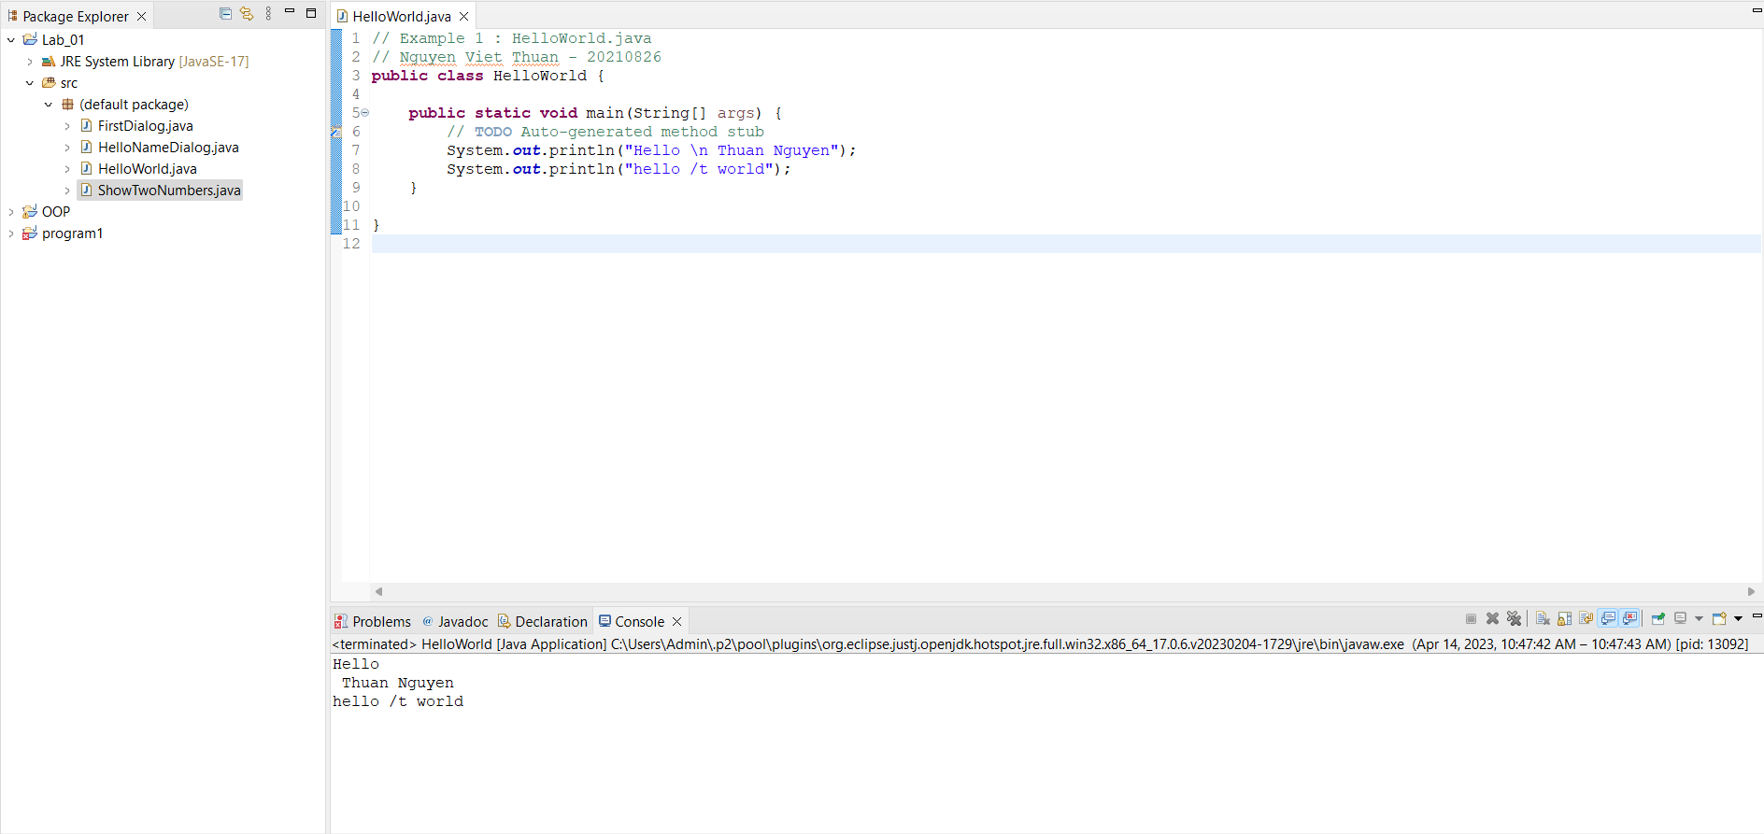

## 2.2.2 Write, compile the first dialog Java program

### Screen Shot 2019-02-12 at 12

## 2.2.3 Write, compile the first input dialog Java application

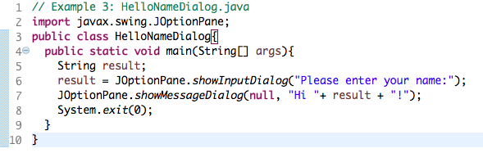

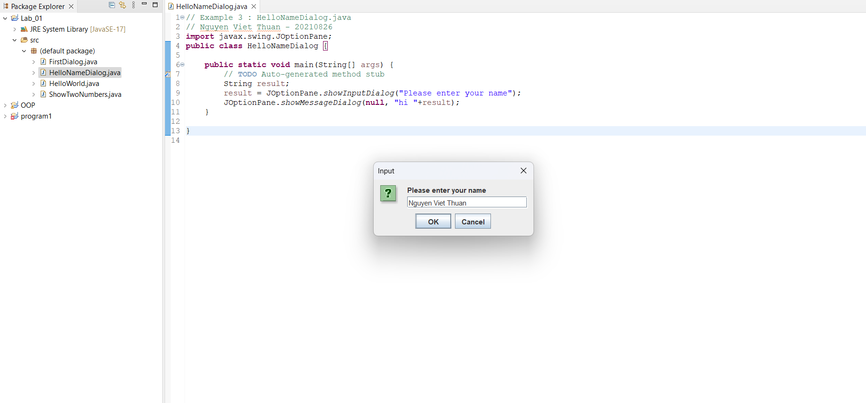

## 2.2.4 Write, compile, and run the following example:

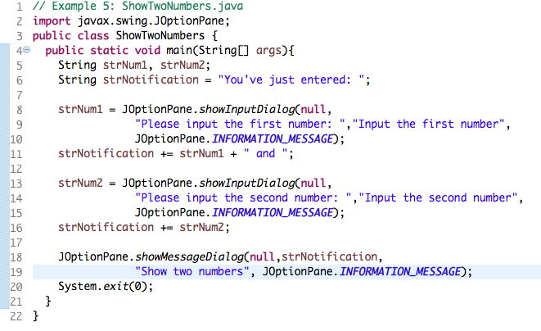

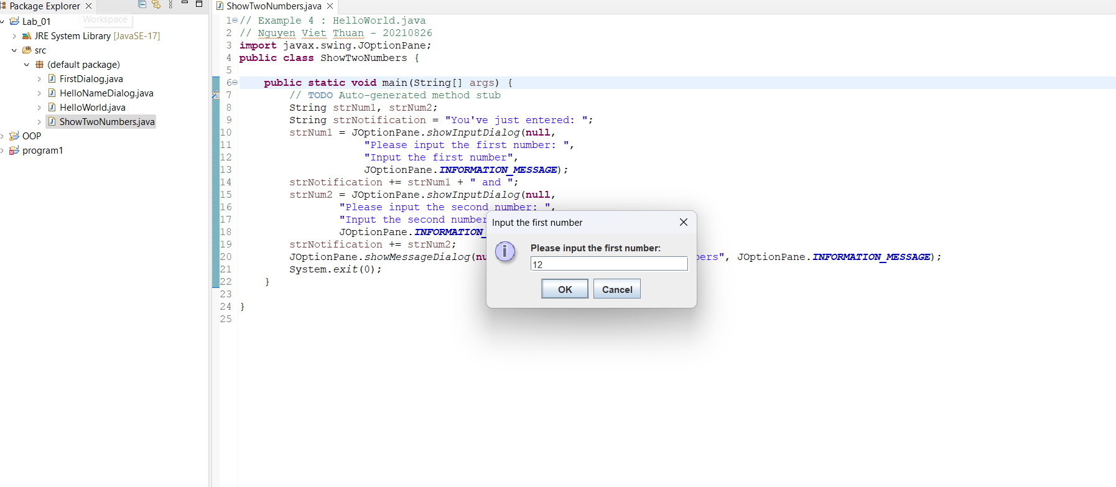

## 2.2.5 Write a program to calculate sum, difference, product, and quotient of 2 double numbers which are entered by users.

2.2.6 Solving equation.

2.2.6.1 First degree equation.

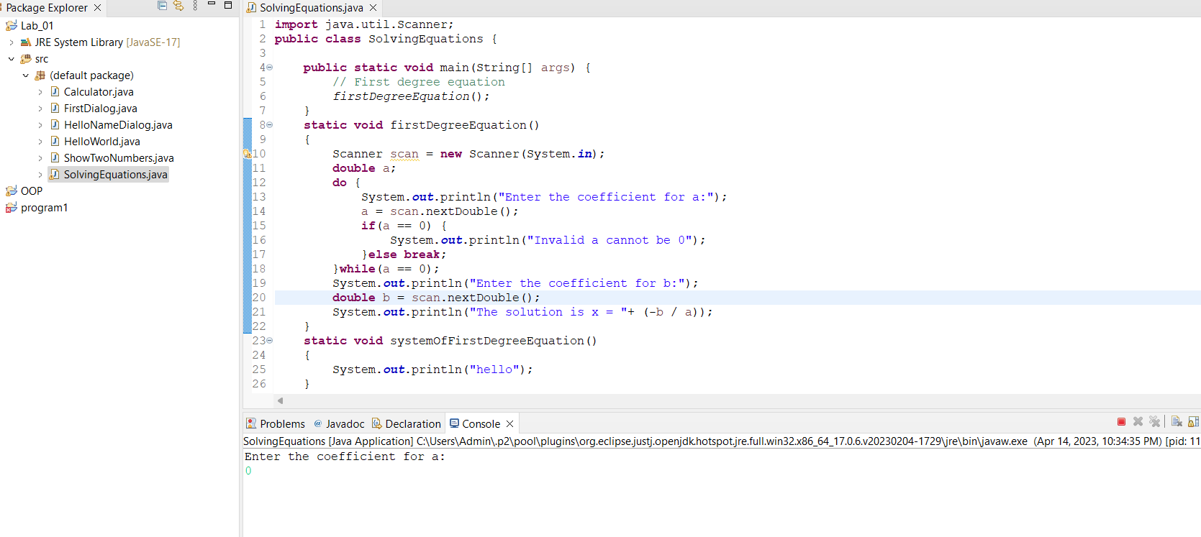

2.2.6.2 System of first degree equation

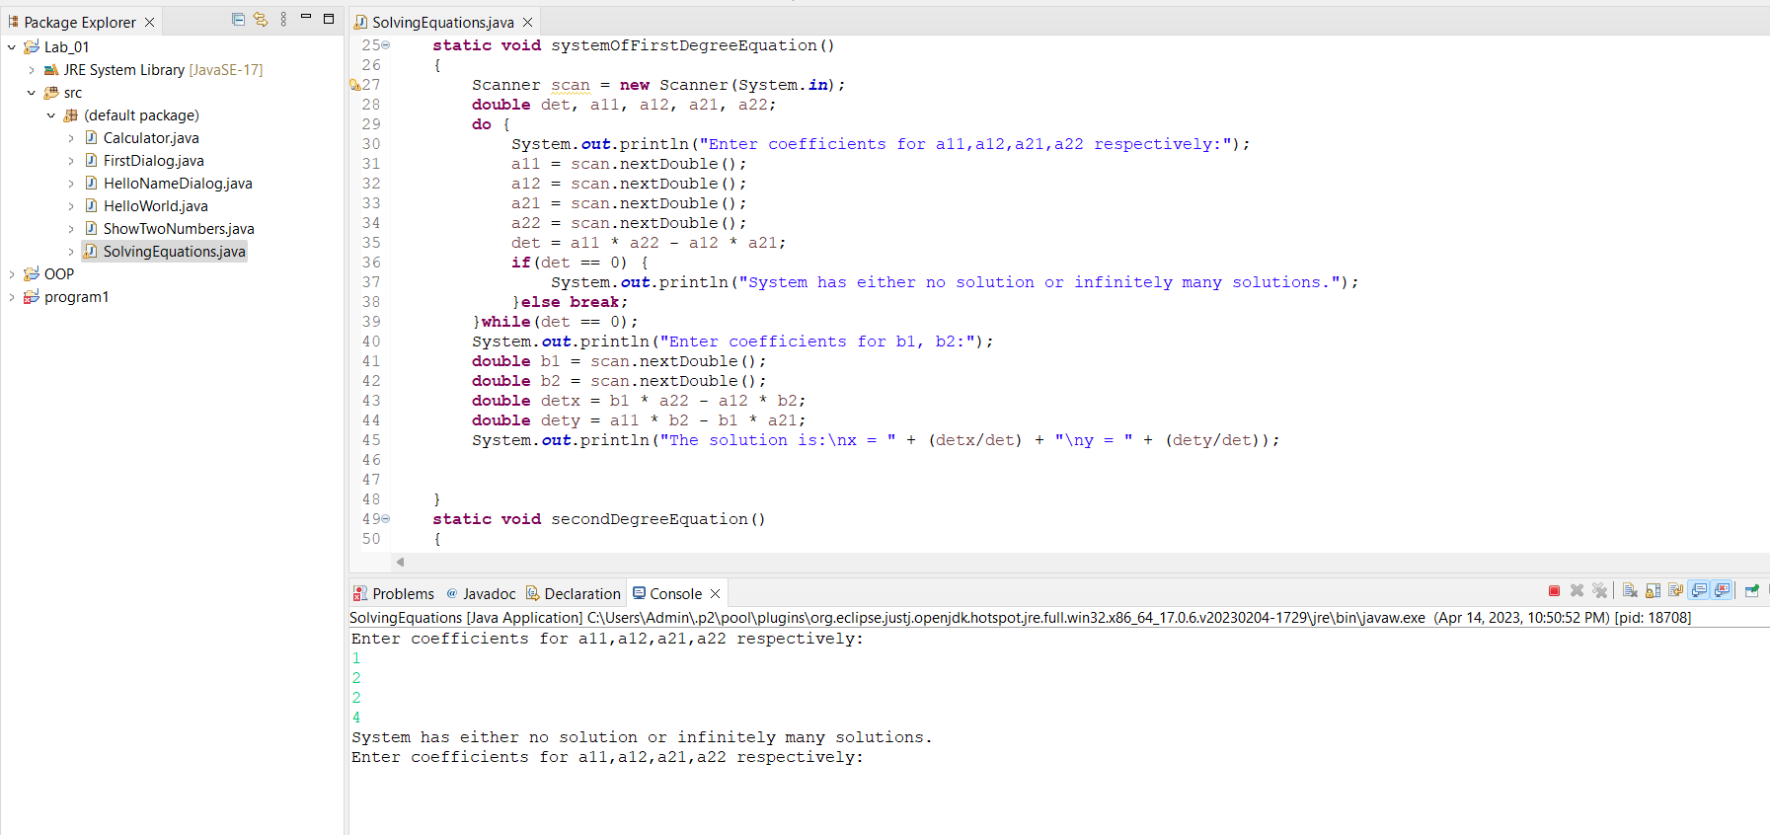

2.2.6.3 Second degree equation

- No root

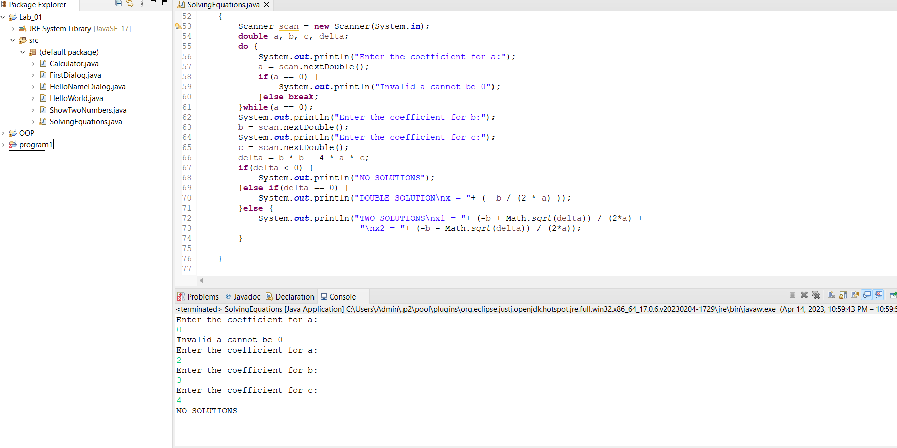

- Double root

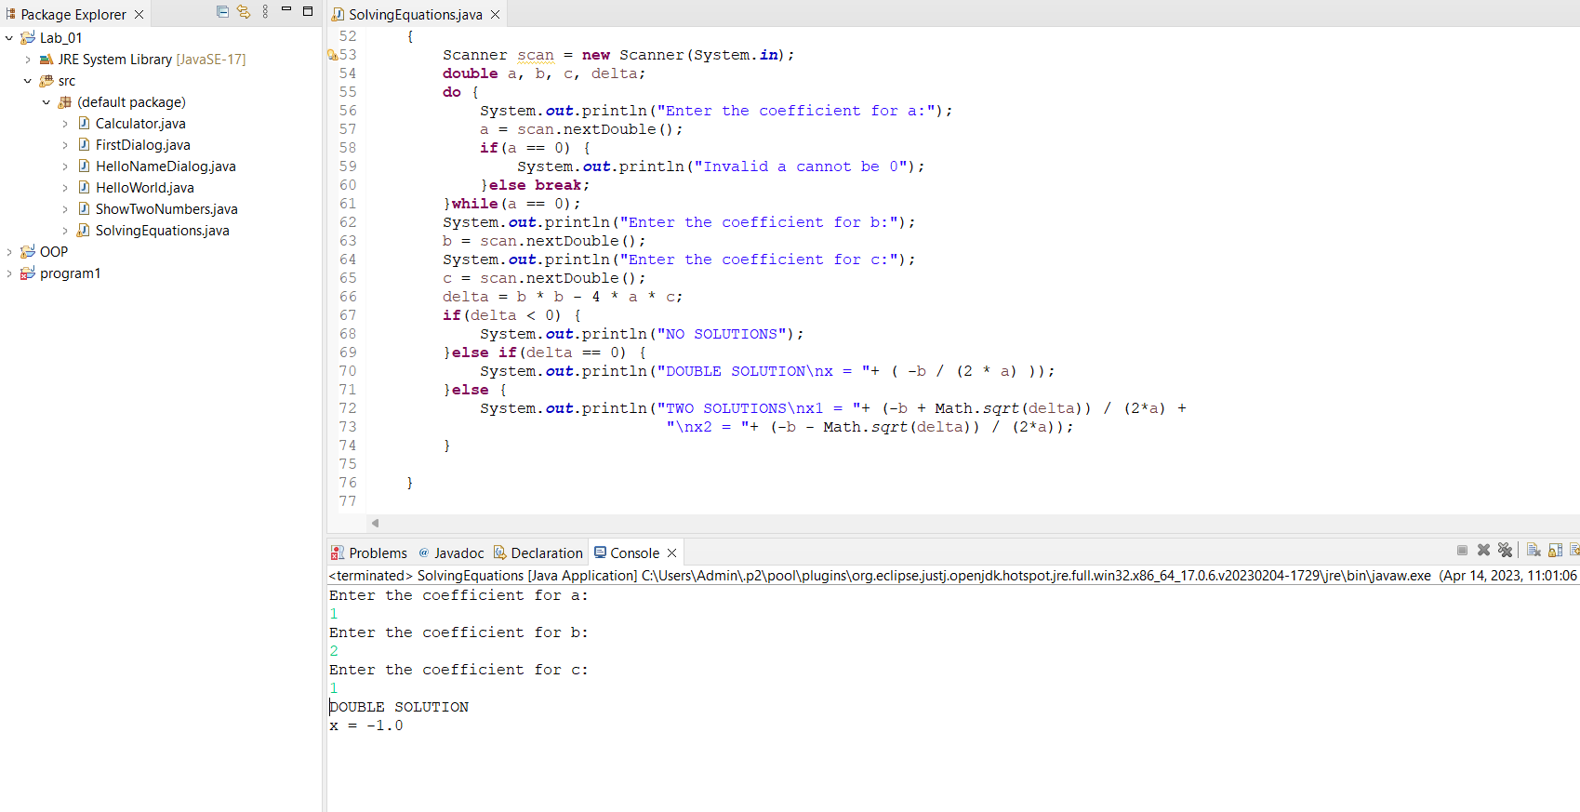

- Two roots

6.1

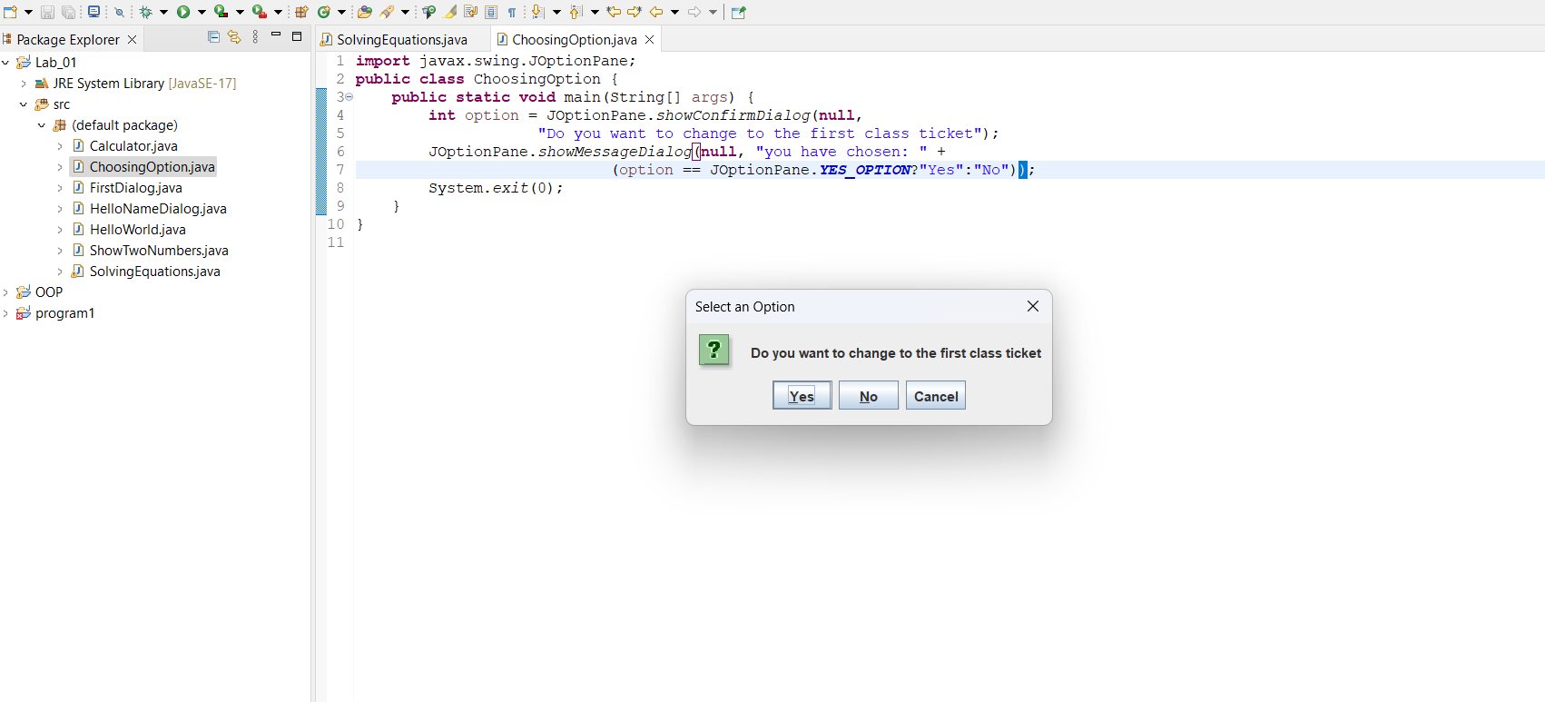

6.2

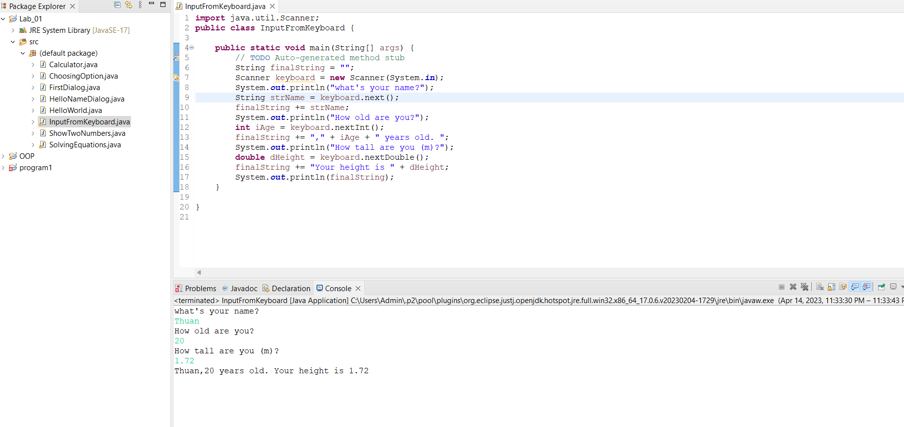

6.3

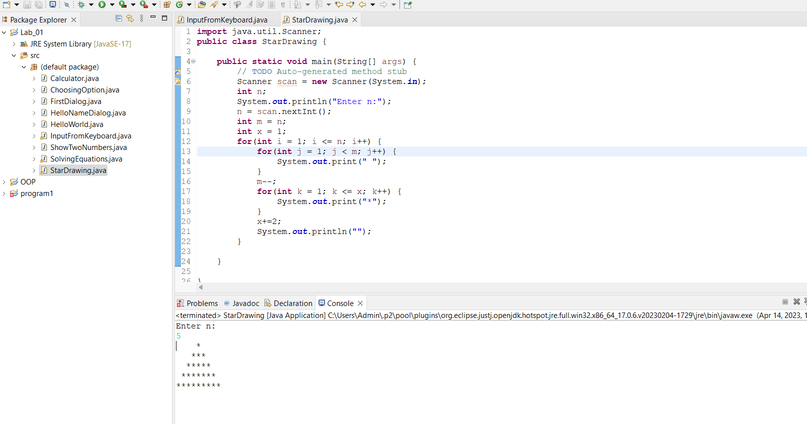

6.4

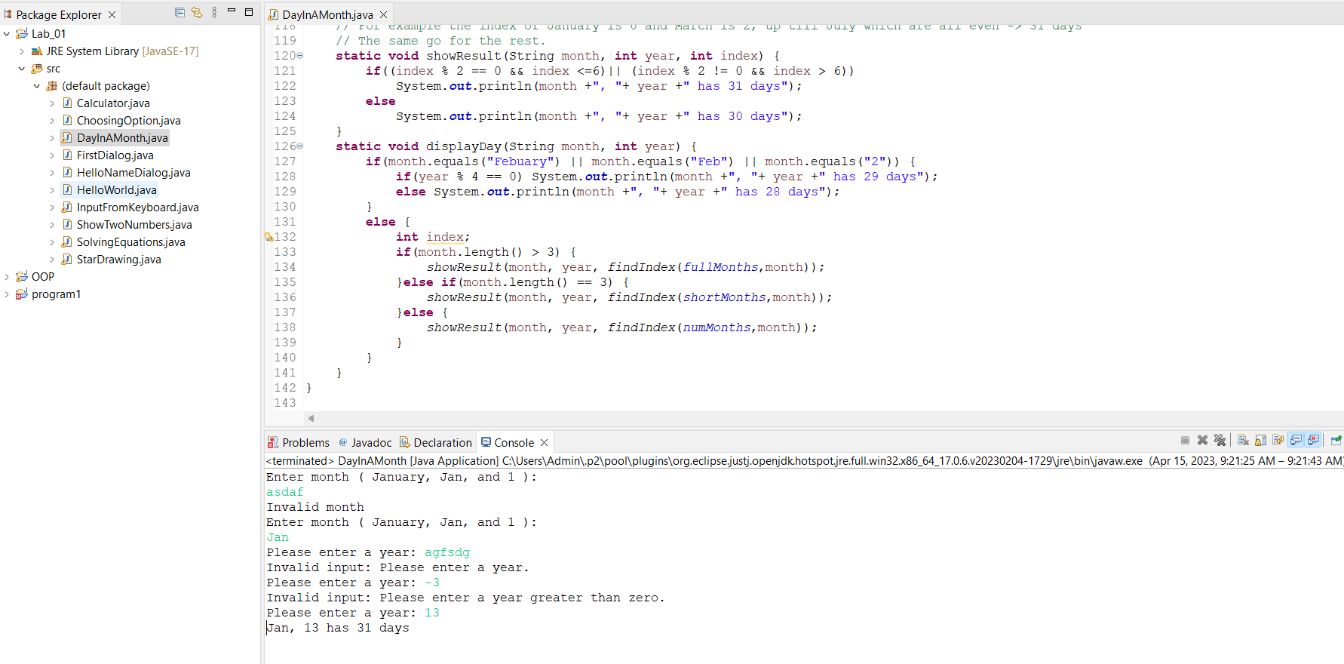

6.5

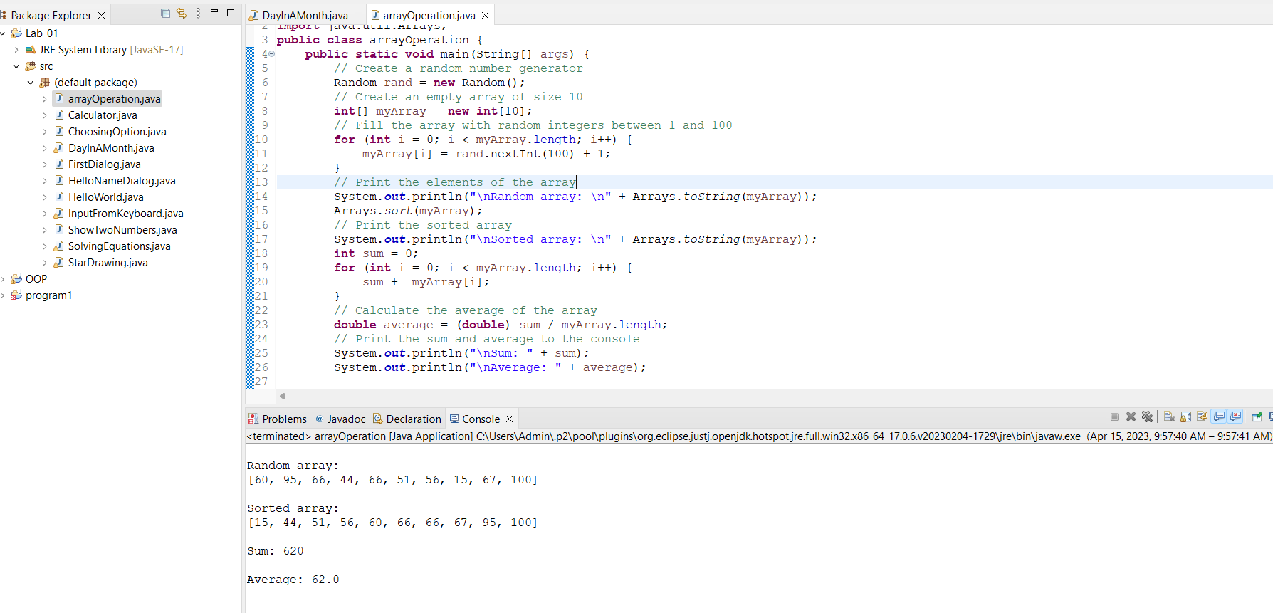

6.6

