CEBU ROOSEVELT MEMORIAL COLLEGES
San Vicente St., Bogo City, Cebu
COLLEGE OF COMPUTER STUDIES

HELPDESKCRMC: AN AI-ASSISTED STUDENT INQUIRY AND CONCERN
MANAGEMENT SYSTEM

A System and Analysis, and Design (SAD) Project Presented
To the Faculty of the College of Computer Studies,
Cebu Roosevelt Memorial Colleges

In Partial Fulfillment
Of the Requirements for the Degree of
Bachelor of Science in Information Technology

JOHN RENZ B. REDOBLE
JOHN MARK C. BURLAOS
CHRISLER D. MALINAO

OCTOBER 2026
Table of Contents

CHAPTER 1
THE PROBLEM
Introduction
Educational institutions handle numerous student inquiries and concerns every day, ranging from enrollment and academic requirements to financial services, student records, and other administrative matters. As student populations continue to grow, responding to these concerns promptly and consistently becomes more challenging for school personnel. Many institutions still rely on traditional communication methods such as face-to-face consultations, emails, and other manual forms of communication. These methods often result in delayed responses, inconsistent information, and difficulties in tracking the progress of student concerns, which can affect both the quality of student support services and the overall student experience.
Advancements in technology have created opportunities to improve how educational institutions provide support to students. According to Assayed, Alkhatib, and Shaalan (2024), automated inquiry systems improve service quality by reducing response delays, minimizing manual work, and increasing the efficiency of managing student inquiries. Similarly, Labadze, Grigolia, and Machaidze (2023) found that AI-powered chatbots provide immediate assistance, improve access to information, and lessen the workload of administrative staff in educational institutions.
Despite these advancements, many existing systems are designed primarily to answer frequently asked questions and provide automated responses. They often lack features that allow school personnel to effectively manage, assign, monitor, and track student concerns from submission to resolution. The limited integration of Artificial Intelligence with Customer Relationship Management (CRM) functionalities creates a need for a more comprehensive system that supports both automated communication and efficient concern management.
To address this need, the researchers propose HELPDESKCRMC: An AI-Assisted Student Inquiry and Concern Management System. The proposed system combines AI-assisted responses with CRM functionalities to help students receive timely information while providing school personnel with a centralized platform for managing and monitoring student concerns. By automating routine inquiries and maintaining organized records throughout the resolution process, the system aims to improve the efficiency and quality of student support services at Cebu Roosevelt Memorial Colleges.
Statement of the Problem
With the increasing number of college students seeking academic and administrative assistance, educational institutions need an efficient system for managing student inquiries and concerns. However, many institutions still rely on traditional communication methods, resulting in delayed responses and inefficient concern management. Therefore, this study aims to develop HELPDESKCRMC, to improve student support services through AI-assisted responses and CRM-based features.
However, several key challenges were identified during the conduct of this study, namely:

- Problems with the Efficiency of Managing Student Inquiries and Concerns
- Traditional methods of handling student inquiries and concerns are often manual and time-consuming which results in delayed responses, inefficient tracking, and increased workload for administrative staff.
- Lack of Real-Time AI-Assisted Responses
- Students cannot receive immediate answers to frequently asked questions outside office hours. This delay in communication may cause inconvenience and slow down the resolution of academic and administrative concerns.
- Delayed Resolution of Student Concerns
- Without a centralized system for monitoring and managing inquiries, concerns may be overlooked or assigned late leading to reduced student satisfaction.
- Lack of a Centralized Inquiry and Concern Management System
- Many institutions still rely on separate communication platforms such as emails or face-to-face inquiries making it difficult to organize and manage student concerns efficiently.
- Unable to Maintain and Analyze Inquiry History
- In the absence of a centralized database it becomes difficult to store inquiry records, monitor concern status and generate reports that can support decision-making and improve student support services.

Statement of Purpose
This proposed project focuses on developing a system that generally aims to address the problems identified during the conduct of the study. Specifically, it seeks to:
- Develop a system that improves the efficiency of managing student inquiries and concerns.
- Provide AI-assisted real-time responses to reduce delays in answering student inquiries.
- Develop a system that facilitates timely handling and tracking of student concerns.
- Develop a centralized web-based platform for managing student inquiries and concerns.
- Provide a database to securely store inquiry and concern records for future reference, analysis, and reporting.
Significance of the Study
The development of this system aims to improve the management of student inquiries and concerns through AI-assisted responses and Customer Relationship Management (CRM) features. This study is expected to be beneficial to the following:
Students. The developed system will provide students with a convenient platform for submitting academic and administrative inquiries and concerns. Through AI-assisted responses and inquiry tracking, students can receive timely assistance, monitor the status of their concerns, and access information more efficiently.
School Administrators and Staff. This study provides administrators and staff with an efficient tool for managing student inquiries and concerns. The system centralizes records, reduces manual workloads, improves response time, and helps monitor and organize concerns, allowing them to provide better student support services.
Researchers. This project provides a significant contribution to the researchers' knowledge in the fields of artificial intelligence, Customer Relationship Management (CRM), and information systems. It also enhances their skills in system development, research, and the application of technology to improve institutional services.
Future Researchers. This study serves as a reference for future researchers who intend to develop or enhance AI-assisted helpdesk systems, Customer Relationship Management (CRM) systems, or other information systems for educational institutions. The findings and the developed system may provide valuable insights for related studies and future innovations.
Scope and Limitations
This project primarily focuses on developing a web-based AI-Assisted Student Inquiry and Concern Management System integrated with Customer Relationship Management (CRM) features. The proposed system aims to improve the handling of student inquiries and concerns by using AI to assist with responses and by giving staff a more organized way to manage concerns, monitor inquiry progress, and maintain records.

Scope
The primary objective of the HELPDESKCRMC system is to provide students with a centralized platform for academic and administrative inquiries and concerns. Instead of visiting different offices or waiting for updates, students can receive AI-assisted answers to common questions, submit their concerns online, and track the status of their requests in real time.
The system includes CRM functionalities that allow authorized school personnel to receive, assign, manage, and resolve student concerns efficiently. It also provides an inquiry tracking feature that records the progress of each concern from submission to resolution.
The system maintains a centralized database that securely stores inquiry and concern records for future reference, reporting, and analysis. Administrators are provided with a default account that allows them to manage user accounts, assign staff roles, monitor inquiry history, and generate reports that support decision-making and improve student support services.
Limitation
In developing this project, the researchers identified several limitations. The system requires a stable internet connection to operate and cannot function without network connectivity. It is designed exclusively for Cebu Roosevelt Memorial Colleges and cannot be used by other institutions without modification. The system cannot answer inquiries that are not included in its knowledge base and cannot replace school personnel in handling complex, sensitive, or emergency concerns. Furthermore, the system cannot provide accurate responses if the information stored in its database is incomplete, inaccurate, or outdated.
Technical Background
The HELPDESKCRMC project utilizes several technologies to develop a web-based AI-Assisted Student Inquiry and Concern Management System. The following technologies are planned for the development of the project:
Artificial Intelligence (AI). Conceptually, the system utilizes Google Gemini API (gemini-3.6-flash) to power its intelligent conversational chatbot named Ben. Ben greets students, guides them through selecting a school office and concern category, and understands free-text student inquiries in natural language. The AI is engineered with a specialized system prompt embedding CRMC institutional policies, office schedules, guidelines, and procedures. This enables Ben to generate clear, contextual, and accurate responses directly tailored to student concerns rather than displaying static pre-written templates. Ben maintains multi-turn conversation history context, allowing students to ask natural follow-up questions smoothly. When Ben provides a complete answer to a specific inquiry, it politely confirms if the concern was resolved. If a student's inquiry requires official staff intervention or remains unresolved, it can be escalated into a formal inquiry and forwarded directly to the appropriate school office with the conversation transcript attached.
Customer Relationship Management (CRM). Conceptually, CRM serves as the core framework for organizing, tracking, assigning, and managing student inquiries and concerns. It enables school personnel to monitor concern status, maintain communication records, and improve the overall quality of student support services.
Hypertext Markup Language (HTML). Technically, HTML is used to structure and organize the content of the web application, including forms, dashboards, navigation menus, and inquiry pages.
Cascading Style Sheets (CSS). Technically, CSS controls the visual appearance of the web application by defining layouts, colors, fonts, responsiveness, and overall user interface design.
JavaScript. Technically, JavaScript provides dynamic functionality for the web application. It enables interactive features such as real-time inquiry updates, chatbot interactions, form validation, notifications, and dashboard responsiveness.
PHP. Technically, PHP serves as the server-side programming language responsible for processing user requests, managing application logic, communicating with the database, and handling authentication and inquiry management functions.
MySQL Database. Conceptually, MySQL functions as the centralized database that stores student accounts, staff accounts, inquiry records, concern status, AI knowledge base, and system logs. It ensures secure storage, retrieval, and management of institutional data.
Google Gemini API and PHP Integration. Technically, the system integrates the Google Gemini API (gemini-3.6-flash) directly into the PHP backend via a dedicated GeminiAiController class, eliminating external Python/Flask microservice dependencies. It processes student inquiries using advanced Generative AI capabilities governed by a system prompt containing CRMC office procedures, timelines, and department rules. The controller sends HTTPS REST requests containing the user's message along with conversation history context and safety configurations, receiving real-time, natural responses from Gemini. If the API key is unavailable or an error occurs, the backend gracefully falls back to structured response handling.
XAMPP. Technically, XAMPP provides the local development environment by integrating Apache, PHP, and MySQL, allowing the system to be developed, tested, and deployed efficiently.
Visual Studio Code. Technically, Visual Studio Code serves as the integrated development environment (IDE) used for writing, editing, debugging, and maintaining the system's source code.
GitHub. Conceptually, GitHub is utilized for version control and collaborative development. It enables the researchers to track code changes, manage project versions, and collaborate efficiently throughout the system development process.
Development Model
In this proposed project, the researchers utilizes the Agile Development Model as its basis.
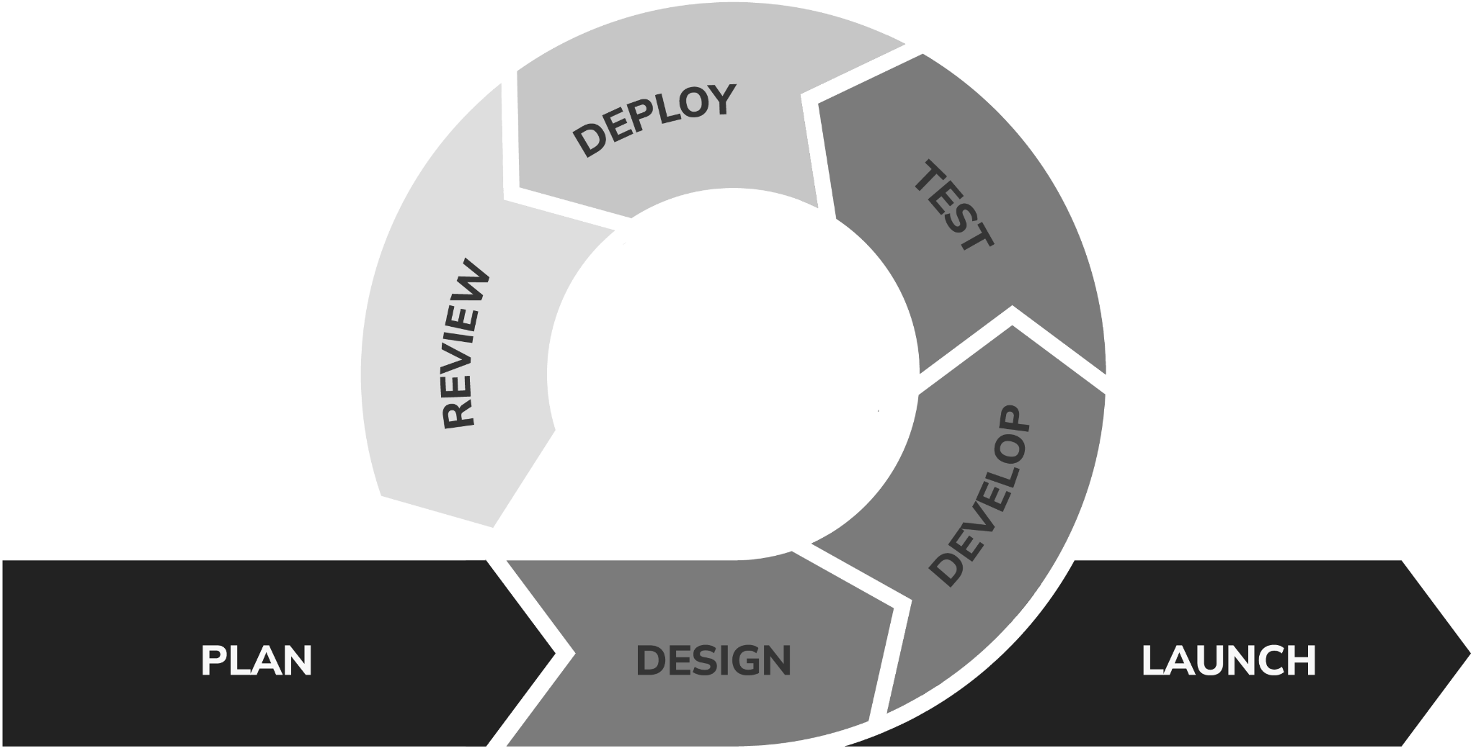
Figure 1 Agile Development Model
The development will process of this project will pass through this following phases:
Plan
The foundational phase in which project scope, strategic objectives, and high-level requirements for the HELPDESKCRMC system are formally defined. Key stakeholder requirements are gathered to establish the operational trajectory for the iterative development lifecycle.
Design
The structural architecture phase during which functional requirements are translated into system topologies, relational database schemas, and high-fidelity user interface prototypes. This stage establishes the technical blueprint connecting project planning to iterative execution.
Develop
The primary construction phase is characterized by the incremental building of core system modules—including secure user authentication, AI-assisted response mechanisms, inquiry management pipelines, and administrative control panels—across successive development sprints.
Test
The quality assurance phase focused on rigorous empirical evaluation. Functional correctness, system component integration, interface usability, and operational performance are validated against defined institutional use cases.
Deploy
The staging phase in which thoroughly tested system iterations are compiled into release-ready builds. This includes configuring the MySQL database and training the AI knowledge base in preparation for institutional deployment at Cebu Roosevelt Memorial Colleges.
Review
The post-iteration evaluation phase dedicated to gathering structured feedback from students, administrative staff, and office personnel. System efficiency and user satisfaction metrics are analyzed to identify necessary refinements prior to subsequent planning cycles.
Launch
The final implementation milestone where the fully validated and operational HELPDESKCRMC system is formally commissioned for institutional-wide deployment.

CHAPTER 2
PRESENTATION, ANALYSIS, AND INTERPRETATION OF DATA

Results and Discussion
This section presents the data gathered through surveys and have been analyzed by the researchers. Results will be discussed based on the responses from the students, and the tabulation of responses will be presented in this section.
Respondent Profile
The survey gathered a total of 113 responses from Cebu Roosevelt Memorial Colleges students across several programs. Of the 113 respondents who indicated their program, the largest groups came from BS Psychology (24%), BSIT (13%), and BSEd Social Studies (12%), with the remaining respondents spread across twelve other programs, including Criminology, Business Administration, Hospitality Management, Tourism Management, and other Education majors. Respondents' ages ranged from 17 to 24, with an average age of 20. By year level, third-year students made up the largest share at 45%, followed by second-year (26%), first-year (24%), and fourth-year students (5%).
In terms of prior experience, 54% of the respondents had not previously submitted an inquiry or raised a concern with a school office, while 46% had. When asked how they usually submit their inquiries or concerns, most respondents relied on Facebook/Messenger (42%) and face-to-face visits (35%), with smaller numbers using phone calls (11%) and email (10%). This suggests that informal, unstructured channels remain the primary means by which students currently raise their concerns, which supports the need for a centralized system such as HELPDESKCRMC.
The remainder of this section presents the results of the twenty (20) survey statements measuring student experience with the current inquiry and concern process and their receptiveness toward an AI-assisted inquiry and concern management system. Each statement was rated on a five-point scale: 1 – Strongly Disagree, 2 – Disagree, 3 – Neutral, 4 – Agree, and 5 – Strongly Agree.
Table 1
Question 6 | Options | Frequency | Percentage
It is easy to know which office handles my concern | Strongly Disagree | 15 | 13%
It is easy to know which office handles my concern | Disagree | 16 | 14%
It is easy to know which office handles my concern | Neutral | 24 | 21%
It is easy to know which office handles my concern | Agree | 40 | 36%
It is easy to know which office handles my concern | Strongly Agree | 11 | 16%
It is easy to know which office handles my concern | Total | 113 | 100%

Table 1 shows that fifty-one percent (51%) of the respondents agree or strongly agree that it is easy to know which office handles their concern, while twenty-seven percent (27%) disagree or strongly disagree and twenty-one percent (21%) remain neutral. Therefore, while more than half of the respondents can identify the right office, a sizable share of students still find this unclear.
Table 2
Question 7 | Options | Frequency | Percentage
I can easily submit my inquiries or concerns to the appropriate school office. | Strongly Disagree | 9 | 8%
 | Disagree | 21 | 19%
 | Neutral | 26 | 23%
 | Agree | 34 | 30%
 | Strongly Agree | 23 | 20%
 | Total | 113 | 100%
Table 2 shows that fifty percent (50%) of the respondents agree or strongly agree that they can easily submit their inquiries or concerns to the appropriate office, while twenty-seven percent (27%) disagree or strongly disagree. Therefore, submitting inquiries remains only moderately easy for students under the current process.

Table 3
Question 8 | Options | Frequency | Percentage
The current process of submitting student inquiries and concerns is convenient. | Strongly  Disagree | 11 | 10%
 | Disagree | 17 | 15%
 | Neutral | 27 | 24%
 | Agree | 34 | 30%
 | Strongly  Agree | 24 | 21%
 | Total | 113 | 100%

Table 3 shows that fifty-one percent (51%) of the respondents agree or strongly agree that the current process of submitting inquiries and concerns is convenient, while twenty-five percent (25%) disagree or strongly disagree and twenty-four percent (24%) are neutral. Therefore, the current process is perceived as convenient by only about half of the respondents.

Table 4
Question 9 | Options | Frequency | Percentage
School offices respond to my inquiries within a reasonable time. | Strongly Disagree | 9 | 8%
 | Disagree | 23 | 20%
 | Neutral | 29 | 26%
 | Agree | 31 | 27%
 | Strongly Agree | 21 | 19%
 | Total | 113 | 100%
Table 4 shows that forty-six percent (46%) of the respondents agree or strongly agree that school offices respond to their inquiries within a reasonable time, while twenty-eight percent (28%) disagree or strongly disagree and twenty-six percent (26%) are neutral. Therefore, response time from school offices is a concern for a substantial portion of the students surveyed.

Table 5
Question 10 | Options | Frequency | Percentage
My concerns are resolved within a reasonable time. | Strongly Disagree | 7 | 6%
My concerns are resolved within a reasonable time. | Disagree | 19 | 17%
My concerns are resolved within a reasonable time. | Neutral | 26 | 23%
My concerns are resolved within a reasonable time. | Agree | 36 | 32%
My concerns are resolved within a reasonable time. | Strongly Agree | 24 | 22%
My concerns are resolved within a reasonable time. | Total | 113 | 100%

Table 5 shows that fifty-four percent (54%) of the respondents agree or strongly agree that their concerns are resolved within a reasonable time, while twenty-three percent (23%) disagree or strongly disagree. Therefore, resolution time is acceptable to a slight majority, but delays remain a notable issue for the rest.

Table 6
Question 11 | Options | Frequency | Percentage
Delays in receiving responses make it difficult for me to complete my school-related concerns. | Strongly Disagree | 7 | 6%
 | Disagree | 16 | 14%
 | Neutral | 24 | 22%
 | Agree | 32 | 29%
 | Strongly Agree | 32 | 29%
 | Total | 113 | 100%

Table 6 shows that fifty-eight percent (58%) of the respondents agree or strongly agree that delays in receiving responses make it difficult for them to complete their school-related concerns, while only twenty percent (20%) disagree or strongly disagree. Therefore, the majority of respondents experience real difficulty caused by response delays.

Table 7
Question 12 | Options | Frequency | Percentage
It is difficult to keep track of my submitted concerns. | Strongly Disagree | 7 | 6%
It is difficult to keep track of my submitted concerns. | Disagree | 19 | 17%
It is difficult to keep track of my submitted concerns. | Neutral | 29 | 26%
It is difficult to keep track of my submitted concerns. | Agree | 36 | 32%
It is difficult to keep track of my submitted concerns. | Strongly Agree | 22 | 19%
It is difficult to keep track of my submitted concerns. | Total | 113 | 100%

Table 7 shows that fifty-one percent (51%) of the respondents agree or strongly agree that it is difficult to keep track of their submitted concerns, while twenty-three percent (23%) disagree or strongly disagree. Therefore, more than half of the respondents lack a reliable way of monitoring the status of their concerns.

Table 8
Question 13 | Options | Frequency | Percentage
I would like to receive updates regarding the status of my concern. | Strongly Disagree | 4 | 4%
 | Disagree | 10 | 9%
 | Neutral | 18 | 16%
 | Agree | 41 | 36%
 | Strongly Agree | 40 | 35%
 | Total | 113 | 100%
Table 8 shows that seventy-one percent (71%) of the respondents agree or strongly agree that they would like to receive updates regarding the status of their concern, while only thirteen percent (13%) disagree or strongly disagree. Therefore, the majority of respondents want status updates that the current process does not provide.

Table 9
Question 14 | Options | Frequency | Percentage
Having all my inquiries and concerns recorded in one system would be beneficial. | Strongly Disagree | 6 | 5%
 | Disagree | 6 | 5%
 | Neutral | 27 | 25%
 | Agree | 34 | 31%
 | Strongly Agree | 37 | 34%
 | Total | 113 | 100%
Table 9 shows that sixty-five percent (65%) of the respondents agree or strongly agree that having all their inquiries and concerns recorded in one system would be beneficial, while only ten percent (10%) disagree or strongly disagree. Therefore, most respondents support the idea of a centralized record of their inquiries and concerns.

Table 10
Question 15 | Options | Frequency | Percentage
An AI-assisted chatbot would make it easier to ask school-related questions. | Strongly Disagree | 14 | 13%
 | Disagree | 17 | 16%
 | Neutral | 18 | 16%
 | Agree | 29 | 26%
 | Strongly Agree | 32 | 29%
 | Total | 113 | 100%
Table 10 shows that fifty-five percent (55%) of the respondents agree or strongly agree that an AI-assisted chatbot would make it easier to ask school-related questions, while twenty-nine percent (29%) disagree or strongly disagree. Therefore, a majority of respondents are receptive to an AI-assisted chatbot, although some remain hesitant.

Table 11
Question 16 | Options | Frequency | Percentage
I am willing to use an AI-assisted inquiry system. | Strongly Disagree | 5 | 4%
I am willing to use an AI-assisted inquiry system. | Disagree | 16 | 14%
I am willing to use an AI-assisted inquiry system. | Neutral | 25 | 22%
I am willing to use an AI-assisted inquiry system. | Agree | 33 | 30%
I am willing to use an AI-assisted inquiry system. | Strongly Agree | 33 | 30%
I am willing to use an AI-assisted inquiry system. | Total | 113 | 100%
Table 11 shows that fifty-eight percent (58%) of the respondents agree or strongly agree that they are willing to use an AI-assisted inquiry system, while eighteen percent (18%) disagree or strongly disagree. Therefore, the majority of respondents are open to adopting an AI-assisted system for their inquiries.

Table 12
Question 17 | Options | Frequency | Percentage
AI-assisted responses to common inquiries would reduce the time I spend waiting for information. | Strongly Disagree | 3 | 3%
 | Disagree | 18 | 16%
 | Neutral | 31 | 28%
 | Agree | 23 | 20%
 | Strongly Agree | 37 | 33%
 | Total | 113 | 100%

Table 12 shows that fifty-four percent (54%) of the respondents agree or strongly agree that AI-assisted responses to common inquiries would reduce the time they spend waiting for information, while nineteen percent (19%) disagree or strongly disagree and twenty-eight percent (28%) remain neutral. Therefore, most respondents expect AI-assisted responses to shorten their waiting time.

Table 13
Question 18 | Options | Frequency | Percentage
An AI-assisted inquiry system would make it easier for me to communicate with the appropriate school office. | Strongly Disagree | 5 | 5%
 | Disagree | 16 | 14%
 | Neutral | 28 | 25%
 | Agree | 30 | 27%
 | Strongly Agree | 32 | 29%
 | Total | 113 | 100%

Table 13 shows that fifty-six percent (56%) of the respondents agree or strongly agree that an AI-assisted inquiry system would make it easier to communicate with the appropriate school office, while nineteen percent (19%) disagree or strongly disagree. Therefore, the majority of respondents believe an AI-assisted system would improve communication with school offices.

Table 14
Question 19 | Options | Frequency | Percentage
A system that records my inquiry history would be useful. | Strongly Disagree | 6 | 5%
A system that records my inquiry history would be useful. | Disagree | 14 | 12%
A system that records my inquiry history would be useful. | Neutral | 20 | 18%
A system that records my inquiry history would be useful. | Agree | 41 | 37%
A system that records my inquiry history would be useful. | Strongly Agree | 31 | 28%
A system that records my inquiry history would be useful. | Total | 113 | 100%

Table 14 shows that sixty-five percent (65%) of the respondents agree or strongly agree that a system recording their inquiry history would be useful, while only seventeen percent (17%) disagree or strongly disagree. Therefore, the majority of respondents see clear value in keeping a record of past inquiries.

Table 15
Question 20 | Options | Frequency | Percentage
A status tracker showing Pending, In Progress, and Resolved would help me monitor my concerns. | Strongly  Disagree | 3 | 3%
 | Disagree | 17 | 15%
 | Neutral | 18 | 16%
 | Agree | 34 | 31%
 | Strongly Agree | 38 | 35%
 | Total | 113 | 100%
Table 15 shows that sixty-six percent (66%) of the respondents agree or strongly agree that a status tracker showing Pending, In Progress, and Resolved would help them monitor their concerns, while only eighteen percent (18%) disagree or strongly disagree. Therefore, most respondents favor having a visible status tracker for their concerns.

Table 16
Question 21 | Options | Frequency | Percentage
Routing my inquiry to the appropriate school office would help ensure that my concern is handled properly. | Strongly Disagree | 8 | 7%
 | Disagree | 14 | 13%
 | Neutral | 18 | 16%
 | Agree | 42 | 38%
 | Strongly Agree | 29 | 26%
 | Total | 113 | 100%
Table 16 shows that sixty-four percent (64%) of the respondents agree or strongly agree that routing their inquiry to the appropriate school office would help ensure it is handled properly, while twenty percent (20%) disagree or strongly disagree. Therefore, the majority of respondents trust that automatic routing would improve how their concerns are handled.

Table 17
Question 22 | Options | Frequency | Percentage
Receiving notifications about the status or updates of my concern would be beneficial. | Strongly Disagree | 4 | 3%
 | Disagree | 17 | 15%
 | Neutral | 18 | 16%
 | Agree | 29 | 26%
 | Strongly Agree | 45 | 40%
 | Total | 113 | 100%

Table 17 shows that sixty-six percent (66%) of the respondents agree or strongly agree that receiving notifications about the status or updates of their concern would be beneficial, while nineteen percent (19%) disagree or strongly disagree. Therefore, most respondents want to be notified when their concern is updated.

Table 18
Question 23 | Options | Frequency | Percentage
A centralized system for managing student inquiries and concerns would improve the efficiency of student support services. | Strongly Disagree | 13 | 12%
 | Disagree | 15 | 14%
 | Neutral | 17 | 15%
 | Agree | 25 | 23%
 | Strongly Agree | 40 | 36%
 | Total | 113 | 100%

Table 18 shows that fifty-nine percent (59%) of the respondents agree or strongly agree that a centralized system for managing student inquiries and concerns would improve the efficiency of student support services, while twenty-six percent (26%) disagree or strongly disagree. Therefore, a majority of respondents believe centralization would make student support services more efficient.

Table 19
Question 24 | Options | Frequency | Percentage
HELPDESKCRMC would make it more convenient for students to submit and monitor their inquiries and concerns. | Strongly Disagree | 12 | 10%
 | Disagree | 9 | 8%
 | Neutral | 19 | 17%
 | Agree | 27 | 24%
 | Strongly Agree | 46 | 41%
 | Total | 113 | 100%
Table 19 shows that sixty-five percent (65%) of the respondents agree or strongly agree that HELPDESKCRMC would make it more convenient for students to submit and monitor their inquiries and concerns, while nineteen percent (19%) disagree or strongly disagree. Therefore, the majority of respondents anticipate that the proposed system would make the process more convenient.

Table 20
Question 25 | Options | Frequency | Percentage
I believe an AI-assisted inquiry and concern management system would be beneficial to students. | Strongly Disagree | 9 | 8%
 | Disagree | 6 | 5%
 | Neutral | 27 | 24%
 | Agree | 30 | 27%
 | Strongly Agree | 40 | 36%
 | Total | 113 | 100%
Table 20 shows that sixty-three percent (63%) of the respondents agree or strongly agree that an AI-assisted inquiry and concern management system would be beneficial to students, while only thirteen percent (13%) disagree or strongly disagree. Therefore, the majority of respondents believe that an AI-assisted system such as HELPDESKCRMC would benefit the student body as a whole.
Project Requirements
Project requirements are the necessary specifications that define what a project must achieve and the conditions it must meet to be successful.
Functional Requirements
Functional Requirements are the tasks that the system must be able to perform. These are the key features and functions the system must be able to do in order for it to work as intended.
Inputs
The website is capable of accepting the following inputs:
- Admin Login
  - Email/Username
  - Password
- Staff Login
  - Email/Username
  - Password
- Student Login
  - Email/Username
  - Password
- Staff Account Information
  - Name, Email, Role/Department
- Inquiry/Concern Submission
- Knowledge Base Entry
- Filter/Search Criteria
- Feedback/Rating
Processes
The system can perform the following:
Admin can:
- Admin can add a staff account.
- Admin can update staff accounts.
- Admin can delete a staff account.
- Admin can add, update, or delete knowledge base entries.
- Admin can view dashboard.
- Admin can assign concerns to staff.
- Admin can generate inquiry and concern reports.
- Admin can download generated reports.

Staff can:
- Staff can view assigned concerns.
- Staff can respond to and resolve concerns.
- Staff can update the status of a concern.
- Staff can view inquiry history.
Student can:
- Student can submit an inquiry or concern.
- Student can attach files to a concern.
- Student can track the status of a submitted concern.
- Student can receive AI-assisted responses.
- Student can receive real-time notifications.
- Student can rate and give feedback after a concern is resolved.
The AI can perform the following:
- The AI can process student inquiries using Google Gemini API Generative AI with a knowledge-infused system prompt.
- The AI can retrieve and provide the most relevant stored answer.
- The AI can forward unmatched inquiries to school personnel.
- The AI (Ben) can greet the student by name and guide them through selecting an office and a concern type.
- The AI can generate dynamic, intelligent, and contextual responses based on CRMC institutional knowledge rather than displaying pre-defined or static answers.
- The AI can maintain conversation context so students can ask follow-up questions without repeating their concern.
- The AI can ask the student whether the response resolved their concern.
- The AI can offer to escalate an unresolved concern into a formal inquiry, carrying over a summary of the conversation.
Outputs
- AI-Generated Response
- Inquiry Status/Tracking Update
- Notification Alerts
- Inquiry and Concern Report
- Feedback and Satisfaction Report
Non-functional Requirements
Non-functional requirements are the details about the system operational capabilities and constraints.
Compatibility. The website is responsive to any screen sizes of any devices.
Maintainability. The website would be updated and maintained to keep it running for the coming years. The AI knowledge base will be maintained periodically to ensure accurate and up-to-date responses.
Security. The website requires user authentication before a user can log in. Only the admin has the capability to add, update, and delete staff accounts.
Usability. HELPDESKCRMC's website will provide a user-friendly interface that allows students to quickly submit concerns and access AI-assisted answers.
Reliability. The system ensures that inquiries and concerns are accurately recorded, tracked, and not lost between submission and resolution.
Performance. The AI chatbot (Ben via Gemini API) generates and returns responses to student inquiries within a short response time to minimize waiting.

Design of Software, Systems, Products and/or Processes
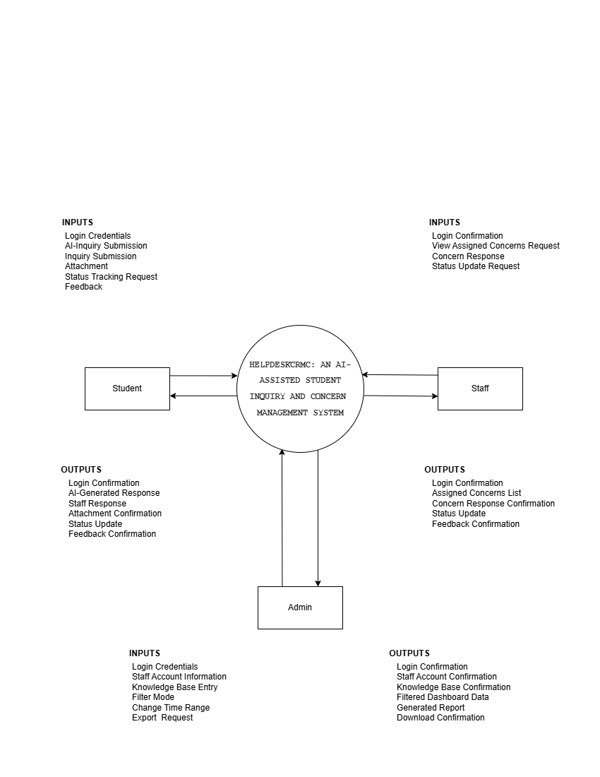

Figure 1: Context Diagram for “HELPDESKCRMC: AN AI-ASSISTED STUDENT INQUIRY AND CONCERN MANAGEMENT SYSTEM”

Data Flow Diagram
Data flow diagram (DFD) a visual aid shows how information moves through a system. DFD shows the flow of information in different processes,entities and data of a system. The main purpose of (DFD) is to visually map out system inputs and outputs. It helps to understand how data interacts within the system.
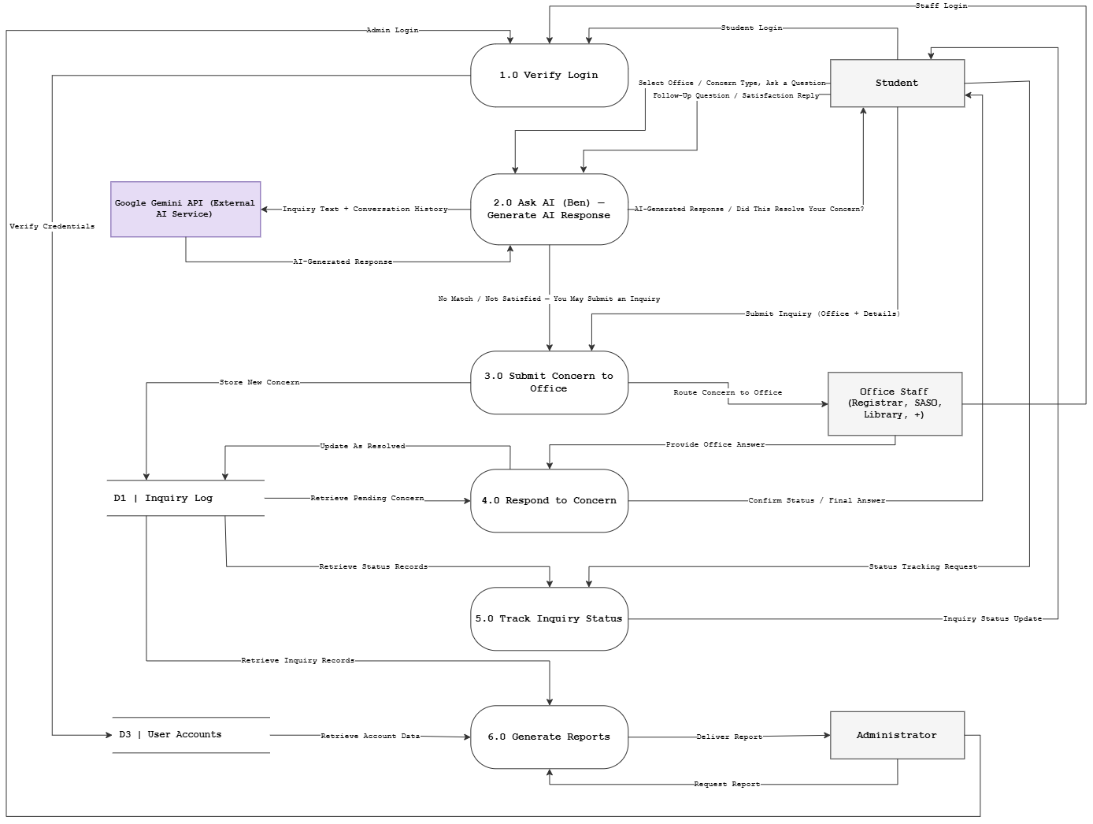
Figure 2: Data Flow Diagram for “HELPDESKCRMC: AN AI-ASSISTED STUDENT INQUIRY AND CONCERN MANAGEMENT SYSTEM”
The diagram shows six processes: Verify Login, Ask AI (Ben) – Match & Generate Response, Submit Concern to Office, Respond to Concern, Track Inquiry Status, and Generate Reports. These draw on four data stores – D1 Inquiry Log, D2 Knowledge Base, D3 User Accounts, and D4 Conversation Log – and involve three external entities: the Student, Office Staff (Registrar, SASO, Library, and other offices), and the Administrator. A student logs in, then asks Ben a question; Ben queries the Knowledge Base and logs the conversation turn while generating a response. If the response does not resolve the concern, the inquiry and a summary of the conversation are routed to the responsible Office Staff, who reply through Respond to Concern. The student can track the concern’s status at any point, and the Administrator draws on the Inquiry Log and User Accounts to generate reports.
Use Case Diagram
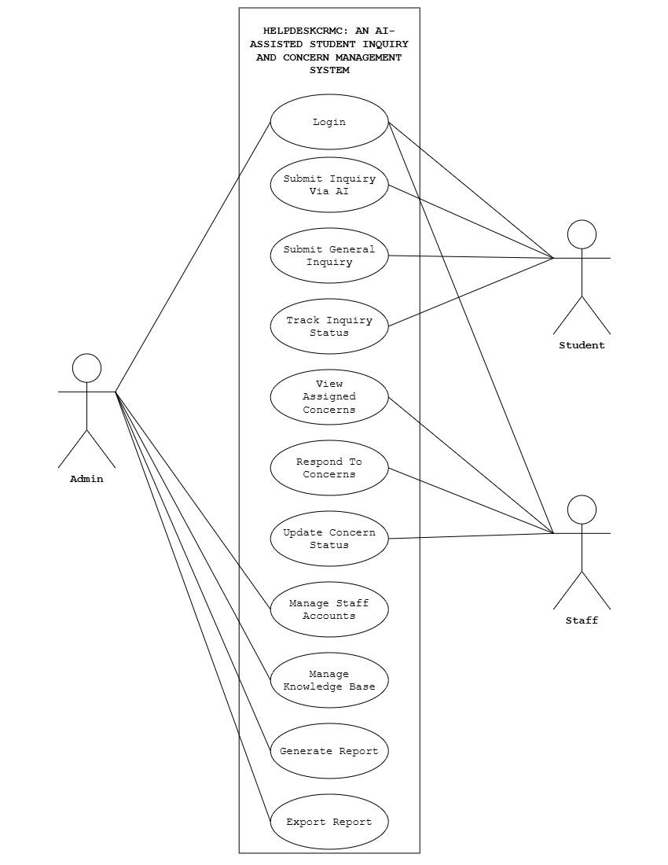
Figure 3: Use Case Diagram for “HELPDESKCRMC: AN AI-ASSISTED STUDENT INQUIRY AND CONCERN MANAGEMENT SYSTEM”
The figure above shows the different privileges of the Admin, Student, and Staff in the HELPDESKCRMC system. The Admin has the privilege to manage staff accounts, manage the knowledge base, generate reports, and export reports. All of these privileges will be accessible upon Admin account login. For Students, they can log in, submit an inquiry through the AI-assisted chatbot Ben or submit a general inquiry, and track the status of their concerns. For Staff, their account allows them to view assigned concerns, respond to concerns, and update the status of concerns.
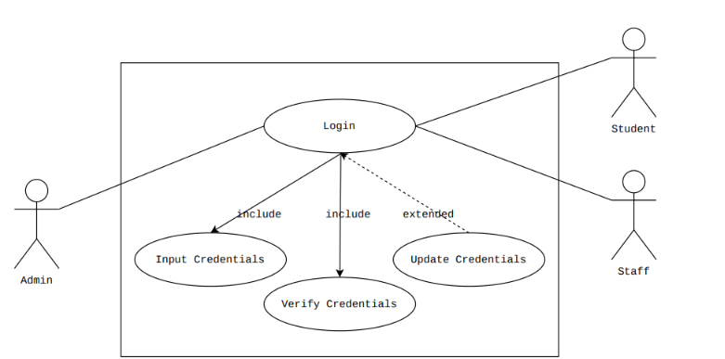
Figure 4: Use Case Diagram For Login
It shows that the website requires the user's credentials to log in, with the option to update credentials if login fails or a password reset is needed.

Table 21
Use Case Scenario for Login
Use Case Name: | Login
Actors: | Admin,Student,Staff
Description: | The Admin/Student/Staff wants to log in to the website.
Triggering Event: | To access the website
Trigger Type: | External Temporal
Related Use Case: | Input Credentials, Verify Credentials, Update Credentials
Pre-condition: | User account must exist
Post-condition: | User credentials successfully verified and access granted.
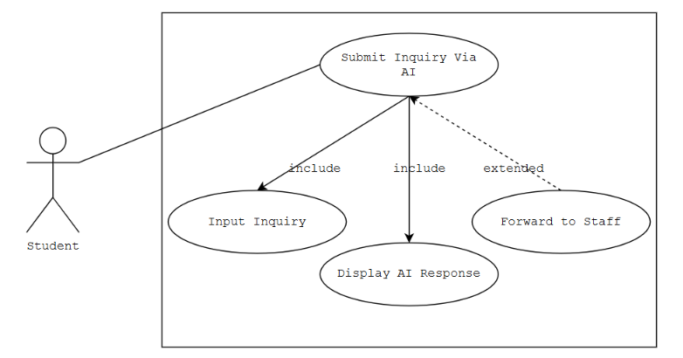
Figure 5: Use Case Diagram For Submit Inquiry Via AI
It shows the AI matching flow, with the unmatched case extending to forward the inquiry to staff.
Table 22
Use Case Scenario for Submit Inquiry Via AI
Use Case Name: | Submit Inquiry Via AI
Actors: | Student
Description: | The student wants to receive an AI-assisted answer to an inquiry.
Triggering Event: | To get an immediate answer to a question.
Trigger Type: | External Temporal
Related Use Case: | Input Inquiry, Display AI Response, Forward To Staff Staff credentials,Update Staff information
Pre-condition: | Student must be logged in.
Post-condition: | Inquiry successfully matched and answered, or forwarded to staff.

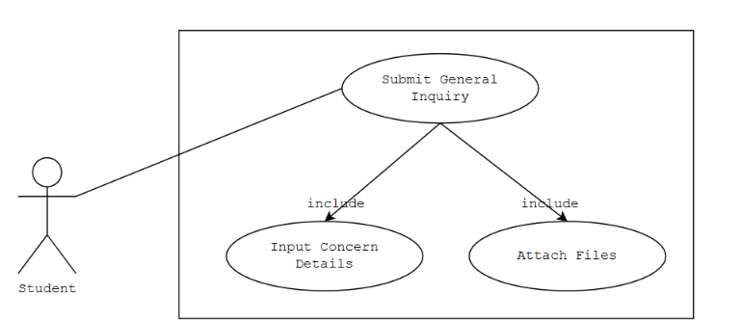
Figure 6: Use Case Diagram for Submit General Inquiry
It shows the manual concern submission flow, with the option to attach supporting files.

Table 23
Use Case Scenario for Submit General Inquiry
Use Case Name: | Submit General Inquiry
Actors: | Student
Description: | The student wants to submit a concern that requires staff handling
Triggering Event: | To report an academic or administrative concern
Trigger Type: | External Temporal
Related Use Case: | Input Concern Details, Attach Files
Pre-condition: | Student must be logged in.
Post-condition: | Concern successfully submitted and recorded in the system.

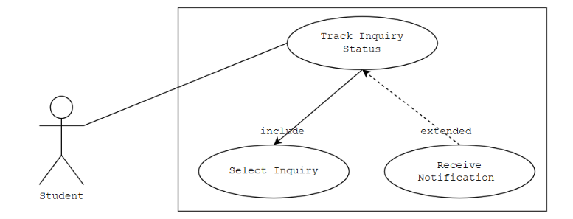
Figure 7: Use Case Diagram for Track Inquiry Status
It shows how a student checks status, optionally extended by a real-time notification.
Table 24
Use Case Scenario for Track Inquiry Status
Use Case Name: | Track Inquiry Status
Actors: | Student
Description: | The student wants to view the current status of a submitted inquiry or concern
Triggering Event: | To monitor the progress of a submitted concern
Trigger Type: | External Temporal
Related Use Case: | Select Inquiry, Receive Notification
Pre-condition: | Inquiry or concern must exist.
Post-condition: | Current inquiry status successfully displayed.

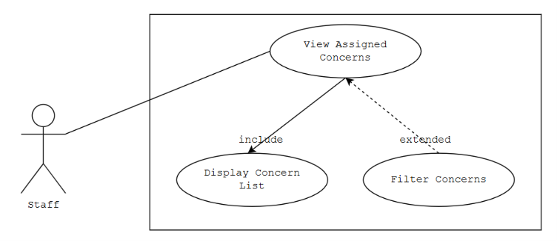
Figure 8: Use Case Diagram for View Assigned Concerns
It shows staff viewing their concern list, with optional filtering.
Table 25
Use Case Scenario for View Assigned Concerns
Use Case Name: | View Assigned Concerns
Actors: | Staff
Description: | The staff wants to view concerns assigned to them.
Triggering Event: | To check pending or assigned concerns
Trigger Type: | External Temporal
Related Use Case: | Display Concern List, Filter Concerns
Pre-condition: | Staff must be logged in and have assigned concerns.
Post-condition: | Assigned concern list successfully displayed.

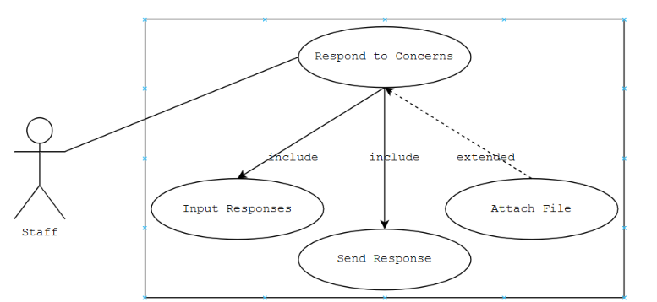
Figure 9: Use Case Diagram for Respond To Concerns
It shows staff drafting and sending a response, with an optional file attachment.
Table 26
Use Case Scenario for Respond To Concerns
Use Case Name: | Respond To Concerns
Actors: | Staff
Description: | The staff wants to respond to an assigned student concern.
Triggering Event: | To provide an answer or update to a student concern
Trigger Type: | External Temporal
Related Use Case: | Input Response, Send Response, Attach File
Pre-condition: | Concern must be assigned to the staff.
Post-condition: | Response successfully sent to the student.

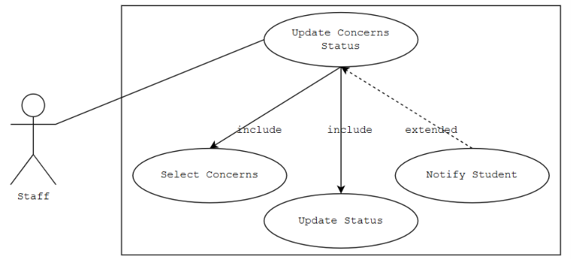
Figure 10: Use Case Diagram for Update Concerns Status
It shows staff changing a concern's status, which can extend to notifying the student.
Table 27
Use Case Scenario for Update Concerns Status
Use Case Name: | Update Concerns Status
Actors: | Staff
Description: | The staff wants to update the status of a concern
Triggering Event: | To reflect progress on a concern
Trigger Type: | External Temporal
Related Use Case: | Select Concern, Update Status, Notify Student
Pre-condition: | Concern must exist and be assigned to the staff.
Post-condition: | Concern status successfully updated.

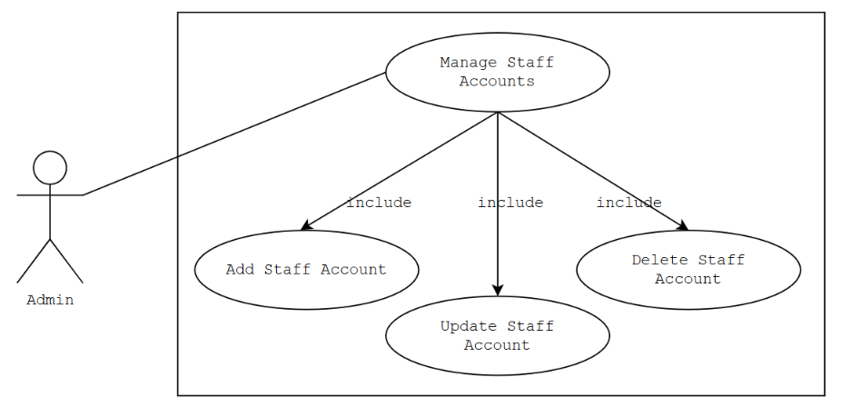
Figure 11: Use Case Diagram for Manage Staff Accounts
It shows the admin managing staff accounts, covering creation, updates, and deletion as included sub-actions of this one use case.
Use Case Name: | Manage Staff Account
Actors: | Admin
Description: | The admin wants to manage staff accounts in the system
Triggering Event: | To add, update, or delete a staff account
Trigger Type: | External Temporal
Related Use Case: | Add Staff Account, Update Staff Account, Delete Staff Account
Pre-condition: | Admin must be logged in.
Post-condition: | Staff account successfully added, updated, or deleted.

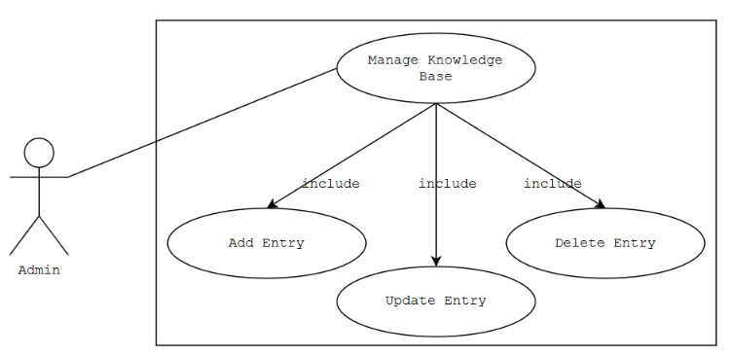

Figure 12: Use Case Diagram for Manage Knowledge Base
It shows the three maintenance actions the admin performs on the AI's knowledge base.
Table 28
Use Case Scenario for Manage Knowledge Base
Use Case Name: | Manage Knowledge Base
Actors: | Admin
Description: | The admin wants to add, update, or delete knowledge base entries
Triggering Event: | To keep the AI's answers accurate and up-to-date
Trigger Type: | External Temporal
Related Use Case: | Add Entry, Update Entry, Delete Entry
Pre-condition: | Admin must be logged in.
Post-condition: | Knowledge base entry successfully added, updated, or deleted .

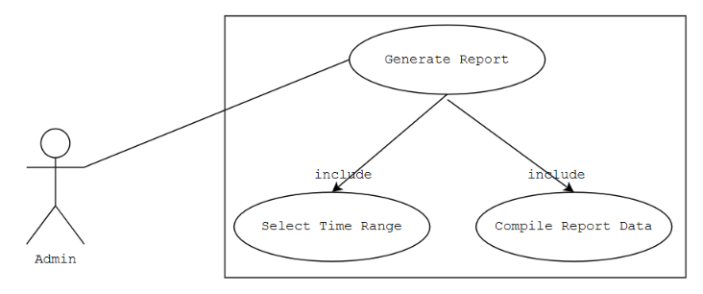
Figure 13: Use Case Diagram for Generate Report
It shows the admin generating inquiry and concern reports over a chosen time range.
Table 29
Use Case Scenario for Generate Report
Use Case Name: | Generate Report
Actors: | Admin
Description: | The admin wants to generate an inquiry and concern report
Triggering Event: | To support decision-making and monitor performance
Trigger Type: | External Temporal
Related Use Case: | Select Time Range, Compile Report Data
Pre-condition: | Inquiry and concern data must exist.
Post-condition: | Report successfully generated.

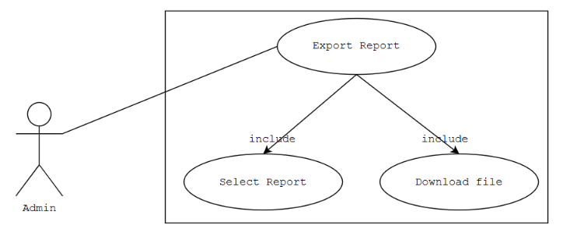
Figure 14: Use Case Diagram for Export Report
It shows the admin downloading a generated report.
Table 30
Use Case Scenario for Export Report
Use Case Name: | Export Report
Actors: | Admin
Description: | The admin wants to export a generated report as a downloadable file
Triggering Event: | To save or share the generated report
Trigger Type: | External Temporal
Related Use Case: | Select Report, Download File
Pre-condition: | Report must be generated.
Post-condition: | Report file successfully downloaded.

Event Table
Event table is one of the widely used tools in system analysis which list and organize major events that affect or take place within a system. It represents how the event table contains timing information about specific events that occur during the scenario.
Event | Trigger | Source | Use Case | Response | Destination
The admin wants log in in the website | To access the website | Admin | Login | Verification for Admin Login | Admin
The staff wants to log in to the website | To access the website | Staff | Login | Verification for Staff Login | Staff
The student wants to log in to the website | To access the website | Student | Login | Verification for Student Login | Student
The student wants an AI-assisted answer to an inquiry | To get an immediate answer to a question | Student | Submit Inquiry Via AI | Display AI Response | Student
The student wants to submit a general concern | To report an academic or administrative concern | Student | Submit General Inquiry | Confirmation for Concern Submission | Student
The student wants to track the status of a submitted concern | To monitor the progress of a submitted concern | Student | Track Inquiry Status | Display Inquiry Status | Student
The staff wants to view assigned concerns | To check pending or assigned concerns | Staff | View Assigned Concerns | Display Assigned Concerns List | Staff
The staff wants to respond to a concern | To provide an answer or update to a student concern | Staff | Respond To Concerns | Send Concern Response | Staff
The staff wants to update the status of a concern | To reflect progress on a concern | Staff | Update Concern Status | Confirmation for Status Update | Staff
The admin wants to add a new staff account | To create a new staff account | Admin | Manage Staff Accounts | Confirmation for New Staff Account | Admin
The admin wants to update a staff account | To modify staff account details | Admin | Manage Staff Accounts | Confirmation for Updated Staff Account | Admin
The admin wants to delete a staff account | To delete an unused or inactive staff account | Admin | Manage Staff Accounts | Confirmation for Deleted Staff Account | Admin
The admin wants to add a knowledge base entry | To keep the AI's answers accurate and up-to-date | Admin | Manage Knowledge Base | Confirmation for New Knowledge Base Entry | Admin
The admin wants to update a knowledge base entry | To correct or improve an existing AI answer | Admin | Manage Knowledge Base | Confirmation for Updated Knowledge Base Entry | Admin
The admin wants to delete a knowledge base entry | To remove an outdated AI answer | Admin | Manage Knowledge Base | Confirmation for Deleted Knowledge Base Entry | Admin
The admin wants to generate an inquiry and concern report | To support decision-making and monitor performance | Admin | Generate Report | Display Generated Report | Admin
The admin wants to export a generated report | To save or share the generated report | Admin | Export Report | Confirmation for Report Download | Admin
The student asks Ben (the AI chatbot) a question about their concern | To get an AI-generated answer without waiting for staff | Student | Submit Inquiry Via AI | Send AI-Generated Response to Student | Student
The student is not satisfied with Ben's AI-generated response and submits a formal inquiry | To have staff review and resolve a concern the AI could not settle | Student | Submit Inquiry Via AI | Route Inquiry to Office Staff Queue | Office Staff

Table 31: Event Table for “HELPDESKCRMC: AN AI-ASSISTED STUDENT INQUIRY AND CONCERN MANAGEMENT SYSTEM”
In the table above, different events are shown. These events take place within the system. The table shows different columns that show multiple components for an event to take place.
Entity Relationship Diagram
The diagram below models the HELPDESKCRMC database, showing how the users, offices, inquiries, and AI knowledge base tables relate to one another.
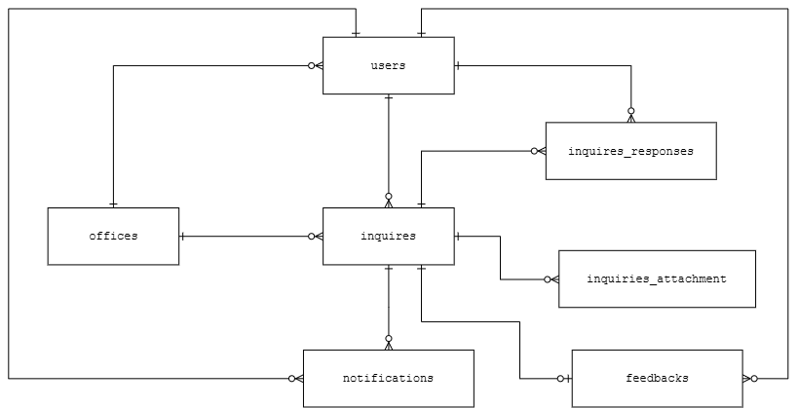
Figure 15: Entity Relationship Diagram for “HELPDESKCRMC: AN AI-ASSISTED STUDENT INQUIRY AND CONCERN MANAGEMENT SYSTEM”
The figure above shows the Entity Relationship Diagram of the HELPDESKCRMC system database. The relationship type used throughout the diagram is one-to-many, denoted by the crow's foot notation. The users entity, which stores student, staff, and admin accounts, is connected to the offices entity to indicate which office a staff member belongs to. A user can submit zero or many records in the inquiries entity, and each inquiry is directed to a single office. Each inquiry can, in turn, have zero or many inquiry_responses from staff and zero or many inquiry_attachments submitted by the student. The knowledge_base entity, which stores the office-specific procedures, requirements, and FAQs used by the AI-assisted matching function, is likewise linked to a single office. The ai_match_logs entity records the outcome of each AI matching attempt for a given inquiry, while the notifications and feedback entities capture the real-time status updates and post-resolution ratings tied to both users and their inquiries.
Class Diagram
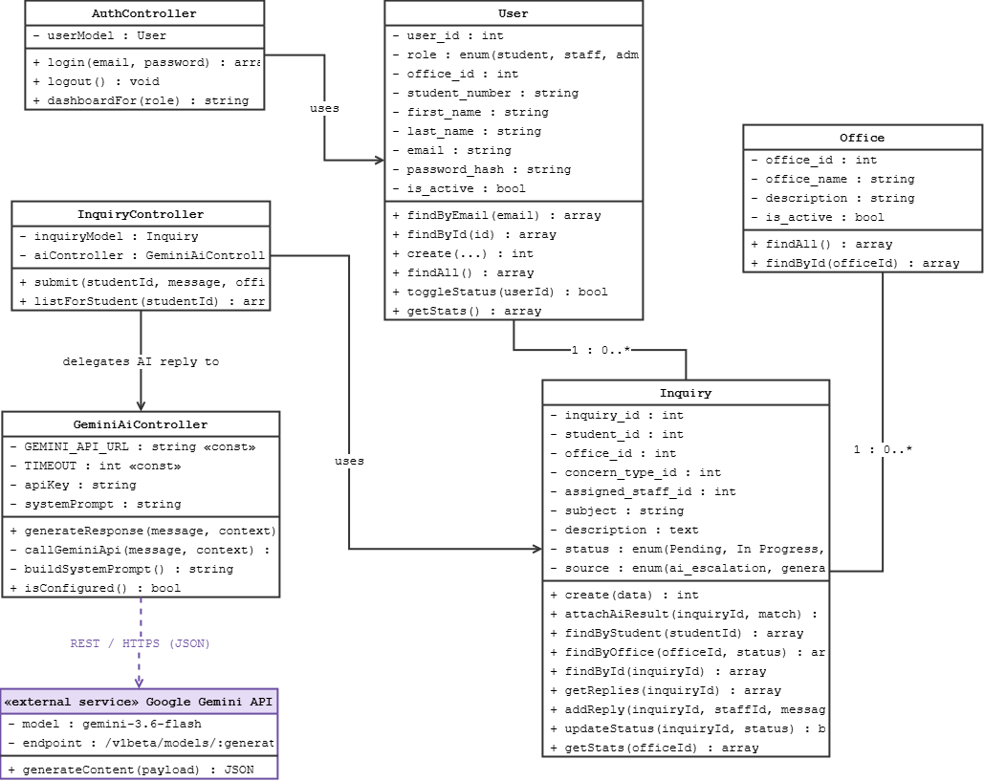
Figure 16: Class Diagram for “HELPDESKCRMC: AN AI-ASSISTED STUDENT INQUIRY AND CONCERN MANAGEMENT SYSTEM”
The figure above is based on the Entity Relationship Diagram, expanded to show each class's attributes and operations. The User class represents students, staff, and admins, and exposes operations such as login(), submitInquiry(), and trackInquiry() for students, alongside account-management operations reserved for admin. The Inquiry class holds the submitted concern and supports attachFile(), updateStatus(), and respond(), the last of which is used by staff to reply to a concern. The Office class groups inquiries and knowledge base entries by the school office responsible for handling them. The KnowledgeBase class stores the verified content the AI-assisted matching function draws from, exposing matchInquiry() for retrieval and addEntry(), updateEntry(), and deleteEntry() for admin maintenance of the knowledge base.
Data Dictionary
The tables below define every field in HELPDESKCRMC’s nine database tables, including each field’s data type and purpose.
Table 32: users
Field Name | Data Type and Values | Description
user_id | int(11) | Classify User Id (Primary Key)
role | enum('student','staff','admin') | Classify User Role
office_id | int(11), nullable | Classify Office Assignment (Foreign Key; required for staff, null for student/admin)
student_number | varchar(30), nullable, unique | Classify Student School Id Number (students only)
first_name | varchar(100) | Classify User First Name
last_name | varchar(100) | Classify User Last Name
email | varchar(150), unique | Classify User Email
password_hash | varchar(255) | Classify Hashed Password
is_active | tinyint(1) | Classify Account Status (1 = active, 0 = inactive)
last_login_at | timestamp, nullable | Classify Date and Time of Last Login
created_at | timestamp | Classify Account Creation Date
updated_at | timestamp | Classify Date of Last Update

Table 33: offices
Field Name | Data Type and Values | Description
office_id | int(11) | Classify Office Id (Primary Key)
office_name | varchar(100), unique | Classify Office Name
description | varchar(255), nullable | Classify Office Description and Services
is_active | tinyint(1) | Classify Whether the Office Is Currently Active
created_at | timestamp | Classify Office Creation Date
updated_at | timestamp | Classify Date of Last Update

Table 34: concern_types
Field Name | Data Type and Values | Description
concern_type_id | int(11) | Classify Concern Type Id (Primary Key)
office_id | int(11) | Classify Related Office (Foreign Key)
type_name | varchar(100) | Classify Concern Type Name
is_active | tinyint(1) | Classify Whether the Concern Type Is Currently Active
created_at | timestamp | Classify Date Added

Table 35: inquiries
Field Name | Data Type and Values | Description
inquiry_id | int(11) | Classify Inquiry Id (Primary Key)
student_id | int(11) | Classify Submitting Student (Foreign Key)
office_id | int(11) | Classify Receiving Office (Foreign Key)
concern_type_id | int(11), nullable | Classify Related Concern Type (Foreign Key)
assigned_staff_id | int(11), nullable | Classify Assigned Staff Member (Foreign Key, set by admin)
subject | varchar(150) | Classify Inquiry Subject
description | text | Classify Inquiry Details
status | enum('Pending','In Progress','Resolved') | Classify Inquiry Status
source | enum('ai_escalation','general_inquiry') | Classify How the Inquiry Was Created (escalated from Ben, or submitted directly)
resolved_at | timestamp, nullable | Classify Date Marked Resolved
created_at | timestamp | Classify Date Submitted
updated_at | timestamp | Classify Date of Last Update

Table 36: inquiry_attachments
Field Name | Data Type and Values | Description
attachment_id | int(11) | Classify Attachment Id (Primary Key)
inquiry_id | int(11) | Classify Related Inquiry (Foreign Key)
response_id | int(11), nullable | Classify Related Staff Response (Foreign Key; null if attached at submission)
uploaded_by | int(11) | Classify Uploading User (Foreign Key)
file_name | varchar(255) | Classify Original File Name
file_path | varchar(500) | Classify Stored File Location
file_type | varchar(100), nullable | Classify File Type / MIME Type
file_size | int(11), nullable | Classify File Size in Bytes
uploaded_at | timestamp | Classify Date Uploaded

Table 37: inquiry_responses
Field Name | Data Type and Values | Description
response_id | int(11) | Classify Response Id (Primary Key)
inquiry_id | int(11) | Classify Related Inquiry (Foreign Key)
staff_id | int(11) | Classify Responding Staff (Foreign Key)
message | text | Classify Staff Response Content
created_at | timestamp | Classify Date Responded

Table 39: ai_conversations
Field Name | Data Type and Values | Description
conversation_id | int(11) | Classify Conversation Id (Primary Key; table unused by the current build)
student_id | int(11) | Classify Student in the Conversation (Foreign Key)
inquiry_id | int(11), nullable | Classify Linked Inquiry, Once Escalated (Foreign Key)
office_id | int(11), nullable | Classify Related Office (Foreign Key)
concern_type_id | int(11), nullable | Classify Related Concern Type (Foreign Key)
is_resolved | tinyint(1) | Classify Whether the Conversation Was Marked Resolved
is_escalated | tinyint(1) | Classify Whether the Conversation Was Escalated to Staff
started_at | timestamp | Classify Date and Time the Conversation Started
ended_at | timestamp, nullable | Classify Date and Time the Conversation Ended (conversation history is actually kept client-side in JavaScript, not persisted here)

Table 40: ai_messages
Field Name | Data Type and Values | Description
message_id | int(11) | Classify Message Id (Primary Key; table unused by the current build)
conversation_id | int(11) | Classify Related Conversation (Foreign Key)
sender | enum('student','ben') | Classify Message Sender
message_text | text | Classify Message Content
created_at | timestamp | Classify Date Sent (not populated by the current client-side chat flow)

Table 42: notifications
Field Name | Data Type and Values | Description
notification_id | int(11) | Classify Notification Id (Primary Key)
user_id | int(11) | Classify Receiving User (Foreign Key)
inquiry_id | int(11), nullable | Classify Related Inquiry (Foreign Key)
title | varchar(150) | Classify Notification Title
message | varchar(500) | Classify Notification Content
is_read | tinyint(1) | Classify Read Status
created_at | timestamp | Classify Date Sent

Table 43: feedback
Field Name | Data Type and Values | Description
feedback_id | int(11) | Classify Feedback Id (Primary Key)
inquiry_id | int(11), unique | Classify Related Inquiry (Foreign Key)
student_id | int(11) | Classify Submitting Student (Foreign Key)
rating | tinyint(1) | Classify Satisfaction Rating (1-5)
comment | varchar(500), nullable | Classify Optional Feedback Comment
created_at | timestamp | Classify Date Submitted
Deployment Diagram

The deployment diagram illustrates the distribution of software components across hardware involves creating a clear representation of how various elements of the system are allocated to physical devices.

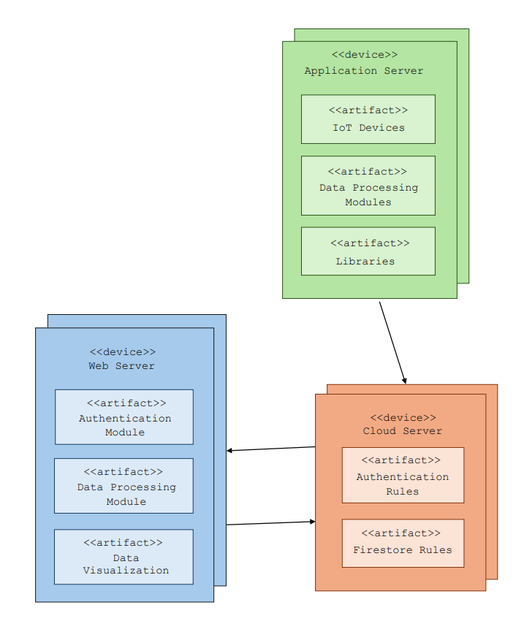
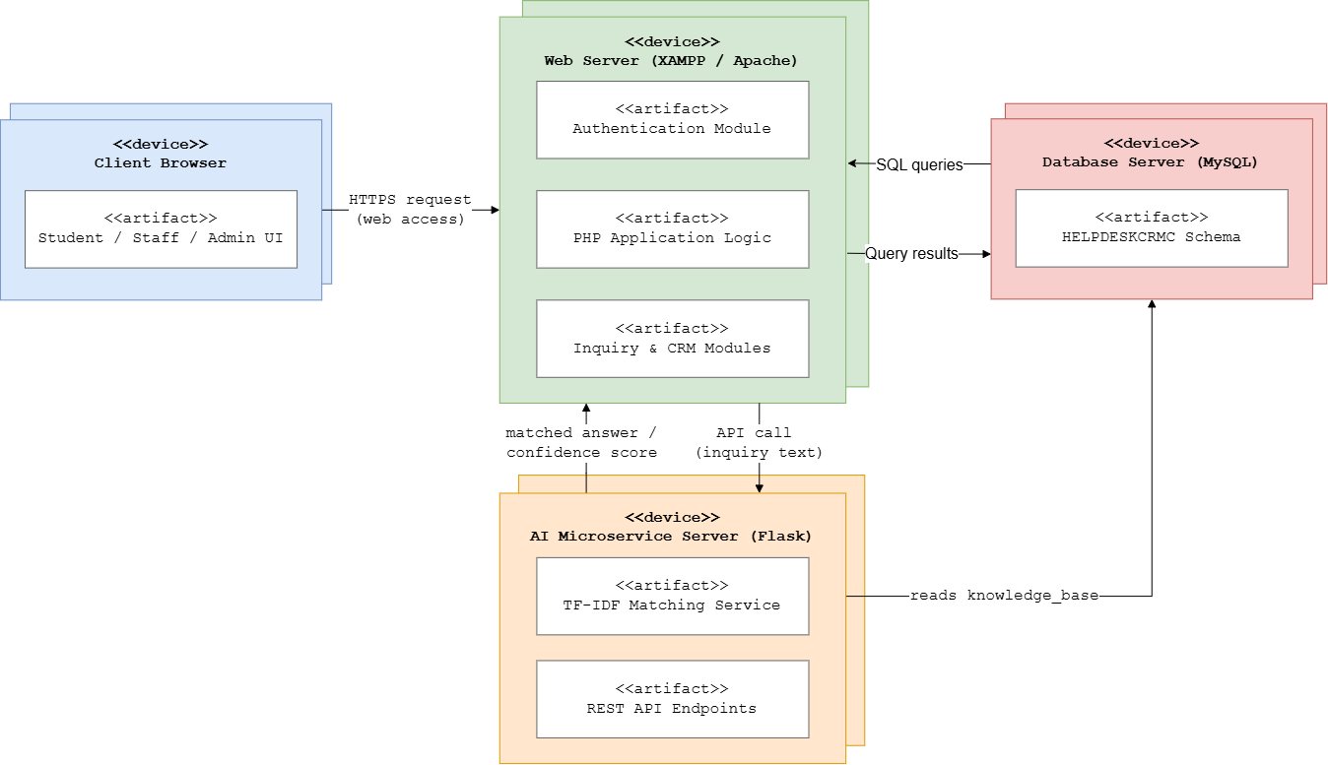

Figure 17: Deployment Diagram for “HELPDESKCRMC: AN AI-ASSISTED STUDENT INQUIRY AND CONCERN MANAGEMENT SYSTEM”
Client Browser - This is the device the student, staff, or admin uses to access HELPDESKCRMC through a standard web browser. It renders the HTML/CSS/JavaScript interface, submits inquiries and login credentials, and displays AI-assisted responses, notifications, and inquiry status updates sent back from the Web Server.

Web Server (XAMPP / Apache) - This hosts the main PHP application. It handles user authentication, session management, inquiry submission and tracking, CRM-style staff and admin dashboards, role-based access control, and the AI chatbot backend (GeminiAiController). When a student sends a message, this server directly communicates with the Google Gemini API via HTTPS, processes the response, and relays it back to the browser.

Cloud AI Gateway (Google Gemini API) - This provides generative AI processing using Google's gemini-3.6-flash model. It receives student message payloads and conversation history from the PHP application via secure REST API requests. Utilizing a CRMC knowledge-infused system prompt, Gemini generates context-aware, natural responses and returns them to the main application in JSON format.

Database Server (MySQL) - This stores the centralized HELPDESKCRMC schema, including user accounts, offices, inquiries, inquiry attachments and responses, match logs, notifications, and feedback records. The PHP Web Server connects directly to this database, maintaining a single source of truth for all system data.

Chapter 3
SUMMARY FINDINGS , CONCLUSION

The researchers went through the planning process, conducted interviews, and gathered data to understand the current challenges. The researcher found that there is a need for a system to address these issues.
Based on the research and data gathered the researchers came with the following results:

E BUTANG

APPENDIX A

APPENDIX B
TRANSMITAL LETTER

APPENDIX C
DOCUMENTATION

APPENDIX D
SURVEY INSTRUMENT

…………
Appendix E
Certificate of Utilization

Appendix F
USER MANUAL

Appendix G
EVIDENCE OF SUBMISSION FOR PUBLICATION

APPENDIX H

