Retail Insights
Sales integrity and customer priorities

Business question
Which reporting issues and customer groups deserve attention before launching retention or product initiatives? The study audits all 541,909 Online Retail records, then connects a reconciled merchandise ledger with customer and product analysis.

Measured scale
The primary ledger records £10,271,034.61 of merchandise purchases and £478,724.18 of negative-quantity credits or adjustments. Purchases less recorded credits are £9,792,310.43; this is not profit or verified accounting revenue.
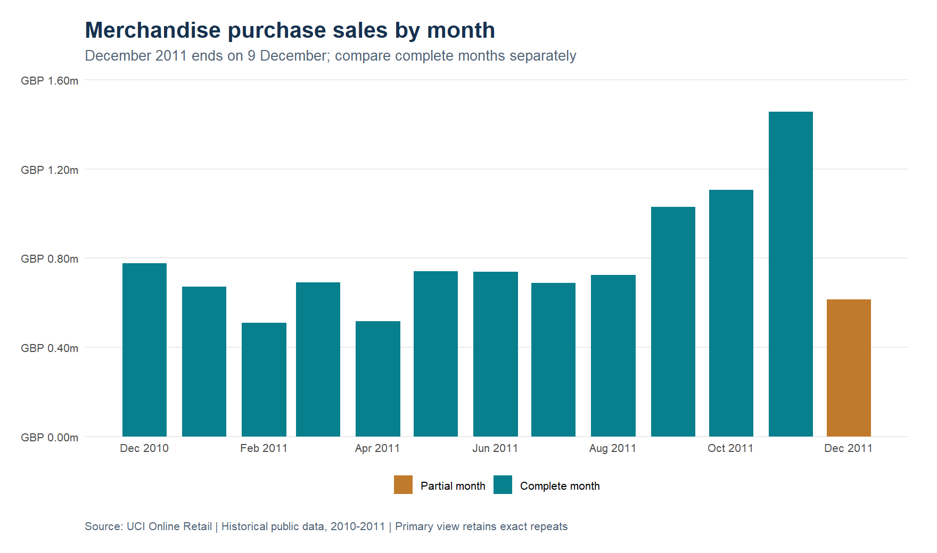
Monthly merchandise purchase value. December 2011 covers only 1–9 December.
Source: Chen, D. (2015), Online Retail, UCI. https://doi.org/10.24432/C5BW33 · CC BY 4.0. Calculations: project R pipeline.

Investigate the ledger before acting

Explicit rules and reconciliation
Every source row receives one class. Administrative codes, invalid or nonpositive prices and cancellation inconsistencies remain visible. The complete row partition and aggregate amounts reconcile to the source.

Sensitivity rather than silent deletion
The 5,268 exact repeated rows are preserved in primary results because no unique line identifier exists. Excluding later repeats reduces purchase value by £24,213.74. That difference is a reporting sensitivity, not recovered money.

Credit candidates
582 groups contain exactly one purchase and one negative-quantity line sharing customer, code, date, absolute quantity and price, with £287,854.70 in candidate purchase value. A further 142 groups are ambiguous. These are investigation candidates, not proven return links.
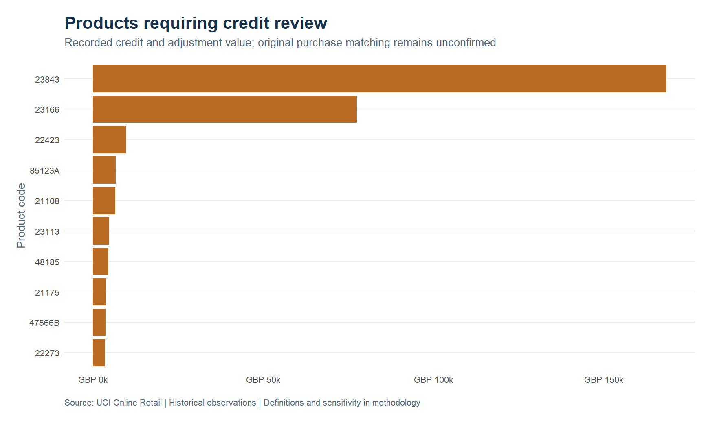
High-credit merchandise codes. Credits alone do not establish defects, return reasons or stock losses.
Source: Chen, D. (2015), Online Retail, UCI. https://doi.org/10.24432/C5BW33 · CC BY 4.0. Calculations: project R pipeline.

Customers and observed cohorts

Concentration and coverage
The 4,334 identified buyers account for 85.3% of purchase value. The top 434 buyers contribute 61.3% of identified purchase value. Anonymous purchases are retained in the sales ledger but excluded from RFM.

Retention priorities
RFM uses a fixed 10 December 2011 snapshot and consistent handling of ties. The segmentation identifies 384 at-risk buyers. Cohorts begin at the first purchase observed in this file, which may be later than a customer’s true first purchase.
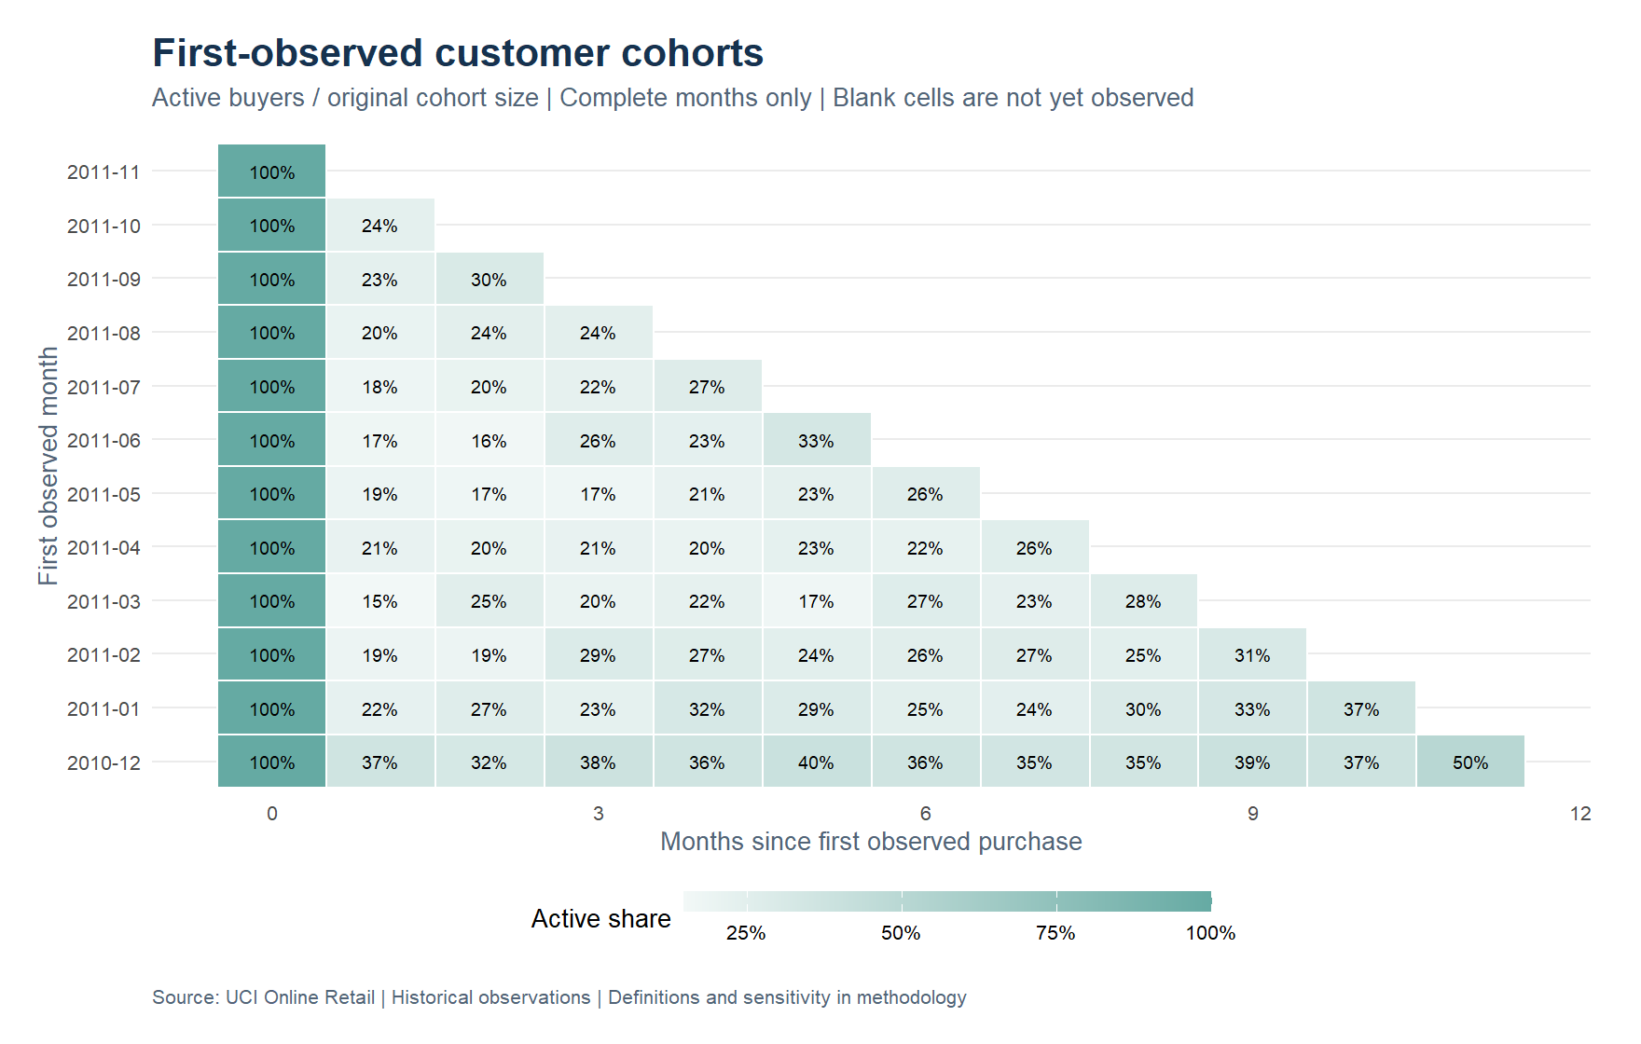
Monthly active-buyer rates for first-observed cohorts. Only complete months enter this view; unobserved future cells remain blank.
Source: Chen, D. (2015), Online Retail, UCI. https://doi.org/10.24432/C5BW33 · CC BY 4.0. Calculations: project R pipeline.

A practical decision sequence

1. Resolve reporting questions
Review high-value credit candidates and administrative codes with invoice owners. Require an invoice-line identifier and a product master before adopting automatic matching or revised revenue rules.

2. Design a measurable retention pilot
Review contact eligibility and consent, randomise comparable eligible buyers into contact and holdout groups, and measure incremental contribution after campaign costs. The scenario calculator uses editable assumptions and does not claim realised benefits.

3. Make the analysis repeatable
Restore renv, verify source checksums, execute rule fixtures and run the complete R pipeline. Use the full report and aggregate workbook for traceability; individual customer identifiers are excluded from the public explorer.
Deliverable | Purpose
10 figures + complete HTML | Methods, reconciliations and interpretation
Interactive white explorer | Markets, month ranges, product ranking and sensitivity
Excel aggregate workbook | Auditable tables and an editable pilot scenario
RStudio project + source records | Repeatable transformations and model rules
Source: Chen, D. (2015), Online Retail, UCI. https://doi.org/10.24432/C5BW33 · CC BY 4.0. Calculations: project R pipeline.

