Urban Demand
Bicycle rentals and operational planning

Business question
How does system-wide rental demand vary by calendar, hour and weather, and how accurately can an interpretable model estimate later recorded counts? The complete archive contains 17,379 hourly observations and 731 daily observations from 2011–2012.

Measured scale
The source records 3,292,679 rentals, with registered riders accounting for 81.2%. Working-day and weekend profiles differ, providing evidence for workload discussions when combined with service times and capacity.
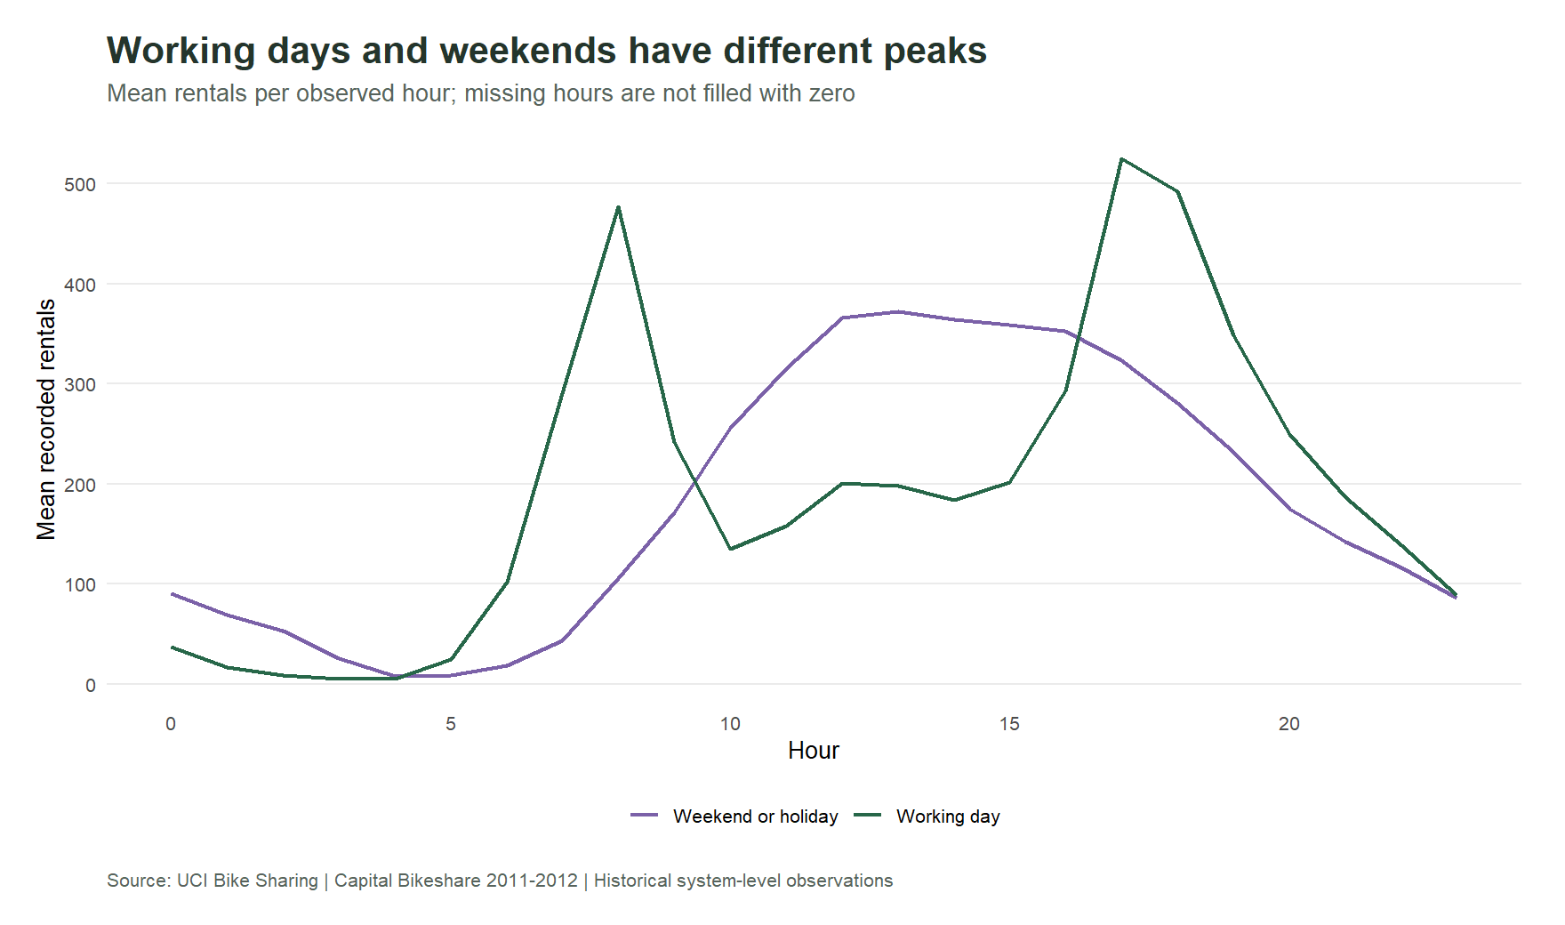
Mean recorded rentals per observed hour, separated by day type. These are system-wide patterns, not station inventory recommendations.
Source: Fanaee-T, H. (2013), Bike Sharing, UCI. https://doi.org/10.24432/C5W894 · CC BY 4.0. Calculations: project R pipeline.

Select models using earlier data

Fair temporal comparison
Four candidates are compared using three expanding training windows and later validation quarters. Average validation MAE selects the spline negative-binomial model. The final October–December 2012 test does not participate in selection.

Control information leakage
Calendar, trend and observed weather enter the model. Casual and registered counts are excluded because they are target components. Spline transformations are fitted within each training window.
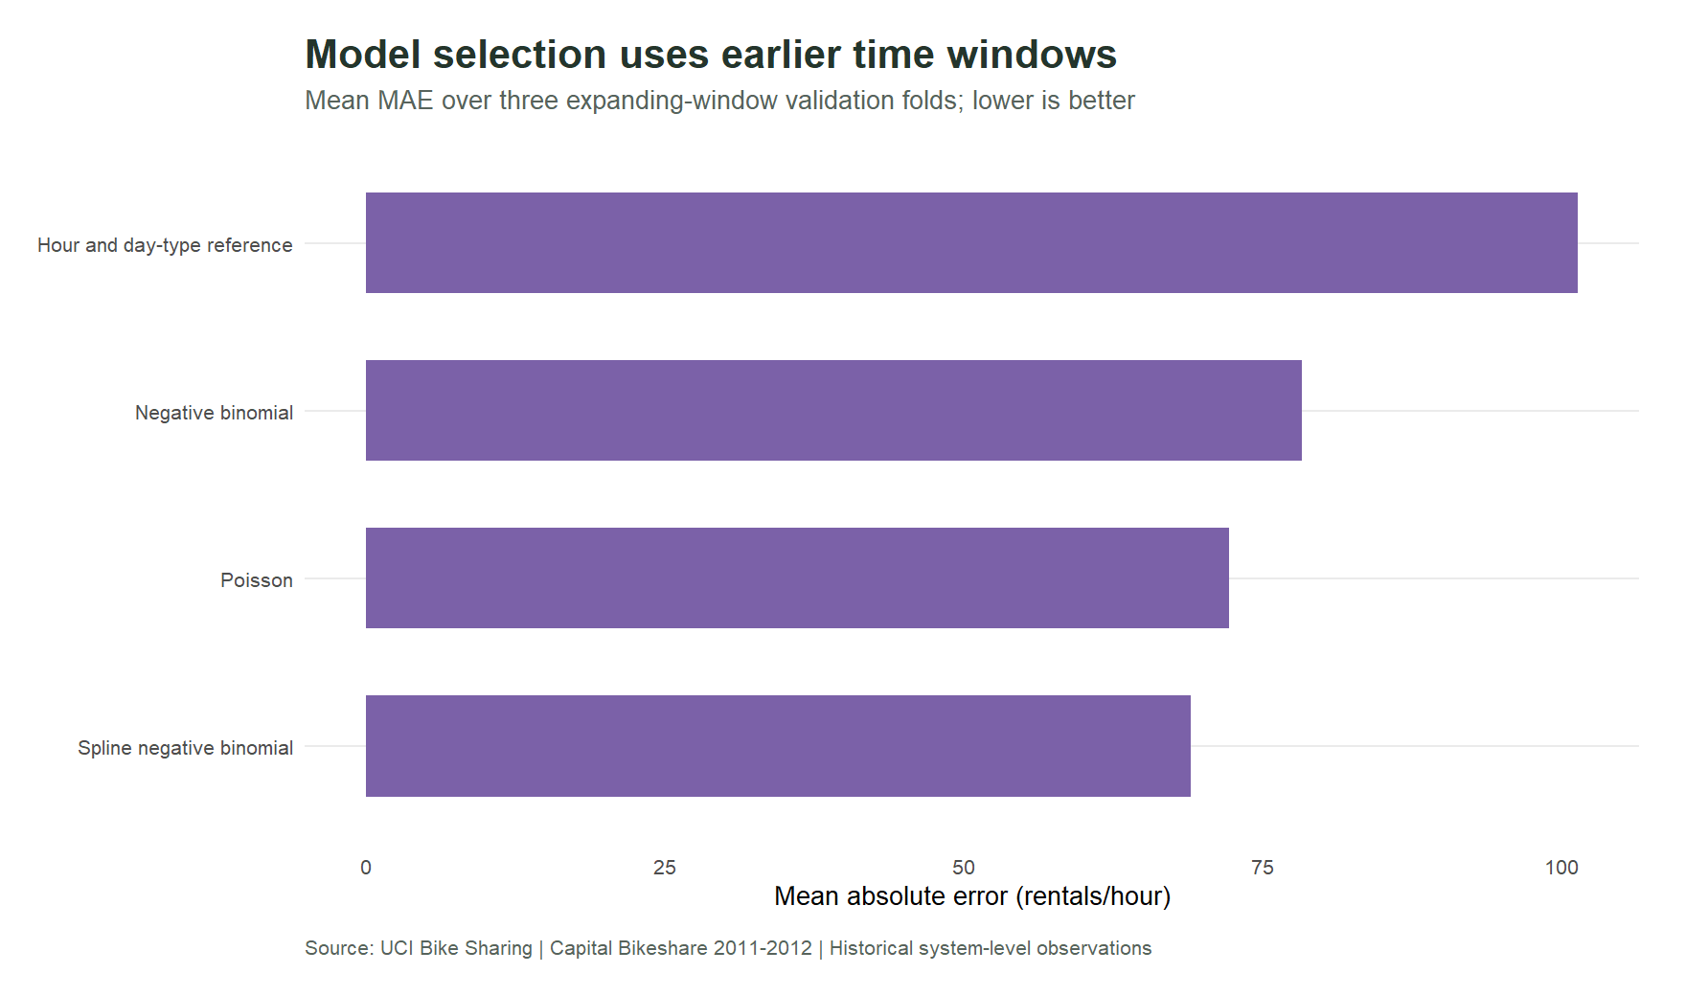
Average MAE over three validation folds; lower is better. The reference uses historical means for hour and day type.
Source: Fanaee-T, H. (2013), Bike Sharing, UCI. https://doi.org/10.24432/C5W894 · CC BY 4.0. Calculations: project R pipeline.

Final-test performance and uncertainty

Out-of-time estimates
On 2,168 final-test hours, the selected model achieves MAE 47.05 rentals/hour versus 79.95 for the reference, a 41.2% reduction. WAPE is 21.5%. Evaluation uses contemporaneous observed weather and does not establish advance-forecast accuracy.

Intervals need calibration
Conditional nominal 95% count intervals cover only 87.6% of test outcomes. Their width omits parameter and weather-forecast uncertainty. Hourly and weather-specific diagnostics expose performance differences hidden by averages.
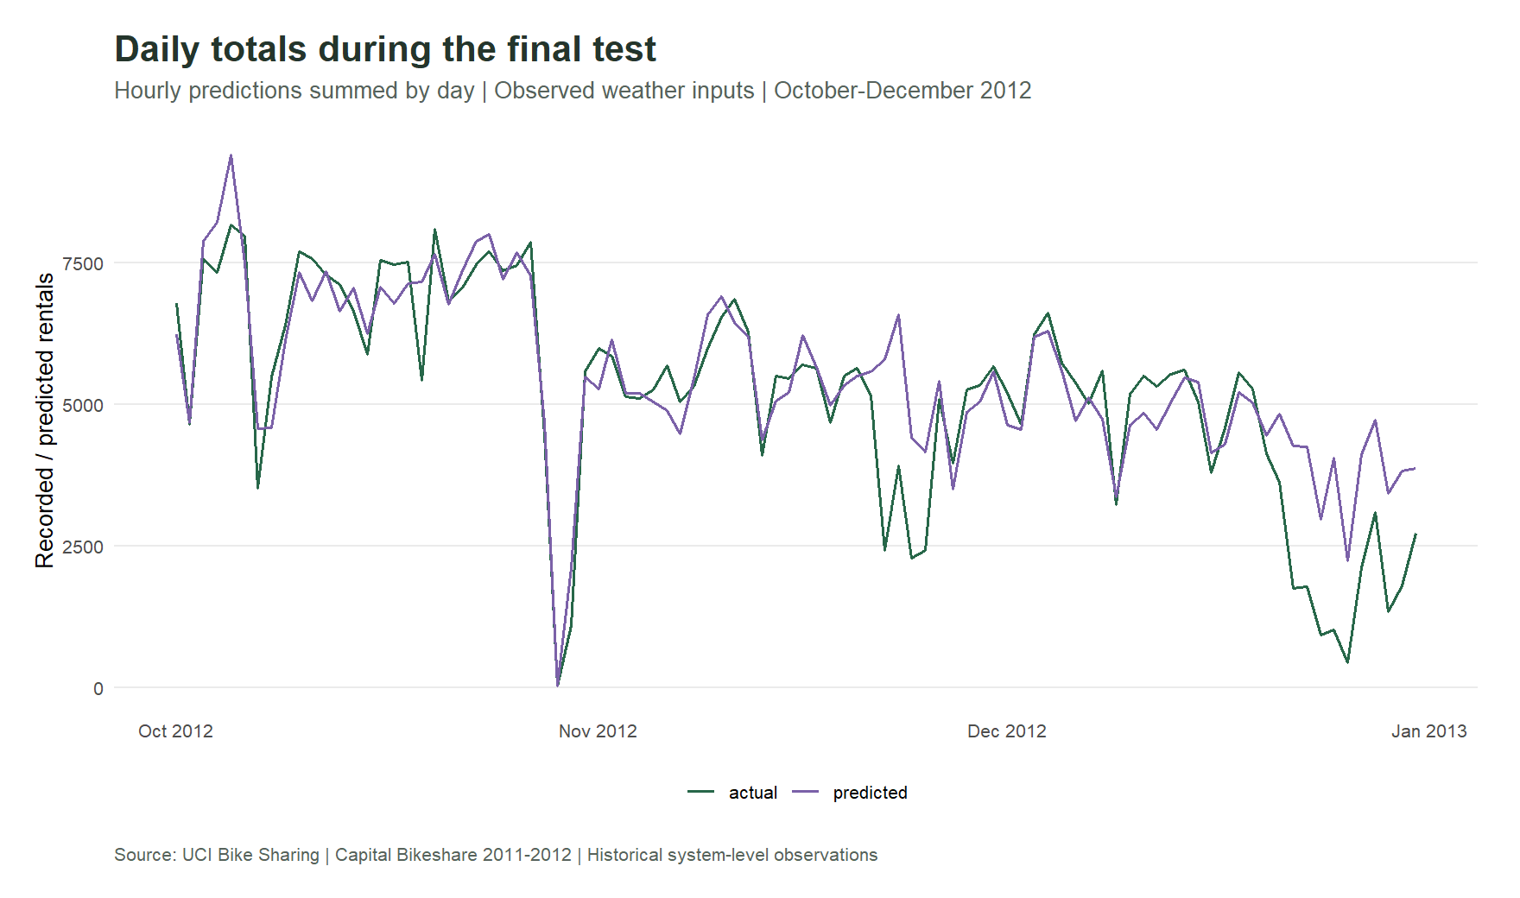
Daily sums of actual counts and saved hourly estimates on the final quarter. These are conditional estimates evaluated on later dates.
Source: Fanaee-T, H. (2013), Bike Sharing, UCI. https://doi.org/10.24432/C5W894 · CC BY 4.0. Calculations: project R pipeline.

From evidence to a planning pilot

1. Preserve missingness
There are 165 absent hour records across 76 days. Observed hourly totals reconcile exactly with every daily total, but the cause of the missing records is unknown. Do not convert absent hours into verified zero demand.

2. Evaluate a real forecasting horizon
Use archived weather forecasts available at the decision time, compare against the same reference on later observations, and calibrate uncertainty before choosing buffers. A seeded seven-day block bootstrap quantifies paired error differences for this historical test.

3. Add operational data
Station movements, capacities, stock-out duration, route costs, staffing service times and costs are required to evaluate deployment decisions. System totals do not measure denied demand, savings or where bicycles should be placed.
Deliverable | Purpose
10 figures + complete HTML | Patterns, temporal validation and diagnostic limits
Interactive white explorer | Year, day type, weather and final-test month
Excel aggregate workbook | Validation, saved estimates and source coverage
RStudio project + locked packages | Source verification and repeatable modelling
Source: Fanaee-T, H. (2013), Bike Sharing, UCI. https://doi.org/10.24432/C5W894 · CC BY 4.0. Calculations: project R pipeline.

