Task1
  - For this practical we have decided to create a music festival called Sonic Horizons Festival. This is a large outdoor festival that’s hosts live performances, food vendors and multiple types of operational services. This festival is divided into several operational areas that work together to provide entertainment, safety and top-notch services. Event organisers should be able to coordinate these areas effectively, especially when responding to weather conditions, capacity limits as well as emergency situations. We have made use of hierarchies so that the entire area can be manged uniformly. This will allow the festival management to perform operations on a complete section without needing to interact directly with every unit.
Group Area (Composite Classes): SonicHorizonsFestival, PerformanceZone, MainStageArea, ElectronicStageArea, FoodCourt, OperationsZone.
OperationalUnits (LeafClasses): MainStage, BackStage, DjStage, DanceFloor, BurgerVendor, BeverageVendor, SecurityPost, FirstAidTent.

Event Structure
SonicHorizonsFestival
|
|----- PerformanceZone
| |---- MainStageArea
| |---- MainStage
| |---- BackStage
|--- FoodCourt
| |--- BurgerVendor
| |--- BeverageVendor
|
  - Observer:
Subject: FestivalSubject
ConcreteSubject: FestivalControl, FestivalGroup
Observer: FestivalObserver,
ConcreteObserver: FestivalUnit, FestivalGroup

FestivalControl generates notices and distributes them through the Observer pattern. FestivalGroup objects receive notices from parent subjects and forward them to lower-level observers. FestivalUnit objects receive notices and react according to their individual responsibilities.

Composite:
Component: FestivalComponent
Leaf: FestivalUnit
Composite: FestivalGroup
ConcreteComposite: SonicHorizonsFestival, PerformanceZone, MainStageArea, ElectronicStageArea, FoodCourt, OperationsZone
ConcreteLeaves: MainStage, BackStage, DJStage, DanceFloor, BurgerVendor, BeverageVendor, SecurityPost, FirstAidTent
The Composite pattern represents the physical structure of the festival. FestivalGroup objects own FestivalComponent objects, allowing individual units and entire areas to be treated uniformly.

1.3
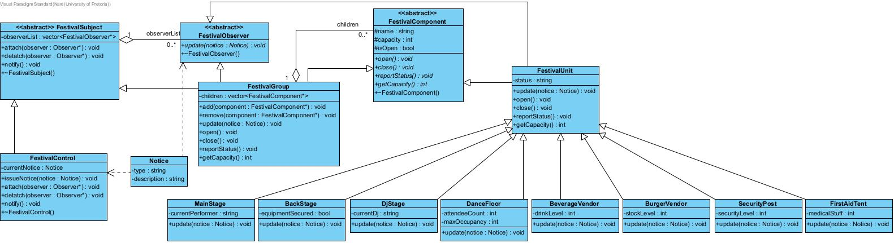
    - a) The FestivalGroup contains FestivalComponents, which can be individual parts (Leaves) or other groups (Composites). Actions like open(), close(), and getCapacity() are passed down to its children. This lets us treat the whole festival and its individual parts in the same way. For example, SonicHorizonsFestival-> PerformanceZone-> MainStageArea-> MainStage.

b) Direct calls would make FestivalControl depend on every festival unit. The Observer pattern lets festival units register for alerts and receive notifications automatically. It allows for a one-to-many dependency and reduces tight coupling. For example, a WEATHER_ALERT can notify the MainStage, DJStage, SecurityPost, and FirstAidTent without changing FestivalControl.

c) Event components are owned exclusively by the FestivalGroup (Composite) that contains them. The root FestivalGroup (SonicHorizonsFestival) is created by the client (our main.cpp) and owns its direct children. Those children, if they are Groups, own their own children, and so on. This creates a clear, acyclic ownership tree where every component has a single owner.

d) Observer references are not owned. The pointers stored in a FestivalSubject's observer’s vector are raw pointers (non-owning). The subject only uses them to call update(). The observer's lifetime is managed by its owner in the Composite tree. This separation is vital: it prevents the Subject from accidentally deleting an object that is also owned by its parent, which would lead to a double-deletion bug.

e) A FestivalGroup can be both a Subject and an Observer because it uses each role for a different purpose. As an Observer, it receives notices from a higher-level Subject. As a Subject, it forwards those notices to its own observers.
For example, MainStageArea receives a notice from PerformanceZone and then forwards it to MainStage and Backstage. Therefore, being both a Subject and Observer is not a misuse because each role has a different purpose in the collaboration.

