SENTRY
A 3-in-1 Static Security Configuration Linter
USER MANUAL
sshd • nginx • docker-compose
Course Mini Project — Custom Ethical Hacking Tool
Hood Security Department · NSSECU2 (S04) · Version 0.1.0
Static analysis only — this tool never connects to a live system.

1. Introduction
Sentry is a static security configuration linter. You point it at a configuration file and it reports insecure settings, insecure defaults, and missing hardening directives, each with a severity, a plain-language explanation, and a suggested fix. It supports three configuration formats through a single engine: OpenSSH server configs (sshd_config), nginx configs, and docker-compose files.
Sentry performs static analysis only: it reads configuration text and never connects to, scans, probes, or tests any running system, service, or network. This makes it safe to run anywhere, including in a lab or classroom setting.

2. System Requirements
Requirement | Detail
Python | Version 3.10 or newer (developed and tested on 3.12)
Operating system | Linux, macOS, or Windows 11 / 10
Dependencies | pyyaml>=6.0 and rich>=13.0
Internet | Only needed once, during installation, to download the two dependencies
Disk / privileges | Negligible; no administrator or root privileges required

3. Installation
Unzip the project and open a terminal in the project folder (the folder that contains pyproject.toml).

Option A — recommended (installs the sentry command)
python -m venv .venv
# Linux / macOS:
source .venv/bin/activate
# Windows (PowerShell):
.venv\Scripts\Activate.ps1

pip install -e .
sentry --version

Option B — no install, dependencies only
Install the two dependencies and run the tool as a Python module. With this option, use python -m sentry wherever this manual writes sentry.
pip install -r requirements.txt
python -m sentry --version

Running on Windows 11 (PowerShell)
Windows 11 works the same way, with a few platform notes that prevent the most common problems:
Install Python from PATH. Install Python 3.10 or newer from python.org and, on the first installer screen, tick “Add python.exe to PATH”. Then close and reopen PowerShell. This prevents the most common “sentry: command not found” and “python is not recognized” errors.
If activation is blocked. If PowerShell refuses to run .venv\Scripts\Activate.ps1 with a message that running scripts is disabled, allow it for your user account only, then run the activate command again:
Set-ExecutionPolicy -Scope CurrentUser -ExecutionPolicy RemoteSigned
Alternatively, skip the virtual environment entirely and use Option B above (python -m sentry), which does not require activation.
Paths and wildcards. Use backslashes in file paths. PowerShell does not expand a samples\*.bad wildcard, so list files explicitly:
sentry samples\sshd_config.bad
sentry samples\nginx.conf.bad samples\docker-compose.bad.yml --min-severity high
Checking the exit code. On Windows use echo $LASTEXITCODE (not $?). It prints 1 when high-severity findings are present and 0 when clean.
Colored output. Run the tool in Windows Terminal (built into Windows 11) for correct colored output. The classic cmd.exe console may not render colors. To open the HTML report from PowerShell, run start report.html.

4. Usage
Point Sentry at one or more files. It detects the config type from the filename, or you can force it with --type. The examples below use forward slashes; on Windows PowerShell use backslashes (see section 3).

Common commands
# Scan a single file (type auto-detected)
sentry samples/sshd_config.bad

# Scan several files of mixed types at once
sentry samples/sshd_config.bad samples/nginx.conf.bad samples/docker-compose.bad.yml

# Show only high-severity issues
sentry samples/nginx.conf.bad --min-severity high

# Produce a shareable HTML report
sentry samples/nginx.conf.bad --format html --output report.html

# List every bundled rule
sentry --list-rules

Options
Flag | Purpose
-t, --type | Force a config type (sshd, nginx, docker-compose) instead of auto-detecting
-f, --format | Output format: console (default), json, or html
-o, --output | Write the report to a file instead of the screen
--min-severity | Hide findings below this severity (default: info)
--fail-on | Exit with code 1 if any finding is at or above this severity (default: high)
--list-rules | Print every bundled rule and exit
--version | Print the version and exit

Exit codes
Sentry sets its exit code so it can be used unattended in a CI pipeline:
Code | Meaning
0 | No findings at or above the --fail-on threshold
1 | Findings at or above the threshold were reported
2 | Usage or input error (missing file, unknown type, etc.)

5. Understanding the Results
Each finding has four parts: a severity, a rule ID and title, a detail line saying what was found and where, and a fix. A reference to a recognised benchmark (CIS, OWASP, Mozilla) is included where applicable.

Severity levels
Severity | Meaning
HIGH | Serious weakness that should be fixed before deployment
MEDIUM | Meaningful weakness worth addressing
LOW | Minor hardening improvement or defence-in-depth
INFO | Informational note, no direct risk
Note that a missing hardening directive is reported as a finding in its own right, because relying on an insecure default is itself a security problem.

6. Sample Run
Scanning the deliberately-weak nginx sample produces the following report. Nine issues are found and grouped by severity, each with the exact line, an explanation, and a fix:
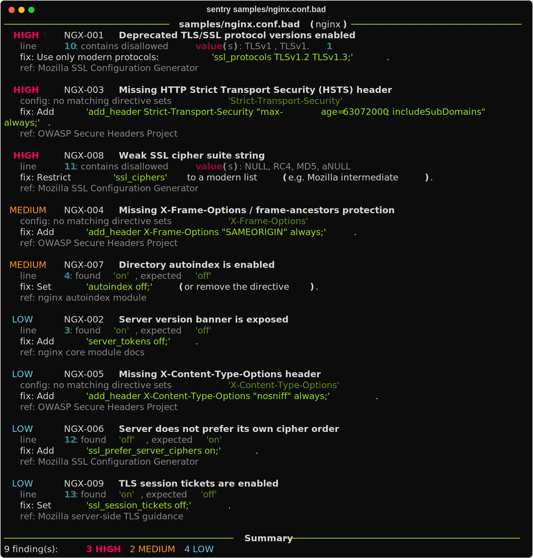
Figure 1 — Console output for sentry samples/nginx.conf.bad
The same scan can be written to a self-contained HTML report with --format html --output report.html, which opens in any web browser and is useful for sharing or including in a report.

7. How It Works
Sentry normalises all three config formats into one common shape and evaluates them with a single, generic rule engine. All security knowledge lives as data in YAML rulesets, so adding a check does not require changing the engine code.
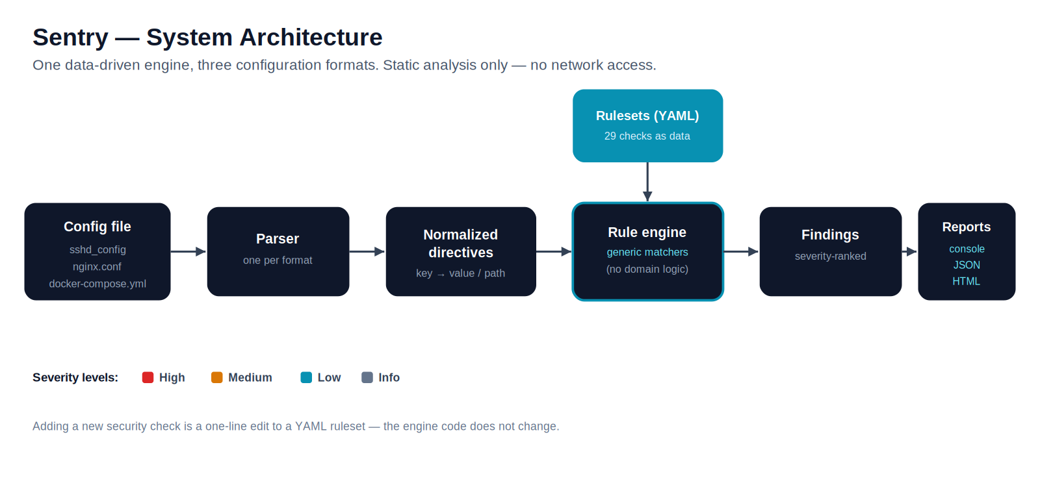
Figure 2 — Processing pipeline

8. Troubleshooting
Symptom | Resolution
“sentry: command not found” | Use Option A (pip install -e .) so the command is created, or run python -m sentry instead.
“python is not recognized” (Windows) | Python is not on PATH. Reinstall Python and tick “Add python.exe to PATH”, then reopen PowerShell.
“running scripts is disabled” (Windows) | Run: Set-ExecutionPolicy -Scope CurrentUser -ExecutionPolicy RemoteSigned, then activate again.
“cannot determine config type” | The filename was not recognised. Add --type sshd | nginx | docker-compose.
ModuleNotFoundError: rich / yaml | Dependencies are not installed. Run pip install -r requirements.txt.
No colour in the output | Expected when output is piped; on Windows, use Windows Terminal rather than cmd.exe.

9. Limitations
Sentry is a deliberately small, educational tool and is not a replacement for mature scanners. It ships with roughly 29 rules across three formats; it does not have CVE or version-vulnerability awareness; its nginx parsing is directive-level rather than fully block-scoped; its secret detection is pattern-based and may miss unusually named secrets; and findings for docker-compose files do not carry line numbers.

10. Ethical Reminder
This tool was developed for educational purposes only. It must only be used in authorized and controlled testing environments. Unauthorized testing against real systems, public websites, or third-party services is strictly prohibited.
Sentry performs static analysis of configuration text you provide. It does not connect to, scan, or test any live system. You are responsible for ensuring you have permission to review any file you run it against.

