Assignment 4: Becoming an Independent Data Scientist:

Index of Happiness Related with Internet usage and PISA scores.

1 Region and Domain

The analysis cover the inter words using statistics and index of most of the Countries of the word.

2 Research Question

We were interested to see the relation of the happiness of a country with:

1. its level of instruction (PISA averages) differences between male and female for the PISA score,
2. The technological distribution using the internet distribution
3. The health/medical status using the Mortality rate, infant (per 1,000 live births)

3 Links

For the analysis 3 different data set have been used:

* PISA stands for "Program for International Student Assessment" and it is applied to 15 year-old students across the world to assess their performance in Math, Reading and Science.

Link to the data set [https://www.kaggle.com/zazueta/pisa-scores-2015/downloads/Pisa%20mean%20performance%20scores%202013%20-%202015%20Definition%20and%20Source.csv](https://www.kaggle.com/zazueta/pisa-scores-2015/downloads/Pisa mean performance scores 2013 - 2015 Definition and Source.csv)

### Reading the Hapiness Dataset.

<http://worldhappiness.report/ed/2017/>

4 Image

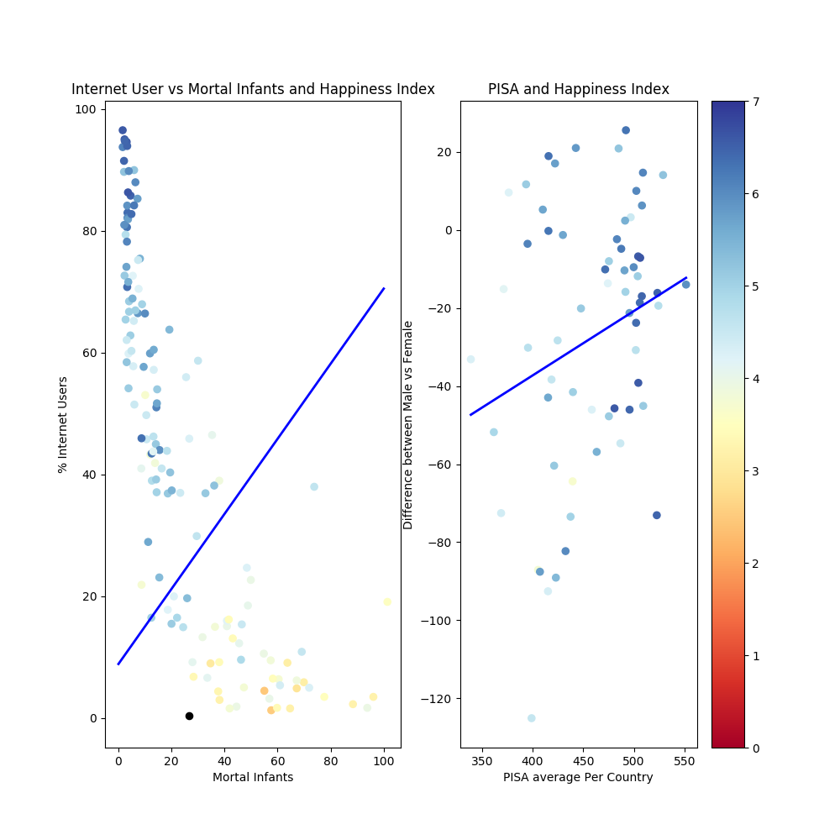

5 Discussion

You must contribute a short (1-2 paragraph) written justification of how your visualization

addresses your stated research question.

This visualization was concerned with answering the question of how the win percentages of the four

major Detroit sports teams (The Detroit Pistons, The Red Wings, The Detroit Tigers, and The Detroit

Lions) have changed over the last 40 years. Wikipedia was scraped for data concerning wins and losses

by season for each team. Any tie games were dropped from the analysis in order to provide a more

level comparison between the sports. A 10 year moving average was plotted to help the reader identify

any major trends in the team’s win percentages.

The plot indicates years of high win percentage for The Detroit Pistons around 1990 and 2005,

with periods of decline following both high points. The Detroit Red Wings’ win percentage shows an

increase in the 1990’s and stays high through the early 2000’s, with a downward trend in recent years.

The Detroit Tiger’s win percentage shows less variation than the other teams, hovering around 50%,

with it’s lowest win percentage in the early 2000’s. The win percentage of the Detroit Lions shows low

levels throughout the early 2000’s, with an increase a