**HelloWorld.go**

This is a basic program intended for developers who are new to BaaS and want to get first hands on with deployment and execution of *.go* files on BaaS instance.

At the time of writing of this post before we start with the code development and deployment we need to activate BaaS service and create an instance of Blockchain. Follow below steps to get started.

**Step 0: Getting started with Blockchain**

Detailed post can be found [here -> Getting started with blockchain - a collection of helpful resources.](https://jam4.sapjam.com/blogs/show/ed8zuG02E39TVFYBAY7sg8)

**Step 1: Activate BaaS instance on SAP Canaary**

Detailed post can be found [here -> How to Use Blockchain Service on Canary Landscape.](https://jam4.sapjam.com/wiki/show/j6PxmZTwyoUIRzYkf1TF6c?_lightbox=true)

**Step 2: Create Blockchain instance**

Detailed post can be found [here -> SAP Blockchain Service - Create Instance [Script].](https://jam4.sapjam.com/wiki/show/j6PxmZTwyoUIRzYkf1TF6c?_lightbox=true)

**Step 3: Source code ( HelloWorld.go) creation**

Source code is written in golang. Sublime editor is the one I used for writing the code.

3.1 Create a local file with name HelloWorld.go

3.2 You can copy the source code to the file and save

( You can compile the .go file locally for the time being let’s keep it simple for the time being).

**Step 4: Deploy .*go* file on BaaS**

4.1 Go to <https://account.int.sap.hana.ondemand.com/> and navigate to your trial subaccount

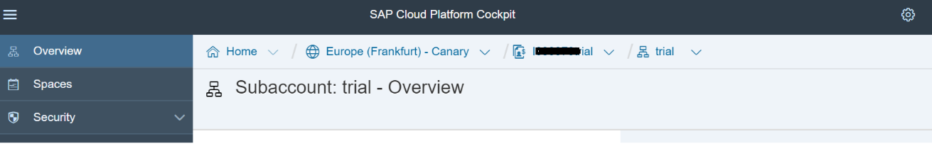

4.2 Select the spaces option to list down spaces of your sub-account. Usually “dev” is used in trial account and blockchain is active under it, so select it.

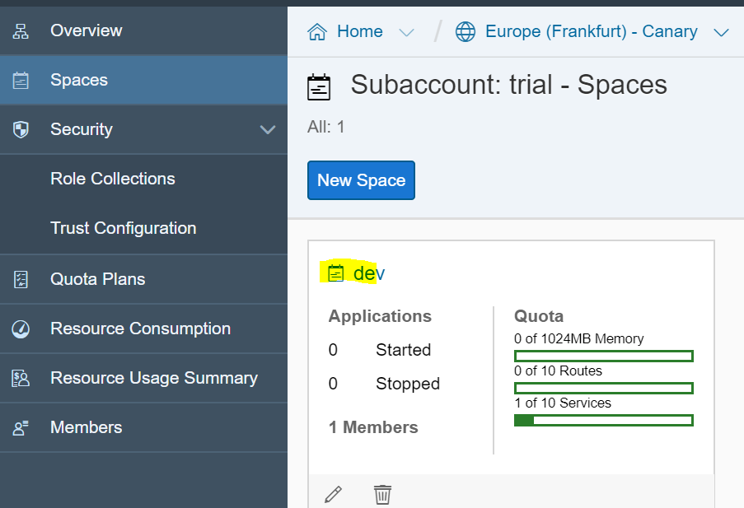

4.3 Select the service-market place option to list available services

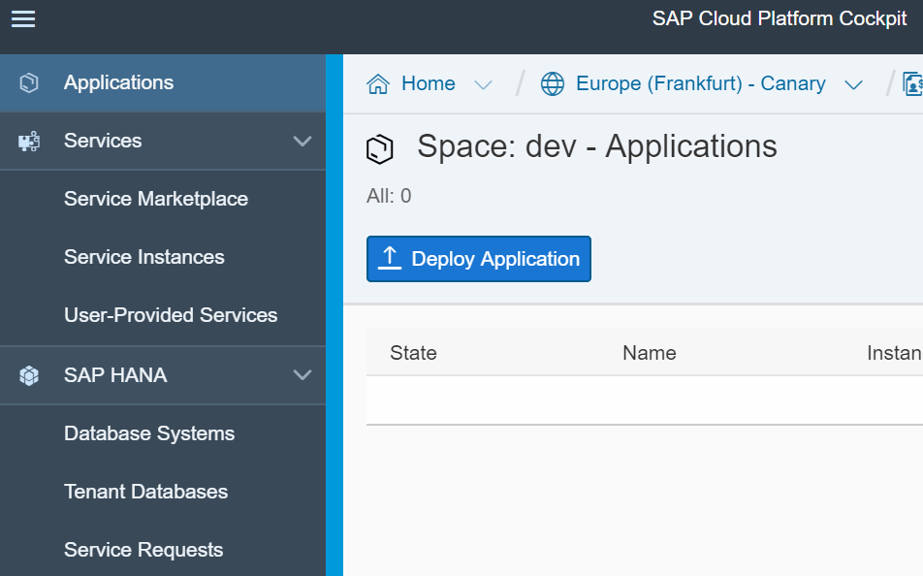

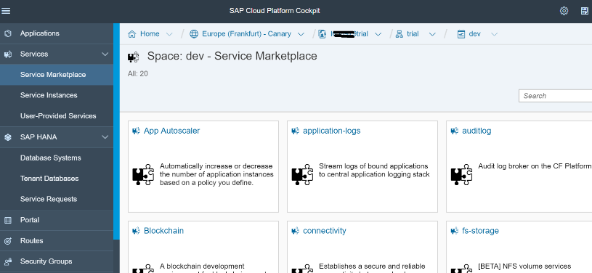

4.4 Select the Blochian service and then the instance

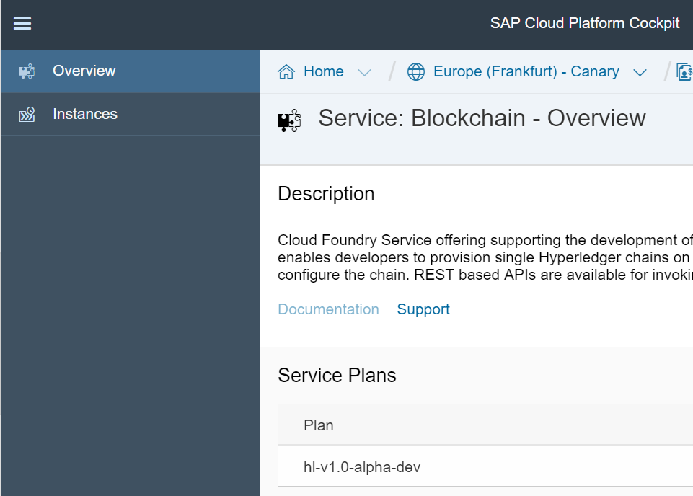

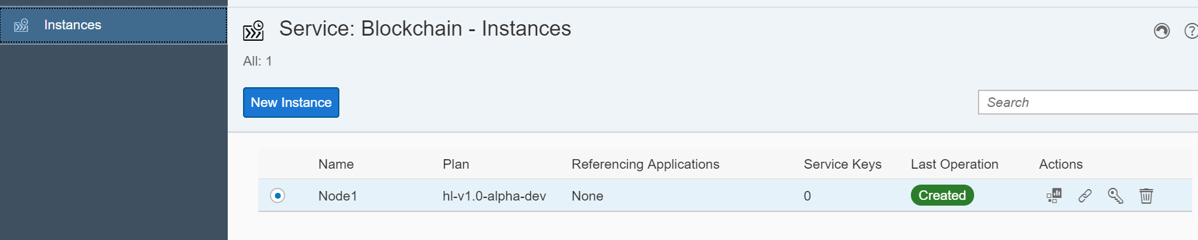

4.5 Select Action “Open Dashboard” of the node to open the Blockchain dashboard.

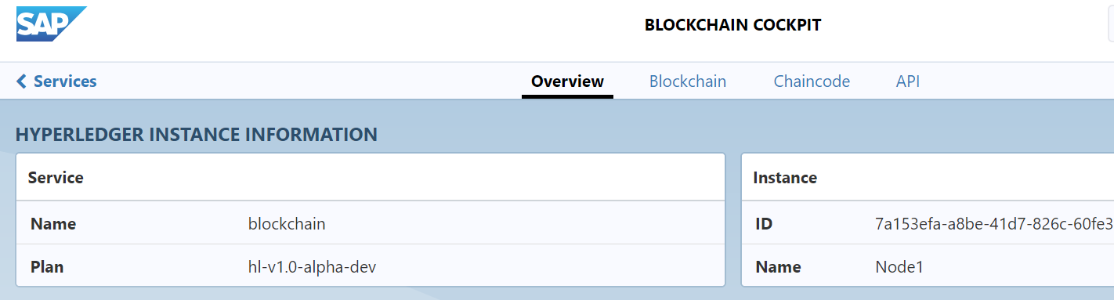

4.6 Select the chaincode tab

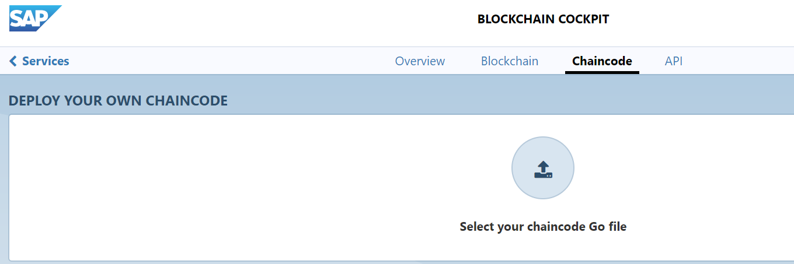

4.7 Upload the chain code file “HelloWorld.go” and then deploy it.

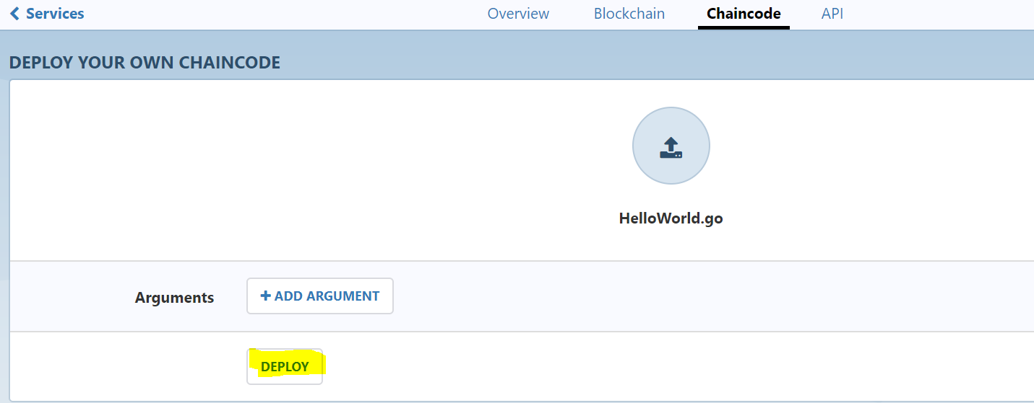

4.8 Once the chaincode is deployed successfully, its API can be executed. Do note the chain code id, it is very important as it is used to call the chain code API.

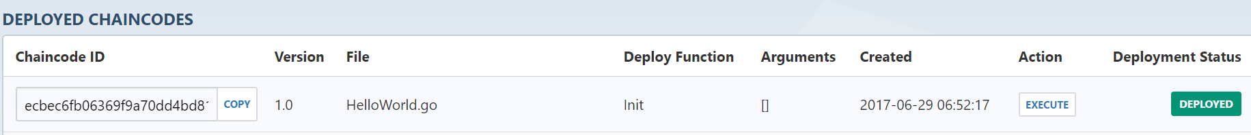

Step 5 Execute and Test chaincode APIs

5.1 Click on API tab and select expand operations

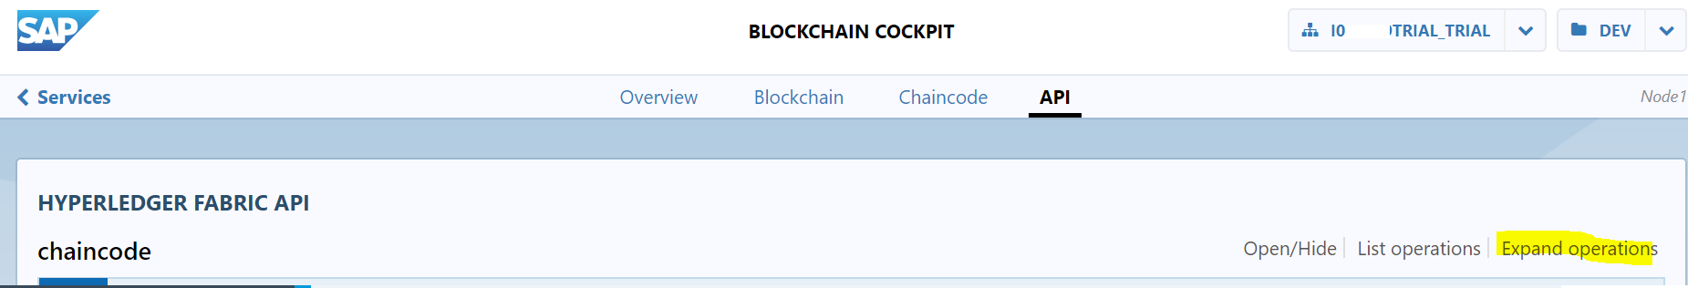

5.2 Go to operation Query, this can be used to test the APIs of chain code. Enter the arguments of chaincode call as below.

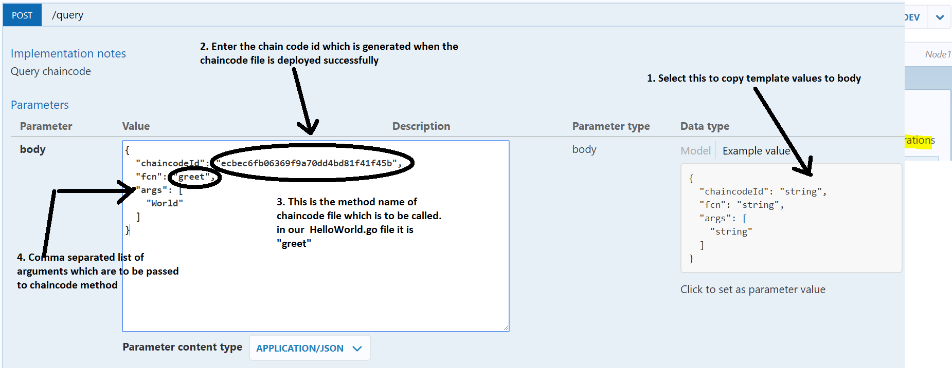

In other words this calls is similar to ObjectRef.Method( ArgumentArray[]) call as ecbec6fb06369f9a70dd4bd81f41f45b.greet(“World”) where ecbec6fb06369f9a70dd4bd81f41f45b is instance reference of chain code object.

5.3 Now press “Try it OUT!” button to execute the transaction on blockchain.

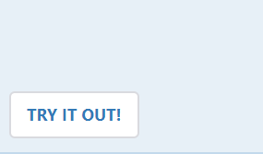

5.4 If the call is successful response code will be “200” result will be displayed in Response body.

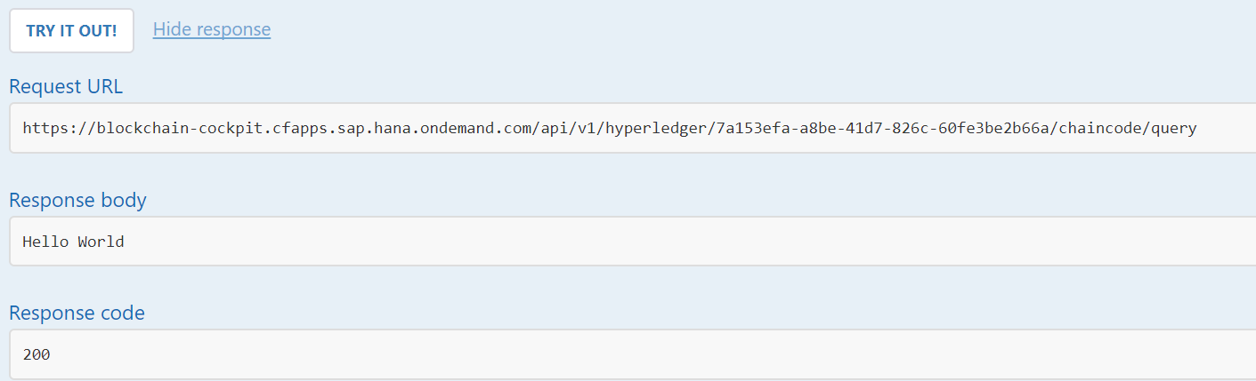

You can re-run this call with different the arguments.

**Input**

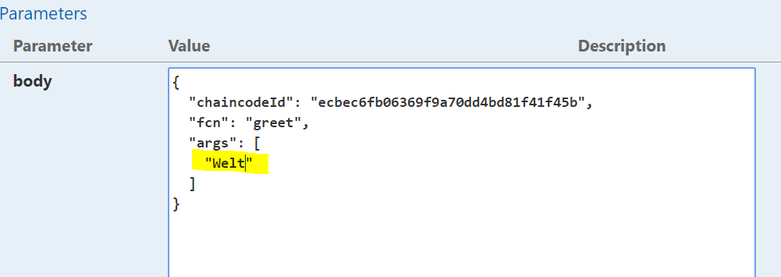

**Output**

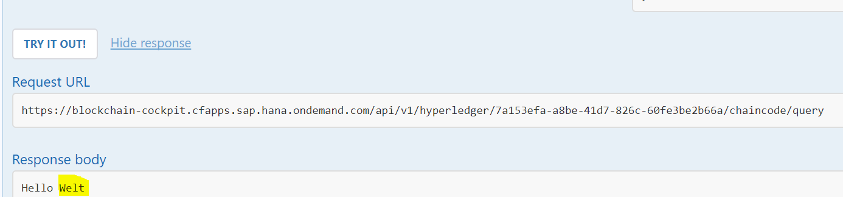

Step 6 Test with external client ( Postman )

In next post

**Source Code**

**Chaincode source**

https://github.wdf.sap.corp/gist/I030979/f2f77d2a585af0779269cf2b8808960c/