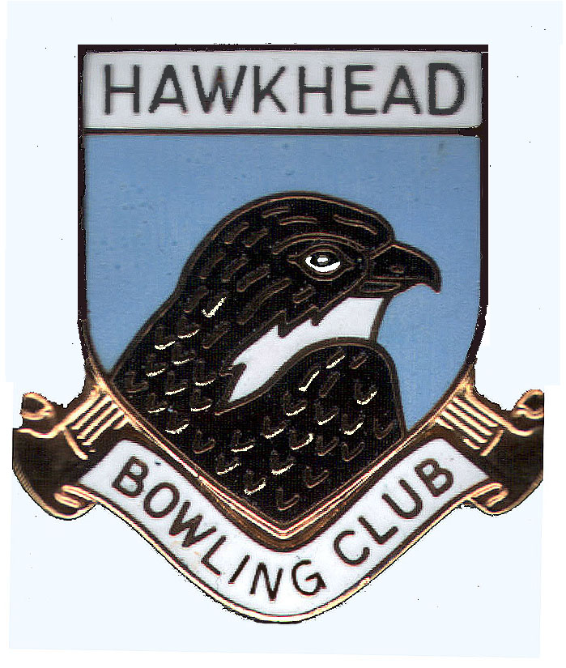

HAWKHEAD BOWLING CLUB

APPLICATION FOR MEMBERSHIP

CATEGORY

* FULL PLAYING LADY □ ASSOCIATE LADY □ JUNIOR □
FULL PLAYING GENT □ ASSOCIATE GENT □

* TICK AS APPROPRIATE

NAME OF APPLICANT…………………………………………………………

I hereby make application for membership as indicated above and agree to abide by the Constitution and
rules of the club and the following conditions of membership.

- I have never been refused membership or expelled from any bowling club affiliated to Bowls Scotland
- On being accepted for playing membership I cannot become a playing member of any other affiliated
bowling club without firstly resigning my membership of Hawkhead Bowling Club.

SIGNATURE ……………………………….. DATE ……………………………….

ADDRESS …………………………………

………………………………… EMAIL ……………………………….

POSTCODE ………………………….. ……. TEL NO ……………………………. .

DOB…………………………………… (Optional)

Admittance approved / rejected * by Management Committee (Delete as appropriate)

DATE………………………..

CHAIRPERSON SIGNATURE…………………………………………..

□ Please tick the box to confirm you are happy to allow your personal contact details to be added to The Club's internal telephone
directory, for use by members only to allow them to contact you to arrange bowling ties, competitions and social events.

