CA357 - INTRA Redesign - Evaluation Report

# A Quick Run-Through of some of the differences in the Redesign

Below is a quick walkthrough of some of the major changes in the new system. This isn’t the main feature of the report so we’ll try to keep it brief.

## Log in Screen

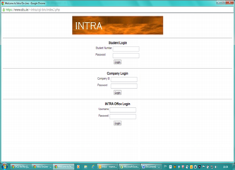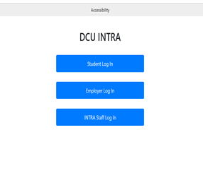

Above are two images comparing the old INTRA login screen with the new one

The new system provides separate login pages for Students, Employers and the Intra staff. This prevents too much information being displayed at once.

## Vacancy List

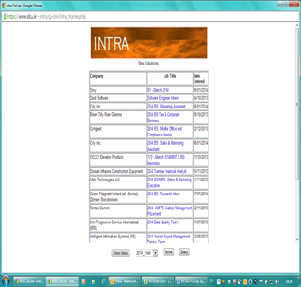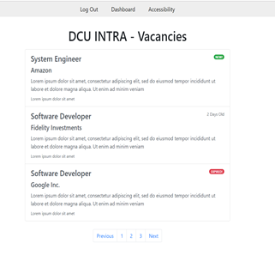

Above are two images comparing the old INTRA vacancy list screen with the new one

The new vacancy section shows only three vacancies at a time and uses pagination to allow the user to click through job posts. This allows enough information to be displayed to the user at a glance but doesn’t allow the user to become overwhelmed. The vacancies are also now sorted by the date they were added to the system.

## Staff Diary

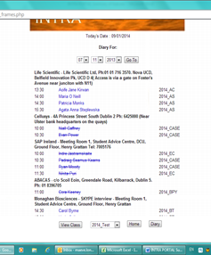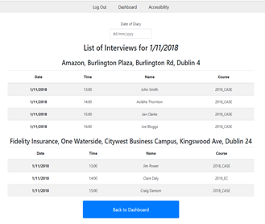

Above are two images comparing the old INTRA staff diary screen with the new one

The new Staff Diary section allows INTRA staff members easily view the interviews planned for a given day. They are displayed in table with rows of alternating colour as this has been proven to help those with ADHD focus on information.

## Candidate Employment Screen

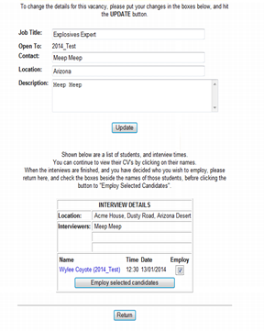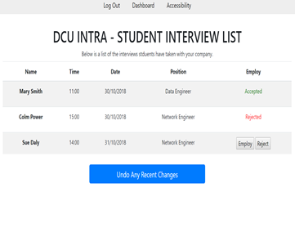

Above are two images comparing the old INTRA candidate employment screen with the new one

The candidate employment page is now a lot cleaner. It uses a similar table to the staff diary page and also has a large undo button, for undoing any misclicks.

## Navigation Bar

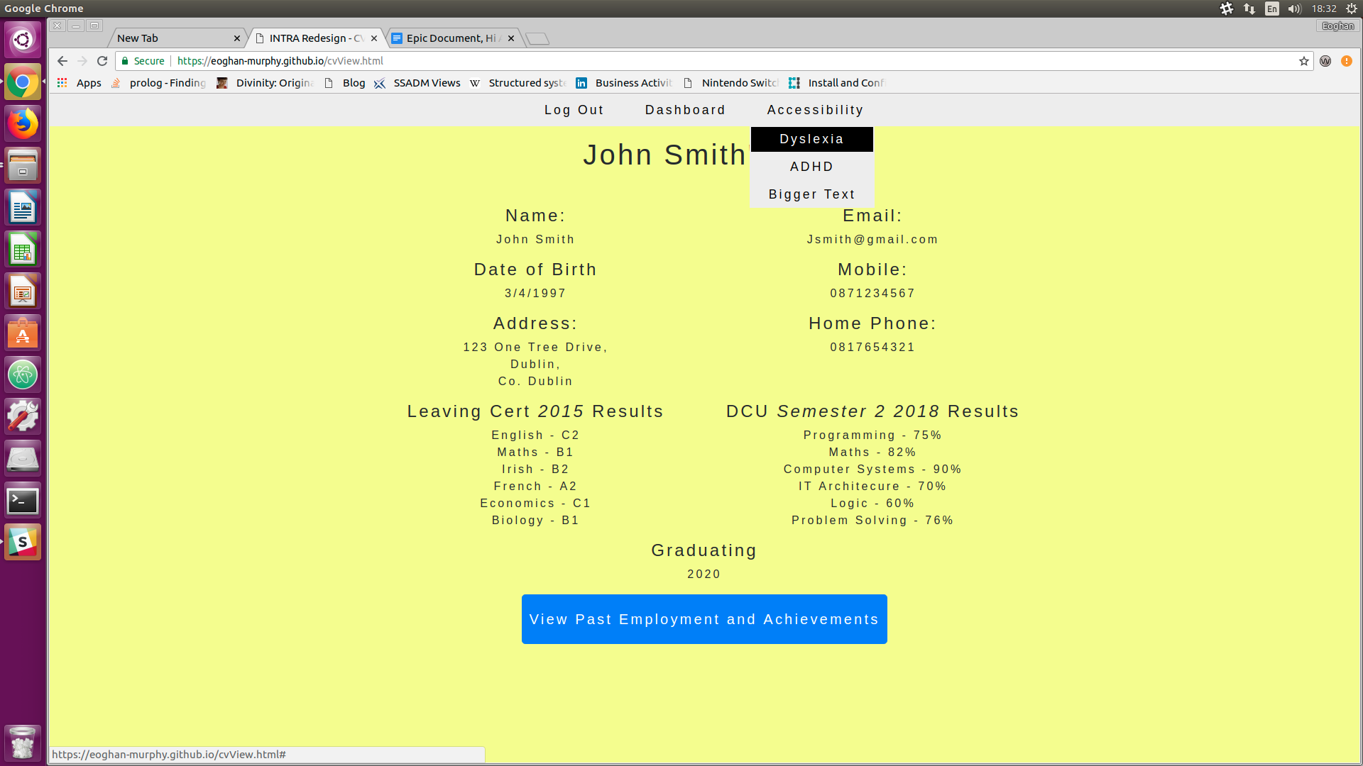

Above is an image displaying the new navigation bar.

The original system was missing a navigation bar. We have added a keyboard and screen reader friendly navigation bar to our system, more detail about this is included later in this report.

# 

# Implementing Requirements

When designing the new INTRA system it was very important to keep all the requirements we gathered earlier in mind.

## Accessibility Requirements

We realised in the requirements gathering stage that we would have to accommodate people of all abilities. We hope to have achieved this in a number of ways.

**Keyboard Accessibility:** While coding our user interface we ensured the site would be able to be easily navigated using only the keyboard. Users can work their way through the website using the TAB and arrow keys. This makes the app accessible for those using screen readers and those with impaired motor functions. It was important to make the navigation bar work well with the keyboard and this was done using code from [www.w3.org](http://www.w3.org) .

**ARIA Tags:** It was very important to us to accommodate blind users or those with impaired vision. We did this through the extensive use of ARIA tags. For example, in the “Add Job” we had an undo button, when pressed this would make a message appear on the screen saying “Changes have been undone”, we used an ARIA live region to capture this change for screen readers.

**Different Stylesheets:** During our requirements gathering phase we researched many different cognitive disabilities and how to better design around them. Unfortunately some of these were conflicting (e.g. Those with dyslexia tend to dislike high contrast but it helps those with impaired vision.). We decided to provide a set of options in a dropdown in the navbar that allow the user to change the stylesheet of the page depending on their disability. For example, when a dyslexic user presses the “Dyslexia” dropdown the site background goes yellow and the text spacing increases. We have researched that this can help dyslexic people read large blocks of text. Currently the different styles accommodate those with ADHD, dyslexia and impaired vision.



Above is an image displaying an option being picked from the navigation bar accessibility dropdown

**Bigger Buttons and Consistency:** We also realised that many users have impaired motor functions. To help accommodate this we ensured all content stayed near the centre of the screen so they wouldn't have to move their mouse too far. Buttons were made bigger and undo options were added in the case of misclicks.

A screenshot of the CV page, showing the size of the buttons


Above is an image showing large buttons on the new site.

## 

## Other Requirements

Here are some further accommodations we made for users based on requirements gathered in the first stage of this assignment:

* **Font change:** We used a clearer sans serif font “Helvetica Neue” as many users mentioned the previous font was too hard to read. We also made it slightly bigger.
* **CV System:** Many users mentioned that the CV creation section of the old webpage had too much information presented all in one page. We broke this section down into a number of more manageable sub pages (e.g a page to just enter your address). Users are also free to revisit these pages and make changes.
* **Mobile Accessibility:** This was a big issue with the old system. Users mentioned the old website didn’t look very good on their phones. We used a component library called Bootstrap. It’s grid system made it very easy to design for all sizes of screen. There are however issues with certain iOS devices but we will go into more detail about this later.
* **Undo Button:** Originally planned as an accessibility feature, the ability to undo most changes was added due to popular demand by users.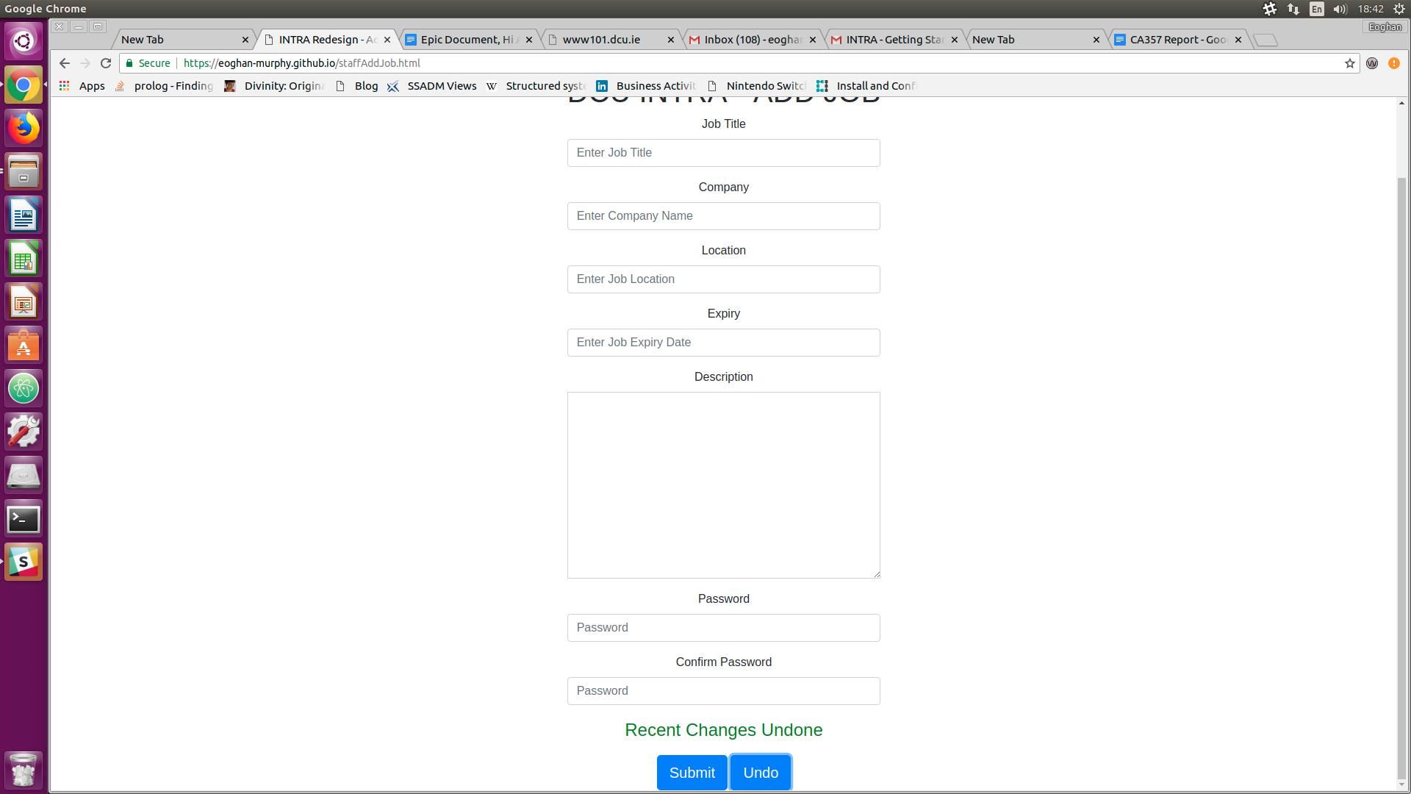

Above is an image showing an undo button, recently clicked.

# 

# Testing & Evaluation

Throughout the course of the project, we tested our system in a variety of ways.

Due to the nature of our project we didn’t have the time to have a design-evaluate-redesign workflow. As such we took a summative approach to evaluating the system. We assessed the usability and effectiveness of our system **after** it had been developed through the use of analytical methods such as Heuristic evaluations and Cognitive Walkthroughs.

We had to take a somewhat predictive approach most of the time and act as though we were the user each time we tested the website.

## User Evaluation

We knew the best way to evaluate the website was to send it out to potential users and hear their opinion on it. We edited our previous survey that we used to gather requirements and used it to gather people’s opinions on our new redesign (many of the questions were still suitable). We sent it out to the people who responded previously and got ten responses.

The survey was divided into different three different sections. One for students, one for employers and one for INTRA staff, so we could ask more targeted questions.

We would have carried out an observation where we got users to use the site while we could watch, but due to time restrictions this was infeasible.

Below we will detail some of the most important questions from the survey along with any conclusions that can be drawn from them.

### 

### Important Questions

**Which of these options best describes you? (student, INTRA Staff or Employer):** This question is important because we need to know how much each demographic is skewing our survey results. Are we getting a view from every possible users perspective? From our results we can see the survey was answered by 80% students, 10% INTRA staff and 10% Employers.

Here is a pie chart showing these results:

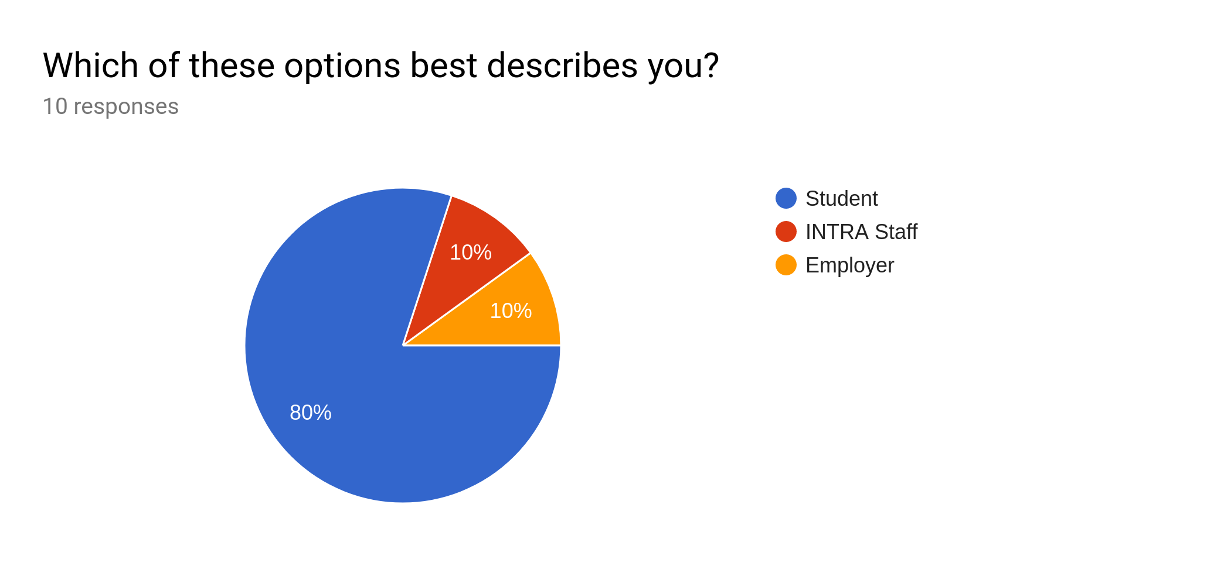

**Conclusion:** This could be a problem as we are hearing mainly responses from students. Our results may not be fully representative of the user base as a whole. Due to time restrictions this is expected.

**Which age range do you fall into?:** This question was important as it helps us see how well different age groups can use the website. If we have made it accessible, age shouldn’t matter when using it. There is a bit of a skew in the results here towards younger people. 20% of those surveyed were over 40.

**Conclusion:** From this question we can divide other question responses and gain insights on how different age groups interact with our system. For example, none of the users aged over 40 used mobile to view the website and they also rated the website 7.5 out of 10 on average, which is a big improvement on what we found in the requirements gathering stage (Over 40s rated the old system 4.5 out of 10 on average).

**Which of the following best describes your field of study:** This question was important as it allows us to spot and avoid certain biases. For example, computing students tend to answer the “How comfortable are you with tech” questions more confidently and are not going to say they have any difficulties.

**Conclusions:** In general students rated the system on average, 8 out of 10. However those outside of a computing course rated it slightly lower at 7 out of 10. Perhaps we need to go back and make it even more approachable.

**How would you rate our new INTRA Portal Design:** This is perhaps the most important question for judging the users reception of the new system at a glance. It takes into account all demographics and shows how they rated the new system out of ten. Below is a bar chart showing the results.

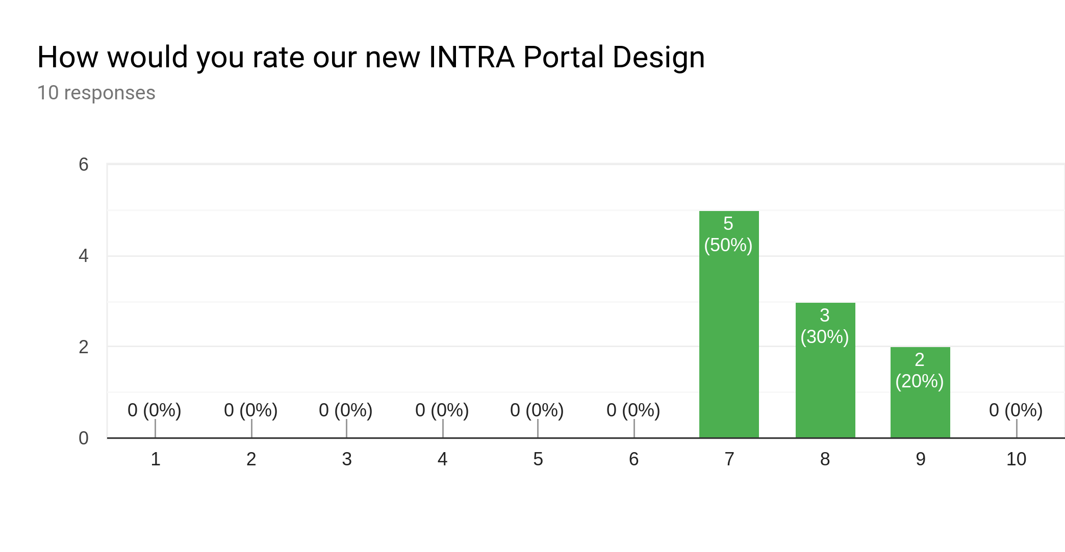

**Conclusion:** From this graph we can see users rated the system, on average, 7.7 out of 10. This is much better than the old systems rating of 4.3 out of 10. Our result still has a positive skew but with all results sitting above 6. Perhaps since we surveyed mostly the same users as before they have an increased level of commitment to the project and want to see it succeed. Nonetheless this is a better result than before.

**What platform did you view the redesign on?:** This question is very important as it allows us to see how the platform a user chose affected their experience. 40% of users picked mobile while 60% used PC. Here is a pie chart with that information:

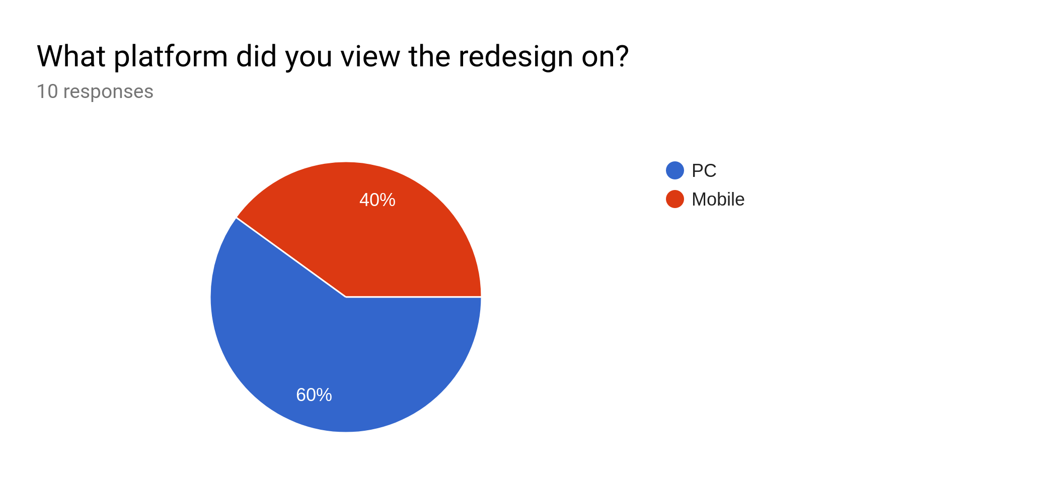

**Conclusion:** From this question we can extract how mobile friendly the website is. On average mobile users rated the website 8 out of 10. This is a huge improvement over the old system’s mobile rating of 2 out of 10. This was expected as our use of Bootstrap helped with keeping everything mobile accessible. We were also able to see any problems users had on iOS as we had no access to an iOS device when testing the website, this will be detailed later.

**Did you struggle with any aspects of the redesign, if so what were they?:** This question allowed us to see any problems with the system that users spotted and we overlooked.

**Conclusion:** From our list of responses we found these new problems:

* Tables don’t display properly on iOS devices.
* Buttons were a bit close together on iOS devices.
* Hard to know which accessibility mode is selected.

Most of these problems will be addressed in the later section “What we plan to fix”.

**Accessibility Questions:** We also asked a few question on whether users had any disabilities. About a third of users did. The most frequent disability was Dyslexia. We also asked if users noticed any changes in the accessibility of the website and how easy it was to use based on their disability.

**Conclusion:** From the responses to our accessibility question we can conclude that most users with disabilities found it easier to use our new system. Users seemed happy with the new accessibility stylesheet menu and the larger buttons. The one user with impaired motor functions also commented on the website consistent layout.

There are few other questions in the survey but due to the number of responses not much of value can be drawn from them.

## Heuristic Evaluation

### Shneiderman's "Eight Golden Rules of Interface Design"

Below we will detail how our system conforms to each of Shneiderman's "Eight Golden Rules of Interface Design"

1. **Strive for consistency:** Consistency is very important in helping a user learn how to use your system for the first time. Most aspects of our system, the layout, the buttons (and what they do), the navigation bar and the color scheme are consistent. For example all of the information needed to use our system appears in the centre of the screen, this consistency was needed to stop those with impaired motor functions from having to move their mouse too far.
2. **Enable Frequent Users to Use Shortcuts:** Frequent users will get tired of pressing the same buttons again and again. This should be minimised by offering them shortcuts. It is easier to navigate our new system quickly as there is always a navigation bar at the top of the page. A logged in user can press the “dashboard” button at any time to return to their dashboard. You can also skip the navigation bar when using a screen reader by pressing the tab button, this is far better than having to tab through every option. Perhaps we should have provided a way to enable more keyboard shortcuts for INTRA staff as they will be performing advanced repetitive work.
3. **Offer informative feedback:** Users should have no doubt that an action they performed was successful. Our system conforms to this rule. An example of this is when you press any of the undo buttons a message appears saying “Recent changes have been undone”. The new CV creator section also has a progress bar at the bottom showing users how close they are to completing their CV.
4. **Design dialog to yield closure**: When users have a task ahead of them it should be broken up into more manageable steps. The old system’s CV creator required you to enter all of your details all at once. Our new system has this onerous task broken down into multiple steps. For example the one page of the site just requires you to enter your address details.
5. **Offer simple error handling:** The user should not be able to make major errors and if they do they should be able to recover from them. Our system does not take any input that could cause a major problem. This is more of an implementation problem and would be an issue if we were tasked with coding a back end. For now, simple unit tests should detect if user actions can break the system and these have been provided (see later section titled “Unit Tests”).
6. **Permit easy reversal of actions:** Users should be able to revert any changes they make, this alleviates any fear of exploration and makes the user far more open to using a new system. We have provided several undo buttons so if a user makes a mistake in a text field or misclicks submit they can easily undo their recent changes.
7. **Support internal locus of control**: Users should always feel like they are in control of the system. Our system doesn’t do anything unless the user initiates the action. For example in order for new jobs to be added a user has to add them, the system doesn’t generate these jobs, it just allows users to post them.
8. **Reduce short-term memory load:** Users shouldn’t be tasked with remembering too much information. The system should rely on the user’s recognition of information rather than making them recall it. Our system is broken up into many pages and the layout is kept consistent and simple. All information needed for each page is displayed on each page. Perhaps we shouldn’t of used pagination in the job listing page as users will need to remember which page the job post they’d like to access is on as all job posts are not on the same page.

**What we learned from our heuristic evaluation:** While designing the web site we had Shneiderman's rules in mind from the start. As such the heuristic evaluation hasn’t shown us many issues except for the ones highlighted already above.

## 

## Cognitive Walkthrough

When evaluating the system we created a number of cognitive walkthroughs. For the sake of brevity, we have only included one of these.

**Task/Scenario 1:**  A user wants to log into the site.

|  |  |  |  |  |
| --- | --- | --- | --- | --- |
| **Process** | **Will the user try and achieve the right outcome?** | **Will the user notice the correct action is available to them?** | **Will the user associate the correct action with the outcome they expect to achieve?** | **If the correct action is performed, will the user see progress being made toward their expected outcome?** |
| **1. Navigate to Site** | Yes, the user will know the site URL. |  |  |  |
| **2. Choose Correct Demographic** | Yes. The user is expected to know what demographic group they belong to (Student, Employer or Staff). | The user will be presented with three login options. The user will be able to click on their option. | Yes. | Yes, the login form is presented with the demographic title. |
| **3.Enter Username and Password.** | The user is expected to know his/her login credentials and is expected to use those credentials. | Yes, input forms will be presented with labels marking the username slot and password slot. | Clicking the submit button, the user will brought to their dashboard page. | Yes, the user will be presented with their dashboard page. |

## 

## Screen Reader

Initially we had no idea how a screen reader works. We downloaded “JAWS Screen Reader” and after getting used to it with a few different websites we tested our system by going through it using solely JAWS and with our monitor switched off. The bulk of the website worked well, everything was read out to us, but our navigation bar didn’t work. It would tell us it was a “Menu” and that we could “use arrow keys to navigate” but nothing would happen when we pressed them, we also had to tab through the whole nav bar every time we wanted to access the main content. This testing helped us find a few flaws in our navigation bar and helped us to ultimately design a better one using code from [www.w3.org](http://www.w3.org).

**What we learned from Screen Reader Testing:** We discovered that the previous navigation section was unskippable and couldn’t be navigated properly with only the keyboard.

## Unit Tests

Due to the nature of our application unit testing was not one of our main focuses. We instead took a more physical approach of actually using the website every time a new feature was added (e.g. going through the website with a screen reader to test the nav bar). Unit tests are still important and helped with testing the javascript on the website.

We used the Jasmine Javascript framework to implement our test cases. Since a lot of our javascript was imported from other sources (w3 and jQuery) we only needed to test two major functions, switching between accessibility modes and displaying an undo message. Two test suites were designed and these can be found in the files **accessibilitySpec.js** and **undoSpec.js**.

The first test suite, **accessibilitySpec.js,** tests the different accessibility modes. Our website chooses which accessibility mode to apply based on a list stored in the client’s “session storage”. The test cases in **accessibilitySpec.js** would activate different accessibility modes and check that list in session storage was updated accordingly.

Our second test suite, **undoSpec.js**, was used to test the undo button. It would check if pressing the undo button made the correct message display in a paragraph tag with the “**jobMessage**” id.

Our test cases were quite basic but we hope they illustrate what would roughly be needed if we had more time to test the system thoroughly.

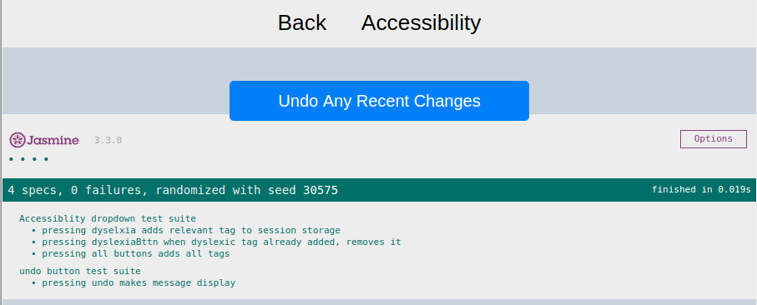

Above is an image displaying the jasmine test cases being run.

If you would like to see the test cases run, please use the **test.html** file. This page (for obvious reasons) is not linked anywhere on the site, but can be accessed at: <https://eoghan-murphy.github.io/test.html>

**What we learned from our unit tests:** We found an issue with how undo messages were displaying (outside of the intended paragraph element). No issues were found with the accessibility modes.

# 

# What we plan to fix

After our evaluation was complete we realised there were a few things that we needed to fix. Due to time constraints we weren’t able to fix everything.

Here’s a list of what we had planned:

* **Unnecessary Pages:** Our initial design had a few unnecessary pages that required extra clicks to navigate out of but didn't add any functionality. For example, when an INTRA staff member added a job they were brought to a “Job Successfully Added” page. We decided this was unnecessary and replaced it with a text pop up that simply says “New Job Added” and clears the submissions form.
* **iOS fixes:** Our survey brought a few problems regarding iOS devices to our attention. We need to fix how tables display on iOS devices and the layout of buttons on the users dashboard.
* **Difficult to know which accessibility option is selected:** Our system uses a drop down menu to change the stylesheet based on the disabilities of the user. A response in our survey informed us that its difficult to tell which options you have selected. We need to change the css so selected options appear differently.
* **Undo Buttons:** When we evaluated the website we realised the undo messages from clicking on the undo buttons were not displaying properly. This has since been fixed.

# 

# 

# Code Sources

Here is a list of external source we used code from:

* Navigation Bar: <https://www.w3.org/TR/wai-aria-practices/examples/menubar/menubar-1/menubar-1.html>
* Bootstrap: <https://getbootstrap.com/>
* JQuery: <https://jquery.com/>
* Jasmine: <https://jasmine.github.io/>
* Font: https://fontawesome.com/