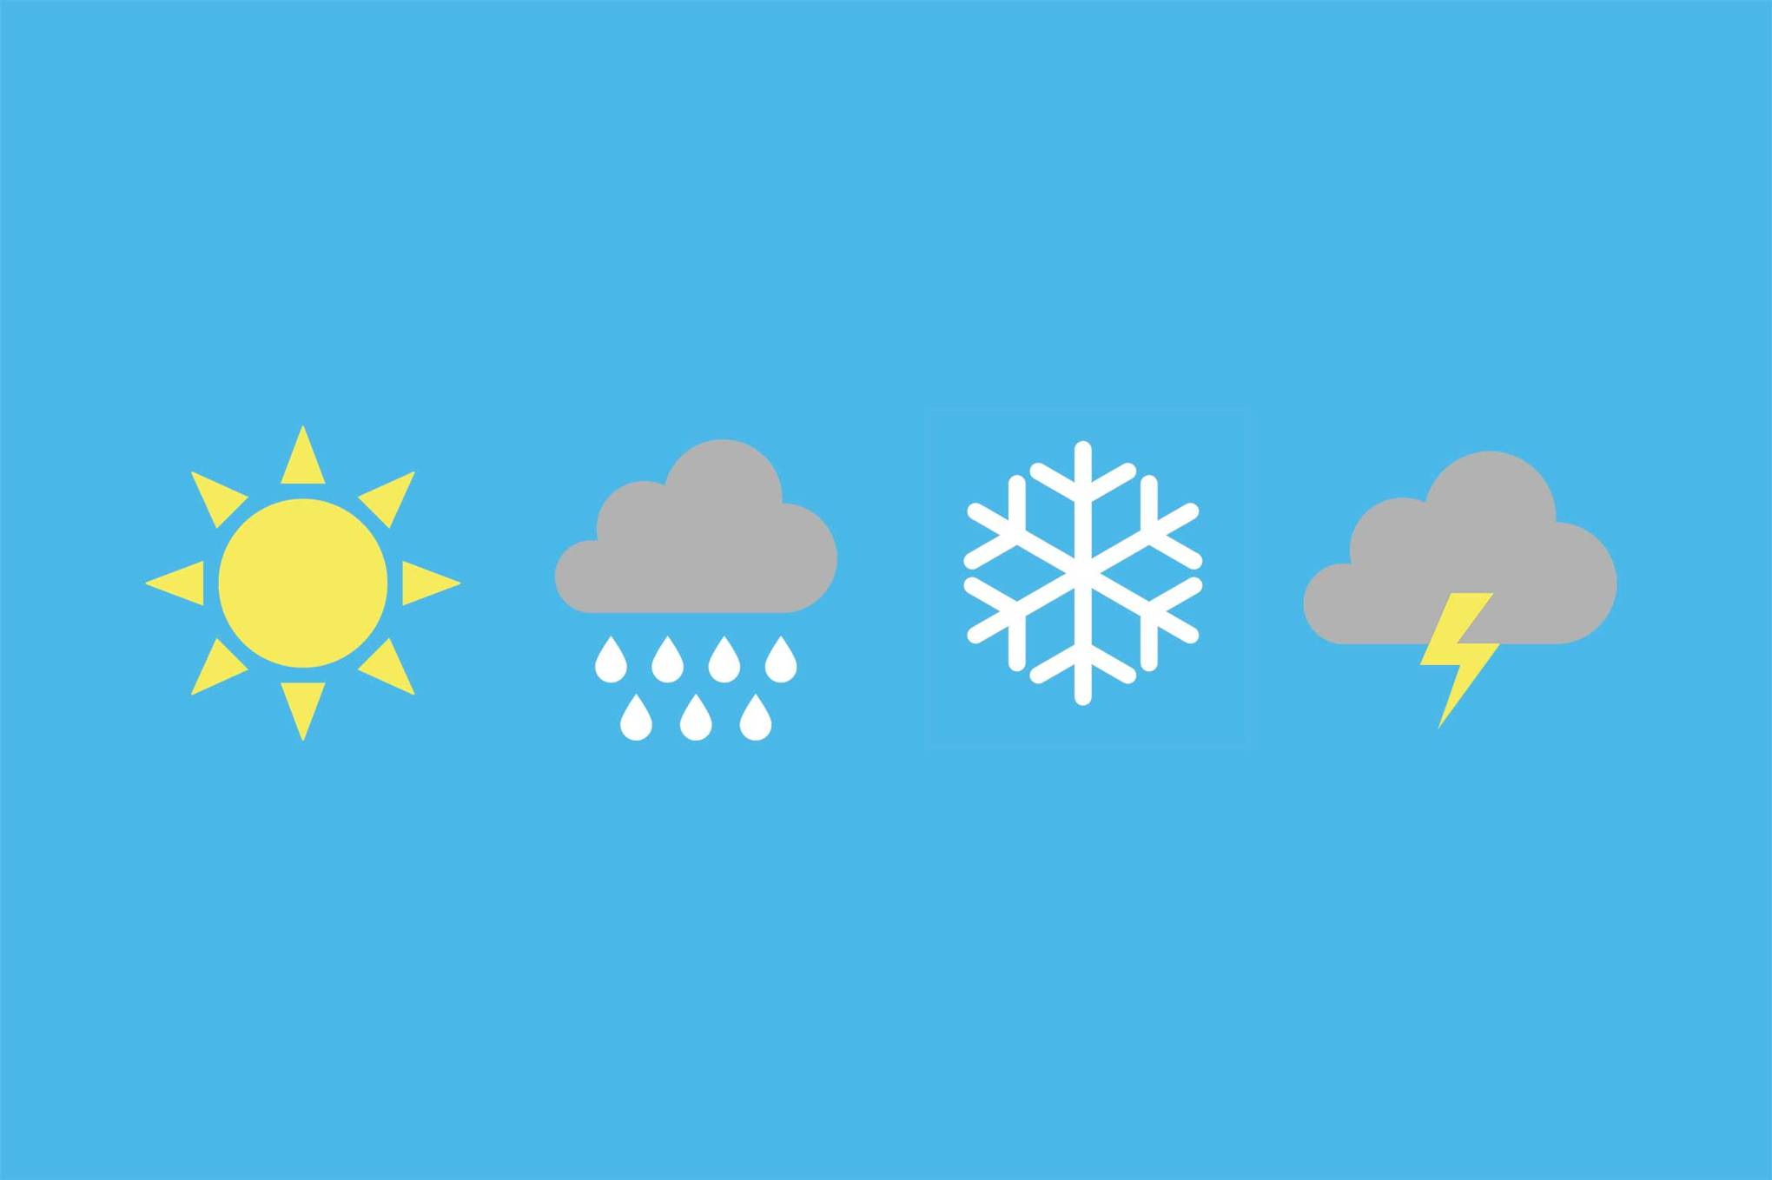

Weather App

A Weather app built in Xarmain

Eoghan O’Connor G00330972 | Software Development | September 2019

# Weather App

* I decided to make an Irish weather app to allow users to get real time information about their current location or the location in which they are heading.
* The App will have a very simple design allowing it to be used by people of varying abilities.
* It will save previous searches to allow users to make searches quicker.

## How does it get the weather infomanton?

The Weather App uses openweather api, it is a free to use weather api. It requires the user to sign up and generates unique api keys the allow the real time weather information.

## The Design

The design of my application will be very simple. I personally don’t believe in a complicated UI, it makes the application difficult to use and creates an overwhelmed feeling for user.

## Other weather apps

Using the IOS app store I looked through many different apps. The default IOS weather app is very good for providing a graphical representation of the weather, However this may the overwhelming for some users. Similarly with most other weather applications.