B.Sc Computer Games Development, Year 3, HTML5 and Android

Game Design Document

28th - October - 2014

**“Multiplayer Breakout”**

Author: Eoghan Gibbons

Project Supervisors: R.Palmer & D O’Broine

Table of contents

Overview

1.1 The Elevator Pitch / High Concept

1.2 Summary Overview

1.3 Target Audience

1.4 Platforms

1.5 Key Features

1.6 Theme, Setting and Genre

1.7 View

1.8 Influences

GamePlay

2.1 The First Minute (60 seconds of play)

2.2 Gameflow

2.3 Actions

2.4 Controls

Detailed Design

3.1 Gameplay & mechanics

3.2 HUD

3.3 Assets

**1.0 Overview**

**1.1 The Elevator Pitch/High Concept**

Simply put, the singleplayer mode of the game is a recreation of Atari’s classic Breakout, when played as a multiplayer game, the game becomes a mix of Breakout and Pong

**1.2 Summary Overview**

What I am aiming to achieve is a fun, smooth playing Breakout type game in singleplayer, that when played with a friend is more akin to pong, but with blocks randoming spawning throughout the playing field, these blocks will play a multitude of roles, from providing obstacles and shielding to the players, as well as rewarding the player who breaks them by dropping a powerup in their direction.

**1.3 Target Audience**

The game is aimed at all ages and players, with the average time taken to run out of lives being between 2 and 10 minutes, this will allow players to enjoy the game while going about their day, waiting for a bus, or just when sitting on the toilet,

**1.4 Platforms**

The game is developed with Android and IOS in mind, and also works all all web browsers.

**1.5 Key Features**

* Simple and clean graphics
* Responsive controls
* Multiplayer
* Levels of increasing difficulty

**1.6 Theme, Setting, and Genre**

The theme of the game is arcade-y and fun, set in an abstract 2d world, the genre of the game is that of a breakout clone in singleplayer, and then in Multiplayer becomes a cross-genre Breakout/Pong game.

**1.7 View**

The view of the game is a 2d view of a game that takes place in a 2d world.

**1.8 Influences**

Breakout

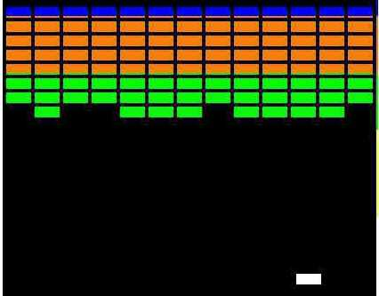

Pong

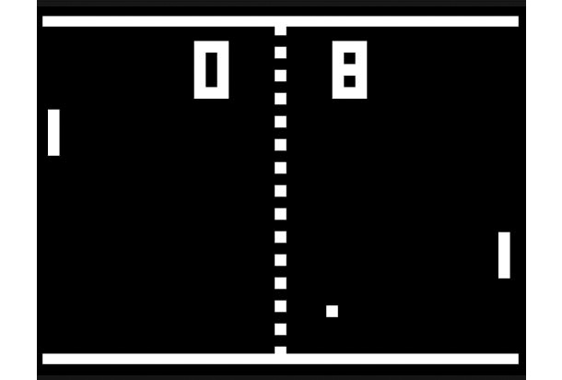

**2.0 Gameplay**

**2.1 The First Minute (60 seconds of play)**

The game starts and the player’s sprite appears in the middle of the screen



The ball falls directly downward from the middle of the screen, and from then will bounce in different directions based on where on the paddle the player hits the ball with

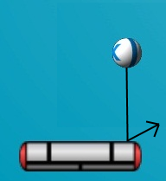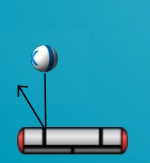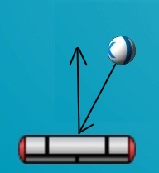

**2.2 Gameflow**

The game flows quickly and with a consistent speed, the yVelocity of the ball always remains the same, and the xVelocity changes based on where the ball is hit by the paddle

**2.3 Action**

The players move their paddles to the left and the right.

**2.4 Controls**

The controls for both games will be handled by touch events, the paddle will appear to follow the players fingers, allowing for a responsive and fun control scheme.

**3.0 Detailed Design**

**3.1 Gameplay & Mechanics**

The mechanics that are introduced throughout the game include a lives system, blocks that throughout levels increase in health, and blocks that drop powerups.

**3.2 HUD**

The in game HUD shows the player how many lives they have left, as well as their score.

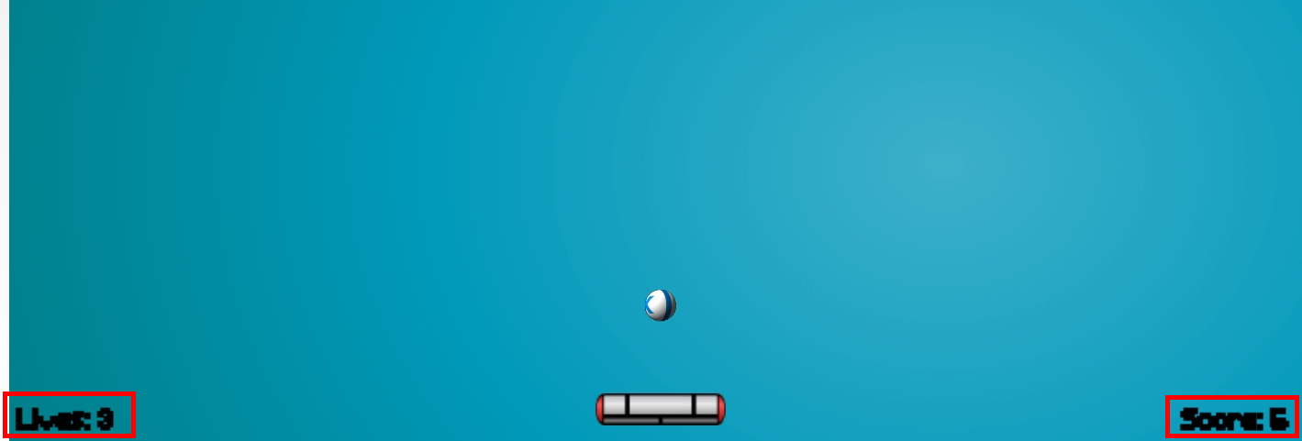

**3.3 Assets**

**Text Assets**

I used the font Minecraft, which I downloaded from dafont.com  
<http://www.dafont.com/minecraft.font>

**Art Assets**

All art assets have been custom made by myself.

**Sound Assets**

For the menu music I used the song Bit Rush, which I downloaded from youtube  
<https://www.youtube.com/watch?v=BO3XLE_eRPk>

And for the ball bouncing sound effect I used a free sound file called boing1.wav, which I downloaded from freesound.org  
<http://www.freesound.org/people/Greenhourglass/sounds/159376/>