Cheat Sheat

ARM

- Support of a itemset is the proportion of transactions in the database that contain all the items in S.

- Support of a rule is the proportion of transactions in which the items in L and R occur together.

- Confidence of a rule is the proportion of transactions for which the rule is satisfied.

- Support applies to the entire database

Apori
Create L₁ = set of supported itemsets of cardinality 1
Set k to 2
while(L_{k-1} != {})
{
Create C_{k} from L_{k-1}
Prune all the itemsets in C_{k} that are not supported, to create C_{k}
k = k +1
}

Apori-gen
C_{k} = empty;
//join step
for( A : L_{k-1})
{
for(B : L_{k-1})
{
if(A!=B)
{
if(A.sub(0,k-2) == B.sub(0,k-2) && !C_{k}.contains(union(A,B)))
C_{k} .add(union(A,B));
}
}
}
//prune step
for( c : C_{k})
{
for( sub : subset(c, k-1))
{
if( !L_{k-1.}includes(sub) )
{
C_{k.}remove(c);
break;
}
}
}
return C_{k};

Classification

TDIDT

If all instances in the training set belong to the same class.
THEN return the value of the class
ELSE
a) Select an attribute A to split on
b) Sort the instances in the training set into subsets, one for each value of A.
c) return a tree with one branch for each non-empty subset, each branch having a descendant sub-tree or a class value produced by applying the algorithm recursively.

Information gain is defined as the difference between the original information requirement and the new requirement. It tells us how much would be gained by branching on a attribute.
Biased toward tests with many outcomes, prefers to select attributes having a large number of values. What if you have a attribute that is a unique identifier, result in a large number of partitions

Steps:
First calculate the expected information needed to classify a tuple in D:

p_{i} is the probability of that a tuple D belongs to class C_{j}

for each attribute A:
{
Calculate the expected information required to classify a tuple from D based on the partitioning by A

Calculate the information gain for the attribute A:

}
Then choose the attribute with the highest information gain to split on.

Gain ratio attempts to over come the bias with information gain on attributes having a large number of values. It does this by applying a form of normalization to info gain using a split information value:

SplitInfo considers the number of tuples having the outcome with respect to the total number of tuples in D.

Gini index measures the impurity of a data partition or a set of training tuples. Gini index considers the binary split of each attribute. To determine the best binary split examine all subsets of A excluding the power and empty sets.

Steps for selection using Gini index:

First calculate the impurity of D:

For each attribute A
{
for all possible binary splits of A, A partions D into D₁ and D₂
{
Calculate the gini index of that split:

}
Choose the binary split with the lowest gini index.
Calculate the change in impurity for the lowest gini index:
(The symbol for “change in” is delta(triangle))

}
Select the attribute that maximizes the reduction in impurity and split on.

Clustering

k-means

Step 1: Select a value for K
- This step is to determine how many clusters we want to form.

Step 2:Select K points to act as out initial centroids
- we select K points so that we can begin to assign our points to their cluster.

Step 3:Assign each of the points to the cluster of its nearest centroids
- The goal of this step is to create our k clusters

Step 4:recalculate the centroids
- as our centroids are no longer the true centroid value we need to recalculate the centroids

Step 5:repeat steps 3 and 4 until the centroids no longer move

The process terminates when we find the values of the centroids from step 3 have not moved once we recalculated them in step 4 i.e. Their value was the same, no points moved cluster.

AHC

Step 1: Assign each object to its ow single-object cluster Calculate the distance between each pair of clusters.

Step 2: Choose the closest pair of clusters and merge them into a single cluster

Step 3: Calculate the distance between the new cluster and each of the old clusters

Step 4: Repeat steps 2 and 3 until all the objects are in a single cluster.

Single-link Clustering: The distance between two clusters is taken as the shortest distance from any member of one to any member of the other.

Complete-link clustering: The distance is taken as the longest

Average-link clustering : The distance is taken as the average distance.

Multi-dimensional modelling

Fact table
- Located in the center of star and snowflake schemas.
- When multiple are used they are arranges in a fact constellation.
- Typically two types of columns, dimension foreign keys and facts/measures.

Dimensions table
- Stores attributes to describe objects in fact table.
- Categorise and describe data warehouse facts and measures in a way to support meaningful answers to business questions.
- Relates to fact table on Primary → Foreign Key relationship

Star Schema
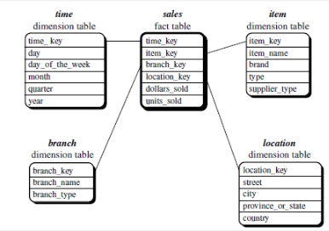
Snowflake schema
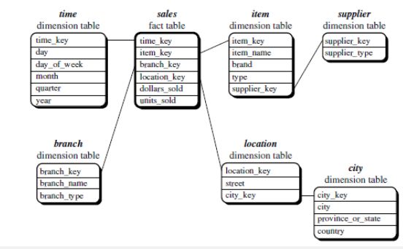
- Variant of Star where some dimension tables are normalized further spliting the data into additional tables.

Fact Constellation Schema
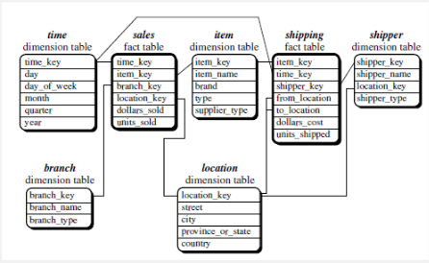
- Multiple fact tables.

Concept Hierarchy
- Defines a sequence of mappings from a set of low-level concepts to higher-level, more general concepts.

OLAP Operations

- Roll up: Summarize data by climbing up hierarchy or by dimension reduction.
- Drill Down: Reverse of roll up from higher-level sumarry to lower level or detailed data, or introducin new dimensions.
- Slice and dice : Project and select
- Pivot: Reorient the cube, visulization, SD to series of 2D planes
- Drill across: involving(across) more then one fact table.
- Drill Through: Through the bottom level of the cube to its back-end relational tables(using SQL)

