2015 repeat Data Mining

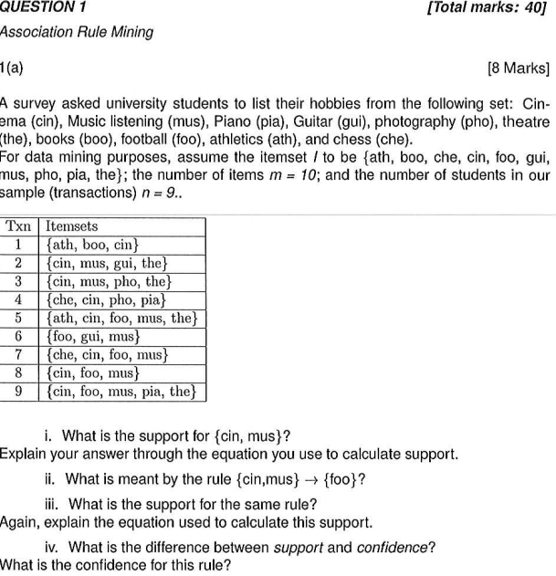
a)
I)
support for an itemset is the proportion of transactions that contain all the items in S defined as:

Where Count(S) = number of transactions matching S

ii)
the rule {cin,mus} → {foo} means that when cin and mus are chosen we can predict foo will also be chosen.

Iii)
Support for a rule L → R is the proportion of transactions in which the items in both L and R occur together defined as:

iv)
Support applies to all transactions in the database, whereas confidence is the proportion of transactions for which the rule is satisfied and is defined as:

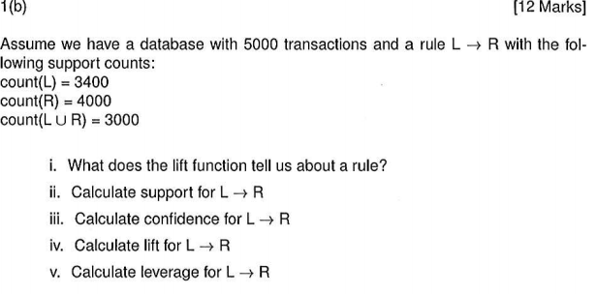
b)
I)
The lift function tells us how interesting a rule may be:

ii)

iii)

iv)

v)

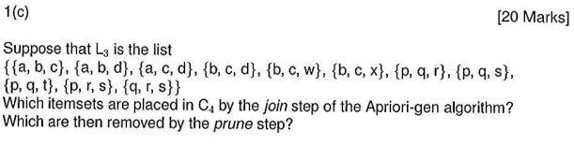
c)
Join Step
k = 4, k-2 = 2
First itemset | Second itemset | Contribution to C
{a,b,c} | {a,b,d} | {a,b,c,d}
{b,c,d} | {b,c,w} | {b,c,d,w}
{b,c,d} | {b,c,x} | {b,c,d,x}
{p,q,r} | {p,q,s} | {p,q,r,s}
{p,q,r} | {p,q,t} | {p,q,r,t}

C₄ = {{a,b,c,d},{b,c,d,w},{b,c,d,x},{p,q,r,s},{p,q,r,t}}

Prune Step
ItemsSet in C₄ | subsets | Subsets all in L3
{a,b,c,d} | {a,b,c},{a,c,d},{a,b,d}{b,c,d} | YES
{b,c,d,w} | {b,c,d},{b,d,w},{b,d,w},{c,d,w} | NO
{b,c,d,x} | {b,c,d},{b,c,x},{b,d,x},{c,d,x} | NO
{p,q,r,s} | {p,q,r},{p,r,s},{p,q,s},{q,r,s} | YES
{p,q,r,t} | {p,q,r},{p,r,t} | NO

C₄ = {{a,b,c,d},{p,q,r,s}}

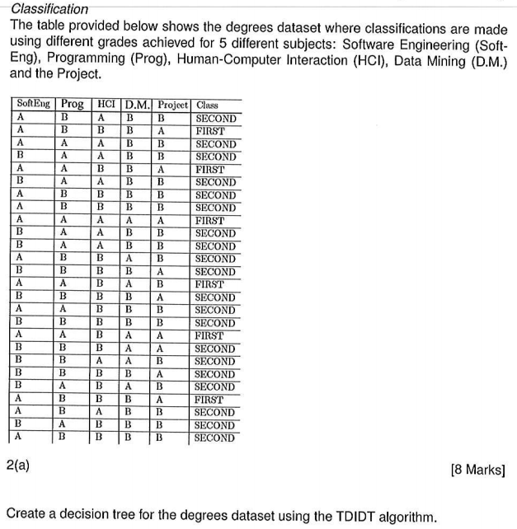
Same as 2014 Q4 a

