Search-tech 2015
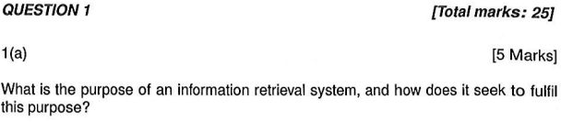

a)

The purpose of an IR system is to satisfy a users information need. It does this by seeking to locate relevant content that is deemed by the user to completely or partially fulfil their information need.

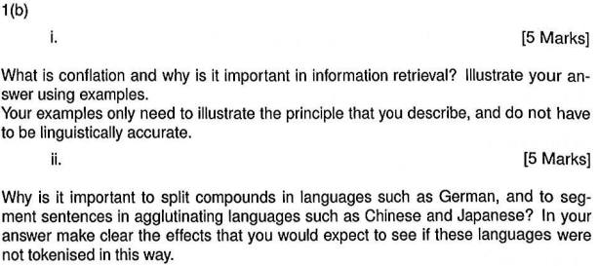
B)
I)

Conflation is the process of bringing together word that are related to each other in some way. There are two main classes of conflation algorithms:
- Stemming
- String similarity measures

Examples of the need for conflation:
- incorrect spelling : LINEAR and LYNEAR
- Alternitive spelling: SULPHER and SULFUR
- Multi-word concepts: DATABASE and DATA BASE
- Affixes: SINGLE and SINGULAR

An example of String similarity measures is fuzzy string matching also known as approximate string matching(levinstien distance, n-grams, suffix-tree).

Stemming is the process of removing suffixes by matching the ending of a word against a suffix dictionary and removing any suffix.
Example:
ALARMINGLY → (1)ALRAMING → (2)ALARM

(1): remove -LY suffix
(2): remove -ING suffix

ii)

Splitting compounds or decompounding in productive languages such as German is important words are joined toghter to create new meanings these compounds can be rare or unique in documents and requests are unlikely to match. Usefull search terms must be extracted by decompounding the word (splitting).

Its is important to segment sentances in agglutinating languages as these do not have spaces in between words and as such would need to segment them to generate search terms.

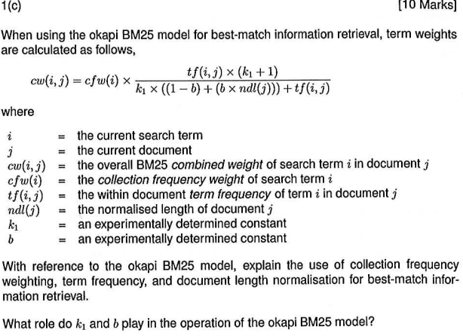
c)

Collection frequency, term frequency and document length normalization are sources of applying weighting to terms.

Collection frequency:
concept: terms that occur in only a few documents are often more valuable than ones which occur in many. As known as inverse document frequency(IDF)

n(i) = number of documents t(i) occurs in
N = number of documents in archive

Term frequency:
Concept: the more often a term occurs in a document, the more likely it is to be important.
tf(i,j) = the number of occurrences of t(i) in document d(j)

Document length:
concept: Document relevance is independent of document length.

dl(i) = total number of term occurrences in document d(j)

k₁ and b are experimentally determined constants that control the effect of tf(i,j) and the degree of length normalisation respectively.

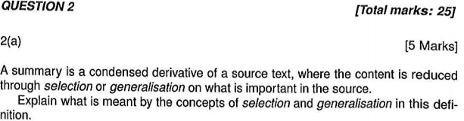
a)

Selection: forming a summary focused on a subset of the topical content of the source document in detail

Generalization: forming a summary which overviews the entire topical contents of the source document.

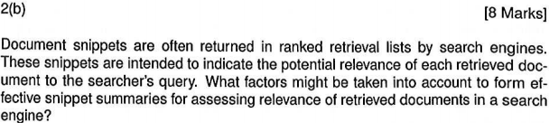
b)

Factors to take into account to form effective snippet summaries are:
- The form of the source text
- The purpose of the summary
  - What is the function of the summary
  - is the summary for a narrow targeted or more general audience
  - what level of subject knowledge should be assumed.

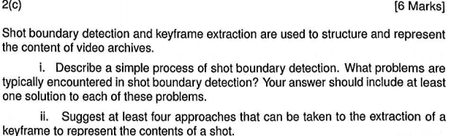
c)
I)

A shot boundary is crossed what a new camera is used or a recording instance ends and a new one begins(shot cuts).
A simple process of shot boundary detection is by examining every frame and looking for shot cuts which can be based on a change in colour, texture or intensity/ brightness of the adjacent frame.
Problems typically encountered are:
- Dropped shot boundaries:
  - fade-in and fade-out
  - dissolving
  - morphing
  - wipes
  - etc
- False shot boundaries:
  - zooming and panning
  - tilting
  - booming and tracking
  - events in the content – camera flashes

ii)
Four methods of selecting key frames from a shot can be:
- take the First or last frame
- Choosing the middle frame
- Choosing the frame with the most average colour histogram from the shot
- A virtual centroid – a frame that does not actually exists, but contains the average of all colour data in the shot.

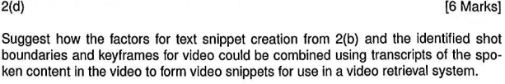
d)

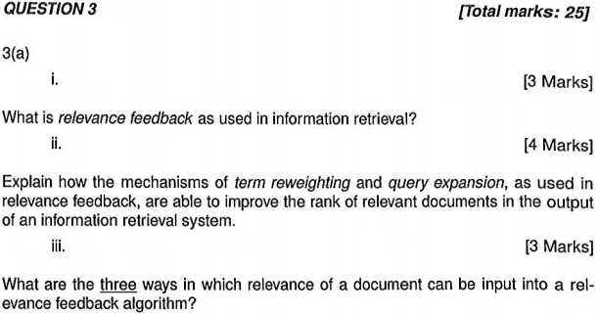
a)
I)
Relevence feedback uses relevence information from the initial retriaval run for the current query to:
- Add signnificant terms from relevant documents to the current query.
- Modify the weights of terms to improve the ranks of documents which are likely to be relevant.

ii)
In the vector space model Query expansion can be seen as adjusting term weights in the query vector. Emphasising or reducing the importance of a query term corresponds to increasing or decreasing its weight

In the probabilistic model term weighting and query expansion are taken separately:

Computing relevance weights seeks to answer the question: “how much evidence does the presence of this term provide for the relevance of this document.”

Selecting new terms to add to a query should answer a different question: “how much will adding this term to the request benefit the overall performance of the search formulation”

iii)

Three was in which which relevance of a document can be input into relevance feedback algorithms are:
- Explicit feedback: the user can mark documents from the current run relevant.
- Implicit feedback: the system can assume that returned documents clicked on by the user are relevant.
- Blind or pesudo feedback: The system can simply assume the top ranked documents are all relevant. e.g. the top 5 or 10 returned.

