CA4012: Statistical Machine Translation

Assignment 3: EM Algorithm for Word-based Translation model

Eoin Murphy 11487358

Step 1 (Initialisation)
Input Words: {The, blue, book }
output Words: {leabhar, An, gorm}

t(leabhar | The) = 1/3
t(An | The) = 1/3
t(gorm | The) = 1/3
t(leabhar | book) = 1/3
t(An | book) = 1/3
t(gorm | book) = 1/3
t(leabhar | blue) = 1/3
t(An | blue) = 1/3
t(gorm | blue) = 1/3

Step 2(Expectation)
2-1:Calculate the probability of f and e under the alignment a:

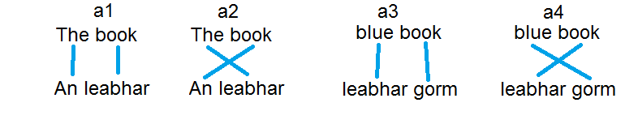

2-2: Normalise for all alignments – probability distribution of the alignment a:

Step 3 (maximisation)
3-1: Collect fractional counts c:

3-2: Normalise fractional counts to yield revised parameter values

2nd Iteration

Step 2 (Expectation)

2-2 Normalization

Step 3 (Maximisation)

3-2: Normalization

As the values after the 2nd iterations maximisation step have not converged we would continue to repeat steps 2 and 3 until convergence however in this question we are only asked to calculate the translation probabilities after the two iterations above

