Trello Github and Wordpress links – SAB CA1

Trello: <https://trello.com/eoinkarlmarkolumide>

Github : <https://github.com/Eoin1539/SAB>

Wordpress: <https://sab-eoin1539.c9users.io/>

Pictures for proof

Trello

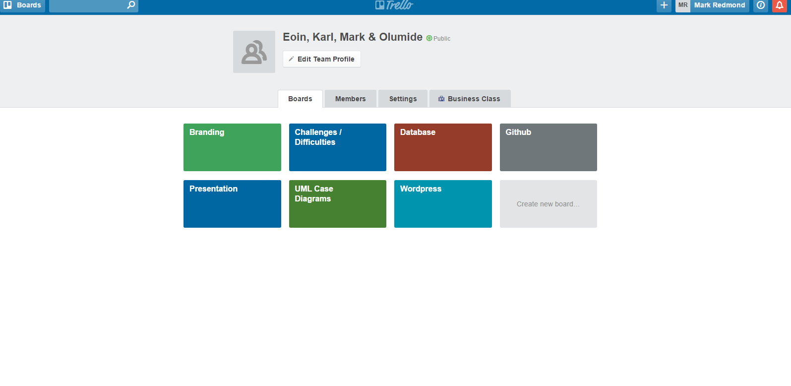

Github

