**Q1. Advantages and Disadvantages of the client/ Server Architecture?**

Advantages:

* All files stored In a central Location
* Network Peripherals are controlled Centrally
* Backups and Network security controlled centrally
* Users can access shared data which is centrally controlled

Disadvantages:

* A Specialist network operating system is needed
* The Server is expensive to purchase
* Specialist network staff are needed
* A lot of disruption can occur if any section of the network fails

**Q2. How does the Bit Torrent Protocol Work?**

Bit torrent is a useful decentralized peer-to-peer protocol with significant advantages over other Protocols. In a bit torrent network data is transferred between a swarm of multiple computers negating the need for a central server. A computer joins a swarm when a .torrent file is loaded in a bit torrent client. The client then contacts a tracker which holds the addresses for each computer in the swarm. once connected a bit client server starts to download data, when data is downloaded it then starts to upload the data speeding up the time it takes to download the data for other users.

There are then seeders and Leecher, a Leecher is somebody who is downloading the data and a seeder is supplying the data. If a torrent has no seeders it is not possible to download it.

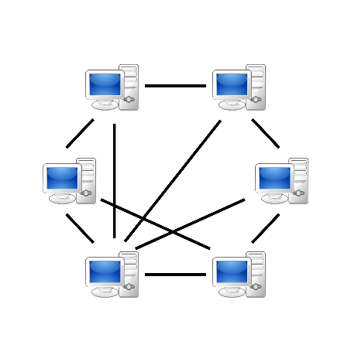**Q3. In the peer-to-peer network architecture with authoritative host, describe how the peers communicate with each other using diagrams.**

In a Peer-to-peer with an authoritative host one client is the centralized controller of the network. The host takes in all actions and inputs from the other clients and carries out the actions. Using a peer-to-peer network can cause issues with lag and due to the time it takes to travel across the network, because of this one client can appear differently to the host clients and other clients on the network.

The main Authoritative host acts like a server, when it receives a packet from another client it deals with that on the host machine and then sends that back to all other clients to update them to match the host machine.