2. a-20 b-15, c-5, d-15, e-45

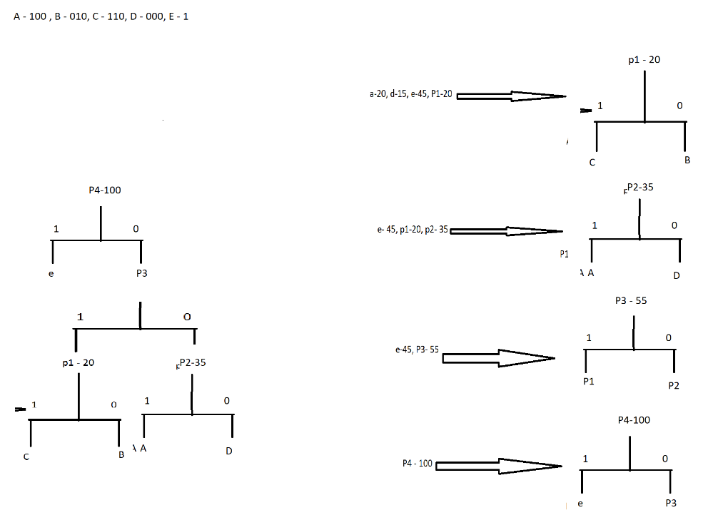

A = 20 \* 3 = 60

B = 25 \* 3 = 75

C = 5 \* 3 = 15

D = 15 \* 3 = 45

E = 45 \* 1 = 45

Total = 240 / 100

Average bits = 2.4

3.

