Student Eoin Mannix (TL_KCOMP_B_Y3)
T00247454@mymtu.ie
GitHub URL
The Link for the GitHub repo can be found here EoinMannix/skyboard
Render URL
The Link for the Render Website can be found here
SkyBoard - Live departures and arrivals
Progress Update
This Report contains Information about the Skyboard project, its progress reports, Views, Controllers, Models and the API
Web frameworks project
SkyBoard

Table of Contents
1. Summary 2
2. Introduction 3
2.1 About Skyboard 3
2.2 Links 3
2.3 Progress Log 3
3. Views 6
3.1 List of Views 6
3.2 How I Built Them 6
3.3 UIF Components 7
3.4 How data is set to the Views 8
3.5 Responsive Design 9
4. Controllers 11
4.1 Controllers Built 11
4.2 How data is structured 11
5. Routes 12
5.1 Page Routes 12
5.2 API Routes 12
6. Model 13
6.1 Mongoose Schema 13
6.2 Connecting to the Database 14
6.3 Sample Data 15
7. Starting the API 16
7.1 API Design 16
7.2 Error Messages 16
7.3 Testing in Postman 18
7.4 Calling the API from Express 23
8. Reflection 24
9. References and sources I used 25

1. Summary
This report goes through where I’m at with the back end of Skyboard, my live departures and arrivals board for Dublin Airport. So far I’ve got the static site built with pug views and bootstrap and I’ve moved all the flight data out of the views and into the controllers, so the pages show what the controller sends to them.
I’ve also set up a database on MongoDB Atlas and made a Mongoose schema for the airports and their flights. Getting connected took a bit of work, between a few mistakes in the connection string and the college Wi-Fi blocking the database, but it’s all connecting fine now.
The biggest change since my last report is that the dashboard now gets its flights from the database through the API instead of hard-coded data. The project also sends a new airport from the express side to the API with a POST.

2. Introduction

2.1 About Skyboard
Skyboard is a web app that shows live departures and arrivals at Dublin Airport. The idea is that users can register and log in to save flights to their own watchlist. It’s built with the MEAN stack using MVC, it’s hosted on Render and the database is on MongoDB Atlas.

2.2 Links
GitHub: EoinMannix/skyboard
Render: SkyBoard - Live departures and arrivals

2.3 Progress Log
Following the first lab sheet doing initial commits renaming variables and changing the code so that it suits my Skyboard project.

  - Lab 1: Setup and Deployment
- Created the Express app and re-constructed the MVC folders (app_server/routes, controllers, views).
- Set up the Git, added a .gitignore so node_modules isn’t committed, pushed to GitHub, and deployed to Render.
- A problem I had was committing all the node_modules but I used a .gitignore and git rm -r –-cached node_modules to fix it.
- Another problem I encountered was that my bootstrap link wasn’t working. I did some research online and found that you could use bootstrap from the web which I used in my project and ended up working in the end. Here is the reference I used to get that link Get started with Bootstrap · Bootstrap v5.3

  - Lab 2: Routes and Controllers
- Followed the lab but replaced Loc8r’s Locations/Others with Skyboard’s flights.js (dashboard) and auth.js (login and register).
- Three routes: / for the main dashboard, /login and /register.
- Used a tutorial from the MTU library on bootstrap to get a better understanding of how to write Bootstrap code. Bootstrap 4 for Beginners - Build 5 Websites from Scratch - ProQuest
- Also used the pughtml.com converter to convert html written code to pug.
- Bootstrap documentation was also really useful for the grid system and tables

  - Lab 3: Data in Controller
- Followed the lab and got rid of all the hardcoded data out of the dashboard.pug view and into the dashboard function in the flights.js controller. Now the view only has variables in it.
- Grouped the title, airport code and summary into a pageHeader object like Loc8r does and referenced them in pug using #{ } and =.
- Replaced Loc8r’s locations array with Skyboard’s departures, arrivals and watchlist arrays, with each flight as an object (flight, place, time ,gate/terminal, status).
- Used pug’s each/in loop to go through each array and build the table of rows instead of writing out every flight in the view.
- Added a colour value to each flight so the status badge shows Bootstrap’s success, warning or danger colours.
- Used the _includes/sharedHTMLfunctions.pug file for mixins, similar to the lab’s star rating mixin, so reusable pug code isn’t repeated on each page.

  - Lab 4: Data Model (Mongoose)
- Installed mongoose and mongodb and created db.js in app_server/models, then required it at the top of app.js
- Set up a cluster on MongoDB Atlas (SkyBoard-Cluster) with a SkyBoard database and connected to it from db.js
- Kept the connection string in a .env file using dotenv, and .env is in the .gitignore so the password isn’t published to GitHub.
- Followed the lab but replaced Loc8r’s locations.js with SkyBoard’s flights.js model. The flightSchema (flight, direction, place, time, gate, terminal, status, colour, starred) is nested inside the airportSchema the same way openingTimeSchema is nested inside locationSchema.
- Used required: true on the main fields and default of false on starred, then built the Airport model with mongoose.model
- Left out the rating min/max and coords from the lab as Skyboard doesn’t have any number or location fields.
- A problem I had was the connection string, it still had the < > around the password and the wrong options on the end which gave a mongoError, but I fixed the string in the .env which fixed the issue.
- Another problem was not being able to connect on the college Wi-Fi. Test-NetConnection showed port 27017 was blocked, so I added 0.0.0.0/0 to the Atlas IP access list and it connected fine at home.

  - Lab 5: Building a REST API
- Made a new app_api folder next to app_server with its own routes and controllers, and added app.use(‘/api’, apiRoutes) to app.js.
- Did the API routes from the lab but used airports instead of locations and flights instead of reviews, since my flights are stored inside each airport.
- To start with, the controllers just sent back “success” so I could check the routes worked. Tested them with GET and PUT in Postman.
- Moved the models folder from app_server into app_api and updated the path in app.js.
- Got airportsReadOne working with findById so the API sends back real airport data from the database. Then added the error messages from the lab for a missing id, an id that isn’t there, and a bad id.
- Got airportsCreate working so I can add a new airport with two flights from Postman. Added Cork Airport this way.
- The lab said to take out the index route, so the dashboard showed “Not found”.
- A problem I had was that I put the /api line below the 404 handler in app.js so every API request just gave a 404. I tried moving it up which fixed this issue.
- When I went to commit, Git was tracking node_modules again, so I had to remove it again and check the .gitignore was actually working.

  - Lab 6: Connecting Express to the API
- Put the index route back in app.js so the dashboard works again.
- Installed the request module so the Express side can call my API.
- Added apiOptions at the top of app_server/controllers/flights.js, so it uses the localhost when I’m working on it and my Render address when it’s live.
- Moved the res.render into its own _renderDashboard function, the same as the lab does with _renderHomepage.
- The dashboard controller now calls /api/airports/ with Dublin’s id and sends what comes back to _renderDashboard, so the page shows what’s actually in Atlas. I decided to hardcode Dublin’s id for now, the same way the lab hard-codes the longitude and latitude.
- My API gives back one airport with all its flights together, but my view wants departures and arrivals separate so I used a JavaScript function I learned in my Client_Side_Scripting module called .filter() which splits them by direction.
- Left the watchlist hardcoded for now, like the lab leaves its sidebar text.
- The lab only shows a POST example for creating a location, so I did the same for creating an airport with airportCreate. It sends the new airport to /api/airports and goes back to the dashboard if the API sends back a 201, which means it worked.
- The lab shows the POST controller and says to try to get it working yourself. To do that I needed a route, so I added router.post(‘/airports/new’), written the same way as the routes from Lab 2 but as a POST since it’s sending data. I tested it in Postman like in Lab 5 and Shannon airport popped up in Atlas confirming that it worked. I used documentation from the official expressjs site to assist me with the creation of the code piece. Link: Routing · Express.js

3. Views

3.1 List of Views
View | What it displays
layout.pug | Navbar and footer shared by every page
dashboard.pug | Departures, arrivals and the watchlist
login.pug | Login form
register.pug | Registration form
error.pug | Error page

3.2 How I Built Them
All the views extend layout.pug so the navbar and the footer are only written once. I wrote the pages in HTML first and then used the pughtml.com converter to turn them into Pug.
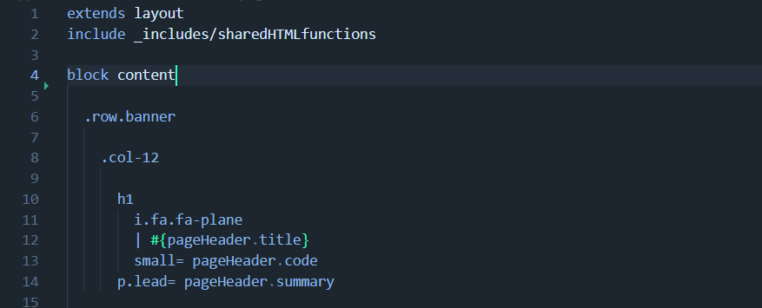

3.3 UIF Components
I used Bootstrap 5 for the layout and the components:
- Cards for the Departures, Arrivals and my watchlist sections.
- Tables for the flights.
- Badges for the flight status, coloured with bg-success, bg-warning and bg-danger.
- Font Awesome for the plane and star icons.
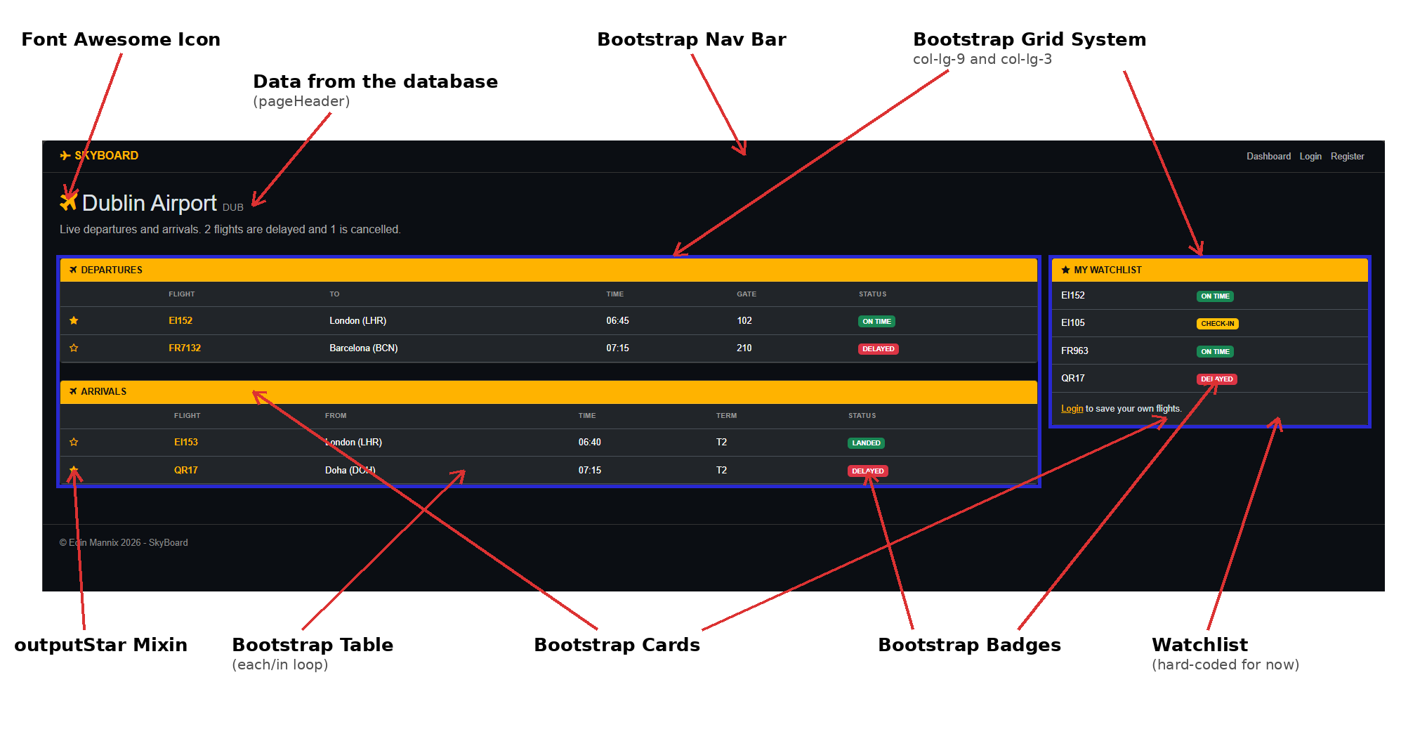
My dashboard on the standard desktop view with the bootstrap parts I used labeled.

3.4 How data is set to the Views
The views don’t have any data typed into them, just variables. #{} puts data inside text and = puts it straight after a tag. Pug’s each/in loop goes through each array and builds a table row for every flight.
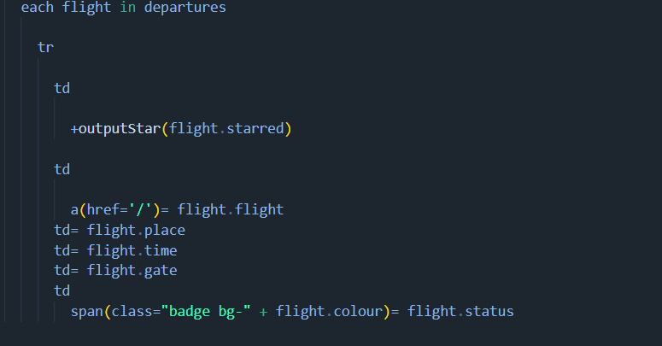

The outputStar mixin in _includes/sharedHTMLfunctions.pug shows a filled or empty star depending on whether the flight is starred. That way I didn’t have to write the same things in both tables.
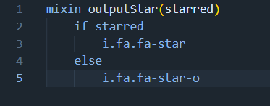

Since Lab 6 the data comes from the database through the API, but the view didn’t need to change at all. It still gets pageHeader, departures, arrivals and watchlist, they just come from somewhere else now.

3.5 Responsive Design
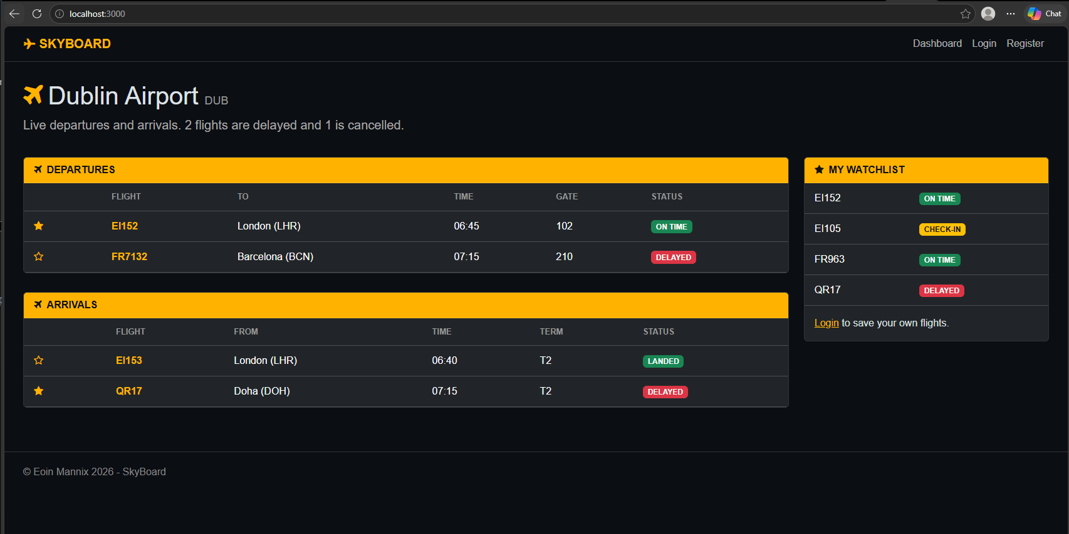
  - The default layout where you can see the flights in the center and the watchlist to the right.
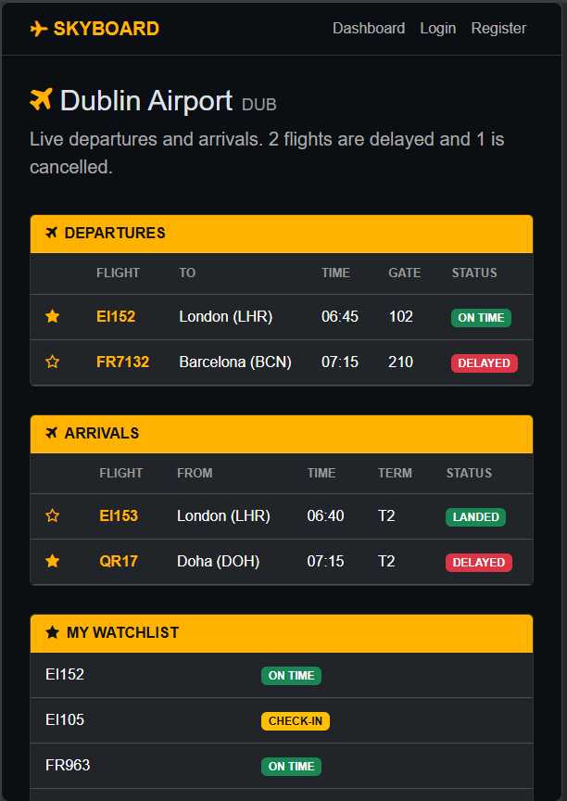
  - The Mobile interface where the watchlist goes below the departures and arrivals.

4. Controllers

4.1 Controllers Built
File | Function | What it does
app_server/controllers/flights.js | dashboard | Calls the API for Dublin Airport, then renders the page
app_server/controllers/flights.js | _renderDashboard | Renders dashboard.pug with the airport data
app_server/controllers/flights.js | airportCreate | Sends a new airport to the API with POST
app_server/controllers/auth.js | Login / register | Render the login and register pages
app_api/controllers/airports.js | airportsCreate | Saves a new airport to Atlas
app_api/controllers/flights.js | flights | Placeholders for now

4.2 How data is structured
In Lab 3 the dashboard data was all typed into the controller as a pageHeader object and arrays of departures, arrivals and the watchlist. In Lab 6 I took that out. Now the controller gets one airport document from the API and _renderDashboard puts it into the same shape the view already wanted.
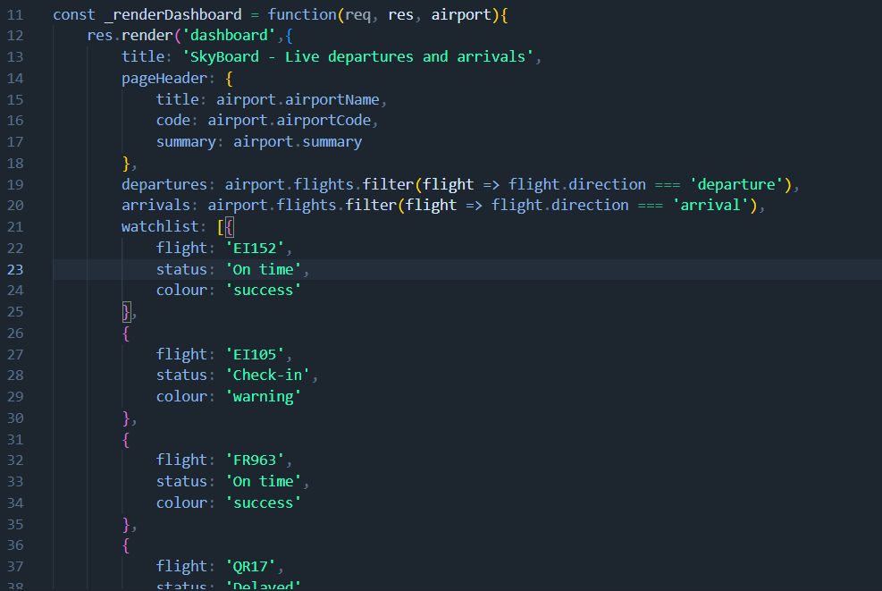
Departures have a gate and arrivals have a terminal. The colour value decides what colour the status badge is. The .filter() lines split the flights up by direction, which I picked up from my Client-Side Scripting module where I did JavaScript.

5. Routes

5.1 Page Routes
The page routes are in app_server/routes/index.js. Each one sends a URL to a controller function.
URL | Method | Controller
/ | GET | ctrlFlights.dashboard
/airports/new | POST | ctrlFlights.airportCreate
/login | GET | ctrlAuth.login
/register | GET | ctrlAuth.register

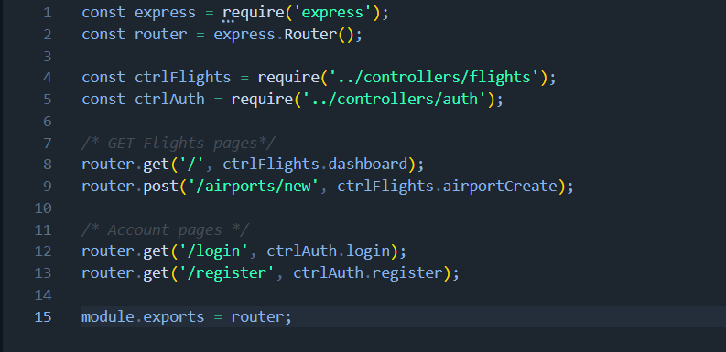
The /airports/new route isn’t in the lab, the lab only shows the controller code. I needed a route so the controller could be called, so I added it the same way as the GET routes from Lab 2.

5.2 API Routes
The API routes are in app_api/routes/index.js and they all start with /api. They’re in section 7.

6. Model

6.1 Mongoose Schema
The model is in app_api/models/flights.js (it moved there from app_server in Lab 5). The flightSchema sits inside the airportSchema, the same way openingTimeSchema sits inside locationSchema in the lab, so each airport holds a list of its own flights.
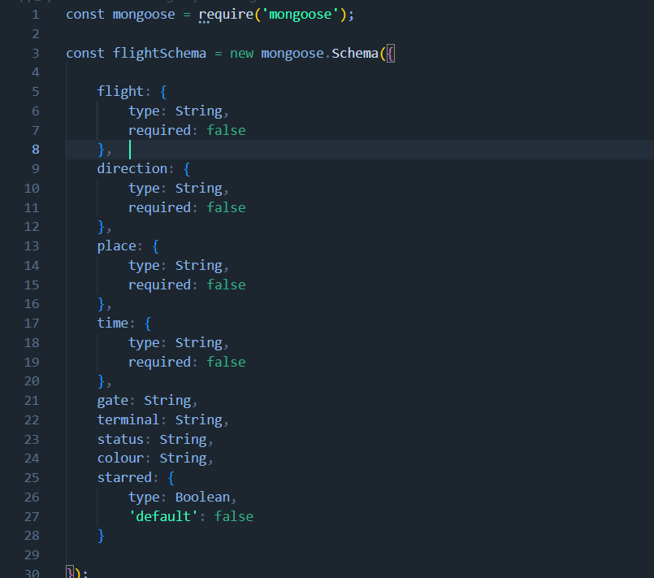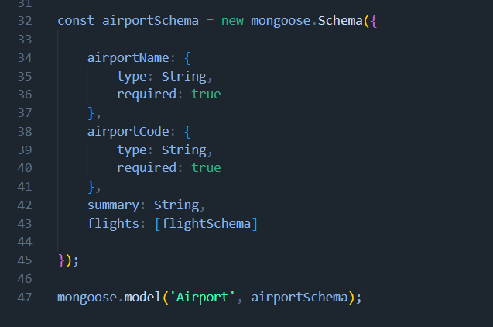
- airportName and airportCode are required, so an airport can’t be saved without them.
- Direction is either departure or arrival, so one schema works for both.
- Starred defaults to false so new flights don’t go on the watchlist.
- The flight fields were required: done in lab 4, but lab 5 says to set them to false to test for the POST.
- I left out the rating min/max, coords and reviewSchema from the lab as Skyboard doesn’t need them.

6.2 Connecting to the Database
db.js connects to MongoDB Atlas using the connection string from the .env file and then brings in the flights model.
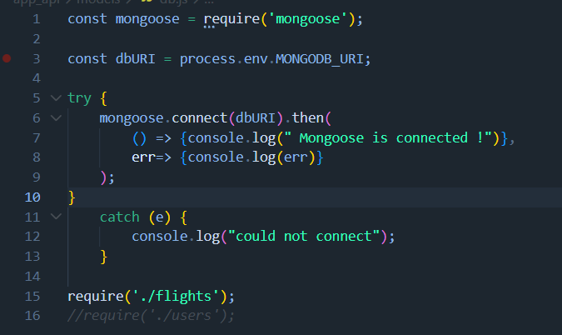

6.3 Sample Data
I added Dublin Airport and its flights to the airports collection with mongosh. Cork Airport was added through the API in Lab 5, and Shannon Airport through the Express POST in Lab 6.
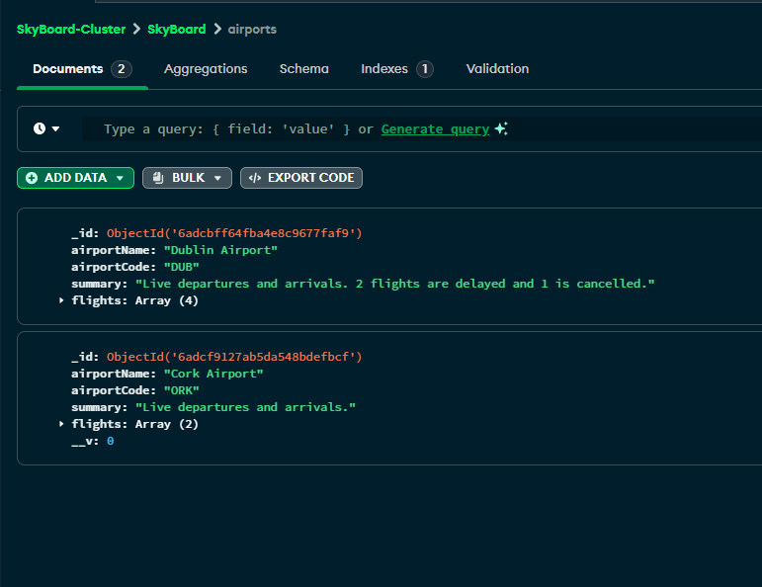

7. Starting the API

7.1 API Design
The API has its own app_api folder and all the API URLs start with /api. You get to a flight through the airport it belongs to
URL | Method | What it does
/api/airports | GET | List airports (placeholder)
/api/airports | POST | Create an airport
/api/airports/:airportid | GET | Get one airport
/api/airports/:airportid | PUT / DELETE | Update or delete an airport (placeholder)
/api/airports/:airportid/flights | POST | Add a flight (placeholder)
/api/airports/:airportid/flights/:flightid | GET / PUT / DELETE | Get, update or delete a flight (placeholder)

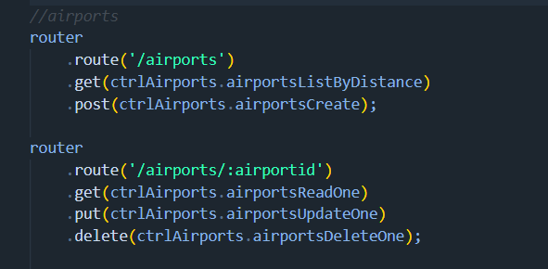

7.2 Error Messages
airportsReadOne first checks there’s an airportid in the request, then looks it up with findById and sends back a different status depending on what happened.
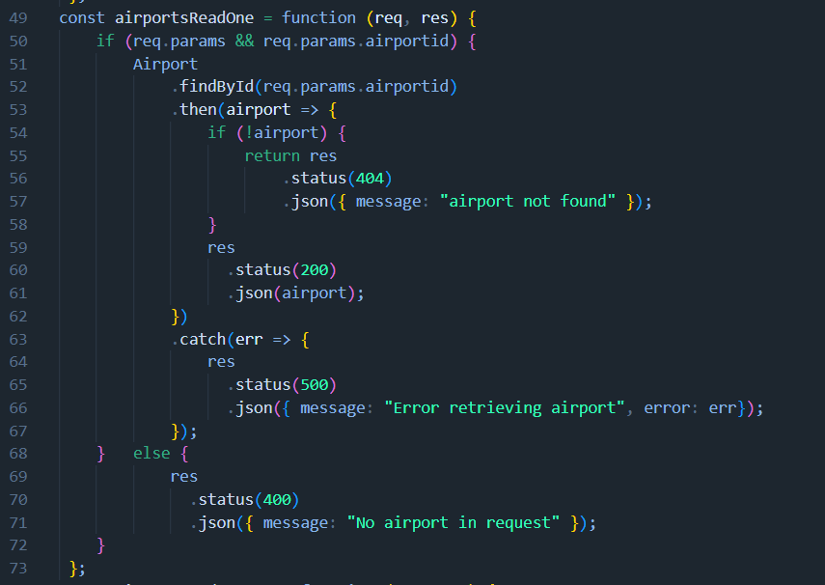
Status | Meaning
200 | Ok, here’s the airport
201 | Created, the new airport was saved
400 | Bad request, no airportid or a required field is missing
404 | Airport not found
500 | Error retrieving airport e.g. an id that isn’t valid like 1234

7.3 Testing in Postman

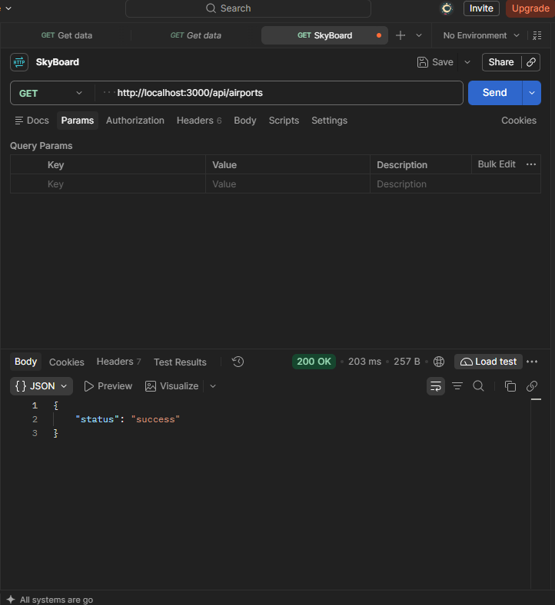
The GET from /api/airports sending back the placeholder success message.
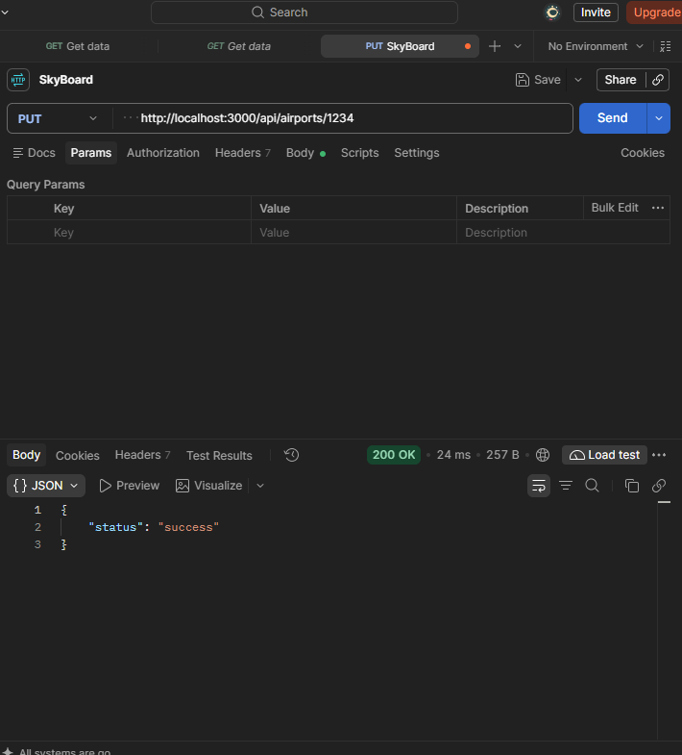
The PUT from /api/airports/1234 sending back the placeholder success message.

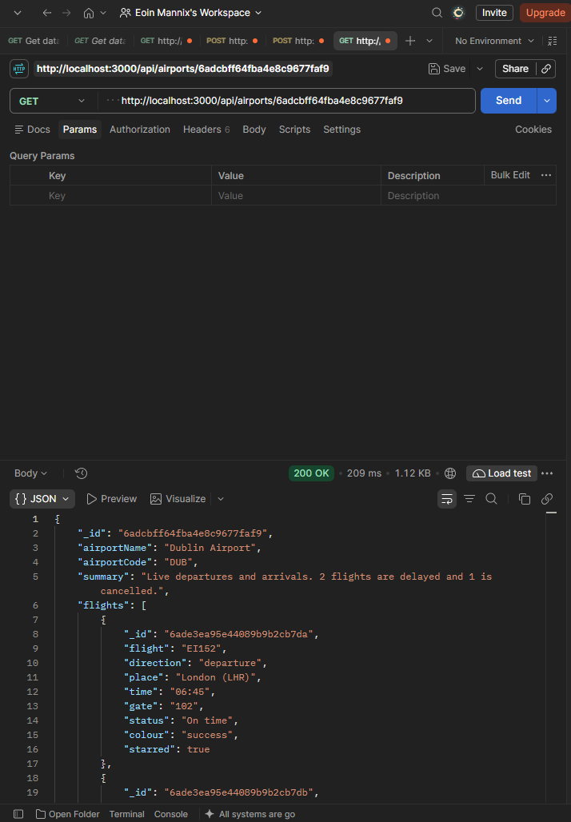
The GET from /api/airports/6adcbff64fba4e8c9677faf9 sending back the values for Dublin Airport
  - 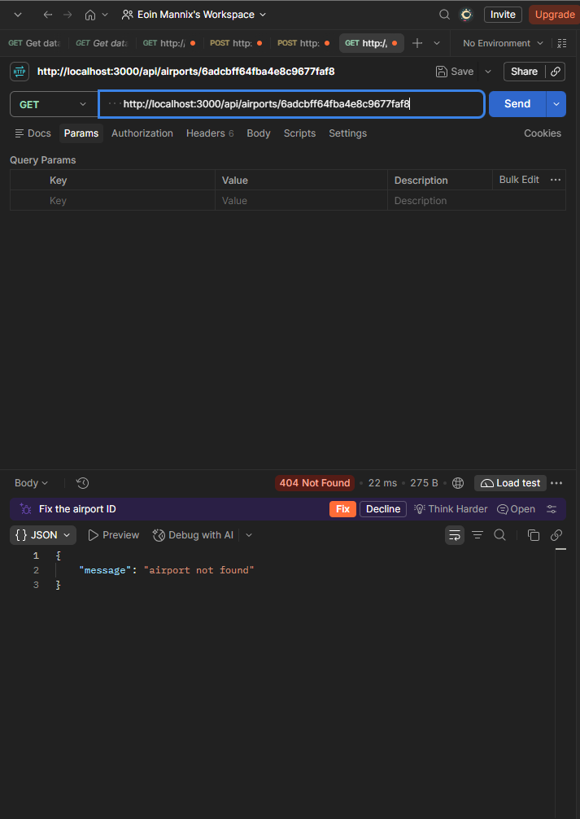
The GET from /api/airports/6adcbff64fba4e8c9677faf8 sending back an error as I changed the last character of the id by putting an 8 at the end instead of a 9.
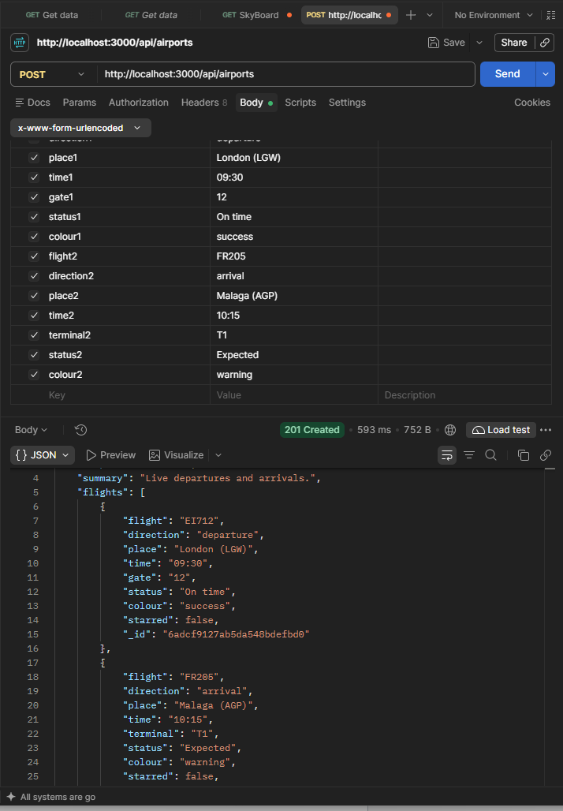
The POST from /api/airports sending back the created values for Cork airport

7.4 Calling the API from Express
In Lab 6 I connected to Express side to the API using the request module. apiOptions decide which server to call, localhost on my laptop or my Render address when it’s live.
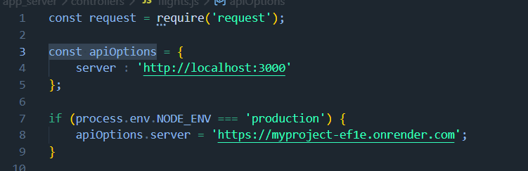

The dashboard controller builds the request, calls the API and passes whatever comes back to _renderDashboard. If something goes wrong it still renders the page with an empty airport so the browser isn’t left hanging.
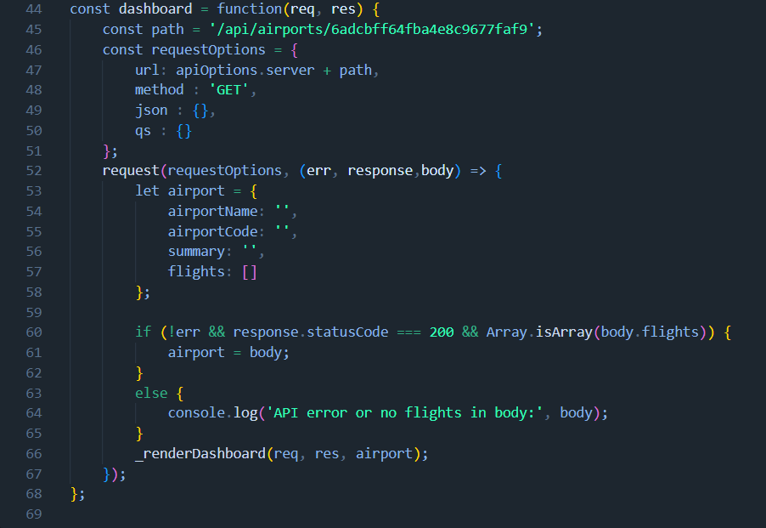

8. Reflection
Looking back, I’ve learned a lot about the MEAN architecture as a whole. I thought the lab sheets were nice to work through being shown step by step what to code and how that code works. A lot of my time went on the database connection, between mistakes in the connection string and the college Wi-Fi blocking the connection from the database on my machine. I tried to work consistently on the labs up until lab 4 where this project collided with another modules project, disrupting my routine up until the end.
The part I found most useful and interesting was seeing the MVC structure pay off in Lab 6. As I had already built the views and controllers, switching from hard-coded data to the API only meant changing the controller. The view didn’t need to change at all.
Next, I need to add a user model so I can do the POST for registration and login, then move on to Angular and Passport for the final report. If I had to start over, I’d test each change straight away so that small mistakes like typos don’t pile up

9. References and sources I used
- Claude was used for:
  - Debugging: I used it to debug Pug errors and explain errors in the command line such as node files still being committed after the .gitignore
  - Spelling & Grammar: Once I was done with my report I used AI to help me spot any spelling or grammar mistakes I may have missed.
  - Understanding: When I was working through the lab sheets and couldn’t quite understand a certain topic I got Claude to explain it to me in depth helping better my understanding for the code.
- Bootstrap 4 for Beginners - Build 5 Websites from Scratch - ProQuest
- Grid system · Bootstrap v5.3
- Cards · Bootstrap v5.3
- Tables · Bootstrap v5.3
- Badges · Bootstrap v5.3
- Background · Bootstrap v5.3
- Form controls · Bootstrap v5.3
- Buttons · Bootstrap v5.3
- Float · Bootstrap v5.3
- Color modes · Bootstrap v5.3
- Template Inheritance – Pug
- PugHTML - HTML to Pug/Jade Converter with Bootstrap & Tailwind CSS

