

**CSIS 3003**

**PROJECT I**

**Game Trade - Second-Hand Game Disc Purchasing, Selling, Rent, and Exchange Management System (Stage 1)**

**Wong Yik Khen (D170325B)**

**Wong Juin Zheng (D170231B)**

**Ng Weng Kang (D170264B)**

**Lecturer: Mr. So Yong Quay**

**26th April 2018**

**Department of Computer Science**

**Faculty of Engineering and Information Technology**

Table of Contents

1.0 Introduction 1

2.0 Objective 2

2.1 Project Objective 2

2.2 Personal Objective 2

3.0 Background Research 3

3.1 Glyde – Online market website 3

4.0 Methodology 4

4.1 Iterative model 4

5.0 Requirement Specification 7

5.1 User Requirements 7

5.1.1 Identification of business process stage 7

5.1.2 Analysis of problem and solution stage……………….......……..…………………9

6.0 Literature Review 10

6.1 Research 10

6.2 Financial Justification 12

7.0 Project Scope 13

8.0 Project Schedule 14

9.0 Team Member Duty and Monitoring…………………………………………………….15

10.0 Curriculum Vitae 16

11.0 References 22

1.0 Introduction

In this high technology era, everyone is living in convenient and rapid development era, high-tech tools are always accompanying us in all of the time. This phenomenon already makes the modern people lazy to go out, this is because the rise of the online shopping system is already helping nowadays people to buy things by using the website. Online shopping website is becoming most popular website in the network likes Taobao, Lazada, Amazon and so on to let the user visit the online store or open an online store on the website.

In this era, every product is rising prices even though it is a food, it must also have risen price with many factors in world trade market likes GST, tariff tax, material tax or other factors. Therefore, the prices of the game disc market are also raising prices at on market, this situation causes many gamers can’t buy the game disc when the price of game disc is already over their budget. So, that is the reason that we start our project to let them can use the lowest price to buy, rent the game disc they want by using our website.

Our project title is Game Trade – Second-Hand Game Disc Purchasing, Selling, Rent, and Exchange Management System, which is developed for all the gamer having a platform to buy, sell, rent and exchange their game disc with other user. The user can be a buyer, seller or both of them and they will reduce the time for finding each other when using our website. The buyer can buy the used game disc by lower prices, rent or exchange the game disc from the administrator. The seller also can sell their second-hand game disc through this website by supply a good quality used game disc to the administrator.

2.0 Objective

2.1 Project Objective

By developing this project, we can achieve the objective below;

* To make user easier to buy, sell, rent and exchange second-hand game
* To decrease the cost of the buying game disc
* To reuse the unused game disc

2.2 Personal Objective

We choose this topic because we would like to try to develop a website about the second-hand game disc market. This is a big challenge to us, because shopping website already has a large market. Of course, we also hope through developing this project can enhance our website development skill.

3.0 Background Research

3.1 Glyde – Online market website



The Glyde is a website which is helping people in purchasing and selling tablets, phone, iPods and video games in this website. (Glyde, 2018). This website works on a dual identity concept because the user can be a buyer, seller or both of them when using this website.

People need to register or login into the website with the complete and real personal detail when using this website. When you are buyer, you can find a quality, second-hand game with a great price on this website, after that Glyde will track your shipment and keeps you updated through email. If there's a problem, they’re here to set right things with a full refund to the buyer. When you are seller, you need to type out what you’re selling into the search bar on the website and select your item from the drop-down options. It’s free to list, no need to upload a photo or length descriptions to write. When your item sold, they will send you a Glyde shipping kit, complete with a pre-paid label. Place your item inside and put the package in your outgoing mail. Your shipment is fully insured and tracked every step of the way. Last, the proceeds are deposited into your Glyde account 3 days after delivery to your buyer. Use the cash on the Glyde, withdraw it to your bank account (free), select Bitcoin as your payment method (free), or get a paper check mailed to you ($2.00 fee). (Glyde, 2018)

This website requires network connection and location services. This website also uses, a web service to retrieve data and information from Web servers. This website is using following tool or technique MySQL, PHP, Web service and JavaScript. Therefore, in my project I may use the same technology to improve the features.

4.0 Methodology

4.1 Iterative model

By developing this web-based system, the methodology that we use in this project is iterative model. An iterative model is a particular implementation of a software development life cycle (SDLC) that focuses on an initial, simplified implementation, which then progressively gains more complexity and a broader feature set until the final system is complete. Furthermore, the concept of incremental development will also often be used liberally and interchangeably, which describes the incremental alterations made during the design and implementation of each new iteration. (Air Brake. 2016) By using this iterative model, our project can be divided into several parts.

Listed below in Figure is the Iterative process model.

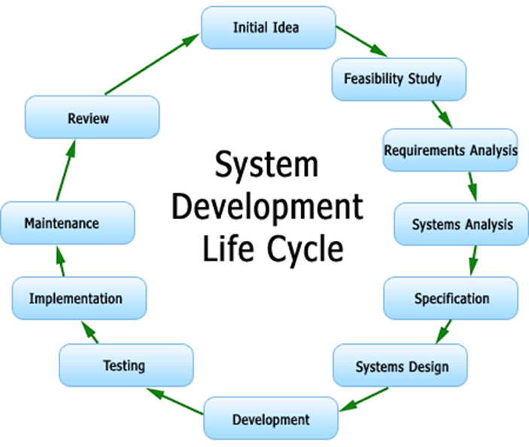

*Figure 1 Iterative Model*

The following are the phases in the development of the proposed system:

1. **Planning**: As the start of the development project, the first step is going through an initial planning stage to map out the specification documents, establish software or hardware requirements, and generally prepare for the upcoming stages of the cycle.
2. **Requirement**: In this phase, requirements are gathered from the customer who want to develop the software, these requirements will let the programmer easier to know what the customer want and what the function of the website is can’t do by now technology.
3. **Analysis**: After getting the requirement, system analyst analyses the requirements that whether these requirements are can be fulfilled or not. If customer requirements can be fulfilled than whether these requirements are fulfilled within budget or out of the budget. An analysis is performed to nail down the appropriate business logic, database models, and the like that will be required at this stage in the project.
4. **Design**: In the design phase, software, team designs the software. This may be a new design, or an extension of an earlier design. Different diagrams are also drawn in this phase for software. Some of these are used a class diagram, activity diagram, data flow diagram, sequence diagram and other diagram.
5. **Implementation**: With the planning and analysis out of the way, the actual implementation and coding process can now begin. All planning, specification, and design docs up to this point are coded and implemented into this initial iteration of the project. Finally, programs are written and all the designed is converted into computer programs collectively called software.
6. **Testing**: Once this current build iteration has been coded and implemented, the next step is to go through a series of testing procedures to identify and locate any potential bugs or issues that have cropped up. For an example, test the software by using different software testing techniques. Most common are white box, black box, and grey box testing techniques.
7. **Evaluation**: Once all prior stages has been completed, it is time for a thorough evaluation of development up to this stage. This allows the entire team, as well as clients or other outside parties, to examine where the project is at, where it needs to be, what can or should change, and so on.
8. **Deployment**: That is the time to install or deploy the software, web site or apps in its working environment to know that is working properly or not.
9. **Review**: In the review phase, the current requirements are reviewed, and changes and additions to requirement proposed. Validation or review is performed to check the performance and validity of the developed software. If there is any problem then starts a new iteration and again start from requirement gathering and continues the iterative model.
10. **Maintenance**: When software, web site or apps is deployed, there are many bugs in there, so that must be fixed by updating and this process we called maintenance. Maintenance includes debugging and new feature additions.

5.0 Requirement Specification

5.1 User Requirements

5.1.1 Identification of business process stage

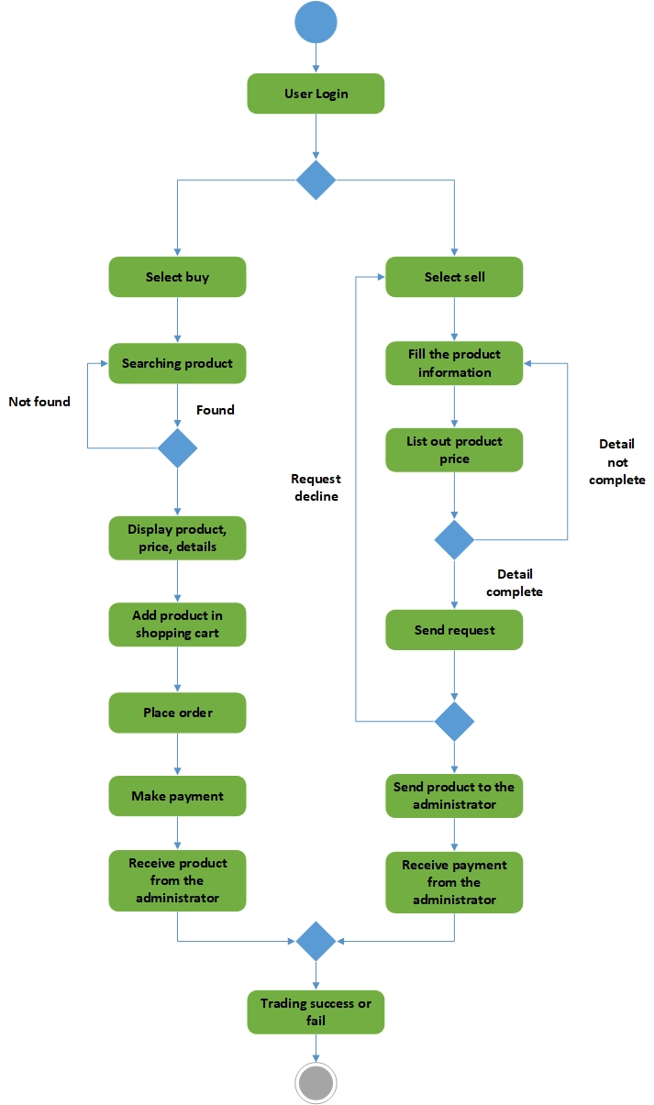

*Figure 2 Activity diagram of existing website*

**Description**

Based on the diagram above, clearly state the process flow,

* User need to sign in to the website by register a Game Trade account.
* After sign in to the website, user can select buy or sell on the website.
* As a buyer user, you can search product in the website, add any product in shopping cart and add payment by any method in the website.
* After the buyer shopping finish and decide to add payment for the product, buyer can select any payment method which lists on the website.
* After the buyer make payment to the administrator, administrator will update the message to the member which is giving the information about the product shipping and status.
* As a seller user, you can sell your product by fill the complete information and add the price for your product. After seller complete fill the request, the request will send to the administrator to decide accept or decline the request.
* If the administrator doesn’t want to buy seller product, he will decline the request of the seller and return a message to the seller.
* After administrator decide to accept the request of the seller, the seller must send the product in 14 days, if the administrator does not receive the product in 14 days, the request will automatically cancel.
* After the administrator receive product from the seller, administrator will make payment to the seller with using credit card, cash or another method.
* The success of trading depends on the user not the system.

5.1.2 Analysis of problem and solution stage

1)Problem: Waste time

Solution: Customers need a lot of time to find some game discs which their want. So, in our application, customers can easy to find their game discs convenient and faster.

2)Problem: Waste money

Solution: Customers buy some new game discs with expensive prices. Thus, in our application, customers can buy some second-hand game discs with reasonable prices. For example, game discs are less expensive than the new alternative, sometimes up to 90% cheaper, but generally at least 50% cheaper.

3)Problem: Waste products

Solution: Users play the game disc temporarily because after they completed mission of the game, they will be tired of the game and throw it aside. Therefore, based on our application, it can help users to reuse probably the unused game discs. For instance, users can pass through to buy, sell, rent or exchange their game discs with other players.

6.0 Literature review

In this part, I am going to explore the research related to my project that have been conducted by other academic previously. Game Trade is an website which comprises PHP, MySQL and Web service. Website is a kind of window application that running on computer platform.

Alex is the gamer that always play PS3. As a PS3 gamer he has a lot of game disc, but few weeks ago he just buys a new PS4 so his PS3 game disc can't be use anymore. Thus, he decides to sell her old PS3 game disc but he can't find the platform that can sell the old game disc.

Jack is a college student, he always plays he PS3 in weekend. He has some game disc only because he just a student which is not having earn money ability. As a college student, he didn't have enough money to buy the game disc. The game disc was too expensive for his, so become he can't play different kinds of game disc.

In one of the game shop, they were selling the game disc to the gamer. But, the price that was too expensive to a few of game player. Thus, the seller decides to rent the games disc to the gamer to make sure other poor people also can play it.

In this high technology generation, a lot of gamer have them own group to discuss the game disc. A few of gamer, they will like to exchange with each other. Combine all of the problems, we decided to create a platform for them. This platform can let them expand them trading their game disc.

6.1 Research

**(a)E-business**

E-business can comprise a range of functions and services, ranging from the development of intranets and extranets to e-service, the provision of services and tasks over the Internet by application service providers. Today, as major corporations continuously rethink their businesses in terms of the Internet, specifically its availability, wide reach and ever-changing capabilities, they are conducting e-business to buy parts and supplies from other companies, collaborate on sales promotions, and conduct joint research. With the security built into today's browsers, and with digital certificates now available for individuals and companies from Verisign, a certificate issuer, much of the early concern about the security of business transaction on the Web has abated, and e-business by whatever name is accelerating.

IBM was one of the first companies to use the term when, in October 1997, it launched a thematic campaign built around e-business.

**(b)MySQL**

MySQL is an open source relational database management system (RDBMS) based on Structured Query Language (SQL).

MySQL runs on virtually all platforms, including Linux, UNIX, and Windows. Although it can be used in a wide range of applications, MySQL is most often associated with web-based applications and online publishing and is an important component of an open source enterprise stack called LAMP. LAMP is a Web development platform that uses Linux as the operating system, Apache as the Web server, MySQL as the relational database management system and PHP as the object-oriented scripting language. (Sometimes Perl or Python is used instead of PHP.)

MySQL, which was originally conceived by the Swedish company MySQL AB, was acquired by Sun Microsystems in 2008 and then by Oracle when it bought Sun in 2010. Developers can still use MySQL under the GNU General Public License (GPL), but enterprises must obtain a commercial license from Oracle.

**(c)PHP**

PHP is a script language and interpreter that is freely available and used primarily on Linux Web servers. PHP, originally derived from Personal Home Page Tools, now stands for PHP: Hypertext Pre-processor, which the PHP FAQ describes as a "recursive acronym."

PHP executes on the server, while a comparable alternative, JavaScript, executes on the client. PHP is an alternative to Microsoft's Active Server Page (ASP) technology. As with ASP, the PHP script is embedded within a Web page along with its HTML. Before the page is sent to a user that has requested it, the Web server calls PHP to interpret and perform the operations called for in the PHP script.

An HTML page that includes a PHP script is typically given a file name suffix of ".php" ".php7," or ".phtml". Like ASP, PHP can be thought of as "dynamic HTML pages," since content will vary based on the results of interpreting the script.

6.2 Financial Justification

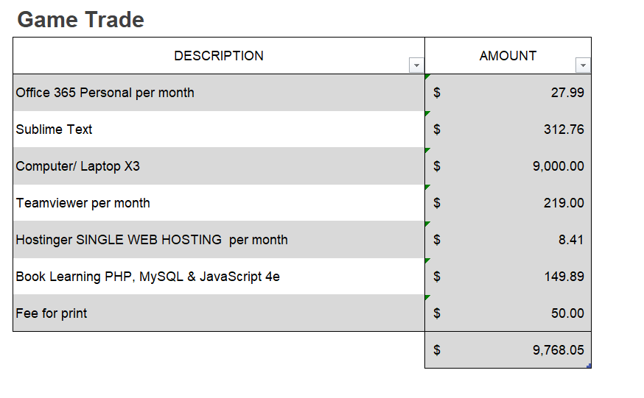

7.0 Project Scope

Based on the user requirement, we have decided to make a marketable website similar to Taobao and others market website, but we are adding some special features like rent game disc, exchange game disc based on user requirement which is required to reduce the cost of getting a new game disc. First, users need to register by giving the real name, address and agree the website terms of service when using my website. All the user’s information is secure and keep it private. User is allowed to insert, delete, modify the data. This system allowed also user to manage the data with more effectively in the user info page. This system allowed user to search the data more convenient with using the search bar in the website. For example, this system can display available of product for the buyer and seller when using search bar. The information of the product is including the product name, prices, stock and other detail. The stock information relates to our stock management system in our website database to make sure the customer will not buy the product which is out of stock. This system will calculate the price to the buyer when want to add payment for the product in the shopping cart. Next, our website also will give the information about the product shipping and status after the buyer makes payment. After the buyer receives the product, they can also give a rate to our website product and give the comment below the product. This system allows the member to sell their used game disc by fill the complete information and add the price for your product. All the transaction product and payment process are secure and it must follow the policy of the e-commerce, means that each party has the right to charge another party which non-compliance in the trading process. All the transaction product and payment process will generate a record or a report to prove that process is exists and it will become an evidence in the future. By following the policy of the e-commerce, we also provide the online services on our website, the user can send the email to the administrator if you have any problem when using our website, we also provide refund services to the user when there is a problem with the payment or the product which is provided by the administrator.

8.0 Project Schedule

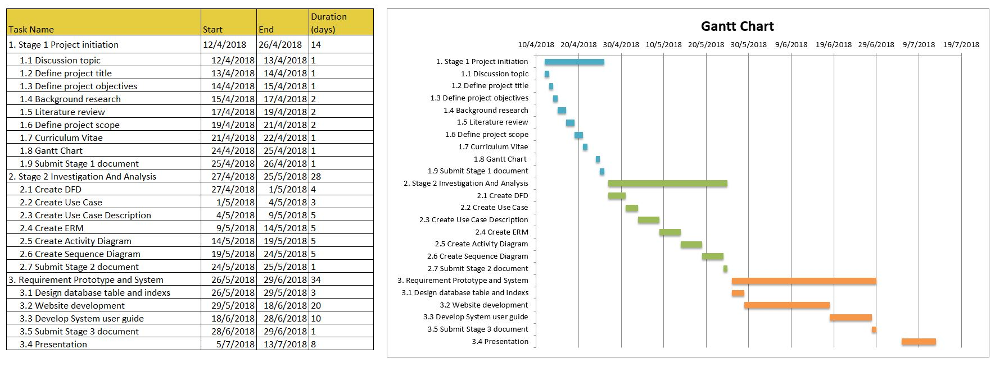

9.0 Team Member Duty and Monitoring

|  |  |  |  |  |
| --- | --- | --- | --- | --- |
| No. | Task | Participants | Due Date | Completion rate |
| 1. | Define project objectives | Ng Weng Kang | 16/4/2018 | 100% |
| 2. | Background research | Wong Juin Zheng | 16/4/2018 | 100% |
| 3. | Literature review | Wong Yik Khen | 16/4/2018 | 100% |
| 4. | Define project scope | Wong Juin Zheng | 26/4/2018 | 100% |
| 5. | Curriculum Vitae | Ng Weng Kang | 26/4/2018 | 100% |
| 6. | Gantt Chart | Wong Juin Zheng | 26/4/2018 | 100% |
| 7. | DFD Diagram | Ng Weng Kang | 25/5/2018 | 20% |
| 8. | Use Case Diagram | Ng Weng Kang | 10/5/2018 | 60% |
| 9. | Use case descriptions | Wong Juin Zheng | 10/5/2018 | 80% |
| 10. | ERM Diagram | Wong Yik Khen | 25/5/2018 | 20% |
| 11. | Activity Diagram | Wong Yik Khen | 25/5/2018 | 20% |
| 12. | Sequence Diagram | Wong Juin Zheng | 25/5/2018 | 20% |
| 13. | Design databases table and index | Wong Juin Zheng | 29/6/2018 | 0% |
| 14. | Website development | Wong Yik Khen | 29/6/2018 | 0% |
| 15. | Develop system user guide | Ng Weng Kang | 29/6/2018 | 0% |

10.0 Curriculum Vitae

**WONG YIK KHEN**

**CURRENT AND HOME ADDRESS**

22, JALAN BERINGIN,

TAMAN RINTING,

81750 MASAI,

JOHOR.

|  |  |  |  |
| --- | --- | --- | --- |
|  |  | **PERSONAL PARTICULARS** | |
| **NRIC** | 990511-08-8557 | |  |
| **AGE** | 19 | |  |
| **NATIONALITY** | Malaysian | | |
| **RELIGION** | Buddhism | | |
| **LANGUAGES** | English, Malay and Mandarin | | |
| **SEX** | Male | | |
| **RACE** | Chinese | | |
| **HEALTH** | Excellent | | |
| **MARITAL STATUS** | Single | | |
| **E-MAIL** | wyk_511@hotmail.com | | |
| **MOBILE NUMBER** | 011-10936769 | |  |

**EDUCATIONS**

**TERTIARY SCHOOL**

|  |  |  |  |
| --- | --- | --- | --- |
| SCHOOL | COURSE | YEAR | RESULT |
| Southern University College | Diploma in Information Technology | April 2017 - Present | **―** |

**SECONDARY SCHOOL (SPM)**

|  |  |  |
| --- | --- | --- |
| SCHOOL | YEAR | RESULT |
| SMK TAMAN MEGAH RIA | January 2011-November 2016 | 1A,5B,2C,1D |

**ADDITIONAL INFORMATION**

**PERSONALITY TRAITS:**

* **Practical and systematic** in completing task.
* **Cooperative and helpful** for team.
* **Able** to take challenges and risks.
* **Ready** and friendly to give full co-operation when work independently and in a team.
* **Committed** to work with a strong sense of urgency.

**Communication Skills:**

* Spoken and write level (Best= 10 and Worst= 1)

|  |  |  |
| --- | --- | --- |
| LANGUAGE | WRITING LEVEL | SPEAKING LEVEL |
| CANTONESE | 1 | 6 |
| ENGLISH | 5 | 5 |
| MADARIN | 6 | 8 |
| MALAY | 5 | 6 |

**Computer Skills** (Best= 10–Worst= 1)

|  |  |
| --- | --- |
| SOFTWARE/PROGRAMING | LEVEL |
| JAVA PROGRAMING | 5 |
| MICROSOFT OFFICE EXCEL | 7 |
| MICROSOFT OFFICE WORD | 7 |
| MICROSOFT OFFICE POWERPOINT | 7 |
| MICROSOFT OFFICE VISIO | 5 |
| MACROMEDIA FLASH | 6 |
| PHOTOPSHOP | 6 |

**CO-CURICULUM**

**PARTICIPATIONS**

|  |  |  |  |
| --- | --- | --- | --- |
| PROGRAM | POSITION | LEVEL | YEAR |
|  |  |  |  |



**WONG JUIN ZHENG**

**CURRENT AND HOME ADDRESS**

47, JALAN KEMULIAAN 37,

TAMAN UNIVERSITI,

81300 SKUDAI,

JOHOR.

|  |  |  |  |
| --- | --- | --- | --- |
|  |  | **PERSONAL PARTICULARS** | |
| **NRIC** | 990719-01-5031 | |  |
| **AGE** | 19 | |  |
| **NATIONALITY** | Malaysian | | |
| **RELIGION** | Buddhism | | |
| **LANGUAGES** | English, Malay and Mandarin | | |
| **SEX** | Male | | |
| **RACE** | Chinese | | |
| **HEALTH** | Excellent | | |
| **MARITAL STATUS** | Single | | |
| **E-MAIL** | [eoss01@outlook.com](mailto:yjk0817@gmail.com) | | |
| **MOBILE NUMBER** | 013-7019419 | |  |

**EDUCATIONS**

**TERTIARY SCHOOL**

|  |  |  |  |
| --- | --- | --- | --- |
| SCHOOL | COURSE | YEAR | RESULT |
| Southern University College | Diploma in Information Technology | April 2017 - Present | **―** |

**SECONDARY SCHOOL (SPM)**

|  |  |  |
| --- | --- | --- |
| SCHOOL | YEAR | RESULT |
| SMK Taman University | January 2011-November 2016 | A(2), A-(3),B(1),C+(1),C(2) |

**ADDITIONAL INFORMATION**

**PERSONALITY TRAITS:**

* **Practical and systematic** in completing task.
* **Cooperative and helpful** for team.
* **Able** to take challenges and risks.
* **Ready** and friendly to give full co-operation when work independently and in a team.
* **Committed** to work with a strong sense of urgency.

**Communication Skills:**

* Spoken and write level (Best= 10 and Worst= 1)

|  |  |  |
| --- | --- | --- |
| LANGUAGE | WRITING LEVEL | SPEAKING LEVEL |
| CANTONESE | 1 | 6 |
| ENGLISH | 6 | 6 |
| HOKKIEN | ― | 5 |
| JAPANESE | 5 | 7 |
| MADARIN | 8 | 8 |
| MALAY | 7 | 7 |

**Computer Skills** (Best= 10–Worst= 1)

|  |  |
| --- | --- |
| SOFTWARE/PROGRAMING | LEVEL |
| JAVA PROGRAMING | 5 |
| MICROSOFT OFFICE EXCEL | 8 |
| MICROSOFT OFFICE WORD | 8 |
| MICROSOFT OFFICE POWERPOINT | 8 |
| MICROSOFT OFFICE VISIO | 8 |
| MACROMEDIA FLASH | 6 |
| PHOTOPSHOP | 7 |

**CO-CURICULUM**

**PARTICIPATIONS**

|  |  |  |  |
| --- | --- | --- | --- |
| PROGRAM | POSITION | LEVEL | YEAR |
|  |  |  |  |

**NG WENG KANG**

**CURRENT AND HOME ADDRESS**

29, JALAN KEJAYAAN 24,

TAMAN UNIVERSITI,

81300 SKUDAI,

JOHOR.

|  |  |  |  |
| --- | --- | --- | --- |
|  |  | **PERSONAL PARTICULARS** | |
| **NRIC** | 980303-01-5733 | |  |
| **AGE** | 20 | |  |
| **NATIONALITY** | Malaysian | | |
| **RELIGION** | Buddhism | | |
| **LANGUAGES** | English, Malay and Mandarin | | |
| **SEX** | Male | | |
| **RACE** | Chinese | | |
| **HEALTH** | Excellent | | |
| **MARITAL STATUS** | Single | | |
| **E-MAIL** | Wengkang0303@gmail. com | | |
| **MOBILE NUMBER** | 016-7826205 | |  |

**EDUCATIONS**

**TERTIARY SCHOOL**

|  |  |  |  |
| --- | --- | --- | --- |
| SCHOOL | COURSE | YEAR | RESULT |
| Southern University College | Diploma in Information Technology | April 2017 - Present | **―** |

**SECONDARY SCHOOL (SPM)**

|  |  |  |
| --- | --- | --- |
| SCHOOL | YEAR | RESULT |
| SMK Taman Universiti | January 2010-November 2016 | A(2), C+(1),D(4),E(1) |

**ADDITIONAL INFORMATION**

**PERSONALITY TRAITS:**

* **Practical and systematic** in completing task.
* **Cooperative and helpful** for team.
* **Able** to take challenges and risks.
* **Ready** and friendly to give full co-operation when work independently and in a team.
* **Committed** to work with a strong sense of urgency.

**Communication Skills:**

* Spoken and write level (Best= 10 and Worst= 1)

|  |  |  |
| --- | --- | --- |
| LANGUAGE | WRITING LEVEL | SPEAKING LEVEL |
| CANTONESE | 1 | 6 |
| ENGLISH | 4 | 6 |
| HOKKIEN | ― | 3 |
| KOREAN | 2 | 5 |
| MADARIN | 8 | 10 |
| MALAY | 5 | 7 |

**Computer Skills** (Best= 10–Worst= 1)

|  |  |
| --- | --- |
| SOFTWARE/PROGRAMING | LEVEL |
| JAVA PROGRAMING | 5 |
| MICROSOFT OFFICE EXCEL | 8 |
| MICROSOFT OFFICE WORD | 8 |
| MICROSOFT OFFICE POWERPOINT | 8 |
| MACROMEDIA FLASH | 6 |
| PHOTOPSHOP | 5 |

**CO-CURICULUM**

**PARTICIPATIONS**

|  |  |  |  |
| --- | --- | --- | --- |
| PROGRAM | POSITION | LEVEL | YEAR |
|  |  |  |  |

11.0 References

* Glyde. (2018). Retrieved from Glyde: https://glyde.com/
* AirBrake. (2016). *Iterative Model: What Is It And When Should You Use It?*
  + https://airbrake.io/blog/sdlc/iterative-model
* T4tutorials. (2017). *Iterative Model in Software Engineering, Iterative Model Advantages and Disadvantages*.

<https://t4tutorials.com/what-is-iterative-model-software-engineering/>

* SearchCIO.(2018). *e-business electronic business*

https://searchcio.techtarget.com/definition/e-business

* SearchCIO.(2018). *MySQL*

<https://searchoracle.techtarget.com/definition/MySQL>

* SearchCIO.(2018). *PHP Hypertext Preprocessor*

https://whatis.techtarget.com/definition/PHP-Hypertext-Preprocessor