# CHAPTER THREE

# PROPOSED SYSTEM ANALYSIS

## Overview of proposed system

The web based drugstore management system is to be developed to minimize the problem of current system as it described in the drawback back of current system on previous chapter which describe existing system. The new proposed system should be effective at the time of registration, update, search, and generate report. In the proposed system analysis phase the document we stated describes the functionalities of the system in terms of use case from the users’ point of view. But in the design phase those functionalities of the system shall be decomposed into smaller sub system to easily handle by developer. Medicine registration system provides away for the physician and the manager to keep the medicine information. The system follows client server architecture. There is a centralized database, saving different data that are used to manage service of the student clinic.

# System Requirement Specification (SRS)

### Use Case Model

A use-case model is a model of how different types of users interact with the system to solve a problem.  As such, it describes the goals of the users, the interactions between the users and the system, and the required behavior of the system in satisfying these goals.A use-case model consists of a number of model elements.  The most important model elements are: use cases, actors and the relationships between them.

#### Use case diagram

A use case diagram illustrates a set of use cases for a system, the actors of these use cases, the relations between the actors and these use cases, and the relations among the use cases. The UML notation for a use case diagram is shown on the figure, in which

* An oval represents a use case,
* A stick figure represents an actor,
* A line between an actor and a use case represents that the actor initiates and/or participates in the process.

**Actors of the system:** The following are the identified actors (users) that will be participating in the system.

* Manager, Admin, Pharmacist and patient.

**Use Case Identification:** We identified the following use cases:

* Login
* Register new medicine
* Search medicine information
* Register patient prescription
* Update employee information
* Create user account
* Delete user account
* Produce medicine report
* Produce purchase report
* Delete expired medicine
* View medicine
* Order medicine
* Give comment
* View comment

Use case diagram

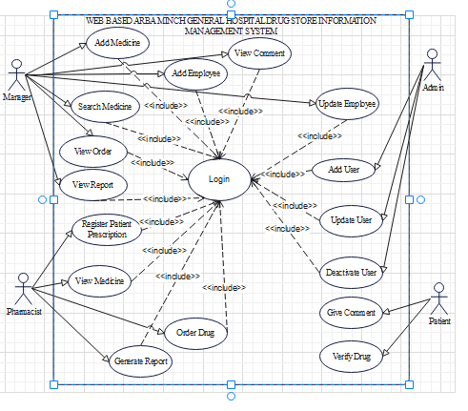

### Use case of documentation (for each case identified)

The following successive tables show the use case documentation for each of the use cases that has been identified in the above use case diagram. Each table contains the use case name, the actor which initiates and interacts with the use case, description of each use case and typical course of event that show the interaction between the actor and the use case which enable the team easily depict the function of the proposed system.

1. The use case documentation for Login

|  |  |  |
| --- | --- | --- |
| Use case name | Login | |
| Actor | Manager, Administrator, pharmacist | |
| Description | This use case describes the process of submitting user name and password to the database | |
| Precondition | User should have username and password or he/she should be a member of the system | |
| Post condition | The user is authenticated and the system displays all features available for the user with their role is associated. | |
| Basic course of Action | Action | System |
| Step1: users should click login button  Step 3: Users should fill login detail and submit it to the database | Ste2: system redirect to the Login page  Step4: System checks the user ID and Password of manager from the database if it exists or not.  Step5: If the user ID and password is valid, users page is displayed |
| Alternate course of Action | If users submit invalid information to database , send a notification to the user to re_ submit valid information | |

1. The use case documentation for create account

|  |  |  |
| --- | --- | --- |
| Use case name | Add User | |
| Actor | Administrator | |
| Description | This use case describes the process of creating new account to employees. | |
| Precondition | Administrator should login system | |
| Post condition | Administrator should create new account to employees. | |
| Basic course of Action | Actor action | System action |
| Step 1: Administrator clicks on “create account” button.  Step 3: Administrator inserts all required information and clicks submit button. | Step 2: Redirect to Manage Account page  Step 4: Checks the validity of the information and save information in database  Step 5: Display Successful message. |
| Alternate course of action | If some of the fields are not filled, sent a notification to the administrator to fill all the fields again | |

Table 8 Creating an Account table

3 The use case documentation for verify drug

|  |  |  |
| --- | --- | --- |
| Use case name | Verify drug | |
| Actor | User | |
| Description | This use case describes the process of verifying medicine in the drugstore. | |
| Precondition | User should initiate system | |
| Post condition | System should show detail of drug to user. | |
| Basic course of Action | Actor action | System action |
| Step1: user should initiate system click verify Button  Step3: user submits verify ID to the system  Step7: user can view drug information. | Step2: Redirect the verify page.  Step4: Check if verifying ID is valid or not from the database.  Step5: If verifying ID is valid, verify page is displayed.  Step6: display all medicine information.  Step8: user services are confirm the system sent provide receipt to the student. |
| Alternate course of action | If the verification ID is invalid, the system displays error message. | |

Use case documentation for delete account

|  |  |  |
| --- | --- | --- |
| Use case name | Deactivate Account | |
| Scenario 4 | Block user account | |
| Actor | Administrator | |
| Pre-Conditions | Account should be created. | |
| Post-Conditions | the account is deactivated successfully | |
| Description | This activity is performed when the administrator wants to deactive user account. This means, user may leave or stop because of some problems so user account will be deactivated. | |
| Basic course of action | Actor action | System response |
| 1**:** System administrator initiate to login  3: System administrator enters username, user type and password.  6: System administrator select delete user account page. Or create account.  If delete account  8**:** User searches any account he/she want to delete by using ID.  11. The user click Deactivate button to the searched account.  14. The user clicks yes. | 2**:** System displays login page.  4**:** System checks the validity and then authentication and authorization of username, user type and password.  5**:** System displays admin page  7**:** System display deactivate account page.  9. The system validates the existence of the account.  10: The system displays the searched account.  12. The system displays “are you sure you want to deactivate”.  15: System deactivates user account.  16: System display account deactivated successfully. |
| Alternative course of action | Step 4: If the username, user type and password is not validated and verified, system displays error message and go to step 2, searched account not exist system display, user not found use case continue with step 2. | |

Table 11 Use case documentation for update account

|  |  |  |
| --- | --- | --- |
| Use case name | Update Account | |
| Scenario 5 | Update user account | |
| Actor | Admin, user | |
| Pre-Conditions | The user has been needed to access system | |
| Post-Conditions: | The user able to get modified user account | |
| Description | This activity is performed when the administrator wants to update user account. | |
| Basic course of action | Actor action | System response |
| 1**:** System user initiate to login  3: System user enters username, user type and password.  6: System user select update user account page.  I  8**:** User search any account he/she want to update by using ID.  12. The user click Update button to the searched account.  14. The user fills the update. | 2**:** System displays login page.  4**:** System checks the validity and then authentication and authorization of username user type and password.  5**:** System displays Admin page.  7**:** System display update account page.  9: The system validate the entry data is valid.  10. The system validates the existence of the account.  11: The system displays the searched account.  13: The system displays the update form.  15: The system validates the entry.  16: System changes the account and display successful message. |
| Alternative course of action | Step 4: If the username, user type and password is not validated and verified, system displays error message and go to step2, searched account not exist system display, user not found use case continue with step 2. Manager leave the form unfilled**,** system informs form fill is required, use case continues with step 2. | |

Use case documentation for add feedback

|  |  |  |
| --- | --- | --- |
| Use case name | Add feedback to the system | |
| Scenario 6 | Giving feedback | |
| Actor | User | |
| Pre-Conditions | The User need to initiate the system | |
| Post-Conditions | Entered user comment or suggestion saved and viewable to admin | |
| Description | This activity is performed when user wants to give feedback about the strength and weakness of the system. | |
| Basic course of action | Actor action | System response |
| 1**:** The user initiates the system.  3: student click on add feedback button.  5: User writes a comment.  9. Use case end. | 2**:** System displays home page.  4: System display comment form.  6**:** The system validate the entry data is valid.  7: The system save the comment.  8**:** System displays your comment saved successfully. |
| Alternative course of action | Step 4: The user leave the form un-filled, system display error fill the form, use case continues with go to step 3, user case end.The user entered invalid data,the system describes which entered data was invalid the use case continues step 3, use case end. | |

Table 14 Use case documentation for view feedback

|  |  |  |
| --- | --- | --- |
| Use case name | View feedback | |
| Scenario 11 | View feedback | |
| Actor | Admin/Manager | |
| Pre-Conditions | The administrator must login success fully | |
| Post-Conditions | View the feedback from the patient and from any user of system. | |
| Description | This activity is performed when the administrator wants to view feedback. | |
| Basic course of action | Actor action | System response |
| 1**:** The user click on login button the system.  3: System administrator enters username, user type and password.  6: System administrator select view feedback button.  8: The admin can view all user comments now. | 2**:** System displays login page.  4**:** System checks the validity and then authentication and authorization of username user type and password.  5**:** With successful login to the system, system displays admin page.  7: The system displays all user comments for the administrator. |
| Alternative course of action | Step 4: If the username, user type and password is not validated and verified, system displays error message and go to step 2. | |

Table 15 Use case documentation for add patient info

|  |  |  |
| --- | --- | --- |
| Use case name | Register patient prescription | |
| Scenario 12 | Add Patient prescription | |
| Actor | Pharmacist | |
| Pre-Conditions | The Pharmacist must login success fully | |
| Post-Conditions | The patient prescription information has been recorded success fully. | |
| Description | This activity is performed when Pharmacist add patient information and prescription. | |
| Basic course of action | Actor action | System response |
| 1**:** The user click on login button from the home page of the web based Drugstore management system.  3: System Pharmacist enters username, user type and password.  6.The user click add patient prescription button.  8:The Pharmacist will fill the data which is to be added. | 2**:** System displays login page.  4**:** System checks the validity and then authentication and authorization of username user type and password.  5**:** With successful login to the system, system displays Pharmacist page.  7:The system display form to add necessary information about patient detail.  9: The system will check format validity.  10. The system saves added data to database. |
| Alternative course of action | Step 4: If the username, user type and password is not validated and verified, system displays error message and go to step 2. | |

Table 15 Use case documentation for update patient information

|  |  |  |
| --- | --- | --- |
| Use case name | Update Employee information | |
| Scenario 12 | Update user status | |
| Actor | Admin | |
| Pre-Conditions | The Admin login success fully | |
| Post-Conditions | The employee information has been updated success fully. | |
| Description | This activity is performed when employee changed and need additional information the Manager update employee status to the system. | |
| Basic course of action | Actor action | System response |
| 1. The user clicks the update patient info button.  8: The Admin will fill the data which is to be updated. | 7: The system display form to update necessary information about employee.  9: The system will check format validity.  10. The system saves updated data to database. |
| Alternative course of action | Step 4: If the username, user type and password is not validated and verified, system displays error message and go to step 2. | |

Table 15 Use case documentation for view medicine

|  |  |  |
| --- | --- | --- |
| Use case name | View Medicine | |
| Scenario 12 | View medicine | |
| Actor | Manager and pharmacist | |
| Pre-Conditions | The users must access the system success fully | |
| Post-Conditions | The medicine must viewable success fully. | |
| Description | This activity is performed when users wants to check and view medicine. | |
| Basic course of action | Actor action | System response |
| 1**:** The user initiates the home page of the web based drugstore management system click login button.  3: the users enter their username and password.  5. The user click view medicine menu.  8: The user will view the medicine status. | 2**:** System displays login page.  4: system validate and authenticate the provided username and password if it correct and valid the system redirect users to their respective page.  7: The system displays all necessary information about medicine. |
| Alternative course of action | Step 4: If the username and password is not validated, system displays error message and go to step 2. | |

Table 15 Use case documentation for add drug prescription

|  |  |  |
| --- | --- | --- |
| Use case name | Add drug/ Medicine | |
| Scenario 12 | Add medicine | |
| Actor | Manager | |
| Pre-Conditions | The manager must login success fully | |
| Post-Conditions | The drug/medicine information has been recorded success fully. | |
| Description | This activity is performed when manageradd new drug and treatment to drugstore database. | |
| Basic course of action | Actor action | System response |
| 1. The user click add drug/medicine button.  3: The manager will fill the data which is to be added. | 2: The system display form to add necessary information about medicine.  4: The system will check format validity.  5. The system saves added data to database. |
| Alternative course of action | Step 4: If the username, user type and password is not validated and verified, system displays error message and go to step 2. | |

Table 15 Use case documentation for view prescription

|  |  |  |
| --- | --- | --- |
| Use case name | View report | |
| Scenario 12 | View report | |
| Actor | Manager and admin | |
| Pre-Conditions | The users must login success fully | |
| Post-Conditions | The report information has been viewable success fully. | |
| Description | This activity is performed when users need to view report on drug, prescription, patient, sales. | |
| Basic course of action | Actor action | System response |
| 1. The user click view report button.   3. The users view any report related to drugstore. | 2: The system display necessary information about report detail. |
| Alternative course of action | Step 4: If the username, user type and password is not validated and verified, system displays error message and go to step 2. | |

# Sequence Diagram

A sequence diagram in a UML is a kind of interaction diagram that shows how processes operate with one another and in what order. A sequence diagram shows object interactions arranged in time sequence. It depicts the objects and classes involved in the scenario and the sequence of messages exchanged between the objects needed to carry out the functionality of the scenario. It shows, as parallel vertical lines (lifelines), different processes or objects that live simultaneously, and, as horizontal arrows, the messages exchanged between them, in the order in which they occur. This allows the specification of simple runtime scenarios in a graphical manner.

Figure 1Sequence diagram for login



Figure 2Sequence diagram for create user account

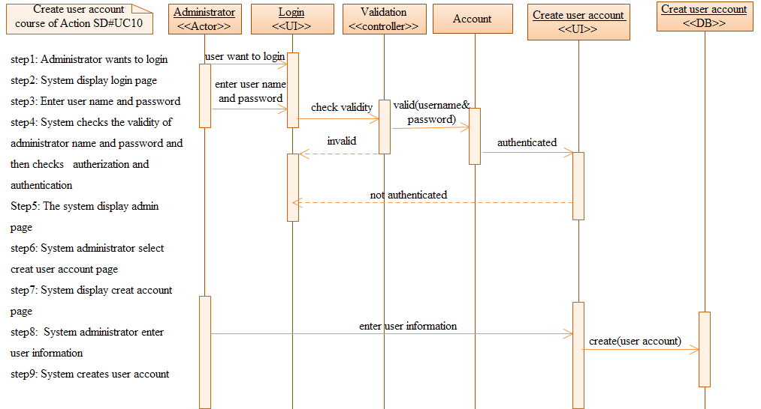

Figure 3Sequence diagram for Delete user account

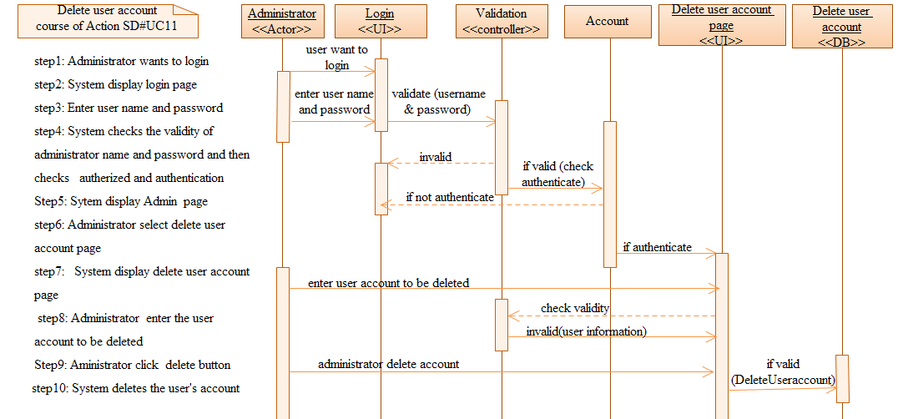

Figure 4 Sequence diagram for Order diminished drug



Figure 5Sequence diagram forGive comment



Figure 6Sequence diagram forRegisterNew drug



Figure 7Sequence diagram forVerify drug



Figure 8Sequence diagram for view expired drug



### Activity Diagram

Activity diagram is another important diagram in UML to describe dynamic aspects of the system. Activity diagram is basically a flow chart to represent the flow form one activity to another activity. The activity can be described as an operation of the system. So the control flow is drawn from one operation to another. This flow can be sequential, branched or concurrent. Activity diagrams deals with all type of flow control by using different elements like fork, join etc.

**Purpose:**

The basic purposes of activity diagrams are similar to other four diagrams. It captures the dynamic behavior of the system. Other four diagrams are used to show the message flow from one object to another but activity diagram is used to show message flow from one activity to another.

Activity is a particular operation of the system. Activity diagrams are not only used for visualizing dynamic nature of a system but they are also used to construct the executable system by using forward and reverse engineering techniques. The only missing thing in activity diagram is themessage part. It does not show any message flow from one activity to another. Activity diagram is some time considered as the flow chart. Although the diagrams looks like a flow chart but it is not. It shows different flow like parallel, branched, concurrent and single.

1. Activity diagram for login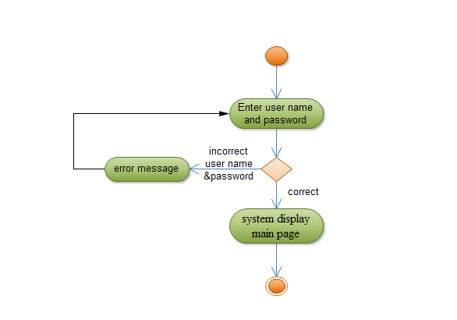
2. Activity diagram for Generate report

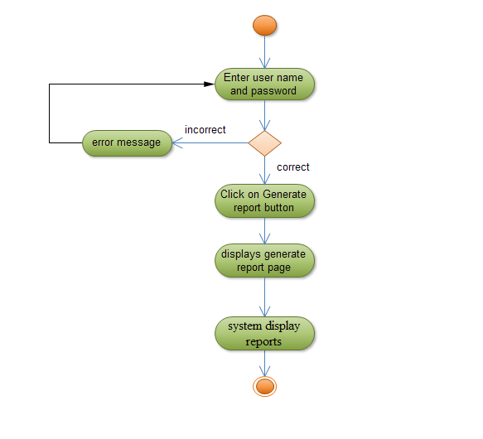

Figure 9Activity diagram for generate report

1. Activity diagram for Administrator create user account

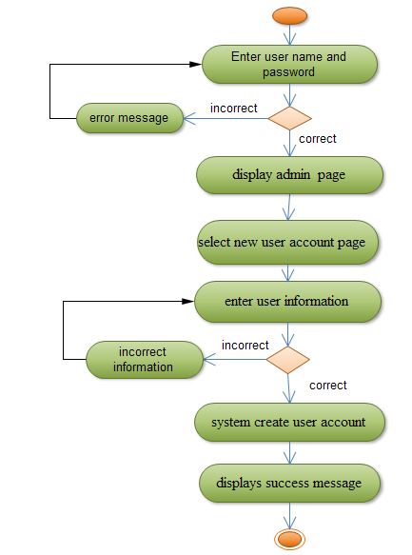

Figure 10Activity diagram for create user account

1. Activity diagram for delete user account

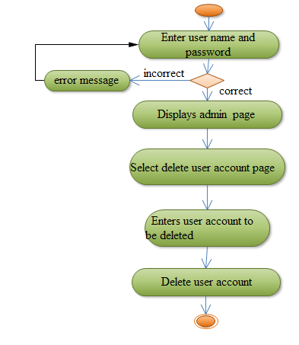

Figure 11Activity diagram for delete user account

Activity diagram for add feedback



New medicine



New prescription



View medicine



View expired medicine



Order new medicine



View ordered medicine



# User interface design

User interface design is the design of computers, applications, software application and websites with the focus on the user‘s experience and interaction. Users communicate with the system through the following user interfaces.

Home Page: This form appears on the site in which the system deployed is opened and contains some links which lead the user to other page according to his privilege, and if the user is authorized user or has an account, he/she will directly go to the page that he want by entering correct username and password.