## CHAPTER THREE

## SYSTEM ANALYSIS

## OVERVIEW OF PROPOSED SYSTEM

The web based student clearance management system is to be developed to minimize the problem of current system as it described in the drawback back of current system on previous chapter which describe existing system. The new proposed system should be effective at the time of registration, update, search, and generate report. In the proposed system analysis phase the document we stated describes the functionalities of the system in terms of use case from the users’ point of view. But in the design phase those functionalities of the system shall be decomposed into smaller sub system to easily handle by developer. There is a centralized database, saving different data that are used to manage service of the student clearance

## SYSTEM REQUIREMENT SPECIFICATION (SRS)

### Use Case Model

A use-case model is a model of how different types of users interact with the system to solve a problem.  As such, it describes the goals of the users, the interactions between the users and the system, and the required behavior of the system in satisfying these goals. A use-case model consists of a number of model elements.  The most important model elements are: use cases, actors and the relationships between them.

#### **Use case diagram**

A use case diagram illustrates a set of use cases for a system, the actors of these use cases, the relations between the actors and these use cases, and the relations among the use cases. The UML notation for a use case diagram is shown on the figure, in which

* An oval represents a use case,
* A stick figure represents an actor,
* A line between an actor and a use case represents that the actor initiates and/or participates in the process.

**Actors of the system:** The following are the identified actors (users) that will be participating in the system.

* Student
* Officer: are different office employees who sign clearance form. Like College Dean, Academic Vice Dean, Student Support Service, Community and Research Officer, Department head, Librarian, Financer.
* Registrar: are officers who administer our system, manage student’s information and approve the student clearance at the end and take a backup to student clearance form.

Once we identify the system user [Actors], the next thing will be to specify the various types of functionality that the system will offer to this actors and the various functionality that they initiate from the system.

1. Student Actor
   * Fill form
   * Request a special need/ask for clearing
   * Submit to registrar
2. Officer
   * Borrow prosperities for the students and check whether they are return or not
   * After that they sign on the form and cleared the students
3. College Dean
   * Check whether the course coordinator sign to the clearance form and the sign to the clearance form if the course coordinator signs.
   * Check whether the students fill coast sharing form and complete their responsibilities
   * Sign and cleared the students
4. Registrar
   * Prepare and Distribute student clearance form
   * Cleared the student clearance and take backup

###### Students Services office

* + Include café and dormitory service officers
  + Sign and cleared the Students

## USE CASE SELECTION

The following are the use cases that included in STBC Clearance system

* + Prepare Student Clearance Form

###### Clear the Students

* + Asking For Clearance Form

###### Take Cleared Clearance Form

* + Store Cleared Student Clearance

## ESSENTIAL USECASE DIAGRAM [CURRENT SYSTEM MODELLING]

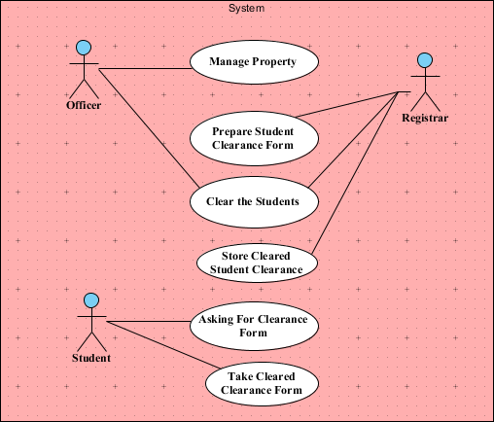

**Figure** 1Essential Use Case Diagram

## ESSENTIAL USE CASE DESCRIPTIONS [CURRENT SYSTEM]

###### Table 10 Preparing student clearance form use case Description

|  |  |  |  |
| --- | --- | --- | --- |
| **Use Case Name:** | **Preparing** | **Student Clearance** | **Form** I**D:** 1 |
| Participating Actor | Registrar | | |
| Description | The registrar Prepare student clearance form at any time. | | |
| Entry condition | The Registrar always should have printed Clearance form for the student in their office | | |
| Flow of event | 1. The Registrar have a soft copy of student clearance form 2. They print out and document in their Office | | |
| Exit condition | The Registrar document and Store a clearance Form | | |

Table 11Asking for clearance form use case Description

|  |  |  |  |
| --- | --- | --- | --- |
| **Use Case Name:** | **Asking for** | **Clearance Form** | I**D:** 2 |
| Participating Actor | Students | | |
| Description | The Student ask clearance form from Registrar when they want to sign clearance. | | |
| Entry condition | Students must decide to signing clearance form | | |
| Flow of event | 1. The Registrar have a soft copy of student clearance form in their office 2. They print out and document in their Office 3. Students ask clearance form from Registrar 4. Registrar give a clearance form paper to the student | | |
| Exit condition | The Registrar give clearance form to students | | |

###### Table 12 Clearing Student use case Description

|  |  |  |  |
| --- | --- | --- | --- |
| **Use Case Name:** | **Clearing** | **Students** | I**D:** 3 |
| Participating Actor | Officer & Registrar | | |

|  |  |
| --- | --- |
| Description | The above Actors Clear the Students by Signing on the Clearance Form if the student doesn’t have any Responsibility. |
| Entry condition | The Student Must be asking for signing clearance |
| Flow of event | 1. The Registrar have a soft copy of student clearance form 2. They print out and document in their Office 3. The Students ask a clearance form from Registrar when they want to sign clearance 4. By taking the clearance form they Travel into different office to sign clearance 5. The officers sign and clear the student if they do not have borrowed material that does not return. 6. The Students then cleared and submit to registrar |
| Exit condition | The Students get Cleared at the registrar |

Table 13 Manage Property use case Description

|  |  |  |  |
| --- | --- | --- | --- |
| **Use Case Name:** | **Manage** | **Property** | I**D:** 6 |
| Participating Actor | Officers | | |
| Description | The officers manage the property of the university by borrowing and receiving the borrowed material | | |
| Entry condition | There student should be borrow the material from officers | | |
| Flow of event | 1. The officers lend the property to the student of the University who want to borrow the material 2. The officer must record the material they borrow with the full address of the borrower 3. The officer delete the record when the borrower return the material they borrow 4. Sign and clear the student | | |
| Exit condition | Validate students as they do not have any property they borrow | | |

###### Table 14Take Cleared Clearance Form use case Description

|  |  |  |  |
| --- | --- | --- | --- |
| **Use Case Name:** | **Take** | **Cleared Clearance Form** | I**D:** 7 |
| Participating Actor | Student | | |
| Description | Student of STBC take a cleared Clearance form after they approved at registrar and submit to registrar. | | |
| Entry condition | The Students must sign in different officers, submit at registrar and must be cleared at Registrar | | |
| Flow of event | 1. Students wish to sign Clearance form 2. Student go to Registrar and ask for clearance form 3. Registrar give Clearance for to the Student 4. Students travel to different officers and sign clearance 5. Student go to registrar and submit cleared clearance form to the registrar officer 6. Registrar officers approved Student’s clearance form and   give to the student | | |
| Exit condition | Students take approved/cleared clearance form | | |

Table 15 Store Cleared Clearance Form

|  |  |  |  |
| --- | --- | --- | --- |
| **Use Case Name:** | **Take** | **Cleared Clearance Form** | I**D:** 8 |
| Participating Actor | Registrar | | |
| Description | Registrar Officers approve the student’s clearance and take a piece of cleared clearance paper as a backup. | | |
| Entry condition | The Students must sign in different officers, submit at registrar and must be cleared at Registrar | | |
| Flow of event | 1. Students wish to sign Clearance form 2. Student go to Registrar and ask for clearance form 3. Registrar give Clearance for to the Student 4. Students travel to different officers and sign clearance 5. Student go to registrar and submit cleared clearance form to the registrar officer 6. Registrar officers approved Student’s clearance form and take a piece of cleared clearance form paper and the give   the other piece of cleared clearance form to the student | | |

|  |  |
| --- | --- |
| Exit condition | Registrar officers store a backup of cleared clearance form of the student |

## PROPOSED SYSTEM ACTOR INDENTIFICATION

An Actor in the Unified Modeling Language (UML) "specifies a role played by a user or any other system that interacts with the subject. The followings are a list of Actors in the Proposed System.

###### Registrar: is someone who uploads material lends student information to the central database and print the approved clearance form and put the seal of the university.

* Officers: is someone who upload material lends student e information to the central database.
* Student: is someone who wishes to sign clearance form due to different reason and at the end of each year.

## USE CASE SELECTION

The following are the use cases that will include in STBC Student Clearance system

###### Manage student clearance

* Manage material lend student information

###### Manage User account

###### Fill Clearance Form

* Request for Approval

###### Save the valid Clearance form

* Manage Student Information

###### Print approved clearance form

* Take Cleared Clearance form

## ESSENTIAL USE CASE DIAGRAM [PROPOSED SYSTEM MODELLING]

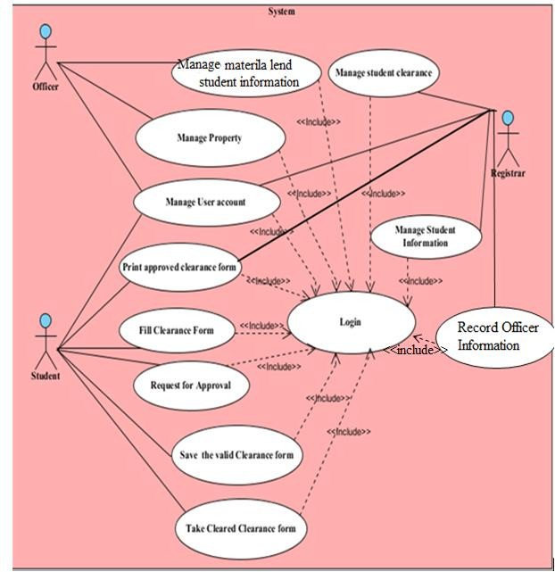

**Figure 2** Essential Use Case Diagram for Proposed System

## NEW SYSTEM DESCRIPTIONS

In the beginning, the above actors will login in to the system based on the access privilege. The officers login into their page and record detail information about the materials and the name of the borrower when the students borrow material. They also upload the student information and the type of material they borrow to the central database. Registrar also login in to their page and manage Student information on their database. The registrar will have a database of student information and the material they borrow from different officers. The student login into their page and will fill the clearance form. The student will request to the central for approval. The system checks their information on the central database and if their information does not exist, the system clear the clearance but if there exist the system reject the request with a message as they have responsibility on that officer. The students save and print the cleared clearance form and sign out from the system. The students have a privilege to change their login password but they cannot change their login user name, also they can recover forget password.

## ESSENTIAL USE CASE DESCRIPTIONS [PROPOSED SYSTEM]

**Table** 16Login use case description

|  |  |
| --- | --- |
| Use case name | Login I**D:** 1 |
| Participating actor | All system user |
| description | Any user who wants to access the system’s functionality must be Authenticated and Authorized and login to the system. |
| Entry condition | The user must be already register (the user must have user name, password and account type) |
| Flow of event | 1. The user open the system 2. The user click login link 3. The system display the login page 4. The user enter his/her identification (user type user name and password) 5. The user click on login button 6. The system takes the user to his/her page. |
| Alternative Flow of event | Step 5, If the identification is not correct the system display incorrect user type, user name and password try again message and the system display the login page. The system give chance to try again. |
| Exit condition | The system user logged in to the system |

|  |  |
| --- | --- |
| Entry condition | Officer login to the system, the property already exist. |
| Flow of event | 1. Officer select on update record Menu. 2. The system display an acknowledgement successfully Edit the information. |
| Alternative Flow of event | Step 3. If the property is not found the system display “information not found” message.  Step 3.If Officer enter wrong information the system displays a message to correct. |
| Exit condition | Modification is recorded. |

**Table 20** upload material lend student information use case description

|  |  |
| --- | --- |
| Use case name | upload material lend student information I**D:** 5 |
| Participating actor | Officer |
| description | This use case helps for Officer to upload material lend student information to the central database |
| Entry condition | Officer login to the system |
| Flow of event | 1. Officer select on upload student information Menu. 2. The system display material lend student information form. 3. Officer fills required information and click save button. 4. The system displays an acknowledgement successfully record the information. |
| Alternative Flow of event | Step 3. If Officer enters wrong information the system display message in order to correct wrong information.  Step 4. If Officer enters duplicate property information the system display “information already exist” message. |
| Exit condition | Materials lend student information uploaded to the central database. |

###### Use case description for account management use case this is general use case for

* + - Create user account

###### Update user account

* + - Delete user account

###### Recover forgotten password use cases

* + - Change Password

###### **Table 21** Create user account use case description

|  |  |
| --- | --- |
| Use case name | Create user account I**D:** 6 |
| Participating actor | Registrar |
| description | This use case helps the user when it is necessary to create new user account. |
| Entry condition | user login to the system |
| Flow of event | 1. User selects Record Student information from menu bar. 2. The system display Student Registration form. 3. User fills all information and click upload button. 4. The system crate new user account 5. The system save the new account 6. The system display an acknowledgement successfully crate the account |
| Alternative Flow of event | Step 3. If user enters wrong the system display message in order to correct wrong information.  Step 4. If users enters duplicate account the system display “information already exist” message. |
| Exit condition | A new user account is crated |

**Table** 22 Update user account use case description

|  |  |
| --- | --- |
| Use case name | Update user account I**D:** 7 |
| Participating actor | Registrar |
| description | This use case helps the users when he/she wants to update their account. |
| Entry condition | User login to the system |
| Flow of event | 1. User selects Manage account link from menu bar. 2. The system display user account form. 3. User search account that he/she want to update. |
|  | 1. The system display information of that account. 2. User makes necessary modification and click Update button. 3. The system asks for conformation. 4. User click ok button. 5. The system saves the change to that account. 6. The system displays an acknowledgement successfully updating the account. |
| Alternative Flow of event | Step 3.If the user account does not exist the system display “account not found” information. |
| Exit condition | Save the change to the account |

###### **Table 23** Change Password use case description

|  |  |
| --- | --- |
| Use case name | Change Password I**D:** 8 |
| Participating actor | All system user |
| description | This use case helps the user when it is necessary to change login password. |
| Entry condition | user login to the system |
| Flow of event | 1. user login to the system 2. User selects change password link. 3. The system display password change form. 4. User fills all information and click change button. 5. The system change the password and save the new password 6. The system display an acknowledgement of password change successfully |
| Alternative Flow of event | Step 3. If user enters wrong the system display |
|  | message in order to correct wrong information.  Step 4. If users input does not exist in the database the system display the password does not exist message |
| Exit condition | A new user account is crated |

**Table 24** Delete user account use case description

|  |  |
| --- | --- |
| Use case name | Delete user account I**D:** 9 |
| Participating actor | Registrar |
| description | This use case helps the user to delete user account if it is no more necessary. |
| Entry condition | The user login to the system, the account exists. |
| Flow of event | 1. Users select Manage account from menu bar 2. the system select Delete account link 3. Users search account who wants to delete. 4. The system display information of that account. 5. User click delete button. 6. The system deletes the account. 7. The system display an acknowledgement successfully deletes the account. |
| Alternative Flow of event | Step 3.If the user account does not exist the system display “account not found” information. |
| Exit condition | the account is deleted |

###### **Table 25** Recover forgotten password use case description

|  |  |
| --- | --- |
| Use case name | Recover forgotten password I**D:** 10 |
| Participating actor | Student |
| Description | The system users may forget their password so  this use case help to the system user to recover |
|  | the forget password . |
| Entry condition | The user must be previously register |
| Flow of event | 1. The user click on forgotten password button 2. The system display forget password recover form 3. The user will enter all required information and click on display button. 4. The system retrieves the password and display on their page and will display acknowledgment successfully retrieve the password. |
| Alternative Flow of event | Step 4.if the user miss required information the system display the message to fill all required information |
| Exit condition | The user knows their password |

**Table 26** Approving Student Clearance use case description

|  |  |  |  |
| --- | --- | --- | --- |
| Use Case Name: | Approving | Student Clearance | ID: 11 |
| Participating Actor | System, Registrar | | |
| Description | The system checks the name and ID of the student on the registrar database and approve if not exist, Registrar take the approved clearance form from the student and approve the clearance form for the last time by putting the seal of the university and their signature. | | |
| Entry condition | The Student Must be Requesting for Approving clearance | | |
| Flow of event | 1. The Registrar have a database of Student and the material they borrow 2. The students login in to the system 3. Student click clearance form link 4. The system display student clearance Form 5. The students fill the required information in students clearance form 6. The student click the approve button 7. The system checks the student information on the registrar Database | | |
|  | 1. The system clears the student and displays the cleared clearance form. 2. The Student save and print the cleared clearance 3. Students go to Registrar and cleared at the end. | | |
| Exit condition | The Students get Cleared | | |

###### **Table 27** Rejecting Student Clearance use case description

|  |  |  |  |
| --- | --- | --- | --- |
| Use Case Name: | Rejecting | Student Clearance | ID: 12 |
| Participating Actor | System, Registrar | | |
| Description | The system and registrar checks the ID of the student on the registrar database and reject if exist. | | |
| Entry condition | The Student Must be Requesting for Approving clearance | | |
| Flow of event | 1. The Registrar have a database of Student and the material they borrow 2. The students login in to the system 3. Student click clearance form link 4. The system display student clearance Form 5. The students fill the required information in students clearance form 6. The student click the submit button 7. The system checks the student information on the registrar Database 8. If the student information exists the system rejects the clearance request with a notification in which office the student have responsibility 9. The displays again on student clearance form page | | |
| Exit condition | The Students clearance request Rejected | | |

**Table 28** Requesting for Clearance approval use case description

|  |  |  |  |
| --- | --- | --- | --- |
| Use Case Name: | Request for | Clearance approval | ID: 13 |
| Participating Actor | Students | | |
| Description | Students click the submit button after they fill the required information to request for clearance approval. | | |
| Entry condition | Student Must fill the required information on the clearance form and click the submit button | | |
| Flow of event | 1. Student login into their own page 2. Students fill the required information on the clearance form 3. Students click the submit button | | |
| Exit condition | Students waiting until the system say some thing | | |

###### **Table 29** Filing clearance form use case description use case description

|  |  |  |  |
| --- | --- | --- | --- |
| Use Case Name: | Fill Clearance | Form | ID: 14 |
| Participating Actor | Students | | |
| Description | Students fill the clearance form on their own page | | |
| Entry condition | Students must be login in to the system | | |
| Flow of event | 1. Student login into their own page 2. Students click the clearance form link 3. The system display the clearance form 4. Students fill the required information on the clearance form | | |
| Exit condition | The required information on Clearance form Filled | | |

**Table 30** Mange student information use case description

|  |  |  |  |
| --- | --- | --- | --- |
| Use Case Name: | Manage Student | Information | ID: 15 |
| Participating Actor | Registrar | | |
| Description | Registrar upload the student information and give user name, password and privilege to the student | | |
| Entry condition | Registrar users must be login to the system to their own page. | | |
| Flow of event | 1. Click record student information link 2. The system display the record student information form | | |
|  | 1. The user fill the required field and click add button 2. The system validated the user input and save the data into the database | | |
| Exit condition | Student information inserted to the student information table | | |

**Table 31** Take Cleared Clearance form use case description

|  |  |  |  |
| --- | --- | --- | --- |
| Use Case Name: | Take | Cleared clearance Form | ID: 16 |
| Participating Actor | Student | | |
| Description | Students of STBC sing Clearance online and then they take the approved clearance form | | |
| Entry condition | Students must sign clearance and they must approved by the system and Registrar officer. | | |
| Flow of event | 1. Students wish to sign clearance 2. Students access our system 3. Student login to their page using user name and password 4. Students Click the clearance form link 5. The system display Clearance form 6. Students Fill the clearance form 7. The system check the students information in the central database 8. The system display the cleared clearance form 9. Student save the cleared clearance form 10. Student Go to Registrar 11. Registrar Print the cleared clearance form and approve the student clearance form | | |
| Exit condition | Student take the approved clearance form | | |

**BR 11**-The student must be approved by Registrar officers for the last approval

**BR 12** – The registrar officer should check whether the students are responsible or not on different officer before signing his/her signature and sill of STBC.

**BR 13**- The Registrar officer should first check whether the student approved by the system or not before putting his/her signature on the clearance form.

**BR 14-** The registrar officer should sign and put the sill of STBC on student clearance form which is approved by the system.

* 1. **ESSENTIAL USER INTERFACE**

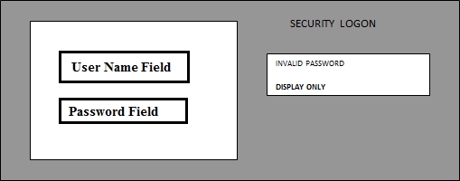

**Figure 3 :** Essential Security Login

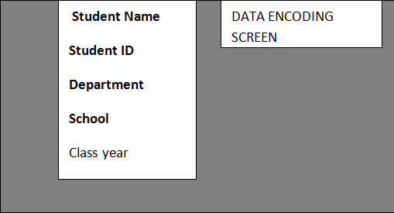

**Figure 4** : Data Entry Screen

##### DYNAMIC MODEL

* + 1. Sequence Diagram

Sequence diagram describes interaction among classes of the STBC Student Clearance management system such as Students, officers and Registrar administrator’s terms of signing clearance form overtime. It models the behavior of these classes within a use case.

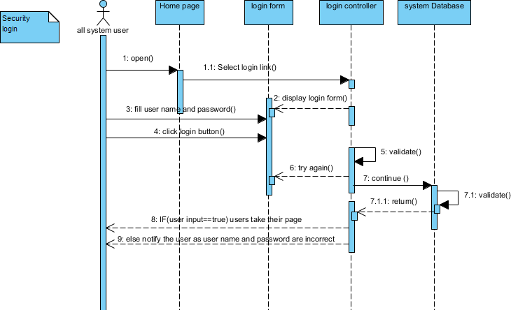

**Figure 5** Sequence Diagram for Login Use case

All the system users open the system and the system display the login page. Then the system user fill the login form fields and the system validate the users input, the user click the login button, the login form creates the login form controller which allow to execute the users input from the database, the systems database validate the users Identification and return the result to the login controller. Login controller validates the result and displays their page to the user. Then the system user work on their own page whatever they want to do.

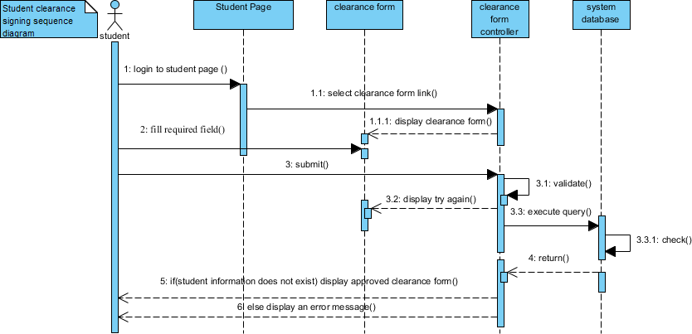

**Figure 6** Sequence Diagram for Signing Clearance Form Use case

This sequence diagram shows the steps how the students of STBC follow to sign clearance online. To sign clearance online the student of the university must be registered and later login based on the previous registration. The user open the system and fill the login form field , click login button, then the system display clearance form page. Students fill the required filed on their own page and click the submit button. The users input validated by the system and creates clearance form controller which allow executing the users input from the database. The systems database validates the query and returns the result to clearance form controller. Then if the users input are valid in systems database the system display the cleared and printable page and create print controller to execute the users command. The system user clicks the print button and takes the cleared clearance form. But if the user’s information

exists in the central database the system notify the user by telling they have responsibility that they must complete and where they have responsibility.

* + 1. Activity Diagram

Activity diagram is another important diagram in UML to describe dynamic aspects of the system. Activity diagram is basically a flow chart to represent the flow from one activity to another activity. The activity can be described as an operation of the system.

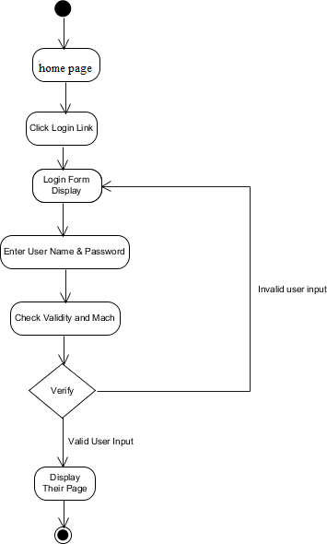

**Figure 7** Activity diagram for login

The above diagram show the activities performed when the system user login into the system. The user opens the systems home page and clicks the login link. The system displays the login form page. Then they fill the user name and password to login and click the login button. The system validates the users input and display their page if the user input are correct or notify the error and display the login form page.

## Analysis Level Class Diagram

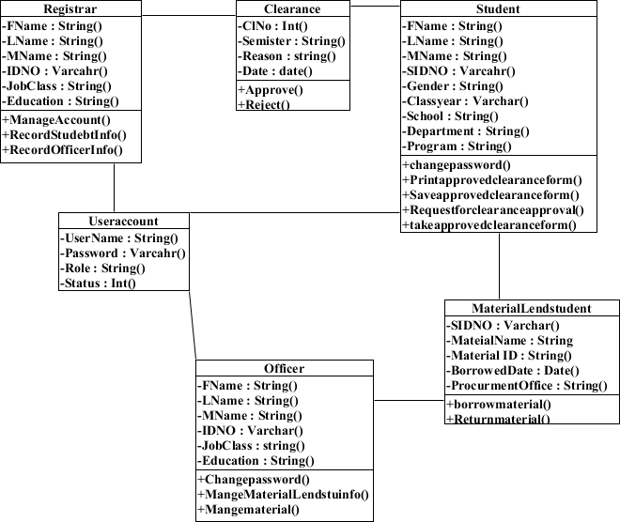

**Figure 8** Analysis Level Class Diagram

## State chart diagrams

UML state machine diagrams depict the various states that an object may be in and the transitions between those states. In fact, in other modeling languages, it is common for this type of a diagram to be called a state-transition diagram or even simply a state diagram. A state represents a stage in the behavior pattern of an object, and like UML activity diagrams it is possible to have initial states and final states. An initial state, also called a creation state, is the one that an object is in when it is first created, whereas a final state is one in which no transitions lead out of. A transition is a progression from one state to another and will be triggered by an event that is either internal or external to the object.

States are depicted as rounded rectangles. Transitions are arrows from one state to another. Events or conditions that trigger transitions are written next to the arrows.

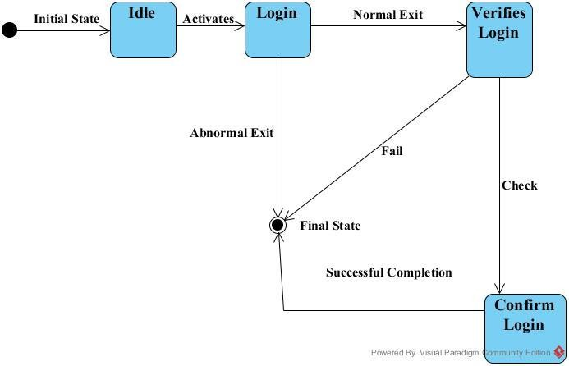

**Figure 9** State chart diagram for login

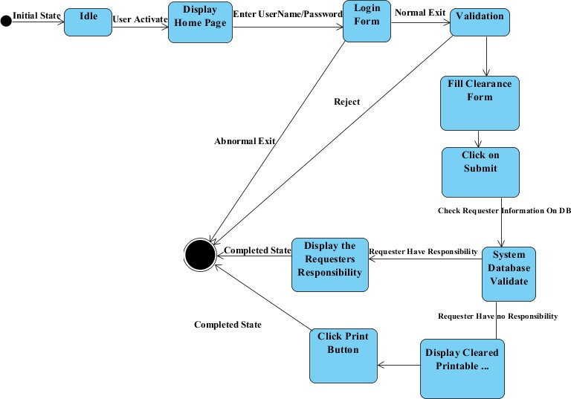

**Figure 10** State-chart diagram for Clearance Form Signing

## STATIC MODEL

Static modeling is used to represent the static constituents of software such as class, objects, Interface and their relationship with each other.

## Class Diagram

Class diagram describe our system in terms of objects, attributes, operations and relationships.

To draw the class diagram, we follow the following steps

1. describing the system functionality shortly, this helps us to identify the class
2. preparation of class responsibility collaborators[CRC]
3. identify the abstraction or class
4. identify the responsibility of each class
5. translating the responsibility of each class in to its attribute and operations needed to perform those responsibility
6. identify the relationship between class
7. finally draw the class diagram of the system based on the above information

###### System functionality description

In the beginning, the student will access the system. After that they login into their page and fill the clearance form. Students who fill the clearance form will send request to the system for approval the system check and cleared. The system displays the printable form and the requester will save and print the clearance form and go to registrar, the Registrar officers print the cleared clearance form paper and put their signature and the seal of the university. Then the students take the approved clearance form paper.

###### Class Responsibility Collaborators [CRC] Identification

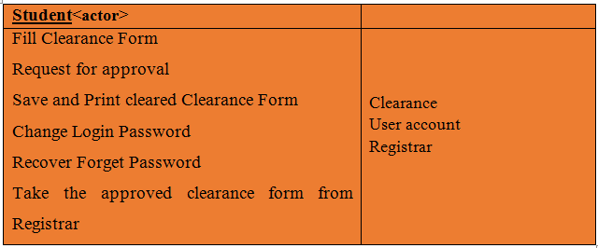

Student class

-this message class is part of clearance package. It helps to manage student information’s Attribute in student class: **-**student class has 7 private attribute and 5 private methods

###### First name:-used to set and get student first name

* Last name:- used to set and get student Last name

###### Sex:-used set and get student sex

* Id number:-used to set and get student id number

###### Facility:-used to set and get student faculity

* Department:-used to set and student department

###### Program :-used to set and get student program

* Class/year:-used to set and get student class/year

###### Academic year:-used to set and get student academic year

Method in student class: - all method in student class is private

###### Save ():- used to insert student information in to the database.

* Show ():- used to show previously store student information
* Print ():- used to print the cleared clearance form
* Change Password ():- used to allow change the login password of the student
* Recover Forget Password ():- used to allow to recover forget password

User account class

-This user account class is part of clearance package. It helps for the Registrar administrator to manage user information.

Attributes in user account object: **-** all attribute in user account class visibility is private those are

###### First name: - used to set and get user first name

* Last name:- used to set and get user last name

###### User type :-used to set get user type

* User name :-used to set get user name

###### Password :-used to set get user password

* ID No:-used to set get user id number

Methods in user account Class:-

###### Save ():- this method used to enter users information in to the database.

* Edit ():- this method used to modify user account information.

###### Delete ():-this method used to delete user information from the database.

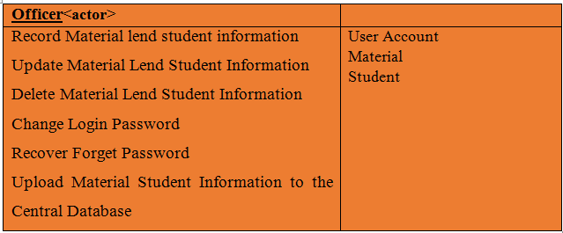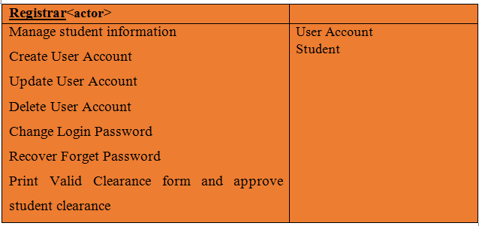

* + - 1. Identify Classes from the Use Case and CRC

***Use cases classes***

###### Fill form, student classes

1. encode-data officer, Registrar and Property classes

###### Login account classes

1. Update, Delete property officer classes

###### Requesting for signing Student and Clearance classes

4. Identifying the responsibility of each class

1. **Student:-**

**Attributes: -** Used to keep information about the student (first name, last name middle name, faculty, department, year, student ID, and program)

**Operation:** Show Clearance (), Print Clearance ()

1. Registrar: -

**Attributes:** First name, last name, middle name, user name, user type, and password

**Operation:** Create user account (), Update user account (), Delete user account (), Change Password (), view Report (), record report (), delete Recorded report (), update recorded report ()

1. account

**Attributes:** username, password and user type

**Operation:** verify account ()

1. Clearance:-

**Attributes:** Reason, Semester, date

**Operation:** Approve (), Reject ()

###### Material:-

**Attributes:** Quantity, Borrow date, material name

**Operation:** lend (), return ()

###### Identifying The Relationship Between Classes

In our class diagram, the following types of relationship exist. Association relationship exists between the following classes:

o Many-to-many relationship: - Officer to Student.

In this case many Officer will have information about many students who borrow materials from officers and many officers may upload many material lend student information to the central Database.

o one-to-one relationship:- Student to account, Registrar to Account, Officers to Account

Each student who is a member of STBC will have only one account and each Officer also will have only one account.

o One-to-many relationship: - Registrar to Student, Student to Material.

In this case one student can borrow many materials from officers and one material can be borrowed by many students. In this case Registrar will have information about many students.

###### Draw the class diagram of the system

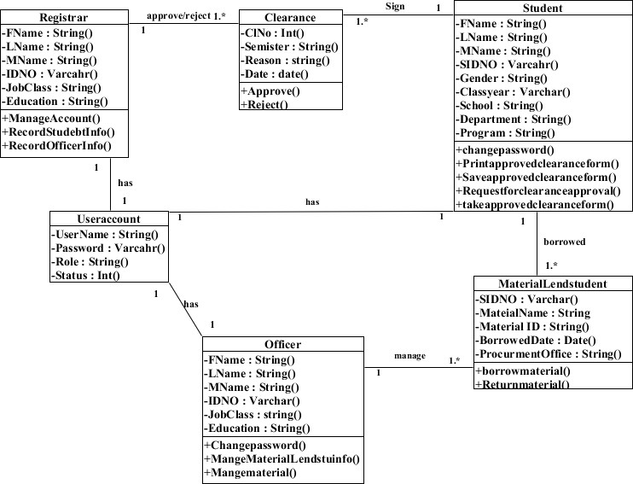

**Figure 11** Design Level Class Diagram