

**SATA TECHNOLOGY AND BUSINESS COLLEGE**

**FACULITY OF INFORMATICS**

**DEPARTMENT OF INFORMATION TECHNOLOGY**

**Project Title: - Web Based Drug Stoke Management System for Arba Minch Nech Sar Primary Hospital**

**Group Members ID**

1. **Sinatyehu**

**A Senior Project proposal**

Submitted to Department of Computer Science and IT, SATA Technology and Business College, in partial fulfillment for the requirement of the Bachelors of Science Degree in Information Technology.

**Advisor’s :**

**March 22, 2022**

**LIST OF ABBREVIATED WORDS**

|  |  |
| --- | --- |
| Word | Description |
| RF | Registration Form |
| ODMS | Online Drugstoke Management System |
| UI | User interface |
| DMS | Drugstore Management System |
| HTTP | Hypertext transfer protocol |
| PHP | Preprocessor hypertext |
| SQL | Structured query language |
| HTML | Hypertext markup language |
| LAN | Local area network |
| JS | JavaScript |
| DB | Database |
| RAM | Random access memory |
| CD | Compact disk |

***List of Tables***

Table 1 team composition 4

Table 2 task and schedule 5

Table 3 economic feasibility 8

# Abstract

Nech Sar Primary Hospital is one of the primary hospitals in Arba Minch that is targeting to give quality service regarding to the health. This project is done in Nech Sar Primary Hospital drug store. This document contains the brief description of background information of the hospital and project, method of data collection and analysis, description of the existing system and modeling and design of the proposed system.

**This current drug stoke management system that is in Nech Sar Primary hospital has a lot of problem since manual system is used. Due to this** we are going to develop online system to support drug stoke management which means information related to the drug are maintained and manipulated easily.

# Chapter One

# Introduction

A drug stoke information management system whose primary goal is to manage the movement and storage information of drug within Nech Sar Primary Hospital which is founded in Arba Minch city, and handle the connected transactions is a main part of the supply chain. Drug stoke management system also manages the medicine based on real-time information about the status of products and storage locations. The proposed system will solve many problems that affect the efficiency and effectiveness of the hospital. Problems such as difficulty to know available drug in store, security problem related to manual information recording, difficulty to identify drug which are near to expire date; there is challenge for pharmacist to order drug from drug store it is time consuming. Therefore the system that we propose will fix this problem through providing online access to manage drug stoke. It also improves the process of recording medicine detail and has security for protecting the data from unauthorized access. In addition to this it generate different report related with supplying drug to system users.

An analysis has been done based on the current manual system and all the problems statements and requirements have been identified. Moreover, drug stoke management system is three tier architecture systems which involve client tier, application tier or business tier and database management tier. More recently, the drug store management is focused on storing stock information such as types of medicines, price, medication review and drug information. Currently, to keep track on purchasing transaction such as stock and order information, manual recording system is used by the store manager. In case of that, the Drug Store Management System (DSMS) will be developed based on the manual system in the real situation of hospital. The interfaces for system will be designed according to the requirement. This Drug Store Management System, (DSMS) will help to improve the performance of current situation and overcome the problems that arise in Arba Minch Nech Sar Hospital

# Background of the project

Most of the drug store nowadays, likes to use file system because it is a traditional way and peoples are comfort with that way. But today, the technologies has changes a lot and because of that almost all the application in the world prefer to use computer as their stored information place. More recently, the drug store management is focused on storing stock information such as types of medicines, price, medication review and drug information. Currently, to keep track on purchasing transaction such as stock and order information, manual recording system is used by the store manager. In case of that, the Drug Store Management System (DSMS) will be developed based on the manual system in the real situation of hospital. Furthermore, it is a web based application where user must open a web browser such as Internet Explorer or Mozilla Firefox in their computer and type the address of this Drug Store Management System in the address bar of the web browser. This system has security issues such as the validation for username and password to prevent the intruder from entering the system. This application will be using Hypertext PreProcessor (PHP), Apache HTTP Server and MySQL as the database.

# Background of the Organization

## Mission

Our mission is to improve our society’s health and combating disease potential by giving quality, inclusive and wide reachable service.

## Vision

Our Vision is seeing healthy, producible and prosperous citizen

# Team composition

|  |  |  |  |  |  |
| --- | --- | --- | --- | --- | --- |
| **Project Title** | **WEB BASED DRUG STORE MANAGEMENT SYSTEM FOR ARBA MINCH NECH SAR PRIMARY HOSPITAL** | | | | |
| **Prepared by** | **No** | **Name** | **ID** | **E-mail** | **Responsibility** |
| 1 |  |  |  | Participate in all requirement elicitation. |
| 2 |  |  |  | Participate in system design |
| 3 |  |  |  | Participate in database design |
| 4 |  |  |  | Participate in coding and system testing |
| 5 |  |  |  | Participate in coding and system testing. |

# Tasks and Schedules

Table 2 task and schedule

|  |  |  |  |  |  |  |  |  |  |
| --- | --- | --- | --- | --- | --- | --- | --- | --- | --- |
|  | Tasks/Time | Mar | Apr | | May | Jun | Jul | Aug | |
| 1 | System proposal |  |  | |  |  |  |  | |
| 2 | System Requirement Specification |  |  | |  |  |  |  | |
| 3 | System Design |  |  | | |  |  |  | |
| 4 | Implementation Phase |  |  |  | |  |  | |  |
|  |  |  |  |  | |  |  | |  |

# Problem Statement

Drug store management has kept paper record in filing cabinets. Managing a very large drug store with records on papers will be tedious and boring. In addition to this it is difficult to keep track of inventories with regards to the drugs in the store, expiry date, and quantity of drugs available based on the categories and their functions and pharmacist has to order drugs to replenish the already diminishing stock, ordering of drugs is being carried out manually. As a result significant amount of time is allocated for writing, searching and processing the order of drugs. Furthermore, the manual system is prone to catastrophic frailer such as fire and flood.

# Objective of the Project

### General Objective

The general objective of the project is to develop web based drug store management system for Arba Minch Nech Sar Primary Hospital.

### Specific Objectives

The specific objectives of our project are objectives that we have to follow to reach the final or general objective of our project. To achieve the above general objective the proposed system has the following specific objectives. These are

* + To collect and analyze system requirements
  + To design the proposed system
  + To implement the proposed system
  + To test the system
  + To deploy the proposed system

# Scope of the project

The focus of this project is on Drug Store Management System (DSMS) which is web based system for Nech Sar Primary Hospital that manages the order of drug and medicine information. The system has three end users such as administrator, manager, and pharmacist. The project we try to develop will perform the following activity.

* + Provide for mass storage of relevant data.
  + Make access to the data easy for the user.
  + Provide prompt response to user requests for data.
  + Making modifications to the database available immediately.
  + Allow for multiple users to be active at one time.
  + The system can add, update or delete the medicine information.
  + Protect the data from physical harm and unauthorized access.
  + All transactions made are stored in the system to allow record keeping.
  + Generate medicine report.
  + Generate purchase report of medicine.
  + The system allows adding, updating or deleting users.

# Significance of the project

At the end of the project the System will have much Significance for user of the system. This system helps the drug store management system by making simple, reliable, and convenient through one integrated system. It will also help the pharmacist of the hospital by saving their time. In addition, this project is better compared to manual system which using files system to keep the purchase record. It is because of the security issues that is implemented in this system will help to increase security level in maintaining the records information in cloud. Besides that, in terms of accessibility the data will be remains save because of the different level of users had been applied in this project.

# Target Beneficiaries of the project

* For the managers of the drug
* For the employee of hospital
* For the user of the hospital.

# Feasibility study

## Operational Feasibility

Our project can meet the requirement of the client. It determines the efforts that we have spent on the project, and it will be easily adoptable for the end users. Because of it is easy to implement and learn. It might not be possible to see fully operational system within the given limit of time for Software development. However with great cooperation of the project team we will try to develop the system can give over all function for users.

## Technical Feasibility

To develop this project we use some operating systems and web browsers and to store data permanently we use database and some query languages and programming languages.

Usually new systems established in order to overcome the technical illness of the previous system. In the same way, this system is technically big enough to be applied easily to the problem identified in the existing system. Therefore, it can be concluded that the system is technically feasible.

## **Economic Feasibility**

As we mention earlier we use simply hardware and software for developing and deploying this system are highly available and can be owned with small cost, the system is economically feasible. Simply we use desk top or laptop and these are easily accessible.

Table 3 economic feasibility

|  |  |  |  |
| --- | --- | --- | --- |
| **Item** | **Quantity** | **Approximate cost** | **Specification** |
| Laptop Computer | 1 | 1*32,000=32,000 birr | HP CORE i5 |
| Flash | 1 | 300 birr | 1. B |

## Schedule Feasibility

A project will fail if it takes too long to be completed before it is useful. Typically, this means estimating how long the system will take to develop, and if it can be completed in a given time period using some methods like payback period. Schedule feasibility is a measure of how reasonable the project timetable is. This project is feasible because it will complete within the time schedule given in table 2.

## Economic Feasibility

The system we will develop is economically feasible and the benefit is outweighing the cost. Since the system is changed into online system. Generally the system we developed for Arba Minch Nech Sar Hospital will bring a number of Tangible and intangible benefits.

* + - 1. **Tangible benefits**

The tangible benefit of our proposed system is based on measurable benefit. Our system reduces some outcome cost. The manual system of hospital uses more paper, pen and other materials. To store the data/information of user they use paper. In the present time to update the information after once recorded they use another paper. This is cost consuming. When our system is successfully completed, it will use to manage drug stoke online and it will reduces paper coast, time to store search for drug and etc

In case of our proposed system we divided the tangible benefit in to two ways as follows.

**One-time cost**

* The cost paid for system designers and system analysts
* The cost of Software to be acquired to build and run the system
* The cost to buy server.

**Recurring cost**

* The cost to maintain computers, database and server if there is problem with them.
* Salary of system administrator
* The cost to give training for system end users on how to use the system.
  + - 1. **Intangible benefits**

The Intangible is recognized as a value that clearly exist but not quantifiable. The system we will develop has many intangible benefits that revolve around mental satisfaction of users of this system. These are:

* Increasing the competitiveness of the hospital.
* Faster decision making in organization.
* Facilitating information processing of organization system.

# Methodology

## Fact Finding Techniques

The methods and techniques we use to analyze the existing system and designing web based system includes, interview, document analysis and practical observation. Those methods which help us to gather the required data to analyze our project and those methods selected due to the time and the organization’s willingness.

### Primary Techniques

* + **Interview**

To get information, we conducted with concerned staff of Nech Sar Primay Hospital of Arba Minch city to get general information. We asked the Manager of drug store at 03/6/2015 E.C about that drug store information when we wanted to write this proposal.

* + **Practical Observation**

It helps us to get real information how the drug store is managed and this helps to strength the data that gathered through interview and document analysis.

### Secondary Techniques

* + **Document Analysis**

This technique provides information on how the existing system works. Therefore documents related to the existing system of the drug store management will be assessed.

## System Analysis and Design

The methodology will be employed for our project is **object oriented approach**. This approach as it combined data and process together into objects. The object could be the redefine and reexamined to meet system requirement. The advantage of reusability is additional asset towards this approach. More clearly object oriented analysis and design approach becomes the current practice and trend since it is easy for the user to use the system without knowing the details of functions.

## Design and Implementation Methodology

The design methodology will used in the proposed system is parallel as a result of the fact that parallel methods support the use of the proposed system side by side with the existing system in order to test for the system efficiency. Top down approach is used as well in the design because it allows the analysis of the system to be carried out one after the other. In this stage, the first goal will be decided by task analysis. Next, the prototype of the system will be analyzed. Then test will be made on its usability and design with some design theories. Thus the prototype will be correspondingly looked at. Then a more complete prototype will be tested by potential users to collect feedbacks. Finally, the system will be finalized with the amendment on some problems of the user interface.

# Development Tools

|  |  |
| --- | --- |
| **Activities** | **Tools/ Programs** |
| Client side coding | HTML |
| Client side scripting | JavaScript |
| Platform | MS Windows or Linux |
| Database server | MySQL |
| Web server | Apache |
| Server-side scripting | PHP |
| Browsers | IE 5.5/6.0/7.0, Mozilla Firefox 35.0. |
| Editors | Sublime Text, notepad++ |
| Documentation | MS Word, MS Excel |
| User Training | MS PowerPoint, Video Player |

# Testing procedure

The aim of the system testing process was to determine all defects in our project .The program was subjected to a set of test inputs and various observations were made and based on these observations it will be decided whether the program behaves as expected or not. Our Project went through two levels of testing.

* **Unit testing**

Unit testing is undertaken when a module has been created and successfully reviewed .In order to test a single module we need to provide a complete environment i.e. besides the module we would require.

* The procedures belonging to other modules that the module under test calls
* Non local data structures that module accesses
* A procedure to call the functions of the module under test with appropriate parameters
* **Integration testing**

In this type of testing we test various integration of the project module by providing the input .The primary objective is to test the module interfaces in order to ensure that no errors are occurring when one module invokes the other module.

# **Limitation of the project**

Limitation of this project is

* Interface language is only limited to English language.
* The system doesn’t support online drug shopping.

# CHAPTER TWO

# DESCRIPTION OF EXISTING SYSTEM

## 2.1 Overview of current system

Arba Minch Nech Sar Primary Hospital drugstore is using manual system. Registration of new medicine as well as search for existing medicine record also paper based. The patient arrives at the hospital and he/she will provide his /her information (name, id, age) and he/she will be given a card. There is also another card (chart) that contains the patient information and the report of the treatment.

If the drugstore department wanted to know the drug, they can found the data through manual system and all drugs information were recorded in file. In addition to this pharmacist always does the common mistake such as making multiple orders for the same product:

* No alert message to remind for the critical quantity of each drug.
* No alert message to remind for the expired data of each drug.
* No automated process to manipulate data such as add, delete and searching record.

## 2.2 Major functions of current system

Major function of the existing system of Arba Minch Nech Sar Hospital drugstore management system involves lots and lots of paper work. The system involves that all user details will be taken on a white and black method. To get prescribed drug the pharmacist in clinic have to go there and view the information of available medicine and can actually contact the store keeper for further information. In addition to this the pharmacist prescribes drugs to patient by seeing the paper written by doctor or nurse. Manager can view report prepared on paper which may have false report and may contain error.

## 2.3 Business rule of the current system

**Br1**: Only the patients who have card (registered) can take the service.

**Br2**: To get card or to register the patient should have to pay manually.

**BR3**: Need to be physically present at the hospital.

**Br4**: The Receptionist should have to record patient’s data on paper.

## Forms and other documents of the existing system

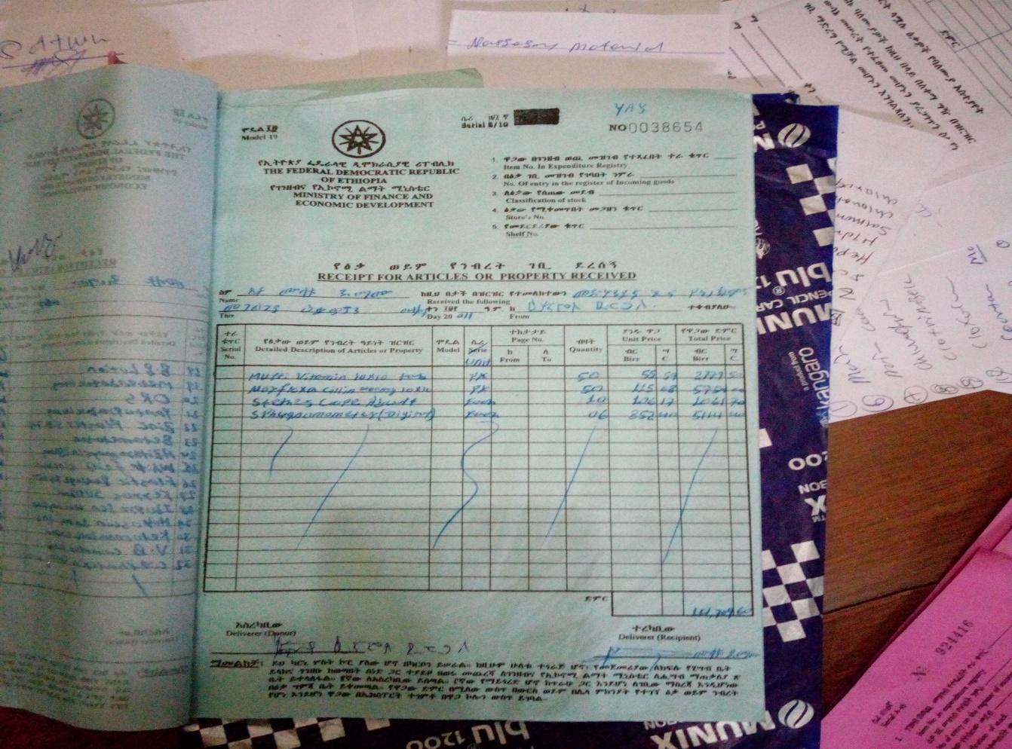

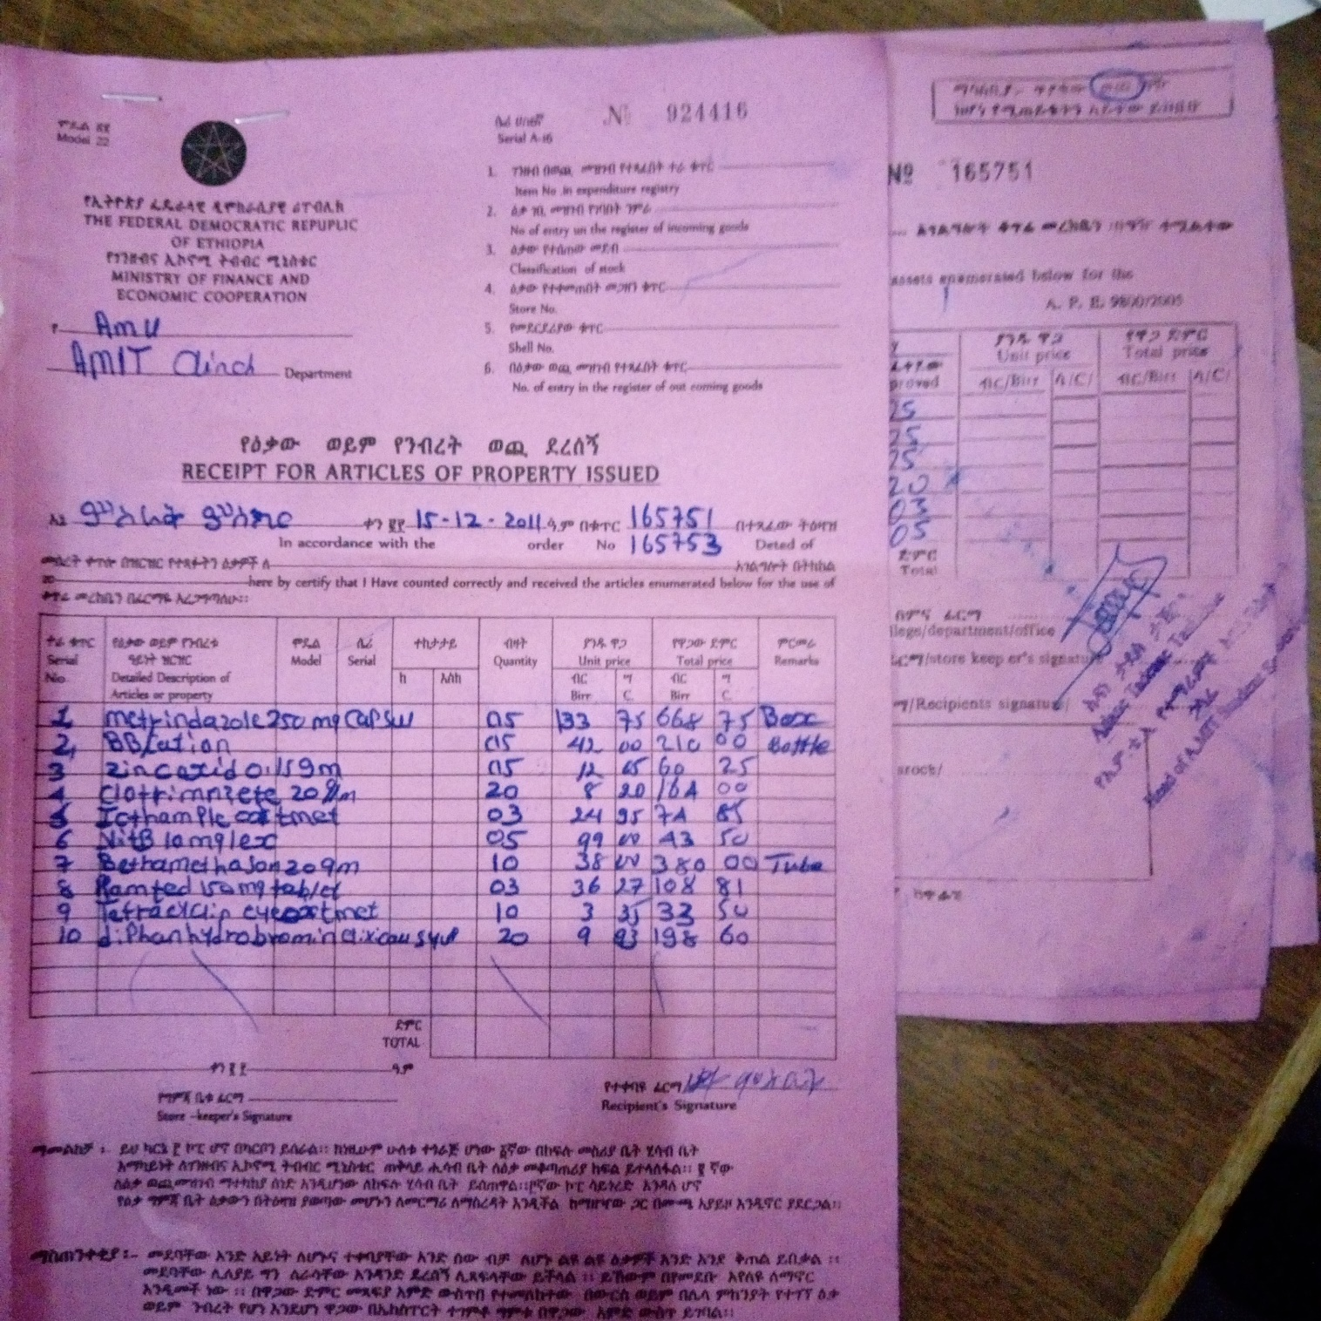

## 2.4 Users of the current system

The main users that are involved in the system are:

* **Manager/store keeper:** is the one who manages and control hospital drugstore and also responsible for prepare report and provide it for responsible person.
* **Pharmacist:** provide drug for patient based on doctor prescription and generate drugstore report.
* **Patient:** The patient can be defined as the actor that will receive services from the hospital.

## 2.5 Bottleneck of the current system

## Performance (Response time)

In terms of performance, the existing/manual system is not as satisfactory because it is slow/time consuming, energy consuming and does not support searching for available medicines, adding or updating new or added medicine automatically

## Input and Output

As the existing system is manual, the redundant, inaccurate data can be registered on the paper. For example one medicine can be registered more than one or its name can be spelt in correctly and it is hard to update because all the information are recorded in the paper.

## Security and Control

Since every record of the patient and medicine is stored manually, therefore it is difficult to control and secure these manual files/data. The files stored physically if they damaged by catastrophic failures such as fire or flood or by theft there is no backup. The existing manual system is not secure there is no authentication mechanism for documenting information.

## Efficiency

It is daunting to identify expired and scarce drugs if there is much many drags in the store. It is also difficult to how many drags are subscribed for how many users per day, week, month or year.

## 2.6 Practice to be preserved

The main activities that are performed in the manual system will be transferred by designing the corresponding simulation of those activities. Each activity that is transferred to the system are designed and automated to achieve the best functionality. The admin can control the overall activity in the system. Manager, pharmacist and patients are governed by the business rule.

## 2.7 Proposed System Description

This new system removes the existing problems which usually occurred in the clinics. The major purpose of the new system is to manage drag store via web app.

**The proposed system provides the following solution:**

* This system is faster.
* It has user friendly interface.
* Allows storing medicine and patient data in database
* Allows searching for medicine and patient data
* It alerts expired medicines.
* It alerts scarce medicines.
* Automated report generator.
* Data backup and secure the service through authentication.

## 2.8 Requirements of the Proposed System

## 2.8.1 Functional Requirements

The functional requirements focus on the main functions that the new application system will provide. The major functional requirements of our proposed system are the following:

* Register users (create account).
* Record / register data related to drug, pharmacist, and manager.
* Validate data
* Verify and authenticate users.
* Arrange medicine in their category.
* Show pharmacist, patient, manager and admin information
* Allows updating the necessary information.
* Allows checking the availability of the drug.
* The system should allow to update the necessary information
* The system should check expired date of the drugs and show expired medicine
* Allows the administrator to control the site
* The system accept comment from user
* The system should generate report

## Non-functional requirements

Non-Functional requirement explains and describes the user visible aspects of the system. The following lists states the non-functional requirements. Constraints on the services or functions offered by the system such as timing constraints, constraints on the development process, standards, etc.

* **Availability:** The new proposed system must be available to the intended users 24h per day.
* **Performance:** The proposed system should respond within a short period of time. It depends on the performance of the hardware environment such as RAM and processor.
* **Maintainability:** The new and proposed system should be maintainable because of the interaction between subsystems will be loosely couple and the interaction between classes and operations will be highly cohered, changes made on our new system such as adding other functionality shouldn’t affect the existing functionality of the system.
* **Reliability:** The new proposed system is reliable with respect to error occurrence. Validate user input on Forms information or data before submitting to database.
* **Security:** On our new proposed system each user is required to enter an individual username, user type and password when accessing the software. User must login form with valid information. Only registered students are filling the form. The time student access is limited. And the administrator has the option of increasing the level of password security.
* **Error handling**: When the user interacts to the new proposed system error may appear. In addition to operating system error handling mechanism we use exception handler during implementation, input validation mechanism. To control this inaccuracy the system will generate different message. It protects unexpected input through java script validation before input submitted to database. System display error message if the user invalid character. Submit data in proper character.
* **Help and support**: The new proposed system has help menu to make system more user friendly and easy to use.
* **User interface:** The developed system provide web application system user interface that are compatible with any platform and user friendly. The user who navigates to other interface of the system to retrieve the collection of the system is also expected to know basic understanding of on how to use it.

# References

# (n.d.). Retrieved from www.w3school.com

(n.d.). Retrieved January 10, 2015, from www.programmersheaven.com.

(n.d.). (programmersheaven) Retrieved January 10, 2015, from www.programmersheaven.com: http://www.programmersheaven.com

(n.d.). (codeproject) Retrieved January 12, 2015, from www.codeproject.com : http://www.codeproject.com

*Arba Minch University*. (2015, Jan 17). Retrieved Dec 14, 2014, from www.amu.edu.et: http://www.amu.edu.et

(2000). modern system anaysis and design. In A. H. Fred.

Saiden, C. (2007). Chiheb Saiden.Decision Support System for the Management of an army’s Tracked and Wheeled Vehicle Fleet march 2007. In C. Saiden, *Decision Support System for the Management of an army’s Tracked and Wheeled Vehicle Fleet .*

w.Amble, S. (2001). *http://Scott w.Ambler Object Primer second edition (2001)* (Vol. second edition).

*w3schools*. (n.d.). Retrieved Jan 11, 2015, from www.w3schools.com: http://www.w3schools.com