**

WOLAITA SODO UNIVERSITY

1. **DEPARTMENT OF INFORMATION TECHNOLOGY**

**INDUSTRIAL PROJECT I PROPOSAL**

**SUBMITTED TO THE DEPARTMENT OF INFORMATION TECHNOLOGY FOR PARTIAL FULFILLMENT OF BSc DEGREE IN INFORMATION TECHNOLOGY**

**LAND INFORMATION MANAGEMENT SYSTEM FOR WOLAITA SODO MUNICIPALITY**

**Team Members**

Graup Members Name Id No

1. Tamirat Teshome IT/WE/366/10
2. Nebiyu Mathios IT/WE/314/10
3. Tariku Tanga IT/WE/ 374/10
4. Samuel Bundassa IT/WE/ 325/10
5. Sekina Kiyar IT/WE/ 332/10
6. Natinael Ermiyas IT/WE/ 309/10
7. Sisaynesh Abrham IT/WE/ 350/10

May, 2022

Wolaita Sodo University, Ethiopia

**WOLAITA SODO UNIVERSITY**

**SCHOOL OF INFORMATICS**

**DEPARTMENT OF INFORMATION TECHNOLOGY**

APPROVAL SHEET

**LAND INFORMATION MANAGEMENT SYSTEM FOR WOLAITA SODO CITY MUNICIPALITY**

**APPROVED BY :**

Name Signature Date

Mr. BIRHANESH F. **_______________**  **_______________**

Advisor

**________________________**  **_______________**   **_______________**

Examiner 1

**________________________** **_______________ _______________**

Examiner 2

Mr Akalu E. **_______________** **_______________**

Dept. head

May, 2022

Wolaita Sodo University, Ethiopia

Contents

Chapter One 1

Introduction 1

1.1 Background of the Organization 1

1.1.1 Vision of the Organization 1

1.1.2 Mission of the Organization 2

1.2 Statement of the Problem 2

1.3 Objective of the Project 2

1.3.1 General Objective 2

1.3.2 Specific Objective 2

1.4 Feasibility Analysis 3

1.4.1 Operational feasibility 3

1.4.2 Technical Feasibility 3

1.4.3 Economic Feasibility 3

1.4.3.1 Tangible benefits 3

1.4.3.2 Intangible benefits 4

1.4.4 Behavioral/Political feasibility 4

1.5 Scope and Limitation of the project 5

1.5.1 Scope of the project 5

1.5.2 Limitation of the project 5

1.6 Significance of the project 5

1.7 Target beneficiaries of the system 6

1.8 Methodology of the project 7

1.8.1 Data Source 7

1.8.2 Fact Finding Techniques 7

✓ Interview 7

✓ Direct Observation 7

✓ Document Analysis 7

1.8.3 Systems Analysis and Design Methodology 7

1.9 Development Tools 8

1.9.1 Software Tools 8

1.9.2 Hardware Tools 8

1.10 Team Composition 8

References 10

# Chapter One

# Introduction

Land Management System is a process of managing the use of land resources. In sodo town land is used for different purpose. For example: for Building house, College, University, hotel. At this time the land management municipality of sodo town has responsible to make the arrangement of the building and use of land resources in the town.

The aim of our project is to specify the problem of the land management system in sodo municipality and give solution by changing the current system in to web based system to increase the efficiency of the system. The existing land management system in sodo municipality is manual (not computerized).In this case the current system is changed to web based system. The proposed system simplifies the problem of current system of the land management municipality in sodo.

# Background of the Organization

**Sodo** or **Wolaita Sodo** or (Wolaytatto: Wolayta Sodo Ambbaa) is a city in south-central Ethiopia. The administrative center of the Wolaita Zone. It has a latitude and longitude of [6°54′N 37°45′E](https://geohack.toolforge.org/geohack.php?pagename=Sodo&params=6_54_N_37_45_E_) with an elevation between 1,600 and 2,100 metres (5,200 and 6,900 feet) above sea level. It was part of the former Sodo woreda which included Sodo Zuria which completely surrounds it.

The organization of the Land Management System of Sodo municipality is found in the Middle of the town. Master plan of the Town is planned in 1965E.C.This Organization is one of governmental organization in the town.

## Vision of the Organization

To see land owner’s use the plan of the town in a good way that the land management organization of sodo town makes current system speedup the service by using science and technology and the developing town in the south region.

## Mission of the Organization

To expand the development and management of Sodo town by keeping the plan of the town, give good service for the land owner’s, provide good administration clearly In the wolaita town.

# Statement of the Problem

Wolaita Sodo town land management municipality office currently uses manual system. Most of the time the manual system has many problems related to getting and giving the service. This manual system is tedious for the users to get the service. The current system is time consuming for the user to obtain the service. This manual system has major problems. Such as:

* The profile of the land owner's may be lost.
* Difficulty of manually cross-checking the land owner profile.
* There is data redundancy.
* Land administration for investment and other purposes is time consuming.
* The recording and management of land administration at Sodo town municipality offices is not well organized.

# Objective of the Project

## General Objective

The general objective of our project is to develop web based land information management system for Wolaita Sodo town.

## Specific Objective

In the specific objective we identify the way to achieve general objective of the project and these are:-

* To collect and analyze system requirements
* To design the proposed system
* To implement the proposed system
* To test the proposed system and
* To deploy the proposed system

# Feasibility Analysis

The most important objective of feasibility study is to examine technical, operational, economical and behavioral feasibility to add new modules and then every system is feasible if there is unlimited resources and never ending.

## Operational feasibility

The newly proposed system can be easily operated and accessed by the user anywhere who interact to the system. It can be develop based on the predictable and concentrated problem as well as the user interest, we have a full confidence the proposed system can meet with the prescribed (desired) objective. The system operation is easy for user so it indicates that the proposed system is operationally feasible.

## Technical Feasibility

The goal of this study is to understand the office ability to construct the proposed system. Our newly proposed system can implement with the current technology and also the users will get enough experience through minimum training using that technology. Therefore it is technically feasible.

## Economic Feasibility

The system we will develop is economically feasible and the benefit is outweighing the cost. Since the system is changed into web based system. Generally the system we developed for Soddo Town municipality office brought a number of Tangible and intangible benefits.

### Tangible benefits

The tangible benefit of our proposed system is based on measurable benefit. Our system reduces some outcome cost. The manual system of Sodo municipality uses more paper, pen and other materials. To store the data/information of user they use paper. In the present time to update the information after once recorded they use another paper. This is cost consuming. Our system is successfully completed it used to store the profile of land owner of wolaita sodo town. In case of our proposed system we divided the tangible benefit in to two ways as follows.

**One-time cost**

* The cost paid for system designers and system analysts
* The cost of Software to be acquired to build and run the system
* The cost to buy server.

**Recurring cost**

* The cost to maintain computers, database and server if there is problem with them.
* Salary of system administrator
* The cost to give training for land owner and employees how to use the system.

### Intangible benefits

The Intangible is recognized as a value that clearly exist but not quantifiable. The system we will develop has many intangible benefits that revolve around mental satisfaction of users of this system. These are:

* Knowledge gain by project developer.
* Increasing the competitiveness of the individual.
* Improving the moral of worker in the organization.
* Faster decision making in organization.
* Facilitating information processing of organization system.
* Having information about the Wolaita Sodo Town Land Management System any time.
* Satisfies the Wolaita Sodo Town Land Owner’s in the way that they trust the system is secure and accurate on giving service.

## Behavioral/Political feasibility

Our project will be accepted by set of decision makers and general public’s in Wolaita Soddo town. Selling and/or buying land is not allowed according to government policy. Paying the tax for land is an obligation for every land owner. The system that we will develop can’t interfere or oppose the above mentioned governmental policy. The reason is that the system gives any information for the user that is provided by the manager. The manager is legal person and obeys the rules and regulations of the government policy. From this point of view our project is politically feasible.

# Scope and Limitation of the project

## Scope of the project

The scope of our project is providing the access for information about the Land Management system to land owners and non-landowners in Wolaita Sodo town only. Land owners in Sodo town can access any type of information related to their land after registered to the Sodo land management system office anywhere they are. Non land owners are the users of the system those can access any information that is posted on the Sodo municipality office website. The website of the wolaita sodo municipality office is accessed publically.

* Our system will be used for only Wolaita Sodo town.
* The function of the system is for only land administration system.
* The system is browser based.
* The function of the system is online.

## Limitation of the project

* In the absence of the internet connection the system cannot function.
* The system does not support any language except English.

# Significance of the project

After completing this project the current system of Sodo town land management municipality is changed to web based system which saves time and resource need. It also manages, control, provide immediate and updated information for the user, and store individual land owner’s information and employees of sodo municipality office information permanently.

The investor has his/her own role to increase the development of Sodo Town. The project gives a service for the investor by saving their time and profile after they registered to Sodo town municipality office. The investors and the manager of the sodo town municipality office share information when investors want to invest in wolaita sodo town. They can send their interest to the manager using the wolaita sodo municipality addresses.

# Target beneficiaries of the system

The manager and surveyor of Wolaita Sodo town land management municipality office, Land owners and None Land owners in sodo town are beneficiaries in our project. We discuss their beneficiaries one by one as follows:

**Land owners** in the wolaita sodo town can access information about their land anytime easily in a short period of time anywhere they are. They can also access other information on the sodo town municipality website.

**Non Land owners** they live anywhere can access the information available in website of sodo town municipality office. When Non land owners get land in case of Rent or Lease in sodo town they can share the information online to the manager to fulfill the rule and regulation of the sodo town municipality.

**The manager** can easily control, create new account for the new land owner, post information’s to the website, update land owners information and Delete the land owner’s account easily.

**The surveyor** can add information into the land owners account easily after he/she collects the information (by measuring and interviewing) on the land.

Generally the target beneficiary of our project is:

* The project gives benefit to manager of the sodo town municipality to easily give service to land owner’s and post information for announcing to the other, allocate land for the land owner’s when they get land by lease or rent.
* The land owner can get fast access and service from the land management system of wolaita sodo town municipality.
* The land owners of Sodo town and the land manager are more beneficial of this system.

# Methodology of the project

## Data Source

The Data sources for our Project to convert the manual land management of wolaita sodo town municipality to web based system are:

* Wolaita Sodo town Land Management Municipality Office.
* Search Engine

## Fact Finding Techniques

We use the basic fact finding technique for our Project to convert the manual land management of wolaita sodo town municipality to web based system are:

* Interview: We used oral discussion and interview with manager and surveyor of wolaita sodo city municipality office for necessary information’s. This information will help us to identify the organization associated problems and also to understand the current system. So, we will analyze information’s of the organization and obtain some basic concepts on how the organization is managed in the current system.
* Direct Observation: - used to gather additional data by observing the actual work being done by the staff member and combine with what was obtained through interview.
* Document Analysis**: -**we referred and analyzed written materials that describe the operations to further strengthen and support the information that applied to above technique.

## Systems Analysis and Design Methodology

The team plan to use the Object Oriented Software Development Methodology (OOSD) for the development of the system among the different methodologies.

Because of the following reasons

* It will help us to assure the reusability quality of the system because it will clearly describe the components.
* This method will help us to also assure the maintainability quality because as we can see we add some additional requirement to what we have given.
* Help the external users to understand the relationship of the objects easily.
* Generally it assures the quality the representative qualities of the software.

# Development Tools

## Software Tools

To develop the proposed system we are going to use software tools listed below.

|  |  |
| --- | --- |
| **Activities** | **Tools** |
| Interface | **HTML** |
| Layout / Styling | **CSS** |
| Client side scripting | **Java script** |
| Local server | **XAMPP** |
| Server side scripting | **PHP** |
| DBMS | **MySQL** |
| Documentation | **MS-words** |
| Browser | **Any standard internet browser** |
| UML Diagram | **Edraw Max** |
| Editing | **Adobe Photoshop** |

Table 1 Software development tools

## Hardware Tools

We are going to use the hardware tools listed below to develop our proposed system.

* PC(Personal Computer)
* 8 GB Flash disc
* Printer
* Digital camera
* 2GB compact disk

# Team Composition

We have organized our self (team member) in a decentralized way that every team member communicates to each other in each topic. Every member of the group attends on the discussion to do the project and share his/her idea freely. From this we choose decentralized team composition to do the project of web based land information management system for wolaita sodo town municipality. The table shows every phase of the project and gathering information is done by every member.

**Team Composition Table**

|  |  |  |  |  |
| --- | --- | --- | --- | --- |
| **No** | **Name** | **ID NO.** | **Email Address** | **Responsibilities** |
| 1. | Tamirat Teshome | 366/10 | Tamiratteshe55@gamil.com | - Programmer |
| 2 | Nebiyu Mathios | 369/10 | - | - Designer |
| 3 | Tariku Tanga | 366/10 | - | - Data collector |
| 4 | Samuel Bundassa | 346/10 | - | - Designer |
| 5 | Sekina Kiyar | 321/10 | - | - Data collector |

Table 1.1 Team composition

**Chapter Two : System Analysis**

1. **Introduction of Existing System**

The users to get service from sodo municipality office they must attend to the office and contact with the employee. The Current manual system of Land management system of sodo municipality office uses several functionalities to distribute the information. Such as:-

**How new information’s are announced:-**this is manual system where the information is edited, printed and it is posted around sodo town by human power on the notice board.

**How new land owners are registered:-**a person who wants to get land in the town he/she must come physically to the sodo land management municipality office and gives the following information to the manager of municipality office. The information share Full name, Address, Age, Sex, Town Identity number, 3x4 photo,Role of the land he/she have and Educational status. After he/she registered get certificate. He/she must obey the rule and regulation of the government policy.

In the proposed system users complete every process with the manager of the sodo municipality online everywhere. If the process is completed they go to the office and they can register. The reason users to go to the office at the time of registering the users must be checked is his/her photo match with the actual person.

The information’s in the proposed system posted to the website of the sodo municipality and every person can access it. The information’s are the same to the manual system but the difference is that in the manual system the information is posted on notice board in the sodo town and in the proposed system it is posted on website for every person everywhere.

1. **Functions/activities in the existing system**

The existing system can register the user in manual form. It gives information to the user through notice board system which can take more time. Users can access their information through manual form by going to the land management office.

1. **Bottlenecks of the existing system**
2. **Performance (Response time)**

The existing system does not provide fast response time because it is difficult to access data from the document and misallocation of land owners profile in the shelf to retrieving the land owners’ status information.

1. **Input (Inaccurate/redundant/flexible) and Output**

The existing system takes the input in the form of hard copy or in the form of paper document. The users request for the service in the current manual system is considered as input. The output of this system is the response for the user’s request and any service given to the user in the town from the office. Since, this all thing is done by manual power; there is inaccuracy because validity is not properly checked and data redundancy. The flexibility of the input is that, when inputs are inserted to the office and it is easily changed.

1. **Security and Controls**

The existing system has less security and there is no data backup when the users profile lost or damaged. The manager can control all activities and gives permission for user to use the resources and control the resources. There is no login form.

1. **Efficiency**

The existing system is less efficient for a land owner to access information about their land information, preparing the certificate is slow. Every activity and data is shared manually.

1. **Players in the existing system**

The players of the existing system of sodo town are manager of the sodo municipality office, secretary of the manager, surveyor of the office, data holder of the office and other employees of the office.

**Manager:** He can control the work activity of the employees in day today activity in the working time and working place (in the office of municipality) and approve the generated report and certificate of land owners. He/she has responsibility to control the overall activities. Updating or re-correct the land information if necessary. Deleting or crossing the services of the land owners from the office. Give the privilege to the new users to register who is get land in the sodo town.

**Surveyor:** he/she collects information on the field of the town that is related to the land in sodo town. He/she collects the information in case of measuring or by interviewing the land owners. Provides certificate for every land owner before the manager is approve. Fill the collected information in to the land information’s form. Generate report and report it to the manager.

**Land owner:** he/she gets the service in the sodo town land management system municipality by contacting with the employees of the office directly. A land owner who register to sodo Land Management municipality Office and gets information from Municipality in sodo Town. He/she get certificate of that to improve their land.

**None Land owners:** users those are not registered in the municipality office of sodo town. When he/she gets land in sodo town in case of Rent or Lease but now they will register in the municipality office.

1. **Business rules**

**BR1:** The land owner agrees with the manager, the land must have its own map.

**BR2:** The land owner must pay tax.

**BR3:** Manager should assign specified area of land for only one owner.

**BR4:** Land owners cannot buy/sell land but.

**BR5:** The owner must use the land properly.

1. **Requirements of the Proposed System** 
   * 1. **Functional requirements**

**The proposed system has the following functional requirements**

* Create user account
* Update user account
* De-activates and activates user account.
* Post land information
* Manage request
* Verify request
* View land information
* Approve request
* Sends request
* Update username and password
* Generate certificate
* Generate Report
  + 1. **Nonfunctional requirement**

Non-functional requirement is a requirement that specifies criteria that can be used to judge the operation of a system, rather than specific behaviors. This requirement is additional quality of system in terms of the following issues.

* + - 1. **Performance**

The user can login to the system easily and can access information on a computer from database. The server is large which is to accept the request from the users and give responses after processing the request in a short period of time. The system serves all users simultaneously. The administrator and users can response to the request and get response their request easily.

* + - 1. **User Interface**

The system GUI is consistent with all other programs. The interface should be clear to understand. The interface has help files that describe the usage and about office that contains the general information about the office access publically of each user interface. The homepage contain the entire pages and it is master page. Non land owners can access the information without login. The manager, surveyor and land owners must login to perform their work.

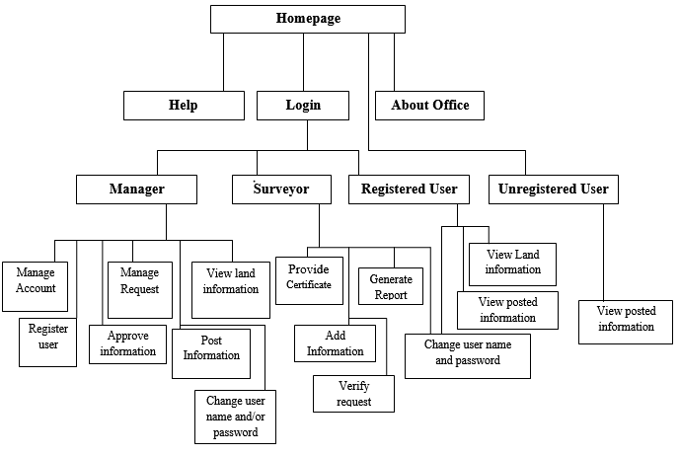

Fig 2.2 user interface

**Description of user interface**

|  |  |  |
| --- | --- | --- |
| **Interface Page Name** | **Identifier** | **Description** |
| Home | UI: 1 | Home page is a user interface part where land management system is viewed and link for related topics. We can add any idea regarding to land management system of sodo Town. |
| Log in | UI: 2 | Login page is a core of user interface part. It is a way users log into a system by entering their valid user name and password to get the next page. |
| Help | UI: 3 | The page that provide help information for users how to use the system. |
| About office | UI: 4 | This page is useful for all people those want to access it. This page contains the general information about the office. The organization can post any new information. |
| Registered user | UI: 5 | User page displays the users needed profile format. It also enables a user can see about their land information by entering valid input for set of questions that is asked by the system. |
| Unregistered user | UI: 6 | This page displays the information in the website for the non-land owners. |
| Manager | UI: 7 | Manager Page that enables the system manager to control all activity, delete, create, and update the information of the users and surveyor those communicate with the system. |
| Surveyor | UI: 8 | The Surveyor Page enables the surveyor provide certificate, generate report to the manager and add information about the user and land information into the created account. |
| View land information | UI: 9 | View information Page enables land users to view their profile with information. |
| Generate report | UI: 10 | Help the surveyor generate the report and submit it to the manager. |
| Manage account | UI: 11 | The page that enables the system manager to create, delete and update Account for user. |
| Manage request | UI: 12 | The system that enables the manager to replay and send request. |
| Verify request | UI: 13 | The Page that the surveyor verifies the user request. |
| View posted information | UI: 14 | Every person can view information of the sodo municipality office by using this page. |
| Provide certificate | UI: 15 | Surveyor can provide certificate for the user after the manager check the correctness of information and approved it. |
| Add information | UI: 16 | Surveyor can add information of the user and their land information in to their account. |
| Register user | UI: 17 | A manager can register users when they get land by means of lease or rent. |
| Post information | UI: 18 | This page enables to the manager she or he can post the information’s on the website for the user. |
| Approve information | UI: 19 | After every process is performed by the employee then the manager check it and approve. |
| Change username and password | UI:20 | A user who has land in sodo town can change his/her password or/and username if it is hacked by other person. |

Fig 2.1 user interface description

* + - 1. **Security and Access permissions**

The new system provides security to prevent and protect unauthorized modification of data, the new database must have a security to control the activities that can be performed by the users and determine which information can be viewed and modified. The system generates warning messages for every invalid input and secures every document in database.

* + - 1. **Backup and Recovery**

Storing data in another place for backup purpose, if the system is destroyed, then it is easy to get the lost data. This can be done by placing the data in another place. If the data is failed or lost, then the lost data can be easily recovered the database.

* + - 1. **Resources, usability, availability**

The system consumes resource that required high processer speed both for server and client and machine having more memory space as a server. We use computer, laptop, disks, paper for layout and properly using them and protecting these resources from damage. We use powerful markup languages which support graphical user interface friendly. The system is available to the user through the server. An authorized user can access the system easily and the system is available to user at any given time

* 1. **Use Case Diagram**

Use case is a methodology used in our system analysis to identify, clarify and organize system requirements. The use case of our system is made up a set of possible sequences of interaction between our system and the users of this system in sodo town. In our proposed system there are 14 use cases and 4 actors are there. The use cases are approve information, register user, report generate, provide certificate, report, post information, view land information, manage account, verify request, view posted information, manage request, send request, add information and change user name and/or password. Manage account contain delete account, update account and create account. Manage request contain reply request and send request. The actors are manager, registered user, surveyor and unregistered user. Here unregistered user is any person who has not land in sodo town. Each actor has a responsibility on the provided use case. Except register and view posted information all use case include login.

The diagram of our proposed system use case is shown below:

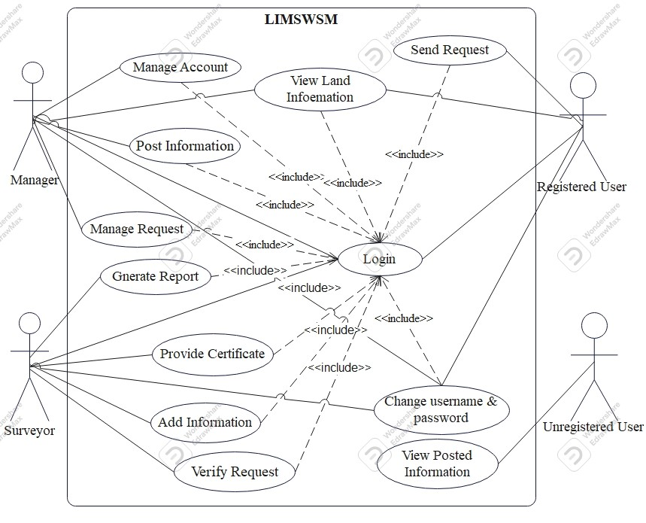Fig 3.1 Use case Diagram

* 1. **Sequence Diagram**

Sequence diagram shows the interaction between participating objects in our use case. It is helpful to identify the missing objects that are not identified in the analysis object model. To see the interaction between objects we draw the sequence diagram of the use case.

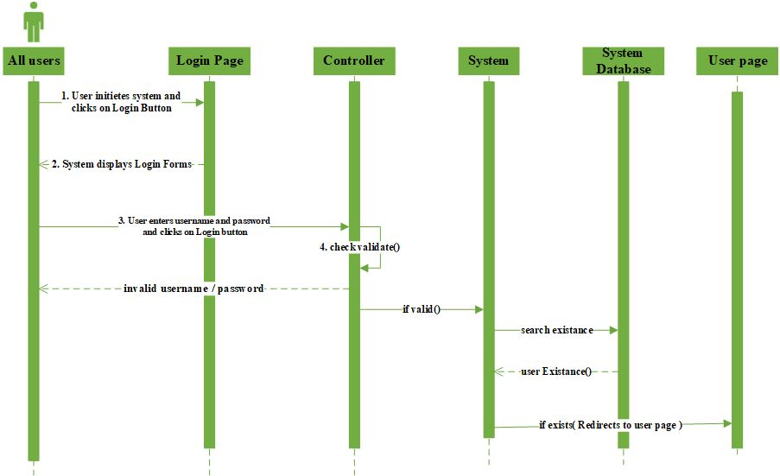

*Sequence diagram for login*

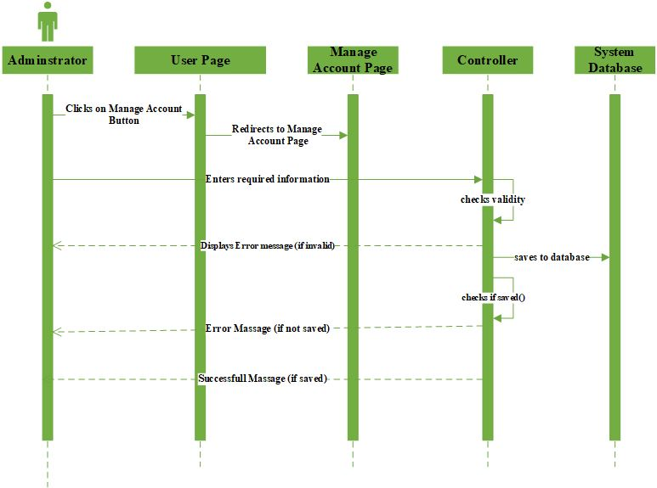

*Sequence Diagram for manage account*

3.3 Sequence Diagram for View land Information



Fig 3.4 Sequence Diagram for Login



Fig 3.5 Sequence Diagram for Login not successfully



Fig 3.6 Sequence Diagram for Update Account



Fig 3.7 Sequence Diagram for Update Data not found



Fig 3.8 Sequence Diagram for Delete Account



Fig 3.9 Sequence Diagram for Add Information



Fig 3.10 Sequence Diagram for Provide Certificate.



Fig 3.11SequenceDiagram for Generating Report

* 1. **Activity Diagram**

Activity diagrams are graphical representations of workflows of stepwise activities and actions with support for choice, iteration and concurrency. In activity diagrams can be used to describe the business and operational step-by-step workflows of components in a system. An activity diagram shows the overall flow of control.



Fig 3.12 activity Diagram for Manager Login



Fig 3.13 Activity Diagram add information



Fig 3.14 Activity Diagramview land information



Fig 3.15 Activity Diagram for Unregistered user

Fig 3.16Activity Diagram for Manager



Fig 3.17 General Activity Diagram

* 1. **Class Diagram**

It represents the properties of entities, their operations and relationships. Also it drives use case diagrams from use case. The class diagram is the main building block in our project modeling. It is used both for general conceptual modeling of the systematic of the application and for detailed modeling translating the models into the code. The classes in a class diagram represent both the main objects and or interactions in the application and the objects to be programmed. Generally the project is including the following class in the class diagram.



3.18 Analysis level class diagram

# Chapter 3: System Design

## Introduction

System design is the transformation of the analysis model into a system design model. System design is the first part to get into the solution domain in a software development. This chapter focuses on transforming the analysis model into the design model that takes into account the non-functional requirements and constraints described in the problem statement and requirement analysis sections discussed earlier.

## Software Architecture

This system uses three-tier architecture. The user interface is implemented on a desktop PC and uses a standard graphical user interface with different modules running on the application server. The middle tiers are usually multitier.

**Advantages of three-tier:-**

* Managing data is independent from the physical storage
* Migration to new graphical environments is faster
* As each tier independent it is possible to use different sets of developers
* Since the client doesn’t have direct access to the database business logic is more secure
* When one tier fails there is no data loss, because you are always secure by accessing the other tier.

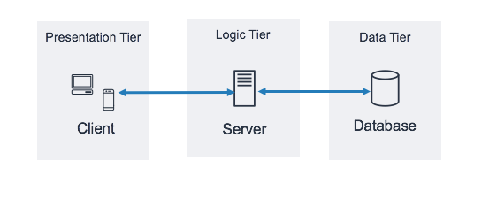

Figure : System Architecture

## Sub System Decomposition Diagram

In this proposed system we break down the system into its components subsystems, analyzing separately and then aggregating them back into complete system.

* ***The following are the sub systems that are derived from the functionality of the system*.**

**Post Information: -** The manager posts land information so that other users can view it.

**Manage Account: -** The manager manages (creates, updates, de-activates and activates) user account.

**Manage Request: -** The manager manages requests from other user (land owners)

**Register sub system: -** In this sub system the user register in to going to municipality office then the manager register the user

**View Land Information: -** The registered users can view land information.

**Send Request: -** The registered users can send request.

**Change username and password: -** The registered users can change their username and password.

**Generate Certificate: -** The Surveyor generates certificate

**Generate Report: -** The Surveyor generates report.

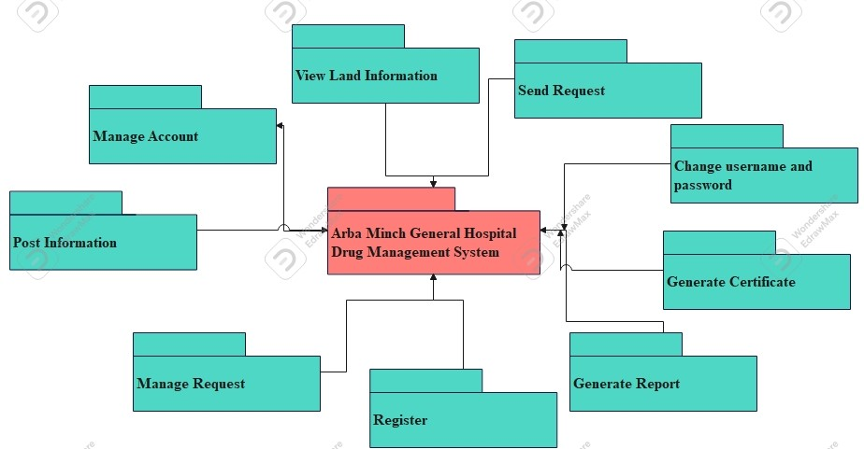

Figure Decomposition Diagram

## Component Modeling

In this Diagram components of the system will be wired showing that there is relation among components, management of the system, database and operations performed on databases such security issue. This in some extent shows which component or objects will be accessed by whom and what type of security infrastructures it is using. The diagram is simulated below:

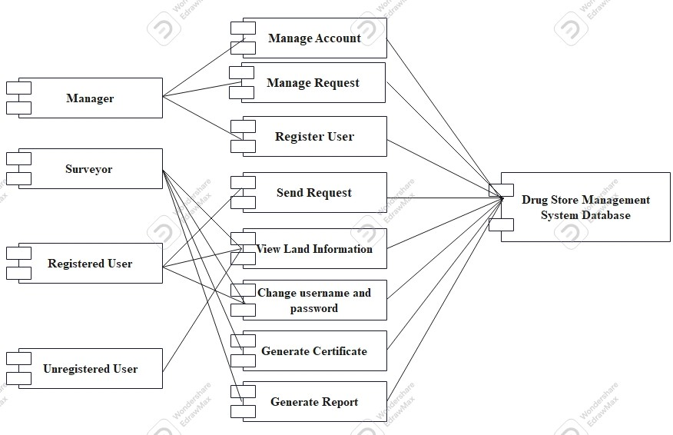 Figure Component modeling

## Deployment Modeling

Deployment modeling is used to show the hardware of the system, the software that is installed in the hardware .It also shows how the software and the hardware components work together.

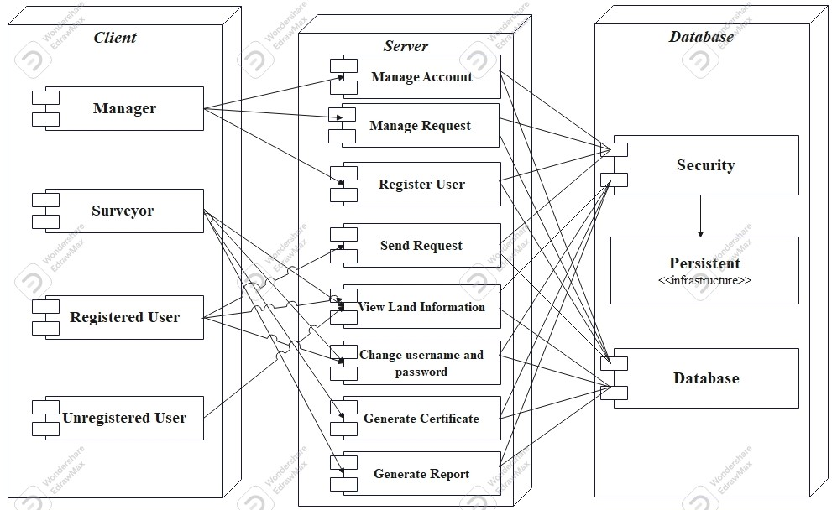

Figure: Deployment Diagram

# Chapter Four: Implementation and Testing

## Introduction

The Implementation phase in the software life-cycle is where the actual software is implemented. The result of this phase consists of source code, together with documentation to make the code more readable. This is what we call software implementation. The purpose of these activities is to convert the final physical system specification into working model with reliable software and hardware, document the work that has been done, and provide help for current and future users and take care of the system.

## Testing of the system

The test plan is designed to analyze the logic used in the implementation of the library management system. The tests will allow us to ensure correct program flow, and to determine the error-handling capability of the system.

Once coding has begun, the testing process can be begin and proceed in parallel. As each program module is produced, it can be tested individually, as a part of larger program, and then as a part of larger system.

* **Unit testing: -** Unit test is a way of testing each of the system functionality independently. Accordingly the team has tested each one of the three major activities and the rest accompanying activities independently using different user input, different login mechanisms and any technique of fault finding so that an incorrect functioning of the activities was corrected at the right time.

* **Integration Testing: -** All the modules combined together and tested it for its fitness with each other and with the systems functionality and other components as well to achieve the central objectives. During combining them, the module with problem (error occurred) will be identified and re combined. Both units testing and integrated testing are performed by all team members at the work place.
* **Security Testing: -** Security testing has also been completed by accessing the system with user name, password and designation authentication and authorization privileges with restrictions. For example without the valid user name and password the user can’t access the system

### Test Cases

#### Test Case 1 – Users login

|  |  |  |
| --- | --- | --- |
| Test Case ID = WB_LIMS– TestCase01 | | |
| Unit to Test = Filling field of choice | | |
| Assumptions = Logged in! | | |
| Test Data = user name (invalid user name, Valid user name, empty) password (invalid password, valid password, empty) | | |
| **Steps to be Executed** | **Data** | **Expected Results** |
| Empty user name and password and Click Login button | Empty | “to login please fill the required data” |
| Invalid user name and Click Login button | User name =w1 | “Incorrect username / password” |
| Enter valid user name, empty password and Click Login button | User name = “ admin” | “Incorrect username / password” |
| All fields with valid data and Click Login button | All fields with valid data | Successfully Login! |

#### Test Case 2 – Change password

|  |  |  |
| --- | --- | --- |
| Test Case ID = WB_LIMS– TestCase02 | | |
| Unit to Test = Filling field of choice | | |
| Assumptions = Logged in! | | |
| Test Data = old password (invalid password, Valid password, empty) new password (invalid password, valid password, empty) | | |
| **Steps to be Executed** | **Data** | **Expected Results** |
| Empty password and Click change password button | Empty | “please enter your password first” |
| Invalid password and Click change password button | User name =w1 | “the minimum length of the password is 6” |
| Enter valid password and Click change password button | User name = “ admin” | “Enter new password and confirm” |
| All fields with valid data and Click change password button | All fields with valid data | Successfully Login! |

## Hardware software acquisitions

For this system implementation, the following Hardware and Software are used.

* **Hardware**
* **Computers**: for client side and server side Dell 780 OptiPlex with
* Hard Disk: 250GB-500GB
* RAM: 2GB-4GB
* Processor: Intel Core 2 DUO CPU E7600 @ 3.06 GH
* **Printer**: To printing the documents
* **Server**: To create connection to the client computer(to host the system)
* **Software**
* PHP Designer 2007 personal o HTML 5 o CSS 3
* Microsoft SQL server 2008

## User manual preparation

Since the system we propose is web based preparation for manual work in undesirable for users, because the system developed is not software and it is not installed on a client computer. After the implementation has been completed, it is directly hosted on cloud.

## Training

During the deployment of the system, the project group members will give short time training for the system manager, surveyor, and users explaining how the system works and in what way they can manage the developed system.

## Installation Process

The proposed system is a web based System, there is no need to install it on a particular machine ones it is hosted on a server by developer, and the user of the system can use it at any time and any place

## Start-up strategy

Once the system has been published, the user can start and access his/her authorized page by entering the correct Username and Password with proper authentication and authorization processes

# Chapter Five

# Conclusion and Recommendation

Given that the web based library field is still quite new, it seems strange to be talking already about enhancing digital libraries. However, in this fast-moving environment, the initial digital libraries resulting from digitization projects, or even virtual collections, are being enhanced as user expectations and technology capabilities allow. In the midst of this furious activity, it is valuable to analyze users' needs and interests that can be used to enhance the digital library.

In developing web based library system where is accessed by many concurrent users we should consider the wide range of access infrastructure verities among users. Some of the users may use pc that is very high performance and to the contrary some of the users may access the webpage using sluggish pc. Especially if the webpage is dynamic the number of request and reply between the user pc and the web server will be much more and managing such bidirectional communication over specific period of time (before the session expires) through high traffic network will be more challenging task. When those users with the second type of specification access the web server the connection between their pc and the server will stay for relatively longer period of time than the first type of users, which results decline in the throughput of the web server which in turn result longer connection time even for the first type of users. In this project to combat such challenges during the deployment stage the team suppose this web based application should be uploaded on a server with better processing speed. And also the team recommends SCEE to implement this project to achieve its usage. However, we have few limitations which are indicated on the scope because of shortage of time. So that, we recommend the next researchers to continue their research considering our limitations.

# References

1. **Dessai, B. C.** An Introduction to Database Systems, West Publishing Company, New York. 2009.

2. **Arekete, S A and Osinowo, M O.** *Modeling Rule-Based Information Systems with MS-Excel.”International Journal of Computer Science,.* 2009.

3. WHAT IS UNIFIED MODELING LANGUAGE. *Visual Paradigm Web Site.* [Online] http://visual-paradigm.com/guide/uml-unified-modeling-language/what-is-uml/.

4. **JOHN, BOB.** *A COMPUTERIZED STUDENTS' RECORDS MANAGEMENT SYSTEM.* OCTOBER, 2015 .