Steady-State Groundwater Inflow Estimation
for Large Open Pit Mining Operations
Analytical Radial Flow Assessment - Detour Lake Mine, Ontario, Canada

Isaiah Ephraim
B.Eng Mining Engineering, Federal University of Technology, Akure, Nigeria

Abstract
This study presents an analytical estimation of steady-state groundwater inflow to the Detour Lake open pit mine in Northern Ontario, Canada. A confined radial flow equation (Thiem equation) was applied using hydrogeological parameters derived from reported fractured bedrock conductivity ranges published in NI 43-101 technical disclosures for the site. Sensitivity analysis was conducted across hydraulic conductivity values spanning three orders of magnitude (K = 10⁻⁸ to 10⁻⁵ m/s). Predicted inflow ranged from approximately 76 m³/day in low-permeability bedrock conditions to 76,079 m³/day where fracture-enhanced shear zone conductivity was applied, consistent with reported operational dewatering scales at the site. Results confirm the dominant influence of structurally controlled permeability on inflow magnitude and demonstrate the practical value of analytical models for preliminary mine water management assessment and pump sizing during early mine planning.
Keywords: mine dewatering, open pit hydrogeology, radial flow, hydraulic conductivity, fractured rock, Detour Lake, groundwater inflow, Thiem equation, Archean greenstone

1. Research Question and Objectives
This study estimates steady-state groundwater inflow into a large open pit gold mine using publicly available hydrogeological parameters from the Detour Lake Mine in Northern Ontario. The objective is to determine how variations in hydraulic conductivity and saturated thickness influence predicted inflow rates when applying an analytical radial flow approach.

1.1 Model Assumptions
- Steady-state groundwater conditions
- Radial symmetry of flow toward the pit
- Homogeneous and isotropic hydraulic conductivity
- Fully penetrating pit geometry
- Constant hydraulic head at the radius of influence
- Negligible recharge within the radius of influence
- No explicit representation of discrete fracture networks

1.2 Model Limitations
- Fracture anisotropy is represented by an equivalent homogeneous hydraulic conductivity - structural orientation effects are not resolved
- Transient drawdown behaviour is not considered under the steady-state assumption
- Dewatering wells and staged pit development are not explicitly simulated
- Surface water–groundwater interactions are excluded
- Geological and structural heterogeneity may produce deviations from ideal radial flow symmetry

1.3 Study Objectives
- Quantify steady-state groundwater inflow to the Detour Lake open pit using analytical radial flow methods
- Evaluate inflow sensitivity to hydraulic conductivity variation across the reported bedrock range
- Compare predicted inflow rates against reported operational dewatering scales
- Assess the implications of inflow estimates for mine water management and pump sizing

2. Mathematical Formulation

2.1 Governing Equation
Groundwater inflow to the open pit is estimated using Darcy's Law applied to steady-state radial flow in a confined aquifer: (Freeze and Cherry, 1979)
Q = -K · A · (dh / dl)

Symbol | Definition
Q | Discharge (m³/s)
K | Hydraulic conductivity (m/s)
A | Flow cross-sectional area (m²)
dh/dl | Hydraulic gradient (dimensionless)

2.2 Radial Flow Geometry
For radial flow converging toward a circular open pit, the flow area at any radial distance r is:
A = 2πrb

Symbol | Definition
R | Radial distance from pit centre (m)
B | Saturated aquifer thickness (m)
Substituting into Darcy’s Law:
Q = -K · (2πrb) · (dh/dr)

2.3 Analytical Solution - The Thiem Equation
Separating variables and integrating from the pit wall (r₁, h₁) to the far-field boundary (r₂, h₂) gives the Thiem equation for steady-state confined radial flow: (Thiem, 1906; Freeze and Cherry, 1979)
Q = (2π · K · b · (h₂ - h₁)) / ln(r₂ / r₁)
This is the standard expression for steady-state inflow into a fully penetrating circular excavation in a homogeneous, isotropic confined aquifer. It forms the basis for all calculations in this study.

3. Model Parameters
The following inputs are required:

Parameter | Description
Hydraulic Conductivity (K) | Ability of the rock mass to transmit groundwater (m/s)
Saturated Thickness (b) | Vertical thickness of the water-bearing formation contributing to flow (m)
Pit Radius (r₁) | Effective radius of the open pit excavation (m)
Radius of Influence (r₂) | Radial distance to the far-field boundary where hydraulic head is undisturbed (m)
Far-Field Head (h₂) | Undisturbed groundwater level at r₂ (m)
Pit Head (h₁) | Groundwater level at the pit wall (m)

4. Site Characterisation - Detour Lake Mine
The Detour Lake Mine is located in the Abitibi Greenstone Belt of northeastern Ontario, Canada, approximately 300 km northeast of Timmins. The mine operates as a large open pit gold operation within Archean metavolcanic and metasedimentary rocks. Groundwater flow is structurally controlled, dominated by fracture networks rather than primary matrix porosity. (Duquette et al., 2024)
The mine was originally operated as an underground operation by Placer Dome from 1987 to 1990, then redeveloped as an open pit by Detour Gold Corporation beginning in 2013. Agnico Eagle Mines Limited acquired the operation in February 2022. (Agnico Eagle, 2024)

4.1 Hydrogeological Framework
Site geology consists of Archean bedrock overlain by glacial overburden ranging from approximately 5 to 30 m in thickness. Permeability is structurally controlled - fracture networks and shear zones carry the bulk of groundwater flow. This characteristic of Archean greenstone terranes means that a single representative K value cannot capture the full range of site behaviour, which is the reason two bounding scenarios are evaluated in this study. (Duquette et al., 2024)

4.2 Hydraulic Conductivity
Reported hydraulic conductivity values for the Detour Lake site are: (Duquette et al., 2024)

Formation | Hydraulic Conductivity (m/s)
Overburden | 1 × 10⁻⁶ to 1 × 10⁻⁵
Fractured bedrock | 1 × 10⁻⁸ to 1 × 10⁻⁵
Shear zones | Upper end of bedrock range; locally elevated

Two scenarios bracket the expected inflow range:
- Conservative bedrock case: K = 1 × 10⁻⁷ m/s - representative of fractured rock away from major structural corridors
- Fracture-enhanced case: K = 1 × 10⁻⁵ m/s - representative of shear zone intersections with the active pit

4.3 Pit Geometry and Hydraulic Head Conditions
The Detour Lake open pit has an ultimate design depth of approximately 600 m and a multi-kilometre surface footprint. For the analytical model it is approximated as an equivalent cylinder with the following parameters: (Duquette et al., 2024 [3])

Parameter | Value and Basis
Equivalent pit radius (r₁) | 1,200 m - derived from surface footprint approximation
Radius of influence (r₂) | 5,000 m - assumed regional flow boundary
Saturated thickness (b) | 200 m - representative fractured flow zone
Head difference (h₂ − h₁) | 100 m - simulating progressive pit depressurisation

5. Modelling Strategy
Two analytical scenarios are evaluated to isolate the effect of hydraulic conductivity on predicted inflow. All geometric and hydraulic head parameters are held constant between the two scenarios - only K changes. This structure allows the sensitivity of dewatering demand to structural permeability to be quantified directly.
- Homogeneous bedrock model - conservative K, representative of intact fractured rock between major structures
- Fracture-enhanced conductivity model - elevated K, representative of shear zone intersection with the dewatered volume

6. Steady-State Groundwater Inflow Estimation
All calculations apply the Thiem equation:
Q = (2π · K · b · (h₂ - h₁)) / ln(r₂ / r₁)
with ln(5000 / 1200) = 1.4271 and the following fixed base case inputs:

Input | Value
Pit radius (r₁) | 1,200 m
Radius of influence (r₂) | 5,000 m
Saturated thickness (b) | 200 m
Head difference (h₂ − h₁) | 100 m

6.1 Scenario 1 - Conservative Bedrock Case
Hydraulic conductivity: K = 1 × 10⁻⁷ m/s
Q = (2π × 1×10⁻⁷ × 200 × 100) / 1.4271 = 8.8 × 10⁻³ m³/s ≈ 761 m³/day
At 761 m³/day, dewatering demand in this zone is manageable with conventional sump pumping. This represents the baseline condition for fractured rock away from major shear zones.

6.2 Scenario 2 - Fracture-Enhanced Conductivity Case
Hydraulic conductivity: K = 1 × 10⁻⁵ m/s
Q = (2π × 1×10⁻⁵ × 200 × 100) / 1.4271 = 0.88 m³/s ≈ 76,079 m³/day
At 76,079 m³/day, dewatering requires high-capacity submersible pump strings, dedicated dewatering bores ahead of the advancing pit face, and a water management circuit capable of handling tens of thousands of cubic metres daily. Shear zones that intersect the pit at depth are the primary risk driver.

6.3 Interpretation
The two-order-of-magnitude jump in K produces a two-order-of-magnitude jump in Q. That linear relationship is direct from the Thiem equation. In practical terms, uncertainty in K translates directly and proportionally into uncertainty in pump sizing. A bulk packer test average that misses a shear zone by even half an order of magnitude will materially underestimate peak inflow.

7. Sensitivity Analysis - Hydraulic Conductivity
Hydraulic conductivity was varied across the full reported bedrock range (K = 10⁻⁸ to 10⁻⁵ m/s) with all other parameters fixed at base case values. Results are tabulated below and plotted in Figure 1.

K (m/s) | Predicted Q (m³/day) - Interpretation
1 × 10⁻⁸ | 76 m³/day - Minor seepage; no active dewatering required
1 × 10⁻⁷ | 761 m³/day - Moderate inflow; sump pumping manageable
1 × 10⁻⁶ | 7,608 m³/day - Significant; dedicated pumping infrastructure required
1 × 10⁻⁵ | 76,079 m³/day - Large-scale shear zone inflow; major dewatering programme

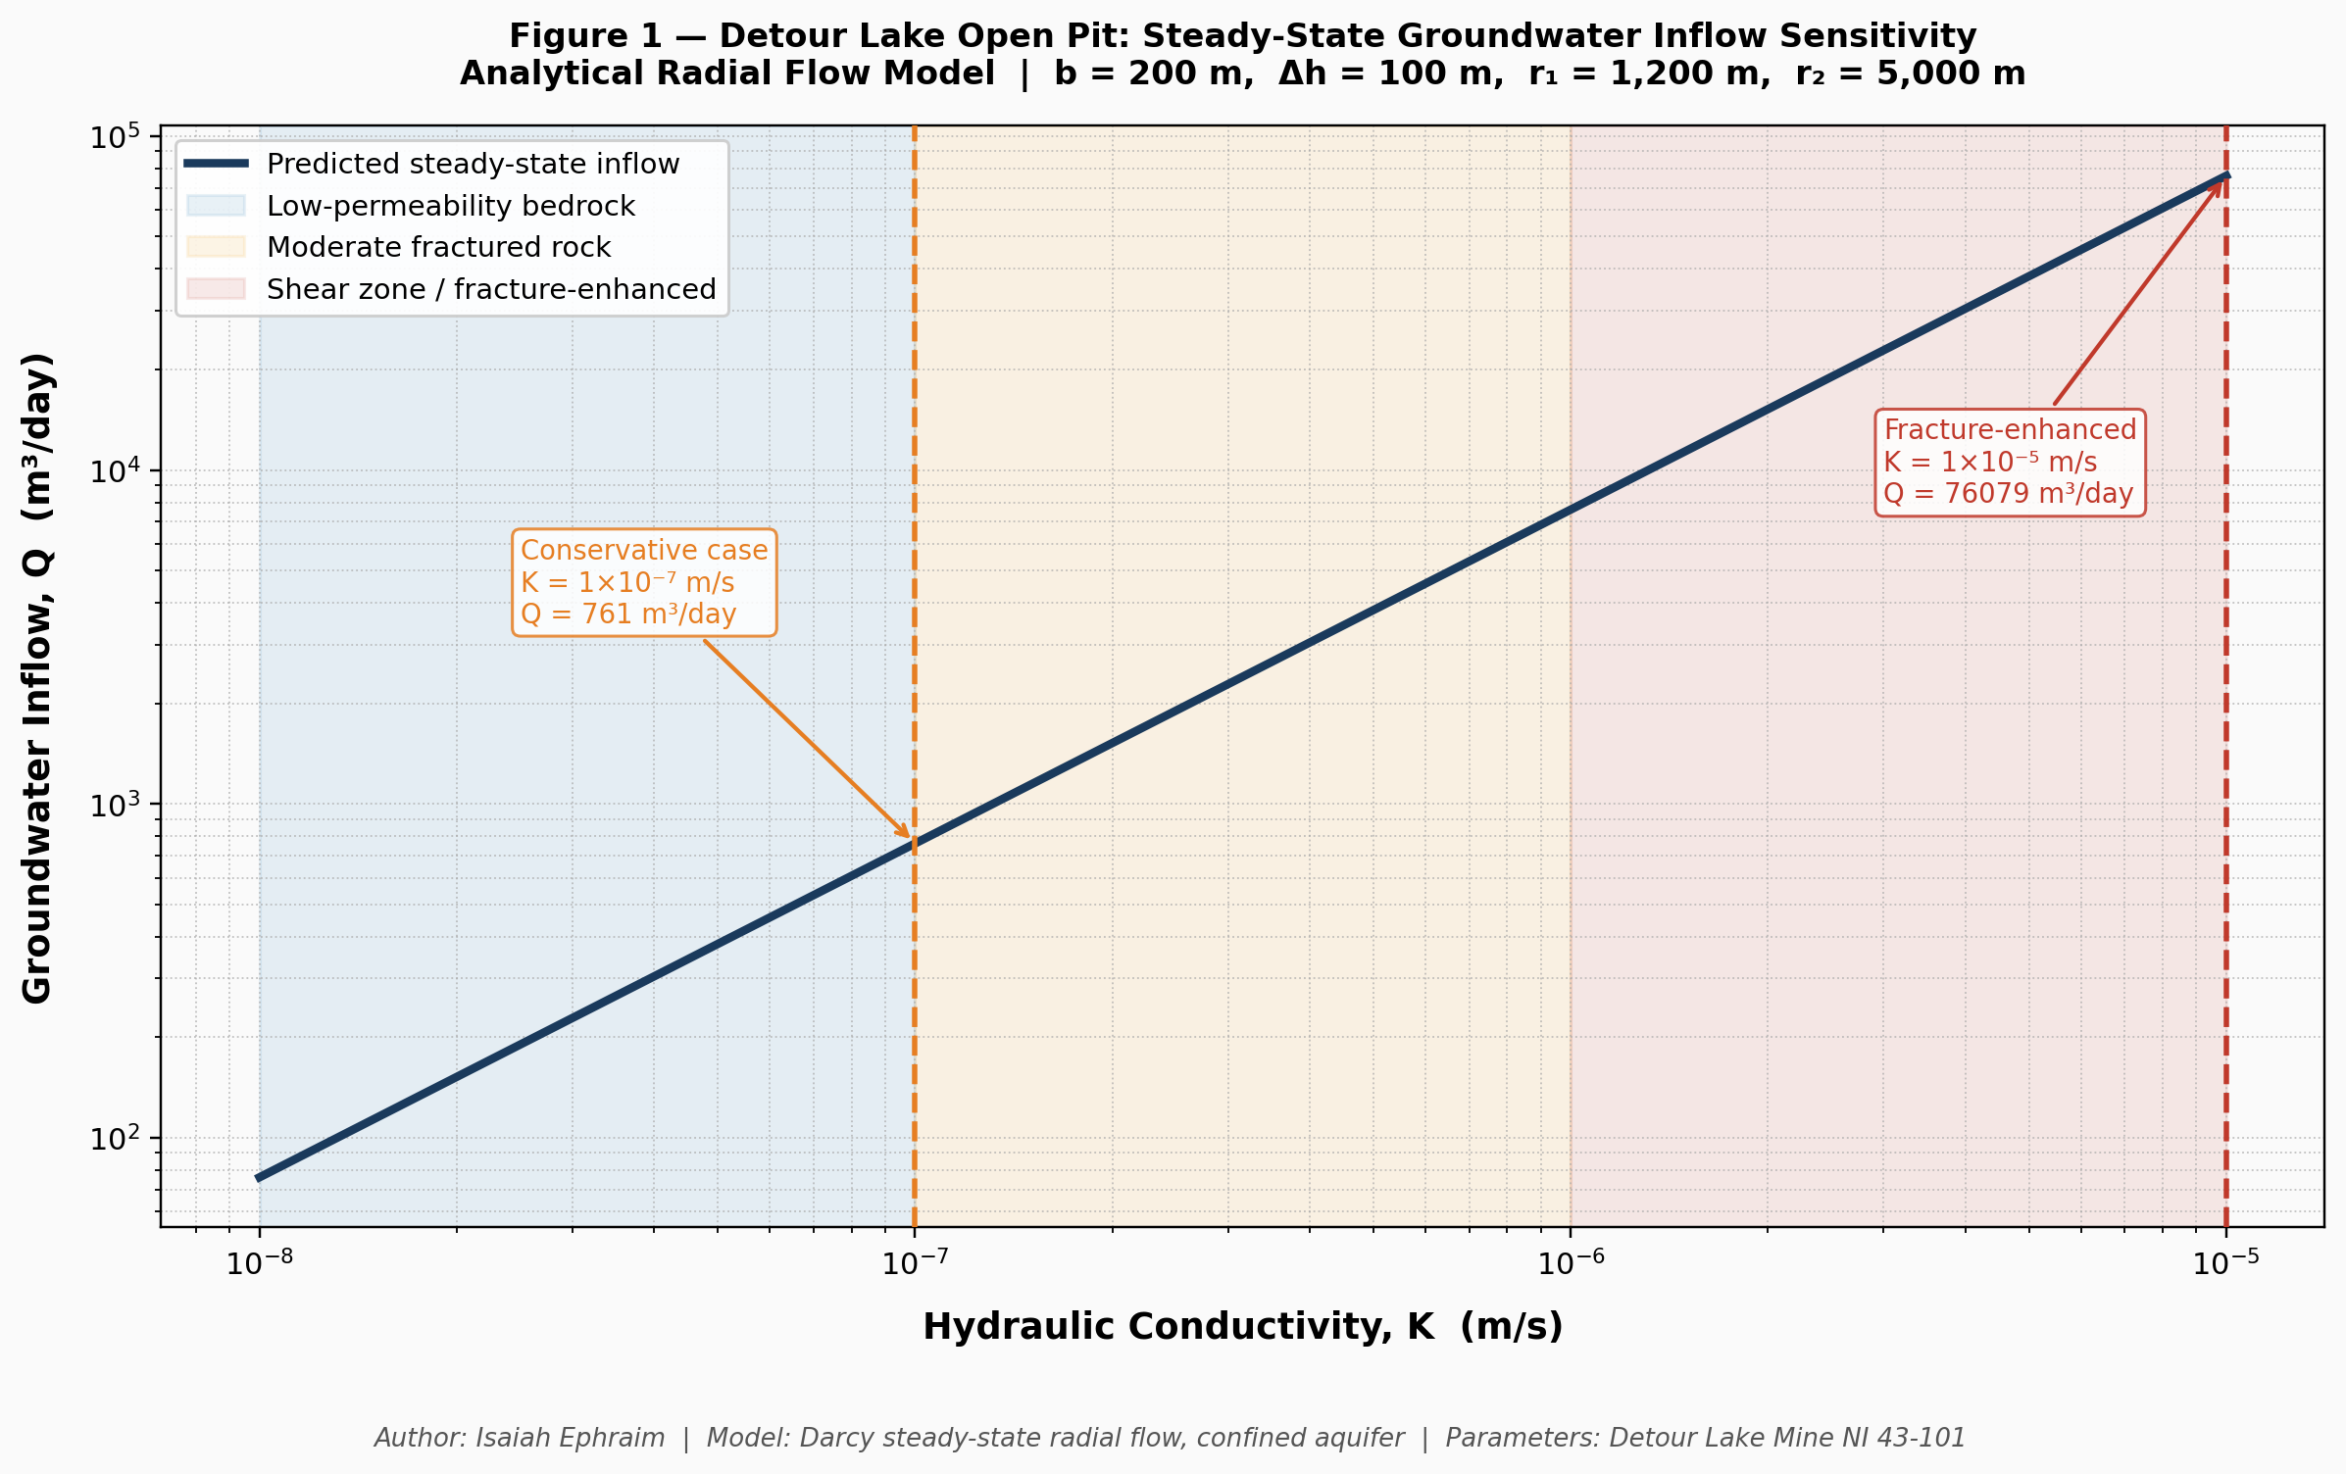
Figure 1. Predicted steady-state groundwater inflow as a function of hydraulic conductivity, Detour Lake open pit. Shaded zones identify permeability domains. Dashed lines mark the two reference scenarios. Fixed parameters: b = 200 m, Δh = 100 m, r₁ = 1,200 m, r₂ = 5,000 m. Computed using Python (NumPy, Matplotlib).

Inflow scales linearly with K on a log–log basis across the full three-order-of-magnitude range, confirming the proportional relationship derived from the Thiem equation. Standard bulk hydraulic testing that averages across intact rock and structural zones will underestimate peak inflow. Shear zones must be targeted individually in any site investigation programme aimed at sizing dewatering infrastructure.

8. Comparison to Reported Dewatering Rates
Life-of-mine technical disclosures for Detour Lake document operational dewatering rates on the order of thousands to tens of thousands of cubic metres per day. (Duquette et al., 2024)
The conservative analytical result (approximately 761 m³/day) corresponds to inflow from lower-permeability fractured bedrock between major structural corridors. The fracture-enhanced result (approximately 76,079 m³/day) corresponds to conditions where active shear zones intersect the dewatered volume. Together, the two scenarios bracket the reported operational range, consistent with the interpretation that structural permeability variability, rather than any single representative K value, governs the span of observed dewatering rates at site.

9. Discussion
The results confirm what field experience in Archean greenstone settings consistently shows: groundwater inflow to large open pits in these environments is not a matrix permeability problem. It is a structural geology problem. The Thiem equation makes this explicit - K dominates the calculation, and K at these sites is controlled by fracture density and shear zone geometry.
A homogeneous radial flow model is adequate for bounding inflow and for preliminary pump sizing. It is not adequate for resolving where inflow will enter the pit, how it will vary as mining progresses to deeper benches, or how a depressurisation bore field should be laid out. Those questions need a numerical model with structural controls explicitly represented.
Real behaviour will deviate from the analytical solution for several reasons. Shear zones are anisotropic - conductivity along strike is typically much higher than across it, and the radial flow assumption does not capture that. Transient drawdown during progressive pit deepening means inflow rates in early mining stages will differ from the steady-state values calculated here. Active dewatering bores, standard practice at sites of this type, alter the hydraulic gradient in ways the Thiem geometry cannot replicate. (Freeze and Cherry, 1979; Todd and Mays, 2005)
Despite these simplifications, the predicted inflow magnitudes align with reported dewatering scales, supporting the use of the analytical approach as a screening tool during feasibility and early prefeasibility work. The key discipline is knowing what question the model can and cannot answer.

10. Conclusion
A steady-state analytical radial flow model was applied to estimate groundwater inflow to the Detour Lake open pit under two representative hydraulic conductivity scenarios derived from NI 43-101 reported data.
Predicted inflow ranged from approximately 761 m³/day in conservative low-permeability fractured bedrock to 76,079 m³/day where shear zone conductivity was applied. The two-order-of-magnitude difference in K produced a two-order-of-magnitude difference in Q. Sensitivity analysis across the full bedrock range confirmed this proportionality holds throughout.
Both results fall within the range of operational dewatering rates documented for the site. Hydraulic conductivity associated with structural zones is the single largest control on dewatering demand. Any site investigation programme that does not specifically target shear zones with packer testing will produce K estimates that understate inflow risk at the upper end.
Subsequent work should progress to transient numerical modelling with explicit structural anisotropy. Coupling surface water interactions and staged pit development into the model framework will further improve the reliability of inflow forecasts as the project moves from prefeasibility into detailed design.

References
All hydrogeological parameters used in this study are derived from publicly available NI 43-101 technical disclosures. Governing equations follow standard confined aquifer radial flow theory as established in the primary groundwater hydrology literature.

Agnico Eagle Mines Limited, 2024. Detour Lake Mine operations overview. Available at: https://www.agnicoeagle.com (Accessed: March 2026).
Detour Gold Corporation, 2018. Detour Lake Operation, Ontario, Canada: NI 43-101 Technical Report. Effective date: 27 June 2018. Report date: 26 November 2018.

Freeze, R.A. and Cherry, J.A., 1979. Groundwater. Englewood Cliffs, New Jersey: Prentice-Hall.

Thiem, G., 1906. Hydrologische Methoden. Leipzig: Gebhardt.

Thurston, P.C., 2002. Autochthonous development of Superior Province greenstone belts. Precambrian Research, 115(1–4), pp.11–36.

Todd, D.K. and Mays, L.W., 2005. Groundwater hydrology. 3rd ed. Hoboken, New Jersey: John Wiley & Sons.

- End of Report -

