**Linux**

**File System**

|  |  |  |  |
| --- | --- | --- | --- |
| **Directory** | **What it does** |  |  |
| /bin | Contains common Linux user commands, such as *ls*, *sort*, *date*, and *chmod* |  |  |
| /boot | Has the bootable Linux kernel and boot loader configuration files (GRUB) |  |  |
| /dev | Contains files representing access points to devices on your systems |  |  |
| /etc | Contains administrative configuration files |  |  |
| /home | Contains directories assigned to each regular user with a login account |  |  |
| /media | Provides a standard location for automounting devices. If the medium has a volume name, that name is typically used as the mount point. |  |  |
| /lib | Contains shared libraries needed by applications in /bin and /sbin to boot the system |  |  |
| /mnt | A common mount point for many devices before it was replaced by the standard /media directory |  |  |

|  |  |  |  |
| --- | --- | --- | --- |
| /misc | A directory sometimes used to automount filesystems upon requests |  |  |
| /opt | Directory structure available to store add-on application software |  |  |
| /proc | Contains information about system resources |  |  |
| /root | Represents the root user’s home directory |  |  |
| /sbin | Contains administrative commands and daemon processes |  |  |
| /tmp | Contains temporary files used by applications |  |  |
| /usr | Contains user documentation, games, graphical files, libraries, and a variety of other commands and files that are not needed during the boot process |  |  |
| /var | Contains directories of data used by various applications |  |  |

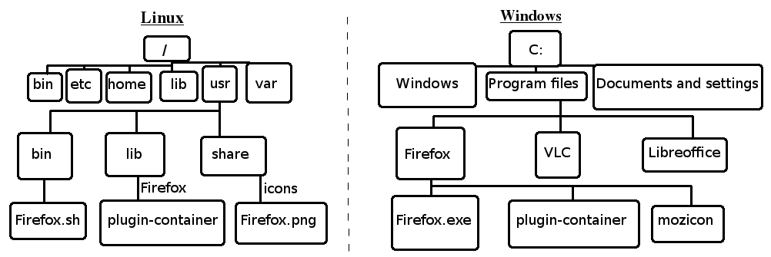

**Filesystem commands**

|  |  |  |  |
| --- | --- | --- | --- |
| **Command** | **What it does** | **Arguments** | **What it does** |
| **cd** | Changes to another directory |  |  |
| **pwd** | Prints the current working directory |  |  |
| **mkdir** | Creates a directory |  |  |
| **chmod** | Changes the permission on a file or directory |  |  |
| **ls** | Lists the contents of a directory | **-a**  Or  **--all** | Lists all contents (even the ones starting with .) of a directory |
| **-A**  Or  **--almost-all** | Lists the contents of a directory except for the ones starting with . and .. (which is default) |
| **--author** | Print the author of each file with **-l** |
| **-b**  Or  **--escape** | Print octal escapes for nongraphic characters |
| **--block-size**=SIZE | Use SIZE-byte blocks |
| **-B**  Or  **--ignore-backups** | Do not list implied entries ending with ~ |
| **-c** |  |
|  |  |
|  |  |