**CATCHABALL FINAL PROJECT**

CatchABall game "Tap & Dash Challenge" is a fast-paced game where players score points by tapping disappearing balls while avoiding tapping elsewhere on the screen, which costs a life. As players progress, the ball’s speed increases, adding to the challenge, and the game ends when all five lives are lost. The game is connected to a database that requires players to create an account and log in, ensuring secure and personalized gameplay. The database stores player progress, including current score, ball speed and lives. Settings like ball color, Game level and sound preferences are stored locally, allowing players to resume their game seamlessly. Additionally, it tracks each player’s high score and features a global leaderboard, encouraging competition among players worldwide.

**Functional Requirements**

1. **User Accounts**:
   * Players must create a user account with a username and password to access the game.
   * Players must log in to their account to start playing.
2. **Gameplay Mechanics**:
   * Players can tap on the ball to score points.
   * Players lose a life if they tap outside the ball.
   * The ball's speed increases after every 5 points scored.
3. **Lives System**:
   * The game starts with 5 lives.
   * The game ends when all lives are lost.
4. **Pause and Resume**:
   * Players can pause the game at any time.
   * Players can resume the game from where they left off.
5. **Customization Settings**:
   * Players can change the ball's color.
   * Players can select the game level.
   * Players can mute or unmute the ball sound.
6. **Scoreboard**:
   * The player's highest score is recorded locally.
   * The global best player's score is displayed for comparison.

**Non-Functional Requirements**

1. The game must run smoothly on devices without noticeable lag.
2. The ball's speed and position updates should be responsive to user interaction.
3. Help or instructions should be available for first-time users.
4. Player progress (score, ball color, and settings) should be saved and retrievable even after closing the game.
5. The game must function on Android
6. The game should not crash or lose progress during gameplay or settings updates  
     
     
     
   **A screen shot of a cell phone

   Description automatically generatedA screen shot of a cell phone

   Description automatically generatedA screenshot of a cell phone

   Description automatically generated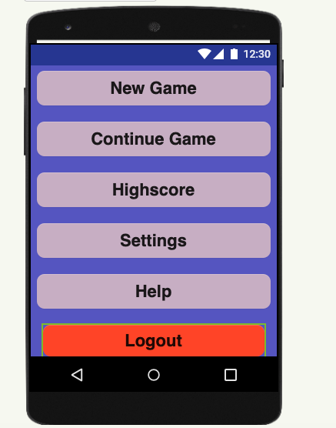A black dots on a white background

   Description automatically generated A screenshot of a device

   Description automatically generatedA screenshot of a device

   Description automatically generated**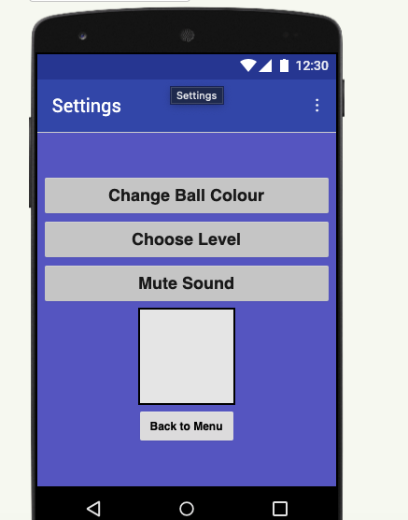

**USER MANUAL**

**1. Registering a New Account**

To play **Catch a Ball**, you need to create a user account. Follow these simple steps:

1. **Launch the Game**: When you open the game for the first time, you will be prompted to create an account.
2. **Enter Details**: Provide a unique **username** and a secure **password**.
3. **Submit Information**: Click the **Register** button to complete your account creation.

After registering, you can log in with your username and password to start playing.

**2. Logging Into the Game**

Once you have registered, you can log in to your account:

1. **Open the Game**: Launch the game and go to the login screen.
2. **Enter Your Username and Password**: Input your credentials.
3. **Click Login**: Access your personalized game profile and start playing.

**3. Game Basics**

* To start click on New Game.
* **Objective**: Tap the disappearing ball to score points. Avoid tapping anywhere else on the screen, as it will cost you a life.
* **Lives**: You start with 5 lives. The game ends when you lose all your lives.
* **Ball Speed**: Every time you score 5 points, the ball speeds up, making the game progressively harder.

**4. Game Features**

* **Settings**:
  + **Change Ball Color**: Personalize your gameplay by adjusting the **RGB color** of the ball using the sliders in the settings menu. The sliders control the **Red**, **Green**, and **Blue** components of the color. Adjust each slider to create your preferred ball color.
  + **Game Level**: Adjust the game difficulty (e.g., beginner, intermediate, or advanced).
  + **Sound Settings**: Mute or unmute the ball sound based on your preferences.
* **Pause & Resume**:  
  If you need to step away during the game, simply press the **Pause** button. When you're ready to continue, click **Start** during the game to begin playing again.
  + You can also **Pause** the game, and the progress will be saved. If you return later, go to the **User Menu** and click **Continue Game** to resume where you left off.
* **Global Leaderboard**:  
  Your **highest score** is saved in the game. Compete against other players around the world for the highest score! The leaderboard will show the best player’s score, which could be from any difficulty level.

**5. Saving Your Progress**

Your game progress is automatically saved in the database, including your high score, current score, and settings. This allows you to:

* **Resume your game** from where you left off after pausing or returning to the game later by clicking **Continue Game** in the user menu.
* **Track your highest score** and see how it compares to the global leaderboard.

**6. Ending the Game**

The game ends when you lose all your lives. At this point, you can:

* **View your score** and see if you’ve beaten your previous best or the global best.
* **Return to the main menu** or **log out** to switch users.